OICA’s Background Information on Working Document GRBP/2025/29

OICA[1] has submitted its proposal WD GRBP/2025/29 to 82nd GRBP as a replacement to its proposal WD GRBP/2024/22 originally issued for the 80th GRBP in September 2024. By doing so, we want to reiterate our concern regarding an existing and non-regulated gap for electric vehicles. Our proposal from last year is already capable to close that grey zone and would have been entered into force from January 2026 on, if adopted at that time.

We take again the path of a direct working document by OICA, as we observe in the dedicated group for this topic no substantial progress. While giving our clear position, OICA is still supporting the ongoing work and seeking for compromises. In case an acceptable solution is worked out, OICA will be happy to amend or withdraw this document.

# **What is our position?**

Industry is seeking solutions that provide manufacturers design flexibility without restricting technologies. We do not agree to prohibit a specific technology, as a technology by itself is not an issue. We present now a refined working document taking into account what we sensed as feedback from CPs, and we incorporated findings from our technical validation work.

We encourage CPs to consider this proposal as a solution to enable a closing of the existing and non-regulated gap. We see this proposal as an interim step that addresses this issue while allowing the group to refine the RD-ASEP concept, in a forthcoming new series of amendments to UN Regulation R51.

# **Why do we believe our approach is good?**

Our proposal is in line with the established principles for exterior sound testing of vehicles. Industry is familiar with the processes and can extend these without greater difficulties to their electric vehicle designs.

The proposal provides only limited changes in the ASEP test principles to be applicable for EVs:

* ASEP for EVs will be evaluated against vehicle speed, instead of engine speed,
* will start from almost standstill,
* be applicable as well under partial load and not only under full acceleration

Our approach enables manufacturers to react on feedback from public and on requests of insurance associations. Manufacturers shall have enough flexibility to design their vehicles in a way, to be better for safety than just the minimum sound requirements as outlined by UN Regulation No. 138***[2].*** The same principle as for environmental progress shall apply. Nobody questions manufacturers aim for making their products quieter as requested by UN Regulation No. 51.

UN Regulation No. 138 defines minimum safety levels for electrically propelled vehicles. At the time of development of this Regulation it became obvious that no sound level could claim to be sufficiently safe.

The moment when a pedestrian intends to cross a road, many parameters influence the decision-making process. The IWG on QRTV at that time believed in the market driving forces to establish sound levels above the minimum sound levels and below the maximum sound levels which provide satisfying safety. The focus was on the speed range between standstill and 20 km/h, while it was already clear that higher speeds should not be excluded.

Studies on established vehicle technologies show how the market has tackled the issue. EVs are today perceived by the public as decent and not disturbing[3]. The graph below shows the actual status of technology for vehicles using only AVAS as a sound enhancement tool, and for vehicles using extended sound enhancement tools.

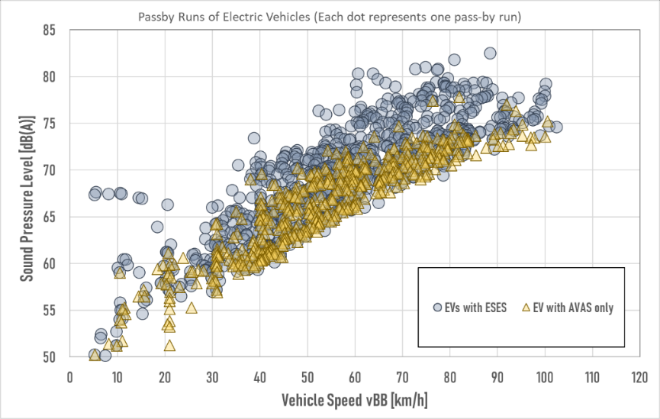

Diagram 1: OICA collected data on EVs with and without Sound Enhancement Systems

Additional studies on safety initiated by OICA, shared with the subgroup on R138/R51, showed that beyond minimum sound an area of “beneficial sound” can be allocated.

This area considers safety as wellunder accelerated test conditions as requested by insurance companies, more realistic background noise, and higher speed to account for areas where extra quiet road surfaces take away the tyre rolling sound as major signal for the approach of a vehicle.

The diagram below shows this area above the minimum sound curve (dark green solid line). The dashed curve shows in a generic way the OICA proposed ASEP maximum sound level curve for electric vehicles.

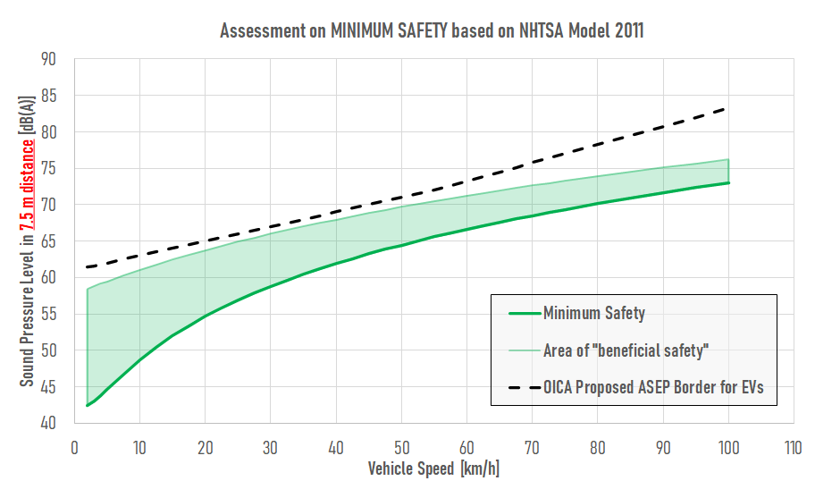

Diagram 2: Area of “beneficial safety” and OICA proposal for maximum sound by ASEP

The ASEP limit curve as suggested by OICA is especially for urban speeds very well framing this safety area. The sound levels are much below the discussed issue of noisy individual vehicles, which are discussed to be identified by noise cameras at sound levels beyond 82 dB(A)[4].

The OICA proposal means a cut for vehicles with sound enhancement systems in a way, manufacturer can provide quick solutions. The diagram below shows, how the ASEP border will impact the sound behavior of those vehicle. It shows further that the difference between EVs with extended sound and EVs with AVAS systems only is very limited. The grey dots in the chart may be seen as the fleet market today. EVs belong to the quietest vehicles on the street, regardless of their technology.



Diagram 3: Application of ASEP as proposed by OICA (all pass-by runs processed according to OICA proposal)

# OICA’s proposal is robust against manipulation.

The outlined test procedure in combination with the general ASEP provisions covers the whole vehicle sound. Any future technology which might be developed is included in the provisions suggested by OICA. Within the given control range there is no chance to bypass the provisions, as ASEP tackles any modes the manufacturer may establish in the vehicles. Outside the ASEP control range, the general ASEP specifications apply.

Alternative ideas as raised in the subgroup, such as prohibition of devices, or back-to-back tests need definitions, which bear the risk that they are incomplete, not covering new technologies, or leave room for interpretation.

# OICA’s proposal does not jeopardize environmental ambitions.

Market observations show that neither consumers nor auto magazines request high dynamic sounding electric vehicles. Data from manufacturer of highly emotional sporty vehicle show that even in this area loud vehicles have a low market acceptance today.

As already pointed out before, EVs are today perceived as decent², some state they are quieter than ICE. Therefore, OICA suggests setting guardrails for the sound development based on the today’s technology.

Vehicles with extended sound in line with the OICA’s proposal have a very limited impact on the environment compared to vehicles without additional sound.

The impact on the environment was assessed by OICA in two scenarios, the first assuming all EVs would have extended sound limited as it is established today, the second that all EVs would have an AVAS only. The second scenario is very unlikely, as manufacturers have very different market strategies. But is was selected to assess a kind of worst case scenario.

The diagram below shows the results of the assessment for a market penetration of 70% EVs under various street scenarios under cruising (left diagram), and full load (right diagram) as it is assumed near roundabouts condition, crossings and traffic lights.

The calculations show that the impact is very limited (less than 0.5 dB) at traffic lights or round abouts, and neglectable under cruising conditions.[5]

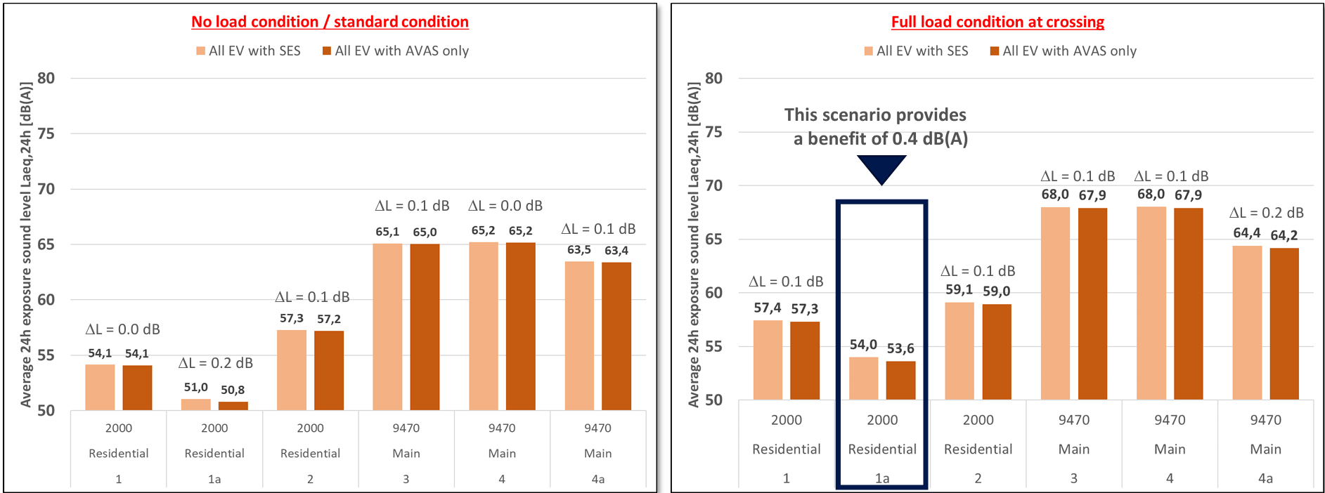

Diagram 4: Calculation scenarios for impact of EVs with extended sound for 70% market penetration

Based on all the considerations above we are convinced that our proposal is well-matured, reasonable, and capable to close the existing grey zone for electric vehicles.

We invite all CPs to take a close look into our proposal before next GRBP. OICA is ready to answer any questions and will provide more detailed material.

1. OICA = International Organization of Motor Vehicle Manufacturers (NGO)
2. See documents of the subgroup on R51 and R138 to UN-ECE GRBP IWG RD-ASEP   
   <https://wiki.unece.org/download/attachments/271089891/20241211_1__UNECE_AVAS_Geh.pdf?api=v2> <https://wiki.unece.org/download/attachments/271089891/20241211_114-e-perception-of-electric-vehicles-data.pdf?api=v2> https://wiki.unece.org/download/attachments/271089891/2024-12-12%20Background%20Information%20-%20QRTV-Safety%20in%20Details%20-%20V03.pdf?api=v2
3. See document of the subgroup on R51 and R138 to UN-ECE GRBP IWG RD-ASEP https://wiki.unece.org/download/attachments/271089891/akzeptanz-aktueller-fussgaengerhinweissysteme-in-der-schweizer-bevoelkerung.pdf?api=v2
4. See documents of UN-ECE GRBP Task Force on Vehicle Sound (former: Task Force Sound Limits): <https://wiki.unece.org/download/attachments/265978242/TFVS-16-04%20-%20Noise%20Camera%20Test%20in%20Geneva.pdf?api=v2> <https://wiki.unece.org/download/attachments/244547675/TFVS-15-04%20Noise%20camera%20presentation%2029.05.2024.pptx?api=v2> <https://wiki.unece.org/download/attachments/198675224/TFVS-12-03%20%28BRUITPARIF%29%20Meduse%20and%20Hydre%20-%20Tackling%20noise%20where%20it%20comes%20from.pdf?api=v2>
5. See document of the subgroup on R51 and R138 to UN-ECE IWG RD-ASEP  
   <https://wiki.unece.org/download/attachments/265978025/SG_R51_138_01.02_Background_Information-ASEP-QRTV-ENVI.updated.pdf?api=v2>