 | United Nations | ECE/TRANS/WP.29/GRSP/2025/30
 | Economic and Social Council |  | Distr.: General  19 September 2025  Original: English
Economic Commission for Europe
Inland Transport Committee
World Forum for Harmonization of Vehicle Regulations
Working Party on Passive Safety
Seventy-eighth session
Geneva, 1–4 December 2025
Item 13 of the provisional agenda
UN Regulation No. 127 (Pedestrian safety)

Proposal for the 05 series of amendments to UN Regulation No. 127 (Pedestrian safety)

Submitted by the experts from Germany and the Kingdom of the Netherlands *
The text reproduced below was prepared by the expert from Germany and the Kingdom of the Netherlands and concerns the transposition of GTR-9 Amendment 3 (ECE/TRANS/WP.29/2024/77) on the technical requirements for Deployable Pedestrian Protection Systems into UN Regulation No. 127. The modifications to the current text of UN Regulation No. 127 are marked in bold for new and strikethrough for deleted characters.

I. Proposal
Contents, update.
Insert new paragraphs 0. to 0.1.5., to read:
“0. Introduction
0.1. For the 05 series of amendments to UN Regulation No. 127
0.1.1. It concerns the transposition of UN GTR No.9 Amendment 3 (ECE/TRANS/WP.29/2024/77) on the test procedure for Deployable Pedestrian Protection Systems and the procedure for the head impact time (HIT) determination simulation into UN Regulation No. 127.
0.1.2. The intention of the 05 series of amendments is to provide test provisions for vehicles equipped with DPPS. Since those test procedures differ depending on the DPPS deployment status at the time of the head impact, for tests on vehicles equipped with DPPS, the determination of the pedestrian’s head impact time (HIT), as defined in chapter 2 of this Regulation, is an indispensable prerequisite. It is also necessary to ensure the pedestrian is properly detected as well as the safety of pedestrians in the cases where the DPPS is not deployed due to vehicle speeds below the deployment threshold during the accident.
0.1.3 A general guideline for the assessment of DPPS is depicted in a flowchart in the Appendix to Annex 7 to this Regulation.
0.1.4. Numerical simulations with Human Body Models (HBM) are employed in the procedure to estimate HIT as described in Annex 8 of this Regulation.
0.1.5. The information about HBMs is available in Addendum 5 of M.R.1 (ECE/TRANS/WP.29/1101).”
Paragraph 2., amend to read:
“2. Definitions
When performing measurements as described in this Part, the vehicle should be positioned in its normal ride attitude.
In case of the vehicle equipped with a deployable pedestrian protection system (DPPS) as defined in paragraph 2.50., the measurements shall be taken with the system undeployed.
If the vehicle is fitted with a badge, mascot….”
Paragraph 2.1., delete footnotes ² and ³.
Paragraph 2.31., replace the reference to 2.27. by 2.29.
Paragraph 2.43., delete footnote ⁵.
Paragraph 2.45., delete footnote ⁶.
Insert new paragraphs 2.50. to 2.61., to read:
“The following definitions are specifically related to Deployable Pedestrian Protection Systems (DPPS):
2.50. "Deployable Pedestrian Protection System (DPPS)" means a technical system, which is activated for head protection of a pedestrian in the event of a collision of the vehicle with a pedestrian. It comprises a deployment module, together with other related components required for its function, such as bonnet, sensors, or wiring, etc.
2.51. "Deployment module" means a unit, comprising components, such as airbags, springs, or pyrotechnic actuators, etc., that are used to change the vehicle outer surface from a position of normal use in the vehicle to a deployed position.
2.51.1. "Initiation of the deployment module" means, at the option of the manufacturer, either the moment when visible movement of the actuator is initially detected, or the moment when the triggering signal is sent from the electronic control unit to the deployment module.
2.52. "Deployment Time (DT)" means the duration from the initiation of the deployment module(s) until the DPPS reaches its maximum deployment height for the first time. Measurement shall be done on the outer surface of the DPPS, in the area above the lifting device(s).
2.52.1. "Deployed position" means the position of the vehicle outer surface equipped with a DPPS that can be maintained by the system after its activation, as shown in Figure 1 of Annex 7.
2.52.2. "Undeployed position" means the position of the vehicle outer surface equipped with a DPPS when the DPPS is not activated.
2.53. "Detection test area" is the area designated to detect a pedestrian in order to activate the deployable system. The width of the detection test area shall be the relevant vehicle width, minus a distance from each side of 12.5 per cent of the relevant vehicle width, but not more than 250mm from each side. The detection test area must not be smaller than the area inboard of the corners of bumper (CoB) minus a distance of 42mm on each side, as measured horizontally and perpendicular to the longitudinal median plane of the vehicle. (see Figure 18).
At the choice of the manufacturer, a wider detection test area may be declared.
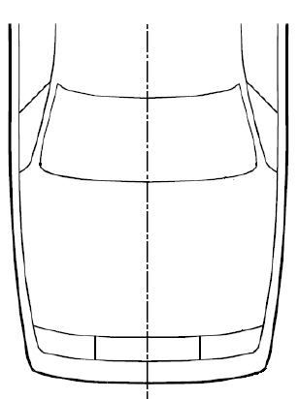
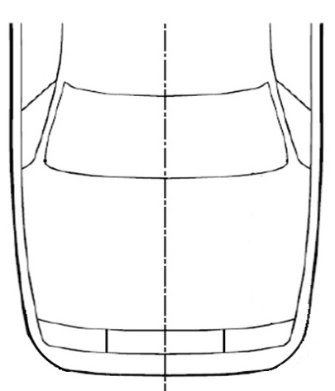
Figure 18
Determination of the Detection Test Area (see paragraph 2.53): examples
CoB -42mm (l+r)
Detection Test Area
Detection Test Area
CoB -42mm (l+r)
CoB (l)
CoB (l)
CoB (r)
CoB (r)
Relevant Vehicle Width (RVW)
75% of RVW
Relevant Vehicle Width (RVW)
75% of RVW
CoB -42mm (l+r) > 75% of RVW
CoB -42mm (l+r) < 75% of RVW

2.54. The "pedestrian Head Impact Time (HIT)" is defined as the elapsed time subsequent to the time of first contact of the pedestrian surrogate (neglecting forearms and hands) with the vehicle outer surface and the time of first contact of its head with the vehicle outer surface.
There are two kinds of HITs:
2.54.1. "HIT_d": to decide whether the physical head test on the deployable system can be done dynamically or statically. The HIT_d is determined with the deployed DPPS.
2.54.2. "HIT_s": to synchronise the test rig for dynamic testing. The HIT_s is determined with the undeployed DPPS.
2.55. "Outer surface" means those components of the vehicle, which may be contacted by the pedestrian in case of an accident. The outer surface may include the bumper, the bonnet, the fenders, but also external airbags or other components.
2.56. "Relevant Vehicle Width (RVW)" is the maximum width of the vehicle without devices for indirect vision, measured on or in front of a vertical transverse plane passing through the front axle of the vehicle.
2.57. "Sensing Time (ST)" means the duration from the time of the first contact of the flexible lower legform impactor (FlexPLI) with the vehicle outer surface to the initiation of the deployment module.
2.58. "Sensors" are pedestrian contact sensors that detect a pedestrian contact with the front of the vehicle. These sensors include, but are not limited to, accelerometers, fibre optic sensors, pressure sensors, etc.
2.59. Testing of the DPPS: the headform impact tests on the DPPS can be performed in three ways: statically, dynamically or combined.
2.59.1. "Static testing" means the launch of the headform on a DPPS being in the deployed position.
2.59.2. "Dynamic testing" means the synchronised launch of the headform onto the deploying DPPS at the appropriate HIT_s.
2.59.3. "Combined testing" means a mixed set of tests on a DPPS in which a given test is run either statically or dynamically.
2.60. "Testing time" for static time constraint means the timeframe after the DPPS reaches its deployed position in which the headform test to the DPPS is to be performed (see Figure 3 of Annex 7.).
2.61. "Total Response Time (TRT)" means the duration from the time of first contact of the FlexPLI with the vehicle outer surface to the time the DPPS reaches its maximum deployment height for the first time. It is the sum of the ST and DT.”
Paragraph 4.2., amend to read:
“4.2. An approval number shall be assigned to each type approved in accordance with Schedule 4 of the Agreement (E/ECE/TRANS/505/Rev.3). Section 2 of the approval number shall be supplemented with a slash and one of the following characters as applicable:
(a) the letter "T" for vehicles approved using the specific provisions on WAD 2,100 boundary in accordance with paragraph 11.19; or
(b) the letter "E" for vehicles approved with the extended WAD 2,500 boundary.
Example:
Example of the first extension to the 2439th type approval issued by the United Kingdom of Great Britain and Northern Ireland for a vehicle approval according to UN Regulation No. 127, third series of amendments and its supplement 1, using the specific provisions related to WAD 2,100 boundary;
E11*127R03/01/T*2439*01."
(c) the letter "F" for vehicles approved using the specific provisions related to BRRL in accordance with paragraphs 11.22. and 11.23.
Example:
Example of the first extension to the 2439th type approval issued by the United Kingdom of Great Britain and Northern Ireland for a vehicle approval according to UN Regulation No. 127, fourth series of amendments and its supplement 1, using the specific provisions related to BRRL boundary;
E11*127R04/01/F*2439*01.”
Paragraph 4.4.3., shall be deleted.
Paragraphs 5.2. to 5.2.2., amend to read:
“5.2. Headform tests
When tested with DPPS activated, the test conditions and requirements in Annex 7 shall apply.
5.2.1. Child and adult headform tests:
When tested in accordance with Annex 5, paragraphs 3., 4., and 5., and if applicable, Annex 7, the HIC recorded shall not exceed 1,000 over two thirds of the combined bonnet top test area and the windscreen test area. Furthermore, the HIC recorded shall not exceed 1,000 over two-thirds of the bonnet top test area. The HIC for the remaining areas shall not exceed 1,700 for both headforms. Measuring points located in the cowl monitoring area shall not be taken into consideration to assess the performance requirements stated in this paragraph. The respective test results are used for monitoring purposes only and do not contribute to the one-third and two-third area calculation.
In case there is only a child headform test area, the HIC recorded shall not exceed 1,000 over two thirds of the test area. For the remaining area the HIC shall not exceed 1,700.
5.2.2. Child headform impact
When tested in accordance with Annex 5, paragraphs 3. and 4., and if applicable Annex 7, the HIC recorded shall not exceed 1,000 over a minimum of one half of the child headform test area. The HIC for the remaining areas shall not exceed 1,700.”
Paragraphs 11.1. to 11.25., replace by:
“11.0. Permanent transitional provisions
11.0.1 Contracting Parties applying this Regulation may grant type approvals according to any preceding series of amendments to this Regulation.
11.0.2 Contracting Parties applying this Regulation shall continue to grant extensions of existing approvals to any preceding series of amendments to this Regulation.
11.1. to 11.25. (deleted)”
Insert new paragraphs 11.26. to 11.29., to read:
“Transitional provisions for the 05 series of amendments:
11.26. As from the official date of entry into force of the 05 series of amendments, no Contracting Party applying this Regulation shall refuse to grant or refuse to accept type-approvals under this Regulation as amended by the 05 series of amendments.
11.27. As from 1 September [2031], Contracting Parties applying this Regulation shall not be obliged to accept type-approvals to any of the preceding series of amendments, first issued after 1 September [2031].
11.28. Contracting Parties applying this Regulation shall continue to accept type approvals issued according to any of the preceding series of amendments to this Regulation, first issued before 1 September [2031], provided the transitional provisions in these respective previous series of amendments foresee this possibility.
11.29. Contracting Parties applying this Regulation shall continue to grant type approvals using the test proceedings related to atypical windscreen fracture behaviour (see Annex 5 paragraphs 4.8. and 5.8.) until 1 September [2033].”
Annex 1, Part 1, paragraph 9.23.1., amend to read:
“9.23.1. A detailed description, including photographs and/or drawings, of the vehicle with respect to the structure, the dimensions, the relevant reference lines and the constituent materials of the frontal part of the vehicle (interior and exterior) shall be provided. This description shall include detail of any active protection system installed (for DPPS, see Annex 7, paragraph 1.2.) and any system, which could change the vehicle height at the front axle while driving (e.g. ARHSS).”
Annex 1, Part 2, paragraph 16.1., delete the text under the table.
Annex 2, text under the heading, amend to read:
“(See paragraphs 4.4. to 4.4.32. of this Regulation)
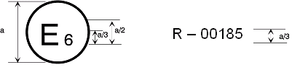
127R – 05185
a = 8 mm min
The above approval mark affixed to a vehicle shows that the vehicle type concerned has been approved in Belgium (E 6) with regard to its pedestrian safety performance pursuant to UN Regulation No. 127. The first two digits of the approval number indicate that the approval was granted in accordance with the requirements of UN Regulation No. 127 as amended by the 04 05 series of amendments; the letter "T" indicates the approval was granted using the specific provisions on WAD 2,100 boundary in accordance with paragraph 11.19.”
Annex 3, paragraph 3.2., amend to read:
“3.2. All devices designed to protect vulnerable road users when impacted by the vehicle shall be correctly activated before and/or be active during the relevant test. It shall be the responsibility of the manufacturer to show that any devices will act as intended in a pedestrian impact.
When tested with DPPS activated, the vehicle shall be adjusted as specified in the test procedure defined in Annex 7.”
Insert new Annexes 7 and 8, to read:
“Annex 7
Test Procedure for Deployable Pedestrian Protection Systems
1. Prerequisites
If all of the following prerequisites are met, the vehicle shall be tested with the DPPS activated as intended (as described below) for the entire headform test area.
For DPPS to be assessed statically, dynamically or combined, it will be necessary for the vehicle manufacturer to identify detailed information highlighted in this Annex before any testing begins. The vehicle manufacturer shall identify all necessary information regarding detection of pedestrians and the deployment of the system. Based on the evidence identified, activation of the system in the headform test will be determined.
The principle of testing the DPPS is as follows:

Figure 1
Deployment Time History Curve
Total Response Time
Sensing Time
Deployment Height
Maximum Deployment Height
Deployed Position
System deployed
undeployed
B
A
Deployment Time
Time
(a) In case of HIT_d < TRT, the headform test shall be performed dynamically;
(b) In case of HIT_d ≥ TRT, the headform test may be performed either statically at a height no more than the deployed position or dynamically.
1.1. If any of the prerequisites from paragraphs. 1.2 to 1.7. are not met, the vehicle shall be tested with the DPPS in the undeployed position.
1.2. System specification:
A technical description of the DPPS components shall be identified by the manufacturer. This shall be accompanied by the following information:
1.2.1. For the sensing system:
(a) Sensor type (e.g. pressure, optical, acceleration, etc.);
(b) Sensor locations;
(c) Operation process (including the lower deployment threshold speed of the DPPS).
1.2.2. Deployment information:
(a) Technology of the DPPS (airbag, active bonnet, etc.);
(b) Mechanism explanation;
(c) Component description (lifting system (e.g. actuator), hinge, latch, etc.);
(d) Deployed position information (not required for dynamic testing);
(e) TRT (ST and DT separately) information (for dynamic testing: ST only);
(f) Evolution of system stability (e.g. pressure or force versus time diagram) (static testing, only).
1.3. The marking of the headform test areas of the DPPS shall always be done in undeployed position, for static, dynamic or combined testing.
1.4. Headform test for protection below the lower deployment threshold speed of the DPPS.
1.4.1. The vehicle outer surface shall remain in undeployed position.
1.4.2. The test procedures specified in Annex 5, paragraphs 3., 4., and 5., shall apply, but only to the bonnet top test area with the impact speed specified at 0.9 times the lower deployment threshold speed. The allocation of the HIC1700 and HIC1000 zones is only related to the bonnet top test area and may differ from those at nominal velocity (9.7 m/s) headform impact tests according to Annex 5 paragraph 3.4 on the bonnet top test area.
However, in the case where the line 82.5 mm forward of the BRRL is not on the bonnet, then the rear of the bonnet top test area at Lower Threshold shall be defined using the rear physical edge of the bonnet as BRRL.
1.4.3. The HIC shall comply with paragraph 5.2 of the Regulation but only related to the bonnet top test area. A minimum of three tests shall be performed.
1.5. HBM shall be qualified according to Addendum 5 of Mutual Resolution No. 1 (M.R.1). HIT information shall be documented according to Annex 8 of this Regulation.
1.6. Verification of the prerequisites for deployed static tests: Deployed Position, Maximum Deployment Height, ST and DT as illustrated in the deployment time history curve (see Figure 1 of this Annex).
The values specified by the manufacturer shall be verified by using appropriate tracking means, such as high-speed videos, accelerometer, or laser at the reference points as indicated by the manufacturer (on the lifting devices). The tolerance for the ST is -5 ms/+3 ms on the specified value, whereas the other tolerances are ±20 percent on the specified values respectively. If a measured value is within the defined tolerances, the values specified by the manufacturer shall be used. Otherwise, the measured values shall be used.
1.7. Sensing System Verification
1.7.0. The detection test area, as defined in paragraph 2.53. of this Regulation, will be subdivided into three thirds of identical width, whereas one third is the geometrical trace between the left and right end of the detection test area, measured with a flexible tape held tautly and horizontally at the height of the UBRL at vehicle centreline and following the outer contour of the bumper , equally divided by three. See Figure 2 below.
Figure 2
Scheme of the detection test area subdivision
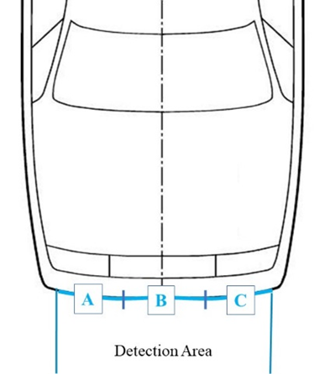
Detection Test Area
A
B
C
In case of ARHSS, sensing system verification shall be done at normal ride attitude.
1.7.1. The vehicle manufacturer shall specify the lowest speed of activation (lower deployment velocity threshold) of the DPPS.
1.7.1.1. For the system deployment verification, sensor activation tests with the FlexPLI, as specified in Annex 4 paragraph 1. of this Regulation, shall be performed within the detection test area at the DPPS lower deployment velocity threshold.
A minimum of one test per third (A, B and C) shall be performed, maintaining a minimum distance of 50 mm to adjacent tests. Upon request of the manufacturer, additional tests outboard either side of the detection test area may be performed to provide for possible future extensions (e.g. aerodynamic attachments) enlarging the detection test area .
1.7.2. A test with the FlexPLI shall be performed at nominal velocity (11.1 m/s) at vehicle centreline (Y0).
1.7.3. Where a test is performed within the tolerances as specified in paragraph 3 of this Annex, but below the lower deployment velocity threshold or outside the detection test area and the system does not deploy, the test must be repeated.
Test Assessment
1.7.4. If the system is not activated during any of the verification tests, all headform tests shall be conducted in undeployed position according to Annex 5, paragraphs 3., 4., and 5. of this Regulation.
1.7.5. For tests with stationary vehicle: the vehicle shall be set to the normal running condition as specified by the manufacturer for a vehicle speed corresponding to the particular use case.
2. Verification of the Total Response Time and /or Sensing Time at Nominal Velocity
2.1. TRT shall be confirmed by using the FlexPLI at the vehicle speed at 11.1 m/s and at the vehicle centreline (Y0).
2.2. ST is measured either independently, or during a TRT measurement test, at the vehicle speed as specified in this Regulation and at the vehicle centreline (Y0).
2.2.1. If the measured ST is within a tolerance of -5 ms/+3 ms, the value specified by the manufacturer shall be used. Otherwise, the measured value shall be used for the test. For dynamic testing, only ST shall be verified.
2.2.2. For tests with stationary vehicle: the vehicle shall be set to the normal running condition as specified by the manufacturer.
3. Tolerances
For verification tests of paragraphs 1.7. and 2. of Annex 7 with the FlexPLI, the following tolerances shall apply:
3.1. For tests with a moving vehicle impacting the stationary impactor:
Target speed: ±0.6 m/s: impact accuracy: ±50 mm.
3.2. For tests with a propulsion system propelling the impactor against the stationary vehicle:
Target speed, impact accuracy, angle tolerances are those of the performance tests, as in paragraph 1. of Annex 5 of this Regulation.
4. Headform Test Procedure at Nominal Velocity (9.7m/s)
The selection of impact points and the allocation of the HIC1700 and HIC1000 zones shall always be based on and related to the test area with undeployed DPPS.
4.1. Static test option:
If the vehicle manufacturer opts for the static test procedure, the following conditions shall be fulfilled. If so, the headform tests on the headform test area shall be performed statically.
If any of the following conditions are not met, the headform tests on the headform test area shall be performed dynamically.
4.1.1. Where the vehicle manufacturer has demonstrated by numerical simulations on the deployed DPPS, that HIT_d ≥ TRT for the smallest selected pedestrian stature, as defined in Annex 8, then all tests may be performed statically.
4.1.2. The vehicle outer surface shall represent the deployed position (see Figure 1, B section) within the specified tolerances, while the resisting force is considered:
4.1.2.1. Static time constraint condition, linked to the resisting force:
When there is a constraint on time for the stability of the system and HIT_d ≥ TRT, the launching time of the headform impactor shall ensure that the system remains stable (tolerance ±10 per cent of corresponding resisting force), as identified by the manufacturer (prerequisite in paragraph 1.2. of Annex 7).
Based on the evolution of system stability (see Figure 3), a decision can be made on how to perform the test. During the static tests it shall be ensured that the resisting force of the DPPS is equivalent to the actual situation at HIT.
Figure 3
Timeline for dynamic, static time constraint and static testing representing real life conditions
HIT_d<TRT
TRT
OR HIT_d ≥ TRT without stable position of DPPS
DPPS (Bonnet…) stable
Dynamic
Static time constraint
DPPS (bonnet, airbag…) unstable
DPPS (bonnet, airbag…) stable
time
time
time
Testing time
Timespan for the testt
HIT_d <TRT
Static
HIT_d <TRT
HIT_d ≥ TRT
HIT_d ≥ TRT

4.1.2.2. Appropriate means (e.g. actuator surrogates) may be used to ensure that the corresponding resisting force of the DPPS is reached.
4.1.3. The test procedures specified in Annex 5, paragraphs 3., 4., and 5. shall apply.
4.1.4. Test accuracy at impact location
4.1.4.1. Prior to conducting the static tests at 9.7 m/s, one headform test at the discretion of the test laboratory may be conducted on the undeployed DPPS to confirm that impact velocity and impact location are within tolerances.
4.1.4.2. If the tolerances for impact speed and location are met during the test on the undeployed DPPS, there is no requirement to prove that these tolerances are still met during the static tests, provided that test inputs remain the same.
4.1.4.3. Alternative methods to demonstrate the test accuracy may also be accepted.
4.2. Dynamic test option
4.2.1. The dynamic verification of a DPPS is based on a headform test performed on the DPPS, where the headform launch device and DPPS deployment are synchronised to achieve the correct HIT_s.
The following steps are conducted:
4.2.1.1. Test accuracy at impact location
Prior to conducting the dynamic tests at 9.7 m/s, one headform test at the discretion of the test laboratory shall be conducted on the undeployed DPPS to confirm that impact velocity and impact location are within tolerances.
If the tolerances for impact speed and location are met during the undeployed test, there is no requirement to meet these tolerances during dynamic tests, provided test inputs remain the same.
4.2.1.2. To enable dynamic testing to be conducted, HIT_s and ST are required inputs, which shall be established by the following:
(a) HIT_s (see Figure 4 hereafter, obtained from Annex 8, Figure 3).
Figure 4
Head Impact Time(s for synchronisation) versus Wrap Around Distance
(HIT_s vs WAD)
WAD (mm)
AM95
AM50
AF05
6YO
HIT_s (ms)

(b) ST is determined from the manufacturer prerequisite or sensor verification test, carried out at the vehicle centreline (Y0).
4.2.1.3. Fire Delay
The test facility shall ensure that the head impact occurs at the correct time relative to the deployment of the DPPS, taking into account the HIT_s for the corresponding WAD of the head impact point from Figure 4 and ST, as shown in the example in Figure 5 (a) below.
"Fire Delay" is the elapsing time between the initiation of the headform launch and the initiation of the DPPS deployment module. It is determined according to the equation:
Fire Delay = Launching Duration Headform Impactor – (HIT_s – ST).
The "Launching Duration Headform Impactor" is rig-specific and is the time period between launching of the headform impactor and the theoretical time of head impact on the undeployed DPPS. Due to the DPPS deployment during testing, the actual launching duration of the headform impactor is expected to differ from the calculated launching duration headform impactor (time difference: see example in Figure 5 (b)).
Figure 5 (a)
Synchronization of Test Rig and DPPS Deployment (Example).

HBM Leg impact
Suppressed initiation of deployment module
HBM Head impact on undeployed DPPS
Initiation of headform launch
Headform impact
Theoretical headform impact on DPPS undeployed
Sensing time (ST)
Fire delay
Launching Duration Headform Impactor
Timeline of
HBM simulation:
Timeline of
dynamic test:
HIT_s
Initiation of deployment module
Fire delay = Launching duration headform impactor - (HIT_s - ST)

Figure 5 (b)
Effect of DPPS Deployment on Launching Duration Headform Impactor (Example).
Fire Delay
H (mm)
t (ms)
DPPS Undeployed
Headform Impactor
Head Impact
Fire Head
Fire DPPS
Launching Duration Headform Impactor
DPPS Deploying
HBM „HIT Delay"

4.3. "Combined" test option:
Combined static and dynamic tests may apply, at manufacturer’s choice.
If the headform test area consists of sections where the HIT_d at the corresponding impact point is less than TRT (HIT_d < TRT) , as in the A section in Figure 1, and sections where the HIT_d at the corresponding impact point is greater than or equal to TRT (HIT_d ≥ TRT, as in the B section in Figure 1, then all test points forward of the corresponding WAD (HIT_d < TRT) shall be tested dynamically. The remaining section of the headform test area may be tested statically (see Figure 6 below, obtained from Annex 8, Figure 2).
Figure 6
Scheme of HIT_d vs WAD for Combined Testing
WAD (mm)
HIT_d (ms)
AM95
AM50
AF05
6YO
TRT
DYNAMIC TESTS
QUALIFIES FOR STATIC TESTS

Annex 7 - Appendix
Flowchart DPPS Assessment Guideline
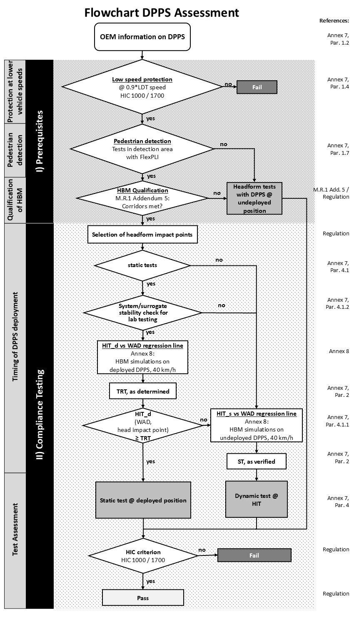

Annex 8

Head Impact Time (HIT)- Determination simulation
1. Introduction
1.1. An HIT-Determination simulation is a computer simulation for determination of HIT over WAD in the DPPS vehicle model for deriving the test conditions for the assessment of deployable systems as specified in the Annex 7.
Pass requirements
HBM qualification simulation
Documentation (M.R.1-Section 3)
Test without DPPS activation
No
Yes
HIT_d determination sim. with deployed DPPS (40km/h)
HIT_d ˃ TRT
No
Yes
HIT_s determination sim. with undeployed DPPS (40km/h)
HIT_s/WAD graph for dynamic test
Qualifies for static test
M.R.1-Addendum 5
Annex 8
Static test required testted
No*
Yes
* For example: airbag
GV Model
HBM
Vehicle model
HIT_d/WAD graph
1.2. Definitions
For the purposes of this annex:
1.2.1. "Generic Vehicle (GV) Models" are generic replications of car fronts representing three vehicle categories: Family Cars (FCR), Roadsters (RDS), Sports Utility Vehicles (SUV). (The shape of the generic Multi-Purpose-Vehicle (MPVs) was found to lay in between the generic FCR and generic SUV and is therefore covered already.) The vehicle models provide representative shapes for the selected vehicle categories as well as median structural response upon pedestrian impact in terms of force- deflection characteristics and are modelled to be robust and transferable to all considered explicit Finite Element (FE) codes.
1.2.2. "Human Body Model (HBM)" is understood as a virtual geometric and mechanical representation of the human body, which takes the human anatomy into consideration. The procedure described in this Annex refers to HBMs used for the simulation of pedestrian impacts. Pedestrian models which are required for GTR No. 9 shall be selected from the following statures, a six-year-old (6YO), 5th percentile female (AF05), 50th percentile male (AM50) and 95th percentile male (AM95).
1.2.3. "HBM qualification simulation": A computer simulation (HBM vs. GV Model) providing evidence that the specific HBM simulation is comparable with reference simulations and shows consistent results – in particular referring to HIT and WAD. The reference simulations are based on models which have been validated by comparing their simulation response with PMHS tests. Another purpose is to make sure that models give comparable results with varying hardware or software environments when applied for a specific purpose.
1.3. General Requirements
1.3.1. It shall be ensured that the HBMs used in this Annex comply with all requirements within Addendum 5 of Mutual Resolution No.1 (M.R.1). The qualification results shall be documented as specified in Addendum 5 of M.R.1.
1.3.2. Only those HBM statures selected according to paragraph 2.2. of this Annex shall be qualified.
1.3.3. The pedestrian HBM that is qualified is the very same model as used for HIT determination simulations. This applies to:
(a) Version of the HBM;
(b) Node-Position of every single node of the HBM;
(c) Identical material cards (including fracture mode), contact cards, control cards and constraints;
If available:
(d) Identical initial element stresses/strains;
(e) Identical initial contact penetrations/contact forces.
1.3.4. Furthermore, all simulations (qualification and HIT determination) shall be performed with consistent settings. This applies to:
(a) Solver-Version and type (e.g. processing type, precision, parallelisation);
(b) The time-step used for simulations;
(c) Time-step settings (relating to initial and dynamic mass scaling);
(d) Contact settings (between HBM and Vehicle);
(e) Control settings which are affecting the pedestrian model.
2. Procedure
2.1. Impact Simulations
Pedestrian models shall be selected from the following statures, a six-year-old (6YO), 5th percentile female (AF05), 50th percentile male (AM50) and 95th percentile male (AM95). The pedestrian position and stance to be used in the model is defined in Addendum 5 of M.R.1. The pedestrian model has to be positioned, such that the head centre of gravity (CoG) is aligned with the vehicle centreline.
The vehicle model has to be positioned in the setup such that the vehicle ground level is aligned with the ground level used in the qualification simulations.
As described in Addendum 5 of M.R.1, the HBM shall be exposed to a vertical acceleration field constituting the gravitational loading.
A local vehicle coordinate system has to be initially aligned with the global coordinate system defined in Addendum 5 of M.R.1 and shall be connected to the vehicle model CoG.
The initial speed of the vehicle model has to be prescribed and is 40 km/h for all simulations. The y and z motion of the car has to be constrained and the motion in x-direction must not be constrained.
2.2. Selection of HBMs
The selected HBMs (needed to draw the WAD/HIT-line in the evaluation) are those HBMs where the head hits the DPPS properly, which is when:
(a) there is a contact between the head and DPPS.
(b) at time of this contact the x-coordinate of the CoG of the head is between the smallest and largest x-coordinate of the DPPS at y=0.
Simulations with the next tallest HBM shall also be performed, but only to prove that this HBM does not hit the DPPS properly.
If only one HBM hits the DPPS properly, the next tallest HBM shall also belong to the selected HBMs.
Figure 1
Example (where the CoG of the head lies behind the DPPS at time of contact. This HBM does not hit the DPPS properly (only contact with chin of HBM))
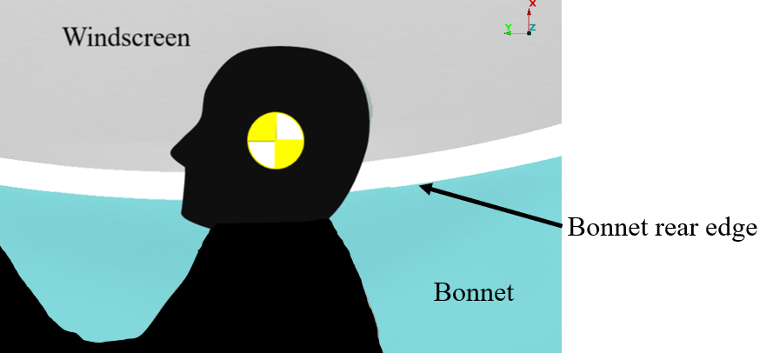
Bonnet rear edge
Windscreen
Bonnet
2.3. Output Requirements
It shall be confirmed that the following outputs have been generated from each simulation, time history curves of:
(a) x and z coordinate of HC and AC in the global coordinate system;
(b) x displacement of vehicle CoG in the global coordinate system;
(c) Resultant acceleration of HC;
(d) Contact forces (between vehicle and HBM without upper extremities, vehicle and HBM head and total contact force);
(e) Total hourglass and internal energies of the total setup;
(f) Mass increase.
All shall be plotted every 0.1ms or less.
Furthermore, animations of the simulations shall be generated with an output interval of 1ms.
2.4. Quality Checks
The following Quality Checks shall be performed:
(a) Contact force (between HBM and vehicle) is zero at simulation start;
(b) Total energy remains constant within a 15 per cent tolerance;
(c) Hourglass energy ≤ 10 per cent of the total energy;
(d) Artificial mass increase is less than 3 per cent.
2.5. Calculation of Head Impact Time
Time of first contact is defined as the first time where the contact force is not zero anymore.
The Head Impact Time (HIT) is defined as the elapsed time subsequent to the time of first contact of the HBM (neglecting forearms and hands) with the vehicle outer surface and the time of first contact of its head with the vehicle outer surface.
If this method is for any reason not applicable, an appropriate alternative method may be applied and shall be reported.
2.6. Determination of WAD corresponding to HIT
For the determination of the WAD, a point on the surface of the vehicle is necessary. This point is defined as follows (all coordinates relative to the local vehicle coordinate system):
At the time of first head contact with the DPPS the point ($x_{head}$, 0, $z_{head}$), where:
$x_{head}$ is the x-coordinate; and
$z_{head}$ is the z-coordinate of the CoG of the head,
will be projected orthogonally onto the surface of the undeployed vehicle. (If there are multiple projection points take the one with the highest x value.)
Compute the WAD for this point rounded the nearest full millimetre.
3. Documentation
3.1. General
The following information shall be documented:
(a) Date of report;
(b) Name of car manufacturer;
(c) Type and release version of software (FE-software package name, revision and version);
(d) Name and version of the HBM;
(e) Specification of car.
Images showing the front view and side view of the pedestrian, at t0 and at the time of head impact shall be added to the report.
3.2. Consistency with qualification simulations
For all simulations Table 1 shall be filled in.
Table 1
Check of consistency between qualification and HIT determination simulations
Check-list for simulation settings | Consistent between qualification and HIT determination simulations:
Identical HBM | Y/N
Solver Version | Y/N
Timestep | Y/N
All other control settings | Y/N

3.3. Quality checks
For all simulations Table 2 shall be filled in.
Table 2
Quality Checks
Verification evaluation criteria | Allowed | Observed | Pass:
Coefficient of friction between Vehicle and HBM | 0.3 |  | Y/N
Head centre of gravity is positioned at vehicle centreline | Y = 0 mm |  | Y/N
Contact force between HBM and vehicle at simulation start | 0 |  | Y/N
Change in total energy throughout simulation | ≤ 15 % |  | Y/N
Amount of hourglass energy relative to total energy | ≤ 10 % |  | Y/N
Artificial mass increase relative to total mass of the setup | ≤ 3 % |  | Y/N

3.4. Results of HIT determination simulations
For those HBMs that are selected according to paragraph 2.2. of this Annex, the computed HIT-Values and corresponding WADs have to be filled into the following Tables 3 and 4.
If HIT_d ≥ TRT for all HBMs, simulations on the undeployed DPPS are not required.
Table 3
HIT_d Simulations on DPPS in Deployed Mode
HBM | WAD (mm) | HIT_d (ms)
6YO
AF05
AM50
AM95

Table 4
HIT_s Simulations on DPPS in Undeployed Mode
HBM | WAD (mm) | HIT_s (ms)
6YO
AF05
AM50
AM95

For each simulation, the following diagrams shall be documented:
(a) ACx and HCx as a function of time;
(b) ACz and HCz as a function of time;
(c) HCz as a function of HCx and ACz as a function of ACx;
(d) Total Contact Force between HBM and vehicle as a function of time;
(e) Total, kinetic, internal and hourglass energy as a function of time.
4. Evaluation
4.1. HIT_d Simulations with Deployed DPPS
Based on the results of Table 3, a graph shall be plotted using a linear regression line for comparison with TRT in the diagram as shown in Figure 2.
Figure 2
Wrap Around Distance versus Head Impact Time_for decision
(WAD vs HIT_d)
WAD (mm)
HIT_d (ms)
AM95
AM50
AF05
6YO
TRT
DYNAMIC TESTS
QUALIFIES FOR STATIC TESTS
WAD_TRT

4.2. HIT_s Simulations with Undeployed DPPS
Based on the results of Table 4, a graph shall be plotted using a linear regression line as shown in Figure 3. The lines have to be extrapolated in both directions.
Figure 3
Wrap Around Distance versus Head Impact Time_s (s for synchronisation) (WAD vs HIT_s)

HIT_s (ms)
AM95
AM50
AF05
6YO
WAD (mm)
”

* In accordance with the programme of work of the Inland Transport Committee for 2025 as outlined in proposed programme budget for 2025 (A/79/6 (Sect. 20), table 20.6), the World Forum will develop, harmonize and update UN Regulations in order to enhance the performance of vehicles. The present document is submitted in conformity with that mandate.

