|  |  |  |  |
| --- | --- | --- | --- |
|  | United Nations | ECE/TRANS/WP.29/GRE/2025/5 | |
| Description: _unlogo | **Economic and Social Council** | | Distr.: General  3 February 2025  Original: English |

**Economic Commission for Europe**

Inland Transport Committee

**World Forum for Harmonization of Vehicle Regulations**

**Working Party on Lighting and Light-Signalling**

**Ninety-second session**

Geneva, 22–25 April 2025

Item 6 (a) of the provisional agenda

**Installation UN Regulations:**

**UN Regulation No. 48 (Installation of Lighting and Light-Signalling Devices)**

Proposal for a new Supplement to the 09 series of amendments to UN Regulation No. 48

**Submitted by the expert from the International Organization of Motor Vehicle Manufacturers[[1]](#footnote-2)\***

The text reproduced below was prepared by the expert from the International Organization of Motor Vehicle Manufacturers (OICA) to permit the installation of an optional rear mounted manoeuvring lamp. The modifications to the existing text of the UN Regulation are marked bold for new and strikethrough for deleted character.

I. Proposal

*Paragraph 2.5.19.,* amend to read:

"2.5.19. "Manoeuvring lamp" means a lamp used to provide supplementary illumination to the side and/or the rear of the vehicle to assist during slow manoeuvres."

*Paragraph 6.26.2.,* amend to read:

"6.26.2. Number

**Side mounted:**

One or two (one per side) on vehicles not exceeding 6m in length.

A maximum of four (up to two per side) on vehicles above 6m and up to and including 9m in length.

A maximum of six (up to three per side) on vehicles exceeding 9m in length.

**Rear mounted:**

**One.**

However, installed lamps **(mounted to the side or rear)** shall be type-approved according to the 00 or subsequent series of amendments to UN Regulation No. 23, or to the 00 or subsequent series of amendments to UN Regulation No. 148."

*Paragraph, 6.26.4.,* amend to read:

"6.26.4.2. In height:

Side mounted: Above the ground, not more than 1,500mm.

Rear mounted no higher than the vehicle."

II. Justification

1. This proposal intends to permit an optional rear mounted manoeuvring lamp. This would support connecting and alignment of a trailer coupling with a vehicle. Systems are available that use the vehicle’s corner radars and rear camera to align the hitch with the trailer coupler.
2. UN Regulation No. 48 currently prescribes that a "Reversing lamp" means the lamp used to illuminate the road to the rear of the vehicle and to warn other road-users that the vehicle is reversing or about to reverse. So even though this light operates when the vehicle is in reverse, it does not appropriately illuminate the coupling location. Due to the height restrictions needed for these lights it cannot be positioned suitably either. For the rear camera to be able to assist in revering up and coupling a trailer, we need to better illuminate the specific area especially when the vehicle distance between the trailer nears, approximately 1-5 metres.

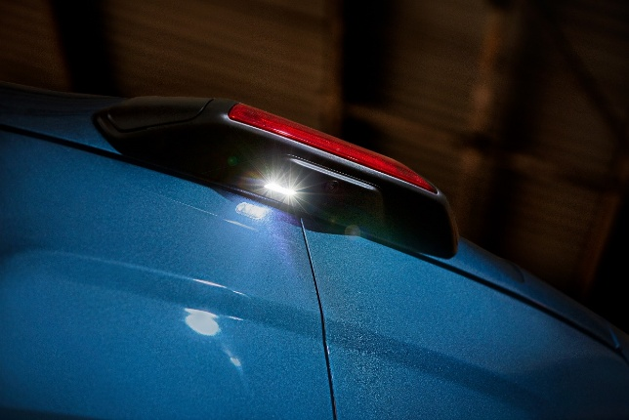

**Figure 1**

Manoeuvring lamp position (image is not subject to copyright)

1. It is not intended to change any more paragraphs than above, and the current paragraph 6.26.7. contains restrictions which would constrain a rear mounted manoeuvring lamp to the extent that we believe it would not cause any issues.
2. Only night time operation is described in paragaph 6.26.7.:

“6.26.7. Electrical connections:

Motor vehicles: Manoeuvring lamps shall be so connected that they cannot be switched ON unless the main-beam headlamps or the dipped-beam headlamps of the motor vehicle are switched ON at the same time.”

1. Restrictions as to when they can operate, and they shall automatically be switched off:

“The manoeuvring lamp(s) shall be switched ON automatically for slow manoeuvres up to 15km/h provided that one of the following conditions is fulfilled:

(a) Prior to the vehicle being set in motion for the first time after each manual activation of the propulsion system; or

(b) Reverse gear is engaged; or

(c) A camera-based system which assists parking manoeuvres is operating.

The manoeuvring lamps shall be automatically switched OFF if the forward speed of the vehicle exceeds 15km/h and they shall remain switched OFF until the switch ON conditions are met again.”

1. A lamp would always point downwards (see the 10m requirement in Annex 14):

“6.26.9. Other Requirements

6.26.9.1. The Technical Service shall, to the satisfaction of the Type Approval Authority, perform a visual test to verify that there is no direct visibility of the apparent surface of these lamps, if viewed by an observer moving on the boundary of a zone on a transverse plane 10m from the front of the vehicle, a transverse plane 10m from the rear of the vehicle, and two longitudinal planes 10m from each side of the vehicle; these four planes to extend from 1m to 3m above and parallel to the ground as shown in Annex 14.”

1. \* In accordance with the programme of work of the Inland Transport Committee for 2025 as outlined in proposed programme budget for 2025 (A/79/6 (Sect. 20), table 20.6), the World Forum will develop, harmonize and update UN Regulations in order to enhance the performance of vehicles. The present document is submitted in conformity with that mandate. [↑](#footnote-ref-2)