 | United Nations | ECE/TRANS/WP.29/GRSP/2025/12
 | Economic and Social Council |  | Distr.: General  22 September 2025  Original: English
Economic Commission for Europe
Inland Transport Committee
World Forum for Harmonization of Vehicle Regulations
Working Party on Passive Safety
Seventy-eighth session
Geneva, 1–4 December 2025
Item 20 of the provisional agenda
Collective amendments to UN Regulations that impact automated vehicles

Proposal for supplement 1 to the 05 series of amendments to UN Regulation No. 12 (Steering mechanism)

Submitted by the expert from Germany on behalf of the GRSP Task Force on Automated Vehicles Regulation Screening (TF-AVRS) *
The text reproduced below was prepared by the expert from Germany on behalf of TF-AVRS, to enable the application of the regulation to vehicles equipped with an Automated Driving System (ADS). The modifications to the existing text of the UN Regulation are marked in bold for new or strikethrough for deleted characters.

I. Proposal
Insert a new paragraph 0., to read:
“0. Introduction
0.1. For supplement 1 to the 05 series of amendments:
0.1.1. The Regulation is amended to account for vehicles of category X¹. Vehicles of category Y¹ are not in the scope of this Regulation.
0.1.2. The Regulation was originally drafted for vehicles with driver and manual driving controls. It is the intention of this new amendment to keep the spirit of the regulation and to extend its application to vehicles without driver and without manual driving controls inside the vehicle. In the absence of driver/manual driving controls in the vehicle, provisions related to them shall not be taken into account if not already covered by this amendment.
0.1.3. In case of vehicles equipped with an Automated Driving System (ADS)1 other than vehicles of categories X and Y, in the manual driving mode no special provisions or exemptions apply. In a mode where an ADS feature is active the relevant ADS requirements apply.
0.1.4. To improve the structure of the Regulation the scope is separated into vehicles with regard to the protection of occupants against the steering mechanism and/or against electrical shock in a frontal collision and to steering controls with regard to the protection of occupants in the event of an impact, pursuant to the relevant part of Regulation No. 12.
0.1.5. Amendments in paragraphs 3.1.2. and 3.2.2. are not related to the task to make UN Regulations applicable for vehicles with an ADS. The request to send documents in triplicate is outdated.”
Paragraph 1.1., amend to read:
“1.1. This Regulation applies to the behaviour of the steering mechanism and to the electric power train operating on high voltage as well as the high voltage components and systems which are galvanically connected to the high voltage bus of the electric power train, of motor vehicles of category M₁, motor vehicles of category M₁¹ and to vehicles of category N₁¹ with a maximum permissible mass less than 1,500 kg, with regard to the protection of the occupants in a frontal collision. both categories equipped with [one or both of the following]:
(a) a steering mechanism with regard to the protection of occupants against the steering mechanism in a frontal collision, and/or [either or both of]
(b) an electric power train operating on high voltage as well as the high voltage components and systems which are galvanically connected to the high voltage bus of the electric power train with regard to the protection of the occupants in a frontal collision.”
Paragraph 1.1., insert new footnote 1, to read:
“¹ As defined in the Consolidated Resolution on the Construction of Vehicles (R.E.3.), document ECE/TRANS/WP.29/78/Rev.8, para. 2 -
https://unece.org/transport/vehicle-regulations/wp29/resolutions”
Insert new paragraphs 1.3. and 1.4., to read:
“1.3. This Regulation applies to a steering control type with regard to the protection of occupants against the steering mechanism in the event of an frontal collision, pursuant to the relevant part of Regulation No. 12.
1.4. This Regulation does not apply to vehicles of category Y.”
Paragraph 2.1., amend to read:
“2.1. "Approval of a vehicle" means the approval of a vehicle type with regard to the protection of the driver an occupant against the steering mechanism (if fitted) and, if fitted with an electric power train operating on high voltage, against electrical shock in the event of impact;”
Paragraphs 2.2.1. and 2.2.1.1., amend to read:
“2.2.1. Vehicle powered by an internal combustion engine:
2.2.1.1. The structure, dimensions, lines and constituent materials of that part of the vehicle forward of the steering control (if fitted);”
Paragraphs 2.2.2. and 2.2.2.1., amend to read:
“2.2.2. Vehicle powered by an electric engine
2.2.2.1. The structure, dimensions, lines and constituent materials of that part of the vehicle forward of the passenger compartment and/or if fitted with a steering mechanism, forward of the steering control;. For vehicles of category X without a steering control, the structure, dimensions, lines and constituent materials of that part of the vehicle forward of the passenger compartment”
Paragraph 2.3., amend to read:
“2.3. "Approval of a steering control" means the approval of a steering control type with regard to the protection of the driver an occupant against the steering mechanism in the event of impact;”
Paragraph 2.5., amend to read:
"2.5. "Steering control" means the steering device, usually the steering wheel, which may be actuated by the a driver;
Paragraph 2.7.1., amend to read:
“2.7.1. Designed to protect the vehicle driver an occupant in an impact against the steering control;”
Paragraph 2.8., amend to read:
“2.8. "Steering control rim" means the quasi-toroidal outer ring in the case of the a steering wheel usually griped by the driver's hands during manual driving;
Paragraph 3.1.1., amend to read:
“3.1.1. The application for approval of a vehicle type with regard to the protection of the driver an occupant against the steering mechanism and the application for approval of a vehicle type against electrical shock in the event of impact shall be submitted by the vehicle manufacturer or by his duly accredited representative.”
Paragraph 3.1.2., amend to read:
“3.1.2. It shall be accompanied by the undermentioned documents in triplicate and the following particulars:”
Paragraphs 3.1.2.6. to 3.1.2.8., amend to read:
“3.1.2.6. Evidence that the steering mechanism complies with the specifications of paragraph 5.2.2. of UN Regulation No. 94 or with the specifications of paragraph 5.2.2.1. of UN Regulation No. 137 if the application for approval is submitted by the applicant pursuant paragraph 5.1.2. below, if applicable.
3.1.2.7. Evidence that the steering control complies with the specifications of paragraphs 5.2.1.4. and 5.2.1.5. of UN Regulation No. 94 or with the specifications of paragraphs 5.2.1.1.3. and 5.2.1.1.4. of UN Regulation No. 137 if the application for approval is submitted by the applicant pursuant paragraph 5.2.1. below, if applicable.
3.1.2.8. A general description of the electrical power source type, location and the electric power train (e.g. hybrid, electric), if fitted.”
Paragraph 3.2.1., amend to read:
“3.2.1. The application for approval of a steering control type with regard to the protection of the driver an occupant against the steering mechanism in the event of impact shall be submitted by the vehicle manufacturer or by his duly accredited representative.”
Paragraph 3.2.2., amend to read:
“3.2.2. It shall be accompanied by the undermentioned documents in triplicate and the following particulars:”
Paragraph 3.2.2.3, amend to read:
“3.2.2.3. Evidence that the steering control complies with the specifications of paragraphs 5.2.1.4. and 5.2.1.5. of Regulation No. 94, if the application for approval is submitted by the applicant pursuant paragraph 5.2.1. below, if applicable.”
Paragraph 4.3.4.1, renumber the call to footnote 1 and the footnote itself as footnote 2.
[Footnote 2 (renumbered), amend to read:
¹²The distinguishing numbers of the Contracting Parties to the 1958 Agreement are reproduced in Annex 3 to the Consolidated Resolution on the Construction of Vehicles (R.E.3), document ECE/TRANS/WP.29/78/Rev.2/Amend.1. ECE/TRANS/WP.29/78/Rev.8, Annex 3 – https://unece.org/transport/vehicle-regulations/wp29/resolutions]

Paragraph 5.1., renumber footnote 2 as footnote 3 and amend to read:
“5.1. When the unladen vehicle, equipped with a steering mechanism, in running order, without a manikin, is collision-tested against a barrier at a speed of 48.3 km/h (30 mph), it shall meet paragraphs 5.2. to 5.5.5.5.4.5. and the top of the steering column and its shaft shall not move backwards, horizontally and parallel to the longitudinal axis of the vehicle, by more than 12.7 cm and also not more than 12.7 cm vertically upwards, both dimensions considered in relation to a point of the vehicle not affected by the impact²³.”
Paragraph 5.1.1. renumber as 5.2., and amend to read:
“5.2.5.1.1. Additionally vehicles Vehicles equipped with electric power train shall meet paragraph 5.5.5.6. In case of vehicles equipped with a steering mechanism This this could be demonstrated in a separate frontal impact test at the request of the manufacturer after validation by the Technical Service, given that the electric components do not influence the driver's occupant protection performance of the vehicle type as defined in this Regulation.”
Former paragraph 5.1.2. renumber as 5.1.1.
Insert new paragraph 5.2.1., to read:
“5.2.1. Specifications of paragraph 5.2. above are deemed to be met if the vehicle equipped with such a steering system complies with the specifications of paragraph 5.2.2. of UN Regulation No. 94 or with the specifications of paragraph 5.2.2.1. of UN Regulation No. 137.”
Renumber former paragraphs 5.2 to 5.6., as 5.3. to 5.7.
Paragraph 5.3.1. (renumbered), renumber the reference to 5.2. as 5.3.
Paragraph 5.5. 5.4 (renumbered), amend to read:
“5.5.5.4. TheA steering control shall be designed, constructed and fitted in such a way that:”
Paragraph 5.5.1. 5.4.1 (renumbered), amend the first paragraph to read:
“5.5.1.5.4.1. Before the impact test prescribed in paragraphs 5.2. and 5.3 5.3. and 5.4. above no part of the steering control surface, directed towards the driver an occupant, which can be contacted by a sphere of 165 mm in diameter shall present any roughness or sharp edges with a radius of curvature of less than 2.5 mm.”
Paragraph 5.5.1.1. 5.4.1.1 (renumbered), amend to read:
“5.5.1.1. 5.4.1.1. After any impact test prescribed in paragraphs 5.2. and 5.3 5.3. and 5.4. the part of the steering control surface directed towards the driver an occupant shall not present any sharp or rough edges likely to increase the danger or severity of injuries to the driver. Small surface cracks and fissures shall be disregarded.”
Paragraph 5.5.1.1.1. (renumbered), renumber the reference to 5.4.1.1. as 5.5.1.1.
Paragraph 5.5.2. 5.4.2 (renumbered), amend to read:
“5.5.2. 5.4.2. The steering control shall be so designed, constructed and fitted as not to embody components or accessories, including the horn control and assembly accessories, capable of catching in the driver's clothing of an occupant or jewellery in normal driving movements.”
Paragraph 5.6.1. (renumbered), renumber the references to 5.5.1.1., 5.5.1.4.2., 5.5.1.4, 5.5.1.3. and 5.5.1.4 as 5.6.1.1., 5.5.1.4.2., 5.6.1.4, 5.6.1.3. and 5.6.1.4.
Paragraph 5.6.1.4. (renumbered), renumber the references to 5.5.1.4.1. and 5.5.1.4.2. as 5.6.1.4.1. and 5.6.1.4.2.
Paragraph 5.6.1.4.2. (renumbered), renumber the references to 5.5.1.3. and 5.5.1.1. as 5.6.1.3. and 5.6.1.1.
Paragraph 5.7. (renumbered), renumber the references to 5.5. and 5.5.4. as 5.6. and 5.6.4.
Paragraph 6.1., renumber the reference to 5.4. as 5.5.
Annex 1 A, paragraph under “Production definitively discontinued”, amend to read:
“ of a vehicle type with regard to the protection of the driver an occupant against the steering mechanism in the event of impact, pursuant to Regulation No. 12.
of a vehicle type with regard to the protection against electrical shock in the event of impact, pursuant to Regulation No. 12.”
Annex 1 A, paragraph 5., amend to read:
“5. Brief description of the steering mechanism and the components of the vehicle contributing to the protection of the driver an occupant against the steering mechanism in the event of impact ”
Annex 1 B, paragraph under “Production definitively discontinued”, amend to read:
“ of a steering control type with regard to the protection of the driver an occupant against the steering mechanism in the event of impact, pursuant to the relevant part of Regulation No. 12.”
Annex 1 B, paragraph 5., amend to read:
“5. Brief description of the steering control and of the components contributing the protection of the driver an occupant against the steering mechanism in the event of impact ”
Annex 2, amend to read:
“Model A
(See paragraph 4.2.4. of this Regulation)
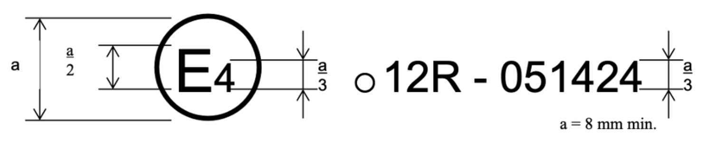
The above approval mark affixed to a vehicle shows that the vehicle type concerned has, with regard to the protection of the driver an occupant against the steering mechanism (if fitted) and/or against electrical shock (if the vehicle is equipped with an electric power train operating on high voltage) in the event of impact, been approved in the Netherlands (E4) pursuant to Regulation No. 12. The approval number indicates that the approval was granted according to the requirements of Regulation No. 12 as amended by the 05 series of amendments.
Model B
(See paragraph 4.2.5. of this Regulation)
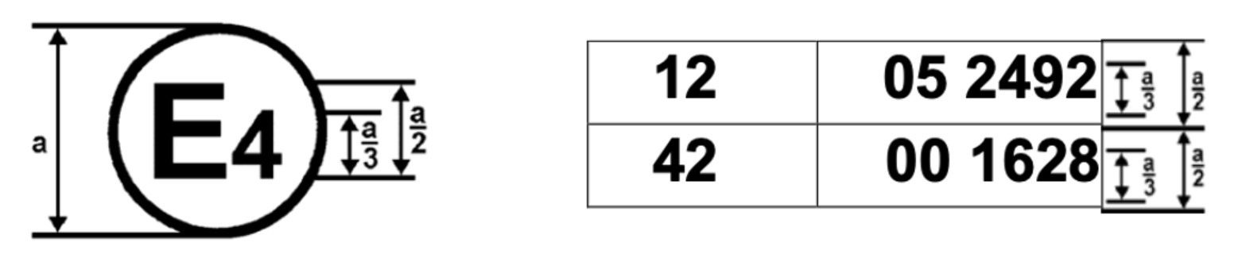
a = 8 mm min.
The above approval mark affixed to a vehicle shows that the vehicle type concerned has been approved in the Netherlands (E4) pursuant to Regulations Nos. 12 and 42¹. The approval numbers indicate that, at the dates when the respective approvals were given, Regulation No. 12 included the 05 series of amendments and Regulation No. 42 the 00 series of amendments.
Model C
(See paragraph 4.3.4. of this Regulation)
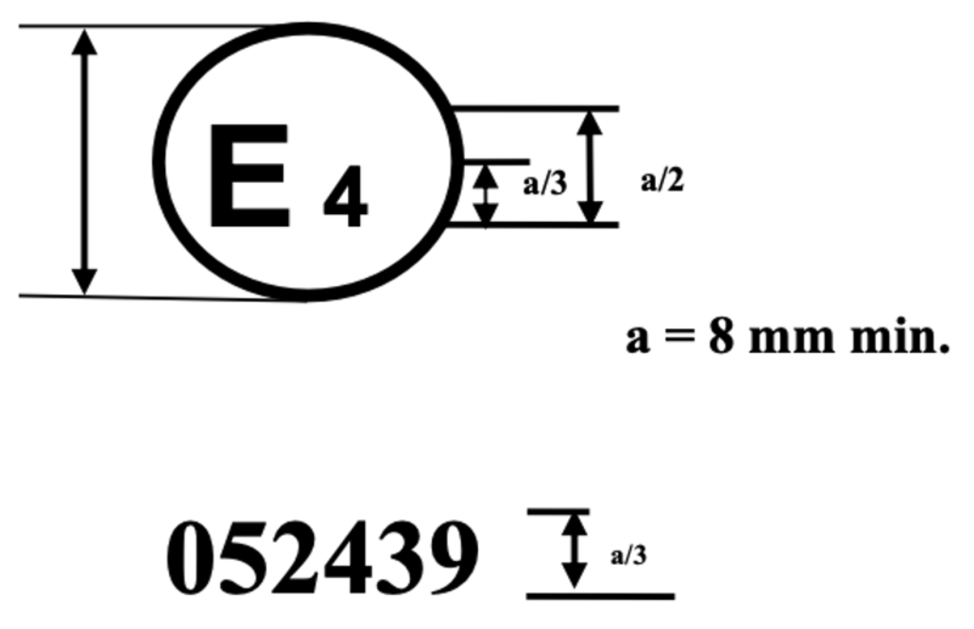
The above approval mark affixed to a steering control shows that the steering control type concerned has, with regard to the protection of the driver an occupant against the steering mechanism in the event of impact, been approved in the Netherlands (E4) pursuant to the relevant part of Regulation No. 12 as amended by the 05 series of amendments.
Model D
(See paragraph 4.3.4.3. of this Regulation)
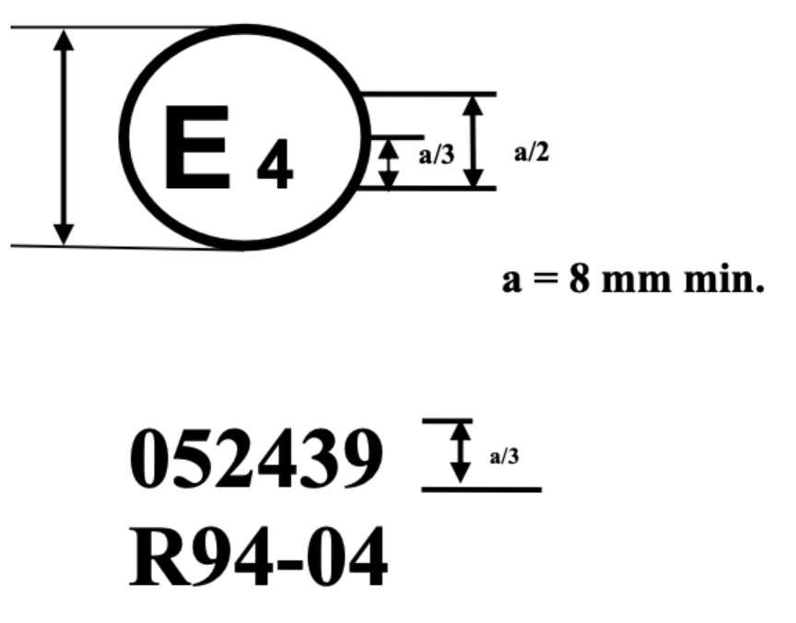
The above approval mark affixed to a steering control shows that the steering control type concerned has been approved in the Netherlands (E4) with regard to the protection of the driver an occupant against the steering mechanism in the event of impact, pursuant to provisions of paragraphs 5.1.2. and/or 5.2.1. of UN Regulation No. 12 as amended by the 05 series of amendments.”
Annex 4, paragraph 1., renumber the reference to 5.2. as 5.3.
Annex 4, paragraph 2.7.1., renumber the reference to 5.2. as 5.3.
Annex 5, paragraph 1., renumber the reference to 5.3. as 5.4.
Annex 7, first sentence, renumber the reference to 5.5. as 5.6.

II. Justification
See paragraph 0. of the proposal.

* In accordance with the programme of work of the Inland Transport Committee for 2025 as outlined in proposed programme budget for 2025 (A/79/6 (Sect. 20), table 20.6), the World Forum will develop, harmonize and update UN Regulations in order to enhance the performance of vehicles. The present document is submitted in conformity with that mandate.

