Proposal for supplement 13 to the 01 series of amendments to UN Regulation No. 43 (SAFETY GLAZING MATERIALS
Changes to the current text of the regulation are marked in red characters.
I. Proposal
Paragraph 2.5 of Annex 21., amend to read:
2.5. Definition of the datum points (see Figure 3)
The datum points are points situated at the intersection with the outer surface of the windscreen of lines radiating forward from the V points:
2.5.1. Upper vertical datum point forward of V₁ and 7° above the horizontal (P_{r1});
2.5.2. Lower vertical datum point forward of V₂ and 5 4° below the horizontal (P_{r2});
2.5.3. Horizontal datum point forward of V₁ and 17° to the left (P_{r3});
2.5.4. Three additional datum points symmetrical to the points defined under paragraphs 2.5.1. to 2.5.3. in relation to the longitudinal median plane of the vehicle (respectively P'_{r1}, P'_{r2}, P'_{r3}).

Figure 3 of Annex 21, amend to read:
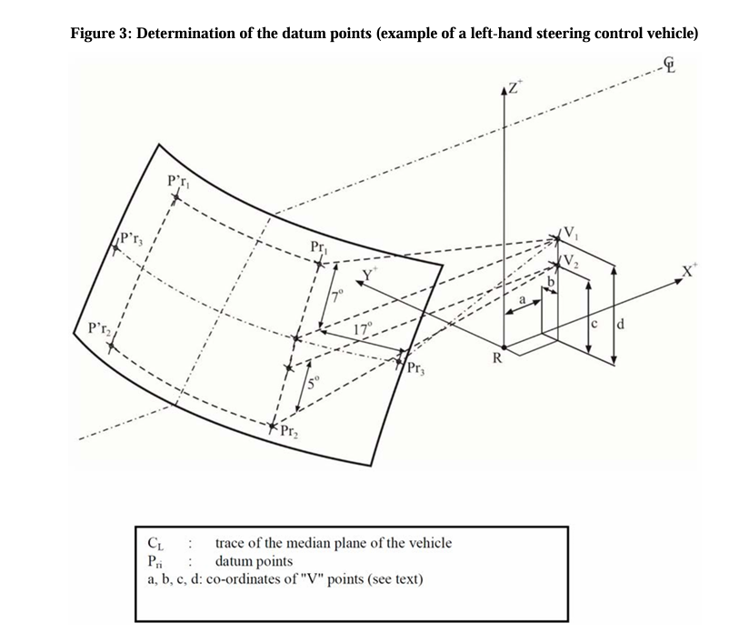
5 4°
II. Justification
Definition of the datum points is described in both R43 and R125. Historically, there has been an inconsistency in R125 between the lower datum point (paragraph 5.1.1.3.) and the obstruction requirement (paragraph 5.1.3.). To resolve such an inconsistency, the proposal to amend R125 (see the informal document GRSG-130-XX) harmonizes the location of the lower datum point (at 5°) of the para.5.1.1.3. to the angle of obstruction requirement in paragraph 5.1.3. (at 4°).
This proposal is to align with the proposed amendment to R125 (informal document GRSG-130-XX) regarding the lower datum point.

