Proposal for a corrigendum 3 to UN Global Technical Regulation No. 9 (Pedestrian safety) in its original version
The text reproduced below was prepared by the expert from Germany to facilitate a target-orientated quasistatic certification of the upper legform impactor for the upper legform to bumper test, as described in Chapter 7 of UN Global Technical Regulation No. 9. The modifications to the current text of UN Global Technical Regulation No. 9 are marked in bold for new and strikethrough for deleted characters.

I. Proposal
Part B, Chapter 6, Paragraph 6.3.1.2.4., amend to read:
“6.3.1.2.4. The torque limiting joint shall be set so that the longitudinal axis of the front member is vertical at the time of impact with a tolerance of ± 2°, with the joint friction torque set to a minimum of 650 Nm but no more than 850 Nm. 675 Nm ± 25 Nm.”
Part B, Chapter 8, Paragraph 8.2.4.1., amend to read:
“8.2.4.1. The impactor shall be mounted to the propulsion and guidance system, by a torque limiting joint. The torque limiting joint shall be set so that the longitudinal axis of the front member is perpendicular to the axis of the guidance system, with a tolerance of ± 2°, with the joint friction torque set to a minimum of 650 Nm but no more than 850 Nm. 675 ± 25 Nm. The guidance system shall be fitted with low friction guides that allow the impactor to move only in the specified direction of impact, when in contact with the pendulum.”

II. Justification
1 To avoid damages to the upper legform impactor, to further test equipment or to the test stand during severe vehicle impacts, the torque limiting joint is set to a minimum of 650 Nm. When exceeding this setting during a vehicle test, the torque limiting joint is released, allowing the upper legform impactor to rotate around the joint of its rear member.
2. For a corresponding setting of the joint friction torque, the joint pivot bolt has to be tightened with a torque of approximately 80-150 Nm, depending on the respective upper legform impactor to be certified, see Fig. 1. In case of exceeding the permitted maximum value of 700 Nm during the quasistatic certification test, the pivot bolt and the friction discs of the joint have to be removed and to be prepared again for the next intent. In some cases the friction discs and the pivot bolt have to be exchanged. In any case this results in higher efforts and costs.
3. During the development of the upper legform impactor, Working Group 17 of the European Enhanced Vehicle-safety committee (EEVC) recommended a minimum setting of 650 Nm for the joint friction torque, only. When introducing the first legal requirements on pedestrian safety, Commission Regulation 2004/90/EC followed these recommendations. The upper limit of a calibration corridor was firstly introduced with Regulation (EU) 631/2009; however, the relatively small corridor for the setting with an upper limit of 700 Nm may lead to unnecessary burden during the quasistatic certification.
4. Since a moderate increase of the maximum torque setting for obtaining a broader certification corridor is associated with no higher risk for damage to the impactor or the guidance system, but may reduce the efforts and costs of the certification significantly, it is recommended to raise the upper limit to 850 Nm.
5. The proposal is made as a Corrigendum to Chapters 6 and 8 of the Global Technical Regulation No. 9 in its original version.

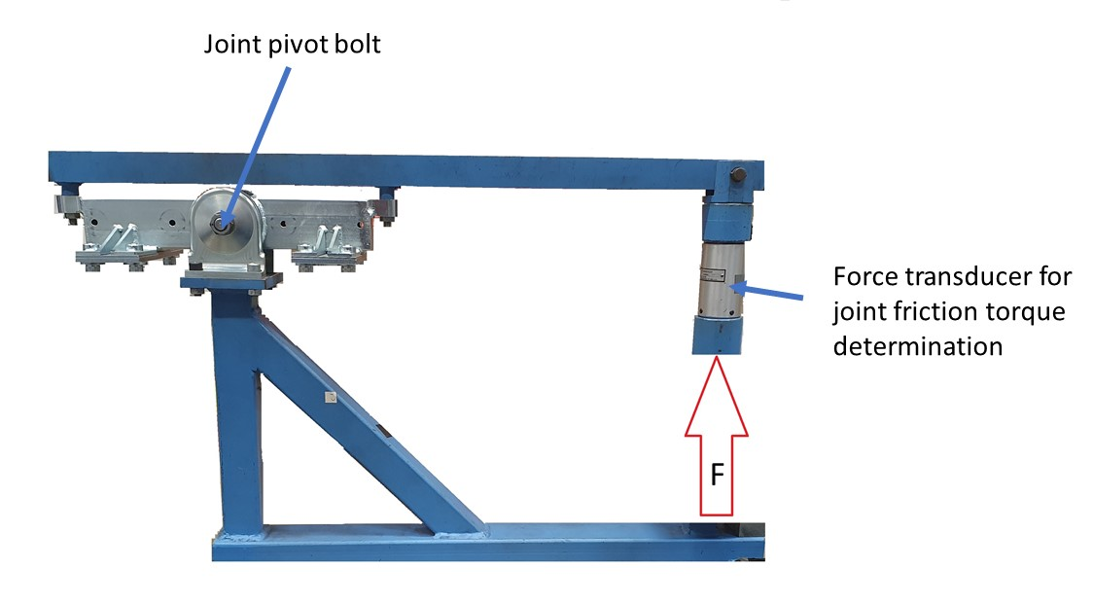
Figure 1. Test setup for the quasistatic certification of the upper legform impactor (example)

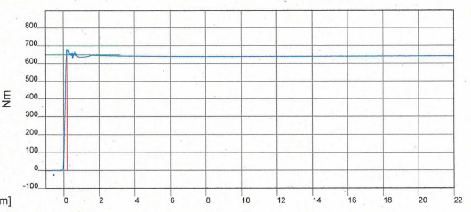
Figure 2. Joint friction torque during certification (example)

