OICA Alternative Proposal to GRE/2025/02

This document is an alternative proposal to ECE/TRANS/WP.29/GRE/2025/02 which is submitted to the ninety second session of the Working Party on Lighting and Light-Signalling (GRE).

In order to follow a technology neutral approach, it should not matter if a front lighting function, or if a front light signalling function produces a logo if the performance is the same. Thus, OICA proposes new requirements to regulate the use of logos in UN Regulation No. 149 which would allow a vehicle with an adaptive front lighting system (AFS) to create a similar front lighting appearance as a vehicle equipped with a front position lamp including a logo.

The OICA proposal follows the same approach for the approval of logos used in UN Regulation No. 148, however any logo approved under this Regulation (R149) would be limited in intensity to 140 cd. This aligns with the maximum intensity of the front position lamp so the performance of a logo in the AFS is identical to already accepted designs at nighttime.

The proposed modifications to the current text are marked in bold for new or strikethrough for deleted characters.

Proposal for a new Series of Amendments to UN Regulation 149.
- Proposal
Paragraph 3.1.2.1., amend to read:

"3.1.2.1. drawings, sufficiently detailed to permit identification of the type and, if applicable, of the class of the lamp, showing:
(a) Geometrically in what position(s) the lamp(s) and/or the lighting units may be mounted on the vehicle in relation to ground and vehicle longitudinal median plane;
(b) The axis of observation to be taken as the axis of reference in the tests (horizontal angle H = 0°, vertical angle V = 0°) or in the case of lighting units showing each of them in vertical (axial) section and in front elevation, with main details of the optical design including the axis/axes of reference; and the point to be taken as the centre of reference during the tests;
(c) The limit of the apparent surface of the function(s);
(d) The space reserved and the arrangement intended for the approval marking or the Unique Identifier;
(e) In case of replaceable light source module(s), the module(s) and the space reserved for the specific identification code(s) of the module(s) on the lamp and on the module(s);
(f) A frontal view, with details of lens ribbing if any, and the cross section and any optical features, of the lens, if applicable;
(g) In the case of a lamp that may incorporate a vehicle manufacturer logo, the vehicle manufacturer logo."

Paragraph 3.1.2.2., amend to read:

"3.1.2.2. A brief technical description stating in particular:
(a) In the case of lamps with replaceable UN approved light sources, the category or categories of light source(s) prescribed;
(b) In the case of lamps with replaceable light source modules, the light source module specific identification code;
(c) The make and type of electronic light source control gear(s), if any and if not being part of an installation unit;
(d) In the case the lamp shall also be approved with the LED substitute light source(s) according to UN Regulation No. 128, the category or categories of light source(s) prescribed;
(e) If the device (lamp) is equipped with an adjustable reflector, the mounting position(s) of the lamp in relation to the ground and the longitudinal median plane of the vehicle;
(f) In the case of a lamp that may incorporate a vehicle manufacturer logo, the applicant shall confirm by a statement provided by the vehicle manufacturer that the vehicle manufacturer logo is the official appropriate one related to the brand name of the vehicle manufacturer or body manufacturer. "

Insert new paragraph 4.20., to read:
"4.20 On request of the applicant, the internal structure of the optical components and/or the texture of the outer lens inside of the apparent surface of a lamp (function) may incorporate only one manufacturer logo build by transparent or non-transparent components provided that all requirements for the specific function of this Regulation are fulfilled and in addition the following conditions:

(a) Irrespective of the marking requirements in paragraph 3.3., only the logo of the brand name of the vehicle manufacturer or the body manufacturer is allowed. This shall be confirmed by the applicant by a statement (see paragraph 3.1.2.2. (f)).

(b) Size: the enclosed light emitting surface of the logo (incorporating transparent and non-transparent components of the logo) of such a lamp in the direction of the reference axis shall not exceed 100 cm2.

(c) Symmetry: notwithstanding the requirements of paragraph 5.5.2. of UN Regulation No. 48, the logo light emitting surface (incorporating transparent and non-transparent components of the logo) does not have to be symmetrical by itself.

(d) The intensity of the light distributed from the enclosed light emitting surface of the logo when all other areas of the lamp are covered must not exceed 140 cd."

- Justification
- GRE/2025/02 and its replacement document GRE-92-20 propose to ban the implementation of logos in any device other than those approved to UN Regulation No. 148 by means of a new supplement to UN Regulation No. 48. A ban of logos in UN Regulation No. 48 without addressing component regulations means that lamps approved to the latest series of amendments of UN Regulation No. 149 could be refused by a contracting party to UN Regulation No. 48. This is not allowed according to Article 3 of the treaty.
- GRE/2020/05/Rev.1 identified that “The existing UN Regulations do allow symmetrical logos”. Thus, regulating or banning logos changes existing requirements. According to the “General Guidelines for United Nations regulatory procedures and transitional provisions” (ECE-TRANS-WP29-1044-Rev3 B1) such changes must be introduced as a series of amendments not as a supplement, especially in installation regulations.
- The introduction of regulations on logos in light signalling devices led to a new series of amendments to UN Regulation No. 148. Similarly, the regulation of logos in road illumination devices must follow suit.
- A new series of UN Regulation No. 149 is mandatory to regulate logos on a component level, and to exempt mandatory trademarks of lamp manufacturers from the ban on logos.
- Article 1 paragraph 2 of the 1958 agreement identifies that, “Technical requirements shall be performance oriented and not design restrictive”. The ban of a logo in a road illumination device having the same performance as the same logo in a front position lamp is not performance oriented.
- This OICA proposal adheres to the treaty rules and transitional provisions, introducing a performance-oriented approach to the regulation of logos.
- By the suggested text, the same performance is required for lighting and light signalling devices - UN Regulation No. 48 does not conflict with the component regulations and defines the number and performance on an installation level only. These requirements already apply to all logos, therefore no changes to UN Regulation No. 48 are necessary.
- Visualization: There is no performance difference between a logo in a position lamp and the same logo in an AFS.
Examples:
Vehicle with position lamp with logo and headlamp

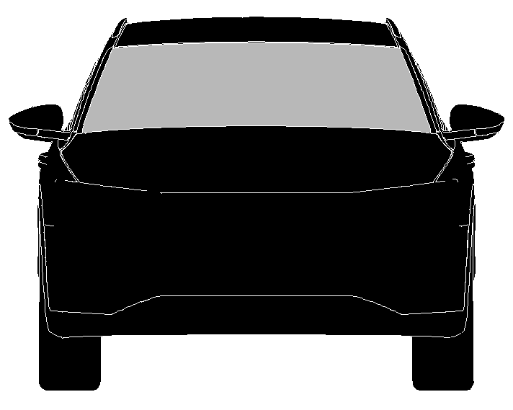
Logo

Vehicle when the headlamp of an AFS substitutes the position lamp according to UN Regulation No. 48 paragraph 5.12.1. and the same logo.

Logo

