|  |  |  |  |
| --- | --- | --- | --- |
|  | United Nations | ECE/TRANS/WP.29/GRE/2024/16/Rev.1 | |
| Description: _unlogo | **Economic and Social Council** | | Distr.: General  3 February 2025  Original: English |

**Economic Commission for Europe**

Inland Transport Committee

**World Forum for Harmonization of Vehicle Regulations**

**Working Party on Lighting and Light-Signalling**

**Ninety-second session**

Geneva, 22–25 April 2025

Item 9 of the provisional agenda

**Other UN Regulations**

Proposal for Supplement [13] to UN Regulation No. 65

**Submitted by the experts from Germany and the International Automotive Lighting and Light-Signalling Expert Group** [[1]](#footnote-2)\*

The text reproduced below was jointly prepared by the experts from Germany and from the International Automotive Lighting and Light-Signalling Expert Group (GTB) with the aim to correct and clarify the existing provisions. The modifications to the existing text of the UN Regulation are marked in bold for new or strikethrough for deleted characters.

I. Proposal

*Paragraph 4.4.1.3.,* amend to read:

“4.4.1.3. "T", "HT" or "X" according to the category of the unit, followed by "A" or "B" or "R" according to **any** ~~the~~ colour ~~of~~ the unit **can emit** (see paragraph 2.1. above).”

*Paragraph 5.1.*, amend to read:

“5.1. The special warning lamps must be so designed and constructed that in normal conditions of use, and notwithstanding the vibrations to which they may be subjected in such use, their satisfactory operation remains assured and they retain the characteristics prescribed by this Regulation.

The special warning lamps shall be so designed and constructed that the relevant requirements with regard to internal voltage higher than 60 V DC are fulfilled; e.g. by marking the device, as defined in paragraph ~~5.1.1.5.~~ **5.1.1.4.** in UN Regulation No. 100.”

*Paragraph 5.8.*, amend to read:

“5.8. ~~A rotating or flashing special warning lamp device of Category T may emit light of several colours.~~

~~In this case all the requirements shall be met for each colour separately over the full angular range specified.~~

**A special warning lamp device of Category T, HT or X may be approved for the colours blue, amber and red separately. In this case, t**~~T~~he activation of more than one colour at the same time shall be prohibited.

The lamp manufacturer shall supply mounting information, for correct mounting on a vehicle, to ensure that only one colour of the special warning lamp is activated at the same time.”

*Paragraph 5.9.*, amend to read:

“5.9. In the case of special warning lamps approved under this Regulation, it shall be not possible for the user to activate groups of several flashes (flash patterns), which do not conform to the requirements in paragraph 6 **of this Regulation.** ~~of Annex 5.~~”

*Annex 2*, amend to read:

**“Annex 2**

**Examples of approval mark**

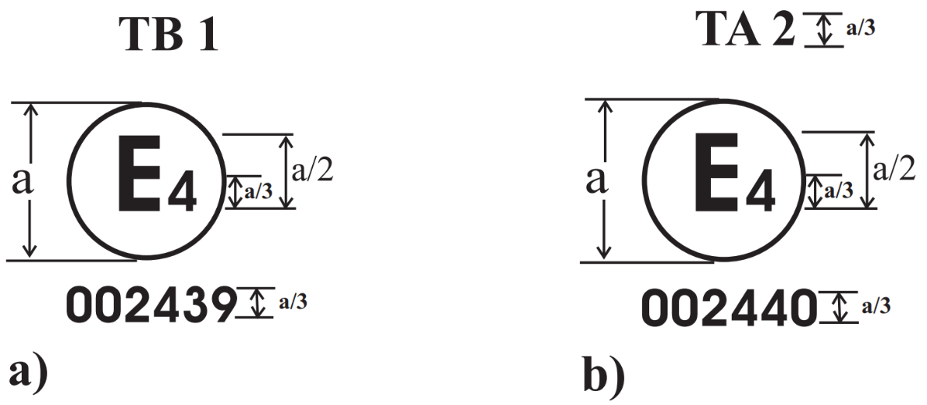

a ≥ ~~8~~**5** mm

1. …
2. …

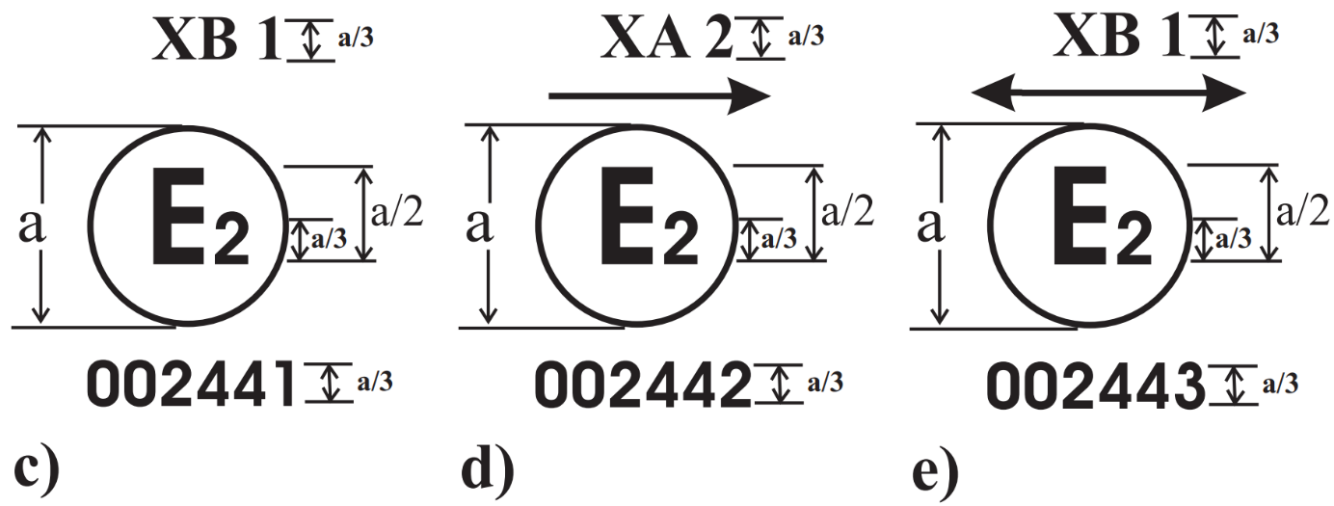

a ≥ ~~8~~**5** mm

…”

II. Justification

*Paragraph 4.4.1.3.*

1. Special warning lamps of different colours are often combined on a vehicle. According to national requirements, sometimes the use and installation of all possible colours is not allowed. In order to avoid misuse, the obligation is added to indicate in the approval marking of the unit on the vehicle any colour that the unit can emit, so that national obligations can be checked easily by police, during roadside checks and periodical technical inspections.

*Paragraph 5.1.*

2. Supplement 2 to the 02 series of amendments to UN Regulation No. 100 renumbered paragraph 5.1.1.5. as 5.1.1.4. This proposal is updating the reference in UN Regulation No. 65 accordingly.

*Paragraph 5.8.*

3. The installation of special warning lamps is usually regulated at the national level. However, in order to establish a minimum quality level, national requirements often refer to UN Regulation No. 65 and allow devices which have been approved according to this Regulation.

4. Special warning lamps of different colours are often combined on a vehicle to serve different use cases. For this reason, the current text of UN Regulation No. 65 permits special warning lamp devices of Category T to emit light in different colours under specific conditions described in paragraph 5.8.

5. A common combination is a special warning lamp of Category T at the front of the roof, often shadowed to the rear due to special equipment on the roof, and thus an additional half bar at the rear of the roof is added.

6. The current text of UN Regulation No. 65 allows such an arrangement only for vehicles with blue special warning lamps. The same vehicles with yellow special warning lamps do not have this possibility, because it is not possible to approve the yellow half bar.

7. In order to solve this inconsistency and for the sake of technological neutrality, the proposal aims to allow Category HT and X special warning lamps emitting light in different colours in the same manner as Category T.

*Paragraph 5.9.*

8. Paragraph 5.9 was inserted in 2014 with Supplement 9 to UN Regulation No. 65. The intention at that time was to assure that groups of flashes shall meet the requirements in paragraph 6 of Annex 5, in which the "TIME DISTANCE Δt" between consecutive flashes is described. Since then, this amendment has always been interpreted by the technical services as an additional requirement for groups of flashes on top of all the other requirements for special warning lights.

9. The proposal intends to clarify the current text, preventing the design of flash patterns that meet only the “TIME DISTANCE Δt” requirements of paragraph 6 in Annex 5, but do not comply with other important aspects of UN Regulation No. 65, such as frequency, photometry, ON time and OFF time. By referring to paragraph 6, the complete requirements have to be fulfilled, not just those in paragraph 6 of Annex 5.

*Annex 2*

10. In 2012, the marking requirements for lighting, light-signalling and associated devices were harmonised regarding their size and ratio requirements (a/2, a/3), see ECE/TRANS/WP.29/GRE/2012/9. Unfortunately, UN Regulation No. 65 was overlooked at that time. This proposal aims to align the size requirement of approval markings also for special warning lamps, from 8 to 5 mm.

1. \* In accordance with the programme of work of the Inland Transport Committee for 2025 as outlined in proposed programme budget for 2025 (A/79/6 (Sect. 20), table 20.6), the World Forum will develop, harmonize and update UN Regulations in order to enhance the performance of vehicles. The present document is submitted in conformity with that mandate. [↑](#footnote-ref-2)