Progress report of
the informal group on Automated Driving Systems
and
the GRVA Workshops on Automated Driving Systems

The text reproduced below was submitted by the chairpersons of the informal group on ADS and the chairpersons of the GRVA Workshops on ADS. It provides a progress report on the activities under the informal working group and GRVA workshops. It proposes the structure for the progress reports on the activities and work.
GRVA-21-44/Add.1 contains the progress report to AC.3. that relates specifically to the development of a new UN GTR on ADS (ECE/TRANS/WP.29/AC.3/64).
I. Objective of the proposal to develop regulation on ADS
- The representatives of China, Canada, European Commission, Japan, United Kingdom of Great Britain and Northern Ireland and the United States of America proposed that GRVA develop of a UN Regulation and a UN GTR on Automated Driving System based on the outcome of the pre-regulatory phase which concluded with the adoption of “Guidelines and recommendations for Automated Driving System safety requirements, assessments and test methods to inform regulatory development” (ECE/TRANS/WP.29/2024/39). The World Forum for Harmonization of Vehicle Regulations and the Executive Committee of the 1998 Agreement (WP.29/AC.3) gave their consent for development of a global regulation on the safety of automated driving systems (ECE/TRANS/WP.29/AC.3/64).
- The objective of this regulatory activities is to develop a truly global regulation addressing the needs of the Contracting Parties to the 1958 and 1998 vehicle regulations Agreements, aimed to prevent the fragmentation of regulatory approaches and avoid delaying the deployment of new technologies with the potential of improving road safety, promoting cleaner and greener transport, promoting social inclusion, and supporting economic growth.
II. Background
- Since its inception in 2018, GRVA structured its activities using the Framework Document on Automated Vehicles, which provided a safety vision and key principles that needed to be considered when developing requirements connected and automated vehicles as well as the mandate for the GRVA activities on Functional Requirements for Automated Vehicles and on the Validation Method / New Assessment Test Method. The two activities produced the document title “Guidelines and recommendations for Automated Driving System safety requirements, assessments and test methods to inform regulatory development”. Following the completion of this pre-regulatory phase and the adoption by WP.29, GRVA discussed the modalities of the following activities.
- As established in the Framework Document, GRVA started in 2018 to develop several legislative elements for vehicle automation:
- Functional Requirements for Automated/Autonomous Vehicles (FRAV)
- Validation Methods for Automated/Autonomous Driving (VMAD)
- Requirement for Cyber Security and Software updates (CS/OTA)
- Requirements for data storage (EDR and DSSAD)
- Items 3 and 4 (EDR) have been mostly completed and resulted in harmonised guidelines and UN Regulations (UN Regulation 155 on cybersecurity and UN Regulation 156 on software updating). Item 4 (DSSAD) is still in progress.
- The informal working group on FRAV delivered guidelines for regulatory requirements to be accepted in GRVA and finally in WP29.
- The informal working group for VMAD had their first deliverable (“Master Document on New Assessment and Test Methods”) endorsed in WP.29 in June 2021 as a reference document. A second iteration was endorsed in WP.29 in June 2022, together with its translation into Guidelines. These Guidelines are an extract of all requirements from the Master Document, leaving out backgrounds and explanations.
- The integration of the results from FRAV and VMAD led to the overall ADS requirements and validation document mentioned above. The FRAV and VMAD mandates expire in September 2024.
- During that process, the industry has repeatedly indicated the need for an ADS regulation to be delivered by 2025; the European Commission urged WP.29 and GRVA to update their work programme in that direction. The industry consistently expressed its concern with the lack of progress in addressing such request.
- In 2022, the European Commission issued rules for the type-approval of specific ADS functionalities in small series, implementing the principles and methodologies developed by the FRAV and VMAD IWGs. At present, also other 1958 Agreement CPs started the regulatory work to allow ADS-equipped vehicles on their roads.
- In 2022, the UK government set out its vision and plan for connected and automated mobility in a policy paper titled 'Connected and automated mobility 2025: realising the benefits of self-driving vehicles'. In 2024, the UK Government passed the Automated Vehicles Act (2024) into law which built upon a multi-year review of the law relating to self-driving vehicles. Work has begun to establish a legislative framework for the safe and secure roll-out of automated vehicles, for which a harmonised approval regulation for automated driving systems would play an important role.
III. Subjects for review and tasks to be undertaken
- The task undertaken by the IWG on ADS are listed in para. X below.
- The tasks of the GRVA Workshops on ADS include the development of administrative requirements for a GTR ADS, a UNR ADS as well as the development of an interpretation document which is planned as a second phase activity.
For the UN GTR:
Task # Topic
1 Statement of technical rationale
2 Introduction
3 Procedural background
4 Technical background
5 Principle for developing the regulation
6 Technical rationale and justification
7 Benefits and costs
/ Appendix: Documentation of development of GTR
For the UN Regulation:
Task # Topic
1 Application for approval
2 Approval
3 Modification of vehicle type and extension of approval
4 Conformity of production
5 Penalties for non-conformity of production
6 Production definitively discontinued
7 Names and addressed of Technical Services responsible for conduction approval tests and of Type Approval Authorities
8 Communication and information document
9 Arrangement of approval marks
IV History of the discussions
A. Details from the IWG on ADS session
- See GRVA-21-44/Add.1
B. Details from the GRVA Workshops on ADS.
(i) First workshop
- The first GRVA Workshop on Automated Driving System took place on June 2024 as an online meeting. The experts reviewed in detail the three tasks assigned by the Regulatory approach for Automated Driving System (WP.29-191-31/Rev.1):
(a) Drafting and discussing the specific provisions needed for a UN Global Technical Regulation (e.g. technical rationale),
(b) Drafting and discussing the specific provisions for a UN Regulation (e.g. marking provisions),
(c) Preparing a guiding/interpretation document for the implementation of the regulations.
(d) The Workshop called for volunteers to be “Officers of Principal Interest” (OPI) to develop the necessary paragraphs mentioned in the tasks (a) and (b).
(ii) Second workshop
- The second GRVA Workshop on Automated Driving System was organized as an online meeting in September 2024. The Workshop reviewed the initial input provided by the volunteers. They noted that the final wording would develop following the review of the draft paragraph in light of the progress made by the IWG on ADS. The workshop received a presentation from industry providing views and considerations for an Automated Driving System (ADS) regulation.
(iii) Third Workshop
- The third GRVA Workshop on Automated Driving Systems was hosted by China in Beijing in October 2024 as a hybrid event. The workshop discussed on proposals provided by the designated OPIs towards UN Global Technical Regulation as well as UN Regulation. The experts nominated as OPIs towards UN Global technical regulation submitted a consolidated draft version of the document towards statement of technical rationale and justification. This document was well discussed during the workshop and received inputs from other experts. Similarly, experts nominated as OPIs towards UN regulation submitted a draft towards relevant paragraphs of UN regulation.
- In addition to above draft documents, expert from industry presented a document for consideration of new approach for the UN regulation on ADS. The participants noted that such considerations should not delay the ongoing work. OICA was asked to prepare a more elaborated version of the proposal together with some other participants. An option could be to prepare this proposal as an interpretation (Task 3)
- The workshop also discussed on the status as well as synchronising the work with IWG on ADS. It was noted that this activity can be progressed once draft structures would be made available, It is agreed to discuss this topic in upcoming schedules of workshop as well as IWG-ADS.
(iv) Fourth Workshop
- The fourth GRVA Workshop on Automated Driving Systems (ADS) took place online on December 17 and 19, 2024. Chaired by representatives from Germany, China, and Japan, the workshop brought together 72 experts from various countries and organizations. The primary goal was to review the progress of the Informal Working Group (IWG) on ADS and discuss the development of the UN Global Technical Regulation (GTR) and the UN Regulation on ADS. The session aimed to integrate inputs from different task forces and informal groups to ensure a harmonized approach to ADS regulation.
- The workshop began with a progress review of the IWG on ADS, presented by the expert from Japan. This presentation highlighted upcoming meetings, projected deliverables, and the coordination between the IWG on ADS, GRVA ADS workshop, and ambassadors. The group agreed on the proposed timeline to finalize draft inputs by April 2025 and present an integrated document by July 2025. Discussions also covered the agreed structure of the regulation and the progress on various chapters, including the overlap between the new UN Regulation on ADS and UN Regulation No. 157 (ALKS).
- The review of inputs for the UN GTR on ADS included presentations on the Detailed Task Decomposition Framework Structure and OPIs Table for GTR. The group discussed the need for additional volunteers for open sections in the GTR and reviewed the integrated document prepared by the expert from China. Key sections such as the introduction, procedural background, technical background, principles for developing the GTR, and technical rationale and justification were discussed. The group noted the need to revisit the terminology used for Operational Design Domain (ODD) and agreed to further review the benefits and cost section in the upcoming workshop.
- For the UN Regulation on ADS, the secretariat presented the updated Detailed Task Decomposition Framework Structure and OPIs Table. The expert from the Netherlands presented documents relevant to the scope of the draft UN Regulation on ADS and justifications to exclude ALKS from its scope. The group discussed the need to harmonize the text and agreed to further discussions on the safety management system, approval, and approval marking. The expert from the United Kingdom, on behalf of the OPI for the approvals topic, presented possible solutions for mutual recognition based on the 1958 Agreement, and the group agreed that further discussion was needed. The workshop concluded with a briefing on future sessions and the integration of documents with the IWG on ADS, with the next session scheduled for February 13-14, 2025, in an online format. The group also agreed to prepare a report for consideration by GRVA in January 2025 and requested the secretariat to compile the information for WP.29 and AC.3.
V. Work schedule
- Schedule of meetings: (Subject to changes)
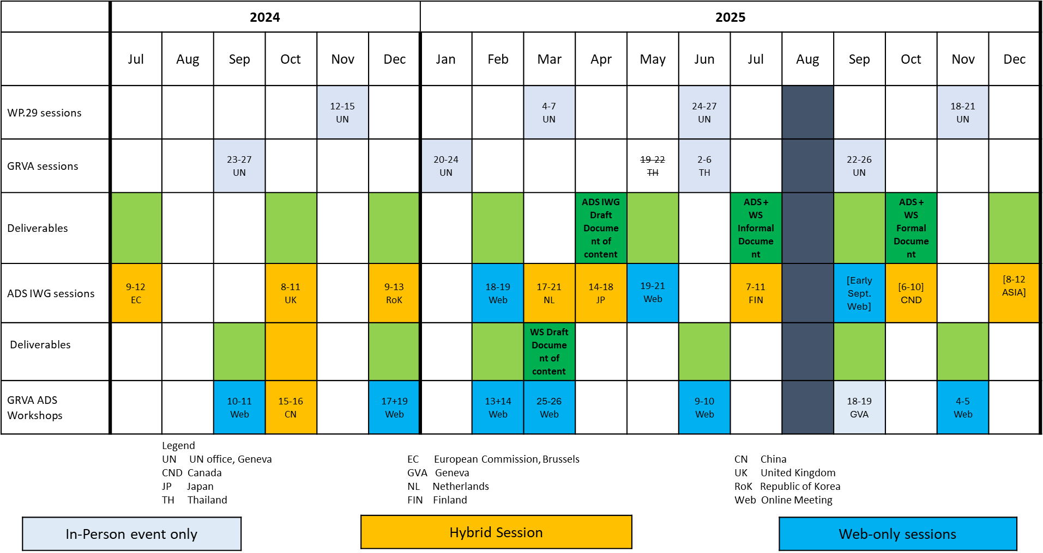
VI. Specific reporting to AC.3
See GRVA-21-44/Add.1

UN Economic Commission for Europe, Revised Framework document on automated/autonomous vehicles (ECE/TRANS/WP.29/2019/34/Rev.2), last amended March 2023 by ECE/TRANS/WP.29/2023/43 and ECE/TRANS/WP.29/2023/151
Commission Implementing Regulation (EU) 2022/1426 of 5 August 2022 laying down rules for the application of Regulation (EU) 2019/2144 of the European Parliament and of the Council as regards uniform procedures and technical specifications for the type-approval of the automated driving system (ADS) of fully automated vehicles (OJ L 221, 26.8.2022, p. 1–64)
UK government, Connected and automated mobility 2025: realising the benefits of self-driving vehicles, 19th August 2022
UK Government, Automated Vehicles Act 2024, https://www.legislation.gov.uk/ukpga/2024/10/contents , 20th May 2024

