Improvements to ECE/TRANS/WP.29GRE/2025/5

This document is a revised proposal to amend ECE/TRANS/WP.29/GRE/2025/05 which is submitted to the ninety second session of the Working Party on Lighting and Light-Signalling (GRE). The proposed modifications to the current UN Regulation No. 48 text are marked in bold for new or strikethrough for deleted characters. The changes to the formal document are marked in red.

The red text in paragraph 6.26.4.3. adds additional clarity to the length requirements for the proposed additional rear manoeuvring lamp. Only editorial changes are made to paragraph 6.26.4.2.

1. Proposal

*Paragraph 2.5.19.,* amend to read:

"2.5.19. "Manoeuvring lamp" means a lamp used to provide supplementary illumination to the side and/or the rear of the vehicle to assist during slow manoeuvres."

*Paragraph 6.26.2.,* amend to read:

"6.26.2. Number

**Side mounted:**

One or two (one per side) on vehicles not exceeding 6m in length.

A maximum of four (up to two per side) on vehicles above 6m and up to and including 9m in length.

A maximum of six (up to three per side) on vehicles exceeding 9m in length.

**Rear mounted:**

**One.**

However, installed lamps **(mounted to the side or rear)** shall be type-approved according to the 00 or subsequent series of amendments to UN Regulation No. 23, or to the 00 or subsequent series of amendments to UN Regulation No. 148."

*Paragraph, 6.26.4.2.,* amend to read:

"6.26.4.2. In height:

Side mounted: ~~A~~above the ground, not more than 1,500mm.

Rear mounted: no higher than the vehicle."

*Paragraph, 6.26.4.3.,* amend to read:

"6.26.4.3. In length:

**Side mounted:** ~~I~~**i**n the case of the installation of more than one manoeuvring lamp, lamps shall be mounted as symmetrically as practicable along each side of the vehicle.

The distance between two adjacent manoeuvring lamps on the same side shall not be less than 0.5 m.

**Rear mounted: at the rear of the vehicle.**"

1. Justification
2. This proposal intends to permit an optional rear mounted manoeuvring lamp. This would support connecting and alignment of a trailer coupling with a vehicle. Systems are available that use the vehicle’s corner radars and rear camera to align the hitch with the trailer coupler.
3. UN Regulation No. 48 currently prescribes that a "Reversing lamp" means the lamp used to illuminate the road to the rear of the vehicle and to warn other road-users that the vehicle is reversing or about to reverse. So even though this light operates when the vehicle is in reverse, it does not appropriately illuminate the coupling location. Due to the height restrictions needed for these lights it cannot be positioned suitably either. For the rear camera to be able to assist in revering up and coupling a trailer, we need to better illuminate the specific area especially when the vehicle distance between the trailer nears, approximately 1-5 metres.

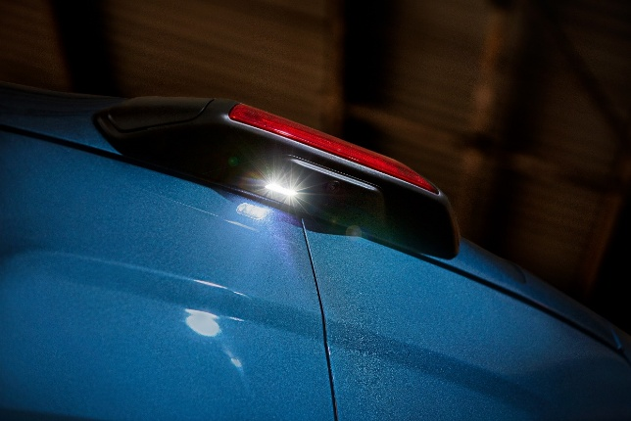

**Figure 1**

Manoeuvring lamp position (image is not subject to copyright)

1. After discussion with a wider audience, it seemed necessary to clarify the length requirements (paragraph 6.26.4.3) in the case of the existing side mounted manoeuvring lamps and the proposed additional rear mounted manoeuvring lamp. The same term ‘at the rear of the vehicle’ is commonly used in the requirements for other lamps in UN R48 (reversing lamp, stop lamp, rear fog etc…).
2. It is not intended to change any more paragraphs than above, and the current paragraph 6.26.7. contains restrictions which would constrain a rear mounted manoeuvring lamp to the extent that we believe it would not cause any issues.
3. Only nighttime operation is described in paragraph 6.26.7.:

“6.26.7. Electrical connections:

Motor vehicles: Manoeuvring lamps shall be so connected that they cannot be switched ON unless the main-beam headlamps or the dipped-beam headlamps of the motor vehicle are switched ON at the same time.”

1. Restrictions as to when they can operate, and they shall automatically be switched off:

“The manoeuvring lamp(s) shall be switched ON automatically for slow manoeuvres up to 15km/h provided that one of the following conditions is fulfilled:

(a) Prior to the vehicle being set in motion for the first time after each manual activation of the propulsion system; or

(b) Reverse gear is engaged; or

(c) A camera-based system which assists parking manoeuvres is operating.

The manoeuvring lamps shall be automatically switched OFF if the forward speed of the vehicle exceeds 15km/h and they shall remain switched OFF until the switch ON conditions are met again.”

1. A lamp would always point downwards (see the 10m requirement in Annex 14):

"6.26.9. Other Requirements

6.26.9.1. The Technical Service shall, to the satisfaction of the Type Approval Authority, perform a visual test to verify that there is no direct visibility of the apparent surface of these lamps, if viewed by an observer moving on the boundary of a zone on a transverse plane 10m from the front of the vehicle, a transverse plane 10m from the rear of the vehicle, and two longitudinal planes 10m from each side of the vehicle; these four planes to extend from 1m to 3m above and parallel to the ground as shown in Annex 14."

8. This optional rear-mounted manoeuvring lamp enhances the effectiveness of a rear camera by providing an additional illumination to the ground area immediately behind the vehicle. This is significantly different to reversing projections which project only white rectangular shapes as a signal to inform other road users.