|  |  |  |  |
| --- | --- | --- | --- |
|  | United Nations | ECE/TRANS/WP.29/2025/104 | |
| _unlogo | **Economic and Social Council** | | Distr.: General  26 August 2025  Original: English |

**Economic Commission for Europe**

Inland Transport Committee

**World Forum for Harmonization of Vehicle Regulations**

**197th session**

Geneva, 11–14 November 2025

Item 4.7.2 of the provisional agenda

**1958 Agreement:**

**Consideration of draft amendments to existing**

**UN Regulations submitted by GRSG**

Proposal for 02 series of amendments to UN Regulation No. 73 (Lateral protection devices)

Submitted by the Working Party on General Safety Provisions[[1]](#footnote-2)\*

The text reproduced below was adopted by the Working Party on General Safety Provisions (GRSG) at its 129th session (ECE/TRANS/WP.29/GRSP/108, paragraph 10). It is based on GRSG-129-21-Rev.5. It is submitted to the World Forum for Harmonization of Vehicle Regulations (WP.29) and to the Administrative Committee (AC.1) for consideration at their November 2025 sessions.

*Paragraphs 1.1.1. to 1.1.3., footnote 1,* amend to read:

"1 As defined in the Consolidated Resolution on the Construction of Vehicles (R.E.3.), document ECE/TRANS/WP.29/78/Rev.7. - <https://unece.org/transport/vehicle-regulations/wp29/resolutions>"

*Paragraph 5.1.2.,* amend to read:

"5.1.2. An approval number shall be assigned to each type approved in accordance with Schedule 4 of the Agreement (E/ECE/TRANS/505/Rev.3). "

*Paragraph 5.1.4.1., footnote 2,* amend to read:

"2 The distinguishing numbers of the Contracting Parties to the 1958 Agreement are reproduced in Annex 3 to the Consolidated Resolution on the Construction of Vehicles (R.E.3), document ECE/TRANS/WP.29/78/Rev.7. - <https://unece.org/transport/vehicle-regulations/wp29/resolutions>"

*Paragraph 5.2.2*.,amend to read:

"5.2.2. An approval number shall be assigned to each type approved in accordance with Schedule 4 of the Agreement (E/ECE/TRANS/505/Rev.3). "

*Paragraph 5.3.2.,* amend to read:

"5.3.2. An approval number shall be assigned to each type approved in accordance with Schedule 4 of the Agreement (E/ECE/TRANS/505/Rev.3). "

*Insert new paragraphs 11.5. to 11.10.*, to read:

"11.5. As from the official date of entry into force of the 02 series of amendments, no Contracting Party applying this UN Regulation shall refuse to grant or refuse to accept type approvals under this UN Regulation as amended by the 02 series of amendments.

11.6. As from 1 September 2027, Contracting Parties applying this UN Regulation shall not be obliged to accept type approvals to any of the preceding series of amendments, first issued after 1 September 2027.

11.7. Until 1 September 2028, Contracting Parties applying this UN Regulation shall accept type approvals to the 01 series of amendments, first issued before 1 September 2027.

11.8. As from 1 September 2028, Contracting Parties applying this UN Regulation shall not be obliged to accept type approvals issued to any of the preceding series of amendments to this UN Regulation.

11.9. Contracting Parties applying this UN Regulation may grant type approvals according to any preceding series of amendments to this UN Regulation.

11.10. Contracting Parties applying the UN Regulation shall continue to accept type approvals of, and to grant extensions of approvals to, the vehicles or the vehicle systems/equipment/parts to the preceding series of amendments to the UN Regulation which are not affected by the changes introduced by the 02 series of amendments

11.11. The requirement for the height of the lower edge of LPD as specified in paragraphs 12.8. and 15.6. as amended by the 02 series of amendments are not compulsory for the purpose of granting type-approval to the 02 series of amendment, until 1 September 2034. These exemptions shall remain applicable in the case of extensions of approvals first granted before 1 September 2034.

11.12. Notwithstanding the transitional provisions above, Contracting Parties whose application of this Regulation comes into force after the date of entry into force of the most recent series of amendments are not obliged to accept approvals which were granted in accordance with any of the preceding series of amendments to this Regulation."

*Paragraph 12.8.,* amend to read:

"12.8. The lower edge of LPD shall at no point be more than 450 mm above the ground. In the case of vehicles where the distance between the centers of adjacent axles exceeds 6.5m, the height of the lower edge of the LPD may be no more than 550 mm above the ground."

*Paragraph 13.1.1.*, shall be deleted

*Insert new paragraph 13.1.1.*, to read:

"13.1.1. Reserved"

*Paragraph 16.1.1.*, shall be deleted

*Insert new paragraph 16.1.1.*, to read:

"16.1.1. Reserved"

*Paragraph 15.6.,* amend to read:

"15.6. The lower edge of LPD shall at no point be more than 450 mm above the ground. In the case of vehicles where the distance between the centers of adjacent axles exceeds 6.5m, the lower of the bottom edge of the LPD may be no more than 550 mm above the ground."

*Paragraph 15.7.4.,* amend to read:

"15.7.4. On a vehicle fitted with a crane for loading, unloading or other operations, having a permanently fitted operator's workstation or operating platform from which the crane may be controlled, the upper edge of the LPD may be determined in accordance with paragraphs 15.7.1. and 15.7.2., the workstation or operating platform being considered as if it was the load carrying platform."

*Annex 2,* amend to read *(01→ 02):*

"**Annex 2**

**Arrangements of Approval Marks**

**Model A**

(see paragraphs 5.1.4. and 5.3.4. of this Regulation)

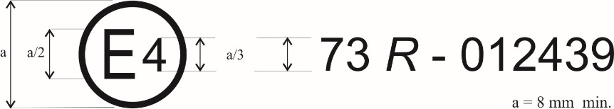

73 *R* - 022439

The above approval mark affixed to a vehicle or to an LPD shows that the vehicle type concerned has, with regard to its lateral protection, been approved in the Netherlands (E 4) pursuant to Regulation No. 73 under approval number 022439 as a complete vehicle. The first two digits of the approval number indicate that the approval was granted in accordance with the requirements of Regulation No. 73 as amended by the 02 series of amendments.

**Model B**

(see paragraph 5.2.4. of this Regulation)



73 *R* - 022439

The above approval mark affixed to an LPD shows that the LPD type concerned has, with regard to its lateral protection, been approved in the Netherlands (E 4) pursuant to Regulation No. 73 under approval number 022439. The first two digits of the approval number indicate that the approval was granted in accordance with the requirements of Regulation No. 73 as amended by the 02 series of amendments.

**Model C**

(see paragraphs 5.1.5. and 5.3.5. of this Regulation)

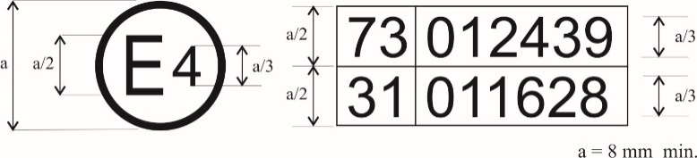

022439

021628

021628

The above approval mark affixed to a vehicle shows that the vehicle type concerned has been approved in the Netherlands (E 4) pursuant to Regulations Nos. 73 and 31[[2]](#footnote-3). The first two digits of the approval numbers indicate that, at the dates when the respective approvals were granted, Regulation No. 73 included the 02 series of amendments and the approval was granted for a completed vehicle, and Regulation No. 31 included the 02 series of amendments."

1. \* In accordance with the programme of work of the Inland Transport Committee for 2025 as outlined in proposed programme budget for 2025 (A/79/6 (Sect. 20), table 20.6), the World Forum will develop, harmonize and update UN Regulations in order to enhance the performance of vehicles. The present document is submitted in conformity with that mandate. [↑](#footnote-ref-2)
2. This latter number is given as an example only. [↑](#footnote-ref-3)