Proposal for 12 Series of Amendments to UN Regulation No. 17 (Strength of Seats)

Submitted by the experts from CLEPA [1]*

The text reproduced below was prepared by the experts from the European Association of Automotive Suppliers (CLEPA). It is based on GRSP-75-30, distributed at the seventy-fifth session of the Working Party on Passive Safety (GRSP) (ECE/TRANS/WP.29/GRSP/75 paragraph 14) and to the Informal Working Group Equitable Occupant Protection, Task Force 2 meeting on 4 September 2024. The proposal aims to improve the whiplash behaviour of occupants of smaller stature and, in particular, of female drivers. The modifications to the current text of UN Regulation No. 17 are marked in bold for new and strikethrough for deleted characters.

**I. Proposal**

*Insert new paragraph 2.31.*, to read:

"**2.31. *"Seat back structure"* means any part of the seat back which has a hardness of more than 50 Shore A.**"

**2.32. *"Head restraint structure"* means any part of the head restraint which has a hardness of more than 50 Shore A and which is situated vertically above the seat back structure.**

*Amend paragraph 5.6.1.1.1. to 5.6.1.1.2.* to read:

5.6.1.1.1. The head restraint shall conform to paragraphs 5.6.2.1., 5.6.3. through ~~5.6.7.~~ **5.6.8.**, 5.7., 5.8., and 5.10., of this Regulation.

5.6.1.1.2. The head restraint shall conform to paragraphs 5.6.2.1., 5.6.3. through 5.6.5., 5.6.7., **5.6.8.**, 5.8., 5.9., and 5.10., of this Regulation.

*Insert new paragraph 5.6.8.*, to read:

"**5.6.8. Head restraint structure**

**For vehicles of M1 and N1 with the seat back placed in its design torso angle and the head restraint placed in its lowest position of use, the head restraint structure shall not allow a cylinder of diameter of 120 +1/-0 mm to pass from the front to the rear through the head restraint structure when the axis of the cylinder is placed horizontally in a plane parallel to the longitudinal plane of the vehicle which passes through the R-point of the seat.**

**The lowest edge of the cylinder in its test position shall remain above the horizontal tangent to the seat back structure. In the case of head restraints integral with the seat back, the lowest edge of the cylinder is not required to be placed lower than the front face of the head restraint as defined in paragraph 5.5.1.2.**"

*Delete paragraph 13.14.5.*

*Insert new paragraphs 13.15. to 13.15.7.*, to read:

**13.15. Transitional provisions applicable to the 12 series of amendments**

**13.15.1 As from the official date of entry into force of the 12 series of amendments, no Contracting Party applying this Regulation shall refuse to grant or refuse to accept type approvals under this Regulation as amended by the 12 series of amendments.**

**13.15.2. As from 1 September 2026, Contracting Parties applying this Regulation shall not be obliged to accept type approvals to any of the preceding series of amendments, first issued after 1 September 2026.**

**13.15.3. Until 1 September 2028, Contracting Parties applying this Regulation shall accept type approvals to any of the preceding series of amendments, first issued before 1 September 2026, provided the transitional provisions in these respective preceding series of amendments foresee this possibility.**

**13.15.4. As from 1 September 2028, Contracting Parties applying this Regulation shall not be obliged to accept type approvals issued to any of the preceding series of amendments to this Regulation.**

**13.15.5. Notwithstanding paragraph 13.15.4., Contracting Parties applying the Regulation shall continue to accept type approvals issued according to any of the preceding series of amendments to this Regulation, for vehicles which are not affected by the changes introduced by the 12 series of amendments, provided the transitional provisions in these respective preceding series of amendments foresee this possibility.**

**13.15.6. Contracting Parties applying this Regulation may grant type approvals according to any of the preceding series of amendments to this Regulation.**

**13.15.7. Contracting Parties applying this Regulation shall continue to grant extensions of existing approvals to any of the preceding series of amendments to this Regulation.**

*Annex 2, amend* to read:

**Annex 2**

**Arrangements of the Approval Mark**

Model A

(see paragraphs 4.4., 4.4.1., 4.4.2. and 4.4.3. of this Regulation)

**Vehicle with at least one seat fitted or capable of being fitted with a head restraint**

a = 8 mm min.

The above approval mark when affixed to a vehicle shows that the vehicle type concerned, with regard to the strength of the seats fitted or capable of being fitted with head restraints and with regard to characteristics of the head restraints, has been approved in the Netherlands (E 4) pursuant to UN Regulation No. 17, under the approval number ~~11~~**12**2439. The first two digits of the approval number indicate that the Regulation already contained the ~~11~~**12** series of amendments at the time of approval. The above approval mark also shows that the vehicle type was approved pursuant to UN Regulation No. 17 with regard to the strength of any seats on the vehicle which are ~~not~~ fitted or capable of being fitted with head restraints.

Model B

(see paragraphs 4.4.; 4.4.1. and 4.4.2. of this Regulation)

**Vehicle with seats not fitted or not capable of being fitted with head restraints**

 a = 8 mm min.

The above approval mark when affixed to a vehicle shows that the vehicle type has seats not fitted or capable of being fitted with head restraints, and has, with regard to the strength of the seats and their anchorages, been approved in the Netherlands (E 4) pursuant to UN Regulation No. 17 under the approval number ~~11~~**12**2439. The first two digits of the approval number indicate that the Regulation already contained the ~~11~~**12** series of amendments at the time of approval.

Model C

(see paragraphs 4.5. of this Regulation)

**Vehicle with at least one seat fitted or capable of being fitted with a head restraint**

 a = 8 mm min.

The above approval mark when affixed to a vehicle shows that the vehicle type has at least one seat fitted or capable of being fitted with a head restraint, and was approved in the Netherlands (E 4) pursuant to UN Regulations Nos. 17 and 33.3

The approval numbers indicate that, on the dates when approval was granted, UN Regulation No. 17 included the ~~11~~**12** series of amendments but UN Regulation No. 33 was still in its original form. The above approval mark also shows that the vehicle type was approved pursuant to UN Regulation No. 17 with regard to the strength of any seats on the vehicle which are not fitted or capable of being fitted with head restraints.

Model D

(see paragraphs 4.5. of this Regulation)

**Vehicle with seats not fitted or not capable of being fitted with head restraints**

 a = 8 mm min.

The above approval mark when affixed to a vehicle shows that the vehicle type has seats not fitted or capable of being fitted with head restraints, and was approved in the Netherlands (E 4) pursuant to UN Regulations Nos. 17 and 33.1 The approval numbers indicate that, on the dates when approval was granted, UN Regulation No. 17 included the ~~11~~**12** series of amendments but UN Regulation No. 33 was still in its original form.Une image contenant texte, Police, blanc, capture d’écran

**II. Justification**

1. In some vehicles, the head of a smaller occupant may be less well supported in the lowest position of the head restraint compared to a medium-sized male::

Figure 1  
**The Head of a Smaller Occupant is Well Retained**

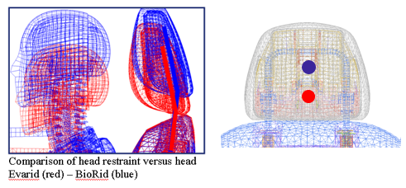

Comparison of head restraint versus head Evarid (red) – Biorid (blue)

Figure 2  
**The Head of a Smaller Occupant is Less Well Retained by the Head Restraint Frame**

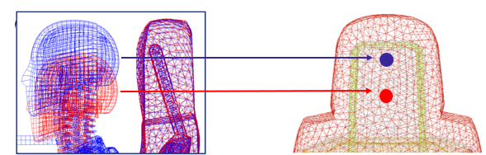

2. It is therefore proposed to improve the rearward retention of the head of smaller occupants by adding a geometry check with a cylinder of diameter of 120 mm.

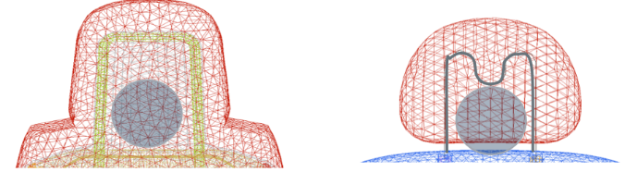

3. In this case the geometric requirements are not fulfilled and additional stiff parts have to be added to the head restraint.

1. * In accordance with the programme of work of the Inland Transport Committee for 2024 as outlined in proposed programme budget for 2024 (A/78/6 (Sect. 20), table 20.5), the World Forum will develop, harmonize and update UN Regulations in order to enhance the performance of vehicles. The present document is submitted in conformity with that mandate.