Proposal for amendments to …/GRVA/2026/10
This document was prepared by the experts of the GRVA task force on regulatory fitness for ADS (TF FADS). It amends the justifications of the working document GRVA/2026/10, itself amending UN Regulation No. 79.
Proposal
Section II. "Justification", amend to read:

(a) Paragraph 5.8.5.1.
1. The proposed text shall ensure that a Control Strategy Corrective Steering Function (CSF), which supports vehicle stability as defined in UN Regulation No. 79, can also be used in cases where an Automated Driving System (ADS) employs an Electronic Stability Control (ESC) or Vehicle Stability Function (VSF) approved in accordance with the relevant UN Regulations on vehicle stability (i.e. UN Regulations Nos. 13 and 140), and which already incorporate CSF functionality.

(b) Paragraph 5.8.6.2.1.
2. The requirement in para. 5.8.6.2.1. does not account for systems utilizing hydraulic energy transmission, which is standard in trucks. These systems do not feature an energy reservoir, but rather rely on an energy source, typically a hydraulic pump driven by the engine or transmission that provides sufficient hydraulic flow to steer the wheels, as long as the engine is running or the vehicle is in motion. Such systems should be considered appropriate. Failure scenarios and corresponding performance criteria are addressed in paragraph 5.8.6.3 and shall be detailed in accordance with Annex 6. Furthermore, failure scenarios (e.g., a leakage in the hydraulic system) are addressed in paragraph 5.3.1.3. of the Regulation, which is calling the general warning section 5.4. In addition, the section 5.8.3. would require such warnings to be transmitted to the ADS and section 5.8.3.1. would also address the issue of faults usually detected by a driver (e.g., increase in steering force)

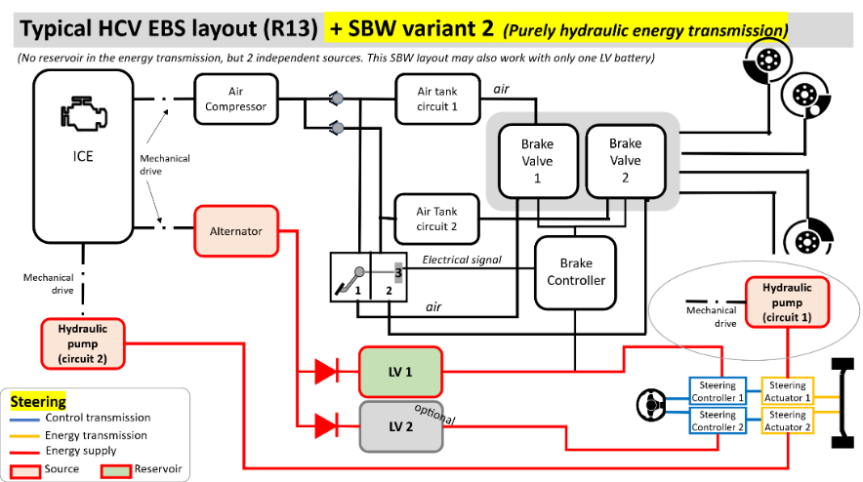
Figure 1
Example layout of a typical heavy commercial vehicle system

