 | United Nations | ECE/TRANS/WP.29/GRE/2025/15
 | Economic and Social Council |  | Distr.: General  6 August 2025  Original: English
Economic Commission for Europe
Inland Transport Committee
World Forum for Harmonization of Vehicle Regulations
Working Party on Lighting and Light-Signalling
Ninety-third session
Geneva, 21–23 October 2025
Item 5 of the provisional agenda
UN Regulations on Light Sources and the Consolidated Resolution
on the Common Specification of Light Source Categories
Proposal for Amendment [xx] to the Consolidated Resolution on the Common Specification of Light Source Categories (R.E.5)
Submitted by the expert from the International Automotive Lighting and Light-Signalling Expert Group (GTB)*
The text reproduced below was prepared by the expert from GTB with the aim to amend the Consolidated Resolution on the common specification of light source categories (R.E.5) (ECE/TRANS/WP.29/2016/111) and its subsequent amendments 1 through 11. There are no associated amendments to UN Regulation Nos. 37, 99 or 128. The modifications to the existing text of the Resolution are marked in bold for new or strikethrough for deleted characters.

I. Proposal
The Status table, amend to read:
"Status table
This consolidated version of this Resolution contains all provisions and amendments adopted so far by the World Forum for Harmonization of Vehicle Regulations (WP.29) and is valid from the date as indicated in the following table until the date on which the next revision of this Resolution becomes valid:
Version of the Resolution | Date * as from which the version is valid | Adopted by WP.29 |  | Clarification
Version of the Resolution | Date * as from which the version is valid | Session No. | Amendment document No. | Clarification
1 (Original) | 22.06.2017 | 170 | ECE/TRANS/WP.29/2016/111 | Based upon Annexes 1 of Regulations:  - No. 37, up to and including Supplement 44  - No. 99, up to and including Supplement 11  - No. 128, up to and including Supplement 5
[xx] | [xx.xx.2026] | [xxx] | [ECE/TRANS/WP.29/2026/xx] | Amended details in paragraph 3.1, group 1, group 2, and group 3, concerning phase out of certain light source categories  Introduction of new LED light source categories LRR8A and LRR8B
* This date is the date of adoption of the amendment to the Resolution by WP.29 or the date of entering into force of an amendment to UN Regulation No. 37, 99 or 128 adopted by AC.1 as a package with the amendment to the Resolution in the same session of WP.29.
”
Paragraph 3.1.,
Group 1, amend to read:
"
Group 1
Filament light source categories (or types within these categories) without general restrictions:
 | Category | Note(s) | Sheet number(s)
 | H1 | *⁶ | H1/1 to 3
 | H3 | *⁶ | H3/1 to 4
 | H4 |  | H4/1 to 5
 | H7 |  | H7/1 to 4
 | H8 |  | H8/1 to 4
 | H8B |  | H8/1 to 4
 | H9 | *³ | H9/1 to 4
 | H9B | *³ | H9/1 to 4
 | H10 |  | H10/1 to 3
 | H11 |  | H11/1 to 4
 | H11B |  | H11/1 to 4
 | H13 |  | H13/1 to 4
 | H15 |  | H15/1 to 5
 | H16 |  | H16/1 to 4
 | H16B |  | H16/1 to 4
 | H17 |  | H17/1 to 6
 | H18 |  | H18/1 to 4
 | H19 |  | H19/1 to 5
 | H20 |  | H20/1 to 4
 | H21W | *² | H21W/1 to 2
 | H27W/1 |  | H27W/1 to 3
 | H27W/2 |  | H27W/1 to 3
 | HB3 |  | HB3/1 to 4
 | HB4 |  | HB4/1 to 4
 | HIR2 |  | HIR2/1 to 3
 | HS1 | *⁶ | HS1/1 to 5
 | HS5 | *⁵ | HS5/1 to 4
 | PSX24W | *² | P24W/1 to 3
 | PSX26W | *² | PSX26W1 to 3
 | S2 | *⁵,*⁶ | S1/S2/1 to 2
"
Group 2, amend to read:
"
Group 2
Filament light source categories (or types within these categories) only for use in signalling lamps, cornering lamps, reversing lamps and rear registration plate lamps:
 | Category | Note(s) |  | Sheet number(s)
 | C5W |  | *⁶ | C5W/1
 | H6W |  |  | H6W/1
 | H10W/1 |  |  | H10W/1 to 2
 | HY6W |  |  | H6W/1
 | HY10W |  |  | H10W/1 to 2
 | HY21W |  |  | H21W/1 to 2
 | P13W |  |  | P13W/1 to 3
 | P21W |  | *⁶ | P21W/1 to 2
 | P21/4W |  |  | P21/4W/1 |  | (P21/5W/2 to 3)
 | P21/5W |  | *⁶ | P21/5W/1 to 3
 | P27W |  |  | P27W/1 to 2
 | P27/7W |  |  | P27/7W/1 to 3
 | PR21W |  |  | PR21W/1 |  | (P21W/2)
 | PR21/5W |  |  | PR21/5W/1 |  | (P21/5W/2 to 3)
 | PS19W |  |  | P19W/1 to 3
 | PS24W |  |  | P24W/1 to 3
 | PSY19W |  |  | P19W/1 to 3
 | PSY24W |  |  | P24W/1 to 3
 | PW13W |  |  | P13W/1 to 3
 | PW16W |  |  | PC16W/1 to 3
 | PWR16W |  |  | PC16W/1 to 3
 | PWY16W |  |  | PC16W/1 to 3
 | PW19W |  |  | P19W/1 to 3
 | PWR19W |  |  | P19W/1 to 3
 | PWY19W |  |  | P19W/1 to 3
 | PW24W |  |  | P24W/1 to 3
 | PWR24W |  |  | P24W/1 to 3
 | PWY24W |  |  | P24W/1 to 3
 | PY21W |  |  | PY21W/1 | (P21W/2)
 | PY21/5W |  |  | PY21/5W/1 to 3
 | PY24W |  |  | P24W/1 to 3
 | PY27/7W |  |  | PY27/7W/1 | (P27/7W/2 to 3)
 | R5W |  | *⁶ | R5W/1
 | R10W |  | *⁶ | R10W/1
 | RR5W |  |  | R5W/1
 | RR10W |  |  | R10W/1
 | RY10W |  | *⁶ | R10W/1
 | T4W |  | *⁶ | T4W/1
 | W2.3W |  |  | W2.3W/1
 | W3W |  | *⁶ | W3W/1
 | W5W |  | *⁶ | W5W/1
 | W10W |  | *⁶ | W10W/1
 | W15/5W |  |  | W15/5W/1 to 3
 | W16W |  |  | W16W/1
 | W21W |  |  | W21W/1 to 2
 | W21/5W |  |  | W21/5W/1 to 3
 | WR5W |  |  | W5W/1
 | WR21/5W |  |  | WR21/5W/1 | (W21/5W/2 to 3)
 | WT21W |  |  | WT21W/1 to 2
 | WT21/7W |  |  | WT21/7W/1 to 3
 | WTY21W |  |  | WT21W/1 to 2
 | WTY21/7W |  |  | WT21/7W/1 to 3
 | WY5W |  | *⁶ | W5W/1
 | WY10W |  | *⁶ | W10W/1
 | WY16W |  |  | W16W/1
 | WY21W |  |  | WY21W/1 to 2

"

Group 3, amend to read:
"
Group 3
Filament light source categories (or types within these categories) only for use in lamps as replacement parts for lamps on vehicles in use originally equipped with such lamps:
 | Category | Note(s) | Sheet number(s) | From date onwards**
 | C5W | *⁷, *⁸ | C5W/1 | 26 July 2013
 | C21W | *⁸ | C21W/1 to 2 | 11 June 2008
 | H1 | *⁷ | H1/1 to 3 | 26 July 2013
 | H3 | *⁷ | H3/1 to 4 | 26 July 2013
 | H8B |  | H8/1 to 4 | 1 April 2028
 | H9B | *³ | H9/1 to 4 | 1 April 2028
 | H10W/1 | *⁸ | H10W/1 to 2 | 1 April 2028
 | H11B |  | H11/1 to 4 | 1 April 2028
 | H12 |  | H12/1 to 3 | 15 July 2015
 | H13A |  | H13/1 to 4 | 15 July 2015
 | H14 |  | H14/1 to 4 | 26 July 2013
 | H16B |  | H16/1 to 4 | 1 April 2028
 | H20 |  | H20/1 to 4 | 1 April 2028
 | H27W/1 |  | H27W/1 to 3 | 1 April 2028
 | H27W/2 |  | H27W/1 to 3 | 1 April 2028
 | HB3A |  | HB3/1 to 4 | 15 July 2018
 | HB4A |  | HB4/1 to 4 | 15 July 2018
 | HIR1 | *³ | HIR1/1 to 3 | 15 July 2015
 | HS1 | *⁷ | HS1/1 to 5 | 26 July 2013
 | HS2 | *⁷ | HS2/1 to 3 | 26 July 2013
 | HS2 | *⁶ | HS2/1 to 3 | 1 September 2018
 | HS5 | *⁵ | HS5/1 to 4 | 1 April 2028
 | HS5A | *⁵ | HS5A/1 to 3 | 1 September 2018
 | HS6 | *⁴ | HS6/1 to 4 | 15 July 2018
 | HY10W/1 | *⁸ | H10W/1 to 2 | 1 April 2028
 | P19W | *⁸ | P19W/1 to 3 | 28 October 2016
 | P21W | *⁷, *⁸ | P21W/1 to 2 | 26 July 2013
 | P21/5W | *⁷, *⁸ | P21/5W/1 to 3 | 26 July 2013
 | P24W | *⁸ | P24W/1 to 3 | 1 September 2018
 | PC16W | *⁸ | PC16W/1 to 3 | 28 October 2016
 | PCR16W | *⁸ | PC16W/1 to 3 | 28 October 2012
 | PCY16W | *⁸ | PC16W/1 to 3 | 28 October 2016
 | PR19W | *⁸ | P19W/1 to 3 | 28 October 2012
 | PR21/4W | *⁸ | PR21/4W/1 ;  (P21/5W/2 to 3) | 15 July 2015
 | PR24W | *⁸ | P24W/1 to 3 | 28 October 2012
 | PR27/7W | *⁸ | PR27/7W/1 ;  (P27/7W/2 to 3) | 15 July 2015
 | PS19W | *⁸ | P19W/1 to 3 | 1 April 2028
 | PS24W | *⁸ | P24W/1 to 3 | 1 April 2028
 | PSR19W | *⁸ | P19W/1 to 3 | 28 October 2012
 | PSR24W | *⁸ | P24W/1 to 3 | 28 October 2012
 | PSX24W | *² | P24W/1 to 3 | 1 April 2028
 | PSX26W | *² | PSX26W/1 to 3 | 1 April 2028
 | PSY19W | *⁸ | P19W/1 to 3 | 1 April 2028
 | PSY24W | *⁸ | P24W/1 to 3 | 1 April 2028
 | PW13W | *⁸ | P13W/1 to 3 | 1 April 2028
 | PW16W | *⁸ | PC16W/1 to 3 | 1 April 2028
 | PW19W | *⁸ | P19W/1 to 3 | 1 April 2028
 | PW24W | *⁸ | P24W/1 to 3 | 1 April 2028
 | PWR16W | *⁸ | PC16W/1 to 3 | 1 April 2028
 | PWR19W | *⁸ | P19W/1 to 3 | 1 April 2028
 | PWR24W | *⁸ | P24W/1 to 3 | 1 April 2028
 | PWY16W | *⁸ | PC16W/1 to 3 | 1 April 2028
 | PWY19W | *⁸ | P19W/1 to 3 | 1 April 2028
 | PWY24W | *⁸ | P24W/1 to 3 | 1 April 2028
 | PX24W | *² | P24W/1 to 3 | 1 September 2018
 | PY19W | *⁸ | P19W/1 to 3 | 28 October 2016
 | PY21/5W | *⁸ | PY21/5W/1 to 3 | 1 April 2028
 | PY24W | *⁸ | P24W/1 to 3 | 1 April 2028
 | R2 |  | R2/1 to 3 | 11 June 2008
 | R5W | *⁷, *⁸ | R5W/1 | 26 July 2013
 | R10W | *⁷, *⁸ | R10W/1 | 26 July 2013
 | RY10W | *⁷, *⁸ | R10W/1 | 26 July 2013
 | S1 |  | S1/S2/1 to 2 | 11 June 2008
 | S2 | *⁷ | S1/S2/1 to 2 | 26 July 2013
 | S3 |  | S3/1 | 26 July 2013
 | T1.4W | *⁸ | T1.4W/1 | 15 July 2015
 | T4W | *⁷, *⁸ | T4W/1 | 26 July 2013
 | T4W | *⁶, *⁸ | T4W/1 | 1 April 2028
 | W3W | *⁷, *⁸ | W3W/1 | 26 July 2013
 | W5W | *⁷, *⁸ | W5W/1 | 26 July 2013
 | W10W | *⁷, *⁸ | W10W/1 | 26 July 2013
 | WP21W | *⁸ | WP21W/1 to 2 | 1 September 2018
 | WPY21W | *⁸ | WP21W/1 to 2 | 1 September 2018
 | WY2.3W | *⁸ | WY2.3W/1 | 15 July 2015
 | WY5W | *⁷, *⁸ | W5W/1 | 15 July 2014
 | WY10W | *⁷, *⁸ | W10W/1 | 26 July 2013

"

Paragraph 3.3.,
Group 2, amend to read:
"
Group 2
LED light source categories only for use in signalling lamps, cornering lamps, reversing lamps and rear registration plate lamps:
 | Category |  | Sheet number(s)
 | LR1 |  | LR1/1 to 5
 | LW2 | 2 | LW2/1 to 5
 | LR3A |  | Lx3/1 to 6
 | LR3B |  | Lx3/1 to 6
 | LW3A | 2 | Lx3/1 to 6
 | LW3B | 2 | Lx3/1 to 6
 | LY3A |  | Lx3/1 to 6
 | LY3B |  | Lx3/1 to 6
 | LR4A |  | LR4/1 to 5
 | LR4B |  | LR4/1 to 5
 | LR5A |  | Lx5/1 to 6
 | LR5B |  | Lx5/1 to 6
 | LW5A | 2 | Lx5/1 to 6
 | LW5B | 2 | Lx5/1 to 6
 | LY5A |  | Lx5/1 to 6
 | LY5B |  | Lx5/1 to 6
 | LR6A |  | Lx6/1 to 6
 | LR6B |  | Lx6/1 to 6
 | LW6A | 2 | Lx6/1 to 6
 | LW6B | 2 | Lx6/1 to 6
 | LY6A |  | Lx6/1 to 6
 | LY6B |  | Lx6/1 to 6
 | LW7A | 2 | Lx7/1 to 6
 | LW7B | 2 | Lx7/1 to 6
 | LRR8A |  | LRR8/1 to 6
 | LRR8B |  | LRR8/1 to 6
¹ Not for use in conformity of production control of lamps.
² Not for use behind red and amber lenses"

Annex 3,
List of sheets for LED light sources and their sequence, amend to read:
"
Sheet number(s)
C5W/LED/1 to 4
H11/LED/1 to 7
L1/1 to 5
LR1/1 to 5
LW2/1 to 5
Lx3/1 to 6
LR4/1 to 5
Lx5/1 to 6
Lx6/1 to 6
Lx7/1 to 6
LRR8/1 to 6
PY21W/LED/1 to 4
R5W/LED/1 to 4
W5W/LED/1 to 4
"

After sheet Lx7/6, insert new sheets LRR8/1 to 6, to read:
(see following pages; one page per sheet)

" Categories LRR8A, LRR8B Sheet LRR8/1
The drawings are intended only to illustrate the essential dimensions of the LED light source.

Figure 1*
Main Drawing

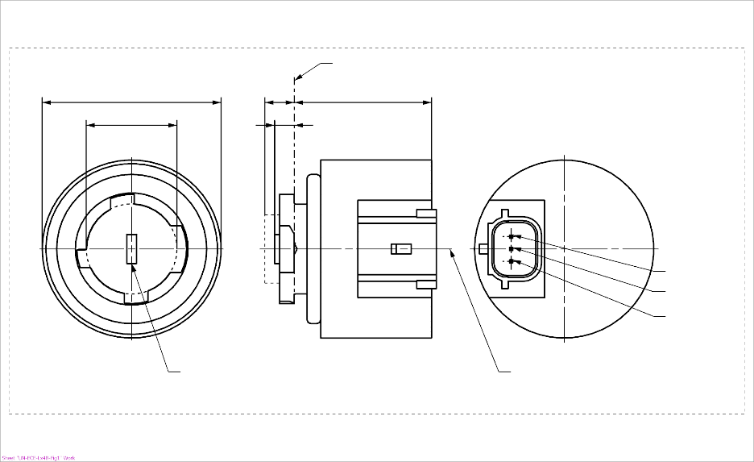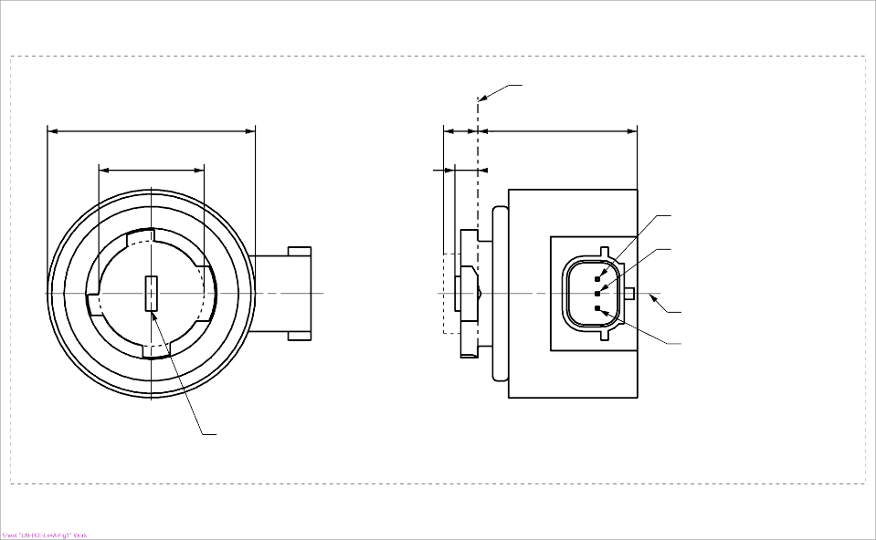
b
c
d
e
a
LRR8B
Ground
Reference axis²
Major Function
Minor Function
Reference plane¹

Light emitting area³
c
a
e
d
Reference plane¹
Major Function

Minor Function
Reference axis²
Ground

b
Light emitting area³
LRR8A
⁴
⁴

* Projection method:

For the notes see sheet LRR8/2
Categories LRR8A, LRR8B Sheet LRR8/2
Table 1
Essential dimensional, electrical and photometric characteristics of the LED light source

Dimensions |  |  |  |  |  | Production LED light sources |  |  |  | Standard LED light sources
a |  |  |  |  | mm | 6.0 max.
b |  |  |  |  | mm | c + 10.0 min.  38.0 max.
c |  |  |  |  | mm | 18.5 ± 0.1
d |  |  |  |  | mm | 28.0 max.
e ^{8/} |  |  |  |  | mm | 3.0 ± 0.30 |  |  |  | 3.0 ± 0.15
Cap | LRR8A, LRR8B |  | PGJ18.5t-1 |  | in accordance with IEC Publication 60061 (sheet 7004-185-3)
Electrical and photometric characteristics
 |  |  |  |  |  | Minor function |  | Major function | Minor function |  | Major function
Rated values |  | Volts |  |  |  | 12 |  |  | 12
 |  | Watts |  |  |  | 1.0 | 4.0 |  | 1.0 |  | 4.0
Test voltage |  | Volts (DC) |  |  |  | 13.5 |  |  | 13.5
Objective Values ⁶ |  | Watts (at test voltage) |  |  |  | 1.0 max. | 4.5 max. |  | 1.0 max |  | 4.5 max
 |  | Luminous flux (in lm at test voltage) ^{5, 10, 11} |  |  |  | 10 ± 30% | 120 ± 20 % ⁷ |  | 10 ± 20% ⁹ |  | 120 ± 10 % ⁷
 |  | Luminous flux (in lm at 9 V DC) ⁵ |  |  |  | 2 min | 28 min
^{1/} The reference plane is the plane defined by the contact points of the cap-holder fit.
^{2/} The reference axis is perpendicular to the reference plane and passing through the centre of the bayonet core.
^{3/} Light emitting area: to be checked by means of the box system in Figure 2
^{4/} A minimum free air space of 5 mm around the light source shall be respected for convection; the connector interface can be neglected.
^{5/} The emitted light shall be red.
^{6/} After continuous operation for 30 minutes at 23 ± 2.5° C.
^{7/} The measured value shall be in between 100 per cent and 70 per cent of the value measured after 1 minute.
^{8/} Light centre length; the major function is operated during the measurement; for the method of measurement, see Annex K of IEC 60809, Edition 4.
^{9/} The measured value shall be in between 110 per cent and 90 per cent of the value measured after 1 minute.
^{10/} When minor and major functions are powered at the same time, the luminous flux shall not be less than the minimum objective value of the major function (96 lm) and shall not be more than the maximum objective value given by the sum of both functions (157 lm).
^{11/} No light shall be emitted in the case the light source LRR8A is powered with a connector counterpart having the pin assignment of the light source LRR8B, and vice versa

Electrical characteristics

In case of LED light source failure (no light emitted) the max. electrical current draw, when operated between 12 V and 14 V, shall be less than 20 mA (open circuit condition).

Categories LRR8A, LRR8B Sheet LRR8/3

Screen projection requirements

The following test is intended to define the requirements for the light emitting area of the LED light source and to determine whether the light emitting area is correctly positioned relative to the reference axis and reference plane in order to check compliance with the requirements.
The position of the light emitting area is checked by the box system defined in Figure 2, which is aligned to the planes C₉₀ and C₁₈₀ and shows the projection when viewing along direction γ = 0º at e = 3.0 mm (C, γ as defined in Figure 3).
The luminous flux Φ emitted into the viewing direction shall be calculated as given below:

$$Φ=L⋅S⋅Ω$$
with
S = area to be considered
L = luminance average of area S
Ω = solid angle defined by the entrance aperture of the measurement system

The distribution of luminous flux originating from the LEA as shown in Figure 2 shall fulfil the requirements given in Table 3. All numbers shall be given in % of the total luminous flux emitted into the viewing direction from the bayonet core area, i.e. a circular area with diameter c = 18.5 mm (see Figure 1).

Note: When evaluating the luminous flux distribution emitted from the LEA, reflections and stray light within the measurement equipment shall be reduced as much as possible and if necessary, corrected. More details regarding measurement of light-emitting areas can be found in the publication describing general photometry accuracy guidelines currently prepared by CIE TC2-67

Figure 2

Box definition of the light emitting area with dimensions as specified in Table 2

Reference axis perpendicular in
the centre of the light-emitting area
C₂₇₀
C₁₈₀
C₉₀
C₀

f/3
f/3
f/3
f/3
f/3
f/3
A
B
B
B
B
C
C
C
C
f/2
f/2

Table 2

Dimensions of the box system in Figure 2

Dimensions in mm | f
LED light sources of normal production | 4.5
Standard LED light sources | 4.5
CATEGORIES LRR8A, LRR8B Sheet LRR8/4

Table 3

Proportion of the total luminous flux emitted into the viewing direction from the areas specified in Figure 2

Area(s) | LED light sources of normal production  for minor function and major function | Standard LED light sources  for minor function and major function
Each B individually | ≥10% | ≥15%
Each A, B individually | < 40% | < 30%
All B together | ≥ 60% | ≥ 65%
Each C individually | - | < 10%
All A, B and C together | ≥ 90% | ≥ 90%

Categories LRR8A, LRR8B Sheet LRR8/5
Normalized luminous intensity distribution
The following test is intended to determine the normalized luminous intensity distribution of the light source in an arbitrary plane containing the reference axis. The intersection of the reference axis and the parallel plane to the reference plane in distance e = 3.0 mm is used as the coordinate system origin.
The light source is mounted on a flat plate with the corresponding mounting lug features. The plate is mounted to the goniometer table by a bracket, so that the reference axis of the light source lines up with one of the rotating axes of the goniometer. The corresponding measurement set-up is described in Figure 3.
Luminous intensity data is recorded with a standard photo-goniometer. The measurement distance should be chosen appropriately, to make sure that the detector is located in the far field of the light distribution.
The measurements shall be performed in C-planes C₀, C₉₀, C₁₈₀ and C₂₇₀, which contain the reference axis of the light source. The test points for each plane for multiple polar angles γ are specified in Table 4.
The measured luminous intensity values, normalised to the measured luminous flux of the individual light source under test, shall be converted to normalised luminous intensity values of a 1,000 lm light source. The data shall comply with the tolerance band as defined in Table 4.

The drawings are intended only to illustrate the essential set-up for measurement of the LED light source.

Figure 3

Set-up to measure the luminous intensity distribution

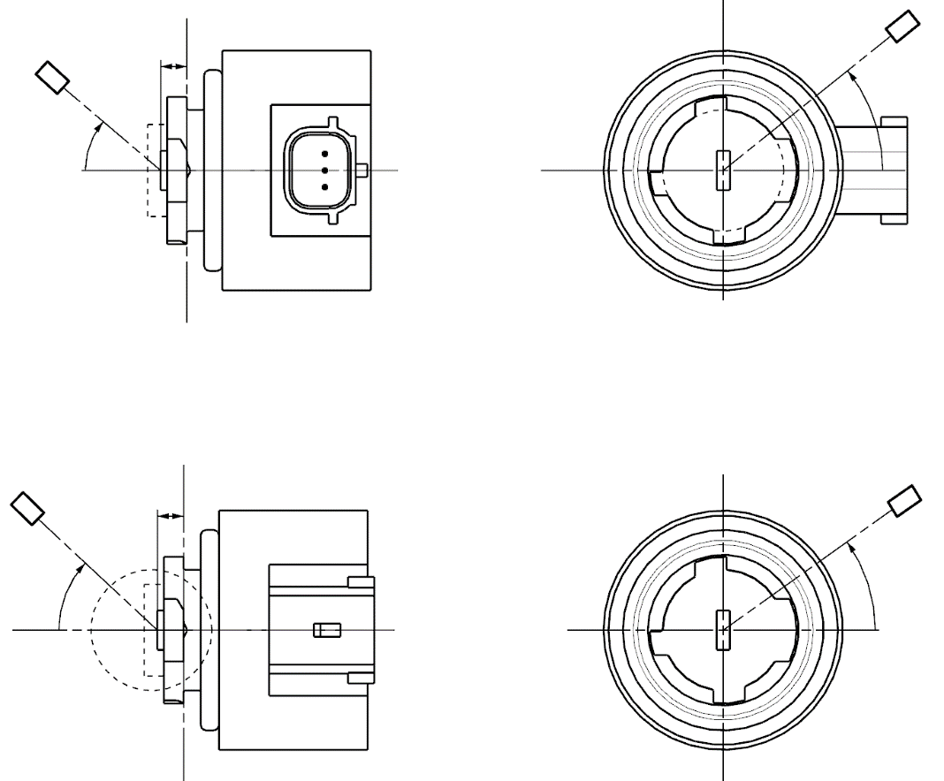
Reference axis
Reference plane
Photo-Detector of Goniometer
C-plane definition
Viewing direction along reference axis
LRR8B
Reference axis
Reference plane
C-plane definition
Viewing direction along reference axis
Photo-Detector of Goniometer
LRR8A
C
γ
e
C₀
C
γ
e
C₀

Categories LRR8A, LRR8B Sheet LRR8/6

The light pattern as described in Table 4 shall be substantially uniform, i.e. in between two adjacent grid points the relative luminous intensity requirement is calculated by linear interpolation using the two adjacent grid points. In case of doubt this may be checked in addition to verification of the grid points given in Table 4.

Table 4
Test point values of normalized intensities

 | LED light sources of normal production  for minor function and major function |  | Standard LED light sources  for minor function and major function
Angle γ | Minimum Intensity  in cd /1000 lm | Maximum Intensity  in cd/1000 lm | Minimum Intensity  in cd /1000 lm | Maximum Intensity in cd /1000 lm
0° | 200 | 425 | 250 | 390
15° | 190 | 415 | 240 | 370
30° | 170 | 380 | 220 | 335
45° | 145 | 310 | 180 | 275
60° | 85 | 245 | 105 | 220
75° | 0 | 160 | 0 | 150
90° | 0 | 70 | 0 | 65

"

II. Justification
1. This document is a consolidation of proposed amendments by experts in GTB to the Consolidated Resolution on the common specification of light source categories (R.E.5) (ECE/TRANS/WP.29/1127) and its subsequent amendments 1 through 11. The amendments cover two topics and for clarity the justification for the document is structured to provide the justifications by topic under their respective topic headers.
- Amendment to introduce new light emitting diode (LED) light source categories LRR8A and LRR8B
2. This proposal introduces new LED light source categories for signalling to accommodate an increasing market demand for LED light sources according to UN Regulation No. 128. The ongoing trends towards style driven rear combination lamps requires light sources with higher luminous output to compensate the lower efficiency of the corresponding optical designs.
3. In general, standardized and replaceable UN Regulation No. 128 LED light sources can serve individual signalling lamp designs with limited development efforts. The proposed categories of a high luminous flux dual level red light source are based on an established cap concept with an increased and more precise light output, applying an improved dual level specification of the Light-Emitting-Area, that was previously introduced for the LR4 dual level category.
4. The category designation of LRR8 is established as follows. The proposed category name establishes a convention with two colour designation letters “R” for each of the red functions, anticipating future development of UN Regulation No. 128 light sources with dual functions, such as a potential white-amber combination for a combined front position and direction indicator application (for such a future category the designation LWYn, containing the colour designation letters “W” and “Y” would be considered to indicate the use for dual function in white (W) and amber (Y) colours). The number “8” in the category name signifies the next available sequential numerical designation of a UN Regulation No. 128 category, following LW7.
5. The cap/holder system for the new dual level red emitting light source is based on the IEC PGJ18.5d fit, a family of cap/holders that has already been successfully employed in existing LED light sources in UN Regulation No. 128. Keys from the PGJ18.5d fit that are not in use so far have been assigned to the newly proposed categories. Following established LED light source categories, the new dual level red emitting light source is proposed with an elbow connector at the side – the A version – as well as with a straight connector at the bottom – the B version. The assigned category designations are LRR8A and LRR8B respectively.
- Amendment of details in paragraph 3.1, group 1, group 2, and group 3, concerning phase out of certain light source categories
6. With the introduction of new light source categories, GTB regularly evaluates which light source categories could be phased out based upon technological progress and our evaluation of the need to keep these categories in the regulation. This proposal is the outcome of such an evaluation.
7. The proposal is not aimed at completely deleting categories of light sources from the Consolidated Resolution on the common specification of light source categories (R.E.5), but at moving some categories or types of categories from group 1 and group 2 to group 3 of paragraph 3.1. In this way, these categories of light sources can still be approved and used as replacement parts. However, they can no longer be used for type approval of new lamps, unless these lamps are intended as replacement parts for vehicles in use.

* In accordance with the programme of work of the Inland Transport Committee for 2025 as outlined in proposed programme budget for 2025 (A/79/6 (Sect. 20), table 20.6), the World Forum will develop, harmonize and update UN Regulations in order to enhance the performance of vehicles. The present document is submitted in conformity with that mandate.

