|  |  |  |  |
| --- | --- | --- | --- |
|  | United Nations | ECE/TRANS/WP.29/GRVA/2025/16 | |
| _unlogo | **Economic and Social Council** | | Distr.: General  11 November 2024  Original: English |

**Economic Commission for Europe**

Inland Transport Committee

**World Forum for Harmonization of Vehicle Regulations**

**Working Party on Automated/Autonomous and Connected Vehicles**

**Twenty-first session**

Geneva, 20-24 January 2025

Item 8(c) of the provisional agenda

**UN Regulations Nos. 13, 13-H, 139, 140 and UN GTR No. 8:**

**Clarifications**

Proposal for amendments to UN Regulation No. 13 (Heavy vehicle braking)

Submitted by the experts from the European Association of Automotive Suppliers [[1]](#footnote-2)\*

The text reproduced below was prepared by the expert from the European Association of Automotive Suppliers (CLEPA) to resolve the problem of decreasing trailer brake performance caused by brake pads and linings “falling asleep”. The modifications to the existing text of the Regulation are marked in bold for new characters and in bold strikethrough for deleted characters.

I. Proposal

*Annex 10,*

*Paragraph 1.1.,* amend to read:

1.1. Vehicles of categories M2, M3, N, O2, O3 and O4 shall meet all the requirements of this annex. If a special device is used, this shall operate automatically.1

However, vehicles in the above categories which are equipped with an anti-lock braking system and fulfil the relevant requirements of Annex 13, shall also fulfil all the relevant requirements of this annex with the following exceptions:

(a) Compliance with the adhesion utilization requirements associated with diagrams 1A, 1B or 1C, as appropriate, is not required.

(b) In the case of towing vehicles and trailers, equipped with a compressed air braking system, compliance with the unladen compatibility requirements associated with diagrams 2, 3**, 4 or 5**, as appropriate, is not required. However, for all load conditions, a braking rate shall be developed between a pressure of 20 kPa and 100 kPa or the equivalent digital demand value at the coupling head of the control line(s).

*Paragraph 5.1.3.* amend to read:

5.1.3. The permissible relationship between the braking rate TR/PR and the pressure pm shall lie within the designated areas in diagram ~~2~~ **5** of this annex for all pressures between 20 and 750 kPa, in both the laden and unladen states of load.

*Annex 10, paragraph 5.2.1.,* amend to read:

5.2.1. The permissible relationship between the braking rate TR/PR and the pressure pm shall lie within two areas derived from diagram ~~2~~ **5** of this annex, by multiplying the vertical scale by 0.95. This requirement shall be met at all pressures between 20 and 750 kPa, in both the laden and unladen states of load.

*Annex 10, Diagram 2, title,* amend to read:

Diagram 2  
**Towing vehicles ~~and trailers~~**

(except tractors for semi-trailers ~~and semi-trailers and full trailers~~)

(see paragraph 3.1.5.1. of this annex)

*Annex 10, Diagram 2 and Diagram 4A*, amend to read:

**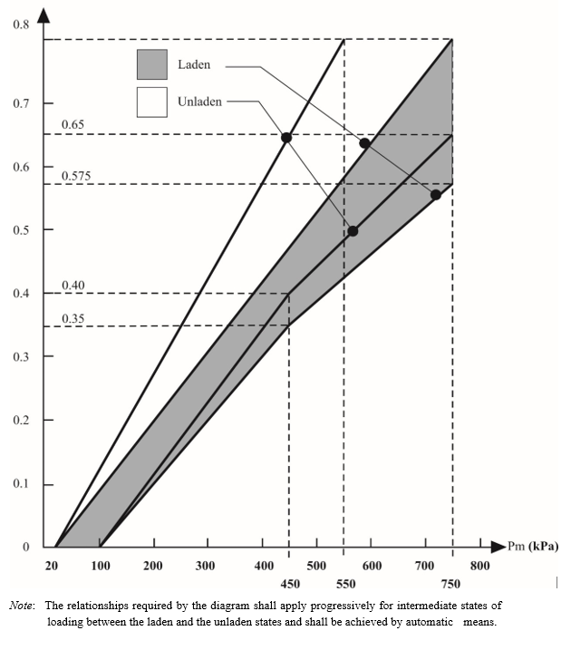**

*Note*: The relationships required by the diagram shall apply progressively for intermediate states of loading between the laden and the unladen states and shall be achieved by automatic means.

# Diagram 4A

# **Semi-trailers**

(see paragraph 4. of this annex)

*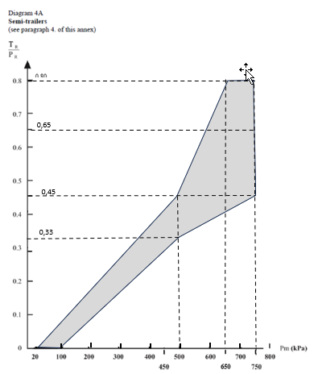*

*Insert a new diagram 5,* as follow:

**Diagram 5**

**Full trailers and centre-axle trailers**

**(see paragraph 5 of this annex)**

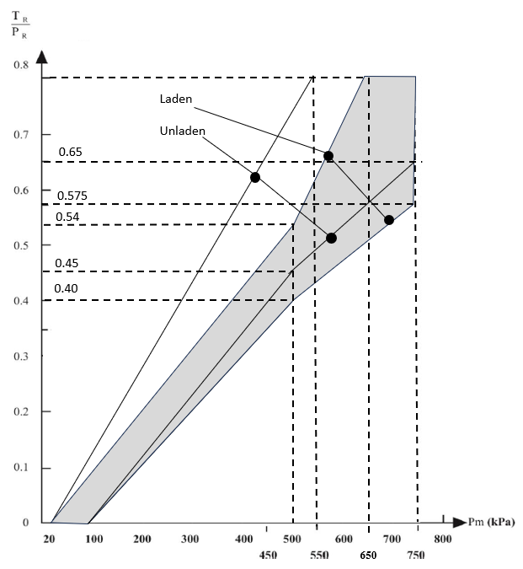II. Justification

1. Annex 10, paragraph 1.1. of Regulation No. 13 defines the requirements for compatibility between towing vehicles and trailers.

2. The compatibility bands were created more than 50 years ago when antilock braking systems were not available. The goal was to have a similar brake performance of both towing vehicles and trailers and to reach simultaneously locking of wheels of both towing vehicle and trailer to ensure best stability of the combination​. Truck and trailer axles shall decelerate their own portion of mass.

3. For towing vehicles and trailers with Antilock Braking Systems (ABS) an exemption has been implemented. These vehicles do not need to fulfill the unladen compatibility bands, because the Antilock Braking Systems will avoid locking of wheels and ensure vehicle stability even with full brake application under all load conditions.

4. Problem:

(a) The number of trucks with strong endurance braking systems is increasing since a long time. With increasing electrification of vehicles more highly efficient energy recuperating systems will be installed in future. This leads to the situation that the use of friction brakes is more and more reduced.

(b) Depending on the use of the commercial vehicle, brake pads and linings often do not reach a temperature that is needed for the development of optimum brake performance. In particular in trailers a loss of brake force is experienced due to brake pads and linings that lose their performance - they “fall asleep” and need to be replaced although they are not worn out.

(c) On the other hand, the maximum brake force, which may be installed in trailers is limited by the upper line of the compatibility band​ as currently shown in diagrams 2 (for truck and full-trailer) and 4A (for semi-trailer) of Annex 10.

5. Solution:

(a) Extension of the compatibility bands at higher control pressure (pm **≥** 500 kPa) by modification of diagram 4A for semitrailers and adding a new diagram 5 for full trailers instead of using diagram 2 for towing vehicles.

(b) This allows to install ​ stronger brakes with higher brake forces and higher safety margin to compensate for the possible loss of brake performance as described above.

(c) With pm < 500 kPa, the same characteristic as of today will ensure brake compatibility for harmonization of brake forces between towing vehicle and trailer. Higher brake force can be realized e.g. by using next size of brake chambers (e.g. 20” brake chamber instead of 16” which results in 25 per cent brake force increase).

III. Comparison of proposals

Changes are marked in red

Current Diagram 4A New Diagram 4A

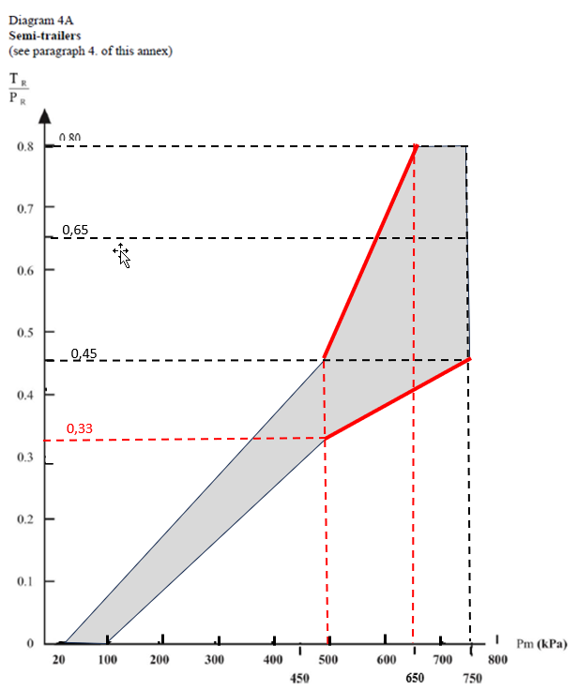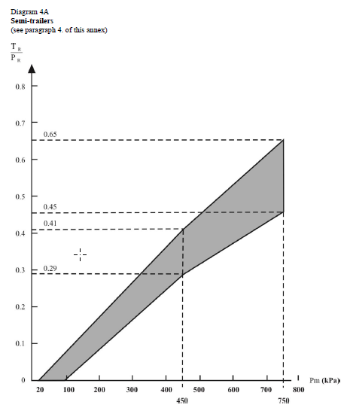

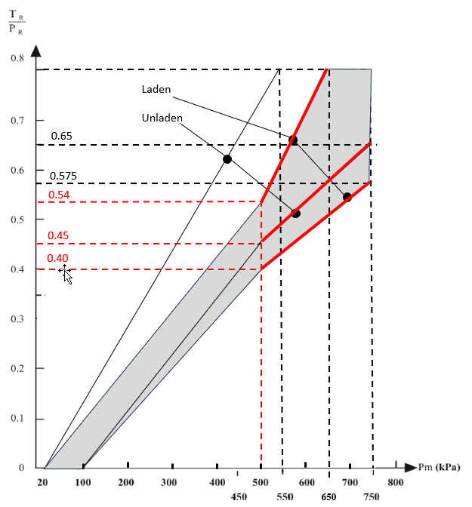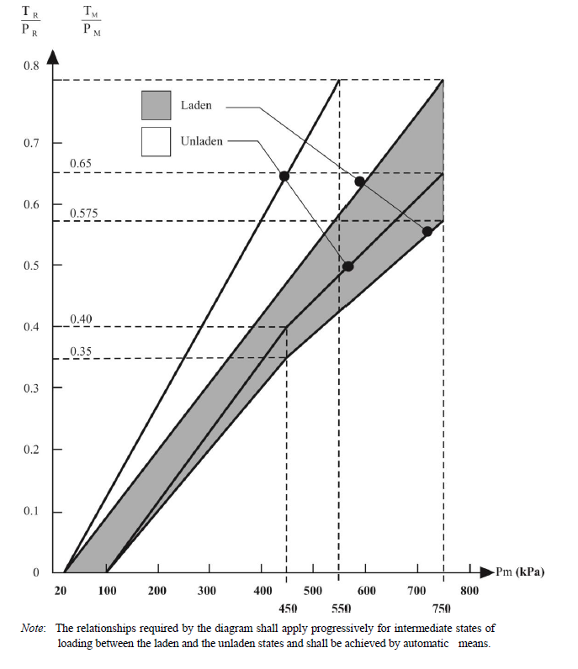Current diagram 2 for Trucks & trailer New:

1. \* In accordance with the programme of work of the Inland Transport Committee for 2025 as outlined in proposed programme budget for 2025 (A/79/6 (Sect. 20), table 20.6), the World Forum will develop, harmonize and update UN Regulations in order to enhance the performance of vehicles. The present document is submitted in conformity with that mandate. [↑](#footnote-ref-2)