|  |  |  |  |
| --- | --- | --- | --- |
|  | United Nations | ECE/TRANS/WP.29/GRVA/2025/XX | |
| _unlogo | **Economic and Social Council** | | Distr.: General  DD Month Year  Original: English |

**Economic Commission for Europe**

Inland Transport Committee

**World Forum for Harmonization of Vehicle Regulations**

**Working Party on Automated/Autonomous and Connected Vehicles**

**Twenty-first session**

Geneva, 20-24 January 2025

Item XX of the provisional agenda

**Task Force for Fitness of Automated Driving Systems:**

**TF FADS**

Proposal for supplement to UN Regulation No. 13 (Heavy vehicle braking)

Submitted by the expert from XX

OICA/CLEPA amendment in green

1. Proposal

*Paragraph 2.3.,* amend to read:

2.3. "*Braking system*" means the combination of parts whose function is progressively to reduce the speed of a moving vehicle or bring it to a halt, or to keep it stationary if it is already halted; these functions are specified in paragraph 5.1.2. The system consists of the control (if any)**,** the transmission, and the brake proper;

*~~Paragraph 2.4.,~~* ~~amend to read:~~

~~2.4. "~~*~~Control~~*~~" means the part actuated directly by the driver (or in the case of some trailers, by an assistant) to furnish to the transmission the energy required for braking or controlling it. This energy may be the muscular energy of the driver, or energy from another source controlled by the driver, or in appropriate cases the kinetic energy of a trailer, or a combination of these various kinds of energy;~~

*~~Paragraph 2.13.,~~* ~~amend to read:~~

~~2.13. "~~*~~Progressive and graduated braking~~*~~" means braking during which, within the normal operating range of the equipment, and during actuation of the brakes (see paragraph 2.4.1. above);~~

~~2.13.1.   The driver can at any moment increase or decrease the braking force by acting on the control;~~

~~2.13.2.   The braking force varies proportionally as the action on the control (monotonic function); and~~

~~2.13.3.   The braking force can be easily regulated with sufficient precision;~~

*~~Paragraph 2.29.,~~* ~~amend to read:~~

~~2.29. "~~*~~Automatically commanded braking~~*~~" means a function within a complex electronic control system where actuation of the braking system(s) or brakes of certain axles is made for the purpose of generating vehicle retardation with or without a direct action of the driver, resulting from the automatic evaluation of on‑board initiated information.~~

*Paragraph 2.34.2.1.,* amend to read:

2.34.2. Control functions within a vehicle stability function:

2.34.2.1. "*Directional control*" means a function within a vehicle stability function that assists the driver or the ADS, in the event of under steer and over steer conditions, within the physical limits of the vehicle in maintaining the direction intended by the driver or the ADS in the case of a power-driven vehicle and assists in maintaining the direction of the trailer with that of the towing vehicle in the case of a trailer.

*Paragraph 5.1.2.1.,* amend to read:

5.1.2.1. Service braking system

The service braking system shall make it possible to control the movement of the vehicle and to halt it safely, speedily and effectively, whatever its speed and load, on any up or down gradient. It shall be possible to graduate this braking action. ~~The~~ A driver, if any, shall be able to achieve this braking action from his driving seat without removing his hands from the steering control.

*Paragraph 5.1.2.2.,* amend to read:

5.1.2.2. Secondary braking system

The secondary braking system shall make it possible to halt the vehicle within a reasonable distance in the event of failure of the service braking system. It shall be possible to graduate this braking action. ~~The~~ A driver, if any, shall be able to obtain this braking action from his driving seat while keeping at least one hand on the steering control. For the purposes of these provisions it is assumed that not more than one failure of the service braking system can occur at one time.

*Paragraph 5.1.2.3.,* amend to read:

5.1.2.3. Parking braking system

The parking braking system shall make it possible to hold the vehicle stationary on an up or down gradient even in the absence of the driver, the working parts being then held in the locked position by a purely mechanical device. ~~The~~ A driver, if any, shall be able to achieve this braking action from his driving seat, subject, in the case of a trailer, to the provisions of paragraph 5.2.2.10. of this Regulation. The trailer air brake and the parking braking system of the towing vehicle may be operated simultaneously provided that the driver or the ADS (as appropriate) is able to check, at any time, that the parking brake performance of the vehicle combination, obtained by the purely mechanical action of the parking braking system, is sufficient.

*Paragraph 5.1.2.4.3.3.,* amend to read:

5.1.2.4.3.3. Additional requirement in the case of an endurance braking system solely based on an electric regenerative braking system:

Prior to the time when the braking force of the electric regenerative braking can no longer be provided (e.g. when the battery is fully loaded), the driver ~~or the ADS as applicable~~ shall be informed about the situation (e.g. an information on the remaining retardation capacity, a reduction of the provided retardation force).

*Paragraph 5.1.4.7.1.,* amend to read:

5.1.4.7.1. Where the operational status is indicated to the driver by warning signals, as specified in this Regulation, it shall be possible at a periodic technical inspection to confirm the correct operational status by visual observation of the warning signals following a power-on. ~~Where those warning signals are to be communicated to an ADS, it shall be possible to verify that the ADS processes them.~~

*Paragraph 5.2.1.2.1.,* amend to read:

5.2.1.2. The systems providing service, secondary and parking braking may have common components so long as they fulfil the following conditions:

5.2.1.2.1. There shall be at least two controls, independent of each other and readily accessible to the driver from his normal driving position.

For all categories of vehicles, except M2 and M3, every brake control (excluding an endurance braking system control) shall be designed such that it returns to the fully off position when released. This requirement shall not apply to a parking brake control (or that part of a combined control) when it is mechanically locked in an applied position;

For vehicles of categories X and Y, the controls may be otherwise. However, it shall be ensured through technical means that vehicles of category X or Y cannot exceed 6 km/h whilst a braking control, if fitted, is in ~~use~~/[operational].

*Paragraph 5.2.1.2.7.2.,* amend to read:

5.2.1.2.7.2. If the service braking force and transmission depend exclusively on the use, controlled by the driver, of an energy reserve, there shall be at least two completely independent energy reserves, each provided with its own transmission likewise independent; each of them may act on the brakes of only two or more wheels so selected as to be capable of ensuring by themselves the prescribed degree of secondary braking without endangering the stability of the vehicle during braking; in addition, each of the aforesaid energy reserves shall be equipped with a warning device as defined in paragraph 5.2.1.13. below. In case of compressed-air braking systems, in each service braking circuit in at least one of the air reservoirs a device for draining and exhausting is required in an adequate and easily accessible position;

For vehicles of sub-categories X and Y, the ADS shall be capable of continuously monitoring the status of each energy reserve and detecting any potential failures or drops in energy levels.

~~Where applicable, it shall be possible for the ADS to transmit relevant alerts through the in-service monitoring to a remote operator.~~

*Insert 5.2.1.11.2.1.1.,* to read:

5.2.1.11.2. Checking the wear of the service brake friction components

5.2.1.11.2.1. It shall be possible to easily assess this wear on service brake linings from the outside or underside of the vehicle, without the removal of the wheels, by the provision of appropriate inspection holes or by some other means. This may be achieved by utilizing simple standard workshop tools or common inspection equipment for vehicles.

Alternatively, a sensing device per wheel (twin wheels are considered as a single wheel), which will warn the driver at his driving position when lining replacement is necessary, is acceptable. In the case of an optical warning, the yellow warning signal specified in paragraph 5.2.1.29.1.2. below may be used.

~~5.2.1.11.2.1.1. For vehicles of categories X and Y, it shall be possible for an ADS to forecast maintenance operations for braking system components, including but not limited to the service brake linings.~~

~~Where applicable, it shall be possible for the ADS to transmit maintenance alerts through the in-service monitoring to a remote operator.~~

*Paragraph 5.2.1.11.2.1.,* amend to read:

5.2.1.11.2.2. Assessment of the wear condition of the friction surfaces of brake discs or drums may only be performed by direct measurement of the actual component or examination of any brake disc or drum wear indicators, which may necessitate some level of disassembly. Therefore, at the time of type approval, the vehicle manufacturer shall define the following:

(a) The method by which wear of the friction surfaces of drums and discs may be assessed, including the level of disassembly required and the tools and process required to achieve this;

(b) Information defining the maximum acceptable wear limit at the point at which replacement becomes necessary.

This information shall be made freely available, e.g. vehicle handbook or electronic data record.

*Insert 5.2.1.12.1.,* to read:

5.2.1.12. In hydraulic-transmission braking systems, the filling ports of the fluid reservoirs shall be readily accessible; in addition, the receptacles containing the reserve fluid shall be so designed and constructed that the level of the reserve fluid can be easily checked without the receptacles having to be opened. If this latter condition is not fulfilled, the red warning signal specified in paragraph 5.2.1.29.1.1. shall draw the driver's attention to any fall in the level of reserve fluid liable to cause a failure of the braking system. The type of fluid to be used in the hydraulic transmission braking systems shall be identified by the symbol in accordance with figure 1 or 2 of Standard ISO 9128:2006. The symbol shall be affixed in a visible position in indelible form within 100 mm of the filling ports of the fluid reservoirs; additional information may be provided by the manufacturer.

5.2.1.12.1. The ADS shall access information regarding the fluid level in the reservoirs and respond accordingly to any warning signals indicating a drop in fluid levels that could compromise braking performance.

~~Where applicable, it shall be possible for the ADS to transmit alerts regarding a drop in fluid levels through the in-service monitoring to a remote operator.~~

*~~Paragraph 5.2.1.13.1.1.,~~* ~~amend to read:~~

5.2.1.13. Warning device

5.2.1.13.1.1. However, in the case of vehicles which are only considered to comply with the requirements of paragraph 5.2.1.5.1. of this Regulation by virtue of meeting the requirements of paragraph 1.2.2. of Part C of Annex 7 to this Regulation, the warning device shall consist of an acoustic signal in addition to an optical signal. These devices need not operate simultaneously, provided that each of them meet the above requirements and the acoustic signal is not actuated before the optical signal. The red warning signal specified in paragraph 5.2.1.29.1.1. shall be used as the optical warning signal.

5.2.1.25.5. If the operation of the electric component of braking is ensured by a relation established between the information coming from the control of the service brake and the braking force at the respective wheels, a failure of this relation leading to the modification of the braking distribution among the axles (Annex 10 or 13, whichever is applicable) shall be signalled to the driver by an optical warning signal at the latest at the moment when the control is actuated and this signal shall remain lit as long as this defect exists and that the vehicle control switch (key) is in the "ON" position.

*Paragraph 5.2.1.26.4.,* amend to read:

5.2.1.26.4. ~~After the ignition/start switch which controls the electrical energy for the braking equipment has been switched off and/or the key removed~~ If the braking system is no longer energized, it shall remain possible to apply the parking braking system, whereas releasing by using the parking brake control shall be prevented.

However, the parking braking system may also be released when this action is part of an operation of a remote-control system fulfilling the technical requirements of an ACSF of Category A as specified in the 02 series of amendments to UN Regulation No. 79 or later series of amendments.

Furthermore, the parking brake shall be automatically applied, at least when the vehicle is detected to be stationary and additionally any of the following conditions is fulfilled:

(a) The ignition/start switch which controls the electrical energy for the braking equipment has been switched off and/or the key removed;

(b) The driver is deemed to leave the driving seat (e.g. via a detection of door opening, unfastening of seat belt). Alternatively, for vehicles of category M, the parking brake shall be automatically applied if no input to any control by the driver nor any brakes application are detected for a time greater than 30 seconds.

However, the automatic application of the parking braking system may be suppressed by the driver (e.g. during maintenance operation, manoeuvring situations, to avoid park brake freezing in winter conditions) with a dedicated action (e.g. by pedal actuation, a switch).

*Paragraph 5.2.1.26.5.,* amend to read:

5.2.1.26.5. If the parking braking system detects a request (generated automatically or by the driver or the ADS):

(a) To fully apply the parking brake (i.e. to reach the mechanically locked position of the parking brake), or

(b) To gradually control the parking brake action,

The actuation of the warning as required in paragraph 2.6. of Annex 8 may be delayed until the parking brake system has detected the correct clamping of the parking brake.The yellow warning signal specified in paragraph 5.2.1.29.1.2. shall be displayed at the latest 10s rafter the request for a full parking brake application, in the case the stable state is not reached.

*Paragraph 5.2.2.8.2.1.,* amend to read:

5.2.2.8.2.1. It shall be possible to easily assess this wear on service brake linings from the outside or underside of the vehicle, without the removal of the wheels, by the provision of appropriate inspection holes or by some other means. This may be achieved by utilizing simple standard workshop tools or common inspection equipment for vehicles.

Alternatively, a trailer mounted display providing information when lining replacement is necessary or a sensing device per wheel (twin wheels are considered as a single wheel), which will warn the driver at his driving position when lining replacement is necessary, is acceptable. In the case of an optical warning, the yellow warning signal specified in paragraph 5.2.1.29.2. above may be used provided that the signal complies with the requirements of paragraph 5.2.1.29.6. above.

For vehicles of sub-categories X and Y, it shall be possible for an ADS to forecasting maintenance operations for braking system components, including but not limited to the service brake linings.

~~Where applicable, it shall be possible for the ADS to transmit maintenance alerts through the in-service monitoring to a remote operator.~~

*~~Paragraph 5.2.2.15.2.,~~* ~~amend to read:~~

5.2.2.15.2. In the case of a failure within the electric control transmission (e.g. breakage, disconnection), a braking performance of at least 30 per cent of the prescribed performance for the service braking system of the relevant trailer shall be maintained. For trailers, electrically connected via an electric control line only, according to paragraph 5.1.3.1.3., and fulfilling 5.2.1.18.4.2. with the performance prescribed in paragraph 3.3. of Annex 4 to this Regulation, it is sufficient that the provisions of paragraph 5.2.1.27.10. are invoked, when a braking performance of at least 30 per cent of the prescribed performance for the service braking system of the trailer can no longer be ensured, by either providing the "supply line braking request" signal via the data communication part of the electric control line or by the continuous absence of this data communication.

*Paragraph 5.2.2.24.6.3.,* amend to read:

5.2.2.24.6.3. A towing trailer may only be operated in conjunction with a power-driven vehicle which is equipped with at least a pneumatic and an electric control line, as per 5.1.3.1.2. In the event of such a trailer being connected to a power-driven vehicle equipped with only an electric control line according to paragraph 5.1.3.1.3. it is considered that this combination is not compatible. In this case the towing trailer, when electrically connected to the power-driven vehicle, shall automatically apply the brakes of the trailer or remain braked. The driver shall be warned by the separate yellow warning signal specified in paragraph 5.2.1.29.2.

*Paragraph 5.3.3.,* amend to read:

5.3.3. Whilst the ADS is active, ~~detected faults and other~~ warnings (e.g. defect warning signals) and other information intended for the driver as specified in this UN Regulation (including those received from a trailer) shall be transmitted to the ADS.

*Insert 5.3.3.1.,* to read:

~~5.3.3.1.~~ ~~For vehicles in subcategories X and Y, the ADS may not emit acoustic/optical/haptic alerts when it receives one of the signals described above. However, in place of driver-oriented warning signals, vehicles in subcategories X and Y shall ensure that any necessary maintenance or operational issues are duly communicated to any relevant operator.~~

5.3.3.1. The signalling to the driver of warnings and other information is not required [for vehicles of category X or Y, except when being manually driven / while an ADS feature of Type 2 is active / while an ADS is active].

*Insert 5.3.4.,* to read:

5.3.4. Where ADS is acknowledged as an alternative to the driver in the current regulation, it shall be understood that the responsibility for the vehicle control is delegated to the ADS in the absence of a human driver, specifically for maintaining stability, braking, and parking functions as defined in the present regulation in paragraph 5.1.2. and sub-paragraphs.

From here on, the elements shared have not been reviewed during the 20th session of the TF FADS.

\_\_\_\_\_\_\_\_\_\_\_\_\_\_\_\_\_\_\_\_\_\_\_\_\_\_\_\_\_\_\_\_\_\_\_\_\_\_\_\_\_\_\_\_\_\_\_\_\_\_\_\_\_\_\_\_\_\_\_\_

Annex 4

Braking tests and performance of braking systems

1. Braking tests

[Any requirement of this Annex, dedicated to the driver and the operation of controls (e.g. steering wheel angle, brake pedal force) are not relevant for vehicles of the subcategory X or Y. For any test with a vehicle of subcategory X or Y the actuation of the corresponding brake(s) shall be realised in an appropriate way. This shall be subject to discussion and agreement between the manufacturer and the technical service. A detailed description of the used method is to be added to the test report.]

1.1.2. The stopping distance shall be the distance covered by the vehicle from the moment when the driver begins to actuate the control of the braking system until the moment when the vehicle stops; the initial speed shall be the speed at the moment when the driver begins to actuate the control of the braking system; the initial speed shall not be less than 98 per cent of the prescribed speed for the test in question.

The mean fully developed deceleration (dm) shall be calculated as the deceleration averaged with respect to distance over the interval vb to ve, according to the following formula:



|  |  |  |
| --- | --- | --- |
| Where: | | |
| vo | = | initial vehicle speed in km/h, |
| vb | = | vehicle speed at 0.8 vo in km/h, |
| ve | = | vehicle speed at 0.1 vo in km/h, |
| sb | = | distance travelled between vo and vb in metres, |
| se | = | distance travelled between vo and ve in metres. |

The speed and the distance shall be determined using instrumentation having an accuracy of ±1 per cent at the prescribed speed for the test. The mean fully developed deceleration may be determined by other methods than the measurement of speed and distance; in this case, the accuracy of the mean fully developed deceleration shall be within ±3 per cent.

1.2.10. During the tests specified in paragraphs 1.2.9. and 1.2.9.1. above, wheel locking is not allowed. However, steering correction is permitted if the angular rotation of the steering control is within 120° during the initial 2 seconds and not more than 240° in total.

1.2.11. Status of the energy reserve during the Annex 4 tests:

(a) For a vehicle with electrically actuated service brakes powered from traction batteries (or an auxiliary battery) which receive(s) energy only from an independent external charging system, these batteries shall, during braking performance testing, be at an average of not more than 5 per cent above that state of charge at which the brake failure warning prescribed in paragraph 5.2.1.27.6 is required to be given.

If this warning is given, the batteries may receive some recharge during the tests, to keep them in the required state of charge range.

(b) For a vehicle with an electrical transmission braking system, and without a simulated failure, the state of the electrical storage devices shall be kept above the level specified in paragraph 5.2.1.13.1.b.

4. Response time

4.1. Where a vehicle is equipped with a service braking system which is totally or partially dependent on a source of energy other than the muscular effort of the driver, the following requirements shall be satisfied:

Annex 8

Provisions relating to specific conditions for compressed-air braking systems fitted with spring braking systems

1. Definition

1.1. "*Spring braking systems*" are braking systems in which the energy required for braking is supplied by one or more springs acting as an energy storage device (energy accumulator).

1.1.1. The energy necessary to compress the spring in order to release the brake is supplied and controlled by the "control" actuated by the driver (see definition in paragraph 2.4. of this Regulation).

2. General

2.1. A spring braking system shall not be used as a service braking system. However, in the event of a failure in a part of the transmission of the service braking system, a spring braking system may be used to achieve the residual performance prescribed in paragraph 5.2.1.4. of this Regulation provided that the driver can graduate this action. In the case of power-driven vehicles, with the exception of tractors for semi-trailers meeting the requirements specified in paragraph 5.2.1.4.1. of this Regulation, the spring braking system shall not be the sole source of residual braking. Vacuum spring braking systems shall not be used for trailers.

2.6. When the pressure in the line feeding energy to the spring compression chamber - excluding lines of an auxiliary release device using a fluid under pressure - falls to the level at which the brake parts begin to move, an optical or audible warning device shall be actuated. Provided this requirement is met, the warning device may comprise the red warning signal specified in paragraph 5.2.1.29.1.1. of this Regulation. This provision does not apply to trailers.

Annex 9

Provisions relating to parking braking systems equipped with a mechanical brake-cylinder locking device (Lock actuators)

2. Special requirements

2.1. When the pressure in the locking chamber approaches the level at which mechanical locking occurs, an optical or audible warning device shall come into action. Provided this requirement is met, the warning device may comprise the red warning signal specified in paragraph 5.2.1.29.1.1. of this Regulation. This provision shall not apply to trailers.

In the case of trailers, the pressure corresponding to mechanical locking shall not exceed 400 kPa. It shall be possible to achieve parking braking performance after any single failure of the trailer service braking system. In addition, it shall be possible to release the brakes at least three times after the trailer has been uncoupled, the pressure in the supply line being 650 kPa before the uncoupling. These conditions shall be satisfied when the brakes are adjusted as closely as possible. It shall also be possible to apply and release the parking braking system as specified in paragraph 5.2.2.10. of this Regulation when the trailer is coupled to the towing vehicle.

Annex 10

Distribution of braking among the axles of vehicles and requirements for compatibility between towing vehicles and trailers

1. General requirements

1.1. Vehicles of categories M2, M3, N, O2,O3 and O4 shall meet all the requirements of this annex. If a special device is used, this shall operate automatically.[[1]](#footnote-2)

However, vehicles in the above categories which are equipped with an anti-lock braking system and fulfil the relevant requirements of Annex 13, shall also fulfil all the relevant requirements of this annex with the following exceptions:

(a) Compliance with the adhesion utilization requirements associated with diagrams 1A, 1B or 1C, as appropriate, is not required.

(b) In the case of towing vehicles and trailers, equipped with a compressed air braking system, compliance with the unladen compatibility requirements associated with diagrams 2, 3 or 4, as appropriate, is not required. However, for all load conditions, a braking rate shall be developed between a pressure of 20 kPa and 100 kPa or the equivalent digital demand value at the coupling head of the control line(s).

1.1.1. Where the vehicle is installed with an endurance braking system, the retarding force shall not be taken into consideration when determining the vehicle performance with respect to the provisions of this annex.

1.2. The requirements relating to the diagrams specified in paragraphs 3.1.5., 3.1.6., 4.1., 5.1. and 5.2. of this annex, are valid both for vehicles with a pneumatic control line according to paragraph 5.1.3.1.1. of this Regulation and for vehicles with an electric control line according to paragraph 5.1.3.1.3. of this Regulation. In both cases, the reference value (abscissa of the diagrams) will be the value of the transmitted pressure in the control line:

(a) For vehicles equipped according to paragraph 5.1.3.1.1. of this Regulation, this will be the actual pneumatic pressure in the control line (pm);

(b) For vehicles equipped according to paragraph 5.1.3.1.3. of this Regulation, this will be the pressure corresponding to the transmitted digital demand value in the electric control line, according to ISO 11992:2003 and its Amd.1:2007.

Vehicles equipped according to paragraph 5.1.3.1.2. of this Regulation (with both pneumatic and electric control lines) shall satisfy the requirements of the diagrams related to both control lines. However, identical braking characteristic curves related to both control lines are not required.

1.3. Validation of the development of braking force.

1.3.1. At the time of type approval it shall be checked that the development of a braking on an axle of each independent axle group shall be within the following pressure ranges:

(a) Laden vehicles:

At least one axle shall commence to develop a braking force when the pressure at the coupling head is within the pressure range 20 to 100 kPa or equivalent digital demand value.

At least one axle of every other axle group shall commence to develop a braking force when the coupling head is at a pressure <120 kPa or equivalent digital demand value.

(b) Unladen vehicles:

At least one axle shall commence to develop a braking force when the pressure at the coupling head is within the pressure range 20 to 100 kPa or equivalent digital demand value.

1.3.1.1. With the wheel(s) of the axle(s) raised off the ground and free to rotate, apply an increasing brake demand and measure the coupling head pressure corresponding to when the wheel(s) can no longer be rotated by hand. This condition is defined as the development of the braking force.

1.4. In the case of vehicles of category O with pneumatic braking systems, when the alternative type approval procedure defined in Annex 20 is utilized, the relevant calculations required in this annex shall be made using the performance characteristics obtained from the relevant Annex 19 verification reports and the centre of gravity height determined by the method defined in Annex 20, Appendix 1.

2. Symbols

|  |  |  |
| --- | --- | --- |
| i | = | axle index (i = 1, front axle; i = 2, second axle; etc.) |
| Pi | = | normal reaction of road surface on axle i under static conditions |
| Ni | = | normal reaction of road surface on axle i under braking |
| Ti | = | force exerted by the brakes on axle i under normal braking conditions on the road |
| fi | = | Ti/Ni, adhesion utilized by axle i[[2]](#footnote-3) |
| J | = | deceleration of vehicle |
| g | = | acceleration due to gravity: g = 9.81 m/s2 |
| z | = | braking rate of vehicle = J/g[[3]](#footnote-4) |
| P | = | mass of vehicle |
| h | = | height above ground of centre of gravity specified by the manufacturer and agreed by the Technical Services conducting the approval test |
| E | = | wheelbase |
| k | = | theoretical coefficient of adhesion between tyre and road |
| Kc | = | correction factor: semi-trailer laden |
| Kv | = | correction factor: semi-trailer unladen |
| TM | = | sum of braking forces at the periphery of all wheels of towing vehicles for trailers |
| PM | = | total normal static reaction of road surface on wheels of towing vehicles for trailers[[4]](#footnote-5) |
| pm | = | pressure at coupling head of control line |
| TR | = | sum of braking forces at periphery of all wheels of trailer |
| PR | = | total normal static reaction of road surface on all wheels of trailer4 |
| PRmax | = | value of PR at maximum mass of trailer |
| ER | = | distance between king-pin and centre of axle or axles of semi-trailer |
| hR | = | height above ground of centre of gravity of semi-trailer specified by the manufacturer and agreed by the Technical Services conducting the approval test |

3. Requirements for power-driven vehicles

3.1. Two-axled vehicles

3.1.1. For all categories of vehicles for k values between 0.2 and 0.8:[[5]](#footnote-6)

z ≥ 0.10 + 0.85 (k - 0.20)

3.1.2. For all states of load of the vehicle, the adhesion utilization curve of the rear axle shall not be situated above that for the front axle:

3.1.2.1. For all braking rates between 0.15 and 0.80 in the case of vehicles of category N1 with a laden/unladen rear axle loading ratio not exceeding 1.5 or having a maximum mass of less than 2 tonnes, in the range of z values between 0.3 and 0.45, an inversion of the adhesion utilization curves is permitted provided that the adhesion utilization curve of the rear axle does not exceed by more than 0.05, the line defined by the formula k = z (line of ideal adhesion utilization in diagram 1A of this annex).

3.1.2.2. For all braking rates between 0.15 and 0.50 in the case of other vehicles of category N1, this condition is considered satisfied if, for braking rates between 0.15 and 0.30, the adhesion utilization curves for each axle are situated between two lines parallel to the line of ideal adhesion utilization given by the equation k = z ±0.08 as shown in diagram 1C of this annex where the adhesion utilization curve for the rear axle may cross the line k = z - 0.08; and complies for a braking rate between 0.30 and 0.50, with the relation z ≥ k - 0.08; and between 0.50 and 0.61 with the relation z ≥ 0.5k + 0.21.

3.1.2.3. For all braking rates between 0.15 and 0.30 in the case of vehicles of other categories;

This condition is also considered satisfied if, for braking rates between 0.15 and 0.30, the adhesion utilization curves for each axle are situated between two lines parallel to the line of ideal adhesion utilization given by the equation k = z ±0.08 as shown in diagram 1B of this annex and the adhesion utilization curve for the rear axle for braking rates z ≥ 0.3 complies with the relation:

z ≥ 0.3 + 0.74 (k -0.38).

3.1.3. In the case of a power-driven vehicle authorized to tow trailers of category O3 or O4 fitted with compressed-air braking systems.

3.1.3.1. When tested with the energy source stopped, the supply line blocked off, a reservoir of 0.5 litre capacity connected to the pneumatic control line, and the system at cut-in and cut-out pressures, the pressure at full application of the braking control shall be between 650 and 850 kPa at the coupling heads of the supply line and the pneumatic control line, irrespective of the load condition of the vehicle.

3.1.3.2. For vehicles equipped with an electric control line, a full application of the control of the service braking system shall provide a digital demand value corresponding to a pressure between 650 and 850 kPa (see ISO 11992:2003 including ISO 11992-2:2003 and its Amd.1:2007).

3.1.3.3. These values shall be demonstrably present in the power-driven vehicle when uncoupled from the trailer. The compatibility bands in the diagrams specified in paragraphs 3.1.5., 3.1.6., 4.1., 5.1. and 5.2. of this annex, should not be extended beyond 750 kPa and/or the corresponding digital demand value (see ISO 11992:2003 including ISO 11992-2:2003 and its Amd.1:2007).

3.1.3.4. It shall be ensured that at the coupling head of the supply line, a pressure of at least 700 kPa is available when the system is at cut-in pressure. This pressure shall be demonstrated without applying the service brakes.

3.1.4. Verification of the requirements of paragraphs 3.1.1. and 3.1.2. above.



3.1.4.1. In order to verify the requirements of paragraphs 3.1.1. and 3.1.2. of this annex, the manufacturer shall provide the adhesion utilization curves for the front and rear axles calculated by the formulae:



The curves shall be plotted for both the following load conditions:

3.1.4.1.1. Unladen, in running order with the driver on board; in the case of a vehicle presented as a chassis-cab, a supplementary load may be added to simulate the mass of the body, not exceeding the minimum mass declared by the manufacturer in Annex 2 to this Regulation;

3.1.4.1.2. Laden; where provision is made for several possibilities of load distribution, the one whereby the front axle is the most heavily laden shall be the one considered.

3.1.4.2. If it is not possible, for vehicles with (permanent) all-wheel drive, to carry out the mathematical verification pursuant to paragraph 3.1.4.1., the manufacturer may instead verify by means of a wheel lock sequence test that, for all braking rates between 0.15 and 0.8, lockup of the front wheels occurs either simultaneously with or before the lockup of the rear wheels.

3.1.4.3. Procedure to verify the requirements of paragraph 3.1.4.2. above.

3.1.4.3.1. The wheel lock sequence test shall be conducted on road surfaces with a coefficient of adhesion of not more than 0.3 and of about 0.8 (dry road) from the initial test speeds specified in paragraph 3.1.4.3.2. below.

3.1.4.3.2. Test speeds:

60 km/h, but not exceeding 0.8 vmax for decelerations on low coefficient of friction road surfaces;

80 km/h, but not exceeding vmax for decelerations on high coefficient of friction road surfaces.

3.1.4.3.3. The pedal force applied may exceed the permissible actuation forces pursuant to Annex 4, paragraph 2.1.1.

3.1.4.3.4. Pedal force is applied and increased such that the second wheel on the vehicle will reach lockup between 0.5 and 1 s after initiating the brake application, until lockup of both wheels on one axle occurs (additional wheels may also lock during the test, e.g. in the case of simultaneous lockup).

3.1.4.4. The tests prescribed in paragraph 3.1.4.2. above shall be carried out twice on each road surface. If the result of one test fails, a third, hence decisive test shall be carried out.

3.1.4.5. For vehicles fitted with an electric regenerative braking system of category B, where the electric regenerative braking capacity is influenced by the electric state of charge, the curves shall be plotted by taking account of the electric regenerative braking component under the minimum and maximum conditions of delivered braking force. This requirement is not applicable if the vehicle is equipped with an anti-lock device which controls the wheels connected to the electric regenerative braking and shall be replaced by the requirements of Annex 13.

3.1.5. Towing vehicles other than tractors for semi-trailers

3.1.5.1. In the case of a power-driven vehicle authorized to tow trailers of category O3 or O4 fitted with a compressed air braking system, the permissible relationship between the braking rate TM/PM and the pressure pm shall lie within the areas shown on diagram 2 of this annex for all pressures between 20 and 750 kPa.

3.1.6. Tractors for semi-trailers

3.1.6.1. Tractors with unladen semi-trailer. An unladen combination is understood to be a tractor in running order, with the driver on board, coupled to an unladen semi-trailer. The dynamic load of the semi-trailer on the tractor shall be represented by a static mass Ps mounted at the fifth wheel coupling equal to 15 per cent of the maximum mass on the coupling. The braking forces shall continue to be regulated between the state of the "tractor with unladen semi-trailer" and that of the "tractor alone"; the braking forces relating to the "tractor alone" shall be verified.

3.1.6.2. Tractors with laden semi-trailer. A laden combination is understood to be a tractor in running order, with the driver on board, coupled to a laden semi-trailer. The dynamic load of the semi-trailer on the tractor shall be represented by a static mass Ps mounted at the fifth wheel coupling equal to:

Ps = Pso (1 + 0.45z)

|  |  |  |
| --- | --- | --- |
| Where: |  |  |
| Pso | represents the difference between the maximum laden mass of the tractor and its unladen mass. | |

For h the following value shall be taken:



|  |  |  |
| --- | --- | --- |
| Where: |  |  |
| ho | is the height of the centre of gravity of the tractor, | |
| hs | is the height of the coupling on which the semi-trailer rests, | |
| Po | is the unladen mass of the tractor alone. | |

and:

P

P

P

1

2

*+*

P

P

*+*

o

s

g

*=*

*=*

3.1.6.3. In the case of a vehicle fitted with a compressed air braking system, the permissible relationship between the braking rate TM/PM and the pressure pm shall be within the areas shown on diagram 3 of this annex for all pressures between 20 and 750 kPa.

3.2. Vehicles with more than two axles

The requirements of paragraph 3.1. of this annex shall apply to vehicles with more than two axles. The requirements of paragraph 3.1.2. of this annex with respect to wheel lock sequence shall be considered to be met if, in the case of braking rates between 0.15 and 0.30, the adhesion utilized by at least one of the front axles is greater than that utilized by at least one of the rear axles.

4. Requirements for semi-trailers

4.1. For semi-trailers fitted with compressed-air braking systems:

4.1.1. The permissible relationship between the braking rate TR/PR and the pressure pm shall lie within two areas derived from diagrams 4A and 4B for all pressures between 20 and 750 kPa, in both the laden and unladen states of load. This requirement shall be met for all permissible load conditions of the semi-trailer axles.

4.1.2. The provision of paragraph 4.1.1. does not have to be fulfilled, if a semi‑trailer with a Kc factor less than 0.95 meets at least the braking performance specified in paragraph 3.1.2.1. or in paragraph 3.1.3.1., as appropriate, of Annex 4 to this Regulation.

5. Requirements for full and centre-axle trailers

5.1. For full trailers fitted with compressed-air braking systems:

5.1.1. For full trailers with two axles the following requirements apply:

5.1.1.1. For k values between 0.2 and 0.8:6

z ≥ 0.1 + 0.85 (k – 0.2)

5.1.1.2. For all states of load of the vehicle, the adhesion utilization curve of the rear axle shall not be situated above that for the front axle for all braking rates between 0.15 and 0.30. This condition is also considered satisfied if, for braking rates between 0.15 and 0.30, the adhesion utilization curves for each axle are situated between two lines parallel to the line of ideal adhesion utilization given by the equations k = z + 0.08 and k = z - 0.08 as shown in diagram 1B of this annex and the adhesion utilization curve for the rear axle for braking rates z ≥ 0.3 complies with the relation

z ≥ 0.3 + 0.74 (k – 0.38).

5.1.1.3. For the verification of the requirements of paragraphs 5.1.1.1. and 5.1.1.2. above the procedure should be as that in the provisions of paragraph 3.1.4.

5.1.2. For full trailers with more than two axles the requirements of paragraph 5.1.1. of this annex shall apply. The requirements of paragraph 5.1.1. of this annex with respect to wheel lock sequence shall be considered to be met if, in the case of braking rates between 0.15 and 0.30, the adhesion utilized by at least one of the front axles is greater than that utilized by at least one of the rear axles.

5.1.3. The permissible relationship between the braking rate TR/PR and the pressure pm shall lie within the designated areas in diagram 2 of this annex for all pressures between 20 and 750 kPa, in both the laden and unladen states of load.

5.2. For centre-axle trailers fitted with compressed-air braking systems:

5.2.1. The permissible relationship between the braking rate TR/PR and the pressure pm shall lie within two areas derived from diagram 2 of this annex, by multiplying the vertical scale by 0.95. This requirement shall be met at all pressures between 20 and 750 kPa, in both the laden and unladen states of load.

5.2.2. If the requirements of paragraph 3.1.2.1. of Annex 4 to this Regulation cannot be satisfied due to lack of adhesion, then the centre-axle trailer shall be fitted with an anti-lock system complying with Annex 13 to this Regulation.

6. Requirements to be met in case of failure of the braking distribution system

When the requirements of this annex are fulfilled by means of a special device (e.g. controlled mechanically by the suspension of the vehicle) or if the vehicle is equipped with such a special device, it shall be possible, in the event of the failure of its control, to stop the vehicle under the conditions specified for secondary braking in the case of power-driven vehicles; for those power-driven vehicles authorized to tow a trailer fitted with compressed-air braking systems, it shall be possible to achieve a pressure at the coupling head of the control line within the range specified in paragraph 3.1.3. of this annex. In the event of failure of the control of the device on trailers, a service braking performance of at least 30 per cent of that prescribed for the vehicle in question shall be attained.

7. Markings

7.1. Vehicles which meet the requirements of this annex by means of a device mechanically controlled by the suspension of the vehicle or if the vehicle is equipped with such a device, shall be marked to show the useful travel of the device between the positions corresponding to vehicle unladen and laden states, respectively, and any further information to enable the setting of the device to be checked.

7.1.1. When a brake load sensing device is controlled via the suspension of the vehicle by any other means, the vehicle shall be marked with information to enable the setting of the device to be checked.

7.2. When the requirements of this annex are met by means of a device which modulates the air pressure in the brake transmission, the vehicle shall be marked to show the axle loads at the ground, the nominal outlet pressures of the device and an inlet pressure of not less than 80 per cent of the maximum design inlet pressure, as declared by the vehicle manufacturer, for the following states of load:

7.2.1. Technically permissible maximum axle load for the axle(s) which control(s) the device;

7.2.2. Axle load(s) corresponding to the unladen mass of the vehicle in running order as stated in paragraph 13. of Annex 2 to this Regulation;

7.2.3. The axle load(s) approximating to the vehicle with proposed bodywork in running order where the axle load(s) mentioned in paragraph 7.2.2. of this annex relate(s) to the vehicle chassis with cab;

7.2.4. The axle load(s) designated by the manufacturer to enable the setting of the device to be checked in service if this is (these are) different from the loads specified in paragraphs 7.2.1. to 7.2.3. of this annex.

7.3. Paragraph 14.8. of Annex 2 to this Regulation shall include information to enable compliance with the requirements of paragraphs 7.1. and 7.2. of this annex to be checked.

7.4. The markings referred to in paragraphs 7.1. and 7.2. of this annex shall be affixed in a visible position in indelible form. An example of the markings for a mechanically controlled device in a vehicle fitted with compressed-air braking system is shown in diagram 5 of this annex.

7.5. Electronically controlled brake force distribution systems that cannot fulfil the requirements of paragraphs 7.1., 7.2., 7.3. and 7.4. above shall have a self-checking procedure of the functions which influence brake force distribution. In addition, when the vehicle is stationary, it shall be possible to carry out the checks defined in paragraph 1.3.1. above, by generating the nominal demand pressure associated with the commencement of braking for both the laden and unladen conditions.

8. Vehicle testing

At the time of type approval, the Technical Service shall verify conformity with the requirements contained within this annex and carry out any further tests considered necessary to this end. The results of any further tests shall be appended to the type approval report.

# Diagram1A

# **Certain vehicles of category N1**

(see paragraph 3.1.2.1. of this annex)

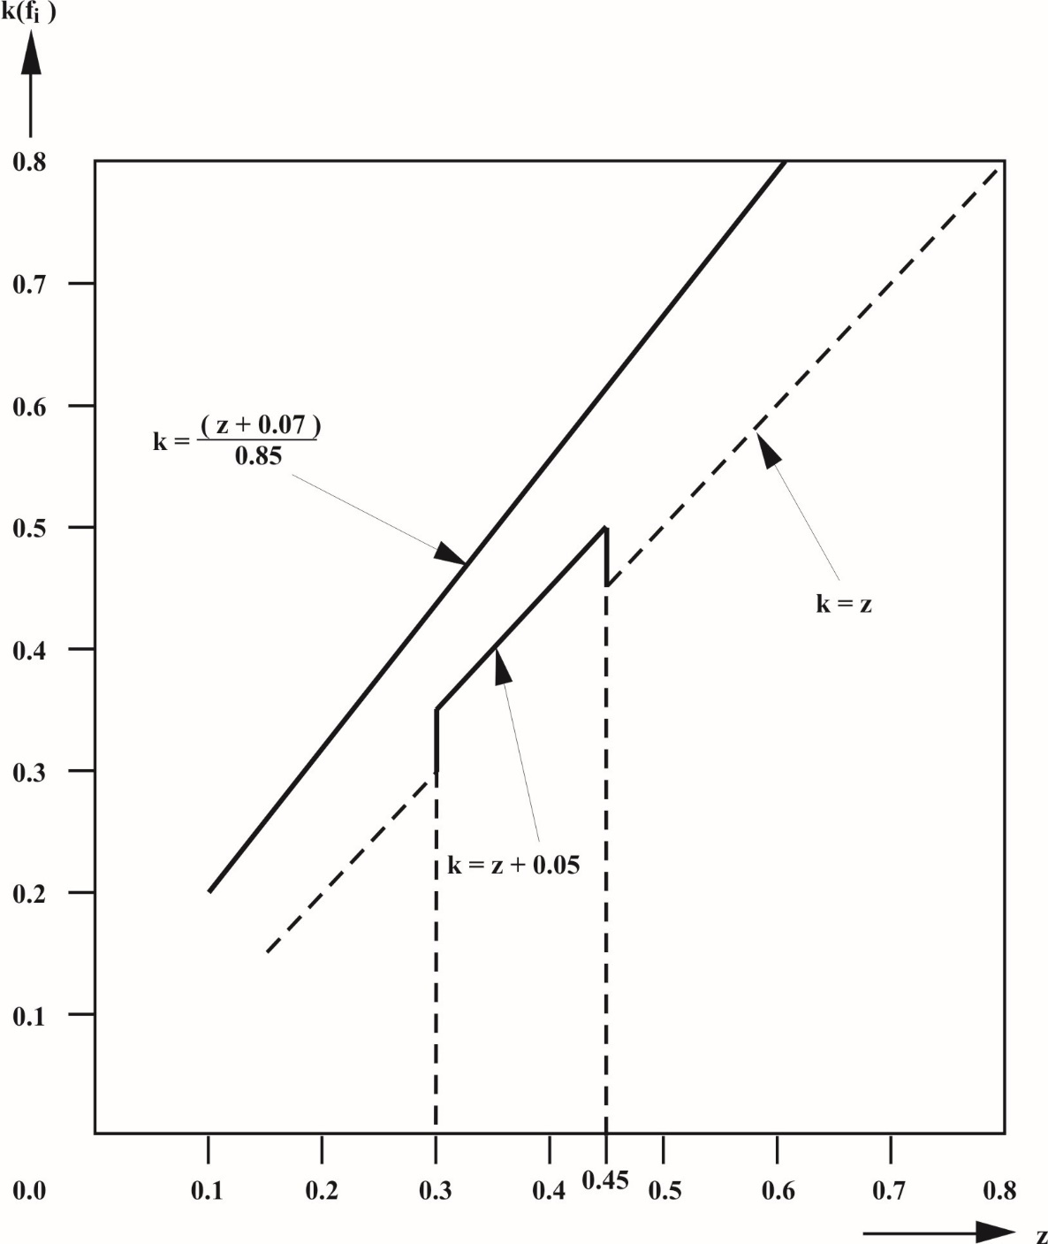

# Diagram 1B

# **Vehicles other than those of category N1 and full trailers**

(see paragraphs 3.1.2.3. and 5.1.1.2. of this annex)

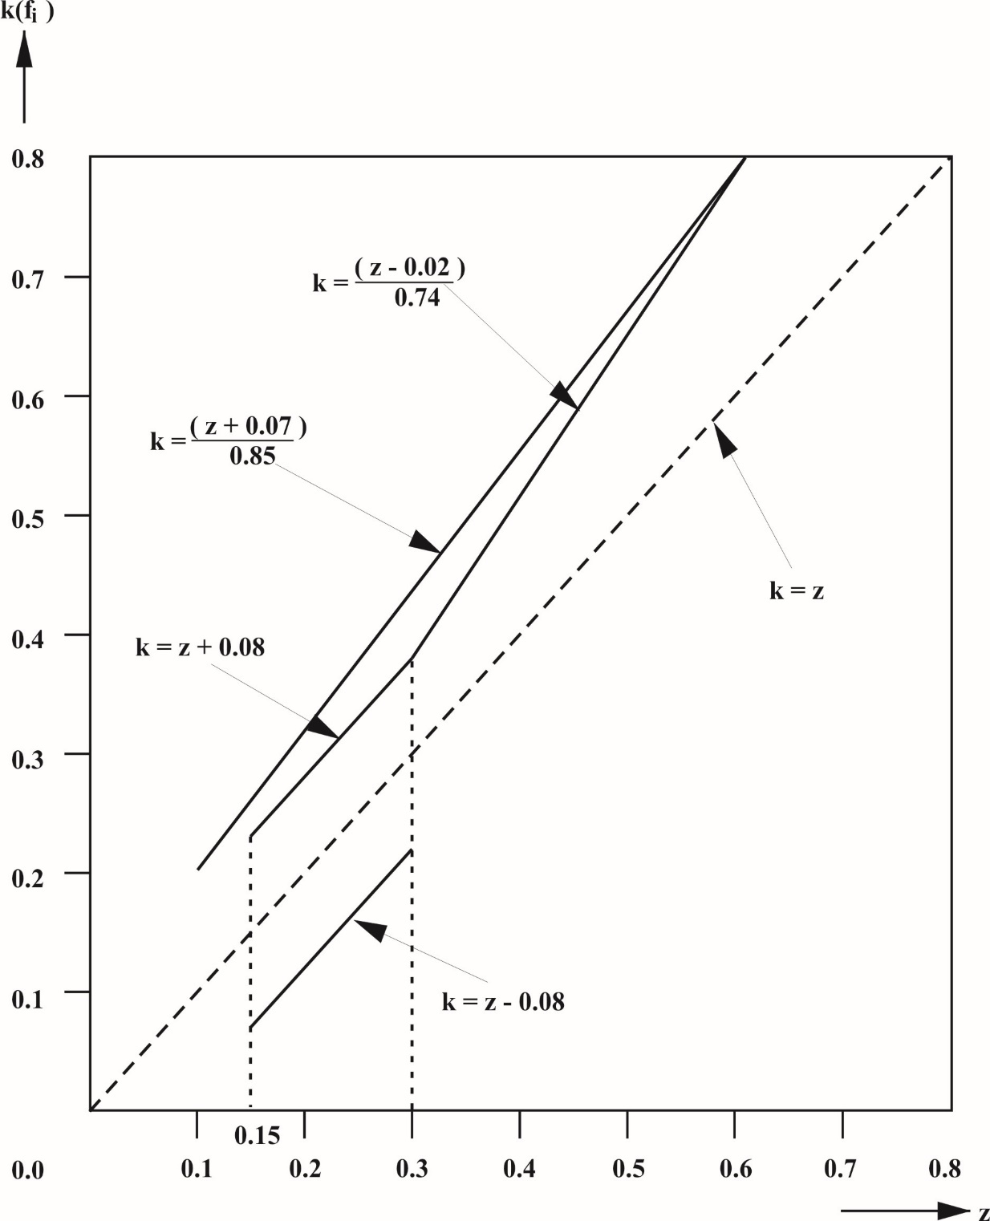

*Note*: The lower limit k = z - 0.08 is not applicable for the adhesion utilization of the rear axle.

# Diagram 1C

# **Vehicles of category N1**

(with certain exceptions after 1 October 1990)

(see paragraph 3.1.2.2. of this annex)

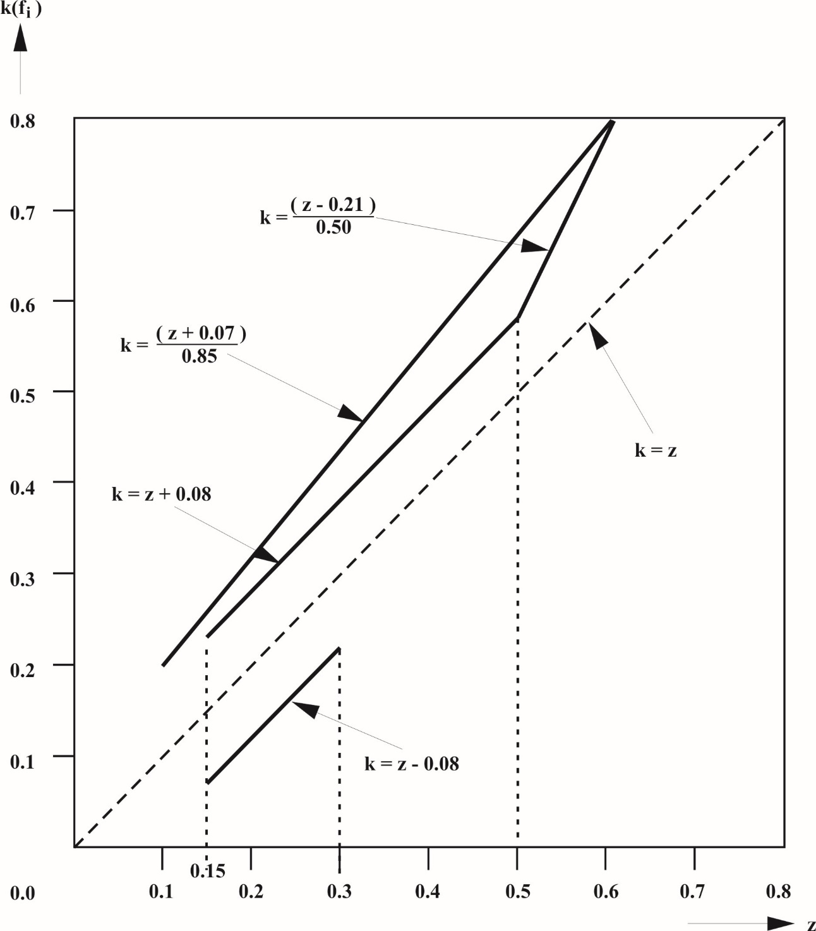

*Note*: The lower limit k = z - 0.08 is not applicable for the adhesion utilization of the rear axle.

# Diagram 2

# **Towing vehicles and trailers**

(except tractors for semi-trailers and semi-trailers)  
(see paragraph 3.1.5.1. of this annex)

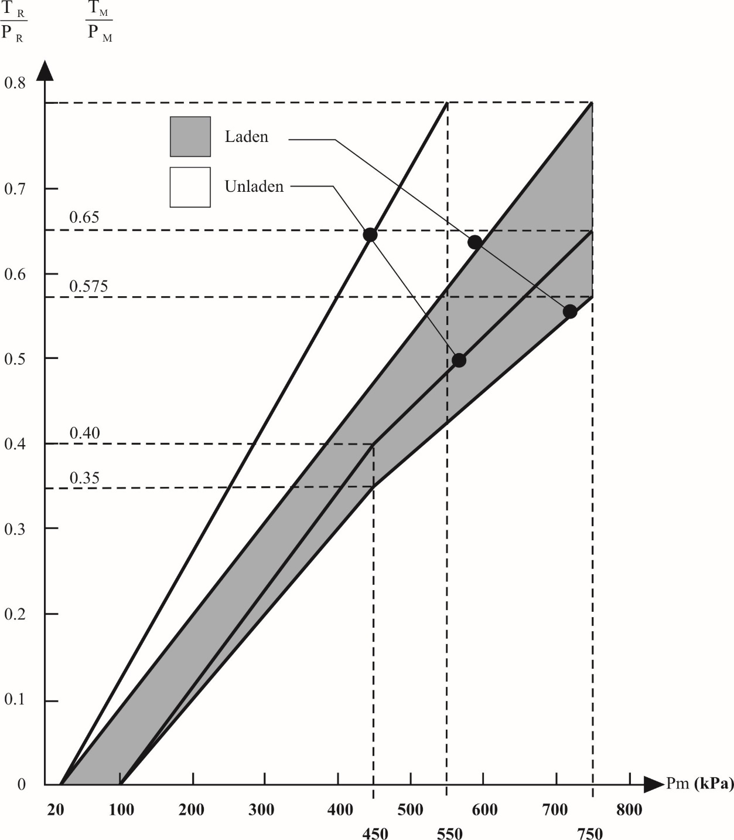

*Note*: The relationships required by the diagram shall apply progressively for intermediate states of loading between the laden and the unladen states and shall be achieved by automatic means.

# Diagram 3

# **Tractors for semi-trailers**

(see paragraph 3.1.6.3. of this annex)

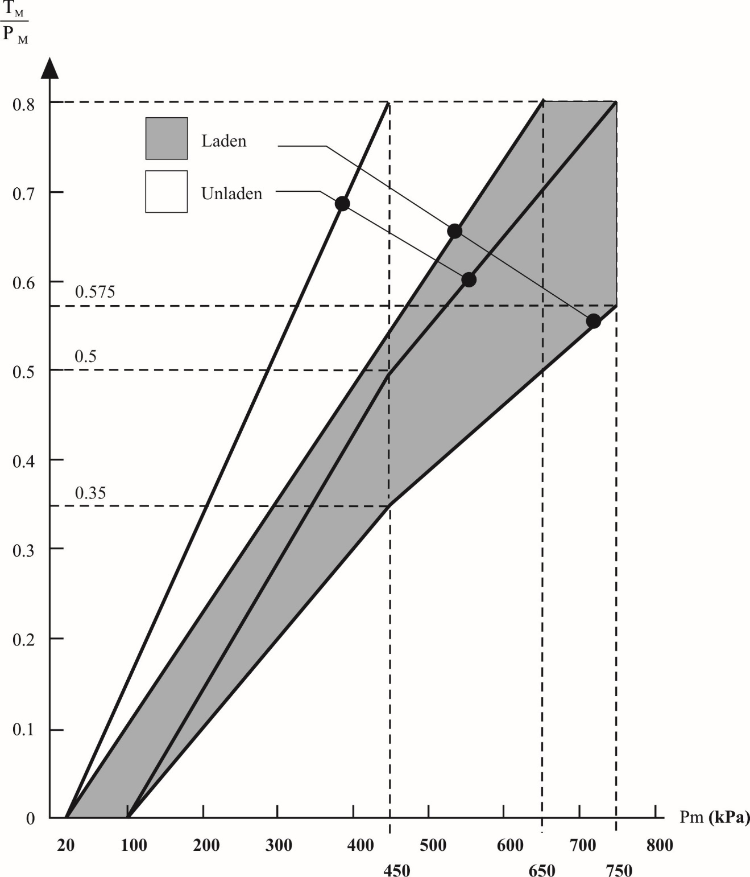

*Note*: The relationships required by the diagram shall apply progressively for intermediate states of loading between the laden and the unladen states and shall be achieved by automatic means.

# Diagram 4A

# **Semi-trailers**

(see paragraph 4. of this annex)

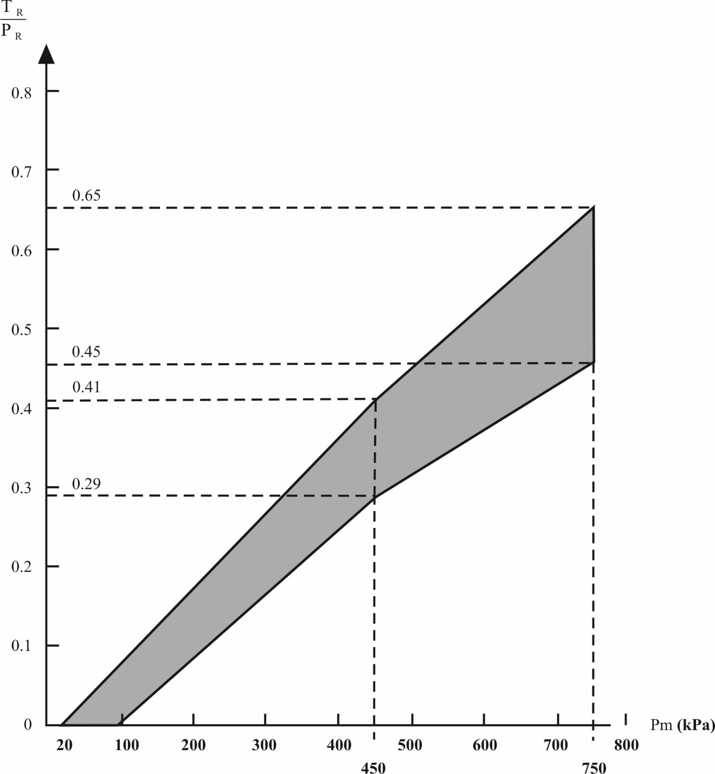

*Note*: The relation between the braking rate TR/PR and the control line pressure for the laden and unladen conditions is determined as follows:

The factors Kc (laden), Kv (unladen) are obtained by reference to diagram 4B. To determine the areas corresponding to the laden and unladen conditions, the values of the ordinates of the upper and lower limits of the hatched area in diagram 4A are multiplied by the factors Kc and Kv respectively.

# **Diagram 4B**

(See paragraph 4. and diagram 4A of this annex)



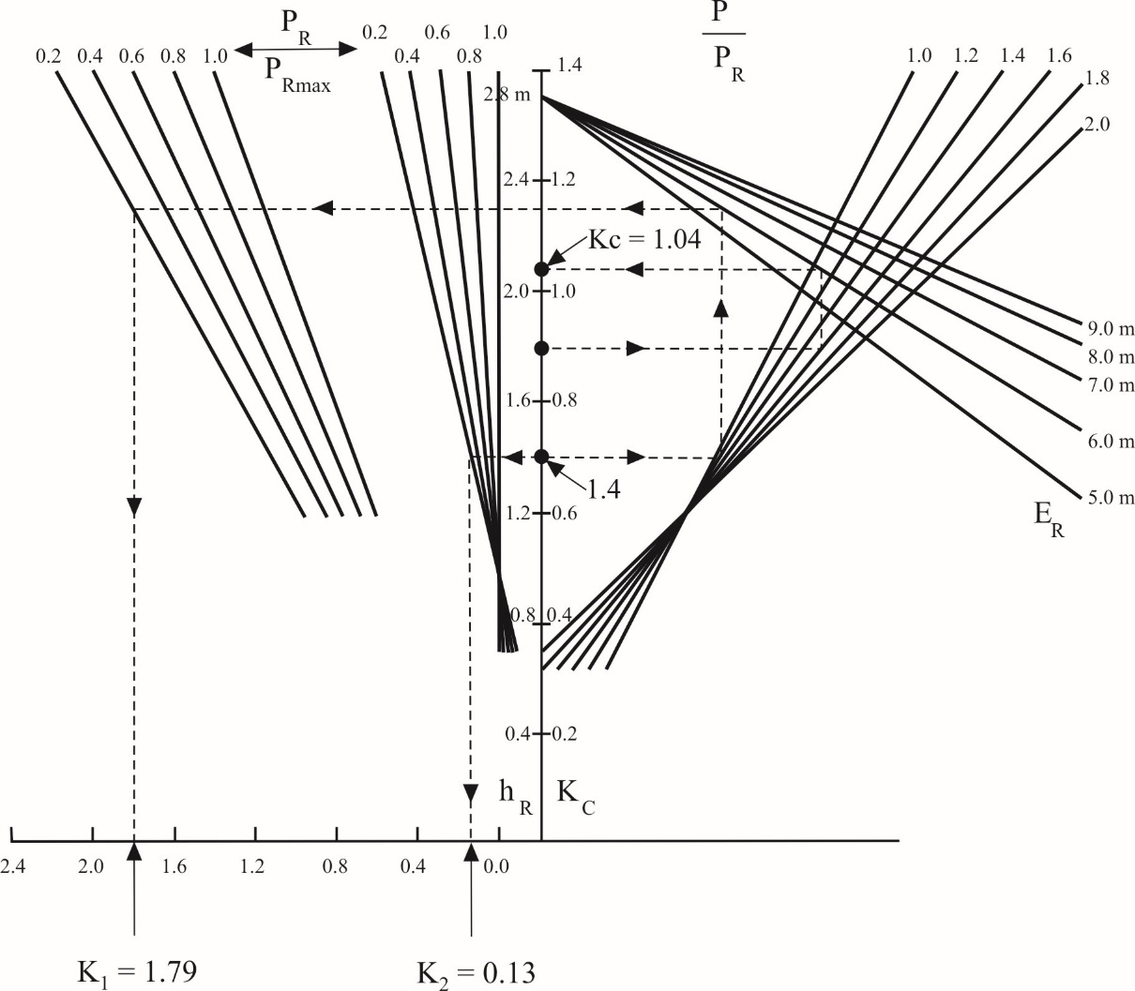

**Explanatory note on the use of diagram 4B**

1. Formula from which diagram 4B is derived:



2. Description of method of use with practical example

2.1. The broken lines shown on diagram 4B refer to the determination of the factors Kc and Kv for the following vehicle, where:

|  | *Laden* | *Unladen* |
| --- | --- | --- |
| P | 24 tonnes (240 kN) | 4.2 tonnes (42 kN) |
| PR | 150 kN | 30 kN |
| PRmax | 150 kN | 150 kN |
| hR | 1.8 m | 1.4 m |
| ER | 6.0 m | 6.0 m |

In the following paragraphs the figures in parentheses relate only to the vehicle being used for the purpose of illustrating the method of using diagram 4B.

2.2. Calculation of ratios

 

 

 

2.3. Determination of the correction factor when laden, KC:

(a) Start at the appropriate value of hR (hR = 1.8 m);

(b) Move horizontally to the appropriate g**.**P/PR line (g  **.**  P/PR = 1.6);

(c) Move vertically to the appropriate ER line (ER = 6.0 m);

(d) Move horizontally to the KC scale; KC is the laden correction factor required (KC = 1.04).

2.4. Determination of the correction factor when unladen, KV:

2.4.1. Determination of the factor K2:

(a) Start at appropriate hR (hR = 1.4 m);

(b) Move horizontally to the appropriate PR/PRmax line in the group of curves nearest to vertical axis (PR/PRmax = 0.2);

(c) Move vertically to the horizontal axis and read off the value of K2 (K2 = 0.13 m).

2.4.2. Determination of the factor K1:

(a) Start at the appropriate value of hR (hR = 1.4 m);

(b) Move horizontally to the appropriate g**.**P/PR line (g**.**P/PR = 1.4);

(c) Move vertically to the appropriate ER line (ER = 6.0 m);

(d) Move horizontally to the appropriate PR/PRmax line in the group of curves furthest from the vertical axis (PR/PRmax = 0.2);

(e) Move vertically to the horizontal axis and read off the value of K1 (K1 = 1.79).

2.4.3.

|  |  |  |  |  |
| --- | --- | --- | --- | --- |
| *Control data* | *Vehicle loading* | *Axle No. 2 load at the ground*  *[daN]* | *Inlet pressure [kPa]* | *Nominal outlet pressure*  *[kPa]* |
|  | Laden  Unladen | 10 000  1 500 | 600  600 | 600  240 |

Annex 18

Special requirements to be applied to the safety aspects of complex electronic vehicle control systems

3.4. Safety concept of the manufacturer

3.4.3. The manufacturer shall provide the technical authorities with an explanation of the design provisions built into "the system" so as to generate safe operation under fault conditions. Possible design provisions for failure in "the system" are for example:

(a) Fall-back to operation using a partial system;

(b) Change-over to a separate back-up system;

(c) Removal of the high level function.

In case of a failure, the driver shall be warned for example by warning signal or message display. When the system is not deactivated by the driver, e.g. by turning the ignition (run) switch to "off", or by switching off that particular function if a special switch is provided for that purpose, the warning shall be present as long as the fault condition persists.

3.4.4. The documentation shall be supported, by an analysis which shows, in overall terms, how the system will behave on the occurrence of any one of those specified faults which will have a bearing on vehicle control performance or safety.

This may be based on a Failure Mode and Effect Analysis (FMEA), a Fault Tree Analysis (FTA) or any similar process appropriate to system safety considerations.

The chosen analytical approach(es) shall be established and maintained by the manufacturer and shall be made open for inspection by the Technical Service at the time of the type approval.

3.4.4.1. This documentation shall itemize the parameters being monitored and shall set out, for each fault condition of the type defined in paragraph 3.4.4. above, the warning signal to be given to the driver and/or to service/technical inspection personnel.

4**.** Verification and test

4.1. The functional operation of "the system"**,** as laid out in the documents required in paragraph 3. above, shall be tested as follows:

4.1.1. Verification of the function of "the system"

As the means of establishing the normal operational levels, verification of the performance of the vehicle system under non-fault conditions shall be conducted against the manufacturer's basic benchmark specification unless this is subject to a specified performance test as part of the approval procedure of this or another Regulation.

4.1.2. Verification of the safety concept of paragraph3.4. above

The reaction of "the system" shall, at the discretion of the type approval authority, be checked under the influence of a failure in any individual unit by applying corresponding output signals to electrical units or mechanical elements in order to simulate the effects of internal faults within the unit.

4.1.2.1. The verification results shall correspond with the documented summary of the failure analysis, to a level of overall effect such that the safety concept and execution are confirmed as being adequate.

Annex 19

Performance testing of braking system components

Part 1 ‑ Performance testing of trailer braking components

1. General

1.1. Part 1 defines the test procedures applicable in defining the performance of the following:

1.1.1. Diaphragm brake chambers (refer to paragraph 2.).

1.1.2. Spring brakes (refer to paragraph 3.).

1.1.3. Trailer brakes - cold performance characteristics (refer to paragraph 4.).

1.1.4. Anti-lock braking systems (refer to paragraph 5.)

*Note*: Procedures for determining the fade test performance for trailer brakes and automatic brake wear adjustment devices are defined in Annex 11 to this Regulation.

1.1.5. Vehicle stability function (refer to paragraph 6.).

1.2. The above test reports may be used in conjunction with the procedures defined in Annex 20 to this Regulation or at the time of evaluating a trailer which is being subject to actual performance requirements defined for the respective trailer.

2. Performance characteristics for diaphragm brake chambers

2.1. General

2.1.1. This section defines the procedure by which the thrust/stroke/pressure characteristics are determined for diaphragm brake chambers which are used in compressed air braking systems[[6]](#footnote-7) to generate forces required in brakes with mechanical actuation.

For the purpose of this verification procedure, the service brake section of a combined spring brake actuator is considered to be a diaphragm brake chamber.

2.1.2. The verified performance characteristics declared by the manufacturer shall be used in all calculations relating to the brake compatibility requirements of Annex 10, the Type-0 cold service braking performance requirements of Annex 20 and the determination of the available actuator stroke with respect to the verification of the hot performance of Annex 11.

2.2. Test procedure

2.2.1. Zero datum position of the brake chamber is to be taken as the non-pressurized position.

2.2.2. In nominal pressure increments of≤ 100 kPa, through a pressure range of 100 to ≥ 800 kPa, the corresponding thrust generated is to be monitored over the full stroke range available for a stroke displacement rate of 10 mm/s or a stroke increment of ≤ 10 mm and whilst not permitting the applied pressure to deviate ±5 kPa.

2.2.3. For each pressure increment the corresponding average thrust (ThA) and the effective stroke (sp) will be determined as per Appendix 9 to this annex.

2.3. Verification

2.3.1. With reference to Appendix 1 to this annex, paragraphs 3.1., 3.2. and 3.3. and 3.4., a minimum of 6 samples are to be tested, with a verification report being issued, providing that the requirements of paragraphs 2.3.2., 2.3.3. and 2.3.4. below are satisfied.

2.3.2. With respect to the verification of average thrust (ThA) - f(p), a graph defining the acceptable performance variation shall be constructed following the model shown in diagram 1, which is based on the manufacturers declared thrust to pressure relationship. The manufacturer shall also define the category of trailer for which the brake chamber may be used and the corresponding tolerance band applied.

2.3.3 It shall be verified that the pressure (p15) required to produce a pushrod stroke of 15 mm from the zero datum position with a tolerance of ±10 kPa by following one of the following test procedures:

2.3.3.1 Utilizing the declared function of thrust (ThA) - f(p) the brake chamber threshold pressure (p15) shall be calculated when ThA = 0. It shall then be verified that when this threshold pressure is applied a pushrod stroke as defined in paragraph 2.3.3. above is produced.

2.3.3.2. The manufacturer shall declare the brake chamber threshold pressure (p15) and it shall be verified that when this pressure is applied the pushrod stroke defined in paragraph 2.3.3. above is produced.

2.3.4. With respect to the verification of effective stroke (sp) **-** f(p), the measured value shall not be less than **–**4 per cent of the sp characteristics at the manufacturer’s declared pressure range. This value shall be recorded and specified in paragraph 3.3.1. of Appendix 1 to this annex. Outside of this pressure range the tolerance may exceed –4 per cent.

# Diagram 1

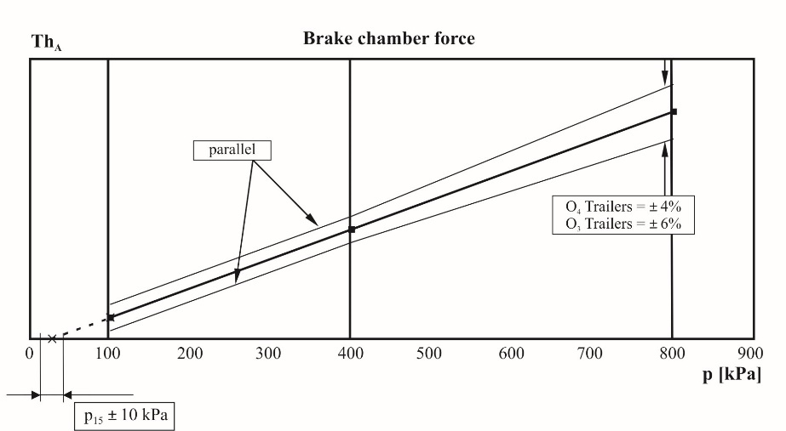

2.3.5. The test results recorded shall be reported on a form, a model of which is shown in Appendix 2 to this annex and shall be included with the verification report, detailed in paragraph 2.4. below.

2.4. Verification report

2.4.1. The manufacturer's declared performance characteristics, verified by the test results recorded in accordance with paragraph 2.3.2. above, shall be reported on a form, a model of which is shown in Appendix 1 to this annex.

3. Performance characteristics for spring brakes

3.1. General

3.1.1. This section defines the procedure by which the thrust/stroke/pressure characteristics are determined for spring brakes[[7]](#footnote-8)2 that are used in compressed air braking systems to generate forces required in brakes with mechanical actuation.

For the purpose of this verification procedure, the spring brake section of a combined spring brake actuator is considered to be a spring brake.

3.1.2. The performance characteristics declared by the manufacturer shall be used in all calculations relating to the parking braking performance requirements of Annex 20.

3.2. Test procedure

3.2.1. Zero datum position of the spring brake chamber is to be taken as the fully pressurized position.

3.2.2. In nominal stroke increments of ≤ 10 mm, the corresponding thrust generated is to be monitored over the full stroke range available at zero pressure.

3.2.3. The pressure shall then be gradually increased until the stroke is 10 mm from the zero datum position, and this pressure, defined as the release pressure, shall be recorded.

3.2.4. The pressure shall then be increased to 850 kPa, or the maximum working pressure declared by the manufacturer, whichever is lower.

3.3. Verification:

3.3.1. With reference to Appendix 3 to this annex, items 2.1., 3.1., 3.2. and 3.3., a minimum of 6 samples shall be tested, with a verification report being issued providing the following conditions are met:

3.3.1.1. Over a range of stroke from 10 mm to 2/3 of the maximum stroke, no one result, measured in accordance with paragraph 3.2.2. above, deviates by more than 6 per cent from the declared characteristics.

3.3.1.2. No one result, measured in accordance with paragraph 3.2.3. above, exceeds the declared value.

3.3.1.3. Each spring brake continues to function correctly after completion of the test in accordance with paragraph 3.2.4. above

3.3.2. The test results recorded shall be reported on a form, a model of which is shown in Appendix 4 to this annex, and shall be included with the verification report detailed within paragraph 3.4. below.

3.4. Verification report

3.4.1. The manufacturer's declared performance characteristics, verified by the test results recorded in accordance with paragraph 3.3.2. above, shall be reported on a form, a model of which is shown in Appendix 3 to this annex.

4. Cold performance characteristics for trailer brakes

4.1. General

4.1.1. This procedure covers the testing of the "cold" performance characteristics of air operated S cam and disc brakes[[8]](#footnote-9)3 fitted to trailers.

4.1.2. The performance characteristics declared by the manufacturer shall be used for all calculations relating to the braking compatibility requirements of Annex 10 and to the Type‑0 cold service braking and parking braking performance requirements of Annex 20.

4.2. Brake factor and brake threshold torque

4.2.1. The preparation of the brake shall be in accordance with paragraph 4.4.2. of this annex.

4.2.2. The brake factor is determined by using the following formula:



and shall be verified for each of the lining or pad materials specified in paragraph 4.3.1.3. below.

4.2.3. The brake threshold torque shall be expressed in a manner that remains valid for variations of brake actuation and is denoted by the symbol Co.

4.2.4. The values of BF shall remain valid for variations of the following parameters:

4.2.4.1. Mass per brake up to that defined in paragraph 4.3.1.5. below.

4.2.4.2. Dimensions and characteristics of external components used to actuate the brake.

4.2.4.3. Wheel size/tyre dimensions.

4.3. Information document

4.3.1. The brake manufacturer shall provide the Technical Service with at least the following information:

4.3.1.1 A description of the brake type, model, size etc.

4.3.1.2 Details of the brake geometry

4.3.1.3. The make and type of brake lining(s) or brake pad(s)

4.3.1.4. The brake drum or brake disc material

4.3.1.5. The maximum technically permitted mass for the brake

4.3.2. Additional information

4.3.2.1. Wheel and tyre sizes to be used for the test

4.3.2.2. The declared brake factor BF

4.3.2.3. The declared threshold torque C0,dec

4.4. Test procedure

4.4.1. Preparation

4.4.1.1. A graph defining the acceptable performance variation shall be constructed, following the model shown in diagram 2, using the manufacturers declared brake factor.

4.4.1.2. The performance of the device used to actuate the brake shall be calibrated within an accuracy of 1 per cent.

4.4.1.3. The dynamic tyre radius at the test loading shall be determined as prescribed for the test method.

4.4.2. Bedding in (burnishing) procedure

4.4.2.1. In the case of drum brakes the tests shall start with new brake linings and new drum(s), the brake linings shall be machined to achieve the best possible initial contact between the linings and drum(s).

4.4.2.2. In the case of disc brakes the tests shall start with new brake pads and new disc(s), machining of the pad material shall be at the discretion of the brake manufacturer.

4.4.2.3. Make 20 brake applications from an initial speed of 60 km/h with an input to the brake theoretically equal to 0.3 TR/Test Mass. The initial temperature at the lining/drum or pad/disc interface shall not exceed 100 °C before each brake application.

4.4.2.4. Carry out 30 brake applications from 60 km/h to 30 km/h with an input to the brake equal to 0.3 TR/Test Mass and with a time interval between applications of 60 s.[[9]](#footnote-10)4 The initial temperature at the lining/drum or pad/disc interface on the first brake application shall not exceed 100 °C.

4.4.2.5. On completion of the 30 brake applications defined in paragraph 4.4.2.4. above and after an interval of 120 s carry out 5 brake applications from 60 km/h to 30 km/h with an input to the brake equal to 0.3 TR/Test Mass and with an interval of 120 s between applications.4

4.4.2.6. Make 20 brake applications from an initial speed of 60 km/h with an input to the brake equal to 0.3 TR/Test mass. The initial temperature at the lining/drum or pad/disc interface shall not exceed 150 °C before each brake application.

4.4.2.7. Carry out a performance check as follows:

4.4.2.7.1. Calculate the input torque to produce theoretical performance values equivalent to 0.2, 0.35 and 0.5 + 0.05 TR/Test Mass.

4.4.2.7.2. Once the input torque value has been determined for each braking rate, this value shall remain constant throughout each and subsequent brake applications (e.g. constant pressure).

4.4.2.7.3. Make a brake application with each of the input torques determined in paragraph 4.4.2.7.1. above from an initial speed of 60 km/h. The initial temperature at the lining/drum or pad/disc interfaces shall not exceed 100 °C before each application.

4.4.2.8. Repeat the procedures defined in paragraphs 4.4.2.6. and 4.4.2.7.3. above, where paragraph 4.4.2.6. is optional, until the performance of five consecutive non monotonic measurements at the 0.5 TR/(Test Mass) constant input value has stabilized within a tolerance of minus 10 per cent of the maximum value.

4.4.2.9. If the manufacturer can demonstrate by field test results, that the brake factor after this bedding in state is different from the brake factor which has developed on the road, additional conditioning is permissible.

The maximum brake temperature, measured at the lining/drum or pad/disc interface, during this additional bedding in procedure shall not exceed 500 °C in the case of drum brakes and 700 °C in the case of disc brakes.

This field test shall be an endurance run with the same type and model of brake as that to be recorded in Annex 11, Appendix 3, test report. The results of at least 3 tests in accordance with paragraph 4.4.3.4. below conducted under the conditions of the laden Type-0 test, during the field test, shall be the basis for determining whether further conditioning is permissible. The brake tests shall be documented as prescribed in Appendix 8 to this annex.

The details of any additional conditioning shall be recorded and appended to the brake factor BF in paragraph 2.3.1. of Annex 11, Appendix 3, by specifying for instance the following test parameters:

(a) Brake actuator pressure, the brake input torque or the brake output torque of the brake application;

(b) Speed at the beginning and the end of the brake application;

(c) Time in the case of a constant speed;

(d) Temperature at the beginning and the end of the brake application or the duration of the brake cycle.

4.4.2.10. In the case of this procedure being carried out on an inertia dynamometer or rolling road, unlimited use of cooling air is permitted.

4.4.3. Verification test

4.4.3.1. The temperature measured at the lining/drum or pad/disc interface shall not exceed 100 °C, at the start of each brake application.

4.4.3.2. The brake threshold torque shall be determined from the measured value of brake input by reference to a calibrated input device.

4.4.3.3. The initial speed for all brake applications is 60 ± 2 km/h.

4.4.3.4. A minimum of six consecutive brake applications shall be made from 0.15 to 0.55 TR/(Test mass) at ascending increments of application pressure, followed by six brake applications made with the same application pressures in descending increments.

4.4.3.5. For each of the brake applications in paragraph 4.4.3.4. above the braking rate is calculated, corrected to take account of rolling resistance, and plotted on the graph specified in paragraph 4.4.1.1. of this annex.

4.5. Test methods

4.5.1. Track test

4.5.1.1. The brake performance test shall be carried out on a single axle only.

4.5.1.2. The tests shall be carried out on a straight level track, with a surface affording good adhesion, and performed when there is no wind liable to affect the results.

4.5.1.3. The trailer shall be loaded (as closely as possible) to the maximum technically permitted mass for each brake, however, additional mass may be added if required to ensure that sufficient mass is over the axle under test to achieve a braking rate of 0.55 TR/(maximum technically permitted mass per brake) without wheel lock.

4.5.1.4. The dynamic rolling radius of the tyre may be verified at low speed, < 10 km/h, by measuring the distance travelled as a function wheel revolutions, the minimum number of revolutions required to determine the dynamic rolling radius is 10.

4.5.1.5. The rolling resistance of the vehicle combination is to be determined by measuring the time taken for the vehicle speed to reduce from 55 to 45 km/h and the distance covered, when tested in the same direction in which the verification test will be carried out and with the engine disconnected and any endurance brake system disengaged.

4.5.1.6. Only the brakes of the axle under test shall be actuated and reach an input pressure at the brake input device of 90 ± 3 per cent (after maximum build up time of 0.7 s) of its asymptotic value. The test shall be carried out with the engine disconnected and any endurance braking system disengaged.

4.5.1.7. The brakes shall be closely adjusted at the start of the test.

4.5.1.8. The brake input for the purpose of calculating the brake threshold torque shall be determined by lifting the wheel and gradually applying the brake whilst the wheel is rotated by hand until resistance is detected.

4.5.1.9. The final speed v2 shall be determined in accordance with Annex 11, Appendix 2, paragraph 3.1.5.

4.5.1.10. The braking performance of the axle under test shall be determined by calculating the deceleration determined from a direct measurement of velocity and distance between 0.8 v1 and v2, where v2 shall not be less than 0.1 v1. This shall be deemed to be equivalent to the mean fully developed deceleration (MFDD) as defined in Annex 4 to this Regulation.

4.5.2. Inertia dynamometer test

4.5.2.1. The test shall be carried out on a single brake assembly.

4.5.2.2. The test machine shall be capable of generating the inertia required by paragraph 4.5.2.5. of this annex.

4.5.2.3. The test machine shall be calibrated for speed and brake output torque within an accuracy of 2 per cent.

4.5.2.4. The instrumentation for the test shall be capable of providing at least the following data:

4.5.2.4.1. A continuous recording of brake application pressure or force.

4.5.2.4.2. A continuous recording of brake output torque.

4.5.2.4.3. A continuous recording of the temperature measured at the lining/drum or pad/disc interface.

4.5.2.4.4. Speed during the test.

4.5.2.5. The inertia (IT) of the dynamometer shall be set as close as possible, with ±5 per cent tolerance, including the internal friction of the dynamometer, to that part of the linear inertia of the vehicle acting upon one wheel necessary for a performance of 0.55 TR/(maximum technically permitted mass) according to the following formula:

IT = Pd⋅R2

|  |  |  |
| --- | --- | --- |
| Where: | | |
| IT | = | actual rotary inertia (kgm2), |
| R | = | tyre rolling radius defined by the formula 0.485 D, |
| D | = | d + 2H[[10]](#footnote-11)5 |
| d | = | rim diameter conventional number (mm), |
| H | = | nominal section height (mm) = S1 x 0.01 Ra, |
| S1 | = | section width (mm), |
| Ra | = | nominal aspect ratio, |
| Pd | = | maximum technically permitted mass/brake as defined in paragraph 4.3.1.5. above |

4.5.2.6. Cooling air at ambient temperature may be used, flowing at a velocity not exceeding 0.33 v over the brake in a direction perpendicular to its axis of rotation.

4.5.2.7. The brake shall be closely adjusted at the start of the test.

4.5.2.8. The brake input for the purpose of calculating the brake threshold torque shall be determined by gradually applying the brake until the onset of brake torque generation is observed.

4.5.2.9. The brake performance shall be determined by applying the following formula to the measured brake output torque.



|  |  |  |
| --- | --- | --- |
| Where: | | |
| Mt | = | average brake output torque (Nm) - based on distance, |
| g | = | deceleration due to gravity (m/s2). |

The average brake output torque (Mt) shall be calculated from the deceleration determined from a direct measurement of velocity and distance between 0.8 v1 and 0.1 v1. This shall be deemed to be equivalent to the mean fully developed deceleration (MFDD) as defined in Annex 4 to this Regulation.

4.5.3. Rolling road test

4.5.3.1. The test will be carried out on single axle with one or two brakes.

4.5.3.2. The test machine shall have a calibrated means of imposing load to simulate the required mass for the brake(s) to be tested.

4.5.3.3. The test machine shall be calibrated for speed and brake torque within an accuracy of 2 per cent taking into account the internal friction characteristics. The dynamic rolling radius of the tyre (R) shall be determined by measuring the rotational speed of the rolling road and the unbraked wheels of the axle under test at a speed equivalent to 60 km/h, and calculated by the formula



|  |  |  |
| --- | --- | --- |
| Where: | | |
| RR | = | radius of the rolling road |
| nD | = | rolling road (rotational) speed |
| nw | = | rotational speed of the unbraked wheels of the axle |

4.5.3.4. Cooling air at ambient temperature may be used, flowing at a velocity not exceeding 0.33 v over the brake(s).

4.5.3.5. The brake(s) shall be closely adjusted at the start of the test.

4.5.3.6. The brake input for the purpose of calculating the brake threshold torque shall be determined by gradually applying brake(s) until the onset of brake torque generation is observed.

4.5.3.7. The brake performance shall be determined by measuring the brake force at the periphery of the tyre calculated to braking rate, taking into account the rolling resistance. The rolling resistance of the loaded axle will be determined by measuring the force at the periphery of the tyre at a speed of 60 km/h.

The average brake output torque (Mt) shall be based on the measured values between the moment the application pressure/force reaches its asymptotic value from the onset of pressure rise at the brake input device and when the energy input has reached the value W60 that is defined in paragraph 4.5.3.8. below.

4.5.3.8. For determining the braking rate an energy input W60 equivalent to the kinetic energy of the corresponding mass for the brake under test when braked from 60 km/h to standstill, shall be taken into account.

Where:



4.5.3.8.1. If the test speed v cannot be maintained at 60 ± 2 km/h during the measurement of the braking rate according to paragraph 4.5.3.8. above, the braking rate shall be determined from the direct measurement of brake force FB and/or brake output torque Mt , so that the measurement of this/these parameter(s) are not affected by the dynamic forces of the inertia mass of the rolling road test machine.

4.6. Verification report

4.6.1. The manufacturer's declared performance characteristics, verified by the test results recorded in accordance with paragraph 4.4.3. above, shall be reported on a form, a model of which is shown in Appendix 3 to Annex 11.

Diagram 2

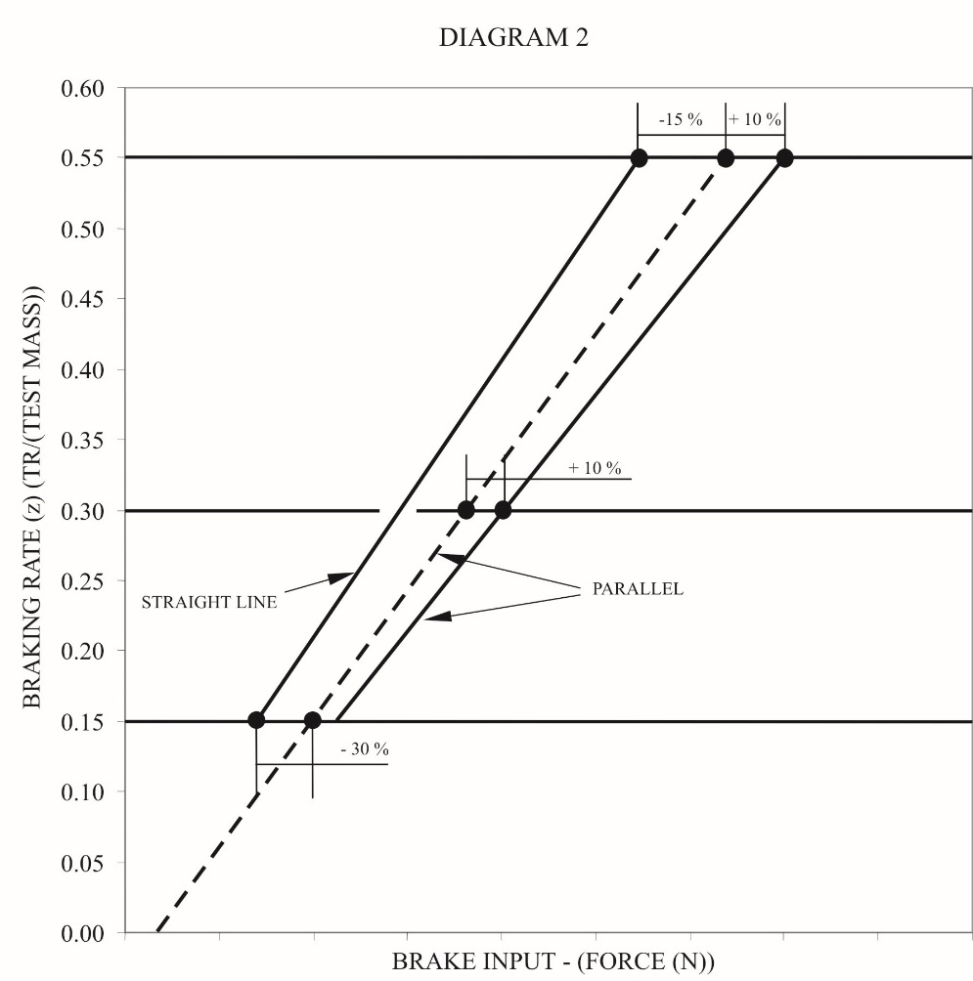

5. Anti-lock braking systems (ABS)

5.1. General

5.1.1. This paragraph defines the procedure to determine the performance of a trailer anti-lock braking system.

5.1.2. Tests carried out on trailers of category O4 will be deemed to cover the requirements for trailers of O3 category.

5.2. Information document

5.2.1. The manufacturer of the ABS shall supply to the Technical Service an information document of the system(s) requiring performance verification. This document shall contain at least the information defined in Appendix 5 to this annex.

5.3. Definition of test vehicles

5.3.1. Based on the information supplied in the information document, in particular the trailer applications defined in paragraph 2.1. of Appendix 5, the Technical Service shall carry out tests on representative trailers having up to three axles and equipped with the respective anti-lock braking system/configuration. Additionally, when selecting trailers for evaluation consideration shall also be given to the parameters defined in the following paragraphs.

5.3.1.1. Suspension type: the method of evaluating the performance of the anti-lock braking system relative to the suspension type will be selected in the following way:

Semi-trailers: for each suspension group e.g. balanced mechanical etc. a representative trailer shall be evaluated.

Full trailers: Evaluation to be carried out on a representative trailer equipped with any one suspension type.

5.3.1.2. Wheelbase: for semi-trailers the wheelbase shall not be a limiting factor, but for full trailers the shortest wheelbase shall be evaluated.

5.3.1.3. Brake type: approval shall be limited to S cam or disc brakes but should other types become available then comparative testing may be required.

5.3.1.4. Load sensing device: The utilization of adhesion shall be determined with the load sensing valve set to laden and unladen conditions. In all cases the requirements of paragraph 2.7. of Annex 13 to this Regulation shall apply.

5.3.1.5. Brake actuation: differentials in the level of actuation shall be recorded for evaluation during the tests to determine the utilization of adhesion. Results obtained from tests for one trailer may be applied to other trailers of the same type.

5.3.2. For each type of trailer under test, documentation showing brake compatibility as defined in Annex 10 to this Regulation (diagrams 2 and 4) shall be made available to demonstrate conformity.

5.3.3. For the purpose of the approval, semi-trailers and centre axle trailers shall be deemed to be of the same vehicle type.

5.4. Test schedule

5.4.1. The following tests shall be conducted by the Technical Service on the vehicle(s) defined in paragraph 5.3. of this annex for each ABS configuration taking into consideration the application list defined in paragraph 2.1. of Appendix 5 to this annex. However, worst case cross referencing may eliminate certain tests. If worst case testing is actually used, this should be stated in the test report.

5.4.1.1. Utilization of adhesion - Tests shall be carried out according to the procedure defined in paragraph 6.2. of Annex 13 to this Regulation for each ABS configuration and trailer type, as defined in the manufacturer's information document (see paragraph 2.1. of Appendix 5 to this annex).

5.4.1.2. Energy consumption

5.4.1.2.1. Axle loading – the trailer(s) to be tested shall be loaded so that the axle load is 2500 kg +/- 200 kg or 35 per cent +/- 200 kg of the permissible static axle load whichever is the lower.

5.4.1.2.2. It shall be ensured that "full cycling" of the anti-lock braking system can be achieved throughout the dynamic tests defined in paragraph 6.1.3. of Annex 13 to this Regulation.

5.4.1.2.3. Energy consumption test - The test shall be carried out according to the procedure defined in paragraph 6.1. of Annex 13 to this Regulation for each ABS configuration.

5.4.1.2.4. To enable trailers submitted for approval to be checked for conformity to the anti-lock energy consumption requirements (see paragraph 6.1. of Annex 13), the following checks shall be carried out:

5.4.1.2.4.1. Prior to the commencement of the energy consumption test (paragraph 5.4.1.2.3. above) in the case of brakes with non-integrated brake wear adjustment the brakes shall be set to a condition where the relationship (Rl) of brake chamber push rod travel (sT) against lever length (lT) is 0.2. This relationship shall be determined for a brake chamber pressure of 650 kPa.

Example:

|  |  |  |
| --- | --- | --- |
| lT | = | 130 mm, |
| sT at 650 kPa brake chamber pressure | = | 26 mm |
| Rl = sT / lT = 26/130 | = | 0.2 |

In the case of brakes with integrated automatic brake wear adjustment the brakes shall be set to the normal running clearance specified by the manufacturer.

Setting of the brakes as defined above shall be carried out when the brakes are cold (< 100 °C).

5.4.1.2.4.2. With the load sensing valve set to the laden condition and the initial energy level set according to paragraph 6.1.2. of Annex 13 to this Regulation, the energy storage device(s) shall be isolated from further supply of air. The brakes shall be applied with a control pressure of 650 kPa at the coupling head and then released. Further applications shall be made until the pressure in the brake chambers is the same as that obtained after completing the tests defined in paragraphs 6.1.3. and 6.1.4. of Annex 13 to this Regulation. The number of equivalent brake applications (ner) shall be noted.

The equivalent number of static brake applications (ne) is to be recorded in the test report.

Where ne = 1.2 . ner and is to be rounded up to the nearest whole integer.

5.4.1.3. Split Friction Test - Where an anti-lock braking system is to be defined as category A system then all such ABS configurations shall be subject to the performance requirements of paragraph 6.3.2. of Annex 13 to this Regulation.

5.4.1.4. Low and high speed performance

5.4.1.4.1. With the trailer set as for utilization of adhesion evaluation, verification of the low and high speed performance shall be carried out according to paragraph 6.3.1. of Annex 13 to this Regulation.

5.4.1.4.2. Where a tolerance exists between the number of exciter teeth and tyre circumference, functional checks shall be carried out at the extremes of tolerance in accordance with paragraph 6.3. of Annex 13 to this Regulation. This may be achieved by utilizing different tyre sizes or by producing special exciters to simulate frequency extremes.

5.4.1.5. Additional checks

The following additional checks shall be carried out with the towing vehicle unbraked and the trailer unladen.

5.4.1.5.1. When the axle or axle group passes from a high adhesion surface (kH) to a low adhesion surface (kL) where kH ≥ 0.5 and kH / kL ≥ 2, with a control pressure at the coupling head of 650 kPa, the directly controlled wheels shall not lock. The running speed and the instant of applying the trailer brakes is so calculated that with the anti-lock braking system full cycling on the high adhesion surface, the passage from one surface to the other being made at approximately 80 km/h and at 40 km/h.

5.4.1.5.2. When the trailer passes from a low adhesion surface (kL) to a high adhesion surface (kH) where kH ≥ 0.5 and kH / kL ≥ 2, with a control pressure at the coupling head of 650 kPa, the pressure at the brake chambers shall rise to an appropriate high value within a reasonable time and the trailer shall not deviate from its initial course. The running speed and the instant of applying the brakes is so calculated that, with the anti-lock braking system full cycling on the low adhesion surface, the passage from one surface to the other occurs at approximately 50 km/h.

5.4.1.6. Documentation relating to the controller(s) shall be made available as required by paragraph 5.1.5 of the Regulation and paragraph 4.1. of Annex 13 to this Regulation, including its footnote 12.

5.5. Approval report

5.5.1. An approval report shall be produced, the content of which is defined in Appendix 6 to this annex.

6. Vehicle stability function

6.1. General

6.1.1. This section defines a test procedure to determine the dynamic characteristics of a vehicle equipped with a vehicle stability function consisting of at least one of the following functions:

(a) Directional control;

(b) Roll-over control.

6.2. Information document

6.2.1. The system/vehicle manufacturer shall supply to the Technical Service an information document of the control function(s) for which performance verification is required. This document shall contain at least the information defined in Appendix 7 to this annex.

6.3. Definition of test vehicle(s)

6.3.1. Based on the stability control function(s) and their application(s) defined in the manufacturer's information document the Technical Service shall carry out a performance verification. This may include one or more dynamic manoeuvres as defined in paragraph 2.2.3. of Annex 21 to this Regulation on a trailer(s) having up to three axles which is representative of the application(s) defined in paragraph 2.1. of the manufacturers information document.

6.3.1.1. When selecting the trailer(s) for evaluation, consideration shall also be given to the following:

(a) Suspension type: for each suspension group, e.g. balanced pneumatic, a trailer of that specification shall be evaluated;

(b) Wheel base: wheel base shall not be a limiting factor;

(c) Brake type: approval shall be limited to trailers with S-cam or disc brakes but should other types become available, then comparative testing may be required;

(d) Braking system: the braking system of the trailer(s) to be evaluated shall comply with all of the relevant requirements of this Regulation.

6.4. Test schedule

6.4.1. To evaluate the vehicle stability control function the tests used shall be agreed between the system/vehicle manufacturer and the Technical Service and shall include conditions, appropriate to the function being evaluated, that would without the intervention of the stability control function result in loss of directional control or roll-over. The dynamic manoeuvres, test conditions and results shall be included in the test report.

6.5. Towing vehicle

6.5.1. The towing vehicle used for evaluating the performance of the vehicle (trailer) stability function shall have the necessary pneumatic and electrical connections and if the towing vehicle is equipped with a vehicle stability function as defined in paragraph 2.34. of this Regulation that function shall be disabled.

6.6. Test report

6.6.1. A test report shall be produced, the content of which shall be at least that defined in Appendix 8 to this annex.

Part 2 ‑ Performance testing of motor vehicle braking components

1. General

Part 2 defines the procedures applicable in defining the performance of the following:

1.1. A vehicle stability function.

1.1.1. General

1.1.1.1. This section defines the procedure of determining the dynamic characteristics of a vehicle equipped with a vehicle stability function as specified in paragraph 5.2.1.32. of this Regulation.

1.1.2. Information document

1.1.2.1. The system manufacturer shall supply the Technical Service with an information document on the vehicle stability control function(s) for which performance verification is required. This document shall contain at least the information defined in Appendix 11 to this annex and shall be attached as an appendix to the test report.

1.1.3. Definition of test vehicle(s)

1.1.3.1. Based on the stability control function(s) and their application(s) defined in the system manufacturer's information document, the Technical Service shall carry out a vehicle based performance verification. This shall include one or more dynamic manoeuvres as defined in paragraph 2.1.3. of Annex 21 to this Regulation on a motor vehicle(s) which is representative of the application(s) defined in paragraph 2.1. of the system manufacturer information document.

1.1.3.2. When selecting the motor vehicles(s) for evaluation, consideration shall also be given to the following:

(a) Braking system: the braking system of the test vehicle(s) to be evaluated shall comply with all of the relevant requirements of this Regulation;

(b) Vehicle category – M2, M3, N2, N3;

(c) Character of the vehicle;

(d) Vehicle configuration(s) (e.g. 4x2, 6x2, etc.): each configuration to be evaluated;

(e) Drive orientation (left or right hand drive): not a limiting factor – evaluation not required;

(f) Single front axle steering: not a limiting factor – evaluation not required (see subparagraphs (g) and (h));

(g) Additional steering axles (e.g. forced steering, self-steering): to be evaluated;

(h) Steering ratio: to be evaluated – end-of-line programming or self-learning systems not a limiting factor;

(i) Drive axles: to be taken into consideration with regard to the use (loss) of wheel speed sensing in the determination of vehicle speed;

(j) Lift axles: lift axle detection / control and lifted condition to be evaluated;

(k) Engine management: communication compatibility to be evaluated;

(l) Gearbox type (e.g. manual, automated manual, semi-automatic, automatic): to be evaluated;

(m) Drive train options (e.g. retarder): to be evaluated;

(n) Differential type (e.g. standard or self-locking): to be evaluated;

(o) Differential lock(s) (driver selected): to be evaluated;

(p) Brake system type (e.g. air over hydraulic, full air): to be evaluated;

(q) Brake type (disc, drum (single wedge, twin wedge, S-cam)): not a limiting factor, however, should other types become available, then comparative testing may be required;

(r) Anti-lock braking configurations: to be evaluated;

(s) Wheelbase: to be evaluated

In the case where vehicles conforming to the minimum and maximum wheelbases as specified in the information document are not available at the time of testing, minimum and maximum wheelbase verification may be carried-out using system manufacturer test data for real vehicles with a wheelbase within 20 per cent of the actual minimum and maximum wheelbase vehicles being tested by the Technical Service;

(t) Wheel type (single or twin): to be covered in the system manufacturer's information document;

(u) Tyre type (e.g. structure, category of use, size): to be covered in the system manufacturer's information document;

(v) Track width: not a limiting factor – covered by variations in the centre of gravity evaluation;

(w) Suspension type (e.g. air, mechanical, rubber): to be evaluated;

(x) Centre of gravity height: to be evaluated

In the case where vehicles conforming to the maximum centre of gravity height as specified in the information document are not available at the time of testing, maximum centre of gravity height verification may be carried-out utilising system manufacturer's test data for real vehicles with a centre of gravity height within +20 per cent of the actual maximum centre of gravity height of the vehicles being tested by the Technical Service;

(y) Lateral acceleration sensor position: installation envelop as specified by the system manufacturer to be evaluated;

(z) Yaw rate sensor position: installation envelop as specified by the system manufacturer to be evaluated.

1.1.4. Test schedule

1.1.4.1.4. Engine management:

Control of the engine, or any other source(s) of motive power, to be shown to be independent from driver demand.

1.1.4.1.6. Differential type/differential lock(s):

Effect of self-locking or driver selected locking to be shown, e.g. function maintained, reduced or switched-off.

Annex 20

Alternative procedure for the type approval of trailers

9.1.8. Vehicle stability function

9.1.8.1. For practical reasons verification of the vehicle stability function shall be limited to an installation check as defined in paragraph 8.2. above and observation of the correct warning signal sequence to ensure no faults are present.

9.1.9. Additional checks

9.1.9.1. The Technical Service may request additional checks to be carried out, if necessary.

Annex 21

Proposal for ESC from OICA/CLEPA not finalized yet

Special requirements for vehicles equipped with a vehicle stability function

2. Requirements

2.1. Power-driven vehicles

2.1.1. Where a vehicle is equipped with a vehicle stability function as defined in paragraph 2.4. of this Regulation, the following shall apply:

In the case of directional control the function shall have the ability to automatically control individually the speed of the left and right wheels on each axle or an axle of each axle group by selective braking based on the evaluation of actual vehicle behaviour in comparison with a determination of vehicle behaviour demanded by the driver.[[11]](#footnote-12)

In the case of roll-over control the function shall have the ability to automatically control the wheel speeds on at least two wheels of each axle or axle group by selective braking or automatically commanded braking based on the evaluation of actual vehicle behaviour that may lead to vehicle roll-over.1

In both cases, the function is not required:

(a) When the vehicle speed is below 20 km/h;

(b) Until the initial start-up self-test and plausibility checks have been completed;

(c) When the vehicle is being driven in reverse;

(d) When it has been automatically or manually disabled. In this case, the following conditions shall apply as appropriate:

i) When a vehicle is equipped with a means to automatically disable the vehicle stability function to provide increased traction by modifying the functionality of the drive train, the disablement and its re-instatement shall be automatically linked to the operation which changes the functionality of the drive train;

ii) When a vehicle is equipped with a means to manually disable the vehicle stability function, the vehicle stability function shall be automatically reinstated at the initiation of each new ignition cycle;

iii) A constant optical warning signal shall inform the driver that the vehicle stability function has been disabled. The yellow warning signal specified in paragraph 2.1.5. below may be used for this purpose. The warning signals specified in paragraph 5.2.1.29. of this Regulation shall not be used.

2.1.2. To realise the functionality defined above a vehicle stability function shall include, in addition to selective braking and/or automatically commanded braking, at least the following:

(a) The ability to control engine power output;

(b) In the case of directional control: The determination of actual vehicle behaviour from values of yaw rate, lateral acceleration, wheel speeds, and from the driver's control inputs to the braking and steering systems and to the engine. Only on-board generated information shall be used. If these values are not directly measured, the evidence of the appropriate correlation with directly measured values under all driving conditions (e.g. including driving in a tunnel) shall be shown to the Technical Service at the time of type approval;

(c) In the case of roll-over control: The determination of actual vehicle behaviour from values of the vertical force on the tyre(s) (or at least lateral acceleration and wheel speeds) and from the driver's control inputs to the braking system and to the engine. Only on-board generated information shall be used. If these values are not directly measured, the evidence of the appropriate correlation with directly measured values under all driving conditions (e.g. including driving in a tunnel) shall be shown to the Technical Service at the time of type approval;

(d) In the case of a towing vehicle equipped according to paragraph 5.1.3.1. of this Regulation: The ability to apply the service brakes of the trailer via the respective control line(s) independently of the driver.

2.1.4. Interventions of the vehicle stability function shall be indicated to the driver by a flashing optical warning signal fulfilling the relevant technical requirements of Regulation No. 121. The indication shall be present as long as the vehicle stability function is in an intervention mode. The warning signal specified in paragraph 5.2.1.29.1.2. of this Regulation shall not be used for this purpose.

Additionally, interventions by systems related to the vehicle stability function (including traction control, trailer stability assist, corner brake control, other similar functions that use throttle individual torque control to operate and share common components with vehicle stability function, and ESC or VSF intervention on the steering angle of one or more wheels for the purpose of vehicle stability) may also be indicated to the driver by this flashing optical warning signal.

Interventions of the vehicle stability function used in any learning process to determine the vehicle operational characteristics shall not generate the above signal.

2.1.5. A vehicle stability function failure or defect shall be detected and indicated to the driver by an optical warning signal fulfilling the relevant technical requirements of Regulation No. 121.

The warning signal specified in paragraph 5.2.1.29.1.2. of this Regulation shall not be used for this purpose.

The warning signal shall be constant and remain displayed as long as the failure or defect persists and the ignition (start) switch is in the "on" (run) position.

2.1.6. In the case of a power-driven vehicle equipped with an electric control line and electrically connected to a trailer with an electric control line the driver shall be warned by a specific optical warning signal fulfilling the relevant technical requirements of Regulation No. 121 whenever the trailer provides the information "VDC Active" via the data communications part of the electric control line. The optical signal defined in paragraph 2.1.4. above may be used for this purpose.

Annex 21 - Appendix 2

Dynamic stability simulation tool and its validation

2. Validation of the simulation tool

2.1. The validity of the applied modelling and simulation tool shall be verified by means of comparisons with a practical vehicle test(s). The test(s) utilised for the validation shall be those which, without control action, would result in loss of directional control (under-steer and over-steer) and/or roll-over control as appropriate to the functionality of the stability control function installed on a vehicle.

During the test(s) the following motion variables, as appropriate, shall be recorded or calculated in accordance with ISO 15037 Part 1:2006 or Part 2:2002 as relevant:

(a) Yaw velocity;

(b) Lateral acceleration;

(c) Wheel load or wheel lift;

(d) Forward velocity;

(e) Driver input.

Annex 22

**Requirements for the brake electric/electronic interface of an automated connector**

3.6. The vehicle user's handbook provided by the manufacturer shall warn the driver of the consequences of not checking the compatibility of the automated connector between the towing vehicle and the trailer. Information about mixed mode operation shall also be provided if applicable.

To enable the driver to check the compatibility, vehicles fitted with an automated connector shall have a marking specifying the category according to paragraph 2. of this annex. For categories B and D also the type of the installed automated connector shall be shown. This marking shall be indelible and visible to the driver when standing on the ground beside the vehicle

1. Justification

1. At its 190th session in June 2023, WP.29 endorsed the report (ECE/TRANS/WP.29/2023/86) transmitted by the expert groups on regulatory fitness for automated vehicles and invited the GRs to start the work on amending the regulations identified by the expert groups in the report.

2. At its seventeenth session in September 2023, the Working Party on Automated/Autonomous and Connected Vehicles (GRVA) agreed that the TF on FADS, which was tasked by GRVA to amend the UN Regulations and Global Technical Regulations under its purview to accommodate automated vehicles, should first submit amendments for automated vehicles, which are also equipped with controls for manual driving. This significantly reduces the number of changes needed regarding testing provisions, which can be carried out under manual driving, as well as those regarding definitions and requirements directly or indirectly related to the presence of a driver.

3. A detailed informal document, explaining the changes and gathering questions and answers regarding this proposal, has been transmitted to GRVA by the TF on FADS as document GRVA-18-33.

4. Where in the current vehicles categories, a driver-oriented warning strategy is essential, in a vehicle of sub-categories X or Y, it might not be the case anymore. The has therefore tried to determine what should be the strategy to be expected from an ADS where no human driver is available to observe and respond to optical or acoustic signals. An ADS shall autonomously monitor, interpret, and address braking performance indicators thus ensuring that the system can promptly detect and respond to potential issues without relying on human intervention.

5. Where the trailer is requested to the transmit an information to the towing vehicle it should be understood that the information shall be transmitted and therefore routed by the ADS.

6. Xx

1. In the case of trailers with electronically controlled brake force distribution, the requirements of this annex shall only apply when the trailer is electrically connected to the towing vehicle by the ISO 7638:2003 connector. [↑](#footnote-ref-2)
2. "Adhesion utilization curves" of a vehicle means curves showing, for specified load conditions, the adhesion utilized by each axle i plotted against the braking rate of the vehicle. [↑](#footnote-ref-3)
3. For semi-trailers, z is the braking force divided by the static load on the semi-trailer axle(s). [↑](#footnote-ref-4)
4. As referred to in paragraph 1.4.4.3. of Annex 4 to this Regulation. [↑](#footnote-ref-5)
5. The provisions of paragraphs 3.1.1. or 5.1.1. do not affect the requirements of Annex 4 to this Regulation relating to the braking performance. However, if, in tests made under the provisions of paragraph 3.1.1. or 5.1.1., braking performances are obtained which are higher than those prescribed in Annex 4, the provisions relating to the adhesion utilization curves shall be applied within the areas of diagrams 1A, 1B and 1C of this annex defined by the straight lines k = 0.8 and z = 0.8. [↑](#footnote-ref-6)
6. Other brake chamber designs may be approved upon presentation of equivalent information. [↑](#footnote-ref-7)
7. 2 Other spring brake designs may be approved upon presentation of equivalent information. [↑](#footnote-ref-8)
8. 3 Other brake designs may be approved upon presentation of equivalent information. [↑](#footnote-ref-9)
9. 4 If the track test method or the rolling road test methods are to be utilized, energy inputs equivalent to those specified shall be used. [↑](#footnote-ref-10)
10. 5 Outer diameter of tyre, as defined in Regulation No. 54. [↑](#footnote-ref-11)
11. Additional interaction with other vehicle systems or components is allowed. Where these systems or components are subject to special Regulations, such interaction shall comply with the requirements of those Regulations, e.g. interaction with the steering system shall comply with the requirements set out in Regulation No. 79 for corrective steering. [↑](#footnote-ref-12)