|  |  |  |  |
| --- | --- | --- | --- |
|  | United Nations | ECE/TRANS/WP.29/2025/58 | |
| _unlogo | **Economic and Social Council** | | Distr.: General  4 April 2025  Original: English |

**Economic Commission for Europe**

Inland Transport Committee

**World Forum for Harmonization of Vehicle Regulations**

**196th session**

Geneva, 24–27 June 2025

Item 4.7.3 of the provisional agenda

**1958 Agreement:**

**Consideration of draft amendments to existing**

**UN Regulations submitted by GRVA**

Proposal for a Supplement 5 to the 13 series of amendments to UN Regulation No. 13 (Heavy Vehicle Braking)

Submitted by the Working Party on Automated/Autonomous and Connected Vehicles[[1]](#footnote-2)\*

The text reproduced below was adopted by the Working Party on Automated/Autonomous and Connected Vehicles (GRVA) at its twenty-first session (ECE/TRANS/WP.29/GRVA/21, para. 118). It is based on ECE/TRANS/WP.29/GRVA/2025/16 as amended by GRVA-21-59. It is submitted to the World Forum for Harmonization of Vehicle Regulations (WP.29) and to the Administrative Committee (AC.1) for consideration at their June 2025 sessions.

*Annex 10,*

*Paragraph 1.1.,* amend to read:

1.1. Vehicles of categories M2, M3, N, O2, O3 and O4 shall meet all the requirements of this annex. If a special device is used, this shall operate automatically.1

However, vehicles in the above categories which are equipped with an anti-lock braking system and fulfil the relevant requirements of Annex 13, shall also fulfil all the relevant requirements of this annex with the following exceptions:

(a) Compliance with the adhesion utilization requirements associated with diagrams 1A, 1B or 1C, as appropriate, is not required.

(b) In the case of towing vehicles and trailers, equipped with a compressed air braking system, compliance with the unladen compatibility requirements associated with diagrams 2, 3, 4 or 5, as appropriate, is not required. However, for all load conditions, a braking rate shall be developed between a pressure of 20 kPa and 100 kPa or the equivalent digital demand value at the coupling head of the control line(s).

*Paragraph 5.1.3.* amend to read:

5.1.3. The permissible relationship between the braking rate TR/PR and the pressure pm shall lie within the designated areas in diagram 5 of this annex for all pressures between 20 and 750 kPa, in both the laden and unladen states of load.

*Annex 10, paragraph 5.2.1.,* amend to read:

5.2.1. The permissible relationship between the braking rate TR/PR and the pressure pm shall lie within two areas derived from diagram 5 of this annex, by multiplying the vertical scale by 0.95. This requirement shall be met at all pressures between 20 and 750 kPa, in both the laden and unladen states of load.

*Annex 10, Diagram 2, title,* amend to read:

Diagram 2  
**Towing vehicles**

(except tractors for semi-trailers)

(see paragraph 3.1.5.1. of this annex)

*Annex 10, Diagram 2 and Diagram 4A*, amend to read:

**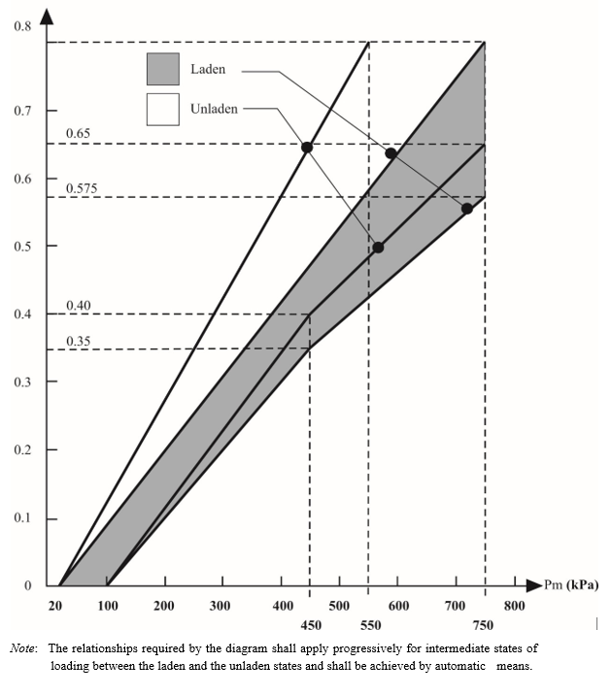**

*Note*: The relationships required by the diagram shall apply progressively for intermediate states of loading between the laden and the unladen states and shall be achieved by automatic means.

# Diagram 4A

# **Semi-trailers**

(see paragraph 4. of this annex)

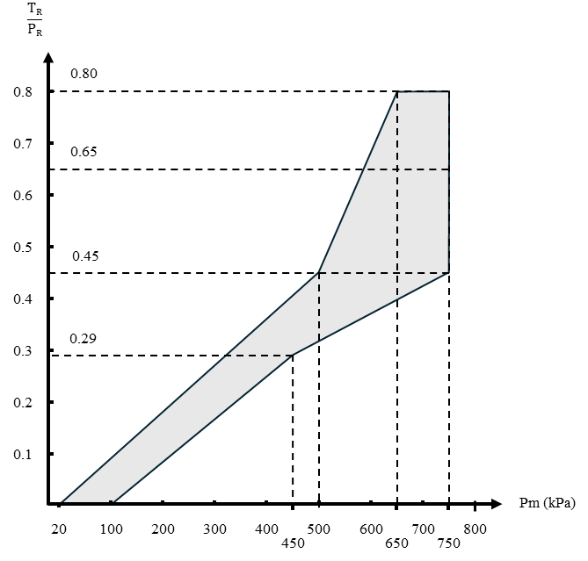

*Insert a new diagram 5,* as follow:

Diagram 5

**Full trailers and centre-axle trailers**

(see paragraph 5 of this annex)

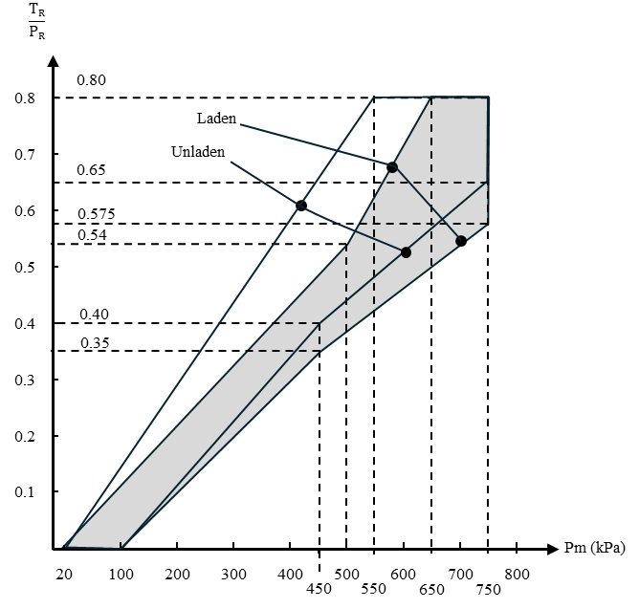

1. \* In accordance with the programme of work of the Inland Transport Committee for 2025 as outlined in proposed programme budget for 2025 (A/79/6 (Sect. 20), table 20.6), the World Forum will develop, harmonize and update UN Regulations in order to enhance the performance of vehicles. The present document is submitted in conformity with that mandate. [↑](#footnote-ref-2)