 | United Nations | ECE/TRANS/WP.29/GRVA/2026/10
 | Economic and Social Council |  | Distr.: General  7 November 2025  Original: English
Economic Commission for Europe
Inland Transport Committee
World Forum for Harmonization of Vehicle Regulations
Working Party on Automated/Autonomous and Connected Vehicles
Twenty-fourth session
Geneva, 19-23 January 2026
Item 4(e)(i) of the provisional agenda
Automated/autonomous and connected vehicles:
Coordination of work on automation between working parties (GRs)
Fitness of UN GTRs and UN Regulations for ADS

Proposal for amendments to UN Regulation No. 79 (Steering equipment)

Submitted by experts from International Organization of Motor Vehicle Manufacturers and the European Association of Automotive Suppliers *
The text reproduced below was prepared by the experts from International Organization of Motor Vehicle Manufacturers (OICA) and the European Association of Automotive Suppliers (CLEPA) introducing additional amendments to UN Regulation No. 79, enabling the type-approval of automated vehicles, including those without manual controls. The modifications to the current text of the Regulation are marked in bold or strikethrough characters.

I. Proposal
Paragraph 5.8.5., reproduced for reference.
"5.8.5. Notwithstanding the provisions of sections 5.1.6. and 5.6., Advanced Driver Assistance Steering Systems shall not be active, or be able to be activated, whilst an ADS feature is active."
Insert a new subparagraph 5.8.5.1., to read:
"5.8.5.1. Steering interventions controlled by an ESC whilst an ADS is active are permitted but are not subject to the CSF requirements of this Regulation. Such functionality shall be subject to the requirements of Annex 6. "
Paragraph 5.8.6.2., reproduced for reference.
"5.8.6.2. ADS Steering Equipment with non-electrical energy transmission shall meet the following additional requirement:
Paragraph 5.8.6.2.1., amendment to read:
"5.8.6.2.1. The level of stored energy in the energy reservoir(s), if fitted, shall be continuously transmitted to the ADS."

II. Justification

(a) Paragraph 5.8.5.1.
1. The proposed text shall ensure that a Control Strategy Function (CSF), which supports vehicle stability as defined in UN Regulation No. 79, can also be used in cases where an Automated Driving System (ADS) employs an Electronic Stability Control (ESC) or Vehicle Stability Function (VSF) approved in accordance with the relevant UN Regulations on vehicle stability (i.e. UN Regulations Nos. 13 and 140), and which already incorporate CSF functionality.

(b) Paragraph 5.8.6.2.1.
2. The requirement in para. 5.8.6.2.1. does not account for systems utilizing hydraulic energy transmission, which is standard in trucks. These systems do not feature an energy reservoir, but rather rely on an energy source, typically a hydraulic pump driven by the engine or transmission that provides sufficient hydraulic flow to steer the wheels, as long as the engine is running or the vehicle is in motion. Such systems should be considered appropriate. Failure scenarios and corresponding performance criteria are addressed in paragraph 5.8.6.3 and shall be detailed in accordance with Annex 6.
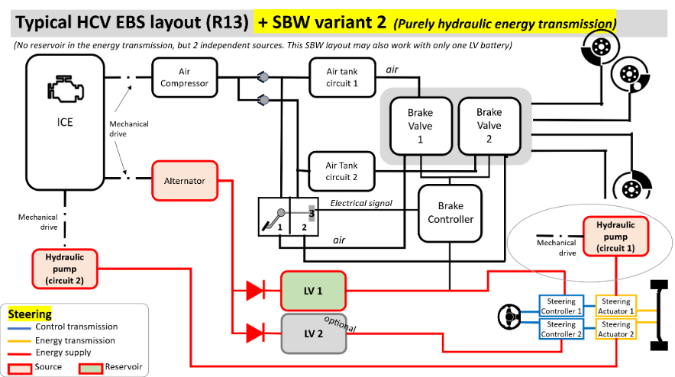
Figure 1
Exemplary layout of a typical Heavy Commercial Vehicle system (as already shared during the recent SBW amendment discussion)

* In accordance with the programme of work of the Inland Transport Committee for 2026 as outlined in proposed programme budget for 2026 (A/80/6 (Sect. 20), table 20.7), the World Forum will develop, harmonize and update UN Regulations in order to enhance the performance of vehicles. The present document is submitted in conformity with that mandate.

