Proposal for amendments to ECE/TRANS/WP.29/GRVA/2025/5
(Proposal for a supplement to the original series of amendments of UN Regulation No. 171 on uniform provisions concerning the approval of vehicles with regard to Driver Control Assistance Systems (DCAS))
The text reproduced below was prepared by the expert from the United Kingdom. It is based on working document ECE/TRANS/WP.29/GRVA/2025/5. The modifications to the existing text of the document are marked in bold for new or strikethrough for deleted characters.
I. Proposal
Paragraph 5.3.7.2.1.1., amend to read:
"5.3.7.2.1.1. A manoeuvre shall only be initiated if the driver is not detected to be disengaged, and
(a) has commanded the system to perform the manoeuvre for a driver-initiated manoeuvre; or
(b) has acknowledged the system’s intention as needed for a driver-confirmed manoeuvre; or
(c) is given sufficient notice to react for a system-initiated manoeuvre."
Paragraph 5.3.7.2.4., amend to read:
"5.3.7.2.4. General requirements for system-initiated manoeuvres
Any feature that performs system-initiated manoeuvres is not permitted irrespective of any reference in this Regulation The requirements of this paragraph and its subparagraphs apply to the system capable of performing system-initiated manoeuvres."
Paragraph 5.5.4.1.1., amend to read:
"5.5.4.1.1. The system shall inform or warn the driver about:
(a) The status of the system or feature: ‘stand-by’ mode (if applicable), ‘active’ mode;
(b) An ongoing manoeuvre;
(c) The need for the driver to perform a specific action (e.g. apply control, check indirect vision devices);
(d) If while in ‘active’ mode the system has detected to have reached a currently relevant system boundary, unless already indicated by (a);
(e) A detected upcoming system boundary;
(f) Detected failures affecting the system or its features, unless the system is in ‘off’ mode;
(g) Intended driver-confirmed or system-initiated manoeuvres."
Paragraph 5.5.4.1.9., amend to read:
5.5.4.1.9. System Messages and Signals for System-Initiated Manoeuvres
5.5.4.1.9.1. The provisions 5.5.4.1.8. shall equally apply. Where possible, information shall be provided at least 3 seconds ahead of a relevant intended manoeuvre.
5.5.4.1.9.2. (Reserved)
Table A4/1 of Annex 4, amend to read:
"Table A4/1
Requirements and system aspects to be tested
Requirements or system aspect to be assessed | Physical test scenario or audit | Reference in main text
Driver Information, Driver Disengagement and Warnings to the Driver | Annex 3  4.1.1. | Paras. 5.1.1. and 5.5.4.
System Assurance of Absence of Driver Disengagement | Annex 3  4.1.1. | Paras. 5.1.2. and 5.5.4.2.
Reasonably foreseeable misuse | Annex 3  4.1.1. | Para. 5.1.3.
System override | Annex 3  4.1.1. | Paras. 5.1.4. and 5.5.3.4.
Equivalent performance of other safety systems (UN Regulations No. 131, No. 152, No. 79 and No. 130) | 4.2.5.2.1.1  4.2.5.2.2.1.  4.2.5.2.3.1.  4.2.5.2.4.  4.2.5.2.8.1.  4.2.5.2.9.1.  4.2.5.2.10.1.  4.2.5.2.11.1. | Para. 5.1.5.
Functional requirements | * | Para. 5.3.
Assessment and response to surroundings as required for the functionality | 4.2.5.2.5.1.  4.2.5.2.6.1. | Para. 5.3.2., 5.3.7.1.2.
Vehicle behaviour in traffic (Avoid disruption of traffic flow, maintain appropriate distance from other road users, reduce risk of collision, deceleration/acceleration, traffic rules, headway distance) | 4.3.1.  4.3.2. | Paras. 5.3.4.,  5.3.7.2.,  5.3.7.5.,  5.4.2.,
Activating relevant vehicle systems | Annex 3  4.1.1. | Para. 5.3.3.
Detecting and Reaching DCAS boundaries | Annex 3  4.1.1. | Paras. 5.3.5., 5.3.7.1.4.
Controllability | Annex 3  4.1.1. | Para. 5.3.6.
Positioning in the lane of travel | 4.2.4.  4.2.5.1.1. | Paras. 5.3.7.1.,  6.1.
Driver-initiated manoeuvres | 4.2.5.1.2. | Para. 5.3.7.2.2.
Driver-confirmed manoeuvres | 4.2.5.1.2. | Para. 5.3.7.2.3.,  5.5.4.1.8.
System-initiated manoeuvres | 4.2.4.  4.2.5.1.1. | Para. 5.3.7.2.4.,  5.5.4.1.9.
Driver unavailability response | * | Para. 5.3.7.3.
Speed limit assistance | 4.3. | Para. 5.3.7.4.
Failure response | * | Para. 5.4.
DCAS operation, driver interaction and driver information | * | Para. 5.5.
Lane change | * | Para. 6.2.
Driver-confirmed lane changes | * | Para. 6.2.9.1.
System-initiated Lane Change | 4.2.4.  4.2.5.1.1. | Para. 6.2.9.2.
Other manoeuvres | 4.3.3. | Para. 6.3.
* Scenarios and test procedures for these items shall be agreed between the manufacturer and the Type Approval Authority."

Paragraph 2.1.8. of Annex 2, deleted:
"2.1.8. Timings and strategy to inform the driver about a (series of) system-initiated manoeuvre(s) (5.5.4.1.9.1.)"
Paragraph 4.2.5.1.3. of Annex 4, amend to read:
"4.2.5.1.3. System-initiated lane changes (reserved)
4.2.5.1.3.1. Base Test: The test shall confirm system-initiated lane changing capabilities declared by the manufacturer.
4.2.5.1.3.1.1. The VUT shall perform a full lane change (e.g., 3.5 m lateral displacement) into the adjacent lane after the system has initiated the LCP.
4.2.5.1.3.1.2. The VUT and the lead vehicle shall travel in a straight line, in the same direction, for at least two seconds prior to the functional part of the test with a VUT to lead vehicle centreline offset of not more than 1 m.
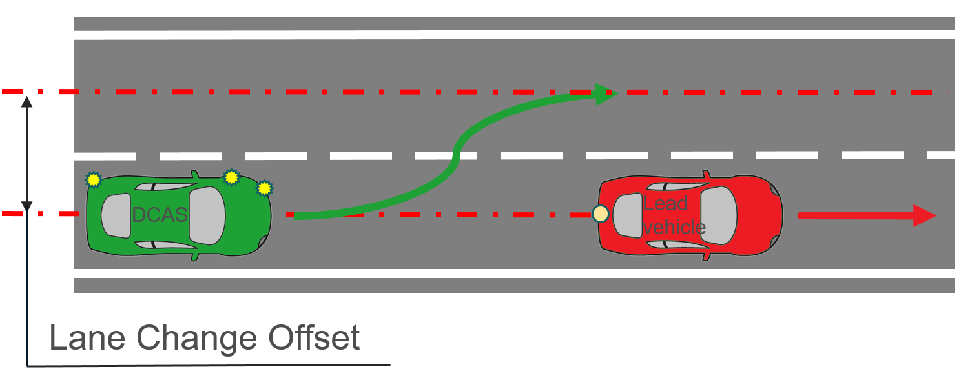
4.2.5.1.3.2. Extended Testing: The test shall demonstrate that the system is able to assist the driver in changing lanes safely:
(a) With other speed differences between the lead vehicle and VUT;
(b) On roads without physical separation; and/or
(c) On roads where pedestrians and cyclists are not prohibited.
4.2.5.1.3.2.1. The test shall be executed at least:
(a) On a road with oncoming or overtaking traffic in the target lane;
(b) With different road users approaching from the rear;
(c) With a vehicle driving beside in the adjacent lane preventing a lane change;
(d) In a scenario where the system reacts to another vehicle that starts changing into the same space within the target lane, to avoid a potential risk of collision."

II. Justification
1. In the development of the original series of amendments to UN Regulation No. 171 the inclusion of system-initiated manoeuvres was being considered as part of the proposal until the penultimate session of GRVA (17th session). When it was agreed to delay system-initiated manoeuvres till another phase some placeholders for provisions were already in place and it was expected that the detailed requirements would be introduced through a supplement. However, the system-initiated manoeuvres were introduced in a new series of amendments which has meant that some of the text concerning system-initiated manoeuvres still remains in the original series.
2. To avoid any confusion over whether system-initiated manoeuvres are considered part of the original series, given that a lack of requirements may not be interpreted as a prohibition, this proposal is looking to remove any problematic reference to system-initiated manoeuvres as well as explicitly stating that any feature that includes such a behaviour is prohibited under the original series of amendments.
___________

