|  |  |  |  |
| --- | --- | --- | --- |
|  | United Nations | ECE/TRANS/WP.29/2024/136 | |
| _unlogo | **Economic and Social Council** | | Distr.: General  27 August 2024  Original: English |

**Economic Commission for Europe**

Inland Transport Committee

**World Forum for Harmonization of Vehicle Regulations**

**194th session**

Geneva, 12–15 November 2024

Item 4.8.19 of the provisional agenda

**1958 Agreement:**

**Consideration of draft amendments to existing**

**UN Regulations submitted by GRSP**

Supplement 2 to the 04 Series of Amendments to UN Regulation No. 127 (Pedestrian safety)

Submitted by the Working Party on Passive Safety[[1]](#footnote-2)\*

The text reproduced below was adopted by the Working Party on Passive Safety (GRSP) at its seventy-fifth session (ECE/TRANS/WP.29/GRSP/75, para. 20). It is based on ECE/TRANS/WP.29/GRSP/2024/10 not amended. It is submitted to the World Forum for Harmonization of Vehicle Regulations (WP.29) and to the Administrative Committee (AC.1) for consideration at their November 2024 sessions.

*Paragraph 2.44.*, *Figure 13*, amend to read:

"Figure 13  
**Upper Corner Definition with "Shortest Distance"**

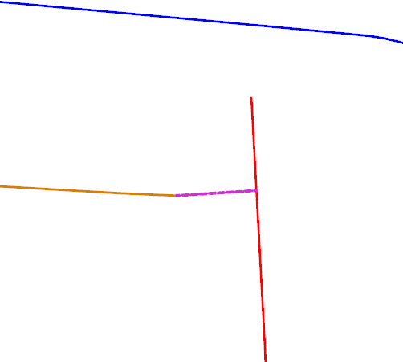

Rear offset is inboard of side offset"

Connecting curve

**Q**

S

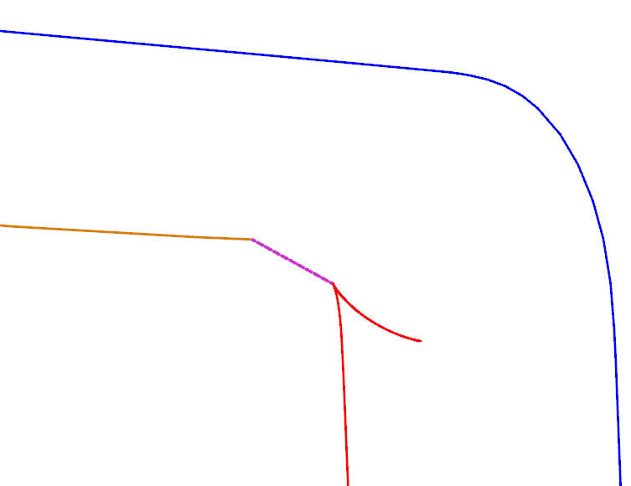

Both side offset and rear offset are short of intersection

Connecting curve

**Q**

S

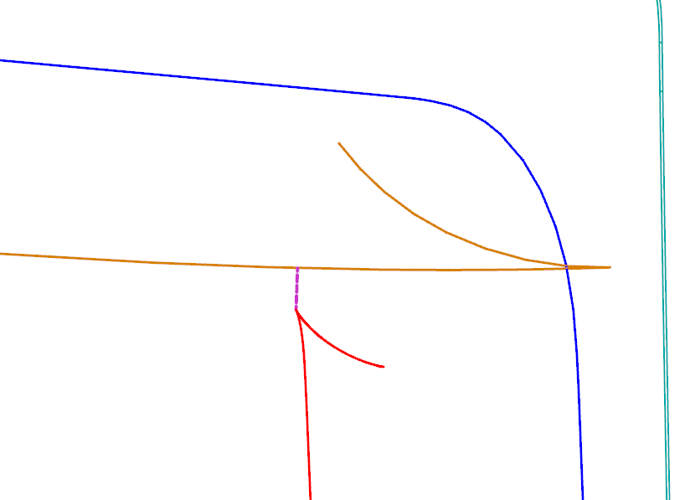

Side offset is forward of rear offset

Connecting curve

**Q**

S

*Paragraph 2.45.*, *Figure 14*, amend to read:

"Figure 14

**Lateral Limits of the Cowl Monitoring Area**

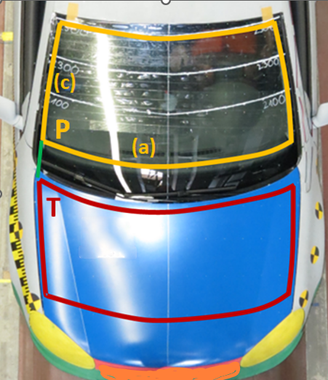"

*Paragraph 2.49.*, amend to read:

"2.49. "One third of the windscreen test area" means the area between the side boundaries of the windscreen test area as defined in paragraph 2.44.(c), divided by the lines passing through the third markings of the lines from P to P' and from Q to Q' (the upper corner points of the windscreen test area), as shown in Figure 17. All lines are to be drawn and the three equal parts to be measured with a flexible tape following the outer contour of the windscreen. In case Q and Q' are coincident with P and P’, Q and Q' are to be created on the side boundary lines as defined in paragraph 2.44. (c) rearward of P and P', respectively.

If there is no unique "Q point" where the lines defined in paragraph 2.44. (b) and (c) intersect, then the "Q point" is defined by the first contact of a vertical plane V45, intersecting the vertical longitudinal vehicle centre-plane at an angle of 45°, with the (b)-(c) transition of the windscreen test area boundary.

If there is no intersection between (b) and (c) and the open test area is closed by a connecting line, as illustrated in Figure 13, then the "Q point" is defined by the centre of this connecting line."

Figure 17 **Thirds of the windscreen test area**

|  |
| --- |
| **P**  **P'**  **Q'**  **1/3**  **1/3**  **1/3**  **1/3**  **1/3**  **1/3**  **(b)**  **(c)**  **Q**  **V45**  **V45**  **Third Markings** |

1. \* In accordance with the programme of work of the Inland Transport Committee for 2024 as outlined in proposed programme budget for 2024 (A/78/6 (Sect. 20), table 20.5), the World Forum will develop, harmonize and update UN Regulations in order to enhance the performance of vehicles. The present document is submitted in conformity with that mandate. [↑](#footnote-ref-2)