|  |  |  |  |
| --- | --- | --- | --- |
|  | United Nations | ECE/TRANS/WP.29/GRPE/2025/17 | |
| _unlogo | **Economic and Social Council** | | Distr.: General  5 August 2025  Original: English |

**Economic Commission for Europe**

Inland Transport Committee

**World Forum for Harmonization of Vehicle Regulations**

**Working Party on Pollution and Energy**

**Ninety-third session**

Geneva, 14-17 October 2025

Item 14 of the provisional agenda

**Automotive Life Cycle Assessment (A-LCA)**

Proposal for a new [Mutual] Resolution [No. 5 (M.R.5)] concerning Automotive Life Cycle Assessment (A-LCA)

**Submitted by the Informal Working Group on Automotive Life Cycle Assessment** [[1]](#footnote-2)\*

The text reproduced below was prepared by the Informal Working Group on Automotive - Life Cycle Assessment (A-LCA). It is a proposal for a new [Mutual] Resolution [No. 5 (M.R.5)] concerning Automotive Life Cycle Assessment (A-LCA). It is submitted to the Working Party on Pollution and Energy consideration at its 93rd session.

1. 1. Representative vehicle (RV) Determination

Vehicles are highly complex products composed of numerous parts manufactured through complex supply chains. Each vehicle’s unique configuration and customisable options make providing and managing LCAs for individual vehicles administratively burdensome for OEMs and but also for authorities. To address this, the methodology introduces the concept of an RV.

In order to ensure comparability of different vehicles /technologies / materials in the automotive industry the compared vehicles ideally should:

1. be calculated with the same functional unit,

Accordingly, comparability is a central challenge. For Level 1 and Level 2 LCA studies, different options (vehicles, technologies, powertrains, materials) are compared within one LCA study. In contrast, for Level 3 and Level 4 it is the aim to allow comparability between the individual LCA studies. This comparability requires the practitioner to define an RV .

Level 1 and Level 2 LCAs are mainly conducted to support strategic decisions. It is recommended to model a vehicle which is representative of the considered entity of vehicles / vehicle fleet. Regarding all parameters relevant for the intended research question, it should have generic & average value depending on the availability of the data (e.g. public studies or literature data). For comparison of vehicle LCAs this requires special attention. See the list above.

For level 3 & level 4, the objective is to rationalise the high administrative burden of LCA reporting, while the RV ensures that the selected vehicle accurately reflects the characteristics and impacts of the entire group of vehicles, which is clearly defined. This group of vehicles can be defined based on specific parameters that influence their lifecycle emissions in the upstream, downstream and end-of-life [stages]. By doing so, different types of emissions are considered throughout the entire life cycle.

An ‘RV’ is a benchmark vehicle that reflects the typical characteristics of a defined group of vehicles, allowing for consistent and meaningful environmental impact evaluations. The benchmark vehicle shall be selected in a way that remains representative of the group of vehicles it represents across their lifecycle, promotes the reduction of emissions and energy consumption, and incentivises the use of actual data when possible.

This paragraph provides a detailed definition of the RV, which serves as a solid foundation for the calculation of carbon footprint by considering the entire lifecycle of vehicles.

The RV is applicable at Levels 3 and 4 (as described in paragraph ‘‎7.1 Level concept) for reporting purposes (where comparability of results amongst different LCA studies is crucial).

* + 1. RV: Modular Approach

Given the complexity of vehicle production and use, a ‘modular approach’ is adopted for carbon footprint calculation. This involves separately calculating each [phase] of the vehicle lifecycle, according to the methodology described in paragraph 4, and then combining the results for the given vehicle.

1. Upstream Emissions: These emissions are associated with production, raw material acquisition, and manufacturing, they depend on the production region.
2. Downstream Emissions: These emissions, which occur during the use phase, are well-documented in certified fuel and energy efficiency data. They vary based on the vehicle’s sales region. Consumables and parts used for the scheduled maintenance, according to the manufacturer specifications, are considered.
3. EoL Emissions: These emissions, which occur during the recycling processes, depend on region of sell/use or -recycling
   * 1. RV: Selection

The RV is selected based on [ the highest weight configuration of a vehicle] within a group which is defined based on specific parameters in paragraph ‎7.9.3.1 called “LCA group”.

[To obtain the RV for an LCA group based on the highest expected or known weight within the LCA group, the selection shall be done consistently and be fixed for the time (representative period) when the LCA in the LCA group is performed. Hence, the vehicle with the highest weight is determined once for a LCA group and remains the RV thereafter.

Documentation for the choice and configuration of the representative vehicle shall be provided during the third-party certification (see verification paragraph ‎10).

The emissions within an LCA group correlate to the mass of the vehicle for a given LCA group, due to similar production characteristics. This selection further decreases deviations when applying the Emissions Factor (EF).

Important Considerations:

1. If the LCA group includes vehicles with non-weight-proportional- relationship (nwpr) parts such as a traction battery, these parts shall be excluded from the calculation of the carbon emissions for upstream & EoL of the individual vehicle as well from the emission factors. This is due to the fact that the its weight do not have a proportional relationship, which would distort the correlation via vehicle mass.
2. The carbon footprint of the nwpr parts must be calculated separately. For the calculation of the total vehicle carbon emissions, the carbon footprint of the nwpr parts shall be subsequently added to the carbon upstream & EoL emission of the vehicle (CFP).

Once the RV is selected, its carbon footprint is calculated using this Resolution (refer to paragraph ‎8), considering upstream, downstream and ‘EoL’ emissions, in case of nwpr parts the carbon footprint of the nwpr parts shall be calculated separately.

* + 1. RV: Upstream Emission

Carbon emissions related to upstream emissions should be calculated according to the method described in paragraph ‎8.2.

To determine the upstream emission for RV and upstream emission factor, a ‘upstream [emission group]’ need to be defined in the paragraph 7.1.3.1.and then choose an RV according to paragraph ‎7.9.2.

* + - 1. Definition of Upstream LCA Group

(reserved

* + - 1. Determination of Upstream Emission factor

In case that CFP values for the vehicles other than the RV need to be declared, the following subchapter will introduce the methodology to estimate the CFP for these vehicles.

The upstream emission factor (UEF), shall be calculated as follows:

(1)

Where;

means the upstream emission factor, [kgCO2eq/kg]

means the upstream carbon emission of the RV, [kgCO2eq];

means the actual mass of the RV (with the accessories & options see paragraph ‎7.9.2), [kg];

In case of powertrain using nwpr parts the emission factor shall be calculated as follows:

(2)

Where;

means the upstream carbon emission of the RV, [kgCO2eq];

means the upstream carbon emission of the nwpr parts of the RV, [kgCO2eq];

means the actual mass of the RV (with the accessories & options), [kg];

means the weight of the nwpr parts of the RV, [kg];

Both and shall be measured on the same RV.

The UEF shall be included in all relevant test reports.

The UEF shall be rounded to 2 points of decimal, the unit of UEF is kgCO2eq/kg.

* + 1. RV: Downstream Emission: In-use

Carbon emissions related to use phase emissions should be calculated according to the method described in paragraph ‎8.3. These emissions are typically derived from certified fuel consumption and energy consumption data, which are included in official homologation documents and regulatory certifications.

* + 1. RV: Powertrain group

As each region or country have their own definition of the powertrain group (e.g. interpolation family approach in EU) it is recommended to use the same powertrain family criteria defined in the ‘fuel and energy consumption regulation’ (see paragraph ‎8.3). In case of WLTP it is defined in UN GTR 15.

* + - 1. Use phase

Each individual vehicle has an ‘energy consumption’ value provided in official documentation (e.g., Certificate of Conformity). Two common approaches to determine downstream emissions are:

1. Interpolation
2. Inertia Class

For representative mass, inertia class defined in the regional fuel consumption regulation must be considered.

Figure 5  
**Explanation of interpolation and inertia approach**

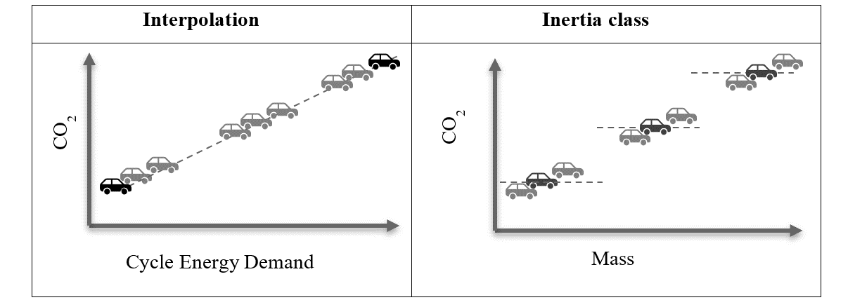

The carbon footprint of a particular type of powertrain and vehicle configuration (mass, aerodynamic, tyre etc.) should be reflected in the selected representative or declared vehicle:

1. In case of ‘interpolation approach’: Individual vehicle configuration of the ‘interpolation family’ should be used as described in the Certificate Of Conformity document.
2. In case of ‘inertia class approach’: Individual inertia class configuration of the ‘powertrain family’ should be used as described in the Certificate Of Conformity document.
   * + 1. Maintenance and leakage

The carbon footprint during the maintenance and leakage does not vary in each powertrain family and hence it is recommended to determine this value for the selected RV of the powertrain family.

* + 1. RV: EoL Emission

EoL emissions encompass carbon emissions generated throughout vehicle collection at the EoL and recycling. Carbon emissions related to EoL emissions should be calculated according to the method described in paragraph ‎8.3.

* + - 1. Definition of EoL LCA group

The main factors that greatly impact the end-of-life carbon footprint of a vehicle is same as that of the upstream phase except the region of recycling. Based on these factors, vehicles can be grouped into clusters (EoL LCA group) according to their common traits such as:

1. All criteria defined for upstream emission except the region of production (see paragraph ‎7.9.3.1)
2. [Expected region of vehicle end-of-life: further expansion of the definition to the region of recycling place is possible]

If the vehicle is produced in the same region as that of expected region of EoL, then both LCA groups Upstream and EoL are the same.

* + - 1. Determination of EoL Emission factor

The EoL emission factor, EEF, shall be calculated as follows:

(3)

Where;

means the EoL emission factor, [kgCO2eq/kg];

means the EoL carbon emission of the RV, [kgCO2eq];

means the actual mass of the RV (with the accessories & options, see paragraph ‎7.9.2), [kg].

In case of powertrain using nwpr parts the emission factor shall be calculated as follows:

(4)

Where;

means the EoL carbon emission of the RV, [kgCO2eq];

means the EoL carbon emission of the nwpr parts of the RV, [kgCO2eq];

means the actual mass of the RV (with the accessories & options), [kg];

means the weight of the nwpr parts of the RV, [kg];

Both and shall be measured on the same RV.

The EEF shall be included in all relevant test reports.

The EEF shall be rounded to 2 points of decimal, the unit of EEF is kgCO2eq/kg.

* + 1. RV: Total carbon footprint

The total carbon footprint of a vehicle is the sum of:

1. Upstream Emissions (see paragraph ‎7.9.3)
2. Upstream Emissions: nwpr parts Emissions (if applicable)
3. Downstream Emissions: use phase energy consumption and maintenance (see paragraph ‎7.9.4)
4. End-of-Life Emissions (see paragraph ‎7.9.6)
5. End-of-Life Emissions: nwpr parts Emissions (if applicable)
   * 1. RV: Carbon footprint value for ‘Declared vehicle ‘

The selected RV (see paragraph ‎7.1.2) should serve as the baseline for estimating the carbon footprint for the values of the other vehicles, if a declaration is required. These vehicles and the RV shall be members of the same [emission group].

The Emission Factors (UEF & EEF) (i.e. carbon emission per kilogram of vehicle weight) is calculated by the ratio between the carbon emissions (upstream & EoL) of the RV and its weight (excluding the weight of the nwpr parts).

Figure 6  
**Explanation of baseline approach**

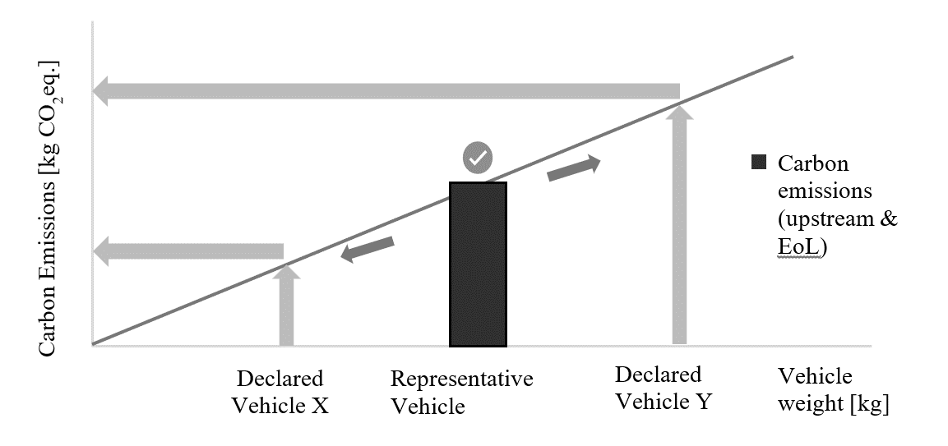

UEF & EEF are describing the correlation between vehicle mass and the CFP value of the RV, as illustrated in Figure 6.

The correlation of CFP value according to the ‘RVs’, may be allowed both below and beyond the mass of the RV,

The carbon emission of the declared vehicles, which belong to the same [emission group], can be estimated using the EFs & the weight of the evaluated vehicle.

The definition of the RV & the Declared Vehicle is considered as follow:

1. the “RV” is the one for which to perform the precise and detailed carbon footprint calculation to determine the emission factors for the upstream- & EoL emission.
2. the [“declared vehicle”] is the vehicle for which to calculate the carbon footprint based on the emission factor of its [emission groups] (according to paragraph ‎7.9.8.1.) and shall be the highest cycle energy demand configuration under the interpolation method (GTR#15) or test vehicle configuration under the inertia weight class method.
   * + 1. Estimated value for the declared vehicles

The upstream emission for the declared vehicles within the same LCA group is estimated using the following formula:

(5)

Where;

means the upstream carbon emission of the declared vehicle, [kgCO2eq];

means the emission factor, [kgCO2eq/kg];

means the actual mass of the declared vehicle (with the accessories & options).

For vehicles with nwpr parts:

(6)

Where;

means the carbon emission of the nwpr parts, [kgCO2eq];

means the weight of the nwpr parts, [kg];

The downstream emission for the declared vehicles (compare paragraph ‎7.9.5.1)

The EoL emission for the declared vehicles within the same LCA group is estimated using the following formula:

(7)

Where;

means the EoL carbon emission of the declared vehicle, [kgCO2eq];

means the EoL emission factor, [kgCO2eq/kg];

means the actual mass of the declared vehicle (with the accessories & options).

For vehicles with nwpr parts:

(8)

Where;

means the EoL carbon emission of the nwpr parts, CO2eq, [kg];

means the weight of the nwpr parts, [kg];

* + - 1. Steps to determine carbon footprint value of the ‘declared vehicle’
         1. Step 1 : initial step to define and calculate the carbon footprint of the RV

1. Step 1.1: Define the ‘upstream LCA Group’ (see paragraph ‎7.1.3.1.)
2. Step 1.2: Define an RV out of the defined ‘upstream LCA group’ (see paragraph ‎7.1.2.)
3. Step 1.3: Calculate the upstream carbon footprint of the RV (excluding the nwpr parts)
4. Step 1.4: Calculate the Emission Factor (EF) of the ‘upstream LCA group’ (see paragraph ‎7.1.3.2.)
5. Step 1.5: Add upstream carbon emission of nwpr parts if available
6. [Optional] – Step 1.6: Calculate the upstream carbon footprint of declared vehicle (see paragraph ‎7.1.8.1)
   * + - 1. Step 2: downstream carbon footprint (depend on cycle energy demand in WLTP and mass for inertia approach)
7. Step 2.1: Check which interpolation family or inertia class the ['defined vehicle'] belongs to.
8. Step 2.2: calculate downstream emission (considering service life, deterioration factor etc.) (see paragraph ‎7.1.4.)
9. Step 2.3: calculate the carbon emission related to leakage & maintenance (see paragraph ‎7.1.5.2.)
   * + - 1. Step 3: EoL carbon footprint (depend on mass)
10. Step 3.1: Define the ‘EoL LCA group’ (see paragraph ‎7.1.6.1.)
11. Step 3.2: Calculate the EoL carbon footprint of the RV (excl. nwpr parts)
12. Step 3.3: Calculate the EoL Emission Factor (EEF) of the ‘EoL LCA group’ (see paragraph ‎7.1.6.2.)
13. Step 3.4: Add EoL carbon emission of nwpr parts if available
14. [Optional] – Step 3.5: Calculate the EoL carbon footprint of declared vehicle (see paragraph ‎7.1.8.1.)
    * + - 1. Step 4: total carbon footprint

Total carbon footprint = Upstream carbon footprint + Downstream carbon footprint + EoL carbon footprint

1. \* In accordance with the programme of work of the Inland Transport Committee for 2025 as outlined in proposed programme budget for 2025 (A/79/6 (Sect. 20), table 20.6), the World Forum will develop, harmonize and update UN Regulations in order to enhance the performance of vehicles. The present document is submitted in conformity with that mandate. [↑](#footnote-ref-2)