|  |  |  |  |
| --- | --- | --- | --- |
|  | United Nations | ECE/TRANS/WP.29/GRPE/2025/17 | |
| _unlogo | **Economic and Social Council** | | Distr.: General  5 August 2025  Original: English |

**Economic Commission for Europe**

Inland Transport Committee

**World Forum for Harmonization of Vehicle Regulations**

**Working Party on Pollution and Energy**

**Ninety-third session**

Geneva, 14-17 October 2025

Item 14 of the provisional agenda

**Automotive Life Cycle Assessment (A-LCA)**

Proposal for a new [Mutual] Resolution [No. 5 (M.R.5)] concerning Automotive Life Cycle Assessment (A-LCA)

**Submitted by the Informal Working Group on Automotive Life Cycle Assessment** [[1]](#footnote-2)\*

The text reproduced below was prepared by the Informal Working Group on Automotive - Life Cycle Assessment (A-LCA). It is a proposal for a new [Mutual] Resolution [No. 5 (M.R.5)] concerning Automotive Life Cycle Assessment (A-LCA). It is submitted to the Working Party on Pollution and Energy consideration at its 93rd session.

* 1. Chain of custody

In the automobiles supply chain, the multiple inputs (resources), outputs (products), and processes exist, and the LCA of automotive products is generally conducted within a complex system. As a method for the appropriate allocation and management of environmental attributes within such a system, Chain of Custody may be applied. ISO 22095:2020 specifies five models of Chain of Custody (Table 4, Figure 13).

Table 4  
**Chain of Custody Models**

| *Input/Output Relation* | *Identity preserved* | *Segregated* | *Controlled blending* | *Mass balance* | *Book and claim* |
| --- | --- | --- | --- | --- | --- |
|  |  |  |  |  |  |
| All input characteristics translate unchanged to output characteristics | ✓ | ー | ー | ー | ー |
| Mixing of inputs from different sources | ー | ー | ✓ | ✓ | ✓ |
| Output characteristics reflect the average of input flow characteristics | ✓ | ー | ✓ | ー | ー |
| Physical connection | ✓ | ✓ | ✓ | ✓ | ー |

Figure 13  
**Overview of chain of custody models**

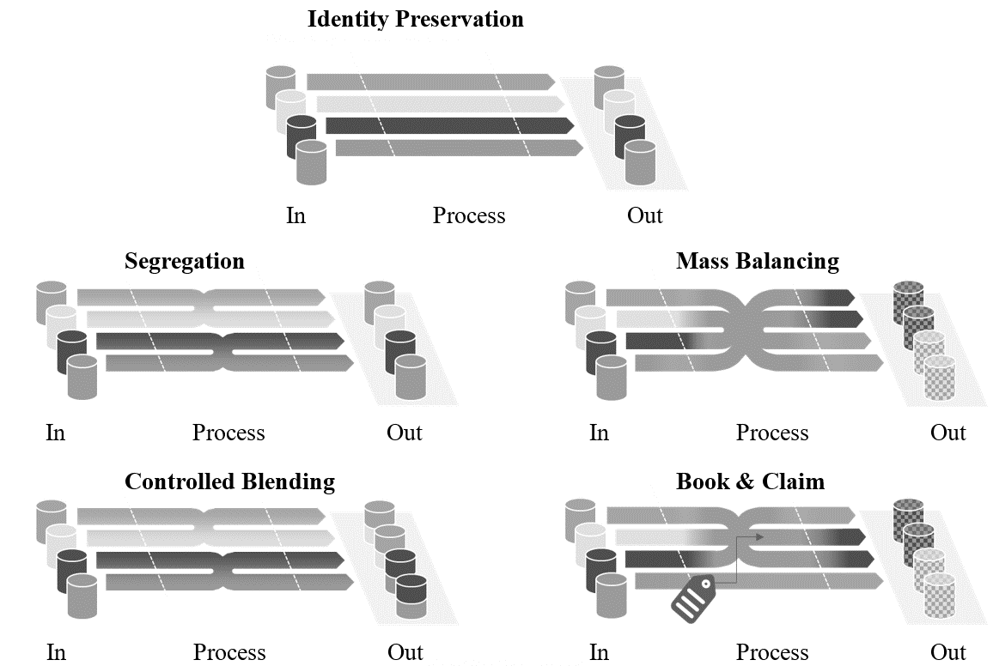

Among these, the Mass Balance model may enable a flexible allocation of environmental attributes; however, in order to ensure transparency and credibility, its application requires prudent consideration. More detailed provisions on Mass Balance are currently under discussion in ISO 13662, while ISO 14077 is addressing its application to LCA.

Accordingly, in automotive LCA, minimum requirements shall be established to prevent diverse interpretations and misuse of Mass Balance. These requirements shall be continuously reviewed and revised, taking into account the developments of global standards such as ISO and the GHG Protocol.

In this resolution, it shall be noted that the Book and Claim model is intended to be applied in the electricity domain, and electricity certificates shall follow Chapter 3.2.15 (Energy modelling).

Requirements for Mass Balance

1. This model shall correspond to “Mass Balance” as defined in ISO 22095:2020.
2. This model shall only be applied when a physical connection exists between input and output.
3. This model shall be operated under the management of the same company, corporate group, or joint venture.
4. This model shall be operated under accounting controls that the claimed output exactly matches the actual input, avoiding any double counting.
5. The reliability of this model shall primarily be ensured through third-party certification, and at a minimum, an equivalent independent and transparent scheme shall be required.
6. When the environmental attributes of products using this model are claimed, clear and transparent information shall be provided to stakeholders.



1. \* In accordance with the programme of work of the Inland Transport Committee for 2025 as outlined in proposed programme budget for 2025 (A/79/6 (Sect. 20), table 20.6), the World Forum will develop, harmonize and update UN Regulations in order to enhance the performance of vehicles. The present document is submitted in conformity with that mandate. [↑](#footnote-ref-2)