|  |  |  |  |
| --- | --- | --- | --- |
|  | United Nations | ECE/TRANS/WP.29/GRPE/2025/17 | |
| _unlogo | **Economic and Social Council** | | Distr.: General  5 August 2025  Original: English |

**Economic Commission for Europe**

Inland Transport Committee

**World Forum for Harmonization of Vehicle Regulations**

**Working Party on Pollution and Energy**

**Ninety-third session**

Geneva, 14-17 October 2025

Item 14 of the provisional agenda

**Automotive Life Cycle Assessment (A-LCA)**

Proposal for a new [Mutual] Resolution [No. 5 (M.R.5)] concerning Automotive Life Cycle Assessment (A-LCA)

**Submitted by the Informal Working Group on Automotive Life Cycle Assessment** [[1]](#footnote-2)\*

The text reproduced below was prepared by the Informal Working Group on Automotive - Life Cycle Assessment (A-LCA). It is a proposal for a new [Mutual] Resolution [No. 5 (M.R.5)] concerning Automotive Life Cycle Assessment (A-LCA). It is submitted to the Working Party on Pollution and Energy consideration at its 93rd session.

1. General methodology
   1. Level Concept

The Level Concept was developed in UNECE IWG A-LCA to reflect the different motivations and goals of determination of CFP for [light duty vehicles] and indicates four classes, or levels, which correspond to intended use cases of an automotive LCA. The importance of LCA has grown considerably in recent years and the number and type of use cases for LCA expanded as a result. The Level Concept also considers the increasing demand for primary data to inform LCA results. By addressing variations in availability and quality of data inputs, the Level Concept helps to ensure a consistent analysis across all product systems and goals. By transparently addressing these new forms of vehicle LCAs and their input data variation, the Level Concept helps to ensure a consistent application of the vehicle LCA method and the appropriate selection of a product system model for an intended application and scope.

Figure 1  
**Life cycle assessment framework based on ISO 14040:2006**

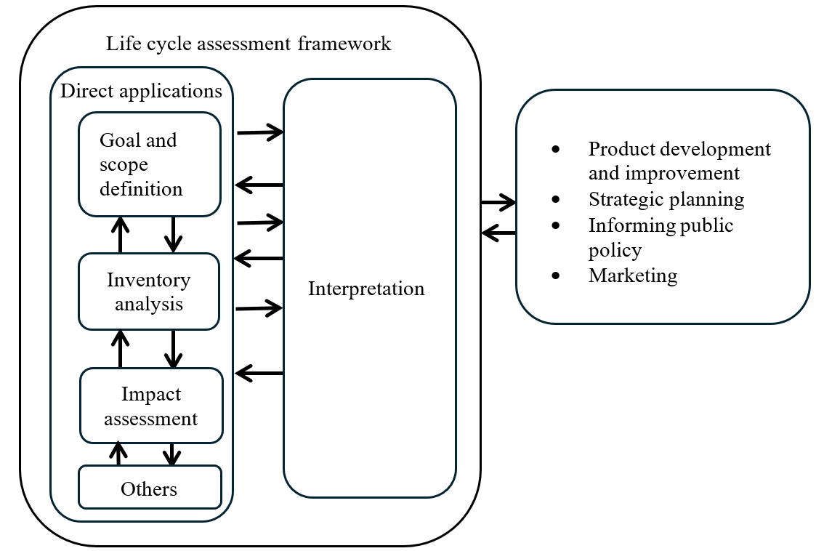

Based on the ISO 14040:2006 standard, a life cycle assessment (LCA) consists of four steps (Figure 1). Goal and scope definition is the first step of these four. In this step the study is defined in detail and central choices are made regarding its conduct.

“The goal definition shall firstly state the intended application(s) of the LCA results in a precise and unambiguous way. The decision-context is one key criterion for determining the most appropriate methods for the LCI model.”[[2]](#footnote-3)

For the practitioner it is crucial to define appropriate requirements for modelling the product system according to the intended purpose and application of an LCA.

At the same time, vehicle LCAs are used by a growing number of stakeholders for an increasing range of different purposes and applications. Traditionally, vehicle LCAs were mainly used in R&D for technology comparisons and support of strategic decision making (e.g. which powertrain / material / production technology / … is environmentally superior?) or by OEM’s (Original Equipment Manufacturer) to show that their successor models were more environmentally friendly than the previous ones (continuous improvement). This is also reflected in the list of direct applications in ISO 14040:2006 (compare Figure 1, box on the right). Currently, an extension of applications towards implementation and reporting of reduction measures – especially in the context of GHG reduction and circular economy (CE) – can be observed by various stakeholders with different expectations from automotive LCAs.

Potential stakeholders are listed below, but are not limited to:

1. Society / Policy makers
2. Green finance & ESG rating
3. Customer
4. OEM
5. Suppliers

Potential motivations are listed below, but are not limited to:

1. Decision support of policy making
2. Comparison / rating
3. Communication / marketing
4. Fair competition
5. Incentivisation
6. Internal steering of decarbonisation
7. Proof of decarbonisation
8. Identification of reduction potentials

As a consequence, this [Mutual] Resolution on A-LCA addresses different types of use cases by using the Level Concept, and highlights where these require different scope definitions and requirements concerning methodology and data granularity.

* 1. Use cases and application of Level Concept

The Level Concept distinguishes four different levels based on the underlying questions of the assessment. This could range from “what is the right mobility concept for a city?” to “what is the carbon footprint of a certain vehicle model?”. This leads to different requirements for the product system model especially with regard to the upstream life cycle phases in the foreground system (supply chain and vehicle production).

According to questions of the assessment granularity, product specificity and the scope of the foreground and background is chosen. To put it the other way round: whereas Level 1 study is representative of a broad range of products, e.g. all vehicles, Level 4 is more focused on the fine variations of individual vehicle models and the supply chain of their specific components (parts).

The choice of representativity and specificity also concerns downstream life cycle [stages] (Well To Wheel (WtW) / use [stage], End of Life (EoL)) or background system processes (e.g. energy production). Also, for the use [stage] or EoL the data for a specific vehicle could be used. This implies however that the LCA is done retrospectively. For many use cases the analysis (declaration) point in time is the moment the product is put on the market. Consequently, the following life cycle [stages] can only be analysed prospectively. For predictive data, average data (e.g. for lifetime milage) can be used. For predictive data there is no way to provide primary data.

In general, every LCA practitioner who has the necessary data (granularity) available for the respective level, may conduct an LCA study for this level. However, in practice mainly OEMs have access to the bills of material (BoM) and the material data system (MDS) which are required as basis of the vehicle models for Levels 2 to 4. Level 1 can be used by government officials for public policy making or by researchers for general research purpose, since it doesn’t require proprietary information by OEM, such as BoM.

shall[can be ensured]

1. data

Table 1 summarises the general structure of the Level Concept, while the practitioner can refer to Chapter ‎8 for the detailed application of the level concept to different life cycle [stages].

[Table 1  
**General structure of the Level Concept**

|  | *Items* | *Level 1\** | *Level 2\** | *Level 3\*\** | *Level 4\*\** |
| --- | --- | --- | --- | --- | --- |
| *Purpose* | *Strategy* | | *Reporting* | |
| Life cycle [stage] | Possible audiences | Policy makers, researchers | Company strategy/product developers, customers | Government programs, customers | |
| Material production [stage] (See 8.1) | Vehicle weight | Primary data | All primary data | | |
| Material distribution | All secondary data | All primary data | | |
| [Scrap/Yield] rate of material | All secondary data | | Partially primary data | All primary data |
| Carbon intensity of material acquisition | All secondary data | | Partially primary data | [All primary data/Partially primary data] |
| Parts production and vehicle assembly [stage] (See 8.2) | Vehicle model | Average for a vehicle fleet | Average for vehicles of a specific segment or a vehicle chosen as representative for a specific segment | Average for specific vehicle models with different equipment variants | Specific vehicle mode |
| Supply chain model | Generic | | Partly specific for hotspot part supply chain | Mainly specific for whole supply chain |
| Waste | Implicit in surcharge factor | | Implicit in surcharge factor except explicit for hotspot part | Fully explicit |
| Gross vs. net material input (scrap) | Implicit in surcharge factor | | Implicit in surcharge factor except explicit for hotspot part | Fully explicit |
| Transport of parts | Implicit in surcharge factor | | Implicit in surcharge factor except explicit for hotspot part | Fully explicit |
| Transport of vehicles | Generic | | Explicitly reported from OEM gate to customer | |
| Primary/secondary material use | Implicit in material production carbon intensity | | Implicit in material production carbon intensity except explicit for hotspot part | Fully explicit |
| Temporal validity | Most recent data | | Most recent data except annual update for hotspot part | Annual update |
| Geographical representativeness | Determined based on the research question | | As specific as possible while plant level for hotspot part | Plant level |
| Use [stage] (See 8.3) | Service life | Officially available data by CPs; if not available, the values in some peer-reviewed reports or methodology | | | |
| Use phase consumption | Certification value, also considering discrepancy factor and deterioration factor | | | |
| Discrepancy factor | Official monitoring info, inventories like EMEP/EEA, etc, or assume 1 | | Default values provided by CPs | OEM-specific average data from real-world operation with similar powertrains, matched to the region of operation |
| Deterioration factor for fuel cell | Efficiency loss of 10% over the lifetime (6000 hours for LDVs), assuming a starting efficiency of 55% and running at an average of 25% of the peak power rating | | | OEM/supplier specific approach or data, validated by independent third-party expert |
| Deterioration factor for battery SoH in PHEV | SoH loss of 20% over the operational life cycle of 2000 charge/discharge cycles hours for LDVs | | | OEM/supplier specific approach or data, validated by independent third-party expert |
| Future changes in energy mix | Energy mix change considered for the use [stage] based on the latest available dynamic scenario: 1. Official general scenario by CPs, 2. [RCM/Stated Policies Scenario] from the IEA [WEO report], [3. Dispatch modelling, 4. Static scenario] | | | |
| Maintenance | Generic | | List of maintenance parts/consumable and associated frequency provided by OEM | |
| Determination of traction battery and fuel cell system replacement | Excluded by default, unless a simple assumption on replacement is provided | | Excluded by default, unless OEM/supplier specific approach to define the need for a replacement over the operational life is provided | |
| End of life [stage] (See 8.4) | Activity data of EoL processes (e.g., weight of vehicle, parts, materials, etc.) | Global secondary data | Primary data based on BoM and MDS | | |
| Carbon intensity data of EoL processes (e.g., dismantling and shredding/sorting, ASR thermal recovery, materials recycling, etc.) | Global, regional, or country specific, primary or secondary data, depending on the study | | Data requirement specified by CPs | |
| Recovered parts disposal and recycling process  (e.g., tyre, lead battery, driving battery, etc.) | Global, regional, or country specific, primary or secondary data, depending on the study | | Data requirement specified by CPs | |
| Material recycling modelling | RCM or CFF | | | |

(\*) There are multiple approaches possible for Level 1 and Level 2. The descriptions for each item in the rows of Level 1 and Level 2 are the minimum requirements for calculation. In other words, the practitioners can adopt any methodologies for each item from the designated or higher levels. For example, for material distribution, Level 1 practitioner can use either secondary data or primary data, and Level 2 practitioner shall use primary data.

(\*\*) Level 3 and Level 4 shall be carried on the single fixed approach throughout the life cycle [stages], and the practitioners shall follow the descriptions for each item in the designated row. ]

* 1. [Hotspots

The 2017 UNEP hotspot Definition[[3]](#footnote-4)

“Having attributed impacts to each life cycle [stage] and normalised / weighted the impacts to allow them to be prioritised, hotspots can be defined. Two approaches may be used. These are illustrated in the figure below.

Figure 3  
**Options for identifying hotspots**

| *Hotspot* | *Warmspot* | *Cold Spot* |
| --- | --- | --- |
|  |  |  |
| A life cycle [stage] whose contribution to the impact category is greater than even distribution of that impact across the life cycle [stages]. | A life cycle [stage] whose contribution is approximately equivalent to an even distribution of the impact across the life cycle [stages]. | A life cycle [stage] whose contribution to any impact category is less than even distribution of that impact across the life cycle [stages] |

| *Hotspot* | *Cold Spot* |
| --- | --- |
|  |  |
| All life cycle [stages] collectively contributing more than 50% to any impact category. | All life cycle [stages] collectively contributing less than 50% to any impact category. |

In the first approach a hotspot shall always be a percentage greater than if the impacts were evenly distributed across life cycle [stages]. So, if there are 5 life cycle [stages], a hotspot should not be defined lower than 20% of the impact category, and if there are 7 [stages], it should not be lower than 14%.

Where the hotspot has been identified based on qualitative information, it will not be possible to identify a hotspot with quantitative precision. To ensure that hotspots are covered, the analysis should therefore be confident that the majority of impacts (i.e., over 50%) (the second approach) are covered. Depending upon the number of impact categories selected, the number of hotspots may vary.

The first approach should be implementable. That is, if a [stage] contributes more than the average share of all [stages] for automotive LCA, then the [stage] is considered to be a hot spot.

Applications of the hotspot definition in the LCA [guideline]

Material/vehicle manufacturing. The current language for separate estimation of battery emissions from the rest of vehicle manufacturing emissions appears to be based on this rationale: The current guideline version allows linear extrapolation of per-vehicle results with vehicle weight. The guideline realises that battery capacity (and weight) may be independent from vehicle weight. In this regard, the guideline should make battery as an unscalable example with vehicle weight for separation. If this is the case, some general consideration, instead of specific battery consideration, for separation based on un-scalability should be worded.

EoL. As determined on June 19, EoL may use static energy system results if EoL is determined not to be emission hotspot.]

1. \* In accordance with the programme of work of the Inland Transport Committee for 2025 as outlined in proposed programme budget for 2025 (A/79/6 (Sect. 20), table 20.6), the World Forum will develop, harmonize and update UN Regulations in order to enhance the performance of vehicles. The present document is submitted in conformity with that mandate. [↑](#footnote-ref-2)
2. ILCD handbook [↑](#footnote-ref-3)
3. Barthel, M., Fava, J., James, K., Hardwick, A., & Khan, S. (2017). Hotspots Analysis: An overarching methodological framework and guidance for product and sector level application. United Nations Environment Programme: Paris, France. <https://www.lifecycleinitiative.org/library/hotspots-analysis-an-overarching-methodological-framework-and-guidance-for-product-and-sector-level-application/> [↑](#footnote-ref-4)