**Proposal to replace document GRBP/2025/17 (Proposal for Supplement 1 to UN Regulation No. 172)**

The changes compared to document GRBP/2025/17 are marked in **bold** for added text and strike through for deleted text, all in blue font.

A green frame highlights the triggering element for the amendment

*Paragraph 5.5.,* amend to read:

"5.5. If the retreaded tyre **approved pursuant to this Regulation** is produced in a retreading production unit which conforms to an approval under **UN** Regulations **Nos.** 108 or 109 **that has the retreaded tyre as part of the range of tyres approved** in **and by** the country which has granted approval under this Regulation, it is not needed to repeat the symbol prescribed in paragraph 5.4.1. above. In such a case the additional numbers and symbols of **UN** Regulations **Nos.** 108 or 109 under which approval has been granted in the country which has granted approval under this Regulation shall be placed adjacent to the symbol prescribed in paragraph 5.4.1. above, as described in Annex 2, Appendix 2 of this Regulation. "

*Paragraph 6.1.,*  amend to read:

"6.1. Snow performance of tyres retreaded either with a pre-cured tread or by using mould cure process, when tested according to Annex 7 to UN Regulation No. 117. [1]/

The retreaded tyre shall meet the minimum snow grip index value compared with the respective Standard Reference Test Tyre (SRTT) as follows:

|  |  |  |  |  |
| --- | --- | --- | --- | --- |
| *Class*  *of tyre* | *Snow grip index*  *(brake on snow method) (a)* | | *Snow grip index*  *(spin traction method) (b)* | *Snow grip index*  *(acceleration method) (c)* |
|  | *Ref.s =~~,~~ SRTT16* | *Ref. = SRTT16C* | *Ref. = SRTT16* | *Ref.s = SRTT19.5, SRTT22.5****, SRTT19.5 siped, SRTT22.5 siped*** |
| C1 | 1.07 | No | 1.10 | No |
| C2 | No | 1.02 | 1.10 | No |
| C3 | No | No | No | 1.25 |

*(a)* See paragraph 3 of Annex 7 to UN Regulation No. 117

*(b)* See paragraph 2 of Annex 7 to UN Regulation No. 117

*(c)* See paragraph 4 of Annex 7 to UN Regulation No. 117"

*Paragraph 6.4.,*  amend to read:

"6.4. In order to be classified as a 'professional off-road tyre', a **special use** tyre shall ~~have~~ **fulfil** ~~all of~~ the following ~~characteristics~~ **additional requirement**:

(a) For **class** C2 tyres~~:~~**,** **the maximum speed category shall be less than or equal to 160 km/h (speed category symbol Q).**

~~(i) A tread depth ≥ 11 mm;~~

~~(ii) A void to fill ratio ≥ 35 per cent;~~

~~(iii) A maximum speed rating of ≤ Q.~~

(b) For **class** C3 tyres~~:~~**,** **the maximum speed category shall be less than or equal to 110 km/h (speed category symbol K).**

~~(i) A tread depth ≥ 16 mm;~~

~~(ii) A void to fill ratio ≥ 35 per cent;~~

~~(iii) A maximum speed rating of ≤ K.~~"

*Add a new paragraph 12.*, to read:

"**12. Transitional provisions**

**12.1. As from 1 September 2030, Contracting Parties applying this Regulation shall not grant** **type approvals based on snow performance tests as described in Annex 7 to UN Regulation No. 117 using one of the two equivalent Standard Reference Test Tyres SRTT19.5 and SRTT22.5 as reference tyre.**

**12.2. As from 1 September 2030, Contracting Parties applying this Regulation shall not be obliged to accept type approvals, first issued after 31 August 2030, based on snow performance tests as described in Annex 7 to UN Regulation No. 117 using one of the two equivalent Standard Reference Test Tyres SRTT19.5 and SRTT22.5 as reference tyre.**

**12.3. Notwithstanding paragraph ~~10.6.~~ 12.1, Contracting Parties applying this Regulation shall continue to grant extensions to existing type approvals of class C3 tyres according** **to** **this Regulation first granted before 1 September 2030, based on snow performance test described in Annex 7 to this Regulation using either SRTT19.5 or SRTT22.5 as reference tyre. In case a new test has to be performed on a different representative tyre size for an extension to be granted after ~~[~~1 September 2030~~]~~, the SRTT19.5 siped and~~/or~~ SRTT22.5 siped ~~will~~ shall be used.**"

*Annex 1 – Appendix 1*

*Paragraph 1.,* amend to read:

"1. TYRES TO BE ~~RETREATED~~ **RETREADED** "

*Annex 1 – Appendix 2*

*Paragraph 1.,* amend to read:

"1. ~~RETREATED~~ **RETREADED** TYRES"

**II. Justification**

1. The wording of paragraph 5.5. has been reviewed to clarify when there is no need to repeat the symbol prescribed in paragraph 5.4.1.
2. The current reference tyres C3 SRTTs 19.5 and 22.5 have been complemented by the new reference tyres C3 SRTTs 19.5 and 22.5 siped introduced by the 04 series of amendments to UN Regulation No. 117 with pertinent transitional provisions. With respect to the transitional provisions given in UN Regulation No. 117 for the same item, two additional years are considered in order to allow the type approval of retreaded tyres by using the UN Regulation No. 117 certificate of new tyres having a tread pattern with the same major features.
3. Editorial revision is proposed to simplify the wording of the requirements for professional off-road tyres.
4. Additionally, the full text of the UN Regulation has been made subject of editorial corrections where needed.
5. 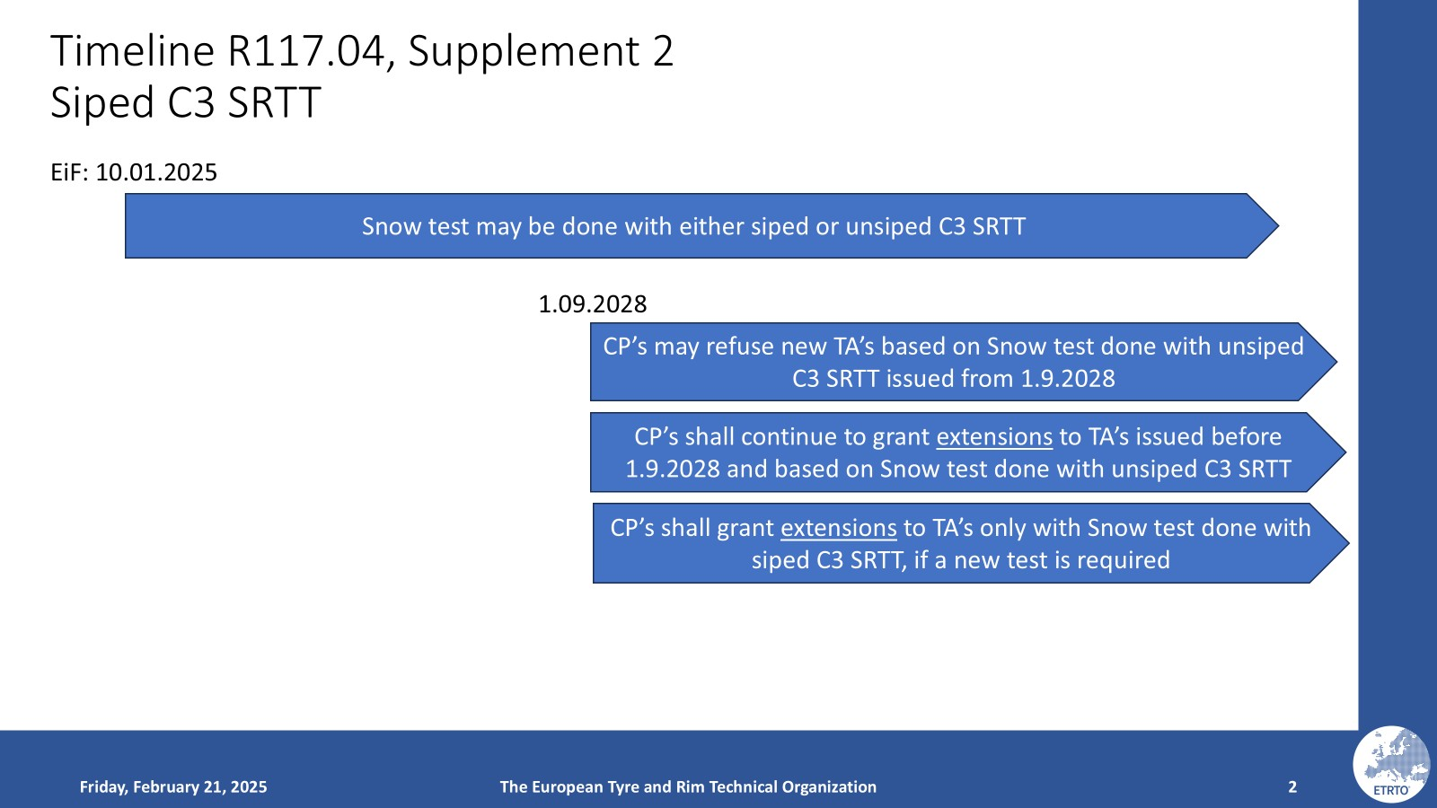
6. 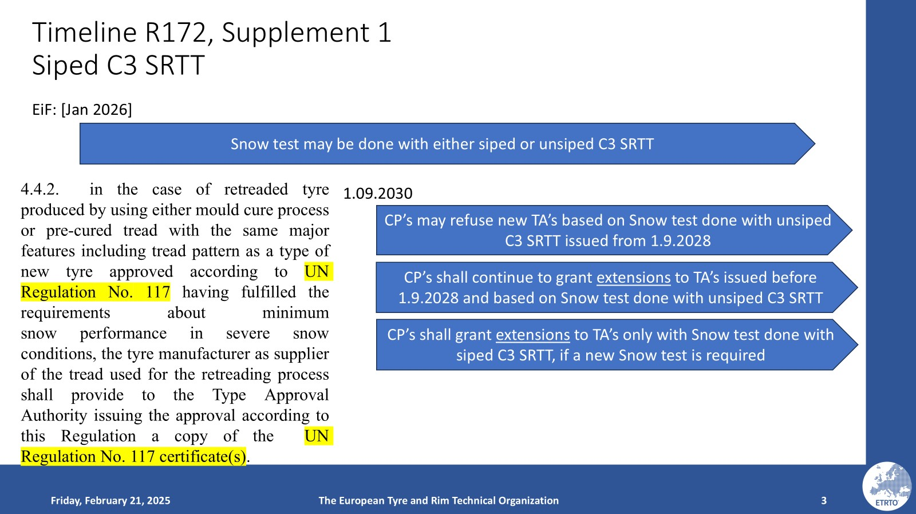

1. / If a tread pattern can be applied by mould cure and pre-cure retread processes, the snow test may be performed with a representative tyre size retreaded with only one of the two possible processes and the snow performance test report can be used for both cases as long as the major features of the tread are technically identical.