|  |  |  |  |
| --- | --- | --- | --- |
|  | United Nations | ECE/TRANS/WP.29/2025/54 | |
| _unlogo | **Economic and Social Council** | | Distr.: General  14 April 2025  Original: English |

**Economic Commission for Europe**

Inland Transport Committee

**World Forum for Harmonization of Vehicle Regulations**

**196th session**

Geneva, 24–27 June 2025

Item 4.6.9 of the provisional agenda

**1958 Agreement:**

**Consideration of draft amendments to existing**

**UN Regulations submitted by GRSP**

Proposal for supplement 1 to UN Regulation No. 170 (Child restraint systems for safer transport of children in buses and coaches)

Submitted by the Working Party on Passive Safety[[1]](#footnote-2)\*

The text reproduced below was adopted by the Working Party on Passive Safety (GRSP) at its seventy-sixth session (ECE/TRANS/WP.29/GRSP/76, paragraph 35). It is based on informal document GRSP-76-03-Rev.2. It is submitted to the World Forum for Harmonization of Vehicle Regulations (WP.29) and to the Administrative Committee (AC.1) for consideration at their June 2025 sessions.

*Introduction,* amend to read:

**"1. Introduction**

Child Restraint Systems (CRS) approved according to UN Regulation No. 129 or UN Regulation No. 44 which can be installed in vehicle seats using the 3-point belt type and/or ISOFIX attachments can be used.

The Requirements defined in this UN Regulation do not apply to CRS approved according to UN Regulation No. 129 or UN Regulation No.44.

In case that the vehicle seat is also intended to be used by an adult, the vehicle seats and its safety-belt anchorages shall be approved according to UN Regulation No. 14 and UN Regulation No. 80 or UN Regulation No. 17 if applicable."

*Paragraph 3.23.1. and 3.23.2.,* amend to read:

"3.23.1. "*Forward-facing seat*" means a seat which can be used while the vehicle is in motion and which faces towards the front of the vehicle in such a manner that the vertical plane of symmetry of the seat forms an angle of less than +10° or -10° with the vertical plane of symmetry of the vehicle.

3.23.2. "*Rearward-facing seat*" means a seat which can be used while the vehicle is in motion and which faces towards the rear of the vehicle in such a manner that the vertical plane of symmetry of the seat forms an angle of less than +10° or -10° with the vertical plane of symmetry of the vehicle."

*Paragraph 4.2.2.,* amend to read:

"4.2.2. Samples of the Child Restraint System requested by the Technical Service responsible for conducting the test;"

*Paragraph 4.2.3.,* amend to read:

"4.2.3. A 10-metre length of each type of strap used in the Child Restraint System;"

*Paragraph 5.2.,* amend to read:

"5.2. Integral Child Restraint Systems that can be used forward and rearward facing, shall have the following label permanently attached on the part hosting the child and visible to the person installing the Child Restraint System:

The manufacturer shall be permitted to include the word "months" to explain the symbol "M" in the label. The word "months" should be in a language commonly spoken in the country where the vehicle with the Child Restraint System is registered. More than one language is allowed.

**Figure 1  
Labels for a forward- and a rearward-facing child restraint system**

Minimum label size: 40 mm × 40 mm

[figure remains unchanged]

…

**Figure 2  
Label for a forward-facing child restraint system**

Minimum label size: 40 mm × 40 mm

[figure remains unchanged]"

*Paragraph 5.5.,* amend to read:

"5.5. Any removable insert, shall have a permanently attached label to indicate the brand, model and size range of the Child Restraint System to which it belongs. The minimum size of the label shall be 40 × 40 mm or the equivalent area. "

*Paragraph 5.6.,* amend to read:

"5.6. Child Restraint Systems shall have a permanently attached label to inform the user of the appropriate method of restraint of the child over the entire stature range declared by the manufacturer. The label shall be visible to the person installing the child restraint system in a vehicle and when a child is seated in the restraint. The label shall have a minimum size of 40 × 60 mm or the equivalent area and shall feature a pictogram of each restraint configuration adjacent to the stature range.

If the Child Restraint System is to be used in combination with an impact shield and/or inserts, the information on where they are stowed shall be available."

*Paragraph 7.2.1.5.,* amend to read:

"7.2.1.5. All restraint devices utilizing a lap strap shall positively guide the lap strap to ensure that the loads transmitted by the lap strap are transmitted through the pelvis. The assembly shall not subject weak parts of the child’s body (abdomen, crotch, etc.) to excessive stresses.

In the case of non-integral Child restraint Systems, the lap portion of the adult safety-belt shall be positively guided on both sides to ensure that the loads transmitted by the adult lap belt are transmitted through the pelvis. The positive guidance of loads over the pelvis shall be realized from the moment that the child is installed; the lap belt shall pass over the top of the thigh, just touching the fold with the pelvis. The angles α and β between the tangent line in which the belt touches the thighs and the horizontal shall be greater than 10° as show in in figure 3.

**Figure 3  
Strapped-in child**

[figure remains unchanged]

…"

*Paragraph 7.3.3.,* amend to read:

"7.3.3. Internal geometric characteristics

The Technical Service conducting the approval tests shall verify that the internal dimensions of the Child Restraint System conform to the requirements of Annex 3. The minimum dimensions for shoulder breadth, hip breadth and sitting height shall be fulfilled simultaneously for any stature within the size range declared by the manufacturer.

Integral Child Restraint System shall also fulfil the minimum and maximum dimensions of shoulder height, for any stature within the size range declared by the manufacturer.

Integral Child Restraint Systems that feature an impact shield shall also be capable of being adjusted to fulfil:

(a) The 5th percentile upper leg thickness and 5th percentile abdomen depth, simultaneously to the 5th percentile shoulder height;

(b) The 95th percentile upper leg thickness and 95th percentile abdomen depth, simultaneously to the 95th percentile shoulder height, shoulder breadth, hip breadth and sitting height.

For any stature within the size range declared by the manufacturer.

Non-integral Child Restraint System shall also fulfil the maximum dimensions of shoulder height, for any stature within the size range declared by the manufacturer."

*Paragraph 8.1.3.1.,* amend to read:

"8.1.3.1. The metal items of the Child Restraint System shall be positioned in a test chamber as prescribed in Annex 4. In the case of a Child Restraint System incorporating a retractor, the strap shall be unwound to full length less 100 ± 3 mm. Except for short interruptions that may be necessary, for example, to check and replenish the salt solution, the exposure test shall proceed continuously for a period of 50 ± 0.5 hours."

*Paragraph 8.1.3.2*, amend to read:

"8.1.3.2. On completion of the exposure test the metal items of the Child Restraint System shall be gently washed, or dipped, in clean running water with a temperature not higher than 38 °C to remove any salt deposit that may have formed and then allowed to dry at room temperature of 18 °C to 25 °C for 24 ± 1 hours before inspection in accordance with paragraph 8.1.2 above."

*Paragraph 8.3.4.,* amend to read:

"8.3.4. In the case of a Child Restraint System making use of a shoulder strap positioner, the dynamic test shall be carried out as follows:"

*Paragraph 8.3.6.5.1., Table 1,* amend as follows:

In the first row, for column "Criterion", replace "in vehicle testing" by "during in-vehicle testing".

*Paragraph 8.3.6.6.1. and 8.3.6.6.1.1.,* amend to read:

"8.3.6.6.1. No part of the head of the dummy shall pass beyond the planes BA as defined in Figure 4 below.

…

8.3.6.6.1.1. …

**Figure 4  
Arrangement for testing a forward-facing device**

[figure remains unchanged]"

*Paragraph 8.3.6.6.2.,* amend to read:

"8.3.6.6.2. During the dynamic tests, no part of the Child Restraint System restraining the child in position shall fail. This includes buckles, locking systems and reclining systems, except were identified as a load limiting device."

*Paragraph 8.3.7.1.1.9.1., heading,* amend to read:

"8.3.7.1.1.9.1. Installation of Integral Child Restraint Systems."

*Paragraph 8.3.7.1.1.9.1., Table 2 heading,* amend to read:

**"Table 2  
Height of the Spacer"**

*Paragraph 8.3.7.1.1.9.2.,* amend to read:

"8.3.7.1.1.9.2. Installation of non-Integral Child Restraint Systems.

The dummy shall be placed in the Child Restraint System.

Pull the upper torso webbing out of the retractor horizontally at a position via the centre of the dummy and allow it to retract. Repeat this operation four times. The shoulder belt should be at the position between the area which shall not be taken off from shoulder and shall not contact with the neck. Apply a 9 N to 18 N tension load to the lap belt. Allow the excess webbing in the shoulder belt to be retracted by the rewind force of the retractor."

*Paragraph 8.3.7.1.1.9.3.,* amend to read:

"8.3.7.1.1.9.3. …

Example for arm alignment is show in in Figure 5:

**Figure 5  
Examples of arm alignment**

[figure remains unchanged]"

*Paragraph 8.4.1.7.1.1.,* amend to read:

"8.4.1.7.1.1. A Child Restraint Systems System having already undergone the dynamic test prescribed in paragraph 8.3. below shall be used for this test."

*Paragraph 8.4.1.7.3.3.1.,* amend to read:

"8.4.1.7.3.3.1. For the strength test two samples have to be used. All adjusters, except for adjusters mounted directly on a Child Restraint System are included in the test."

*Paragraph 8.4.2.9.1.,* amend to read:

"8.4.2.9.1. Conditioning test for adjusters connected to a strap (not directly mounted to the Child Restraint System).

…"

*Paragraph* 8.4.4.3.6.2.2.,amend to read:

"8.4.4.3.6.2.2. After exposure, the strap shall be kept for a minimum of 24 hours in an atmosphere having a temperature of 23 °C **±** 5 °C and a relative humidity of 50 ± 10 per cent. The breaking load shall be determined within five minutes after the removal of the strap from the conditioning installation."

*Paragraph 8.4.5.1.,* amend to read:

"8.4.5.1. Buckle assemblies, retractors, adjusters and lock-off devices that are liable to be affected by temperature, shall be subject to the temperature test specified in paragraph 8.4.5.3. below. This requirement is applicable to any such components that are found on the Child Restraint System, regardless of the means of restraint."

"*Annex 2,* amend to read:

**"Annex 2**

**Arrangements of Approval Marks**

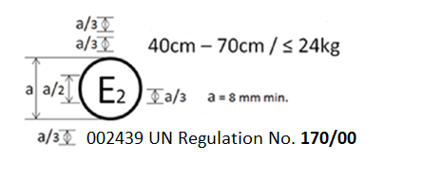

The Child Restraint Systems which bear the above approval mark is a device used for 40 cm – 70 cm size range and mass limit of 24 kg; it is approved in France (E 2) under the number 002439. The approval number indicates that the approval was granted in accordance with the requirements of the UN Regulation concerning the approval of Child Restraint Systems for the Safer Transport of Children in Buses and Coaches as amended by the 00 series of amendments. In addition the name of the regulation has to be identified on the approval mark followed by the series of amendment according to which the approval has been granted."

*Annex 3,* amend to read:

**"Annex 3**

**Internal Measurements**

**Figure 1  
Child dimension**

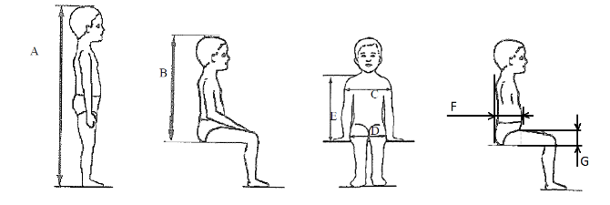

|  |  |  |  |  |  |  |  |  |  |  |
| --- | --- | --- | --- | --- | --- | --- | --- | --- | --- | --- |
| *Applicable to all CRS* | | | | | |  | *Additional internal dimensions for CRS with impact shields systems* | | | |
| *Stature* | *Min* | *Min* | *Min* | *Min* | *Max* |  | *Min* | *Max* | *Min* | *Max* |
| *Sitting height cm* | *Shoulder breadth cm* | *Hip breadth cm* | *Shoulder height cm* | *Shoulder height cm* |  | *Abdomen depth cm* | *Abdomen depth cm* | *Upper leg thickness cm* | *Upper leg thickness cm* |
| *A* | *B* | *C* | *D* | *E1* | *E2* |  | *F1* | *F2* | *G1* | *G2* |
|  | *95th percentile* | *95th percentile* | *95th percentile* | *5th percentile* | *95 percentile* |  | *5th percentile* | *95 percentile* | *5th percentile* | *95th percentile* |
| ≤ 40 |  |  |  | < 27.4 |  |  | Not allowed for these dimensions and stature below 76 cm | | | |
| 45 | 39.0 | 12.1 | 14.2 | 27.4 | 29.0 |  |
| 50 | 40.5 | 14.1 | 14.8 | 27.6 | 29.2 |  |
| 55 | 42.0 | 16.1 | 15.4 | 27.8 | 29.4 |  |
| 60 | 43.5 | 18.1 | 16.0 | 28.0 | 29.6 |  |
| 65 | 45.0 | 20.1 | 17.2 | 28.2 | 229.8 |  |
| 70 | 47.1 | 22.1 | 18.4 | 28.3 | 30.0 |  |
| 75 | 49.2 | 24.1 | 19.6 | 28.4 | 31.3 |  | 12.5 | 15.1 | 5.7 | 8.4 |
| 80 | 51.3 | 26.1 | 20.8 | 29.2 | 32.6 |  | 12.7 | 15.7 | 5.8 | 8.4 |
| 85 | 53.4 | 26.9 | 22.0 | 30.0 | 33.9 |  | 12.9 | 16.2 | 5.9 | 8.5 |
| 90 | 55.5 | 27.7 | 22.5 | 30.8 | 35.2 |  | 13.1 | 16.8 | 6.2 | 8.5 |
| 95 | 57.6 | 28.5 | 23.0 | 31.6 | 36.5 |  | 13.3 | 17.8 | 6.5 | 8.9 |
| 100 | 59.7 | 29.3 | 23.5 | 32.4 | 37.8 |  | 13.5 | 18.2 | 6.5 | 9.6 |
| 105 | 61.8 | 30.1 | 24.9 | 33.2 | 39.1 |  | 13.6 | 18.8 | 6.6 | 10.3 |
| 110 | 63.9 | 30.9 | 26.3 | 34.0 | 40.4 |  | 13.9 | 19.6 | 6.6 | 10.3 |
| 115 | 66.0 | 32.1 | 27.7 | 35.5 | 41.7 |  | 13.9 | 19.9 | 6.6 | 10.4 |
| 120 | 68.1 | 33.3 | 29.1 | 37.0 | 43.0 |  | 14.3 | 20.2 | 6.8 | 10.5 |
| 125 | 70.2 | 33.3 | 29.1 | 38.5 | 44.3 |  | 14.7 | 20.7 | 7.5 | 10.9 |
| 130 | 72.3 | 33.3 | 29.1 | 40.0 | 46.1 |  | Not allowed for these dimensions and stature over 125 cm | | | |
| 135 | 74.4 | 33.3 | 29.1 | 41.5 | 47.9 |  |
| 140 | 76.5 | 34.2 | 29.6 | 43.0 | 49.7 |  |
| 145 | 78.6 | 35.3 | 30.8 | 44.5 | 51.5 |  |
| 150 | 81.1 | 36.4 | 32.0 | 46.3 | 53.3 |  |

All lateral dimensions are measured under a contact force of 50 N with the devices  
described in Figure 2 and Figure 3 of this annex and the following tolerances will applied:

Minimum Sitting height:

(a) Up to 87 cm B – 5 per cent;

(b) From stature from 87 cm and up to 150 cm B – 10 per cent;

(c) Minimum shoulder height (5th percentile): E1 -2+0 cm;

Maximum shoulder height (95th percentile): E2 -0+2 cm;

The mass of the devices described in Figure 2 and Figure 3 of this annex shall be 10 kg ± 1 kg.

**Figure 2  
Measurement device for child restraint systems – side and front view of the measuring device**

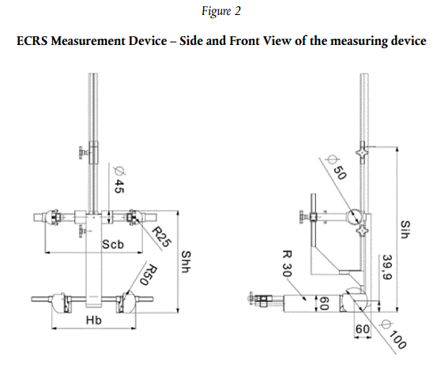

**Figure 3  
Side and front view of the measuring device for measurements of child restraint systems that feature an impact shield**

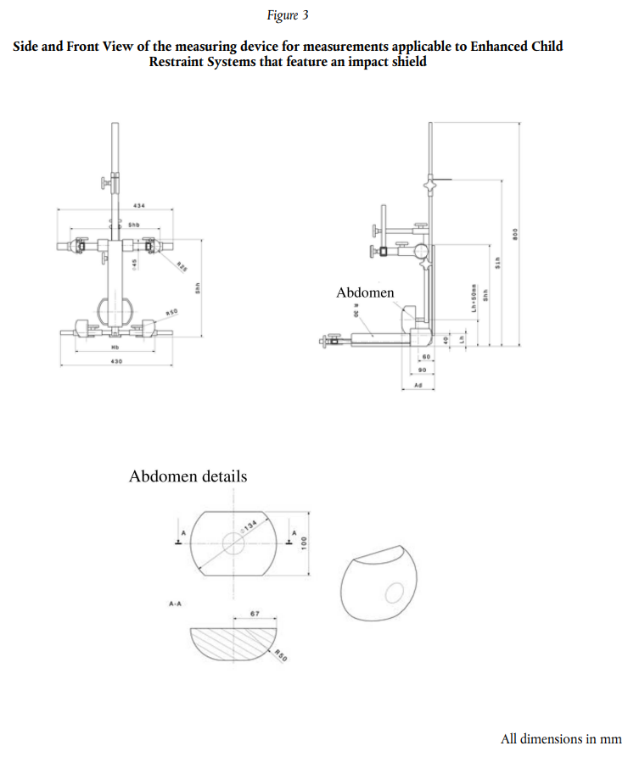"

Abdomen

Abdomen details

All dimensions in mm

*Annex 6, Appendix 2, paragraph 1.2., first paragraph,* amend to read:

"1.2. If that is not the case, a calculation of the value of HPC is made, on the basis of the acceleration (a)1, by the following expression:"

*Annex 6, Appendix 2, paragraph 1.2.,* insert footnote 1 to read:

"1 The acceleration (a) referring to the centre of gravity is calculated from the triaxial components of the acceleration measured with a CFC of 1 000."

*Annex 8, paragraph 1.,* amend to read:

"1. Conditioning for adjusters mounted directly on Child Restraint Systems (Figure 1)"

*Annex 8, paragraph 1.1.2.,* amend to read:

"1.1.2. Attach the adjuster part of the integral harness to the pulling device A."

*Annex 9,* amend to read:

**"Annex 9**

**Micro Slip**

**Figure 1  
Micro slip test method**

Total travel 300 ± 20 mm

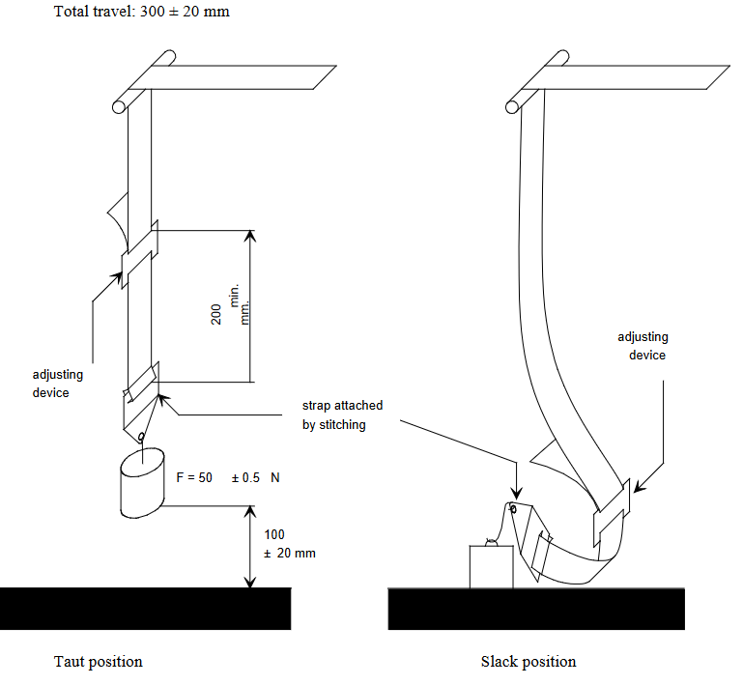

Adjusting device

Slack position

Taut position

Adjusting device

Strap attached by stitching

…"

*Annex 10, figure 2, example 2,* amend to read:

"Example 2

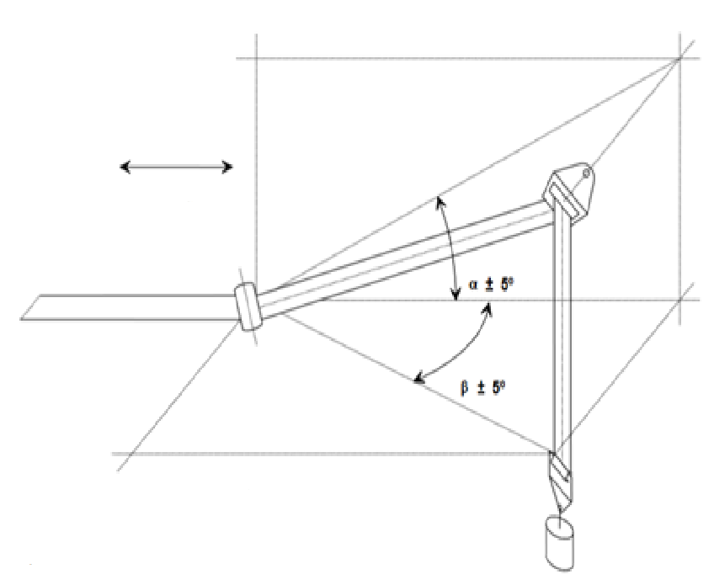

Total travel:

300 ± 20 mm

Test in a guide or pulley

Minimum F= 10 ± 0.1 N

Where α and β reproduce the angles as in the real installation (in the three dimensions)"

1. \* In accordance with the programme of work of the Inland Transport Committee for 2025 as outlined in proposed programme budget for 2025 (A/79/6 (Sect. 20), table 20.6), the World Forum will develop, harmonize and update UN Regulations in order to enhance the performance of vehicles. The present document is submitted in conformity with that mandate. [↑](#footnote-ref-2)