|  |  |  |  |
| --- | --- | --- | --- |
|  | United Nations | ECE/TRANS/WP.29/GRE/2025/17 | |
| Description: _unlogo | **Economic and Social Council** | | Distr.: General  7 August 2025  Original: English |

**Economic Commission for Europe**

Inland Transport Committee

**World Forum for Harmonization of Vehicle Regulations**

**Working Party on Lighting and Light-Signalling**

**Ninety-third session**

Geneva, 21-23 October 2025

Item 5 of the provisional agenda

**UN Regulations on Light Sources and the Consolidated Resolution on the Common Specification of Light Source Categories**

Proposal for Amendment [12] to the Consolidated Resolution on the common specification of light source categories

Submitted by the Task Force on Substitutes and Retrofits[[1]](#footnote-2)\*

The text reproduced below was prepared by the Task Force on Substitutes and Retrofits (TF SR), with the aim to amend the Consolidated Resolution on the common specification of light source categories (R.E.5) (ECE/TRANS/WP.29/1127) and its subsequent amendments 1 through 11, to introduce new light emitting diode (LED) replacement light source categories H8, H16 and HB4, whereof the H8 proposal is based on GRE-92-08, presented at the ninety-second session of the Working Party on Lighting and Light-Signalling (GRE).

The dedicated specifications were derived from the enforced H11\_LEDr category sheet and – based on the established equivalence criteria as detailed in document GRE-83-15 – adapted to the specifications of the corresponding filament light source categories. The proposal for the three categories uses the established bi-directional equivalence concept.

The modifications to the existing text of the Resolution are marked in bold for new or strikethrough for deleted characters.

There are no associated amendments to UN Regulation No. 37.

I. Proposal

The *Status table*, insert a new row at the bottom to read:

“

|  |  |  |  |  |
| --- | --- | --- | --- | --- |
| *Version of the Resolution* | *Date \* as from which the version is valid* | *Adopted by WP.29* | | *Clarification* |
| *Session No.* | *Amendment document No.* |
| 1 **(**Original**)** | 22.06.2017 | 170 | ECE/TRANS/WP.29/2016/111 | Based upon Annexes 1 of Regulations:   * No. 37, up to and including Supplement 44 * No. 99, up to and including Supplement 11 * No. 128, up to and including Supplement 5 |
| …. |  |  |  |  |
| 9 | 08.03.2023 | 189 | ECE/TRANS/WP.29/2023/41 | Amended detail in sheets:  H19/1, H19/2, H19/4, H19/5, L1/5  Amended detail in LED light source sheet LR4/2  Introduction of new LED light source categories LW6A, LW6B, LY6A and LY6B |
| **10** | **13.11.2024** | **194** | **ECE/TRANS/WP.29/2024/156** | **Amended detail in sheets H11\_LEDr/3, H11\_LEDr/6, H11\_LEDr/7 to introduce Configuration-2** |
| **11** | **05.03.2025** | **195** | **ECE/TRANS/WP.29/2025/40** | **Introduction of new LED light source categories LW7A and LW7B** |
| **[12]** | **[xx.xx.2026]** | **[xxx]** | **[ECE/TRANS/WP.29/2026/xx]** | **Introduction of new LED replacement light source categories H8, H16 and HB4** |

“

*Paragraph 3.3., Group 5*, amends to read:

“

|  |  |
| --- | --- |
| ***Group 5*** | |
| ***LED replacement light source categories3, 4 only for use in lamps approved with filament light source(s) with the same category designation*** | |
| ***Category*** | ***Sheet number(s)*** |
| C5W | C5W\_LEDr/1 to 4 |
| **H8** | **H8\_LEDr/1 to 7** |
| H11 | H11\_LEDr/1 to 7 |
| **H16** | **H16\_LEDr/1 to 7** |
| **HB4** | **HB4\_LEDr/1 to 7** |

”

*Annex 3, sheets for LED light sources,* amend the listing to read:

*“*List of sheets for LED light sources and their sequence in this annex:

|  | *Sheet number(s)* |  |
| --- | --- | --- |
|  | C5W/LED/1 to 4 |  |
|  | C5W\_LEDr/1 to 4 |  |
|  | **H8\_LEDr/1 to 7** |  |
|  | H11/LED/1 to 7 |  |
|  | H11\_LEDr/1 to 7 |  |
|  | **H16\_LEDr/1 to 7** |  |
|  | **HB4\_LEDr/1 to 7** |  |
|  | L1/1 to 5 |  |
|  | … |  |

”

*Annex 3,*

*After sheet C5W\_LEDr/4,* insert new sheets H8\_LEDr/1 to 7, and

*After sheet H11\_LEDr/7,* insert new sheets H16\_LEDr/1 to 7 and HB4\_LEDr/1 to 7, to read:

(see following pages; one page per sheet)

**Category H8 Sheet H8\_LEDr/1**

The drawings are intended only to illustrate the essential dimensions (in mm) of the LED light source.

Figure 1

**Main drawings**

# 

Tcap 5/

View C

View A

Reference plane 1/

Reference axis 2/

A

B

e

f

4/

Figure 2

**Maximum LED light source outline 3/**

35

**∅**15.0

25.0

4

44.0

**∅**19.0

**∅**25.0

**∅** 50

50°

Reference plane

Reference axis

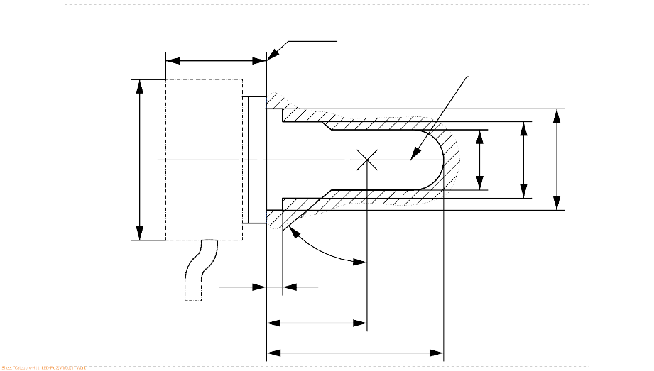

1/ The reference plane is the plane formed by the underside of the bevelled lead-in flange of the cap.

2/ The reference axis is perpendicular to the reference plane and passing through the centre of the 19 mm cap diameter.

3/ The LED light source shall not exceed the envelope as indicated in Figure 2.

4/ The light source shall function in either voltage polarity.

5/ Measurement point for cap temperature Tcap

**Category H8 Sheet H8\_LEDr/2**

Table 1

**Essential electrical and photometrical characteristics of the LED light source**

| *Dimensions in mm* | | | *LED light sources of normal production* |
| --- | --- | --- | --- |
| e 2/ | | | 25.0 nom. |
| f 2/ | | | 3.7 nom. |
| Contrast 4/ | | | 100 min. |
| Elevated ambient air temperature 3/ | | | 60°C |
| Cap H8 PGJ19-1 6/ in accordance with IEC Publication 60061 (sheet 7004-110-3) | | | |
| *Electrical and photometric characteristics 9/* | | | |
| Rated values | | Volts | 12 |
| Watts | 18 8/ |
| Test voltage (DC) | | Volts | 13.2 |
| Objective values | Power | Watts | 18 min. 7/  43 max. 8/ |
| Cap temperature Tcap | °C | 100 max. 7/ |
| Electrical current | mA | 1300 min. 7/  (at 12-14 V DC) |
| Luminous flux 1/ 3/ | lm | 800 ± 15% |
| Luminous flux deviation 5/  (voltage range limits) | lm | ±10% (at 12V)  ±10% (at 14V) |

1/ The light emitted shall be white or selective yellow without a correlated colour temperature restriction.

2/ To be checked by means of a "box system", sheet H8 LEDr/3

3/ The luminous flux measured at the elevated ambient air temperature shall be at least 75% of the objective luminous flux (both measured at test voltage)

4/ The contrast is the proportion of luminous flux originating from two different areas, see details in sheet H8\_LEDr/3

5/ The maximum luminous flux deviation at the tolerance limits is calculated by using the measured flux at test voltage as reference. The luminous flux behaviour shall be substantially uniform within the specified voltage range.

6/ The maximum specifications of parameters G and K are excluded, but the maximum outline dimensions in Figure 2 apply

7/ Not applicable for high-efficiency type

8/ For high-efficiency type 12W rated value and 18W max. objective value applies

9/ In case of LED light source failure (no light emitted) the max. electrical current draw, when operated between 12V and 14V, shall be less than 100 mA (open circuit condition)

**Category H8 Sheet H8\_LEDr/3**

Screen projection requirements

The following test is intended to define the requirements for the apparent light emitting area of the LED light source and to determine whether the light emitting area is correctly positioned relative to the reference axis and reference plane in order to check compliance with the requirements.

The position of the light emitting area is checked by a box system defined in Figure 3 when operated at test voltage, which shows the projections when viewing from A and –A (see sheet H8\_LEDr/1, Figure 1), i.e. along the C-planes C90 and C270 (as defined in Figure 5). The distance z between the surfaces of the opposite light emitting areas shall not exceed 2.9 mm.

The proportion of the total luminous flux emitted into these viewing directions from the area(s) as defined in Figure 3:

* Total box area: (A+B+C) / E shall be not less than 90%
* Area A: A / (A+B+C) shall be not more than 14%
* Areas B1, B2 and B3: B1/B, B2/B, B3/B shall each be not less than 15%
* Area B: B / (A+B+C) shall be not less than 65 %
* Area C: C / (A+B+C) shall be not more than 27%

Figure 3

**Box definition of the light emitting area (dimensions given in Table 2)**

c1

x1

x2

c2

b1

b2

y1

y1

e

a1/2

a2

**E**

**B1**

**B2**

**B3**

**C**

**B**

**A**

Reference axis

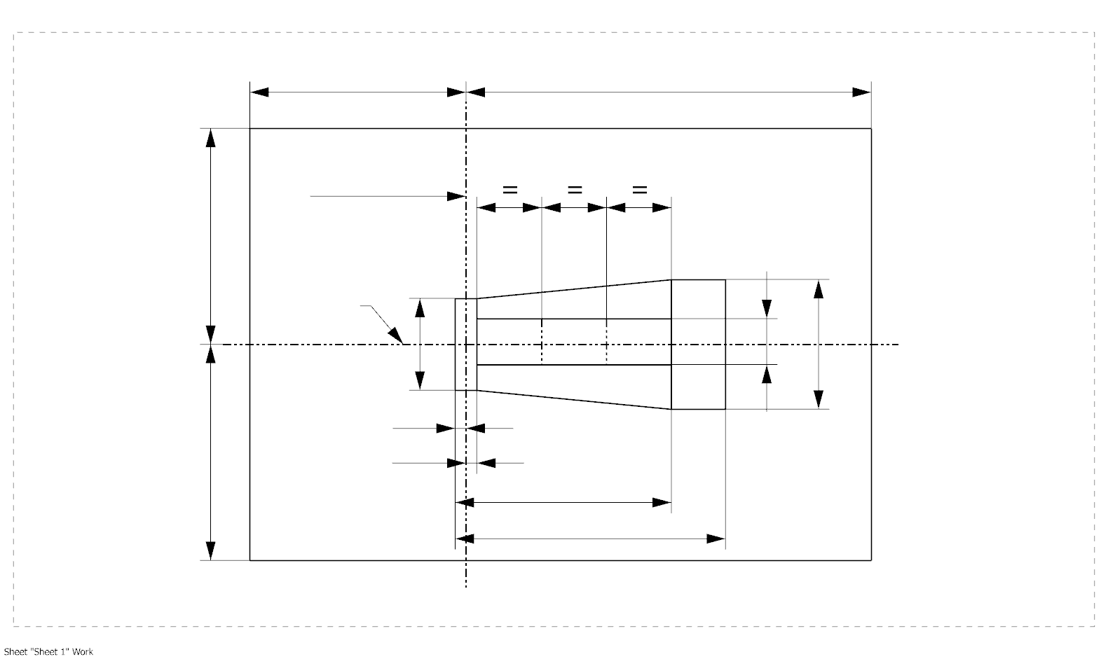

a1

The contrast is checked by a box system defined in Figure 4 when operated at test voltage, which shows the projections when viewing from A and –A (see sheet H8\_LEDr/1, Figure 1), i.e. along the C-planes C90 and C270 (as defined in Figure 5).

**Category H8 Sheet H8\_LEDr/4**

The contrast is the proportion of the total luminous flux values emitted into these viewing directions from the corresponding areas (A+B+C) and D. The value of the contrast (A+B+C) / D shall be within the limits given in Table 1 (see Figure 4 for the definition of the area D).

Figure 4

**Box definition of the area D (dimensions given in Table 2)**

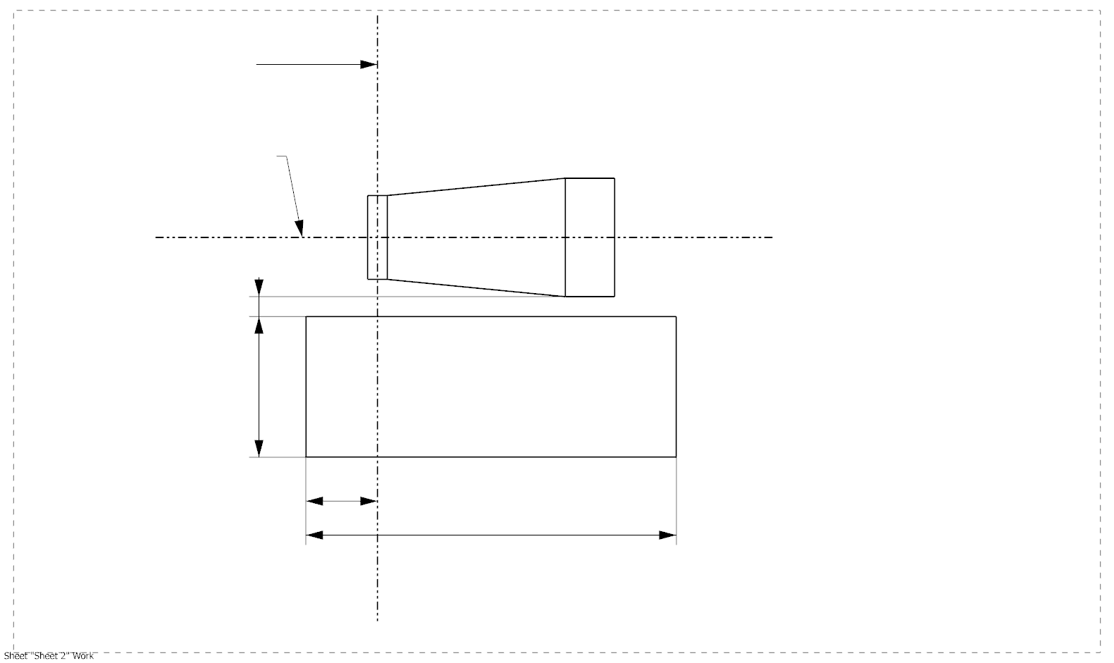

g2

g3

d

g1

**A**

**D**

**C**

**B**

e

Reference axis

Table 2

**Dimensions of the box definitions in Figure 3 and Figure 4**

|  |  |  |  |
| --- | --- | --- | --- |
| *All views*  *(as specified above)* | *Dimensions in mm* | *All views*  *(as specified above)* | *Dimensions in mm* |
| a1 | 1.7 | x1 | 25 |
| a2 | 1.9 | x2 | 19 |
| b1 | 0.25 | y1 | 12.5 |
| b2 | 0.25 | g1 | 2.85 |
| c1 | 4.6 | g2 | 6.9 |
| c2 | 3.5 | g3 | 1.4 |
| d | 0.4 |  | |

**Category H8 Sheet H8\_LEDr/5**

Normalized luminous intensity distribution

The following test is intended to determine the normalized luminous intensity distribution of the light source in the C-planes as described in Figure 5 when operated at test voltage. The intersection of the reference axis and the plane parallel to the reference plane at distance e = 25.0 mm is used as the coordinate system origin.

The light source is mounted on a flat plate with the corresponding holder features. The plate is fixed to the goniometer table by a bracket, so that the reference axis of the light source lines up with one of the rotating axis of the goniometer. The corresponding measurement set-up is described in Figure 5.

Luminous intensity data is recorded with a standard photo-goniometer. The measurement distance should be chosen appropriately in order to make sure that the detector is located in the far field of the light distribution.

The measurements shall be performed in C-planes for which the line of intersection coincides with the reference axis of the light source. The test points for each plane and polar angles γ are specified in Table 3.

The measured luminous intensity values, normalised to the measured luminous flux of the individual light source under test, shall be converted to normalised luminous intensity values of a 1000 lm light source. These data shall comply with the limits as defined in Table 3.

Figure 5

**Setup to measure the luminous intensity distribution and the definition of C-Planes and angle **

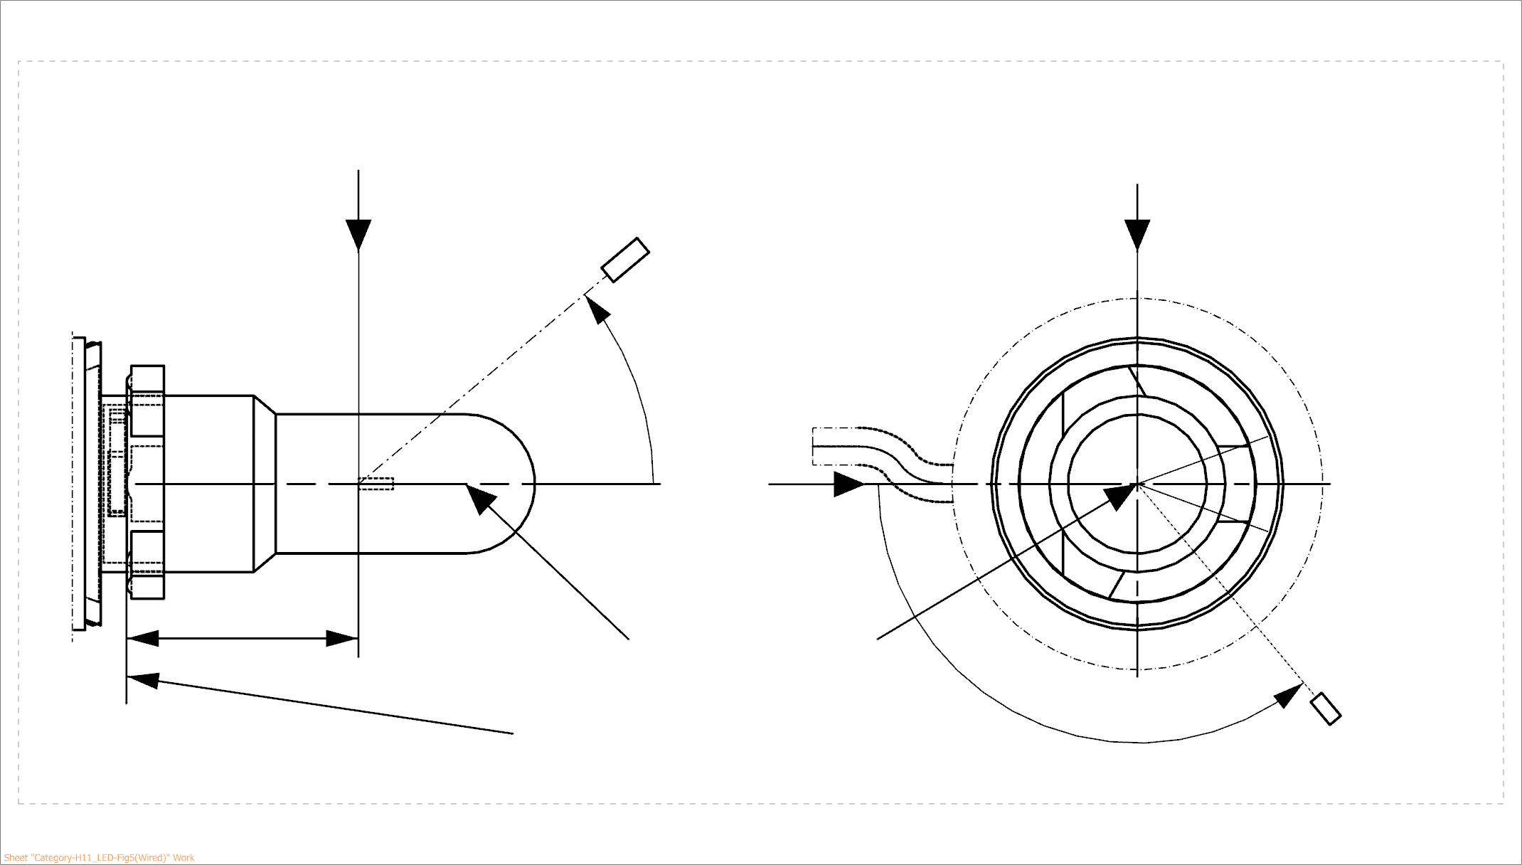

25,0

***View from B***

***View from C***

Reference plane

Reference axis

**B**

**A**

C = 270°

C = 90°

C = 180°

**C**

C = 0°

****

**A**

Photo-Detector of Goniometer

C-planes: see CIE publication 70-1987, "The measurement of absolute intensity distributions".

**Category H8 Sheet H8\_LEDr/6**

Table 3 – Part 1

**Test point values of normalized intensity**

|  |  |  |
| --- | --- | --- |
| *LED light source of normal production* | | |
|  | *Minimum intensity (cd/klm)* | *Maximum intensity (cd/klm)* |
|  | C0, C90, C180, C270 | C0, C90, C180, C270 |
| 0° | n/a | 10 |
| 10° | n/a | 10 |
| 20° | n/a | 10 |
| 30° | n/a | 10 |

The light pattern as described in Table 3 – part 1 shall be substantially uniform, i.e. in between two adjacent grid points the relative luminous intensity requirement is calculated by linear interpolation using the two adjacent grid points. In case of doubt this may be checked in addition to verification of the grid points given in Table 3 – part 1.

Table 3 – Part 2

**Test point values of normalized intensity**

|  |  |  |
| --- | --- | --- |
|  | *LED light source of normal production* | |
|  | *Minimum intensity (cd/klm)* | *Maximum intensity (cd/klm)* |
|  | C90, C270 | C90, C270 |
| 50° | 100 | 160 |
| 60° | 115 | 175 |
| 70° | 125 | 185 |
| 80° | 130 | 190 |
| 90° | 130 | 195 |
| 100° | 130 | 190 |
| 110° | 125 | 185 |
| 120° | 115 | 175 |
| 130° | 100 | 160 |
| 140° | 80 | 145 |

The light pattern as described in Table 3 – part 2 (excluding the sections between C90 and C270 and between C270 and C90) shall be substantially uniform, i.e. in between two adjacent grid points the relative luminous intensity requirement is calculated by linear interpolation using the two adjacent grid points. In case of doubt this may be checked in addition to verification of the grid points given in Table 3 – part 2.

**Category H8 Sheet H8\_LEDr/7**

Table 3 – Part 3

**Test point values of normalized intensity**

|  |  |  |
| --- | --- | --- |
|  | *LED light source of normal production* | |
|  | *Minimum intensity (cd/klm)* | *Maximum intensity (cd/klm)* |
| C-plane |  = 90° |  = 90° |
| C0 | n.a. | n.a. |
| C30 | 50 | 130 |
| C60 | 110 | 175 |
| C90 | 130 | 195 |
| C120 | 110 | 175 |
| C150 | 50 | 130 |
| C180 | n.a. | n.a. |
| C210 | 50 | 130 |
| C240 | 110 | 175 |
| C270 | 130 | 195 |
| C300 | 110 | 175 |
| C330 | 50 | 130 |
| C360 (= C0) | n.a. | n.a. |

The light pattern as described in Table 3 – part 3 (excluding the sections between C150 and C210 and between C330 and C30) shall be substantially uniform, i.e. in between two adjacent grid points the relative luminous intensity requirement is calculated by linear interpolation using the two adjacent grid points. In case of doubt this may be checked in addition to verification of the grid points given in Table 3 – part 3.

**Category H16 Sheet H16\_LEDr/1**

The drawings are intended only to illustrate the essential dimensions (in mm) of the LED light source.

Figure 1

**Main drawings**

# Ein Bild, das Entwurf, Diagramm, Zeichnung, technische Zeichnung enthält. KI-generierte Inhalte können fehlerhaft sein.

Tcap 5/

**View C**

**View A**

Reference plane 1/

Reference axis 2/

A

B

e

f

4/

Figure 2

**Maximum LED light source outline 3/**

35

**∅**15.0

25.0

4

44.0

**∅**19.0

**∅**25.0

**∅** 50

50°

Reference plane

Reference axis

Ein Bild, das Diagramm, Entwurf, technische Zeichnung, Zeichnung enthält.

1/ The reference plane is the plane formed by the underside of the bevelled lead-in flange of the cap.

2/ The reference axis is perpendicular to the reference plane and passing through the centre of the 19 mm cap diameter.

3/ The LED light source shall not exceed the envelope as indicated in Figure 2.

4/ The light source shall function in either voltage polarity.

5/ Measurement point for cap temperature Tcap

**Category H16 Sheet H16\_LEDr/2**

Table 1

**Essential electrical and photometrical characteristics of the LED light source**

| *Dimensions in mm* | | | *LED light sources of normal production* |
| --- | --- | --- | --- |
| e 2/ | | | 25.0 nom. |
| f 2/ | | | 3.2 nom. |
| Contrast 4/ | | | 100 min. |
| Elevated ambient air temperature 3/ | | | 60°C |
| Cap H16 PGJ19-3 6/ in accordance with IEC Publication 60061 (sheet 7004-110-3) | | | |
| *Electrical and photometric characteristics 9/* | | | |
| Rated values | | Volts | 12 |
| Watts | 10 8/ |
| Test voltage (DC) | | Volts | 13.2 |
| Objective values | Power | Watts | 10 min. 7/  26 max. 8/ |
| Cap temperature Tcap | °C | 100 max. 7/ |
| Electrical current | mA | 750 min. 7/  (at 12-14 V DC) |
| Luminous flux 1/ 3/ | lm | 500 + 10% / -15% |
| Luminous flux deviation 5/  (voltage range limits) | lm | ±10% (at 12V)  ±10% (at 14V) |

1/ The light emitted shall be white or selective yellow without a correlated colour temperature restriction.

2/ To be checked by means of a "box system", sheet H16\_LEDr/3

3/ The luminous flux measured at the elevated ambient air temperature shall be at least 75% of the objective luminous flux (both measured at test voltage)

4/ The contrast is the proportion of luminous flux originating from two different areas, see details in sheet H16\_LEDr/3

5/ The maximum luminous flux deviation at the tolerance limits is calculated by using the measured flux at test voltage as reference. The luminous flux behaviour shall be substantially uniform within the specified voltage range.

6/ The maximum specifications of parameters G and K are excluded, but the maximum outline dimensions in Figure 2 apply

7/ Not applicable for high-efficiency type

8/ For high-efficiency type 8W rated value and 10W max. objective value applies

9/ In case of LED light source failure (no light emitted) the max. electrical current draw, when operated between 12V and 14V, shall be less than 100 mA (open circuit condition)

**Category H16 Sheet H16\_LEDr/3**

Screen projection requirements

The following test is intended to define the requirements for the apparent light emitting area of the LED light source and to determine whether the light emitting area is correctly positioned relative to the reference axis and reference plane in order to check compliance with the requirements.

The position of the light emitting area is checked by a box system defined in Figure 3 when operated at test voltage, which shows the projections when viewing from A and –A (see sheet H16\_LEDr/1, Figure 1), i.e. along the C-planes C90 and C270 (as defined in Figure 5). The distance z between the surfaces of the opposite light emitting areas shall not exceed 2.9 mm.

The proportion of the total luminous flux emitted into these viewing directions from the area(s) as defined in Figure 3:

* Total box area: (A+B+C) / E shall be not less than 90%
* Area A: A / (A+B+C) shall be not more than 19%
* Areas B1, B2 and B3: B1/B, B2/B, B3/B shall each be not less than 15%
* Area B: B / (A+B+C) shall be not less than 58 %
* Area C: C / (A+B+C) shall be not more than 32%

Figure 3

**Box definition of the light emitting area (dimensions given in Table 2)**

c1

x1

x2

c2

b1

b2

y1

y1

e

a1/2

a2

**E**

**B1**

**B2**

**B3**

**C**

**B**

**A**

Reference axis



a1

The contrast is checked by a box system defined in Figure 4 when operated at test voltage, which shows the projections when viewing from A and –A (see sheet H16\_LEDr/1, Figure 1), i.e. along the C-planes C90 and C270 (as defined in Figure 5).

**Category H16 Sheet H16\_LEDr/4**

The contrast is the proportion of the total luminous flux values emitted into these viewing directions from the corresponding areas (A+B+C) and D. The value of the contrast (A+B+C) / D shall be within the limits given in Table 1 (see Figure 4 for the definition of the area D).

Figure 4

**Box definition of the area D (dimensions given in Table 2)**



g2

g3

d

g1

**A**

**D**

**C**

**B**

e

Reference axis

Table 2

**Dimensions of the box definitions in Figure 3 and Figure 4**

|  |  |  |  |
| --- | --- | --- | --- |
| *All views*  *(as specified above)* | *Dimensions in mm* | *All views*  *(as specified above)* | *Dimensions in mm* |
| a1 | 1.6 | x1 | 25 |
| a2 | 1.8 | x2 | 19 |
| b1 | 0.25 | y1 | 12.5 |
| b2 | 0.25 | g1 | 2.7 |
| c1 | 3.6 | g2 | 5.4 |
| c2 | 2.6 | g3 | 1.15 |
| d | 0.4 |  | |

**Category H16 Sheet H16\_LEDr/5**

Normalized luminous intensity distribution

The following test is intended to determine the normalized luminous intensity distribution of the light source in the C-planes as described in Figure 5 when operated at test voltage. The intersection of the reference axis and the plane parallel to the reference plane at distance e = 25.0 mm is used as the coordinate system origin.

The light source is mounted on a flat plate with the corresponding holder features. The plate is fixed to the goniometer table by a bracket, so that the reference axis of the light source lines up with one of the rotating axis of the goniometer. The corresponding measurement set-up is described in Figure 5.

Luminous intensity data is recorded with a standard photo-goniometer. The measurement distance should be chosen appropriately in order to make sure that the detector is located in the far field of the light distribution.

The measurements shall be performed in C-planes for which the line of intersection coincides with the reference axis of the light source. The test points for each plane and polar angles γ are specified in Table 3.

The measured luminous intensity values, normalised to the measured luminous flux of the individual light source under test, shall be converted to normalised luminous intensity values of a 1000 lm light source. These data shall comply with the limits as defined in Table 3.

Figure 5

**Setup to measure the luminous intensity distribution and the definition of C-Planes and angle **



25,0

***View B***

***View C***

Reference plane

Reference axis

**B**

**A**

C = 270°

C = 90°

C = 180°

**C**

C = 0°

****

**A**

Photo-Detector of Goniometer

C-planes: see CIE publication 70-1987, "The measurement of absolute intensity distributions".

**Category H16 Sheet H16\_LEDr/6**

Table 3 – Part 1

**Test point values of normalized intensity**

|  |  |  |
| --- | --- | --- |
| *LED light source of normal production* | | |
|  | *Minimum intensity (cd/klm)* | *Maximum intensity (cd/klm)* |
|  | C0, C90, C180, C270 | C0, C90, C180, C270 |
| 0° | n/a | 10 |
| 10° | n/a | 10 |
| 20° | n/a | 10 |
| 30° | n/a | 10 |

The light pattern as described in Table 3 – part 1 shall be substantially uniform, i.e. in between two adjacent grid points the relative luminous intensity requirement is calculated by linear interpolation using the two adjacent grid points. In case of doubt this may be checked in addition to verification of the grid points given in Table 3 – part 1.

Table 3 – Part 2

**Test point values of normalized intensity**

|  |  |  |
| --- | --- | --- |
|  | *LED light source of normal production* | |
|  | *Minimum intensity (cd/klm)* | *Maximum intensity (cd/klm)* |
|  | C90, C270 | C90, C270 |
| 50° | 100 | 160 |
| 60° | 115 | 175 |
| 70° | 125 | 185 |
| 80° | 130 | 190 |
| 90° | 130 | 195 |
| 100° | 130 | 190 |
| 110° | 125 | 185 |
| 120° | 115 | 175 |
| 130° | 100 | 160 |
| 140° | 80 | 145 |

The light pattern as described in Table 3 – part 2 (excluding the sections between C90 and C270 and between C270 and C90) shall be substantially uniform, i.e. in between two adjacent grid points the relative luminous intensity requirement is calculated by linear interpolation using the two adjacent grid points. In case of doubt this may be checked in addition to verification of the grid points given in Table 3 – part 2.

**Category H16 Sheet H16\_LEDr/7**

Table 3 – Part 3

**Test point values of normalized intensity**

|  |  |  |
| --- | --- | --- |
|  | *LED light source of normal production* | |
|  | *Minimum intensity (cd/klm)* | *Maximum intensity (cd/klm)* |
| C-plane |  = 90° |  = 90° |
| C0 | n.a. | n.a. |
| C30 | 50 | 130 |
| C60 | 110 | 175 |
| C90 | 130 | 195 |
| C120 | 110 | 175 |
| C150 | 50 | 130 |
| C180 | n.a. | n.a. |
| C210 | 50 | 130 |
| C240 | 110 | 175 |
| C270 | 130 | 195 |
| C300 | 110 | 175 |
| C330 | 50 | 130 |
| C360 (= C0) | n.a. | n.a. |

The light pattern as described in Table 3 – part 3 (excluding the sections between C150 and C210 and between C330 and C30) shall be substantially uniform, i.e. in between two adjacent grid points the relative luminous intensity requirement is calculated by linear interpolation using the two adjacent grid points. In case of doubt this may be checked in addition to verification of the grid points given in Table 3 – part 3.

**Category HB4 Sheet HB4\_LEDr/1**

The drawings are intended only to illustrate the essential dimensions (in mm) of the LED light source.

Figure 1

**Main drawings**

Reference diameter

Reference plane 1/

Reference axis 2/

Tcap 6/

Ein Bild, das Entwurf, Diagramm, Zeichnung, technische Zeichnung enthält.

5/

**View A**

**View C**

Reference lug

Figure 2

**Maximum LED light source outline 3/**

Reference plane 1/

Ein Bild, das Entwurf, Diagramm, technische Zeichnung, Reihe enthält.

Reference axis 2/

1/ The reference plane is the plane defined by the meeting points of cap-holder fit.

2/ The reference axis is perpendicular to the reference plane and concentric with the reference diameter of the cap.

3/ The LED light source shall not exceed the envelope as indicated in Figure 2.

4/ The light source shall function in either voltage polarity.

5/ The LED light source shall be rotated in the measuring holder until the reference lug contacts the plane of the holder

6/ Measurement point for cap temperature Tcap

**Category HB4 Sheet HB4\_LEDr/2**

Table 1

**Essential electrical and photometrical characteristics of the LED light source**

| *Dimensions in mm 9/* | | | *LED light sources of normal production* |
| --- | --- | --- | --- |
| e 2/ | | | 31.5 nom. |
| f 2/ | | | 5.1 nom. |
| Contrast 4/ | | | 100 min. |
| Elevated ambient air temperature 3/ | | | 60°C |
| Cap HB4 P22d 6/ in accordance with IEC Publication 60061 (sheet 7004-32-2) | | | |
| *Electrical and photometric characteristics 10/* | | | |
| Rated values | | Volts | 12 |
| Watts | 25 8/ |
| Test voltage (DC) | | Volts | 13.2 |
| Objective values | Power | Watts | 25 min. 7/  62 max. 8/ |
| Cap temperature Tcap | °C | 100 max. 7/ |
| Electrical current | mA | 1900 min. 7/  (at 12-14 V DC) |
| Luminous flux 1/ 3/ | lm | 1095 ± 15% |
| Luminous flux deviation 5/  (voltage range limits) | lm | ±10% (at 12V)  ±10% (at 14V) |

1/ The light emitted shall be white or selective yellow without a correlated colour temperature restriction.

2/ To be checked by means of a "box system", sheet HB4\_LEDr/3

3/ The luminous flux measured at the elevated ambient air temperature shall be at least 75% of the objective luminous flux (both measured at test voltage)

4/ The contrast is the proportion of luminous flux originating from two different areas, see details in sheet HB4\_LEDr/3

5/ The maximum luminous flux deviation at the tolerance limits is calculated by using the measured flux at test voltage as reference. The luminous flux behaviour shall be substantially uniform within the specified voltage range.

6/ The maximum specifications of parameter AC, AE and AO are excluded, but the maximum outline dimensions in Figure 2 apply

7/ Not applicable for high-efficiency type

8/ For high-efficiency type 16W rated value and 25W max. objective value applies

9/ Dimensions shall be checked with O-ring removed

10/ In case of LED light source failure (no light emitted) the max. electrical current draw, when operated between 12V and 14V, shall be less than 100 mA (open circuit condition)

**Category HB4 Sheet HB4\_LEDr/3**

Screen projection requirements

The following test is intended to define the requirements for the apparent light emitting area of the LED light source and to determine whether the light emitting area is correctly positioned relative to the reference axis and reference plane in order to check compliance with the requirements.

The position of the light emitting area is checked by a box system defined in Figure 3 when operated at test voltage, which shows the projections when viewing from A and –A (see sheet HB4\_LEDr/1, Figure 1), i.e. along the C-planes C90 and C270 (as defined in Figure 5). The distance z between the surfaces of the opposite light emitting areas shall not exceed 2.9 mm.

The proportion of the total luminous flux emitted into these viewing directions from the area(s) as defined in Figure 3:

* Total box area: (A+B+C) / E shall be not less than 90%
* Area B: B / (A+B+C) shall be not less than 73%
* Areas B1, B2 and B3: B1/B, B2/B, B3/B shall each be not less than 15%
* Area A: A / (A+B+C) shall be not more than 14 %
* Area C: C / (A+B+C) shall be not more than 17%

Figure 3

**Box definition of the light emitting area (dimensions given in Table 2)**

Ein Bild, das Diagramm, technische Zeichnung, Plan, Reihe enthält.

e

E

B3

B2

B1

C

A

B

Reference axis

The contrast is checked by a box system defined in Figure 4 when operated at test voltage, which shows the projections when viewing from A and –A (see sheet HB4\_LEDr/1, Figure 1), i.e. along the C-planes C90 and C270 (as defined in Figure 5).

**Category HB4 Sheet HB4\_LEDr/4**

The contrast is the proportion of the total luminous flux values emitted into these viewing directions from the corresponding areas (A+B+C) and D. The value of the contrast (A+B+C) / D shall be within the limits given in Table 1 (see Figure 4 for the definition of the area D).

Figure 4

**Box definition of the area D (dimensions given in Table 2)**

Ein Bild, das Diagramm, Entwurf, technische Zeichnung, Plan enthält.

Reference axis

e

C

A

B

D

Table 2

**Dimensions of the box definitions in Figure 3 and Figure 4**

|  |  |  |  |
| --- | --- | --- | --- |
| *All views*  *(as specified above)* | *Dimensions in mm* | *All views*  *(as specified above)* | *Dimensions in mm* |
| p | 1.95 | x1 | 31.5 |
| q | 2.4 | x2 | 23.5 |
| u | 0.4 | y1 | 9.9 |
| v | 0.7 | g1 | 3.6 |
| t | 0.9 | g2 | 8.85 |
| r | 3.0 | g3 | 4.43 |
| s | 2.9 | d | 0.4 |

**Category HB4 Sheet HB4\_LEDr/5**

Normalized luminous intensity distribution

The following test is intended to determine the normalized luminous intensity distribution of the light source in the C-planes as described in Figure 5 when operated at test voltage. The intersection of the reference axis and the plane parallel to the reference plane at distance e = 31.5 mm is used as the coordinate system origin.

The light source is mounted on a flat plate with the corresponding holder features. The plate is fixed to the goniometer table by a bracket, so that the reference axis of the light source lines up with one of the rotating axis of the goniometer. The corresponding measurement set-up is described in Figure 5.

Luminous intensity data is recorded with a standard photo-goniometer. The measurement distance should be chosen appropriately in order to make sure that the detector is located in the far field of the light distribution.

The measurements shall be performed in C-planes for which the line of intersection coincides with the reference axis of the light source. The test points for each plane and polar angles γ are specified in Table 3.

The measured luminous intensity values, normalised to the measured luminous flux of the individual light source under test, shall be converted to normalised luminous intensity values of a 1000 lm light source. These data shall comply with the limits as defined in Table 3.

Figure 5

**Setup to measure the luminous intensity distribution and the definition of C-Planes and angle **Ein Bild, das Entwurf, Diagramm, Zeichnung, technische Zeichnung enthält.

**View B**

**View C**

Photo-Detector of Goniometer

Reference plane

Reference axis

C = 0°

C = 180°

C = 270°

C = 90°

C-planes: see CIE publication 70-1987, "The measurement of absolute intensity distributions".

**Category HB4 Sheet HB4\_LEDr/6**

Table 3 – Part 1

**Test point values of normalized intensity**

|  |  |  |
| --- | --- | --- |
| *LED light source of normal production* | | |
|  | *Minimum intensity (cd/klm)* | *Maximum intensity (cd/klm)* |
|  | C0, C90, C180, C270 | C0, C90, C180, C270 |
| 0° | n/a | 10 |
| 10° | n/a | 10 |
| 20° | n/a | 10 |
| 30° | n/a | 10 |

The light pattern as described in Table 3 – part 1 shall be substantially uniform, i.e. in between two adjacent grid points the relative luminous intensity requirement is calculated by linear interpolation using the two adjacent grid points. In case of doubt this may be checked in addition to verification of the grid points given in Table 3 – part 1.

Table 3 – Part 2

**Test point values of normalized intensity**

|  |  |  |
| --- | --- | --- |
|  | *LED light source of normal production* | |
|  | *Minimum intensity (cd/klm)* | *Maximum intensity (cd/klm)* |
|  | C90, C270 | C90, C270 |
| 50° | 100 | 160 |
| 60° | 115 | 175 |
| 70° | 125 | 185 |
| 80° | 130 | 190 |
| 90° | 130 | 195 |
| 100° | 130 | 190 |
| 110° | 125 | 185 |
| 120° | 115 | 175 |
| 130° | 100 | 160 |
| 140° | 80 | 145 |

The light pattern as described in Table 3 – part 2 (excluding the sections between C90 and C270 and between C270 and C90) shall be substantially uniform, i.e. in between two adjacent grid points the relative luminous intensity requirement is calculated by linear interpolation using the two adjacent grid points. In case of doubt this may be checked in addition to verification of the grid points given in Table 3 – part 2.

**Category HB4 Sheet HB4\_LEDr/7**

Table 3 – Part 3

**Test point values of normalized intensity**

|  |  |  |
| --- | --- | --- |
|  | *LED light source of normal production* | |
|  | *Minimum intensity (cd/klm)* | *Maximum intensity (cd/klm)* |
| C-plane |  = 90° |  = 90° |
| C0 | n.a. | n.a. |
| C30 | 50 | 130 |
| C60 | 110 | 175 |
| C90 | 130 | 195 |
| C120 | 110 | 175 |
| C150 | 50 | 130 |
| C180 | n.a. | n.a. |
| C210 | 50 | 130 |
| C240 | 110 | 175 |
| C270 | 130 | 195 |
| C300 | 110 | 175 |
| C330 | 50 | 130 |
| C360 (= C0) | n.a. | n.a. |

The light pattern as described in Table 3 – part 3 (excluding the sections between C150 and C210 and between C330 and C30) shall be substantially uniform, i.e. in between two adjacent grid points the relative luminous intensity requirement is calculated by linear interpolation using the two adjacent grid points. In case of doubt this may be checked in addition to verification of the grid points given in Table 3 – part 3.

II. Justification

1. The GRE Task Force LED Substitutes / Retrofits (TF S/R) has prepared proposals for additional LED replacement light categories in accordance with the intended way forward as detailed in documents GRE-91-14 and GRE-92-08.

2. This proposal introduces three new LED replacement light source categories for front fog applications, categories H8\_LEDr, H16\_LEDr and HB4\_LEDr.

3. These proposals for the category sheets H8\_LEDr, H16\_LEDr and HB4\_LEDr were developed taking into account the equivalence criteria (as detailed in document GRE-83-15):

* Photometric performance
* dedicated near-field photometry including homogeneity and contrast.
* dedicated far-field photometry taking into account the black top region (Table 3 – Part 1) and the distortion free zones (Table 3 – Part 2) of the corresponding filament light source.
* using the established bi-directional equivalence concept, as used for the enforced H11\_LEDr.
* Thermal performance
* Photometric performance at elevated ambient temperature.
* Maximum cap temperature specification to avoid too high temperatures at the holder.
* Electrical performance
* Photometric performance in the range of input voltages from 12 V to 14 V direct current (DC).
* Minimum power consumption to ensure compatibility with failure-detection systems and an option for a “high efficiency” type.

4. The drawing convention for Figure 1 in the HB4\_LEDr proposal deviates from that of Figure 1 in the HB4 filament category sheet. It was decided, for consistency among the LED replacement light source specifications, to align Figure 1 of the HB4\_LEDr category sheet with the drawing convention of the H11\_LEDr, which is also consistent with the one used in the H8\_LEDr and H16\_LEDr proposals.

5. The HB4 filament light source has a bowtie-shaped “butterfly coil box” and the corresponding criteria for the bowtie shaped HB4\_LEDr Light-Emitting-Area (LEA) in Figure 3 of HB4\_LEDr category sheet have been developed based on the formalism given in GRE-83-15 for a trapezoidal coil box.

6. In addition to the amendment of the status table for this proposal, the status table was also amended by inserting a new row for Amendment 10, which had been omitted from document ECE/TRANS/WP.29/GRE/2024/2 at the time of submission.

1. \* In accordance with the programme of work of the Inland Transport Committee for 2025 as outlined in proposed programme budget for 2025 (A/79/6 (Sect. 20), table 20.6), the World Forum will develop, harmonize and update UN Regulations in order to enhance the performance of vehicles. The present document is submitted in conformity with that mandate. [↑](#footnote-ref-2)