 | United Nations | ECE/TRANS/WP.29/2026/38
 | Economic and Social Council |  | Distr.: General  18 December 2025  Original: English
Economic Commission for Europe
Inland Transport Committee
World Forum for Harmonization of Vehicle Regulations
198th session
Geneva, 10–13 March 2026
Item 4.13.3 of the provisional agenda
1958 Agreement:
Consideration of proposals for new UN Regulations submitted
by the Working Parties subsidiary to the World Forum, if any

Proposal for a new UN Regulation No. [181] on Engine Fire Suppression Systems

Submitted by the Working Party on General Safety Provisions *
The text reproduced below was adopted by the Working Party on General Safety Provisions (GRSG) at its 130th session (ECE/TRANS/WP.29/GRSG/109, para. 41). It is based on ECE/TRANS/WP.29/GRSG/2025/47 as amended in annex III to the report. It is submitted to the World Forum for Harmonization of Vehicle Regulations (WP.29) and to the Administrative Committee (AC.1) for consideration at their March 2026 sessions.

UN Regulation No. [181] on uniform technical prescriptions concerning the approval of:

I. The engine fire suppression system for vehicles as a component

II. Vehicles with regard to the installation of the engine fire suppression systems of approved types
Contents
Page**
Regulation
0. Introduction
1. Scope
2. Definitions
3. General requirements
4. Application for approval
5. Approval
6. Part I: Requirements for the engine fire suppression system as a component
7. Part II: requirements for vehicles with regard to the installation of engine fire suppression
systems of approved types
8. Modification and extension of approval
9. Conformity of production
10. Penalties for non-conformity of production
11. Production definitively discontinued
12. Names and addresses of Technical Services responsible for conducting approval tests, and of Type Approval Authorities
Annexes
1 Communication (Part I)
Communication (Part II)
2 Arrangements of the approval mark
3 Test conditions and procedures
Appendix A: Test apparatus
Appendix B: Fire sources, fuel and general test specifications
Appendix C: High-load fire
Appendix D: Low-load fire
Appendix E: High-load fire with fan
Appendix F: Re-ignition test
Appendix G: Fire detection tests

0. Introduction
0.1. This regulation is the result of collaboration between experts from WP.15/AC.1 (the informal working group on the reduction of the risk of a Boiling Liquid Expanding Vapor Explosion) and WP.29 (GRSG). It sets out the technical requirements for an effective Engine Fire Suppression System (EFSS). The fitment of such systems to vehicles transporting dangerous goods by road will reduce the likelihood of a BLEVE occurring and therefore reduce the risk of injuries or diseases from exposure to hazardous substances. This contributes to United Nations Sustainable Development Goal 3 (Ensure healthy lives and promote well-being for all at all ages Good health and well-being).
0.2. The Agreement concerning the International Carriage of Dangerous Goods by Road (ADR) sets out the requirements that must be met for transporting dangerous goods between contracting parties to the agreement.
0.3. Under a mandate from WP.15/AC.1, the informal working group on the reduction of the risk of a Boiling Liquid Expanding Vapour Explosion (BLEVE IWG) has been developing requirements for certain road vehicles transporting dangerous goods in order to reduce the likelihood of a BLEVE occurring. This work includes the insertion of the following text into ADR 2023:
“9.7.9.1 The following vehicles shall be equipped with an automatic fire suppression system for the compartment where the internal combustion engine propelling the vehicle is located:
(a) FL vehicles carrying liquefied and compressed flammable gases with a classification code including an F;
(b) FL vehicles carrying packing group I or packing group II flammable liquids; and
(c) EX/III vehicles.”
0.4. This document describes the technical requirements and test method for the testing and installation of a permanently fitted automatic engine fire suppression system. Such systems will be located in the engine compartment of vehicles listed in ADR 9.7.9.1 and which have an internal combustion engine for propelling the vehicle.

1. Scope
This Regulation applies to:
1.1. PART I: Engine Fire Suppression System as a component intended for installation on vehicles of category N specified in section 9.7.9.1. of the Agreement concerning the International Carriage of Dangerous Goods by Road.
1.2. PART II: Vehicles of category N specified in section 9.7.9.1. of the Agreement concerning the International Carriage of Dangerous Goods by Road with regard to the installation of Engine Fire Suppression Systems which have been type approved to Part I of this Regulation.

2. Definitions
For the purpose of this Regulation, the following definitions apply:
2.1. "Approval of an Engine Fire Suppression System" means the approval of such a type of an Engine Fire Suppression System with respect to the requirements laid down in Part I of this Regulation.
2.2. "Approval of a vehicle" means the approval of a vehicle type with regard to the installation of (a) Fire Suppression System(s) of (an) approved type(s), according to Part II of this Regulation.
2.3 "Engine compartment" means the compartment where the internal combustion engine propelling the vehicle is located as defined by the vehicle manufacturer.
2.4. "Type of Engine Fire Suppression System (EFSS)" for the purpose of type approval as a component means systems which do not essentially differ in the following aspects:
(a) Fire suppression system manufacturer;
(b) Extinguishing agent;
(c) Type of discharge point(s) used (e.g. type of nozzle, extinguishing agent generator or extinguishing agent discharge tube);
(d) Type of propellant gas, if applicable; and
(e) Type of fire detection system.
2.5. "Vehicle type with regard to the installation of EFSS" means vehicles which do not differ in such essential aspects as the manufacturer’s type designation.

3. General requirements
3.1. Vehicles mentioned in paragraph 1 shall be so equipped as to have effective protection against an engine fire.
3.1.1. EFSS approved as a component shall comply with Part I of this Regulation.
3.1.2. Vehicles equipped with EFSS shall comply with Part II of this Regulation.

4. Application for approval
4.1. Part I: Approval of an Engine Fire Suppression System
4.1.1. The application for approval of an EFSS shall be submitted by the manufacturer of EFSS or by its duly accredited representative.
4.1.2. For each type of EFSS the application shall be accompanied by:
4.1.2.1. Documentation describing the technical characteristics of EFSS, including: its configuration, dimensions, detection systems, pipes and hoses, constituent materials, extinguished agent, discharge points and propellant gas.
4.1.2.2. A list of the vehicle types compatible with EFSS.
4.1.2.3. Information regarding the installation of EFSS including an installation manual, including:
4.1.2.3.1. Drawings of each vehicle type included in the application, showing the configuration(s) of the engine compartment with the position of the approved EFSS and design details of its (their) fixing elements to the vehicle.
4.1.2.4. Information regarding the fire hazard analysis as described in 6.7.
4.1.2.5. A sample of the type of EFSS to be approved shall be submitted to the Technical Service responsible for conducting the approval tests.
4.2. Part II: Approval of a vehicle type with regard to the installation of EFSS of approved types
4.2.1. The application for approval of a vehicle type with regard to its EFSS shall be submitted by the vehicle manufacturer or by its duly accredited representative.
4.2.2. It shall be accompanied by the under-mentioned documents and following particulars:
4.2.2.1. Detailed description of the vehicle type with regard to its structure, dimensions, lines and constituent materials in so far as required for the purpose of this Regulation.
4.2.2.2. A list of the EFSS compatible with the vehicle type.
4.2.2.3. At the request of the Type Approval Authority the type approval communication form (i.e. Annex 1 – Part I of this Regulation) of each EFSS shall be also supplied.
4.2.2.4. A detailed description of the installation instructions by the EFSS manufacturer specific to the vehicle type.
4.3. Upon request a vehicle representative of the vehicle type to be approved and fitted with an approved EFSS shall be submitted to the Technical Service responsible for conducting the approval tests.
4.4. A vehicle not comprising all the components proper to the type shall be accepted for test provided that it can be shown by the applicant to the satisfaction of the Type Approval Authority that the absence of the components omitted has no effect on the results of the verifications, so far as the requirements of this Regulation are concerned.
4.5. The Type Approval Authority shall verify the existence of satisfactory arrangements for ensuring effective checks on conformity of production before type approval is granted.

5. Approval
5.1. If EFSS or the vehicle submitted for approval pursuant to this Regulation meets the requirements of paragraph 6 or 7 below, respectively, approval of that type of EFSS or vehicle shall be granted.
5.2. An approval number shall be assigned to each approved type in accordance with Schedule 4 of the 1958 Agreement (E/ECE/TRANS/505/Rev.3).
5.3. Notice of approval or of refusal or of extension or withdrawal of approval or production definitively discontinued of an EFSS type or a vehicle type pursuant to this Regulation shall be communicated to the Parties to the Agreement applying this Regulation, by means of a form conforming to the model in Annex 1, Part I or II as appropriate to this Regulation.
5.4. There shall be affixed, conspicuously and in a readily accessible place specified on the approval form, to every EFSS or vehicle conforming to a type approved under this Regulation an international approval mark consisting of:
5.4.1. A circle surrounding the letter "E" followed by the distinguishing number of the country which has granted approval.
5.4.2. The number of this Regulation, followed by the letter "R", a dash and the approval number to the right of the circle described in paragraph 5.4.1.
5.5. If EFSS or the vehicle conform to a type approved under one or more other Regulations annexed to the Agreement in the country which has granted approval under this Regulation, the symbol prescribed in paragraph 5.4.1. need not be repeated; in this case the Regulation and approval numbers and the additional symbols of all the Regulations under which approval has been granted in the country which has granted approval under this Regulation shall be placed in vertical columns to the right of the symbol prescribed in paragraph 5.4.1.
5.6. The approval mark shall be clearly legible and shall be indelible.
5.6.1. In the case of an EFSS, the approval mark shall be affixed on the major element of the approved EFSS by the manufacturer.
5.6.2. In the case of a vehicle, the approval mark shall be placed on or close to the vehicle data plate affixed by the manufacturer.
5.7. Annex 2 to this Regulation gives examples of the arrangements of the approval mark.

6. Part I: Requirements for engine fire suppression system as a component
6.1. EFSS shall be tested for high-load fire, low-load fire, high-load fire with fan, re-ignition and fire detection.
6.2. The test apparatus, test fires and general test conditions are described in Annex 3 to this Regulation.
6.3. A fire hazard analysis pursuant to paragraph 6.7. shall be conducted for each vehicle type to be included in the EFSS approval.
6.4. The minimum quantity of extinguished agent shall be calculated according to paragraph 6.8.
6.5. For each vehicle type, EFSS shall be scaled from the tested system pursuant to paragraph 6.9., based on the total gross volume of the engine compartment.
6.6. Protection against fire risks
6.6.1. EFSS shall be automatically activated through a fire detection system. The detection system shall be designed so as to detect the fire hazard reliably.
6.6.2. The driver shall be made aware by an acoustic and optical signal in case of activation of the fire suppression system. The signals are not required when the ignition is switched off or when the feature to de-energise the electrical circuits has been activated.
6.6.3. The engine fire suppression system (with all its functions: detecting, signalling and suppressing) shall be operational whenever the engine start device is operated, until such time as the engine stop device is operated. The fire detecting and suppressing functions of the EFSS /shall remain operational after the ignition is switched off and may remain operational after the feature to de-energise the electrical circuits has been activated.
6.7. Fire hazard analysis
6.7.1. A fire hazard analysis for each specific engine compartment shall be conducted in order to determine the location and direction of the extinguishing agent discharge point(s) (e.g. nozzles, extinguishing agent generators, extinguishing agent discharge tube or other distribution points). Potential fire hazards within the engine compartment shall be identified, and the discharge point(s) located such that the extinguishing agent will be distributed to cover the fire hazard when the system activates. The spray pattern and direction of discharge point(s), as well as the discharge distance, shall be configured to cover identified fire hazards. The system shall also be designed to work properly during normal operating conditions of the vehicle.
6.7.2. The fire hazard analysis shall, as a minimum, take into account the characteristics of the engine compartment as well as the following components within the engine compartment:
(a) Those whose surfaces may reach temperatures above the auto-ignition temperature for fluids, gases or substances that are present within the engine compartment.
(b) Electrical components and cables with a current or voltage high enough for an ignition to occur (taking into account (a) and (c)).
(c) Hoses and containers with flammable liquid or gas (and in particular, if those are pressurised).
6.7.3. The fire hazard analysis shall be fully documented.
6.8. Calculation of minimum extinguishing agent quantity
6.8.1. Based on the mass of extinguishing agent needed for extinguishing the fire during the fire suppression tests, the minimum mass of extinguishing agent and the mass of the propellant gas, if applicable, in the installed system shall be calculated using the equation Q_{y} = 1.5 × y
Q_{y} = Minimum mass of extinguishing agent
y = Mass of extinguishing agent established by the fire suppression tests for 4.0 m³
6.8.2. For engine compartments with a different gross volume other (smaller or larger) than the standard 4.0 m³ used in the test apparatus, the system shall be scaled after calculating the minimum required mass of extinguishing agent for the 4.0 m³ standard system. Scaling of the system is made as defined in paragraph 6.9.
6.9. Scaling of the system
6.9.1. Measurement and calculation of engine compartment gross volume in which EFSS is meant to be installed shall be made before scaling a tested suppression system. The volume of components in the engine compartment should not be subtracted. The calculated gross volume shall be rounded to one decimal point place when expressed in m³.
6.9.2. The suppression and detection systems shall be scaled for engine compartments with a gross volume in between 2.0 m³ and 6.0 m³ using equation 𝑆𝑥 = 0.1 × 𝑥 + 0.6
𝑆_{𝑥} = Scaling factor for suppression and detection systems
𝑥 = The gross volume of the engine compartment (m³)
6.9.3. The equation gives a scaling factor that shall be used for scaling the tested suppression system. This includes the calculated minimum mass of the extinguishing agent, all discharge points, and the mass of the propellant gas, if applicable. The system pressure shall remain the same as in the tested system. If the system includes a discharge tube for the extinguishing agent, the length of the tube shall be scaled without nozzles. It is acceptable if the suppression system has more extinguishing agent and/or more discharge points and/or a longer discharge tube for the extinguishing agent and/or more propellant gas than required according to the scaling models found below.
6.9.4. The equation gives a scaling factor that shall be used for scaling the tested detection system. If applicable, this includes number of sensor units, length of linear sensors and number of holes for aspirating systems (the flow rate at each sampling point shall remain the same). If the detection system combines different types of sensors, the scaling applies to each type individually.
6.9.5. Total quantity of extinguishing agent for the scaled system is Q_{total}= Q_{y} × S_{x}
6.9.6. The mass of extinguishing agent is rounded to one decimal place when expressed in kg.
6.9.7. The total discharge time of the system shall, as a minimum, remain the same.
6.9.8. The scaled number of nozzles or other discharge points shall be rounded up to the next integer.
6.9.9. For engine compartments with a volume smaller than 2.0 m³, the system shall be designed for a volume of at least 2.0 m³.
6.10. Installation instructions
Installation instructions shall be provided. Where the mounting is specified by the EFSS manufacturer, the instructions shall contain where relevant, details such as mounting design.

7. Part II: Requirements for vehicles with regard to the installation of engine fire suppression systems of approved types
7.1. The installation of the engine fire suppression system shall comply with the following requirements:
7.1.1. The fire suppression system shall be installed according to the EFSS manufacturer's installation manual.

8. Modification and extension of approval
8.1. Every modification of EFSS type or vehicle type shall be notified to the Type Approval Authority which approved EFSS or vehicle type. The Type Approval Authority may then either:
8.1.1. Consider that the modifications made are unlikely to have an appreciable adverse effect and that in any case EFSS or vehicle still complies with the requirements; or
8.1.2. Require a further test report from the Technical Service responsible for conducting the tests.
8.2. Confirmation or refusal of approval, specifying the alterations shall be communicated by the corresponding procedure specified in paragraphs 5.3. above to the Parties to the Agreement applying this Regulation.
8.3. The Type Approval Authority issuing the extension of approval shall assign a series number of such an extension and inform thereof the other Parties to the 1958 Agreement applying this Regulation by means of a communication form conforming to the corresponding model in Annex 1 to this Regulation.

9. Conformity of production
The conformity of production procedures shall comply with those set out in the Agreement, Schedule 1 (E/ECE/TRANS/505/Rev.3), with the following requirements:
9.1. Every Engine Fire Suppression System or vehicle approved under this Regulation shall be so manufactured as to conform to the type approved system or vehicle by meeting the requirements set out in the respective Parts above.
9.2. The Type Approval Authority that has granted type approval may at any time verify the conformity control methods applied in each production facility. The normal frequency of these verifications shall be one every two years.

10. Penalties for non-conformity of production
10.1. The approval granted in respect of a type of EFSS or a type of vehicle pursuant to this Regulation may be withdrawn if the requirements set forth above are not met or if EFSS or vehicle has failed to pass any test prescribed in Annex 3.
10.2. If a Contracting Party to the Agreement applying this Regulation withdraws an approval it has previously granted, it shall forthwith so notify the other Contracting Parties applying this Regulation, by means of a communication form conforming to the corresponding model in Annex 1 to this Regulation.

11. Production definitively discontinued
If the holder of the approval completely ceases to manufacture a type of EFSS or vehicle approved in accordance with this Regulation, they shall so inform the Type Approval Authority which granted the approval. Upon receiving the relevant communication that Authority shall inform thereof the other Parties to the 1958 Agreement applying this Regulation by means of a communication form conforming to the corresponding model in Annex 1 to this Regulation.

12. Names and addresses of Technical Services responsible for conducting approval tests, and of Type Approval Authorities
The Parties to the 1958 Agreement applying this Regulation shall communicate to the United Nations Secretariat the names and addresses of the Technical Services responsible for conducting approval tests and of the Type Approval Authorities which grant approval and to which forms certifying approval or extension or refusal or withdrawal of approval, issued in other countries, are to be sent.

Annex 1 – Part I
Communication (Part I)

(Maximum format: A4 (210 x 297 mm))

issued by: Name of administration:
......................................
......................................
......................................

Concerning: Approval granted
Approval extended
Approval refused
Approval withdrawn
Production definitively discontinued
of a type of an Engine Fire Suppression System with regard to UN Regulation No. 1XX
Approval No.: ............................................
Section I
1. Make (trade name of manufacturer):
2. Type:
3. Means of identification of type if marked on the component:
3.1. Location of that marking:
4. Name and address of manufacturer:
5. If applicable, name and address of manufacturer's representative:
6. Restrictions on application (if applicable)
7. Vehicles compatible with EFSS and the corresponding scaling factor (Sx)
8. Characteristics of the engine compartment in which the device may be installed (if applicable)

Section II
1. Additional information (where applicable): See addendum
2. Technical Service responsible for carrying out the tests:
3. Date of test report:
4. Number of test report:
5. Remarks (if any):
6. Place:
7. Date:
8. Signature:
Addendum to type approval certificate No. ........ concerning the type approval of an engine fire suppression system as a component with regard to Part I of UN Regulation No. 1XX
1. Additional information
1.1. Extinguishing agent (make and type):
1.2. Mass of extinguishing agent (required for a 4 m³ engine compartment):
1.3. Type of discharge point(s) (e.g. type of nozzles):
1.4. Number of discharge point(s) (required for a 4 m³ engine compartment):
1.5. Length of discharge tube (required for a 4 m³ engine compartment), if applicable:
1.6. Type of propellant gas, if applicable:
1.7. Pressure of propellant gas (needed in a 4 m³ engine compartment), in the case of systems under pressure:
1.8. Dimensions of pipes and fittings, if applicable:
1.9. Type of detection system:
1.10. Type of detection point(s) (e.g. sensor units, length of linear sensors or aspirating holes):
1.11. Number of detection point(s) (required for a 4 m³ engine compartment):

Annex 1 – Part II
Communication (Part II)

(Maximum format: A4 (210 x 297 mm))
issued by: Name of administration:
......................................
......................................
......................................

Concerning: Approval granted
Approval extended
Approval refused
Approval withdrawn
Production definitively discontinued
of a type of vehicle with regard to the installation of an Engine Fire Suppression System (EFSS) of an approved type pursuant to Part II of UN Regulation No. 1XX
Approval No.: ............................................
Section I
1. Make (trade name of manufacturer):
2. Type:
3. Means of identification of type if marked:
3.1. Location of that marking:
4. Name and address of manufacturer:
5. If applicable, name and address of manufacturer's representative:
6. Brief description of the vehicle type as regards its engine compartment:
7. Trade name of EFSS and its (their) approval number(s):
8. Modification of a tested system, if applicable:
Section II
1. Additional information (where applicable):
2. Technical Service responsible for carrying out the tests:
3. Date of test report:
4. Number of test report:
5. Remarks (if any):
6. Place:
7. Date:
8. Signature:
Annex 2

Arrangements of approval marks

Model A (See paragraphs 5.4 of this Regulation)
a
a/2
a/3
1XX R - 001234
a/3

a = 8 mm min
The above approval mark affixed to a vehicle or to a Fire Suppression System shows that the EFSS type or vehicle type concerned has, with regard to the fire suppression system in the event of engine fire, been approved in Spain (E 9), pursuant to UN Regulation No. 1XX under approval number 001234. The approval number indicates that the approval was granted according to the requirements of UN Regulation No. 1XX in its original form.

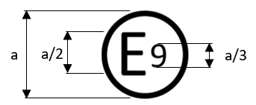
Model B (See 5.5 of this Regulation)
a/3
a/3
a/2
a/2
1XX | 001234
XX | 051302

a = 8 mm min

The above approval mark affixed to an EFSS or vehicle shows that the EFSS or vehicle type concerned has been approved in Spain (E 9) pursuant to UN Regulations Nos. 1XX and XX.1 The first two digits of the approval numbers indicate that, at the dates when the respective approvals were given, Regulation No. 1XX was still in its original form and UN Regulation No. XX included the 05 series of amendments.

Annex 3
Test conditions and procedures
1. The objective of the tests is to ensure system coverage of a complete engine compartment, to test the capability of EFSS under varying ventilation conditions and to test the fire detection system.
2. The installation of the EFSS shall be the same through all tests. EFSS must be restored to its original condition before each test, with all parts installed as intended. Broken or consumable parts must be replaced.
3. The tests are to be performed in an engine compartment test apparatus. Description of the test apparatus is found in Appendix A: Test apparatus.
4. General test criteria
4.1. EFSS is deemed compliant if each of the test scenarios specified in Appendices C to G are passed in the first attempt.
4.2. Pool fires, spray fires and fibreboard fires shall be extinguished within 60 s after activation of the suppression system or upon end of the discharge of the suppression system if discharge time exceeds 60 s.
4.3. The spray shall be active until test is terminated.
4.4. Glowing at termination of test is acceptable for fibre board fires.
4.5. Dripping oil fire shall be extinguished within 15 s after activation of the suppression system and not re-ignite within 300 s after fire is supressed to be considered as no re-ignition.
4.6. The test report shall include:
- Date of the test.
- Description and drawing of the test setup.
- Photos from the tests and test setup.
- Specification, description and drawing of the suppression/detection system.
- Configuration of the suppression/detection system used in the tests.
- Identification of the test equipment and used instruments.
- Deviations from the test method, if any.
- Graph showing the temperatures during the re-ignition test.
Test results.
Any drawings shall be supplied in appropriate scale and in sufficient detail on size A4 or on a folder of A4 format. Photographs, if any, shall show sufficient detail. If the components have electronic controls, information concerning their performance shall be supplied.

Appendix A: Test apparatus
1. Test apparatus
The test apparatus is constructed of steel plate with an open floor constructed of steel grating. The thickness of the steel plate shall be in accordance with Table 1. Figure 1 shows the test apparatus from the front side, Figure 2 from the rear side and Figure 3 from above.
Table 1.
Test apparatus objects
Objects | Plate thickness
Fan cylinder | 1.5 – 3 mm
Obstructions | 1.5 – 3 mm
Exhaust manifold mock-up | 8 mm
Engine mock-up | 2 – 3 mm
Silencer mock-up | 2 – 3 mm
Exhaust pipe | 2 – 3 mm
Connection pipe | 2 – 3 mm
Walls, ceiling and floor | 1.5 – 3 mm
Floor | Steel grating constructed by steel rods, diameter 2 – 3 mm, with 20 – 30 mm in between to create in open floor design

Figure 1
Coordinate system for the positioning of objects in the test apparatus (view from front side)
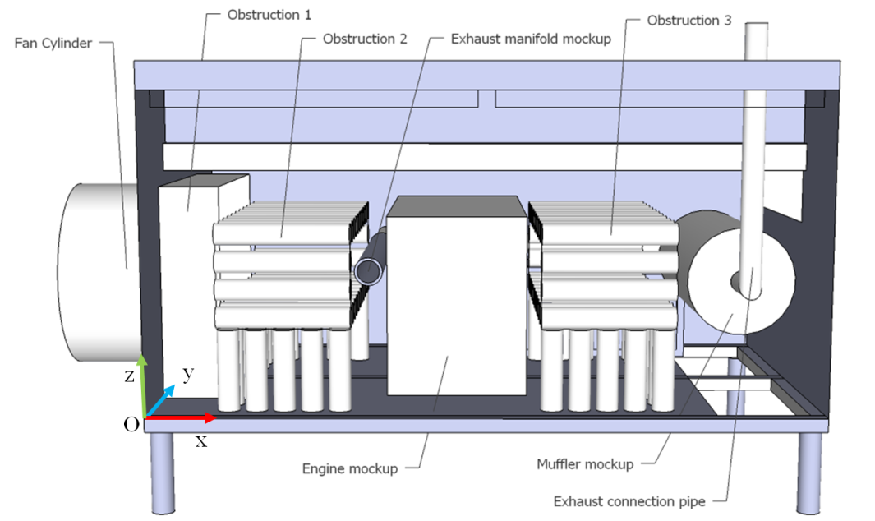

Figure 2
Test apparatus seen from the rear
Figure 3
Test apparatus seen from above
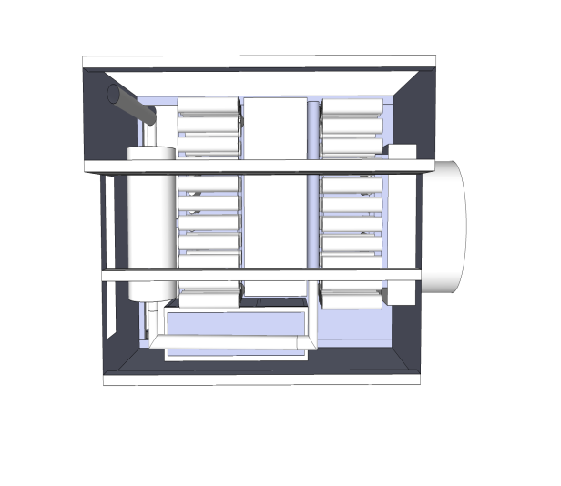

2. Framework
The framework of the test apparatus shall be constructed according to Figure 4. The size of the side and bottom beams are 50 mm × 50 mm and the size of the top beams are100 mm × 50 mm. The framework shall be 300 mm above the ground.

Figure 4
Framework for the test apparatus
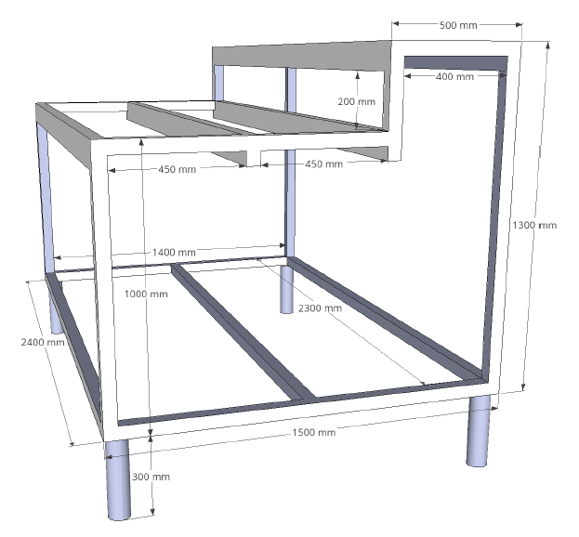
3. Apertures
In addition to the opening for the fan, the test apparatus includes four apertures. It should be noted that all objects inside the test apparatus are hidden in order to more clearly show the apertures. The dimensions and positions of the apertures are according to the coordinates in Table 2.
The positions are given by referring to two diagonally opposite corners as all apertures are rectangular in shape.
The value of the coordinates is the distance in metres from the origin (see Figure 1).
Table 2
Coordinates of apertures in the test apparatus
Aperture | Coordinates [x; y; z] – [x; y; z] | Area of aperture
A1 | [0.03; 0.00; 1.08] – [1.18; 0.00; 1.13] | 0.06 m²
A2 | [1.22; 0.00; 1.08] – [2.37; 0.00; 1.13] | 0.06 m²
B | [2.40; 0.50; 0.70] – [2.40; 1.30; 0.90] | 0.16 m²
C | [0.85; 1.50; 0.03] – [1.24; 1.50; 0.36] | 0.13 m²
 | Total area of aperture: | 0.41 m²

Figure 5
Apertures in the test apparatus
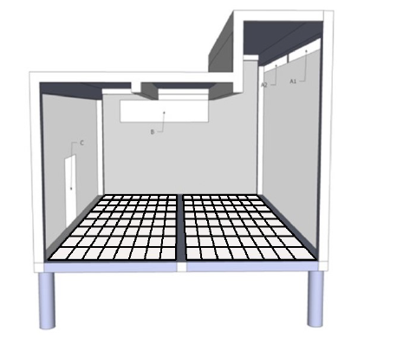

4. Fan
An axial fan duct with inner diameter of 710 mm and a length of 600 mm is installed to the fan opening on the test apparatus, see Figure 6. An axial fan with a diameter of 710 mm (+0 mm, -3 mm) shall be mounted to the ventilation duct. The fan shall produce a certain air flow rate through the duct according to the test scenarios in Appendix C to G. Frequency converter may be used to adjust the fan speed. In tests without fan, the duct and fan shall be left in its installed position, alternatively a concealing plate with the same diameter as the ventilation opening may be positioned in front of the fan duct opening at a distance not closer than 50 mm.
Figure 6
Fan duct
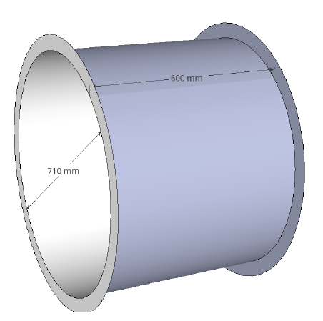
5. Floor
To create an open floor design, the floor in the test apparatus shall be constructed from steel rods, diameter 2 – 3 mm, with 20 – 30 mm in between to support the pool fires placed at floor level.
Figure 7
Example of steel grating for floor design

6. Objects location
All objects in the test apparatus are positioned according to coordinates (x, y, z) as shown in Table 3. The value of the coordinates is the distance in metres from the origin (see Figure 1).
Table 3
Coordinates of objects
Objects | Coordinates [x; y; z]
Fan cylinder | [-0.60; 0.40; 0.10]
Obstruction 1 | [0.0; 0.26; 0.0]
Obstruction 2 | [0.26; 0.05; 0.02]
Exhaust manifold mock-up | [0.76; 0.05; 0.47]
Engine mock-up | [0.87; 0.05; 0.04]
Obstruction 3 | [1.44; 0.05; 0.02]
Obstruction 4 | [0.82; 1.2; 0.0]
Silencer mock-up | [2.0; 0.28; 0.23]

7. Mock-up components
The dimensions of the engine mock-up are 1,000 mm × 650 mm × 500 mm. The dimensions of the silencer mock-up are diameter 400 mm × 800 mm. The exhaust manifold mock-up shall have the inner dimensions of diameter 80 mm × 900 mm. The mock-up components shall be hollow. The exhaust manifold mock-up shall be connected to the silencer mock-up through a pipe with a diameter of 76 mm. A pipe from the silencer mock-up shall also be used to carry the exhaust gases from the prewarming system out from the test apparatus. The whole exhaust gas system from the propane burner inlet to the exhaust gas outlet shall be smoke tight.
Figure 8
Exhaust mock-up system (to be pre-heated for the re-ignition test)
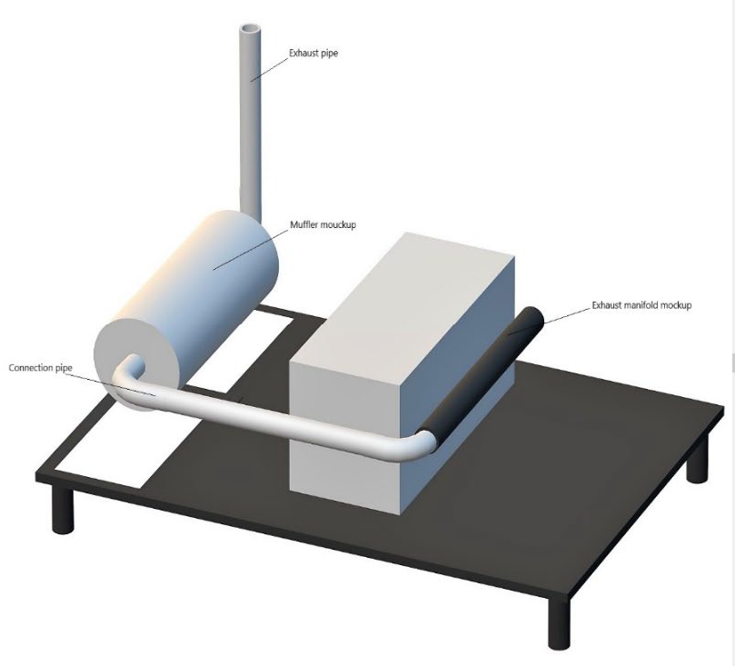

8. Obstructions
Obstruction 1 has the dimensions of 230 mm × 900 mm × 840 mm, as shown in
Figure 9.
Obstructions 2 and 3 consist of horizontal and vertical obstruction tubes as shown in Figure 10 and specified in Table 4. The horizontal obstruction tubes are closed in both ends and hollow. The vertical tubes are hollow and open in the bottom. The distance between the open bottom of the vertical tubes and apparatus floor is 20 mm. The distance between top of the vertical tubes and the horizontal tubes is 30 mm. The first horizontal tube layer from the bottom forms a storey which is 360 mm above the apparatus floor level.
Table 4
Horizontal and vertical tubes specifications
[mm] | Horizontal tubes | Vertical tubes
Outer diameter | 80
Length | 480 | 230
Wall thickness | 1.5 – 3
Distance between tubes | 20

Obstruction 4 is a box measuring 1,250 mm × 300 mm × 390 mm as shown in Figure 11. It includes two openings. The first, on the right short side (240 mm x 330 mm) is open to the interior of the test apparatus, while the other on the rear long side (390 mm x 330 mm) is in conjunction with test apparatus Aperture C, thus being an opening to the outside.

Figure 9
Obstruction 1
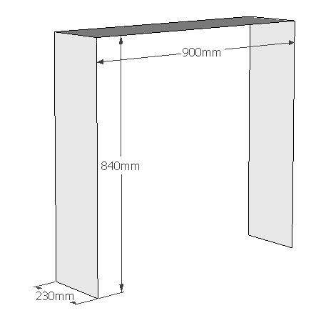

Figure 10
Obstructions 2 and 3
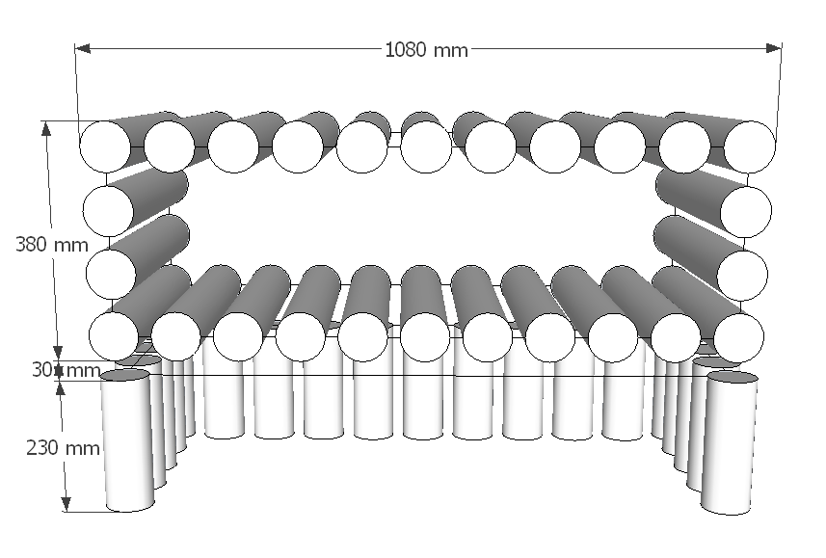

Figure 11
Obstruction 4
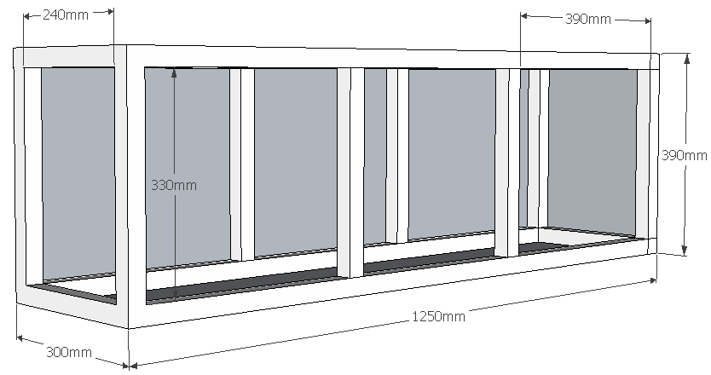

9. Thermocouples
Seven thermocouples (Tc) shall be mounted on the exhaust manifold mock-up, drilled 2 mm into the tube from the outside. The location of the thermocouples shall be in accordance with Figure 12 and Figure 13. Tc1 – Tc4 shall be located on top of the mock-up tube and Tc5 – Tc7 around the mock-up tube, on the same distance from the tube opening as Tc2 (300 mm).
Figure 12
Thermocouples on the exhaust manifold mock-up
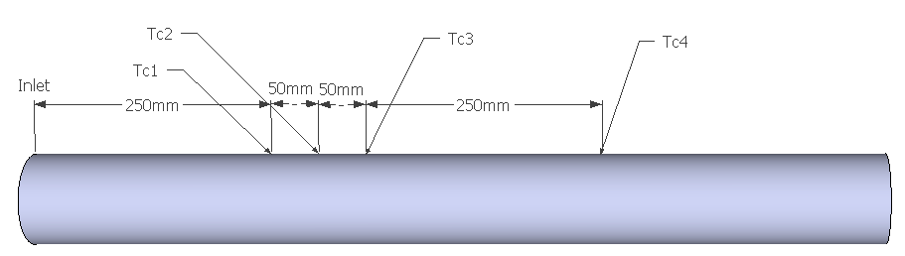

Figure 13
Thermocouples on the exhaust manifold mock-up (the inlet of the mock-up is on the left side)
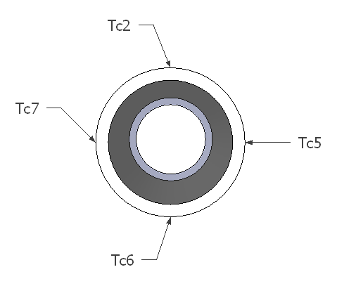

10. Propane burner

The propane burner used to pre-warm the exhaust system shall be chosen as to fulfil the requirements on achieved temperatures specified in. Pressurised air may be added to the flame for better combustion and to create higher volume flowrate through the exhaust manifold.
11. Tolerances
A tolerance of ±5 s for time values and of ±5 per cent for dimensions, positions, temperatures and other measurements shall apply, unless explicitly stated otherwise.

Appendix B: Fire sources, fuel and general test specifications
1. Fire sources
Diesel oil, engine oil, heptane, and fibre board are used as fuels in the test sources described in Table B1.
Table B1
Fire sources used in the test scenarios
Fire source | Description | Dimensions of the fire tray (length x width x height)or (diameter x height) (mm) | Nominal thickness of fire tray (mm) | Water (l) | Diesel (l) | Heptane (l)
#1 | Pool fire | 300 × 300 x 70 | 1.5 | 1.0 | 0.5 | 0.2
#2 | Pool fire and 2 fibreboards | 300 × 300 x 70 | 1.5 | 1.0 | 0.5 | 0.2
#3 | Pool fire | 200 × 300 x 70 | 2.0 | 0.5 | 0.5 | 0.2
#4 | Pool fire | Ø 150 x 100 | 1.5 | 0.2 | 0.2 | 0.1
 | Description and mass flow rate | Specifications | Tolerances (%) | Nominal pressure (bar) | Fuel | Mass flow (g/min)
#5 | Spray fire | Nozzle with 120 ° full cone spray. Lechler 460.368 or equivalent | ±10 | 4.5 | Diesel | 730
#6 | Spray fire | Nozzle with 80° axial flow hollow cone spray. Lechler 212.245 or equivalent | ±10 | 4.5 | Diesel | 190
#7 | Dripping oil fire, 40 droplets/min | Danfoss 0.60X80H or equivalent | -0/ +10 | NA | Engine oil | > 2.7

The nominal dimensions of the fibreboards in fire source #2 shall be 12 mm × 290 mm × 190 mm. The fibreboards shall consist of at least 90 per cent raw material from wood. Their dry density shall be 300 kg/m³ (±10 per cent).
The fibreboards shall be conditioned prior to the test at a temperature of 105 °C for not less than 16 h. The fibreboards shall be used within 8 h after been removed from conditioning.
Fibreboards are completely immersed in diesel oil for at least 10 min prior to the test.
After being immersed in diesel oil, the fibreboards are mounted vertically in the pool fire tray not more than 10 min before the start of the test, see Figure B1. Supports for keeping the fibreboards in position in the fire tray are needed.

Figure B1
Fire tray with fibreboards orientation
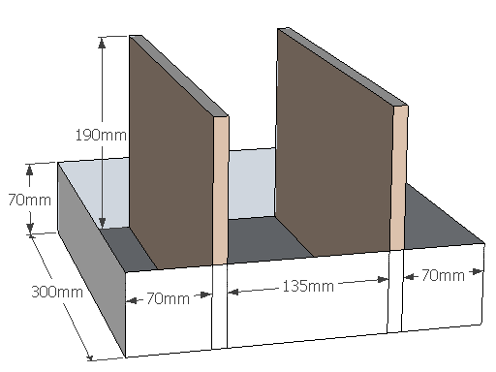

Test fire No. 5 and No. 6 consist of diesel oil spray fires while test fire No. 7 consists of a dripping oil fire (by hot surface ignition).
The spray nozzle for test fire No. 5 shall be a Lechler 460.368 or equivalent. The spray nozzle for test fire No. 6 shall be a Lechler 212.245 or equivalent. The spray nozzle for test fire No. 7 shall be a Danfoss 0.60X80H or equivalent.
2. Fuel specifications
2.1. Diesel oil
Commercial fuel oil or light diesel oil with a density of 0.81 kg/l - 0.85 kg/l.
2.2. Engine oil
Semi-synthetic engine oil 15W-40 intended use in diesel engine.
Reference oil: Statoil MaxWay 15W-40
Base: Mineral oil
Density: 884 kg/m³ at 15 °C
Viscosity: 107 mm² /s at 40 °C
Flash point COC: 230 °C
2.3. Heptane
Product name: Hydrocarbons C7, n-alkanes, iso alkanes, cyclics
Synonyms, tradenames: Exxsol heptane, Heptane shell, Petrosol D heptane, SBP 94/99, Eversol n-paraffin 7, Heptane, Solane 80-110, Essence 80-110.
CAS number: 64742-49-0
Relative density: 0.68 – 0.78 g/cm3
Initial boiling point and boiling point interval: 83 °C – 105 °C
Auto ignition temperature: >200 °C
Flash point: -5 °C
3. General test specifications
3.1. Installation
3.1.1. Installation of the fire suppression system
To obtain the minimum discharge rate condition, an extinguishing system is to be assembled to its maximum dimensional capability with respect to the number of fittings and size and length of pipe, if relevant. The cylinder is to be used with its rated capacity and the cylinder or gas cartridge pressurised with propellant gas to the normal operating pressure, if relevant.
The fire suppression system shall be installed by the system manufacturer or supplier. Figure B2 shows the area where extinguishing agent discharge points such as of nozzles, extinguishing agent generators or extinguishing agent discharge tubes may be located. The discharge points shall be positioned inside the test apparatus, at two different areas:
(a) In the ceiling and at the rear wall. Discharge points positioned in the ceiling shall be positioned at a minimum of 750 mm above the floor level (z ≥ 0.75) and outside of Obstruction 1. Nozzles positioned at the rear wall shall be positioned within 350 mm from the rear wall (y ≥ 1.15) and minimum 450 mm from the floor level (z ≥ 0.45).
(b) Inside the small box (referred to as Obstruction 4) in the rear side of the test apparatus. Nozzles shall be located in the ceiling of the box with a minimum of 290 mm from the floor (z ≥ 0.29).
Figure B2
Nozzle positioning seen from the rear side of test apparatus

The system set-up and configuration shall be observed and documented prior to the test (e.g. amount of extinguishing agent and propellant gas, system pressure, number, type and location of discharge points, length of pipes and number of fittings).
Temperature shall be measured during the re-ignition tests at locations specified in Appendix A.

3.1.2. Installation of the detection system
The fire detection system may consist of a combination of different types of sensors. The sensors of the detector system shall be positioned at least 150 mm above or 50 mm outside the rim of the pool fire trays and on the inside of the test apparatus, if applicable. Positions, directions and lengths of the sensor elements and sensitivity settings of the detector system cannot be changed between the tests.
3.2. Test method
The pool fire trays are to be filled with diesel and heptane on a base of water according to Table B1. Where fibreboards are required to be used as the fire source, they shall be soaked in diesel oil, prior to the test, according to instructions in above.
A pre-burn time is required. The pre-burn time is measured from the time the first fire is ignited. All pool fires in the test scenarios shall be ignited within the allowed ignition-time, according to Appendices C to F, using a suitable ignition source. The low-load fire tests in Table E1 Appendix E shall be performed either individually or concurrently.
A fan is used in some of the test scenarios to obtain a specific air flow rate into the test apparatus. The fan shall be engaged 30 seconds before the suppression system is activated or before ignition in case of fire detection test. The fan shall remain active until the result of the test is determined.
A diesel spray is used in some of the test scenarios. The diesel spray shall be activated 10 seconds prior to activation of the suppression system. The diesel spray shall remain active until the result of the test is determined.
After the stipulated pre-burn time, the suppression system shall be manually or automatically activated.
In the test for re-ignition, the exhaust manifold mock-up tube is pre-heated with a burner prior to the test. Pressurised air may be added to the flame for better combustion. The tube shall be heated from the inner side until the temperature of Tc2 is above 600 °C and Tc1 is above 570 °C and the temperatures of Tc5, Tc6 and Tc7 not are less than 520 °C. When the predefined temperatures are reached the pre-heating procedure stops. After 30 seconds the engine oil shall start dripping and the suppression system activated 15 seconds later. The engine oil shall ignite before activation of the suppression system. The oil shall continue to drip on to the tube until the result of the test is determined.
The fire detection test shall consist of 13 fire tests according to Appendix G1 that shall be tested separately. The test fire shall be detected within 1 minute from ignition.

Appendix C: High-load fire
Table C1
Test Fire
Fire source  (see Table B1) | Description | Coordinates [x; y; z]
#6 | Spray fire (0.45 MPa, 0.19 kg/min) | [1.47; 0.73; 0.46]
#3 | Pool fire 200 mm × 300 mm | [0.97; 0.85; 0.70]
#4 | Pool fire diameter 150 mm | [0.97; 1.28; 0.00]
#3 | Pool fire 200 mm × 300 mm | [1.54; 0.57; 0.36]
#2 | Pool fire 300 mm × 300 mm and 2 Fibreboards | [1.54; 0.77; 0.36]
#3 | Pool fire 200 mm × 300 mm | [1.54; 0.13; 0.00]

Note: The fan is not used
The extinguishing agent container and propellant gas vessel or extinguishing agent generator are conditioned at a temperature lower or equal to -20 ºC for at least 16 h prior to test.
Table C2
Test procedure
Time | Action
00:00 | Start measuring time
01:20 | Ignite pool fires (within 20 seconds)
01:50 | Start diesel spray
02:00 | Activate suppression system

Figure C1
Test fire positioning, view from the front side

Figure C2
Test fire positioning, view from the rear side

Appendix D: Low-load fire
Table D1
Test Fire
Fire source  (see Table B1) | Description | Coordinates [x; y; z]
#4 | Pool fire diameter 150 mm | [0.02; 0.08; 0.00]
#3 | Pool fire 200 mm × 300 mm | [0.37; 0.57; 0.00]
#4 | Pool fire diameter 150 mm | [0.45; 1.20; 0.00]
#4 | Pool fire diameter 150 mm | [0.97; 1.28; 0.00]
#4 | Pool fire diameter 150 mm | [1.54; 0.57; 0.00]

Note: The fan is required to produce an air flow of 1.5 m³/s.

Table D2
Test procedure
Time | Action
00:00 | Start measuring time
01:00 | Ignite pool fires (within 30 seconds)
01:30 | Engage the fan
02:00 | Activate suppression system

Figure D1
Test fire positioning, view from the front side

Figure D2
Test fire positioning, view from the rear side

Appendix E: High-load fire with a fan
Table E1
Test Fire
Fire source  (see Table B1) | Description | Coordinates [x; y; z]
#5 | Spray fire (0.45 MPa, 0.73 kg/min) | [0.37; 0.70; 0.46]
#1 | Pool fire 300 mm × 300 mm | [0.37; 0.47; 0.36]
#2 | Pool fire 300 mm × 300 mm and 2 fibreboards | [0.37; 0.77; 0.36]
#1 | Pool fire 300 mm × 300 mm | [0.37; 0.13; 0.00]
#1 | Pool fire 300 mm × 300 mm | [1.54; 0.13; 0.00]

Note: The fan is required to produce an air flow of 1.5 m³/s.
The fire trays with fibreboards shall have parallel orientation in relation to the forced air flow.
Table E1
Test procedure
Time | Action
00:00 | Start measuring time
01:00 | Ignite pool fires (within 20 seconds)
01:30 | Engage the fan
01:50 | Start diesel spray
02:00 | Activate suppression system

Figure E1
Test fire positioning, view from the front side

Appendix F: Re-ignition test
Table F1
Test Fire
Fire source  (see Table B1) | Description | Coordinates [x; y; z]
#7 | Dripping oil fire (0.2 MPa, 0.01 kg/min) | [0.82; 0.28; 1.22]

Note: The fan is not used.
Prior to test: The area on exhaust pipe where drops fall shall be cleaned with emery cloth.
Preheating: The tube shall be heated from the inner side until the temperature of Tc2 > 600°C, Tc1 > 570 °C and Tc5, Tc6 & Tc7 > 520°C. When the predefined temperatures are reached the pre-heating procedure stops and the burner is removed (time 0:00).

Table F2
Test procedure
Time | Action
Prior to test | Pre-heat tube
00:00 | Pre-defined temperatures are reached
00:30 | Start oil dripping
00:45 | Activate suppression system (the oil shall ignite before activation)
t ext | Extinction of flames
t reignition | Time of re-ignition, no re-ignition allowed
t ext +05:00 | End of test

Figure F1
Test fire positioning, view from the front side
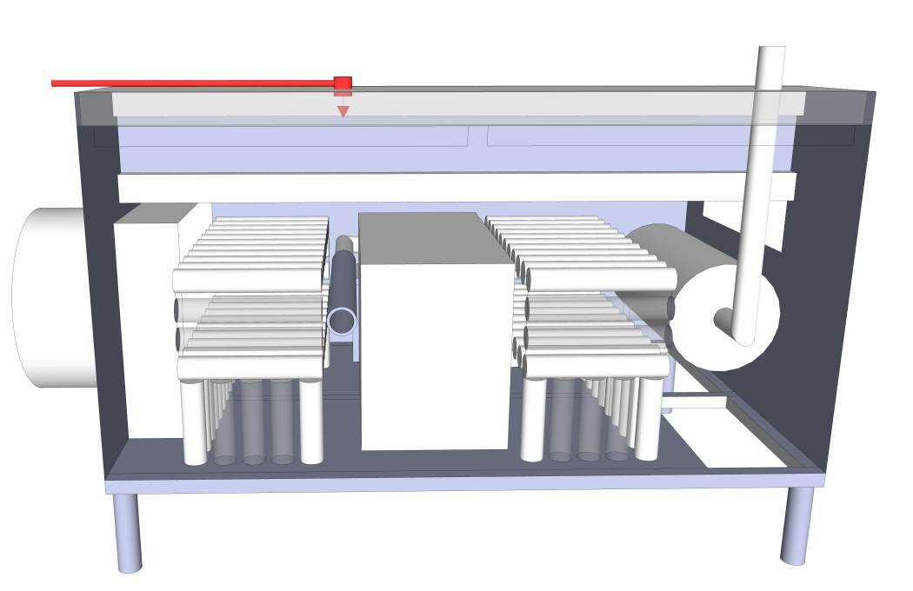

Appendix G: Fire detection tests
Table G1
Test procedure
Time | Action
00:00 | Start measuring time and engage the fan
00:30 | Ignite pool fire
01:30 or if fire detection | End of test

Table G2
Test Fires (System coverage test)
Test No. | Fire source  (see Table B1) | Air flow (m³/s) | Coordinates [x; y; z]
1 | #4 | 0 | [2.23; 0.08; 0.92]
2 | #4 | 0 | [0.97; 1.28; 0.00]
3 | #4 | 1.5 | [1.82; 1.28; 0.00]
4 | #4 | 1.5 | [0.02; 0.08; 0.00]
5 | #3 | 0 | [0.37; 0.87; 0.00]
6 | #3 | 0 | [0.37; 0.57; 0.36]
7 | #3 | 0 | [0.02; 1.20; 0.00]
8 | #3 | 0 | [0.97; 0.85; 0.70]
9 | #3 | 0 | [1.54; 0.13; 0.00]
10 | #3 | 1.5 | [1.54; 0.57; 0.36]
11 | #3 | 1.5 | [0.37; 1.20; 0.00]
12 | #3 | 3.0 | [0.37; 0.13; 0.00]
13 | #3 | 3.0 | [1.54; 0.87; 0.00]

Figure G1
Test fire positioning, view from the front side
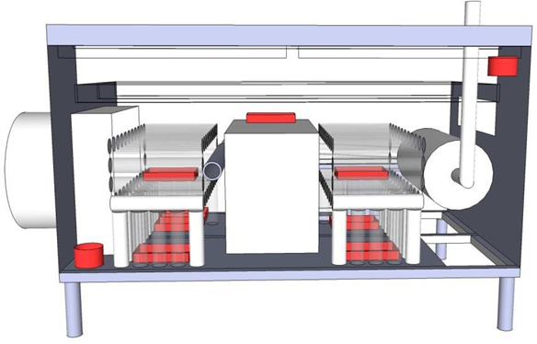

Figure G2
Test fire positioning, view from the rear side
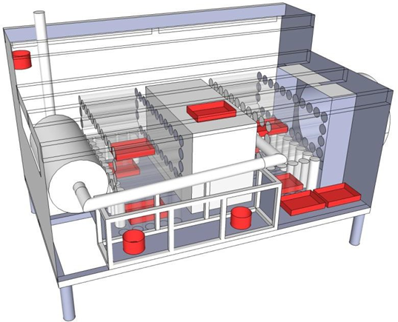

* In accordance with the programme of work of the Inland Transport Committee for 2026 as outlined in proposed programme budget for 2026 (A/80/6 (Sect. 20), table 20.7), the World Forum will develop, harmonize and update UN Regulations in order to enhance the performance of vehicles. The present document is submitted in conformity with that mandate.
** Page numbers will be added later.
The distinguishing numbers of the Contracting Parties to the 1958 Agreement are reproduced in Annex 3 to Consolidated Resolution on the Construction of Vehicles (R.E.3), document ECE/TRANS/WP.29/78/Rev.8
Distinguishing number of the country which has granted/extended/refused or withdrawn approval (see approval provision in the Regulation).
Delete where not applicable.
Distinguishing number of the country which has granted/extended/refused or withdrawn approval (see approval provision in the Regulation).
Delete where not applicable.

