Explanatory note on the Fast Charge Power Curve
This document was prepared by the EV Fast & Smart Charging cluster
I. Introduction
This document introduces the fast charging test procedure and report known as the Fast Charge Power Curve (FCPC). The FCPC has been developed in the EV Fast & Smart charging cluster. The draft version of the FCPC has been submitted as a separate document (GRPE-94-08).
II. Purpose
The F&SC cluster aims to promote the user-friendly, safe and scalable adoption of fast and smart charging functionalities of electric vehicles, and their integration in the energy system. It has focussed its activities on two tasks: A. Fast charging and B. Smart and bi-directional charging. As part of task A it is developing the FCPC.
The FCPC is a harmonised test procedure and report on the fast charging (DC, >50kW) performance of electric light duty vehicles. The test procedure covers the M1, M2 and N1 categories that are either Pure Electric Vehicles (PEVs) or Off-vehicle Charging Hybrid Electric Vehicles (OVC-HEVs).
The current information that is available to users relies on varying testing procedures, calculations and performance indicators. This situation impedes repeatability and comparability. A harmonised test procedure, report and set of key performance indicators will greatly improve the reliability of fast charging performance claims.
Through the FCPC we aim to provide accurate and comparable information for users of PEVs and OVC-HEVs, both when operating a vehicle or when selecting a vehicle. Accurate information on the interaction between these electric vehicles and recharging stations is needed to improve user-friendliness and acceptability of driving and charging.
III. Governance
The concept of the FCPC was conceived by the end of 2024 simultaneously in WP5 and WP29 of the UN-ECE. The WP.5 Informal Task Force on E-Mobility (WP.5 e-mobility TF) and the WP.29 IWG on EVE agreed to join effort to work on fast- & smart-charging of EVs to collect information on standardization trends and to develop harmonized requirements that could be applied globally by interested stakeholders. As such, the F&SC consists of participants of both the WP.5 e-mobility TF and the WP.29 IWG on EVE and also reports to both parts of the UN-ECE organisation.

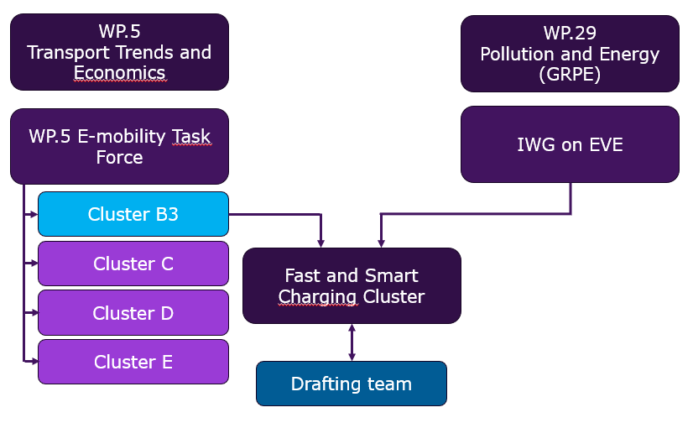
Figure 1 - Position of F&SC cluster within the WP5 and WP29 organisation

WP5 background
The Working Party on Transport Trends an Economics (WP.5) has agreed to create an Informal Task Force on E-Mobility (WP.5 E-mobility TF) at its September 2023 session , which has been endorsed by the Inland Transport Committee at its February 2024 session. Later, the he WP.5 E-mobility TF agreed to split its activity in various clusters of work. Cluster B3 is dedicated to the “Development of harmonized norms and standards for smart charging solutions, including bi-directional charging, by assessing associated infrastructure (incl. energy infrastructure) and vehicle needs as well as defining how to best manage charging loads to underpin the energy system transformation”. Currently, the WP.5 E-mobility TF is considering to reorganise their clusters by combining or otherwise integrating its efforts.
WP29 background
The Working Party on Pollution and Energy (WP.29/GRPE) has agreed to create the Informal Working Group (IWG) on Electric Vehicles and the Environment (EVE) in 2012. Initially to enable the exchange of information and experience on relevant policies and regulations. The IWG on EVE is now established as the main body working on all matters related to sustainable deployment of electric vehicles, as reflected in its latest Terms of References.
Governance of F&SC
F&SC’s main decision making platform is the monthly cluster meeting. In the cluster’s meetings all participants can submit proposals. Decisions have been made through consensus. The Terms of Reference can be downloaded from the UNECE wiki webpage.
F&SC has also established a drafting team for Task A. This drafting team jointly develops the Fast Charge Power Curve and has bi-weekly meetings chaired by the drafting team coordinator. The drafting team consists of a small group of interested stakeholders that actively participate in the development of the FPCP. Documents from the drafting team are submitted for decision-making in the cluster meetings.
IV. Process
Progress up to date
The cluster has seen good progress on the development of the Fast Charge Power Curve.
- After agreeing on the Terms of Reference in January 2025 the inventory phase started.
- Up to May 2025 we collected interests and insights of the cluster members, data on the fast charging behaviour of end-users and of the fast charging performance of vehicles, existing test procedures and experiences with applying those.
- In June 2025 we were able to install our drafting team and coordinator. The team consists in total of 17 experts in the field of EV charging and performance, with representatives from the automotive industry, type-approval authorities, governments and the EC-JRC. Up until March 2026 they had 13 meetings.
- An important milestone has been the Outline document of September 2025 produced by the drafting team. The document identified the key issues that required solutions and/or decisions for having a robust FCPC.
- Up to date the cluster and the drafting team have been working together on resolving those issues and arriving at a consensus for the required decisions. Along the way, we have tested different concepts in lab tests.
- Many of the issues have been resolved and/or consensus has been found. We are therefore now ready to submit an informal document with the first draft version of the FCPC.
Resolution
According to Task A the F&SC cluster should develop the FCPC as a WP.29 resolution. This resolution will determine the FCPC as the globally harmonised and preferred procedure and report for measuring fast charging performance.
This document and the draft version of the FCPC are submitted as an informal document to both WP5 and WP29 (GRPE). Both informal documents are to be discussed in the March 2026 WP29/GRPE meetings. WP.5 and specifically the WP.5 E-mobility TF are also requested to discuss both documents in their upcoming meetings and to submit their comments.
After discussion in WP.5 E-mobility TF (date to be set) and the GRPE meetings of March 2026, the F&SC cluster will submit a Working Document and ultimately a definitive version of the resolution and FCPC for decision-making in the GRPE meetings of October 2026.
V. Ongoing discussions
The submitted draft version of the FCPC shows the current state of play in the drafting team. Issues which have not yet reached final agreement are shown in [brackets]. The main open issues are outlined below.
KPI selection
The F&SC cluster is currently discussing the key performance indicators (KPI) that are to be produced by the FCPC test procedure. Our objective is to establish a set of KPIs that provide value to users both during vehicle operation and in the process of selecting or procuring a vehicle. Secondly, we also seek to balance a set of KPIs that are comprehensive, accurate, and easily understandable, while aligning with the end user’s daily practice. Therefore, the following set of KPI’s is being considered but still need to be agreed:
Determined over a 10-80% battery charge trajectory:
- Charging duration
- Maximum battery charging power
Determined over a 10-80% or a 10-80% and 80-100% battery charge trajectory:
- Average battery charging power
Determined during the first 10 minutes of charging, starting at 10% battery charge:
- Recharged driving range charged in 10 minutes

Method for verifying the set measurement ranges
The charging performance reflected by the KPIs is dependent on the start and end point of the measurement procedure. Hence, these points need to be well defined and verifiable for the FPCP test procedure.
Acknowledging that the battery state of charge (SoC) indicator to the driver is a parameter that is controlled by the manufacturer of the vehicle, a verification is required to ensure the trustworthiness of this SoC indicator. In the ISO 12906 procedure, a verification is included by linking the SoC indicator to the net energy used for driving the vehicle over the applicable type-approval range determination test. The drafting team concluded that this verification method has drawbacks which would compromise its accuracy.
A new approach is currently being developed where the verification is based on linking the charge taken from the battery (by Coulomb-counting in Ah) to the net energy used for driving the vehicle over the applicable type-approval range determination test. Though this method seems very promising, there are some questions and concerns that need to be discussed in more detail before this verification method can be worked out in the draft proposal for the FPCP.

