Submitted by the TF on ADAS Informal document GRVA-21-15/Rev.1 21st GRVA, 20-24 January 2025
Provisional agenda item 6(a)

Proposal for amendments
to document ECE/TRANS/WP.29/2025/7
Proposal for the new 01 series of amendments
to UN Regulation No. 171 (Driver Control Assistance Systems)

The text reproduced below was prepared by the experts from Task Force on Advanced Driver Assistance System (ADAS) to update the draft 01 series of amendments to UN Regulation No. 171. The modifications to the text of the mentioned document are marked in bold for new characters and in strikethrough for deleted characters. The dates indicated in the Transitional Provisions remain in the square brackets, still the subject of final decision by GRVA. Additional corrections are provided in response to the comments made by GRVA experts at the 21st GRVA session. The dates in the transitional provisions are changed according to the agreement reached in the course of the 21st GRVA session.

I. Proposal
Introduction, paragraph 14, amend to read:

“14. The safe use of DCAS requires appropriate understanding by the driver and of the performance capabilities of DCAS available on the vehicle. The provision of the appropriate information to the driver is required to avoid potential driver’s misinterpretation, overestimation, or difficulty with the DCAS/vehicle control…”
Paragraph 2.30., amend to read:
“2.30. “Dynamic Driving Task (DDT)” means the real-time operational and tactical functions required to operate the vehicle. in on-road traffic.”
Paragraph 5.3.7.2.4.11, amend to read:
“5.3.7.2.4.11 A request for the driver to acknowledge that they have read and understood the driver information material outlined in paragraph 5.6 shall be given while the vehicle is in a stopped position. This request shall be given at least once every month. If the vehicle utilises a means of differentiating between users, this may be extended to 3 months for a given user. If the vehicle can identify that a driver has previously acknowledged this request it does not need to be given again for that driver. If the vehicle can identify that the current driver has not acknowledged this request before, then it shall be given upon initiation of the powertrain in the current drive cycle.”
Paragraphs 5.5.3.1., 5.5.4.2.8.1., Annex 4 – paragraph 4.2.2.1.(a)(i) delete references to footnote 3 after the word “powertrain”.
Paragraph 7.2.2.2., amend to read:
“7.2.2.2. If remedial action addressing DCAS design is required to be taken by the manufacturer, the Type Approval Authority shall upload communicate this the information received from the manufacturer in the English language to the secure internet database “DETA”, established by the United Nations Economic Commission for Europe, without undue delay to communicate this information to all Type Approval Authorities. The information shall be sufficient to understand the incident, the cause of it and the remedial action.”
Paragraph 7.2.3.1., in Table 1, amend item 8.b to read:
8. During phases of withholding HORs without driver override of the longitudinal control (if applicable).
8.a. Number of events where an upcoming boundary condition is detected and a HOR is given at least 5s in advance (see 5.5.4.2.6.5.1).
8.b. Number of events where an upcoming boundary condition is detected and a HOR is not given but not at least 5s in advance (see 5.5.4.2.6.5.1).
8.c. Driving distance and time while the system is withholding HORs.

Paragraph 16. (and subparagraphs), (and subparagraphs), amend to read:
“16. Transitional Provisions
16.1. As from the official date of entry into force of the 01 series of amendments, no Contracting Party applying this Regulation shall refuse to grant or refuse to accept type approvals under this Regulation as amended by the 01 series of amendments.
16.2. As from 1 September [2026 2027], Contracting Parties applying this Regulation shall not be obliged to accept type approvals issued to the original version (00 series of amendments) of this Regulation, first issued after 1 September [2026 2027]
16.3. Until 1 September [2028 2030], Contracting Parties applying this Regulation shall accept type approvals issued to the original version (00 series of amendments) of this Regulation, first issued before 1 September [2026 2027].
16.4. As from 1 September [2028 2030], Contracting Parties applying this Regulation shall not be obliged to accept type approvals issued to the original version (00 series of amendments) of this Regulation.
16.5. Notwithstanding the transitional provisions above, Contracting Parties who start to apply this Regulation after the date of entry into force of the most recent series of amendments are not obliged to accept type approvals which were granted in accordance with the original version (00 series of amendments) of this Regulation.
16.6. Contracting Parties applying this Regulation may grant type approvals according to the original version (00 series of amendments) of this Regulation.
16.7. Contracting Parties applying this Regulation shall continue to grant extensions of existing approvals to the original version (00 series of amendments) of this Regulation”.
Annex 3, Appendix 2, amend to read:
“Appendix 2
System design to be assessed during the audit/assessment
1. Introduction
This Appendix reflects a summary of system design aspects outlined in the core text of this Regulation to be assessed by the Type Approval Authority. during the audit/assessment. The following information shall be provided by the manufacturer for assessment by the Type Approval Authority.
2. Information related to DCAS in general
2.1. Driver Interaction and HMI
2.1.1. How the system is designed to ensure the driver remains engaged with the driving task, which includes an outline of the driver monitoring system and its warning strategy (paragraph 5.5.4.2.)
…
Insert new subparagraphs 2.1.1.6. to 2.1.1.8., to read:
“2.1.1.6. How the system addresses the detection and response to multiple subsequent short aversions of eye gaze or head posture by the driver (paragraph 5.5.4.2.5.3.).
2.1.1.7. Strategies implemented for determination when there has been no deviation in eye gaze (or movement of head position when this is being used to determine visual engagement) for a significant period of time, where an EOR shall be issued (paragraph 5.5.4.2.6.5.5.).
2.1.1.8. The number of repeated EOR or HOR warnings due to driver disengagement and the time interval over which these are counted (paragraph 5.5.4.2.8.3.).”
2.2. System Boundaries
Insert a new subparagraph 2.2.4. to read:
“2.2.4. The boundary conditions under which HORs can be withheld (paragraph 5.5.4.2.6.5.).”
2.3. System operation
Insert a new subparagraph 2.3.8. to read:
“2.3.8. How the controllability is ensured in the situations, where HORs are withheld, and in the cases when upcoming boundary conditions which require an HOR are detected less than 5 seconds in advance (paragraph 5.5.4.2.6.5.1.).”
Annex 4
Paragraph 2.1., amend to read:
“2.1. "Time to Collision" (TTC) means the a point in time obtained by dividing the longitudinal distance (in the direction of travel of the VUT) between the VUT and the target by the longitudinal relative speed of the VUT and the target.”
Paragraph 4.1.1., make a reference to table A4/1. Table A4/1 shall be positioned after paragraph 4.1.1. The note under the asterisk shall be positioned after table A4/1.
Paragraph 4.2.5.2.8.1.2., amend text and update diagram to read:
“4.2.5.2.8.1.2. The VUT shall approach the impact point with the bicycle cyclist target in a straight line for at least two seconds prior to the functional part of the test.”
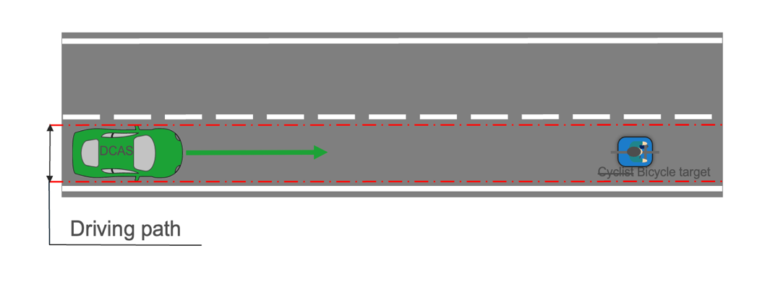

Paragraph 4.2.5.2.10.1.1., update text in diagram to read:
“4.2.5.2.10.1.1. The bicycle target shall travel in a straight line perpendicular to the VUT’s direction of travel at a constant speed of 15 km/h +0/-1 km/h, starting not before the functional part of the test has started. During the acceleration phase of the bicycle target prior to the functional part of the test the bicycle target shall be obstructed. The bicycle target’s positioning shall be coordinated with the VUT in such a way that the impact point of the bicycle target on the front of the VUT is on the longitudinal centreline of the VUT with a tolerance of not more than 0.2 m, if the VUT would remain at the prescribed test speed throughout the functional part of the test and does not brake.”

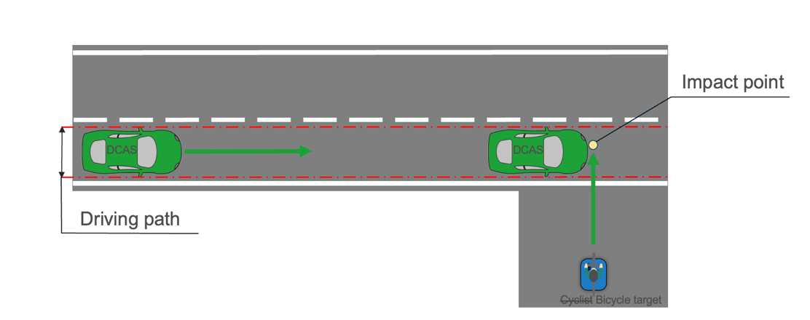

Paragraph 4.2.5.2.12.1.1., amend text and update diagram to read:
“4.2.5.2.12.1.1. The bicycle target shall travel in a straight line perpendicular to the VUT’s direction of travel at a constant speed of 15 km/h +0/-1 km/h, starting not before the functional part of the test has started. During the acceleration phase of the bicycle target prior to the functional part of the test the bicycle target shall be obstructed. The bicycle target’s positioning shall be coordinated with the VUT in such a way that the impact point of the bicycle target on the front of the VUT is on the longitudinal centreline offset of not more than 0.2 m, if the VUT would remain at the prescribed test speed throughout the functional part of the test and does not brake.”
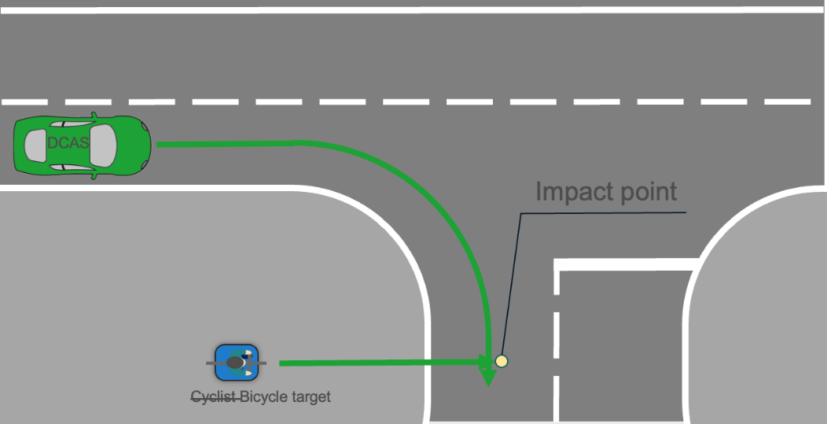

Annex 5, paragraph 3.4.6.3., amend to read:
“3.4.6.3. The manufacturer should demonstrate of how it applies the principles of its Management Systems, e.g. ISO 9001 or a similar best practice or standard, with regard to the competence of its M&S organization and the individuals in that organization and the basis for this determination. It is recommended that the assessor not substitute its judgment for that of the manufacturer regarding the experience and expertise of the organization or its members.”
II. Justification
Amendments to Introduction
1. Amendment to paragraph 14 is a grammatical correction.
Amendments to 2. Definitions
2. The definition of Dynamic Driving Task (2.30) is out of date and updated to align with the definition used by the IWG ADS.
Amendments to 5. General Specifications
3. Paragraph 5.3.7.2.4.11. is updated to clarify how a driver should confirm their knowledge about the system operation.
Amendments to 7. Monitoring of DCAS operation
4. Amendment to 7.2.2.2. is based on the interactions with the IWG on DETA to use the secure database “DETA” to exchange updates between Type Approval Authorities on manufacturer’s information regarding remedial actions.
5. Amendment to item 8.b in Table 1 in paragraph 7.2.3.1. is a grammatical correction.
Amendments to 16. Transitional Provisions
6. Modifying the dates in the Transitional Provisions following the discussions at the 20th GRVA session and recent exchanges within TF on ADAS. Subject to final confirmation by GRVA.
Amendments to Annex 3
7. Amending the header and opening paragraph of Appendix 2 to delete ‘during the audit/assessment’. Audit is related to proof of management systems and upon review of the use of the term in other locations of UN Regulation 171-00/01 it was considered appropriate to change the header title. The amendments to the opening paragraph are editorial to reflect the update to the header.
8. Appendix 2 reflects a summary of system design aspects outlined in the core text of the Regulation to be assessed during the audit/assessment. In the 01 series of amendments to the Regulation, new system design aspects were outlined for the purpose of audit/assessment. Therefore, such new aspects shall be added in Annex 3 – Appendix 2.
These new aspects are reproduced below for reference.
“5.5.4.2.5.3. The system shall be designed to address the detection and response to multiple subsequent short aversions of eye gaze or head posture by the driver (e.g. increased reengagement time and/or immediate issuing of an EOR). This functionality shall be documented and explained by the manufacturer to the Type Approval Authority.”
“5.5.4.2.6.5. Withholding of HORs
The system may withhold HORs when the vehicle is located on a “Highway” and is operated at a speed up to 130 km/h. As outlined in paragraph 5.3.5.2., the manufacturer shall describe in detail, as part of the documentation required for section 9, the boundary conditions under which HORs can be withheld.
Whilst in this mode of operation, the following subparagraphs shall apply:
5.5.4.2.6.5.1. In case of a detected upcoming boundary condition which requires an HOR, this HOR shall be given at the latest 5 seconds in advance of reaching the boundary condition(s).
For situations not detected 5 seconds in advance, a DCA shall be issued unless lateral assistance will still be provided after the driver is motorically reengaged. Where a DCA is not issued, an HOR shall be issued upon detection of the upcoming boundary condition(s).
In addition to the requirements of paragraph 5.3.6., for those situations not detected 5 seconds in advance, the vehicle manufacturer shall demonstrate the controllability of such situations to the Type Approval Authority during the inspection of the safety concept.”
“5.5.4.2.6.5.5. The system shall be designed to determine when there has been no deviation in eye gaze (or movement of head position when this is being used to determine visual engagement) for a significant period of time. An EOR shall be issued in this case. These strategies shall be documented and explained by the manufacturer to the Type Approval Authority.”
“5.5.4.2.8.3. The driver is also deemed to have insufficient engagement if there are repeated EOR or HOR due to driver disengagement within a given time period. The number of warnings and the time interval over which these are counted shall be defined by the manufacturer and justified to the Type Approval Authority.”
Amendments to Annex 4
9. Paragraph 2.1. in Definitions is updated to amend a grammatical correction.
10. In Test procedures, cyclist is amended to bicycle in paragraph 4.2.5.2.8.1.2. because this reference specifically relates to the object and not the rider of the bicycle. The text in the corresponding diagram is updated from Cyclist to Bicycle to align with the terminology in the text.
11. The diagram in paragraph 4.2.5.2.10.1.1. contains text which has been updated from Cyclist to Bicycle to align with the terminology in the text.
12. Paragraph 4.2.5.2.12.1.1.is amended for clarification and accuracy. The corresponding diagram is updated from Cyclist to Bicycle to align with the terminology in the text.
Amendments to Annex 5
13. Amendments to paragraph 3.4.6.3. is a grammatical correction.

____________

4 https://unece.org/data-sharing

