Working document for the IWG on EDR/DSSAD & SG-EDR. This document serves as a place holder for proposals to UN Regulation No. 169, under consideration as part of the ‘EDR Step 2’ workstream.

Initial proposal by the Informal Working Group on EDR/DSSAD amending UN Regulation No. 169, original series, introducing new requirements in line with the ‘Step 2’ workstream (Programme of Work ECE/TRANS/WP.29/2025/1 as revised).
The modifications to the text of UN Regulation No. 169, original series, are marked in bold for new or strikethrough for deleted characters.
2. Definitions
[...]
2.22. "Non-volatile memory" means the memory reserved for maintaining retaining recorded EDR data in a semi-permanent fashion. [Data recorded in non-volatile memory is retained after a loss of power and can be retrieved with EDR data extraction tools and methods.
2.49. "Volatile memory" means the memory reserved for buffering of captured EDR data. The memory is not capable of retaining data in a semi-permanent fashion. [Data captured in volatile memory is continuously overwritten and is not retained in the event of a power loss or retrievable with EDR data extraction tools.]
5. Requirements
[...]
5.3. Data capture
The EDR shall capture data which shall be written to a non-volatile memory when any of the triggers in paragraph 5.3.1. occur.
The EDR shall record the captured data in the vehicle and this data shall remain in the vehicle subject to the provisions of paragraph 5.3.4, at least until they are retrieved in compliance with national or regional legislation, or they are overwritten in compliance with paragraph 5.3.4.
The EDR non-volatile memory buffer shall accommodate the data related to at least five different events.
The data elements for every event shall be captured and recorded by the EDR, as specified in paragraph 5.1. in accordance with the following conditions and circumstances:
5.3.1. Conditions for triggering recording of data
An event shall be recorded by the EDR if one of the following threshold values is met or exceeded. Triggers that occur such that an overlap of data between events would result may be excluded.
5.3.1.1. Sudden Deceleration: Vehicle speed changes at a rate higher than 3.25 m/s2 and the change persists beyond that threshold for at least 0.7 seconds.

Amend paragraph 5.3.1.2., to read:
5.3.1.2. Last Stop: Trigger shall be activated if any of the following applies:
(a) Vehicle speed is reported as 0 km/h for 20 s.
(b) While vehicle speed is reported as 0 km/h, and
i. parking brake system is applied, or
ii. vehicle master control switch is deactivated.
Re-activation of last stop trigger due to threshold criterion (a.) shall be disabled if the vehicle speed is not reported as 24 km/h or more for a minimum of 6s.
“In case of threshold criterion (a.), the EDR may write the captured data in volatile memory only. The data from the volatile memory shall be written in the non-volatile memory if any other trigger [of paragraph 5.3.1.] occurs or the vehicle master control switch is deactivated.”
5.3.1.3. Activation of a safety system is showed in the table below:
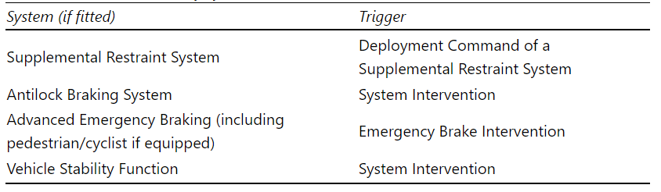

Justification
City buses and garbage collector trucks have multiple of stops during the vehicle life. Every stop longer 20s leads to a trigger event (write to non-volatile memory) which results in a very high memory wear, and failure after a few years. To reduce this memory wear effective and ensuring that the data will be transmitted to non-volatile memory it is proposed that this specific Trigger 5.3.1.2 (a) event can be written and overwritten in the volatile memory until any other trigger occurs.
City bus example:
The EDR non-volatile memory buffer shall accommodate the data related to at least five different events.
At cyclical stops (>20s) the memory buffer is always filled with the five last stops which are overwritten in first-in first-out basis.
These five events would be than processed and overwritten in the volatile memory until any other event occurs (e.g. 5.3.1.2 (b)), which leads to the transfer to the non-volatile memory.
With the additional provision it cannot lead to the issue that the non-volatile will be “empty/old data” since it is ensured that the EDR non-volatile memory is identical to writing direct to it.

_________________

