|  |  |
| --- | --- |
| * Alternative method: payload? It is not mentioned. Shall it be added? | to align with all methods |
| * All methods: The payload shall not exceed [90] per cent of the GVM/GTM.   *🡪The vehicle mass including the payload and  trailer if applicable shall not exceed 90 percent of GVM or GTM*. | PEMS to check the value  “shall not exceed”  proposal:  *The vehicle mass including the payload and  trailer if applicable shall not exceed [90] percent of GVM or GTM*. |
| * Temperature (All methods):   -Test room …a temperature set point of 25 °C and shall not deviate by more than ± 5 °C during the test.  -The test shall be void if the break-off criterion is not reached or the battery temperature is outside the normal operating range specified by the manufacturer.  -The manufacturer shall specify the normal operating range for the battery temperature.  -Driver break:  The minimum and maximum average temperature of the battery (all the REESS) during the driver break shall have a difference of less than 14°C.  -During soak and charge:  The temperature of the battery shall be checked before starting the test. Thermal equilibration is reached if in the preceding [1 hour] the deviations of the temperature of the battery are within a [7 °C] range. If this condition is not met the soak and charge shall be repeated. | agree to remove test room description in all methods  remain open the ± 7 °C for soak and charge  agree on all the rest |
| * 1.1 Vehicle selection   1.1.1. Vehicle selection during certification  The selection of the vehicle configuration during certification to verify the SOCE monitor shall be a vehicle corresponding to the lowest energy demand configuration within Part B family.  In the case that the test procedure is applied ~~during vehicle certification~~ to measure or verify UBEcertified for more than one vehicle, then vehicles shall be selected from different Part B families.1.1.2. Vehicle selection during Part A verification  The vehicle selected during Part A verification shall be randomly selected. In the case in which the number of tests is less than the number of Part B families, then more than one vehicle selection is not allowed from the same Part B family. In the case in which the number of tests is equal to or greater than the number of Part B families, then at least one vehicle shall be selected from each Part B family.]   * + 1. ~~Vehicle selection during certification If the test procedure is applied during vehicle certification to measure or verify UBE~~~~certified~~ ~~for more than one vehicle, then vehicles shall be selected from different Part B families.~~     2. ~~Vehicle selection during Part A verification If the test procedure is applied in-service to verify accuracy of SOCE monitor, then the vehicles shall be randomly selected.~~ | to discuss further  proposal to merge the two 1.1.1 options |
| Required measurements (All Methods)   * As an alternative to the use of voltage and current measurement devices, use of on-board measurement data is permissible if the accuracy and frequency of these data is demonstrated to the responsible authority to meet the minimum requirements for accuracy and frequency described in ‎paragraph 1.2. of this annex.   The on-board measurement data of the voltage and current can be used during the in-service testing only when the accuracy and frequency of on-board measurement data is confirmed during the certification. Safe inspection points shall be made available for the direct measurement verification. |  |
| * PTO   -OICA proposal to postpone 6.5 Part C verification  -OICA proposal to add a new Annex 5 Power to operate the vehicle auxiliary systems/accessory loads  -Proposal: Define a generic constant power to be added to M2 (measured power to inverter) see figure  The generic constant may depend on vehicle class and possible aligned with VECTO generic model assumptions 🡪 new annex 5 with proposed numbers  In addition, allow Transmission PTO energy to be subtracted from M2 (measuring the Transmission PTO energy: *appropriate measurement equipment to determine either mechanical, electrical, hydraulic or pneumatic PTO power, shall be installed*.)  definition  "Total propulsion energy" is the DC energy in kWh supplied to the traction inverter terminals and to auxiliary systems/vehicle accessories necessary for basic vehicle operation (for example, braking, steering, lights, heating, ventilation and air conditioning except for Category 1-2 vehicles, hydraulic system for Category 1-2 vehicles…) discharging the REESS. | Virtual distance equation+ definition of propulsion energy & total energy, PTO not in definition section. We need to add a definition if we accept the new proposals  New sentences added in paragraph 5.2:  -auxiliary systems/vehicle accessories  In the case in which the total propulsion energy does not include the accessory loads, some typical default values can be added to it, following the suggestions in the table xx of Annex 5 of this GTR, with the agreement of the responsible authority.  -Transmission PTO  In the case in which the vehicle configuration foresees a transmission PTO, supplying power from the engine to operate equipment unrelated to vehicle traction or auxiliary systems/vehicle accessories necessary for basic vehicle operation (24V/12V-DCDC), it is allowed to subtract the transmission PTO energy from the total propulsion energy, in agreement with the responsible authority. Appropriate measurement equipment to determine the transmission PTO energy shall be installed in the vehicle.  -proposal on Part C verification will be added.  -proposal on definition will be added |
| * **[Annex 5 Power to operate the vehicle auxiliary systems/accessory loads**   In the case in which the total propulsion energy does not include the accessory loads, some typical default values can be added to it, following the suggestions in the table below, with the agreement of the responsible authority.   |  |  | | --- | --- | | Vehicle Category | Power (W) | | Category 2, <16 tonnes with hydraulic or electric brake system | 900 | | Category 2, <16 tonnes with pneumatic brake system | 1600 | | Category 2, >16 tonnes | 2300 | | Category 1-2, <5 tonnes | xx | |  |  | |  |  | |  |  | |  |
| * Method 1a   The vehicle shall be driven on a test track at standard constant average speeds with a tolerance as specified in paragraph 2.1.2.7.  The battery shall be discharged preferably using a constant speed within the range of the characteristic regional speeds up to a battery state of charge (SOC), as reported by the vehicle, equal or less to 10 per cent.  [In the remaining part of the depleting test the minimum speed shall be targeted at no less than [30] km/h].  ~~The last part of the depleting test may be agreed with the relevant authority [for safety related aspects]~~.It is allowed to complete the last part of the test-driving outside the test track, but inside the test track facility.  [The equivalence with the certification test method and break-off criterion shall be demonstrated to the responsible authority.] | agree on the text  to add a sentence on SOC  In agreement with the [responsible/relevant] authority and based on technical evidence the battery may be discharged to a higher battery state of charge (SOC) in the first part of the depleting test. |
| * Method 1b   The same route may be used at certification and Part A verification in accordance with regional authority, if applicable.  The same regional characteristic vehicle speed used for certification may be used if applicable and in accordance with regional provisions, unless there is an agreement between the regional authority and the manufacturer.  The battery shall be discharged up to a minimum battery state of charge level in agreement with the [responsible/relevant] authority and safety rules.  [The minimum speed in the remaining part of the depleting test shall be targeted at no less than [30] km/h.]  A safe place to perform the test shall be agreed with the [responsible/relevant] authority.  ~~[The vehicle shall be driven up to the break-off criterion].~~  [It is possible to start and end the test at the test facilities to comply with the road safety requirements.]  It is allowed to use static battery discharging systems in the last part of the test to complete the discharge if agreed with the responsible authority. The discharge power of the system should be representative of the characteristic driving speed. The battery power as measured from the battery shall not be less than [10] kW. The break off is reached when the discharging power experience a drop of 10% of the target discharge power for 4 seconds.  In the case these testing provisions are not achievable, a different test method may be applied with the agreement between the manufacturer and the responsible authority. The end of discharge criterion is reached when the break-off criterion is met.  [The equivalence with the certification test method and break-off criterion shall be demonstrated to the responsible authority.] | agree on the text |
| * Method 2   [The bidirectional power supply system shall be able to operate at least at a constant power operating mode and shall comply with the specific requirements for the DC charging/discharging connector.]  The test shall be carried out using a power range derived from the regional characteristic speed and payload per Gross Vehicle Mass (GVM) and Gross Train Mass (GTM) in agreement with the responsible authorities. The payload shall not exceed [90] per cent of the GVM/GTM.  The battery shall be discharged preferably using a power derived from a constant speed within the range of the characteristic regional speeds up to a battery state of charge (SOC), as reported by the vehicle, equal or less to 10 per cent.  In the remaining part of the depleting test the battery shall be discharged with a constant power derived from the constant speed and a payload per Gross Vehicle Mass (GVM) and Gross Train Mass (GTM) in agreement with the responsible authorities with a speed tolerance of ± 7km/h according to specification of paragraph 2.1.1.1. of this annex.  The same power/regional characteristic vehicle speed used for certification shall be used during in-service testing if applicable and in accordance with regional provisions, unless there is an agreement between the regional authority and the manufacturer.  The end of discharge criterion is reached when the break-off criterion is met.  [The equivalence with the certification test method and break-off criterion shall be demonstrated to the responsible authority.] | agree on the text  to check description of bidi system  to add a sentence on SOC  In agreement with the [responsible/relevant] authority and based on technical evidence the battery may be discharged to a higher battery state of charge (SOC) in the first part of the depleting test.  proposal to remove this sentence on speed |
| * Alternative method * Payload?   -Break of the driver: distance vs time (page 61)  -The velocity and test cycle [and payload] shall be determined in agreement with the [responsible/relevant] authorities.  -The constant driving speed shall be related to the vehicle category and characteristic regional speeds. [The payload shall not exceed [90] per cent of the GVM/GTM.] | agree to add payload  value to be verified  verify with China to remove the sentence in [ ] on Coasting resistance calculation |
| **[Annex 2 Values to be read from vehicles** [ The manufacturer shall make available the following values to be read visually or via the on-board network:]  **Mandatory values:**  1. On board SOCE value [%]  2. Odometer (i.e. distance driven by the vehicle)[km]  3. Date of manufacture of the vehicle  4. Elapsed time since last charged by more than 50 per cent state of charge swing [days]  5. Average battery temperature while propulsion system is active; during charging; and (if equipped) during non-usage of the vehicles (i.e. non-propulsion system active, non-charging)  6. Total energy throughput [kWh]  **Values required if manufacturer applies virtual distance option:**  7. Total propulsion energy [kWh]  8. Total distance (sum of the distance driven as reported by the odometer and the virtual distance) [km],  9. Virtual distance [km],  10. Total energy throughput in V2X and/or PTO and/or non-traction purposes [kWh], if applicable  ~~10. Total time of use of the battery~~  ] | additional parameters in the comment  *4. Battery driven odometer [km]*  *5. Production date of the battery pack*  for phase 2 ?  *OICA EVE 81 GTR22 LDV proposal for 3. Date of manufacture of the vehicle?* |
| * Annex 3 Par. 3. Performance parameters: proposal to remove the correction of UBE for HD-OVC-HEVs |  |
| * **Annex 4**  **Battery Energy based (SOCE) minimum performance requirements (optional annex)** * China proposal to introduce a grouping index for the MPRs to solve the different MPR values versus similar metrics for different regions   -Annex 4  This optional annex includes the Minimum Performance Requirements (MPR), which a Contracting Party may elect to enforce for conforming to the requirements of this GTR (see paragraph 5.2. of this GTR).  New sentence:  The energy-throughput, the total amount of energy in kWh discharged from the battery, will be monitored during phase 1 of this GTR in view of a future revision of the lifetime thresholds (years, km, kWh) for confirming the compliance with the minimum performance requirements. | probably having sequential letter is better than group the letter based on regions ?  sentence added for En-th  to check |
|  |  |

Annex 4 Table A4/1

**Battery Energy based (SOCE) MPR for Category 2 vehicles not exceeding 16 tonnes**

| *Battery energy based MPR for* ***Category 2 vehicles not exceeding 16 tonnes*** | *HD-OVC-HEV* | *HD-PEV* |
| --- | --- | --- |
| From start of life to years or km, whichever comes first and [kWh] in monitoring |  |  |
| 6 yr, 150 000 km | 70% | 70% |
| 8 yr, 300 000 km | 70% | 70% |
| 8 yr, 400 000 km | 70% | 70% |
| 10 yr, 375 000 km | 65% | 65% |

Table A4/2

**Battery Energy based (SOCE) MPR for Category 2 vehicles exceeding 16 tonnes**

| *Battery energy based MPR for* ***Category 2 vehicles exceeding 16 tonnes*** | *HD-OVC-HEV* | *HD-PEV* |
| --- | --- | --- |
| From start of life to years or km, whichever comes first and [kWh] in monitoring |  |  |
| 6 yr, 150 000 km | 70% | 70% |
| 8 yr, 600 000 km | 70% | 70% |
| 12 yr, 700 000 km | 55% | 55% |
| 15 yr, 875 000 km | 50% | 50% |

Table A4/3

**Battery Energy based (SOCE) MPR for Category 1-2 vehicle not exceeding 5 tonnes**

| *Battery energy based MPR for* ***Category 1-2 vehicle not exceeding 5 tonnes*** | *HD-OVC-HEV* | *HD-PEV* |
| --- | --- | --- |
| From start of life to years or km, whichever comes first and [kWh] in monitoring |  |  |
| 6 yr, 150 000 km | 70% | 70% |
| 8 yr, 160 000 km | 65% | 65% |
| 8 yr, 300 000 km | 70% | 70% |
| 10 yr, 200 000 km | 60% | 60% |

Table A4/4**Battery Energy based (SOCE) MPR for Category 1-2 vehicle exceeding 5 tonnes but not exceeding 7.5 tonnes**

| *Battery energy based MPR for* ***Category 1-2 vehicle exceeding 5 tonnes but not exceeding 7.5 tonnes*** | *HD-OVC-HEV* | *HD-PEV* |
| --- | --- | --- |
| From start of life to years or km, whichever comes first and [kWh] in monitoring |  |  |
| 6 yr, 150 000 km | 70% | 70% |
| 8 yr, 300 000 km | 65% | 65% |
| 8 yr, 500 000 km | 70% | 70% |
| 10 yr, 375 000 km | 60% | 60% |

Table A4/5 **Battery Energy based (SOCE) MPR for Category 1-2 vehicle exceeding 7.5 tonnes**

| *Battery energy based MPR for* ***Category 1-2 vehicle exceeding 7.5 tonnes*** | *HD-OVC-HEV* | *HD-PEV* |
| --- | --- | --- |
| From start of life to years or km, whichever comes first and [kWh] in monitoring |  |  |
| 6 yr, 150 000km | 70% | 70% |
| 8 yr, 600 000 km | 70% | 70% |
| 12 yr, 700 000km | 50% | 50% |
| 15 yr, 875 000km | 45% | 45% |

]

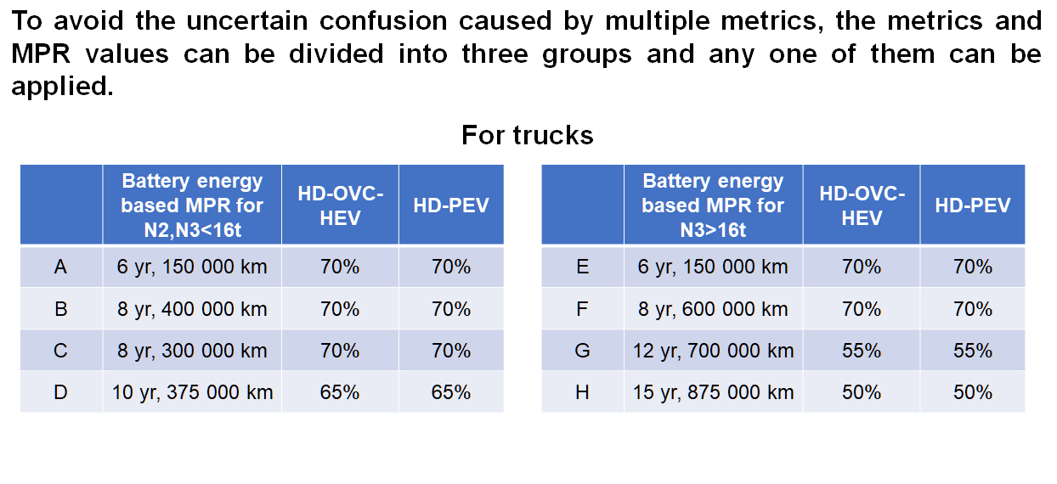

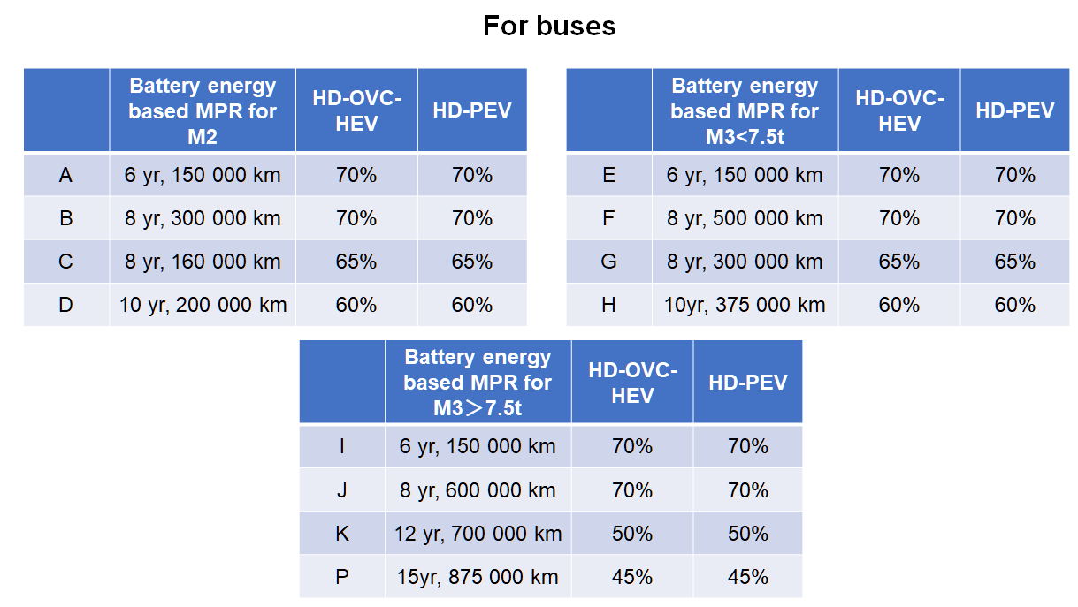

PTO

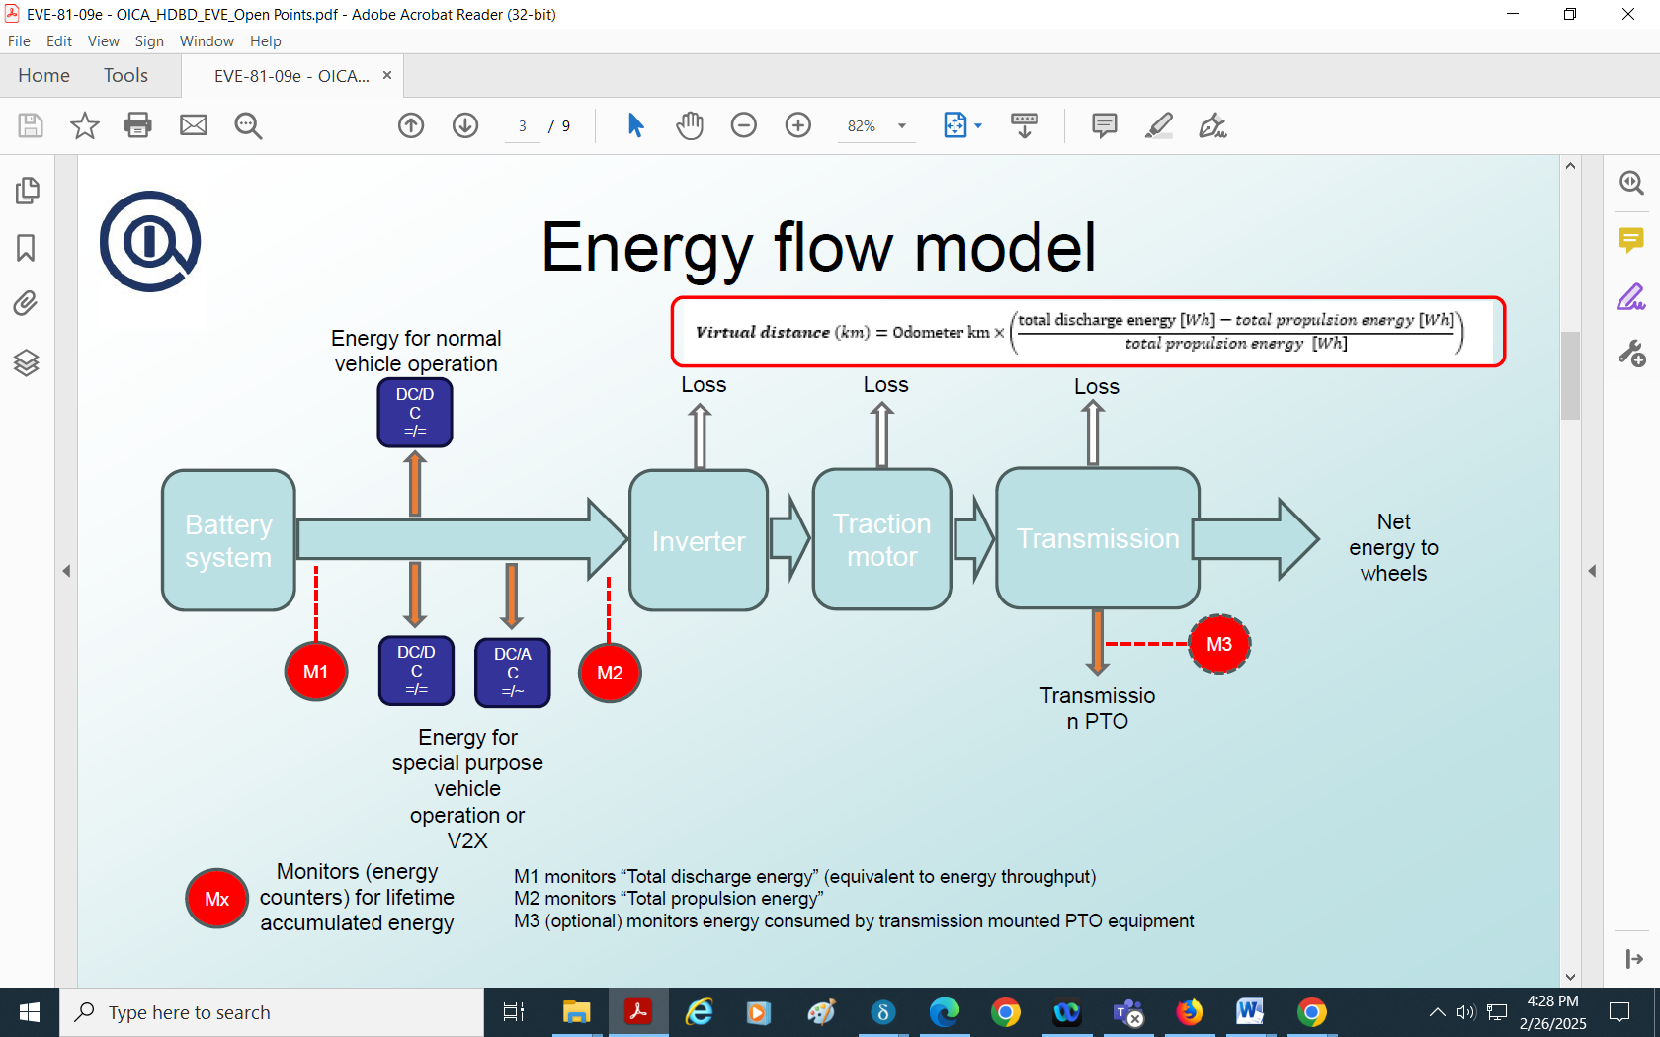 

Method 2

[

Table x.x Specifications of Bidirectional Power Supply

|  |  |
| --- | --- |
| ***item*** | ***Specification*** |
| Altitude | functioning properly under lower or equal to 700 meters above sea level |
| Ambient temperature | functioning properly under greater than or equal to 273.15 K (0 °C) and lower than or equal to 308.15 K (35 °C) |
| Ambient humidity | functioning properly under greater than or equal to 30%RH and lower than or equal to 80%RH (no condensation) |
| Input power | follow the instruction of the product  (shall comply with power unit specification and/or requirement of each region) |
| Discharge power | maximum 150 kW |
| Powering / Regenerating efficiency | more than 80% @ maximum rated |
| Operating mode | Constant Power  (also consider the transient power profile* to duplicate the real-world driving pattern) |
| Response time (10% to 90%） | less than or equal to 25ms (more than or equal to 40Hz) |
| * Charge⇔Discharge change time | less than or equal to 50ms @ 90% of setting |
| Stability (static load fluctuation) | within ±0.5%of maximum rated |
| Accuracy | within ±1.50% of maximum rated ±8.0% of the reading, whichever is smaller |
| Output fluctuation（Ripple） | within ±0.5%rms |
| DC Charging Connector | shall comply with the specific requirement |
| ~~Data recording~~ | ~~be able to record the current (both required and measured) and voltage (measured)~~ |