Proposal for amendments
to document ECE/TRANS/WP.29/2025/7
I. Proposal
Introduction, paragraph 14, amend to read:
“14. The safe use of DCAS requires appropriate understanding by the driver and of the performance capabilities of DCAS available on the vehicle. The provision of the appropriate information to the driver is required to avoid potential driver’s misinterpretation, overestimation, or difficulty with the DCAS/vehicle control…”
Paragraph 2.30., amend to read:
“2.30. “Dynamic Driving Task (DDT)” means the real-time operational and tactical functions required to operate the vehicle.”
Paragraph 5.3.7.2.4.11, amend to read:
“5.3.7.2.4.11 A request for the driver to acknowledge that they have read and understood the driver information material outlined in paragraph 5.6 shall be given while the vehicle is in a stopped position. This request shall be given at least once every month. If the vehicle utilises a means of differentiating between users, this may be extended to 3 months for a given user. If the vehicle can identify that a driver has previously acknowledged this request it does not need to be given again for that driver. If the vehicle can identify that the current driver has not acknowledged this request before, then it shall be given in the current drive cycle.”
Paragraphs 5.5.3.1., 5.5.4.2.8.1., Annex 4 – paragraph 4.2.2.1.(a)(i) delete references to footnote 3 after the word “powertrain”.
Paragraph 7.2.2.2., amend to read:
“7.2.2.2. If remedial action addressing DCAS design is to be taken by the manufacturer, the Type Approval Authority shall upload the information received from the manufacturer in the English language to the secure internet database “DETA”, established by the United Nations Economic Commission for Europe, without undue delay to communicate this information to all Type Approval Authorities. The information shall be sufficient to understand the incident, the cause of it and the remedial action.”
Paragraph 7.2.3.1., in Table 1, amend item 8.b to read:
8. During phases of withholding HORs without driver override of the longitudinal control (if applicable).
8.a. Number of events where an upcoming boundary condition is detected and a HOR is given at least 5s in advance (see 5.5.4.2.6.5.1).
8.b. Number of events where an upcoming boundary condition is detected and a HOR is not given but not at least 5s in advance (see 5.5.4.2.6.5.1).
8.c. Driving distance and time while the system is withholding HORs.

Paragraph 16. (and subparagraphs), (and subparagraphs), amend to read:
“16. Transitional Provisions
16.1. As from the official date of entry into force of the 01 series of amendments, no Contracting Party applying this Regulation shall refuse to grant or refuse to accept type approvals under this Regulation as amended by the 01 series of amendments.
16.2. As from 1 September 2027, Contracting Parties applying this Regulation shall not be obliged to accept type approvals issued to the original version (00 series of amendments) of this Regulation, first issued after 1 September 2027
16.3. Until 1 September 2030, Contracting Parties applying this Regulation shall accept type approvals issued to the original version (00 series of amendments) of this Regulation, first issued before 1 September 2027.
16.4. As from 1 September 2030, Contracting Parties applying this Regulation shall not be obliged to accept type approvals issued to the original version (00 series of amendments) of this Regulation.
16.5. Notwithstanding the transitional provisions above, Contracting Parties who start to apply this Regulation after the date of entry into force of the most recent series of amendments are not obliged to accept type approvals which were granted in accordance with the original version (00 series of amendments) of this Regulation.
16.6. Contracting Parties applying this Regulation may grant type approvals according to the original version (00 series of amendments) of this Regulation.
16.7. Contracting Parties applying this Regulation shall continue to grant extensions of existing approvals to the original version (00 series of amendments) of this Regulation”.
Annex 3, Appendix 2, amend to read:
“Appendix 2
System design to be assessed
1. Introduction
This Appendix reflects a summary of system design aspects outlined in the core text of this Regulation to be assessed by the Type Approval Authority. The following information shall be provided by the manufacturer for assessment.
2. Information related to DCAS in general
2.1. Driver Interaction and HMI
2.1.1. How the system is designed to ensure the driver remains engaged with the driving task, which includes an outline of the driver monitoring system and its warning strategy (paragraph 5.5.4.2.)
…
Insert new subparagraphs 2.1.1.6. to 2.1.1.8., to read:
“2.1.1.6. How the system addresses the detection and response to multiple subsequent short aversions of eye gaze or head posture by the driver (paragraph 5.5.4.2.5.3.).
2.1.1.7. Strategies implemented for determination when there has been no deviation in eye gaze (or movement of head position when this is being used to determine visual engagement) for a significant period of time, where an EOR shall be issued (paragraph 5.5.4.2.6.5.5.).
2.1.1.8. The number of repeated EOR or HOR warnings due to driver disengagement and the time interval over which these are counted (paragraph 5.5.4.2.8.3.).”
2.2. System Boundaries
Insert a new subparagraph 2.2.4. to read:
“2.2.4. The boundary conditions under which HORs can be withheld (paragraph 5.5.4.2.6.5.).”
2.3. System operation
Insert a new subparagraph 2.3.8. to read:
“2.3.8. How the controllability is ensured in the situations, where HORs are withheld, and in the cases when upcoming boundary conditions which require an HOR are detected less than 5 seconds in advance (paragraph 5.5.4.2.6.5.1.).”
Annex 4
Paragraph 2.1., amend to read:
“2.1. "Time to Collision" (TTC) means the point in time obtained by dividing the longitudinal distance (in the direction of travel of the VUT) between the VUT and the target by the longitudinal relative speed of the VUT and the target.”
Paragraph 4.1.1., make a reference to table A4/1. Table A4/1 shall be positioned after paragraph 4.1.1. The note under the asterisk shall be positioned after table A4/1.
Paragraph 4.2.5.2.8.1.2., amend text and update diagram to read:
“4.2.5.2.8.1.2. The VUT shall approach the impact point with the bicycle cyclist target in a straight line for at least two seconds prior to the functional part of the test.”
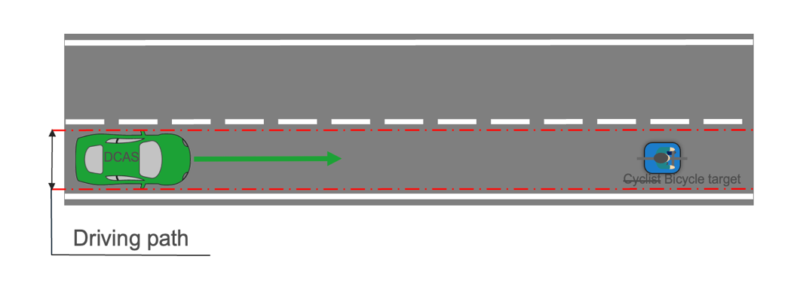
Paragraph 4.2.5.2.10.1.1., update text in diagram to read:
“4.2.5.2.10.1.1. The bicycle target shall travel in a straight line perpendicular to the VUT’s direction of travel at a constant speed of 15 km/h +0/-1 km/h, starting not before the functional part of the test has started. During the acceleration phase of the bicycle target prior to the functional part of the test the bicycle target shall be obstructed. The bicycle target’s positioning shall be coordinated with the VUT in such a way that the impact point of the bicycle target on the front of the VUT is on the longitudinal centreline of the VUT with a tolerance of not more than 0.2 m, if the VUT would remain at the prescribed test speed throughout the functional part of the test and does not brake.”
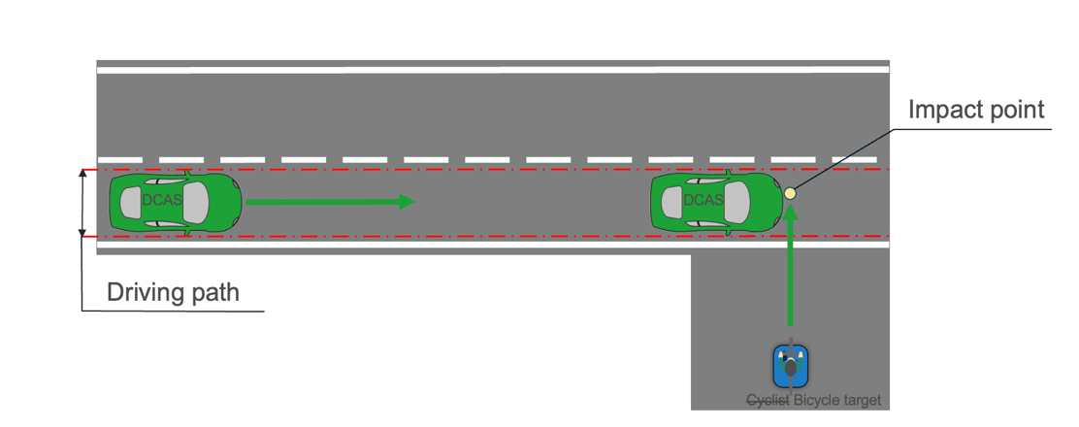
Paragraph 4.2.5.2.12.1.1., amend text and update diagram to read:
“4.2.5.2.12.1.1. The bicycle target shall travel in a straight line perpendicular to the VUT’s direction of travel at a constant speed of 15 km/h +0/-1 km/h, starting not before the functional part of the test has started. During the acceleration phase of the bicycle target prior to the functional part of the test the bicycle target shall be obstructed. The bicycle target’s positioning shall be coordinated with the VUT in such a way that the impact point of the bicycle target on the front of the VUT is on the longitudinal centreline offset of not more than 0.2 m, if the VUT would remain at the prescribed test speed throughout the functional part of the test and does not brake.”
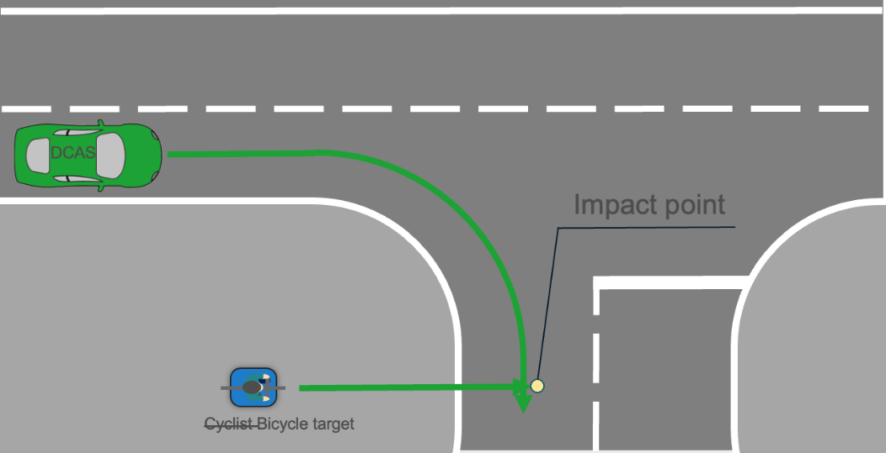
Annex 5, paragraph 3.4.6.3., amend to read:
“3.4.6.3. The manufacturer should demonstrate of how it applies the principles of its Management Systems, e.g. ISO 9001 or a similar best practice or standard, with regard to the competence of its M&S organization and the individuals in that organization and the basis for this determination. It is recommended that the assessor not substitute its judgment for that of the manufacturer regarding the experience and expertise of the organization or its members.”

____________

4 https://unece.org/data-sharing

