Proposal for the 05 series of amendments to UN Regulation No. 129 (Enhanced child restraint systems)
The text reproduced below was prepared by the expert from the Kingdom of the Netherlands to improve the shoulder height requirements to properly take the dimensions of premature newborns into account. The modifications are marked in bold for new and strikethrough for deleted characters.

I. Proposal
Paragraph 6.2.1.1., amend to read:
“6.2.1.1. The restraint of the child shall give the required protection in any position specified for the Enhanced Child Restraint System;
Inserts shall form only one layer on the seat surface. An exception is permitted for one additional insert layer to provide protection for small babies with a stature [≤ 45 cm]. This does not preclude the use of aAdditional ‘comfort’ inserts are permitted for any stature, provided they are not needed to comply with the requirements of the regulation;
For "Special Needs Restraints" the primary means of restraint shall give the required protection in any intended position of the Enhanced Child Restraint System without the use of the additional restraining devices which may be present."
Annex 18, amend to read:
"Annex 18
Geometrical dimensions of Enhanced Child Restraint Systems

Figure 1
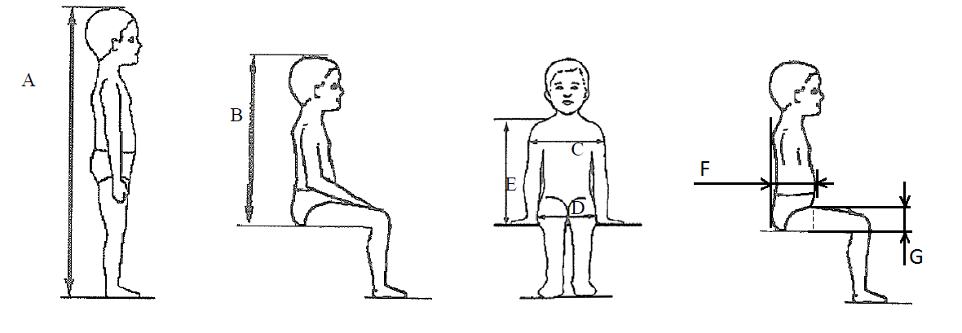

Table 1
Applicable to all ECRS |  |  |  |  |  |  | Additional internal dimensions for ECRS with impact shield systems
 | Min | Min | Min | Min | Max |  | Min |  | Max |  | Min |  | Max
Stature  cm | Sitting height  cm | Shoulder breadth  cm | Hip breadth  cm | Shoulder height  cm | Shoulder height  cm |  | Abdomen depth  cm |  | Abdomen depth  cm |  | Upper leg thickness cm |  | Upper leg thickness cm
A | B | C | D | E1 | E2 |  | F1 |  | F2 |  | G1 |  | G2
 | 95%ile | 95%ile | 95%ile | 5%ile | 95%ile |  | 5%ile |  | 95%ile |  | 5%ile |  | 95%ile
40* |  |  |  | 27.415.8 |  |  | Not allowed for these dimensions and stature bellow 76 cm
45 | 39.0 | 12.1 | 14.2 | 27.417.6 | 29.023.5
50 | 40.5 | 14.1 | 14.8 | 27.619.4 | 29.224.8
55 | 42.0 | 16.1 | 15.4 | 27.821.2 | 29.426.1
60 | 43.5 | 18.1 | 16.0 | 28.023.0 | 29.627.4
65 | 45.0 | 20.1 | 17.2 | 28.224.8 | 29.828.7
70 | 47.1 | 22.1 | 18.4 | 28.326.6 | 30.0
75 | 49.2 | 24.1 | 19.6 | 28.4 | 31.3 |  | 12.5 | 15.1 |  | 5.7 |  | 8.4
80 | 51.3 | 26.1 | 20.8 | 29.2 | 32.6 |  | 12.7 | 15.7 |  | 5.8 |  | 8.4
85 | 53.4 | 26.9 | 22.0 | 30.0 | 33.9 |  | 12.9 | 16.2 |  | 5.9 |  | 8.5
90 | 55.5 | 27.7 | 22.5 | 30.8 | 35.2 |  | 13.1 | 16.8 |  | 6.2 |  | 8.5
95 | 57.6 | 28.5 | 23.0 | 31.6 | 36.5 |  | 13.3 | 17.8 |  | 6.5 |  | 8.9
100 | 59.7 | 29.3 | 23.5 | 32.4 | 37.8 |  | 13.5 | 18.2 |  | 6.5 |  | 9.6
105 | 61.8 | 30.1 | 24.9 | 33.2 | 39.1 |  | 13.6 | 18.8 |  | 6.6 |  | 10.3
110 | 63.9 | 30.9 | 26.3 | 34.0 | 40.4 |  | 13.9 | 19.6 |  | 6.6 |  | 10.3
115 | 66.0 | 32.1 | 27.7 | 35.5 | 41.7 |  | 13.9 | 19.9 |  | 6.6 |  | 10.4
Applicable to all ECRS |  |  |  |  |  |  | Additional internal dimensions for ECRS with impact shield systems
 | Min | Min | Min | Min | Max |  | Min |  | Max |  | Min |  | Max
Stature  cm | Sitting height  cm | Shoulder breadth  cm | Hip breadth  cm | Shoulder height  cm | Shoulder height  cm |  | Abdomen depth  cm |  | Abdomen depth  cm |  | Upper leg thickness cm |  | Upper leg thickness cm
A | B | C | D | E1 | E2 |  | F1 |  | F2 |  | G1 |  | G2
 | 95%ile | 95%ile | 95%ile | 5%ile | 95%ile |  | 5%ile |  | 95%ile |  | 5%ile |  | 95%ile
120 | 68.1 | 33.3 | 29.1 | 37.0 | 43.0 |  | 14.3 | 20.2 |  | 6.8 |  | 10.5
125 | 70.2 | 33.3 | 29.1 | 38.5 | 44.3 |  | 14.7 | 20.7 |  | 7.5 |  | 10.9
130 | 72.3 | 33.3 | 29.1 | 40.0 | 46.1 |  | Not allowed for these dimensions and stature over 125 cm
135 | 74.4 | 33.3 | 29.1 | 41.5 | 47.9
140 | 76.5 | 34.2 | 29.6 | 43.0 | 49.7
145 | 78.6 | 35.3 | 30.8 | 44.5 | 51.5
150 | 81.1 | 36.4 | 32.0 | 46.3 | 53.3
All lateral dimensions are measured under a contact force of 50 N with the devices described in Figure 2 and Figure 3 of this annex and the following tolerances will applied:
Minimum Sitting height:
(a) Up to 87 cm B - 5 per cent;
(b) From stature from 87 cm and up to 150 cm B - 10 per cent.
Minimum shoulder height (5 percentile): E1 ₋₂⁺⁰ cm
Maximum shoulder height (95 percentile): E2 ₋₀⁺² cm
The mass of the devices described in Figure 2 and Figure 3 of this annex shall be
10 kg +/- 1 kg
* The minimum shoulder height dimension for statures below 40 cm shall be determined by extrapolation.
…”

II. Justification
1. Over the last couple of years, several presentations were given at the Langwieder Conference – Protection of Children in Cars, in Munich, making the attendants aware of the mismatch between UN R129 supposed shoulder height dimensions for premature newborns, and actual shoulder heights derived from collected anthropometry datasets.
2. After discharge from hospital, premature newborns are frequently transported home by car and need a safe child restraint system. Concerns have been raised about the fit of these newborns in those ECRSs. The distance between the seat bottom and the lowest shoulder harness outlet is often too large and the ECRS thus provides only an inappropriate fit.
3. There is a need for type-approved ECRSs starting from 40 cm with a proper harness fit. The lowest shoulder harness outlet shall be low enough to ensure the belt is positioned slightly below or at shoulder height to restrain especially small children properly.
4. A good harness fit is usually provided for the Q0 dummy – supposedly because the dummy needs to be restrained effectively in UN R129 front impact, rear impact and overturning tests. Therefore, the Q0 practically determines the lowest harness adjustment in an ECRS while the shoulder height requirements in UN R129 are very generous. If body statures below 48 cm (Q0 dummy) are considered, the more likely it is to have a poor fit of the ECRS.
5. The shoulder height from ≤ 40 cm until 75 cm does not correspond with real-life anthropometrical data of children.
6. The updated shoulder height data are based upon NHS Anthropometry data (see Schleuning et al: 2022). The green lines are based upon the NHS Anthropometry data whereas the blue lines represent the original R129 data
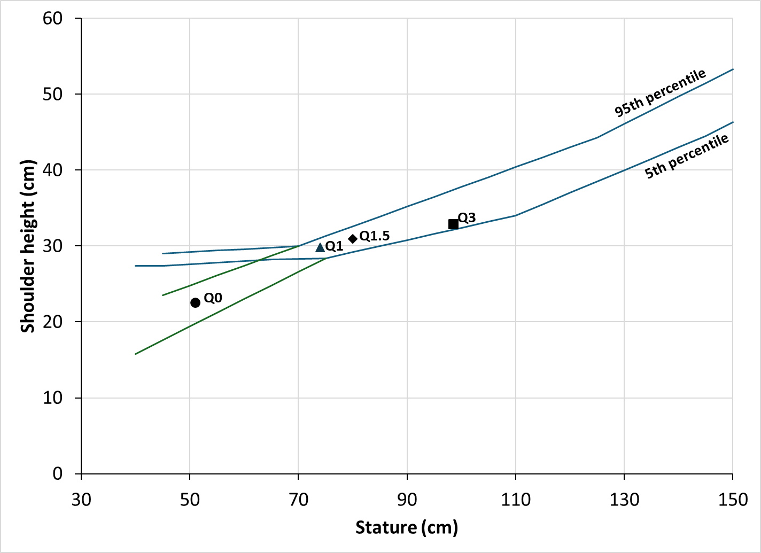
7. Paragraph 6.2.1.1. is modified to allow for one additional insert layer in order for ECRS manufacturers to be able to comply with the requirements, for premature infants [≤ 45 cm].
8. In Annex 18 table 1, the value for statures below 40 cm has been modified, in order to make sure that manufacturers do not declare statures below 40 cm, without properly addressing their corresponding shoulder heights. For that purpose, the shoulder heights below 40 cm may be extrapolated rather than taking the value at 40 cm, as was the case with the original provisions.

