|  |  |  |  |
| --- | --- | --- | --- |
|  | United Nations |  | |
| _unlogo | **Economic and Social Council** | | Distr.: General  xx January 2025  Original: English |

**Economic Commission for Europe**

Inland Transport Committee

**World Forum for Harmonization of Vehicle Regulations**

**Working Party on Pollution and Energy**

**Ninety-second session**

Geneva, 25-28 March 2025

Item 9(a) of the provisional agenda

**Electric Vehicles and the Environment (EVE)**

**UN GTR No. 21 (DEVP) and 22 (In-Vehicle Battery Durability**

**for Electrified Light Duty Vehicles) and [XX] (In-Vehicle Battery**

**Durability for Electrified Heavy Duty Vehicles)**

Proposal for a new UN GTR on In-vehicle Battery Durability for Electrified Heavy Duty Vehicles

Submitted by the Informal Working Group on Electric Vehicles and the Environment (EVE)[[1]](#footnote-2)\*

The text reproduced below was prepared by the Informal Working Group (IWG) on Electric Vehicles and the Environment (EVE) following the authorization given by WP.29/AC.3 in November 2022 to develop this new UN GTR on in-vehicle battery durability for electrified heavy duty electrified vehicles (ECE/TRANS/WP.29/AC.3/60). A first draft of this proposal was made available as an informal document by the EVE IWG at the 91st session of GRPE (see informal document GRPE-91-20).

**UN Global Technical Regulation on In-vehicle Battery Durability for Electrified Heavy Duty Vehicles**

Contents

Page

[1. Purpose 3](#_Toc185608263)

[2. Scope and application 3](#_Toc185608264)

[3. Definitions 3](#_Toc185608265)

[5. Requirements 6](#_Toc185608266)

[5.1. State-of Certified Energy (SOCE) monitor 6](#_Toc185608267)

[5.2. Battery Performance Requirements 6](#_Toc185608268)

[6. In-Use Verification 7](#_Toc185608269)

[6.1. Definitions of Families 7](#_Toc185608270)

[6.2. Information gathering 8](#_Toc185608271)

[6.3. Part A: Verification of SOCE monitor 8](#_Toc185608272)

[6.4. Part B: Verification of Battery Durability 10](#_Toc185608273)

[6.5. Part C: Verification of reported virtual distance or Energy throughput counter 11](#_Toc185608274)

[6.6. Process flow charts for Part A and Part B 13](#_Toc185608275)

[7. Rounding 15](#_Toc185608276)

[Annex 1 16](#_Toc185608277)

[Annex 2 20](#_Toc185608278)

[Annex 3 21](#_Toc185608279)

[1. General 21](#_Toc185608280)

[1.1. Vehicle selection 21](#_Toc185608281)

[1.2. Measurement requirements 21](#_Toc185608282)

[2. Test procedures 22](#_Toc185608283)

[2.1. Method 1a: Discharge by driving on a test track using characteristic regional speeds 22](#_Toc185608284)

[2.2. Method 1b: Discharge by driving on the road 29](#_Toc185608285)

[2.3. Method 2: Discharge using a bidirectional power supply system 35](#_Toc185608286)

[2.4. Alternative Method: Discharge using constant and transient cycles test method by using a HDV chassis dynamometer 41](#_Toc185608287)

[3. Performance parameters 52](#_Toc185608288)

[Annex 4 (optional annex) 56](#_Toc185608289)

I. Statement of technical rationale and justification

[To be prepared]

II. Text of the GTR

**1. Purpose**

This Global Technical Regulation (GTR) provides worldwide harmonised methods to determine in-vehicle battery durability performance of Heavy Duty Pure Electric Vehicles (HD-PEVs) and Heavy Duty Off-Vehicle Charging Hybrid Electric Vehicles (HD-OVC-HEVs).

Minimum performance requirements on in-vehicle battery durability of Heavy Duty Pure Electric Vehicles (HD-PEVs) and Heavy Duty Off-Vehicle Charging Hybrid Electric Vehicles (HD-OVC-HEVs) are introduced in an optional annex.

**2. Scope and application**

This GTR applies to vehicles of categories 1–2 and 2, that have a technically permissible maximum laden mass exceeding 3,855 kg, that (a) are HD-PEV or HD-OVC-HEV vehicles, and (b) have an originally installed battery as defined in this GTR.

[At the option of the Contracting Party, a lower minimum technically permissible maximum laden mass may be used.]

The Contracting Party shall make a decision about the applicability of this GTR to Small Volume Manufacturers and special purpose vehicles and special axle formulas for their jurisdiction.

Electrified vehicle category trailers and semitrailers are out of the scope of this GTR.

**3. Definitions**

The following definitions shall apply in this GTR.

3.1. *"Battery"* means, in the context of this GTR, any assembly of rechargeable electrical energy storage systems (REESS) installed in an electrified vehicle and used mainly for traction purposes.

3.2. *"Originally installed battery"* means the battery that is installed in the vehicle at the time of manufacture [and that is configured according to the manufacturer’s design/certification], or if the vehicle is manufactured without an installed battery, the battery that is installed in the vehicle when it is first operated on the road.

3.3. *"Usable Battery energy (UBEdischarge)"* means the energy supplied by the battery from the beginning of the test procedure used for certification until the applicable end of test criterion of the test procedure as defined in Annex 3 of this GTR.

3.4. *"Certified usable battery energy"* (UBEcertified) refers to the UBE that was determined during the certification of the vehicle, according to Annex 3 of this GTR.

3.5. *"Measured usable battery energy"* (UBEmeasured) means the UBE determined at the present point in the lifetime of the vehicle by the test procedure used for certification, according to Annex 3 of this GTR.

3.6. "*Odometer*" means that part of the odometer equipment, which indicates to the driver the total distance recorded by the vehicle since its entry into service.

3.7. "*Gross Vehicle Mass (GVM)*" of a vehicle means the maximum mass of the fully laden solo vehicle, based on its construction and design performances, as declared by the manufacturer. This shall be less than or equal to the sum of the maximum axles’ (group of axles) capacity.

3.8. "*Gross Train Mass (GTM)*" of a power driven vehicle means the technically permissible maximum mass of the laden vehicle combination, as declared by the manufacturer of the towing vehicle.

3.9. *"State of certified energy"* (SOCE) means the measured or on-board UBE performance at a specific point in its lifetime, expressed as a percentage of *the certified usable battery energy.*

3.10. *"Minimum Performance Requirement" (MPR) means the minimum durability* performance, in terms of SOCE at a specific point in the life of the vehicle, that constitutes compliance with the optional durability provisions of this GTR.

3.11. *"Declared Performance Requirement"* (DPR) means an SOCE value declared by the manufacturer that is greater than that of the corresponding MPR and which then becomes the minimum durability performance that constitutes compliance of that manufacturer with the durability provisions of this GTR.

3.12. *"SOCE monitor"* means an apparatus installed in the vehicle that maintains an estimate of the state of certified energy by means of an algorithm operating on data collected from the vehicle systems.

3.13. *"On-board SOCE"* (SOCEread) means an estimate of state of certified energy produced by an SOCE monitor.

3.14. *"Measured SOCE"* (SOCEmeasured) means the state of certified energy as determined by the measured usable battery energy divided by the certified usable battery energy.

[3.15. *"Total propulsion energy"* is the DC energy in kWh supplied to the traction inverter terminals discharging the REESS.]

3.16. *"V2X"* means the use of the traction batteries to cover external power and energy demand, such as V2G (Vehicle-to-Grid) for grid stabilisation by utilising traction batteries, V2F (Vehicle-to-Facility) for utilising traction batteries as facility storage for local optimisation or emergency power sources in times of power failure, V2H (Vehicle-to-Home) for utilising traction batteries as residential storage for local optimisation or emergency power sources in times of power failure, and V2L (Vehicle-to-Load, only connected loads are supplied) for use in times of power failure and/or outdoor activity in normal times.

[3.17. [Editorial note: a definition relating to power take-off that is appropriate to the requirements of this GTR remains under consideration]

*"PTO"* means Power Take-Off, i.e., any operation during stand still or propulsion of the vehicle for operational purposes other than V2X or motion.

PTO-operation (see R49, rev.07: 2.1.56. without engine-reference): "Power take-off operation" means any energy output for the purposes of powering auxiliary.

Power take-off (PTO) means a secondary engine shaft (or equivalent) that provides substantial auxiliary power for purposes unrelated to vehicle propulsion or normal vehicle accessories such as air conditioning, power steering, and basic electrical accessories.

Power take-off (PTO) means supplying power from the engine (ICE, motor) to operate auxiliaries equipment unrelated to vehicle traction or normal vehicle auxiliaries(24V/12V-DCDC), such as oil pumps, water pumps (for concrete mixers, garbage trucks, fire trucks etc.).

Electrical Power take-off (e-PTO) means directly REESS that provides substantial auxiliary power for purposes unrelated to vehicle propulsion or normal vehicle accessories (heater, 24/12V-DCDC) such as air pump, oil pump, water pump (for Cargo Thermal Control trucks, refrigerator trucks, cabin heater and air-conditioning,…)]

[3.18. *"Total energy throughput during V2X and/or PTO and/*or non-traction purposes *"* means the total amount of energy in kWh discharged during V2X and/or PTO and/or non-traction purposes applications, which needs to be provided according to Annex 2.]

3.19. *"Energy throughput*" is the total amount of energy in kWh discharged from the REESS, which needs to be provided according to Annex 2.

[3.20. *"Energy throughput counter"* means the system including eventual hardware and software that records the amount of energy in kWh during all discharge events.]

3.21. *"Pure electric vehicle"* (PEV) means a vehicle equipped with a powertrain containing exclusively electric machines as propulsion energy converters and exclusively rechargeable electric energy storage systems as propulsion energy storage systems.

3.22. *"Off-vehicle charging hybrid electric vehicle"* (OVC-HEV) means a hybrid electric vehicle that can be charged from an external source.

**4. Abbreviations**

BMS Battery Management System

DPR Declared Performance Requirement

[e-PTO Electrical Power Take-Off ]

FSD Full Scale Deflection

GTM Gross Train Mass

GNSS Global Navigation Satellite System

GVM Gross Vehicle Mass

HD Heavy Duty

HD-OVC-HEV HD Off-Vehicle Charging Hybrid Electric Vehicle

HD-PEV HD Pure Electric Vehicle

MPR Minimum Performance Requirement

OTA Over the Air

PTO Power Take-Off

REESS Rechargeable Electrical Energy Storage System

SOCE State of Certified Energy

UBE Usable Battery Energy

V2F Vehicle to Facility

V2G Vehicle to Grid

V2H Vehicle to Home

V2L Vehicle to Load

V2X Vehicle to Grid, to Facility, to Home, to Load

**5. Requirements**

### 5.1. State-of Certified Energy (SOCE) monitor

The manufacturer shall install a SOCE monitor that operates during the life of the vehicle. The SOCE monitor shall maintain an estimate of the state of certified energy (on-board SOCE).

The manufacturer shall determine the algorithms by which on-board SOCE is determined for the vehicles they produce. The manufacturer shall update the on-board SOCE with sufficient frequency as to maintain the necessary degree of accuracy during all normal vehicle operation.

The on-board SOCE shall have a resolution of at least 1 part in 100 and be used for the purposes of verification as the nearest whole number from 0 to 100.

The manufacturer shall make available the most recently determined values of the on-board SOCE via the OBD port and optionally over-the-air (OTA).

For the purposes of consumer information, the manufacturer shall make easily available to the owner of the vehicle the most recently determined value of the SOCE monitor via at least one appropriate method. The resolution and method for the customer values shall be determined in agreement with the authorities. For example:

(a) dashboard indicator;

(b) infotainment system;

(c) remote access (such as via mobile-phone applications).

### 5.2. Battery Performance Requirements

The battery durability requirements of this GTR are defined in terms of Minimum Performance Requirements (MPR*i*), which represent minimum allowable values for SOCE at specific points in the lifetime of the vehicle.

In order to address regional considerations, a Contracting Party may elect to enforce Minimum Performance Requirements (MPR*i*) specified in the tables of the optional Annex 4 [for vehicles falling under the vehicle types of HD-OVC-HEVs and HD-PEVs].

The MPRs may differ depending on the category of the vehicle and type of propulsion.

A SOCE monitor shall be installed on vehicles of categories 1–2 and 2.

A manufacturer may elect to declare a Declared Performance Requirement (DPR*i*) having an SOCE value that is higher than that of the corresponding MPR. The DPR*i* shall then replace the MPR*i* for the purposes of determining compliance by that manufacturer.

If a Contracting Party elects to enforce Minimum Performance Requirements (MPR*i*) from the tables of the optional Annex 4, the manufacturer shall ensure that batteries installed in vehicles comply with the rules specified in paragraph 6.4.2. for the MPR*i* (or DPR*i* if applicable).

[At the request of the manufacturer and for vehicles designed with V2X or non-traction purpose applications and PTO, the equivalent virtual distance calculated following the equation below shall be reported by each vehicle:

referring to the total energy throughput, sum of the propulsion energy and additional application discharge energy.]

[The total propulsion energy is DC energy supplied to the inverter terminals without recuperation.]

The total distance used for confirming the compliance with the minimum performance requirements, when applicable, shall consist of the sum of the distance driven and the virtual distance. The total virtual distance shall be recorded and monitored.

**6. In-Use Verification**

### 6.1. Definitions of Families

Vehicles having the same characteristics with respect to their evaluation under Part A or Part B below shall be grouped respectively into the Part A or Part B vehicle families for the purpose of compliance verification. Families under Part A shall have the same characteristics with respect to verification of the SOCE monitor. Families under Part B shall have the same characteristics with respect to verification of battery durability.

Families with the same characteristics with respect to compliance verification shall be defined as follows:

6.1.1. For Part A:Verification of the Monitor

Only vehicles that are substantially similar with respect to the following elements may be part of the same monitor family:

(a) Algorithm for estimating on-board SOCE;

(b) Sensor configuration (for sensors used in determination of SOCE estimates);

(c) Characteristics of battery cell which have a non-negligible influence on accuracy of monitor;

(d) Type of vehicle (HD-PEVs or HD-OVC-HEVs).

At the request of the manufacturer, with the approval of the responsible authority and with appropriate technical justification, the manufacturer may deviate from the above criteria for families.

6.1.2. For Part B: Verification of Battery Durability

Only vehicles that are substantially similar with respect to the following elements may be part of the same battery durability family:

(a) Vehicle category (category 1-2 or category 2);

(b) Type and number of electric machines, including net power, construction type (asynchronous/ synchronous, etc.), and any other characteristics having a non-negligible influence on battery durability;

(c) Type of battery (dimensions, type of cell, including format and chemistry, capacity (Ampere-hour), nominal voltage, nominal power;

(d) Battery management system (BMS) (with regards to battery durability monitoring and estimations);

(e) Passive and active thermal management of the battery;

(f) Type of electric energy converter between the electric machine and battery, between the recharge-plug-in and battery, and any other characteristics having a non-negligible influence on battery durability;

(g) Operation strategy of all components influencing the battery durability.

At the request of the manufacturer, with the approval of the responsible authority and with appropriate technical justification, the manufacturer may deviate from the above criteria for families.

[6.1.3. For Part C: Verification of reported virtual distance

Only vehicles that are substantially similar with respect to the following elements may be part of the same virtual distance family:

(a) Algorithm for reported virtual distance;

(b) Sensor configuration (for sensors used in determination of virtual distance);

(c) Characteristics of battery cell which have a non-negligible influence on accuracy of the monitor;

(d) Type of vehicle (HD-PEVs or HD-OVC-HEVs).

At the request of the manufacturer, with the approval of the responsible authority and with appropriate technical justification, the manufacturer may deviate from the above criteria for families.]

### 6.2. Information gathering

The following information shall be made available to the authorities by the manufacturer in a format to be agreed between the authorities and the manufacturer: annual report on relevant warranty claims; and annual statistics on repairs for both batteries and other systems that might influence the electric energy consumption of the vehicle. Such information shall be made available once a year for each battery durability family for the duration of the period defined in the optional Annex 4 after the last vehicle of this family is sold.

### 6.3. Part A: Verification of SOCE monitor

6.3.1. Frequency of verifications

The manufacturer shall complete the procedure for in-use verification for Part A with a frequency agreed with the regional authorities, as defined in the optional Annex 4 after the last vehicle of each monitor family is sold and report the results of the verification to the authorities. The authorities may decide to proceed with their own verification of Part A, at a frequency and magnitude based on risk assessment, or request more information from the manufacturers. With the agreement of all Contracting Parties involved, the verification of Part A for vehicles in the same monitor family may be combined between different Contracting Parties. In such cases the relevant Contracting Parties shall be considered as a single authority for the purposes of this verification.

At the option of the Contracting Party, a minimum annual sales volume for a monitor family may be defined, below which verification of monitors is not required. Such families may still be selected to be tested for Part A, at the request of the responsible authorities.

6.3.2. Verification procedure

In order to verify the SOCE monitor, the value for the usable battery energy shall be measured at the time of the verification and the related value from the monitor shall be collected before the verification test procedure. To support future improvement of the GTR, indicator values shall be collected again after the verification test procedure. Those indicators read after the verification test procedure shall not be considered in the Part A verification.

The measured SOCE value shall be determined by dividing the measured value for the usable battery energy by the certified value for the usable battery energy, in accordance with the procedures defined in Annex 3 of this GTR expressed in per cent.

In cases where UBEmeasured is higher than the UBEcertified, the SOCEmeasured shall be set to 100 per cent.

The different test procedures for the UBE determination are defined in Annex 3:

Method 1a: battery discharge by driving on a test track using characteristic regional speeds (paragraph 2.1. of Annex 3),

Method 1b: battery discharge by driving on the road (paragraph 2.2. of Annex 3)

Method 2: battery discharge using a bidirectional power supply system (paragraph 2.3. of Annex 3).

[As an alternative to these test procedures, the battery may be discharged using a constant and transient cycles test method using a HDV chassis dynamometer (paragraph 2.4. of Annex 3).]

6.3.3. Statistical Method for Pass/Fail decision for a sample of vehicles

An adequate number of vehicles (at least 3 and not more than 16) shall be selected from the same monitor family for testing following a vehicle survey (see Annex 1) which contains information designed to ensure that the vehicle has been properly used and maintained according to the specifications of the manufacturer. The following statistics shall be used to take a decision on the accuracy of the monitor.

For evaluating the SOCE monitor normalised values shall be calculated:

Where

is the on-board SOCE read from the vehicle *i* ; and

is the measured SOCE of the vehicle *i*.

For the total number of *N* tests and the normalised values of the tested vehicles, *x1, x2, … xN,* the average *Xtests* and the standard deviation *s* shall be determined:

and

For each N tests 3 ≤ *N* ≤ *16*, one of the three following decisions can be reached, where the factor A shall be set at 5:

(a) Pass the family if

(b) Fail the family if

(c) Take another measurement if:

where the parameters *tP1,N, tP2,N, tF1,N,* and*tF2* are taken from Table 1.

Table 1

**Pass/fail decision criteria for the sample size**

|  | *PASS* | | *FAIL* | |
| --- | --- | --- | --- | --- |
| *Tests (N)* | *tP1,N* | *tP2,N* | *tF1,N* | *tF2* |
| 3 | 1.686 | 0.438 | 1.686 | 0.438 |
| 4 | 1.125 | 0.425 | 1.177 | 0.438 |
| 5 | 0.850 | 0.401 | 0.953 | 0.438 |
| 6 | 0.673 | 0.370 | 0.823 | 0.438 |
| 7 | 0.544 | 0.335 | 0.734 | 0.438 |
| 8 | 0.443 | 0.299 | 0.670 | 0.438 |
| 9 | 0.361 | 0.263 | 0.620 | 0.438 |
| 10 | 0.292 | 0.226 | 0.580 | 0.438 |
| 11 | 0.232 | 0.190 | 0.546 | 0.438 |
| 12 | 0.178 | 0.153 | 0.518 | 0.438 |
| 13 | 0.129 | 0.116 | 0.494 | 0.438 |
| 14 | 0.083 | 0.078 | 0.473 | 0.438 |
| 15 | 0.040 | 0.038 | 0.455 | 0.438 |
| 16 | 0.000 | 0.000 | 0.438 | 0.438 |

6.3.4. Corrective measures for the SOCE monitor

A fail decision for the sample means that the monitor fails to report accurately the durability of the system and appropriate action shall be taken by the manufacturer with the agreement of the responsible authority. This may lead to the requirement that the manufacturer repairs or replaces the faulty monitor including the relevant sensors or applies software measures in all affected vehicles in the monitor family.

A pass decision or correction of the non-compliance is required for proceeding with Part B.

### 6.4. Part B: Verification of Battery Durability

[This paragraph shall be applied according to regional requirements].

6.4.1. Frequency of verifications

Data shall be collected yearly by the responsible authorities from a statistically adequate sample of vehicles within the same battery durability family selected randomly from a variety of climate conditions. The decision on the number of vehicles in the sample may be taken by the responsible authority based on risk assessment methodology, but in principle should not be less than 500.

If the number of vehicles in the sample is less than 500, then on the request of the manufacturer and with the agreement of the responsible authority, a maximum of 5 per cent of the values may be excluded from the sample. In such a case, the manufacturer shall provide adequate information to the authority on the reason behind the exclusion for each vehicle.

If the number of vehicles in the sample is equal to or more than 500, then all vehicles shall be included in the sample. The data read shall be those of the SOCE monitor (and other relevant data, such as those defined in Annex 2).

6.4.2. Pass/Fail Criteria for the battery durability family

A battery durability family shall pass if equal to or more than 90 per cent of monitor values read from the vehicle sample are above the MPR*i* or DPR*i*.

A battery durability family shall fail if less than 90 per cent of monitor values read from the vehicle sample are above the MPR*i* or DPR*i*.

6.4.3. Corrective Measures for the Battery Durability Family

In the case of a fail for a battery durability family, corrective measures shall be taken by the manufacturer with the agreement of the responsible authority in order to bring the family or part of the family affected by the issue into compliance.

[

### 6.5. Part C: Verification of reported virtual distance or Energy throughput counter

6.5.1. Verification procedure

A verification of the reported virtual distance/energy throughput counter is only required if the manufacturer is requesting to apply the [equivalent virtual distance/energy throughput option]. In order to verify the virtual distance/energy throughput read from the vehicle, a test shall be performed with adequate and representative use of the vehicle in V2X or non-traction purposes and PTO, if applicable, to verify whether the increase in virtual distance reported is accurate. The total discharge energy during this use, or alternatively the total discharge energy of the vehicle (defined as the sum of the discharge energy while driving and while using the V2X, non-traction purpose and PTO) and the total propulsion energy, shall be measured in order to calculate the measured virtual distance. The verification procedure use case (including the minimum amount of discharged energy corresponding to at least 50 km virtual distance) shall be agreed and approved by the responsible authority. If 50 km virtual distance cannot be reached with a fully charged battery, virtual distance required for verification shall be set to a value recommended by the manufacturer.

The following steps shall be performed to determine the necessary verification results. Table 2a refers to virtual distance verification, whilst Table 2b refers to Energy-throughput counter verification.

Table 2a

**Virtual distance verification**

|  |  |  |  |
| --- | --- | --- | --- |
| Step nr. | Input | Description | Output |
| Step 1 | n.a. | Read the initial virtual distance or the total km (driving + virtual distance),[ ~~total discharge energy while driving~~ ~~(~~total propulsion energy~~)~~] and the odometer according to Annex 2 | dvirt,on-board,init [km]  Edrive,init[kWh]  Odometer init [km]  dvirt,on-board,init [km] = total distance - odometers |
| Step 2 | n.a. | Perform the V2X, non-traction purposes, PTO -use case and measure the total discharge energy | E(driving+V2X,PTO),meas [kWh] |
| Step 3 | n.a. | Read the final virtual distance according to Annex 2  or (the total distance – odometer km) | dvirt,on-board,final [km] |
| Step 4 | From Step 1:  dvirt,on-board,init [km]  Edrive,init [kWh]  Odometer,init [km]  or  E(driving+V2X,PTO.), init [kWh]  From Step 2:  E(driving+V2X,PTO),meas [kWh]  From Step 3:  dvirt,on-board,final [km] | Calculate the delta of on-board virtual distance:  Calculate the measured virtual distance: | Δdvirt,on-board [km]  Δdvirt,meas [km] |

[Table 2b

**Energy-throughput counter verification**

Table to be added]

6.5.2. Pass or fail of reported virtual distance

An agreed verification procedure use case (as mentioned in paragraph 6.5.1.) shall be performed with an adequate number of vehicles (at least 1 and not more than 4) used in V2X, non-traction purposes or PTO. The verification of the reported virtual distance shall lead to a fail in the verification procedure if the reported delta virtual distance Δdvirt,on-board according to [Table 2] is more than 5 per cent higher than the measured virtual distance Δdvirt,meas according to [Table 2]. The following statistics shall be used to take a decision on the accuracy of the virtual distance.

For the purposes of deciding on a pass/fail result for the sample, 'p' is the count of passed results, and 'f' is the count of failed results. Each passed test result shall increase the 'p' count by 1 and each failed test result shall increase the 'f' count by 1 for the relevant open statistical procedure.

Upon the incorporation of valid V2X or PTO energy test results to an open instance of the statistical procedure, the responsible authority shall perform the following actions:

(a) update the cumulative sample size 'n' for that instance to reflect the total number of valid tests incorporated to the statistical procedure;

(b) following an evaluation of the results, update the count of passed results 'p' and the count of failed results 'f';

(c) check whether a decision is reached with the procedure described below.

The decision depends on the cumulative sample size 'n', the passed and failed result counts 'p' and 'f'. For the decision on a pass/fail of a verification sample the responsible authority shall use the decision chart in Table 3. The chart indicates the decision to be taken for a given cumulative sample size 'n' and failed count result 'f'.

Two decisions are possible for a statistical procedure for a given vehicle family:

(a) ‘Sample pass’ outcome shall be reached when the decision chart from Table 3 gives a "PASS" outcome for the current cumulative sample size 'n' and the count of failed results 'f'.

(b) ‘Sample fail’ decision shall be reached when, for a given cumulative sample size 'n', when the applicable decision chart from Table 3 gives a "FAIL" decision for the current cumulative sample size 'n' and the count of failed results 'f'.

If no decision is reached, the statistical procedure shall remain open and further results shall be incorporated into it until a decision is reached.

Table 3

**Decision chart for Part C pass/fail verification**

|  |  |  |  |  |  |
| --- | --- | --- | --- | --- | --- |
|  |  |  |  |  |  |
| **Failed result count f** | 3 |  |  | FAIL | FAIL |
| 2 |  | UND | UND | PASS |
| 1 | UND | PASS | PASS | PASS |
| 0 | PASS | PASS | PASS | PASS |
| n |  | 1 | 2 | 3 | 4 |

Note: *"*UND*"* means undecided

6.5.3. Corrective measures for reported virtual distance

A fail decision for the sample means that the virtual distance calculators (algorithm) fail to report accurately the virtual distance of the system and appropriate action shall be taken by the manufacturer with the agreement of the responsible authority. This may lead to the requirement that the manufacturer repairs or replaces the faulty virtual distance calculator in all affected and future vehicles in the battery durability family, to correct already reported virtual distances for this family and to repeat the procedure for verification of Part B in order to confirm the pass or fail.]

### 6.6. Process flow charts for Part A and Part B

The flow charts below illustrate the various steps in the verification process of Part A (Figure 1) and Part B (Figure 2).

Figure 1

**Flow chart for Part A: Verification of Monitors**

YES

None

YES

NO

**Part A: Verification of Monitors**

Vehicle Procurement

Vehicle Survey

according to Annex 1

Obtain on-board SOCE

(used for Part A verification)

**Pass/Fail Decision**

**according to paragraph 6.3.3.**

Obtain on-board SOCE before and after update.

Use the one before update for monitoring

Use the one after update for Part A verification

• Perform Verification Test

• Obtain measured SOCE

• Obtain on-board SOCE (not used for Part A verification)

Check the Exclusion

Criteria

Need more testing according to paragraph

6.3.3.

Exclude from sampling

Or update the monitor by procedure in vehicle survey

Figure 2

**Flow chart for Part B : Verification of Battery Durability**

YES

**Part B : Verification of Battery Durability**

Data Acquisition according to paragraph 5.1.

**Pass/Fail Decision**

**according to paragraph 6.4.2.**

Annual Sample Size is equal or greater than 500 (paragraph 6.4.1.)

NO

Exclude maximum 5% with responsible authority agreement

**7. Rounding**

7.1. When the digit immediately to the right of the last place to be retained is less than 5, that last digit retained shall remain unchanged.

Example:

If a result is 1.2344 kWh but only three places of decimal are to be retained, the final result shall be 1.234 kWh.

7.2. When the digit immediately to the right of the last place to be retained is greater than or equal to 5, that last digit retained shall be increased by 1.

Example:

If a result is 1.2346 kWh but only three places of decimal are to be retained, and because 6 is greater than 5, the final result shall be 1.235 kWh.

## **Annex 1**

Vehicle Survey

The vehicle survey shall be used for all vehicles selected for testing in Part A verification of SOCE monitor, for all the test methods, i.e., Method 1a, Method 1b, Method 2 and Alternative Method of Annex 3. Vehicles that fall under one of the exclusion criteria below shall be eliminated from testing, or otherwise updated according to the procedures described below.

|  |  |  |  |  |
| --- | --- | --- | --- | --- |
|  | **x = Exclusion Criteria** | **x = Checked and reported** | **Confidential** | |
| **Date:** |  |  | **x** | |
| **Name of investigator:** |  |  | **x** | |
| **Location of test:** |  |  | **x** | |
| **Country of registration:** |  | **x** |  | |
|  | **x = Exclusion Criteria** | **x = Checked and reported** |  | |
| **Vehicle Characteristics** | **Confidential** | |
|  |  | |
| **Registration plate number:** |  | **x** | **x** | |
| *The vehicle must have* ***age and distance*** *travelled (defined as the time elapsed after manufacture) below the one required in the optional Annex 4 for the MPR verification* | **x** |  |  | |
| Is the vehicle either HD-PEV or HD-OVC-HEV?  If no: the vehicle cannot be selected | **x** |  |  | |
| **Date of manufacture:** |  | **x** |  | |
|  |  |  |  | |
| **VIN:** |  | **x** |  | |
| **Emission class and character or Model Year** |  | **x** |  | |
| **Country of registration:**  *The vehicle must be registered in a Contracting Party* | **x** | **x** |  | |
| **Model:** |  | **x** |  | |
| **Engine code:** |  | **x** |  | |
| **Engine volume (l):** |  | **x** |  | |
| **Engine power (kW):** |  | **x** |  | |
| **Electric Engine code:** |  | **x** |  | |
| **Electric Engine power (kW):** |  | **x** |  | |
| **Electric powertrain type** |  | **x** |  | |
| **Energy capacity and type of battery** |  | **x** |  | |
| **Gearbox type (auto/manual):** |  | **x** |  | |
| **Drive axle (FWD/AWD/RWD):** |  | **x** |  | |
| **Tyre size (front and rear if different):** |  | **x** |  | |
| **[Average fuel consumption for HD-OVC-HEVs]** |  | **x** |  | |
| **Is the vehicle involved in a recall or service campaign? If yes: Which one? Have the campaign repairs already been done?**  *The repairs must have been done before selecting the vehicle.* | **x** | **x** |  | |
| **Vehicle Owner Interview**  *(the owner will only be asked the main questions and shall have no knowledge of the implications of the replies)* |  |  |  | |
|  |  |  |  | |
| **Name of the owner (only available to the accredited inspection body or laboratory/technical service)** |  |  | **x** | |
| **Contact (address / telephone) (only available to the accredited inspection body or laboratory/technical service)** |  |  | **x** | |
|  |  |  |  | |
| **How many owners did the vehicle have?** |  | **x** |  | |
| **Did the odometer work?** *If no, the vehicle cannot be selected.* | **x** |  |  | |
| **Was the vehicle used for one of the following?** |  |  |  | |
| As vehicle used in show-rooms? |  | **x** |  | |
| For racing / motor sports? | **x** |  |  | |
| Usage not originally prescribed |  | **x** |  | |
| **Has the vehicle carried heavy loads over the specifications of the manufacturer?** *If yes, the vehicle cannot be selected.* | **x** |  |  | |
| **Have there been major engine, electric motor or vehicle repairs?** |  | **x** |  | |
| **Have there been unauthorised major engine or vehicle repairs?**  *If yes, the vehicle cannot be selected.* | **x** |  |  | |
| **Was the propulsion battery changed or repaired?**  *If yes, the vehicle cannot be selected for testing, but information should be collected* | **x** | **x** |  | |
| **Has there been an unauthorised power increase/tuning?** *If yes, the vehicle cannot be selected.* | **x** |  |  | |
| **Was any part of the emissions after-treatment system modified?**  *If yes, the vehicle cannot be selected* | **x** |  |  | |
| **[Where do you use your vehicle more often?]** |  |  |  | |
| % motorway |  | **x** |  | |
| % rural |  | **x** |  | |
| % urban |  | **x** |  | |
| **Has the vehicle been maintained and used in accordance with the manufacturer's instructions?** *If not, the vehicle cannot be selected.* | **x** |  |  | |
| **Full service and repair history including any re-works** *If the full documentation cannot be provided, the vehicle cannot be selected.* | **x** |  |  | |
| **Battery related checks:** |  |  |  | |
| **How often did you charge the vehicle when:**  **% with battery almost at 0 charge**  **% with battery half charged**  **% with battery almost fully charged** |  | **x**  **x**  **x** |  | |
| **[On average how often were fast or ultra-fast\*or MegaWatt\*\* chargers used in a month?]**  \* Ultra-fast charger: up to 600kW (ISO 15118, IEC61851...)  \*\* MegaWatt Charging system: up to 3.75MW (ISO 15118, IEC 62196, …) |  | **x** |  | |
| **What is your estimation of the percentage of time that the vehicle was used in the following ambient temperature ranges:**  **Below -7C:**  **Between -7C and 35C:**  **More than 35C:** |  | **x**  **x**  **x** |  | |
| **Is the vehicle equipped with dynamic charging technology, such as, wireless power transfer, ground-rail, overhead trolley, or with overhead pantograph?** |  | **x** |  | |
| **If available, on average how often was a dynamic charging technology, such as, wireless power transfer, ground-rail, overhead trolley, overhead pantograph, used to charge the vehicle in a month?** |  | **x** |  | |
|  |
|  |  |  |  | |
| **Vehicle Examination and Maintenance by the Testing Centre [(please use the relevant entries according to the type of vehicle)]** | **x= Exclusion Criteria** | **x=checked and reported** | | **Relevant for [EV]** |
|  |  |  | |  |
| **Was the vehicle not charged adequately\* for the last month?**  *If the vehicle was not charged adequately for the last month (as evidenced by values read from the vehicle under [point 4], Annex 2) and the tester wishes to use it for testing, then it has to be conditioned by operating the vehicle in a manner that results in discharge of at least 50 per cent of the usable capacity of the battery, followed by a full recharge.*  Note: \* Adequately in this sense means that the vehicle was not charged in a manner that would lead to an accurate SOCE | **x** |  | | **Y** |
| **Fuel tank level (full / empty)** Is the fuel reserve light ON? *If yes, refuel before test.* |  | **x** | |  |
| **Are there any warning lights on the instrument panel activated indicating a vehicle or exhaust after-treatment system malfunctioning that cannot be resolved by normal maintenance? (Malfunction Indication Light, Engine Service Light, etc?)**  *If yes, the vehicle cannot be selected* | **x** |  | |  |
| **Is the SCR light on after engine-on?**  *If yes, the reagent should be filled, or the repair executed before the vehicle is used for testing.* | **x** |  | |  |
| **Visual inspection exhaust system** Check leaks between exhaust manifold and end of tailpipe. Check and document (with photos) *If there is damage or leaks, the vehicle cannot be tested* | **x** |  | |  |
| **Exhaust gas relevant components** Check and document (with photos) all emissions relevant components for damage. *If there is damage, the vehicle cannot be tested* | **x** |  | |  |
| **Air filter and oil filter** Check for contamination and damage. Change if damaged or heavily contaminated or less than 800 km before the next recommended change. |  | **x** | |  |
| **Wheels (front & rear)** Check whether the wheels are freely moveable or blocked or impeded by the brake.  *If not freely moveable, the vehicle cannot be selected.* | **x** |  | | **Y** |
| **Drive belts & cooler cover** *In case of damage, the vehicle cannot be tested.* | **x** |  | |  |
| **Check fluid levels** Check the max. and min. levels (engine oil, cooling liquid) / top up if below minimum |  | **x** | |  |
| **Vacuum hoses and electrical wiring** Check all for integrity. *In case of damage, the vehicle cannot be tested.* | **x** |  | | **Y** |
| **Injection valves / cabling** Check all cables and fuel lines. *In case of damage, the vehicle cannot be tested.* | **x** |  | | **Y** |
| **Ignition cable (gasoline)** Check spark plugs, cables, etc. In case of damage, replace them. |  | **x** | |  |
| **EGR & Catalyst, Particle Filter** Check all cables, wires and sensors.  *In case of tampering or damage, the vehicle cannot be selected.* | **x** |  | |  |
| **Safety condition** Check tyres, vehicle’s body, electrical and braking system status are in safe conditions for the test and respect road traffic rules.  *If not, the vehicle cannot be selected.* | **x** |  | | **Y** |
| **Semi-trailer** Are there electric cables for semi-trailer connection, where required? |  | **x** | | **Y** |
| **Check if less than 800 km away from next scheduled service, if yes, then perform the service.** |  | **x** | | **Y** |
| **Powertrain Control Module calibration part number and checksum** |  | **x** | | **Y** |
| **OBD diagnosis (before or after the range test)** Read Diagnostic Trouble Codes & Print error log |  | **x** | |  |
| **OBD Service Mode 09 Query (before or after the range test)** Read Service Mode 09. Record the information. |  | **x** | |  |
| **OBD mode 7 (before or after the range test)**  Read Service Mode 07. Record the information |  | **[x]** | |  |
|  |  |  | |  |
|  |  |  | |  |

**Remarks for: Repair / replacement of components / part numbers**

## **Annex 2**

[Values to be read from vehicles:

1. On board SOCE value [%]

2. Odometer (i.e. distance driven by the vehicle)[km]

3. Date of manufacture of the vehicle

4. Elapsed time since last charged by more than 50 per cent state of charge swing [days]

5. Average battery temperature while propulsion system is active, during charging and (if equipped) during non-usage of the vehicles (i.e. non-propulsion system active, non-charging)

~~Maximum, minimum, average ambient temperature\* the vehicle was exposed to during its lifetime~~

6. Total distance (sum of the distance driven as reported by the odometer and the virtual distance) [km], if applicable

7. Virtual distance [km], if applicable

8. Total energy throughput in V2X and/or PTO and/or non-traction purposes [kWh], if applicable

9. Total energy throughput [kWh]

~~10. Capacity throughput~~

~~10. Total time of use of the battery~~

10. Total discharge energy while driving (propulsion system) [kWh]

*~~Note:~~* ~~\* ambient temperature to be read as daily averages~~

]

## **Annex 3**

Test procedures for the UBE determination and performance parameters

1. General

For the calculation of the SOCEmeasured, according to paragraph 6.3.2. of this GTR, the measured and certified values of usable battery energy (UBE) for HD-PEVs and HD-OVC-HEVs are required:

▪ UBEmeasured and UBEcertified

This annex describes the procedures for determining these parameters, in paragraph 2. and gives guidance on which measurements need to be performed on a vehicle selected in the Part A verification procedure.

[

1.1. Vehicle selection

1.1.1. Vehicle selection during certification

The selection of the vehicle configuration during certification to verify the SOCE monitor shall be a vehicle corresponding to the lowest energy demand configuration within Part B family.

1.1.2. Vehicle selection during Part A verification

The vehicle selected during Part A verification shall be randomly selected. In the case in which the number of tests is less than the number of Part B families, then more than one vehicle selection is not allowed from the same Part B family. In the case in which the number of tests is equal to or greater than the number of Part B families, then at least one vehicle shall be selected from each Part B family.]

1.2. Measurement requirements

Measurement devices shall be of certified accuracy, as shown in Table A3/1, traceable to an approved regional or international standard.

All the items in Table A3/1, unless specified otherwise in the table, shall be measured and recorded at a frequency of 20 Hz.

The item ‘room/ambient temperature’ shall be at least recorded as single measurement activity at start of the vehicle battery testing and after end of the vehicle battery testing in all the test procedures as described in paragraph 2. of this annex.

[Table A3/1

**Measurement items and required accuracy**

| *Item* | *Units* | *Accuracy* | *Remarks* |
| --- | --- | --- | --- |
|  |  |  |  |
| Electrical voltage | V | ±0.3 % FSD or ±1 % of reading | Whichever is greater. Resolution 0.1 V. |
| Electrical current | A | ±0.3 % FSD or ±1 % of reading | Whichever is greater. Resolution 0.1 A |
| Room/ambient temperature | K | ±1 °C, with a measurement frequency of at least 0.033 Hz |  |
| Time | s | ± 10 ms; min. precision and resolution: 10 ms |  |
| Vehicle speed | km/h | |  | | --- | | The total trip distance shall deviate by no more than 4 % from the reference distance | | |  | | --- | | GNSS or Sensor or ECU | |

]

2. Test procedures

Table A3/2 summarises the different test procedures for the UBE determination: Method 1a, Method 1b and Method 2.

The test method using a HDV chassis dynamometer is an alternative method.

[The same test method shall be applied at certification to the SOCE monitor family concerned and during in-service testing Part A verification, if applicable and in accordance with regional provisions, unless there is an agreement between the regional authority and the manufacturer.]

Table A3/2

**Testing methods for UBE determination**

|  |  |  |  |
| --- | --- | --- | --- |
| **Testing methods for UBE determination** | | | |
|  | **Method 1a** | **Method 1b** | **Method 2** |
| **Description** | Discharge by driving on a test track using characteristic regional speeds with tolerances  And then charge | Discharge by driving on the road using average speeds [~~with higher tolerances compared to Method 1a~~]  And then charge | Discharging using a bidirectional power supply  And then charge |
| **Alternative Method** | Discharge using constant and transient cycles test method by using a HDV chassis dynamometer  And then charge | | |

2.1. Method 1a: Discharge by driving on a test track using characteristic regional speeds

In Method 1a the battery shall be depleted by driving the vehicle on a test track as specified in this paragraph.

2.1.1. General test requirements

The vehicle shall be driven on a test track at standard constant average speeds with a tolerance as specified in paragraph 2.1.2.7.

The manufacturer shall guarantee that all the traction batteries installed on the vehicle are engaged during the test to determine the Usable Battery Energy (UBE) certified and measured.

[The test track road surface ~~shall be clean and its texture and composition~~ shall be representative of current urban and highway road surfaces, according to regional regulations.]

2.1.1.1. Determine vehicle speed

Vehicle speed shall be determined by at least one of the following methods:

(a) a GNSS; if vehicle speed is determined by a GNSS, the total trip distance shall be checked by calculating and comparing the total trip distance with reference measurements obtained from either a sensor, the validated ECU or, alternatively, from a digital road network or topographic map. It is mandatory to correct GNSS data for obvious errors, e.g., by applying a dead reckoning sensor, prior to the consistency check. The original and uncorrected data file shall be retained and any corrected data shall be marked. The corrected data shall not exceed an uninterrupted time period of 120 s or a total of 300 s. The total trip distance as calculated from the corrected GNSS data shall deviate by no more than 4 per cent from the reference. If the GNSS data do not meet these requirements and no other reliable speed source is available, the test results shall be voided

(b) a sensor (e.g., optical or micro-wave sensor); if vehicle speed is determined by a sensor, the speed measurements shall comply with the accuracy requirements of ±1.0km/h absolute, or alternatively, the total trip distance determined by the sensor shall be compared with a reference distance obtained from a digital road network or topographic map. The total trip distance determined by the sensor shall deviate by no more than 4 per cent from the reference distance.

(c) the ECU; if vehicle speed is determined by the ECU, the total trip distance as determined by the EC can be compared with a reference distance obtained from a digital road network or topographic map. The total trip distance determined by the ECU shall deviate by no more than 4 per cent from the reference.

Vehicle speed determined by the GNSS is considered the favourable option.

2.1.1.2. Test room

If a test room is required to perform the pre-condition, soak and charge as described in paragraphs 2.1.2.5. to 2.1.2.6. and depicted in Figure A3/1, the test cell shall have a temperature set point of 25 °C and shall not deviate by more than ± 5 °C during the test.

2.1.1.3. Reserved

2.1.1.4. Soak area

The temperature of the soak area shall be maintained at 25 °C ±5 °C, if applicable.

2.1.1.5. Required information

The manufacturer shall provide the information required to conduct the test procedure.

The manufacturer shall specify if a testing pure electric operation mode shall be set at vehicle level for performing the test of HD-OVC-HEVs.

[The manufacturer shall provide the responsible authority a list of the deactivated devices and justification for the deactivation.

The testing operation mode shall be approved by the responsible authority and the use of a testing operation mode shall be recorded.

The vehicle’s testing operation mode shall not activate, modulate, delay or deactivate the operation of any part that affects the battery energy throughput under the test conditions except for the internal battery heating-cooling system and the eventual eco mode automatically activated at the end of the depleting phase. The manufacturer shall provide evidence to the responsible authority.]

2.1.1.6. Required measurements

The test vehicle shall be instrumented with measurement devices for measuring the necessary input values for the UBE calculation (voltage and electrical current). The external equipment shall be powered by an external power supply. The discharge and charge energy shall be measured at the battery to avoid combined battery-inverter efficiency and energy losses based on manufacturer specifications and as demonstrated to the responsible authority.

As an alternative to the use of voltage measurement devices, use of on-board measurement data is permissible if the accuracy and frequency of these data is demonstrated to the responsible authority to meet the minimum requirements for accuracy and frequency described in paragraph 1.2. of this annex.

The on-board measurement data of the voltage can be used during the in-service testing only when the accuracy and frequency of on-board measurement data is confirmed during the certification. Safe inspection points shall be made available for the direct measurement verification.

2.1.2. Test sequence

2.1.2.1. General

The test shall be carried out in accordance with ‎‎paragraphs 2.1.2.4. to ‎2.1.2.8. of this annex, (see Figure A3/1 and Figure A3/4). [The test shall be void if the break-off criterion is not reached.]

2.1.2.1.1. Breaks for the driver are permitted as prescribed in Table A3/3, but they shall be verified with [responsible / relevant authorities] so as not to violate local legal rules. [The maximum break times are set so that the battery conditioning is maintained.

Having more than one driver is permitted, however in order to maintain the conditioning of the batteries the changeover time between drivers shall not be more than that allowed for driver breaks, as specified in Table A3/3.]

[The deviations of the temperature of the battery shall be lower than [±7 °C]. If this condition is not met the test shall be repeated.]

Table A3/3

**Breaks for the driver**

| *Driving time (h)* | *Maximum total break (min)* |
| --- | --- |
| every each 1h | 10 |
| More than 4h | Shall be based on the manufacturer’s recommendation or regional authority |
| *Note:* During a break, the powertrain shall be switched off. | |

2.1.2.1.2. [The following operational metrics, if present and if required, shall be monitored and recorded throughout the test:

(a) battery temperature (minimum, maximum, as indicated by temperature of the battery cells, modules, or pack, as available);

(b) battery state of charge (SOC) [(from BMS and dashboard)];

(c) battery cooling on/off, as available

to support the verification of the conditioning of the battery, if needed.

The manufacturer shall specify the normal operating range for each operational metric [in the case that the operational metrics monitoring is applied.]

]

2.1.2.2. Preparation of vehicle

The vehicle shall be presented in good technical condition.

In the case of certification, the vehicle shall be run-in in accordance with the manufacturer’s recommendations.

HD-PEVs and HD-OVC-HEVs shall have been run-in at least 300 km or one full charge distance, whichever is longer.

In the case of in-service conformity check, the vehicle shall be subject to the acceptance check criteria defined in Annex 1 of this GTR.

2.1.2.3. Preparation of measurement devices

The measurement devices shall be installed at suitable and safe position(s) within the vehicle. The manufacturer shall recommend the measurement points with the approval of the responsible authority and with appropriate technical justification.

2.1.2.4. Initial setting of the battery

For HD-PEVs and HD-OVC-HEVs, prior to or during vehicle soak (‎paragraphs 2.1.2.5. and 2.1.2.6. of this annex), the battery shall be charged/discharged to an initial state of charge (SOC), as displayed on the monitor of the vehicle, equal or less than 10 per cent. At the request of the manufacturer, with the approval of the responsible authority and with appropriate technical justification, the manufacturer may specify a different initial SOC of the battery.

The battery shall be charged/discharged to the initial SOC in accordance with the procedure specified by the manufacturer.

2.1.2.5. Vehicle pre-conditioning

The battery of the vehicle shall be discharged, left stabilised for a minimum of 30 minutes and maximum 1h and then fully charged at a power less than or equal to the manufacturer’s recommendation for normal charging before starting the test as specified in Figure A3/1.

The manufacturer may recommend a longer stabilisation time if necessary to ensure stabilisation of the high voltage battery.

This first battery discharge, referred to as pre-conditioning, shall be performed according to manufacturer's recommendation or given speed within the range of the characteristic regional speeds without requirements on the ambient temperature.

[The manufacturer shall guarantee that the battery is as fully depleted as possible by the discharge test procedure].

[During the discharge of the battery, the operational metrics (see ‎‎paragraph 2.1.2.1.2. of this annex) shall be recorded, if required.]

2.1.2.6. Vehicle soak and charge

The soak and charge is performed in the soak area or test room if available.

If the soak and charge is performed in a soak area or test cell the soak area temperature during soak shall be as specified in paragraph 2.1.1.4. of this annex.

Recording the energy consumption for all the soak and charge duration is required.

External devices that control battery temperature, different from charging stations, are not allowed.

The external equipment such as the charging station shall be powered by an external power supply.

Measurement devices installed within the vehicle shall be warmed up as appropriate.

The measurement devices shall start collecting data.

The battery shall be fully charged at a power less than or equal to the manufacturer’s recommendation for normal charging.

[Record the charge current and voltage and the elapsed time required to reach the fully charged battery].

[The vehicle shall be soaked and charged for a minimum of 6 hours and a maximum of 36 hours to ensure temperature stabilisation of the high voltage battery.

The manufacturer may recommend a minimum time for the soak and charge].

The end of charge criterion is reached when a fully charged battery is detected by the on-board or external instruments.

Fully charged battery status shall be reached. If the selected power charging does not allow the full charged status of the battery to be reached automatically due to battery protection systems, it is allowed to complete the charging by applying a slower charging method, unplugging and then plugging in again the vehicle if needed, either with or without a waiting time between the two charges.

[The temperature of the battery shall be checked before starting the test.

~~It may be allowed to extend the soak and charge time to stabilise the temperature of the battery~~

Thermal equilibration is reached if in the last 1 hour the deviations of the temperature of the battery are lower than [±7 °C]. If this condition is not met the soak and charge shall be repeated.]

If the soak and charge is performed in a soak area, the vehicle shall not receive unjustified exposure to temperatures other than 25 °C ±5 °C, but if that is unavoidable this time should in any case be limited to a maximum of [10] minutes.

[To monitor the operating metrics and perform additional conditioning as necessary is allowed to maintain the operating metrics within the normal operating temperature ranges].

2.1.2.7. Method 1a test

The actual test run shall start within a period of 1 hour after the disconnection of the vehicle from the grid, otherwise the preconditioning and charge shall be repeated.

The test shall be carried out on a test track using the regional characteristic speeds and payload per Gross Vehicle Mass (GVM) and Gross Train Mass (GTM) in agreement with the responsible authorities. [The payload shall not exceed [xx]per cent of the GVM/GTM].

[The same regional characteristic vehicle speed used for certification may be used if applicable, and in accordance with regional provisions, unless there is an agreement between the regional authority and the manufacturer.]

The battery shall be discharged preferably using a constant speed within the range of the characteristic regional speeds up to a battery state of charge (SOC), as reported by the vehicle, equal or less to 10 per cent.

In the remaining part of the depleting test the battery shall be discharged with a target constant speed [and a payload] per Gross Vehicle Mass (GVM) and Gross Train Mass (GTM) in agreement with the responsible authorities with a speed tolerance of ± [7km/h] according to the specifications of paragraph 2.1.1.1. of this annex.

[In the remaining part of the depleting test the minimum speed shall be [40] km/h].

[The same target constant speed shall be used during certification and in-service testing ~~or in the case this is not possible the target speed shall be in a range of …+ /- the reference target speed at certification~~, unless there is an agreement between the regional authority and the manufacturer].

During the test, the speed can be controlled manually or by cruise control system if available.

The acceleration and deceleration during vehicle speed change shall be smooth and it is recommended to be accomplished within the range ±1 km/h/sec.

The end of discharge criterion is reached when the break-off criterion is met.

[The equivalence with the certification test method and break-off criterion shall be demonstrated to the responsible authority.]

In the case of HD-PEV, the break-off criterion is reached when the vehicle exceeds the driving speed tolerance or experiences a driving power cut for 4 consecutive seconds or more.

The last part of the depleting test may be agreed with the relevant authority [for safety related aspects].

[In the case of HD-OVC-HEVs ~~t~~he break-off criterion is reached when

[in the last part of the test over a distance ∆km equivalent to [5] per cent of the total available energy of the battery, the |∆EREESS,∆km|/∆km is equal to or less than [3] per cent of the cumulative UBE/(total distance travelled - ∆km) (energy consumption before the last ∆km).

]

where:

∆km distance equivalent to [5] per cent of the total available energy of the battery in the last part of the test

is the measured electric energy change of the battery, over the distance ∆km, defined as, Wh

is the measured electric energy change of battery i, over the distance ∆km, Wh;

i is the index number of the considered battery;

n is the total number of batteries;

and:

where:

is the voltage of battery i, V;

is the electric current of battery i, A;

t0,∆km is the starting time of the driving of the ∆km portion of the test, s;

tend,∆km is the end time of the driving of the ∆km portion of the test, s;

is the conversion factor from Ws to Wh;

is the usable battery energy (UBE) ,Wh, calculated as defined as

where

t0 is the time at the beginning of the discharge test, s.]

The manufacturer shall provide evidence to the responsible authority after the test that this requirement is fulfilled.

The UBE is the total discharged energy calculated as described in paragraph 3. of this annex.

The HD-PEV and HD-OVC-HEV shall be connected to the mains within 120 minutes after coming to a standstill, if required.

The battery shall be fully charged, if required, at a power less than or equal to the manufacturer’s recommendation for normal charging.

The end of charge criterion is reached when a fully charged battery is detected by the on-board or external instruments.

If the selected power charging does not allow the full charged status of the battery to be reached automatically due to battery protection systems, it is allowed to complete the charging by applying a slower charging method, unplugging and then plugging in again the vehicle if needed, either with or without a waiting time between the two charges.

[In the case that UBEcharge is required the total charged energy is calculated as described in paragraph 3. of this annex.]

[The test Method 1a is performed on new vehicles within a family, if the measurement of the UBE is applied at certification, to determine the UBEcertified.

The test Method 1a is performed on aged vehicles within a family to determine the UBEmeasured.]

The SOCEmeasured is derived according to paragraph 6.3.2. of this GTR.

2.1.2.8. End of Method 1a test

At the end of the Method 1a test, the measured values and the operational metrics (see ‎‎‎‎paragraph 2.1.2.1.2. of this annex) shall be recorded.

After the measurements are complete, the vehicle and measurement devices shall be stopped.

2.2. Method 1b: Discharge by driving on the road

In Method 1b the battery shall be depleted by driving the vehicle on the road as specified in this paragraph.

2.2.1. General test requirements

The vehicle shall be driven on the road with speeds [~~and tolerances~~] as specified in paragraph 2.2.2.7.

The manufacturer shall guarantee that all the traction batteries installed on the vehicle are engaged during the test to determine the Usable Battery Energy (UBE) certified and measured.

[The road surface shall have a texture and composition representative of current urban and highway road surfaces, according to regional regulations].

2.2.1.1. Determine vehicle speed

Vehicle speed shall be determined by at least one of the following methods:

(a) a GNSS; if vehicle speed is determined by a GNSS, the total trip distance shall be checked by calculating and comparing the total trip distance with reference measurements obtained from either a sensor, the validated ECU or, alternatively, from a digital road network or topographic map. It is mandatory to correct GNSS data for obvious errors, e.g., by applying a dead reckoning sensor, prior to the consistency check. The original and uncorrected data file shall be retained and any corrected data shall be marked. The corrected data shall not exceed an uninterrupted time period of 120 s or a total of 300 s. The total trip distance as calculated from the corrected GNSS data shall deviate by no more than 4 per cent from the reference. If the GNSS data do not meet these requirements and no other reliable speed source is available, the test results shall be voided

(b) a sensor (e.g., optical or micro-wave sensor); if vehicle speed is determined by a sensor, the speed measurements shall comply with the accuracy requirements of ±1.0 km/h absolute, or alternatively, the total trip distance determined by the sensor shall be compared with a reference distance obtained from a digital road network or topographic map. The total trip distance determined by the sensor shall deviate by no more than 4 per cent from the reference distance.

(c) the ECU; if vehicle speed is determined by the ECU, the total trip distance as determined by the EC can be compared with a reference distance obtained from a digital road network or topographic map. The total trip distance determined by the ECU shall deviate by no more than 4 per cent from the reference.

Vehicle speed determined by the GNSS is considered the favourable option.

2.2.1.2. Test room

If a test room is required to perform the pre-condition, soak and charge as described in paragraphs 2.2.2.5. to 2.2.2.6. and depicted in Figure A3/2, the test cell shall have a temperature set point of 25 °C and shall not deviate by more than ± 5 °C during the test.

2.2.1.3. Reserved

2.2.1.4. Soak area

The temperature of the soak area shall be maintained at 25 °C ±5 °C, if applicable.

2.2.1.5. Required information

The manufacturer shall provide the information required to conduct the test procedure.

The manufacturer shall specify if a testing pure electric operation mode shall be set at vehicle level for performing the test of HD-OVC-HEVs.

[The manufacturer shall provide the responsible authority a list of the deactivated devices and justification for the deactivation.

The testing operation mode shall be approved by the responsible authority and the use of a testing operation mode shall be recorded.

The vehicle’s testing operation mode shall not activate, modulate, delay or deactivate the operation of any part that affects the battery energy throughput under the test conditions except for the internal battery heating-cooling system and the eventual eco mode automatically activated at the end of the depleting phase. The manufacturer shall provide evidence to the responsible authority.]

2.2.1.6. Required measurements

The test vehicle shall be instrumented with measurement devices for measuring the necessary input values for the UBE calculation (voltage and electrical current). The external equipment shall be powered by an external power supply. The discharge and charge energy shall be measured at the battery to avoid combined battery-inverter efficiency and energy losses based on manufacturer specifications and as demonstrated to the responsible authority.

As an alternative to the use of voltage measurement devices, use of on-board measurement data is permissible if the accuracy and frequency of these data is demonstrated to the responsible authority to meet the minimum requirements for accuracy and frequency described in ‎paragraph 1.2. of this annex.

The on-board measurement data of the voltage can be used during the in-service testing only when the accuracy and frequency of on-board measurement data is confirmed during the certification. Safe inspection points shall be made available for the direct measurement verification.

2.2.2. Test sequence

2.2.2.1. General

The test shall be carried out in accordance with ‎paragraphs 2.2.2.4. to 2.2.2.8. of this annex, (see Figure A3/2 and Figure A3/4). [The test shall be void if the break-off criterion is not reached.]

2.2.2.1.1. Breaks for the driver are permitted as prescribed in Table A3/4, but they shall be verified with [responsible / relevant authorities] so as not to violate local legal rules. [The maximum break times are set so that the battery conditioning is maintained.

Having more than one driver is permitted, however in order to maintain the conditioning of the batteries the changeover time between drivers shall not be more than that allowed for driver breaks, as specified in Table A3/4.]

[The deviations of the temperature of the battery shall be lower than [±7 °C]. If this condition is not met the test shall be repeated.]

Table A3/4

**Breaks for the driver**

| *Driving time (h)* | *Maximum total break (min)* |
| --- | --- |
| every each 1h | 10 |
| More than 4h | Shall be based on the manufacturer’s recommendation or regional authority |
| *Note:* During a break, the powertrain shall be switched off. | |

2.2.2.1.2. [The following operational metrics, if present and if required, shall be monitored and recorded throughout the test:

(a) battery temperature (minimum, maximum, as indicated by temperature of the battery cells, modules, or pack, as available);

(b) battery state of charge (SOC) [(from BMS and dashboard)];

(c) battery cooling on/off, as available,

to support the verification of the conditioning of the battery, if needed.

The manufacturer shall specify the normal operating range for each operational metric [in the case that the operational metrics monitoring is applied.]

]

2.2.2.2. Preparation of vehicle

The vehicle shall be presented in good technical condition.

In the case of certification, the vehicle shall be run-in in accordance with the manufacturer’s recommendations.

HD-PEVs and HD-OVC-HEVs shall have been run-in at least 300 km or one full charge distance, whichever is longer.

In the case of in-service conformity check, the vehicle shall be subject to the acceptance check criteria defined in Annex 1 of this GTR.

2.2.2.3. Preparation of measurement devices

The measurement devices shall be installed at suitable and safe position(s) within the vehicle. The manufacturer shall recommend the measurement points with the approval of the responsible authority and with appropriate technical justification.

2.2.2.4. Initial setting of the battery

For HD-PEVs and HD-OVC-HEVs, prior to or during vehicle soak (‎paragraphs 2.2.2.5. and 2.2.2.6. of this annex), the battery shall be charged/discharged to an initial state of charge (SOC), as displayed on the monitor of the vehicle, equal or less than 10 per cent. At the request of the manufacturer, with the approval of the responsible authority and with appropriate technical justification, the manufacturer may specify a different initial SOC of the battery.

The battery shall be charged/discharged to the initial SOC in accordance with the procedure specified by the manufacturer.

2.2.2.5. Vehicle pre-conditioning

The battery of the vehicle shall be discharged, left stabilised for a minimum of 30 minutes and maximum 1h and then fully charged at a power less than or equal to the manufacturer’s recommendation for normal charging before starting the test as specified in Figure A3/2.

The manufacturer may recommend a longer stabilisation time if necessary to ensure stabilisation of the high voltage battery.

This first battery discharge, referred to as pre-conditioning, shall be performed according to manufacturer's recommendation or given speed within the range of the characteristic regional speeds without requirements on the ambient temperature.

[The manufacturer shall guarantee that the battery is as fully depleted as possible by the discharge test procedure.]

[During the discharge of the battery, the operational metrics (see ‎‎paragraph 2.2.2.1.2. of this annex) shall be recorded, if required.]

2.2.2.6. Vehicle soak and charge

The soak and charge is performed in the soak area or test room if available.

If the soak and charge is performed in a soak area or test cell the soak area temperature during soak shall be as specified in ‎‎paragraph 2.2.1.4. of this annex.

Recording the energy consumption for all the soak and charge duration is required.

External devices that control battery temperature, different from charging stations, are not allowed.

The external equipment such as the charging station shall be powered by an external power supply.

Measurement devices installed within the vehicle shall be warmed up as appropriate.

The measurement devices shall start collecting data.

The battery shall be fully charged at a power less than or equal to the manufacturer’s recommendation for normal charging.

[Record the charge current and voltage and the elapsed time required to reach the fully charged battery.]

[The vehicle shall be soaked and charged for a minimum of 6 hours and a maximum of 36 hours to ensure temperature stabilisation of the high voltage battery.

The manufacturer may recommend a minimum time for the soak and charge.]

The end of charge criterion is reached when a fully charged battery is detected by the on-board or external instruments.

Fully charged battery status shall be reached. If the selected power/c-rate charging does not allow the full charged status of the battery to be reached automatically due to battery protection systems, it is allowed to complete the charging by applying a slower charging method, unplugging and then plugging in again the vehicle if needed, either with or without a waiting time between the two charges.

[The temperature of the battery shall be checked before starting the test.

~~It may be allowed to extend the soak and charge time to stabilise the temperature of the battery~~

Thermal equilibration is reached if the last 1 hour the deviations of the temperature of the battery are lower than [±7 °C]. If this condition is not met the soak and charge shall be repeated.]

If the soak and charge is performed in a soak area, the vehicle shall not receive unjustified exposure to temperatures other than 25 °C ±5 °C, but if that is unavoidable this time should in any case be limited to a maximum of [10] minutes.

[To monitor the operating metrics and perform additional conditioning as necessary is allowed to maintain the operating metrics within the normal operating temperature ranges].

2.2.2.7. Method 1b test

The actual test run shall start within a period of 1 hour after the disconnection of the vehicle from the grid, otherwise the preconditioning and charge shall be repeated.

The test shall be carried out on road using the regional characteristic speeds and payload per Gross Vehicle Mass (GVM) and Gross Train Mass (GTM) in agreement with the responsible authorities [and not exceeding [xx]per cent of the GVM/GTM.] [A minimum speed in the remaining part of the depleting test shall be [40] km/h.]

The same route may be used at certification and Part A verification in accordance with regional authority, if applicable.

[The same regional characteristic vehicle speed used for certification may be used if applicable and in accordance with regional provisions, unless there is an agreement between the regional authority and the manufacturer]

The battery shall be discharged up to a minimum battery state of charge level in agreement with the [responsible/relevant] authority and safety rules.

A safe place to perform the test shall be agreed with the [responsible/relevant] authority. ~~[The vehicle shall be driven up to the break-off criterion].~~

[It is possible to start and end the test at the test facilities to comply with the road safety requirements.]

During the test, the speed can be controlled manually or by cruise control system if available.

The acceleration and deceleration during vehicle speed change shall be as smooth as possible in relation to traffic conditions and safety of driving and it is recommended to be accomplished within the range ±1 km/h/sec if applicable. The proportional cumulative positive altitude gain over the entire trip shall be less than 1,200m / 100km and be determined according to regional regulations, for example referring to UN Regulation No. 168.

The end of discharge criterion is reached when the break-off criterion is met.

[The equivalence with the certification test method and break-off criterion shall be demonstrated to the responsible authority.]

In the case of HD-PEV, the break-off criterion is reached when the vehicle exceeds the driving speed tolerance or experiences a driving power cut for 4 consecutive seconds or more.

[It is allowed to use static battery discharging systems in the last part of the test to complete the discharge if agreed with the responsible authority.

The discharge power of the system should be representative of the characteristic driving speed. [The battery power as measured from the battery shall not be less than [10] kW.]

The break off is reached when the discharging power experience a drop of [5kW] for 4 seconds. ][In the case these testing provisions are not applicable, a different test method may be applied with the agreement between the manufacturer and the responsible authority.]

In the case of HD-OVC-HEVs ~~t~~he break-off criterion is reached when

[in the last part of the test over a distance ∆km equivalent to [5] per cent of the total available energy of the battery, the |∆EREESS,∆km|/∆km is equal to or less than [3] per cent of the cumulative UBE/(total distance travelled - ∆km) (energy consumption before the last ∆km).

where:

∆km distance equivalent to [5] per cent of the total available energy of the battery in the last part of the test

is the measured electric energy change of the battery, over the distance ∆km, defined as , Wh

is the measured electric energy change of battery i, over the distance ∆km, Wh;

i is the index number of the considered battery;

n is the total number of batteries;

and:

where:

is the voltage of battery i, V;

is the electric current of battery i, A;

t0,∆km is the starting time of the driving of the ∆km portion of the test, s;

tend,∆km is the end time of the driving of the ∆km portion of the test, s;

is the conversion factor from Ws to Wh;

is the usable battery energy (UBE) ,Wh, calculated as defined as

where

t0 is the time at the beginning of the discharge test, s.]

The manufacturer shall provide evidence to the responsible authority after the test that this requirement is fulfilled.

The UBE is the total discharged energy calculated as described in paragraph 3 of this annex.

The HD-PEV and HD-OVC-HEV shall be connected to the mains within 120 minutes after coming to a standstill, if required.

The battery shall be fully charged, if required, at a power less than or equal to the manufacturer’s recommendation for normal charging.

The end of charge criterion is reached when a fully charged battery is detected by the on-board or external instruments.

If the selected power charging does not allow the full charged status of the battery to be reached automatically due to battery protection systems, it is allowed to complete the charging by applying a slower charging method, unplugging and then plugging in again the vehicle if needed, either with or without a waiting time between the two charges.

[In the case that UBEcharge is required the total charged energy is calculated as described in paragraph 3. of this annex.]

[The test Method 1b is performed on new vehicles within a family, if the measurement of the UBE is applied at certification, to determine the UBEcertified.

The test Method 1b is performed on aged vehicles within a family to determine the UBEmeasured.]

The SOCEmeasured is derived according to paragraph 6.3.2. of this GTR.

2.2.2.8. End of Method 1b test

At the end of the Method 1b test, the measured values and the operational metrics (see ‎‎‎‎paragraph 2.2.2.1.2. of this annex) shall be recorded.

After the measurements are complete, the vehicle and measurement devices shall be stopped.

2.3. Method 2: Discharge using a bidirectional power supply system

In Method 2 the battery shall be depleted with a bidirectional power supply unit as specified in this paragraph.

2.3.1. General test requirements

The manufacturers shall guarantee that all the traction batteries installed on the vehicle are engaged during the test to determine the Usable Battery Energy (UBE) certified and measured [and that they must perform within the same operating limits with regards [power] as in the driving mode].

2.3.1.1. Test room

The test cell shall have a temperature set point of 25 °C and shall not deviate by more than +/- 5 °Cduring the test.

[2.3.1.2. Cooling fan

A cooling fan shall be active if required to perform the tests as described in paragraph 2.3.2.5. to 2.3.2.8., according to bidirectional power supply test.]

2.3.1.3. Bidirectional power supply system

[A bidirectional power supply is a power converter that can convert DC and AC power bi-directionally to any power system. ~~It supports both DC and AC by mounting a bidirectional DC/DC converter and a bidirectional AC/DC converter inside~~.]

2.3.1.4. Soak area

The temperature of the soak area shall be maintained at 25 °C ±5 °C.

2.3.1.5. Required information

The manufacturer shall provide the information required to conduct the test procedure.

The manufacturer shall specify if a bidirectional operation mode shall be set at vehicle level for performing the test, prove given that the operating window for two-way discharge is identical to that for driving.

[The manufacturer shall provide the responsible authority with a list of the deactivated devices and justification for the deactivation.

The bidirectional charge operation modeshall be approved by the responsible authority and the use of a bidirectional charge operation mode shall be recorded.

The vehicle’s bidirectional charge operation mode shall not activate, modulate, delay or deactivate the operation of any part that affects the battery energy throughput under the test conditions except for the internal battery heating-cooling system and the eventual eco mode automatically activated at the end of the depleting phase. The manufacturer shall provide evidence to the responsible authority.]

2.3.1.6. Required measurements

The test vehicle shall be instrumented with measurement devices for measuring the necessary input values for the UBE calculation (voltage and electrical current). The discharge and charge energy shall be measured at the battery to avoid combined battery-inverter efficiency and energy losses based on manufacturer specifications and as demonstrated to the responsible authority.

As an alternative to the use of voltage measurement devices, use of on-board measurement data is permissible if the accuracy and frequency of these data is demonstrated to the responsible authority to meet the minimum requirements for accuracy and frequency described in paragraph 1.2. of this annex.

The on-board measurement data of the voltage can be used during the in-service testing only when the accuracy and frequency of on-board measurement data is confirmed during the certification. Safe inspection points shall be made available for the direct measurement verification.

2.3.2. Test sequence

2.3.2.1. General

The test shall be carried out in accordance with ‎paragraphs 2.3.2.4. to ‎2.3.2.8. of this annex, (see Figure A3/3 and Figure A3/4). [The test shall be void if the break-off criterion is not reached.]

2.3.2.1.1. [The following operational metrics, if present and if required, shall be monitored and recorded throughout the test:

(a) battery temperature (minimum, maximum, as indicated by temperature of the battery cells, modules, or pack, as available);

(b) battery state of charge (SOC) [(from BMS and dashboard)];

(c) battery cooling on/off, as available,

to support the verification of the conditioning of the battery, if needed.

The manufacturer shall specify the normal operating range for each operational metric [in the case that the operational metrics monitoring is applied.]

]

2.3.2.2. Preparation of vehicle

The vehicle shall be presented in good technical condition.

In the case of certification, the vehicle shall be run-in in accordance with the manufacturer’s recommendations.

HD-PEVs and HD-OVC-HEVs shall have been run-in at least 300 km or one full charge distance, whichever is longer.

In the case of in-service conformity check, the vehicle shall be subject to the acceptance check criteria defined in Annex 1 of this GTR.

2.3.2.3. Preparation of measurement devices

The measurement devices shall be installed at suitable and safe position(s) within the vehicle. The manufacturer shall recommend the measurement points with the approval of the responsible authority and with appropriate technical justification.

2.3.2.4. Initial setting of the battery

For HD-PEVs and HD-OVC-HEVs, prior to or during vehicle soak (‎paragraphs 2.3.2.5. and 2.3.2.6. of this annex), the battery shall be charged/discharged to an initial state of charge (SOC), as displayed on the monitor of the vehicle, equal or less than 10 per cent. At the request of the manufacturer, with the approval of the responsible authority and with appropriate technical justification, the manufacturer may specify a different initial SOC of the battery.

The battery shall be charged/discharged to the initial SOC in accordance with the procedure specified by the manufacturer.

2.3.2.5. Vehicle and bidirectional power supply system installation and pre‑conditioning

The battery of the vehicle shall be discharged, left stabilised for a minimum of 30 minutes and maximum 1h and then fully charged at a power less than or equal to the manufacturer’s recommendation for normal charging before starting the test as specified in Figure A3/3.

The manufacturer may recommend a longer stabilisation time if necessary to ensure stabilisation of the high voltage battery.

The vehicle and the bidirectional power supply system shall be installed for the preconditioning if the first discharge of the battery is performed with a bidirectional system.

The bidirectional power supply system shall be [conditioned] or [warmed up in accordance with the manufacturer’s recommendations], as appropriate, so that the internal electrical systems may be stabilised. Auxiliary devices of the vehicle shall be switched off or deactivated during bidirectional charge.

If necessary to operate properly the bidirectional power supply system, the vehicle’s bidirectional charge operation mode shall be activated by using the manufacturer's instruction.

[This first battery discharge, referred to as pre-conditioning, shall be performed according to manufacturer's recommendation or given speed within the range of the characteristic regional speeds or power range derived from the regional characteristic speed and payload without requirements on the ambient temperature.]

[The manufacturer shall guarantee that the battery is as fully depleted as possible by the discharge test procedure].

[During the discharge of the battery, the operational metrics (see ‎‎paragraph 2.3.2.1.1. of this annex) shall be recorded, if required.]

2.3.2.6. Vehicle soak and charge

The soak and charge is performed in the soak area or test room if available.

The battery shall be recharged with the bidirectional power supply system or a charging station.

If the soak and charge is performed in a soak area or test cell the soak area temperature during soak shall be as specified in paragraph 2.3.1.4. of this annex.

Recording the energy consumption for all the soak and charge duration is required.

External devices, that control battery temperature different from charging stations, are not allowed.

The external equipment such as the charging station or the bidirectional power supply system shall be powered by an external power supply.

Measurement devices installed within the vehicle shall be warmed up as appropriate.

The measurement devices shall start collecting data.

The battery shall be fully charged at a power less than or equal to the manufacturer’s recommendation for normal charging, by the bidirectional power supply system or a charging station.

[Record the charge current and voltage and the elapsed time required to reach the fully charge battery.]

[The vehicle shall be soaked and charged for a minimum of 6 hours and a maximum of 36 hours to ensure temperature stabilisation of the high voltage battery.

The manufacturer may recommend a minimum time for the soak and charge.]

The end of charge criterion is reached when a fully charged battery is detected by the on-board or external instruments.

Fully charged battery status shall be reached. If the battery is recharged with a charging station and the selected power charging does not allow the full charged status of the battery to be reached due to battery protection systems, it is allowed to complete the charging by applying a slower charging method, unplugging and then plugging in again the vehicle if needed, either with or without waiting time between the two charges.

[The temperature of the battery shall be checked before starting the test.

~~It may be allowed to extend the soak and charge time to stabilise the temperature of the battery~~

Thermal equilibration is reached if in the last 1 hour the deviations of the temperature of the battery are lower than [±7 °C]. If this condition is not met the soak and charge shall be repeated.]

If the soak and charge is performed in a soak area, the vehicle shall not receive unjustified exposure to temperatures other than 25 °C ±5 °C, but if that is unavoidable this time should in any case be limited to a maximum of [10] minutes.

[To monitor the operating metrics and perform additional conditioning as necessary is allowed to maintain the operating metrics within the normal operating temperature ranges].

2.3.2.7. Method 2 test

The actual test run shall start within a period of 1 hour after the disconnection of the vehicle from the grid, otherwise the preconditioning and charge shall be repeated.

If the same instrument is used both for charging and discharging the battery of the vehicle, the actual test run shall start within a period of 1 hour after the setting of the bidirectional power supply system in the discharging mode, with or without the disconnection of the system according to the operational instruction of the system.

[The test shall be carried out using a power range derived from the regional characteristic speed and payload per Gross Vehicle Mass (GVM) and Gross Train Mass (GTM) in agreement with the responsible authorities.]

[The battery shall be discharged preferably using a power derived from a constant speed within the range of the characteristic regional speeds up to a battery state of charge (SOC), as reported by the vehicle, equal or less to 10 per cent.

In the remaining part of the depleting test the battery shall be discharged with a constant power derived from the constant speed [and a payload] per Gross Vehicle Mass (GVM) and Gross Train Mass (GTM) in agreement with the responsible authorities with a [speed tolerance of ± 7km/h according to specification of paragraph 2.1.1.1. of this annex].]

[In the remaining part of the depleting test the minimum speed shall be [40] km/h].

[The same power/regional characteristic vehicle speed used for certification may be used if applicable and in accordance with regional provisions, unless there is an agreement between the regional authority and the manufacturer.]

The end of discharge criterion is reached when the break-off criterion is met.

[The equivalence with the certification test method and break-off criterion shall be demonstrated to the responsible authority.]

The break-off criterion is reached when [the system cannot maintain the set power any longer/The break off is reached when the discharging power experience a drop of [5kW] for 4 seconds. ]

The UBE is the total discharged energy calculated as described in paragraph 3. of this annex.

The HD-PEV and HD-OVC-HEV shall be connected to the mains within 120 minutes after the break-off criterion is met, if required.

The battery shall be fully charged, if required, at a power less than or equal to the manufacturer’s recommendation for normal charging, by the bidirectional power supply system or a charging station.

The end of charge criterion is reached when a fully charged battery is detected by the on-board or external instruments.

If the selected power charging does not allow the full charged status of the battery to be reached automatically due to battery protection systems, it is allowed to complete the charging by applying a slower charging method, unplugging and then plugging in again the vehicle if needed, either with or without a waiting time between the two charges if the charge is with a charging station.

[In the case that UBEcharge is required the total charged energy is calculated as described in paragraph 3. of this annex.]

[The test Method 2 is performed on new vehicles within a family, if the measurement of the UBE is applied at certification, to determine the UBEcertified.

The test Method 2 is performed on aged vehicles within a family to determine the UBEmeasured.]

The SOCEmeasured is derived according to paragraph 6.3.2. of this GTR

For HD-OVC-HEV the internal combustion engine shall not operate during the duration of the test.

2.3.2.8. End of the Method 2 test

At the end of the Method 2 test, the measured values and the operational metrics (see ‎‎‎‎paragraph 2.3.2.1.1. of this annex) shall be recorded.

After the measurements are complete, the vehicle and measurement devices shall be stopped.

Figure A3/1

**Test sequence Method 1a**

**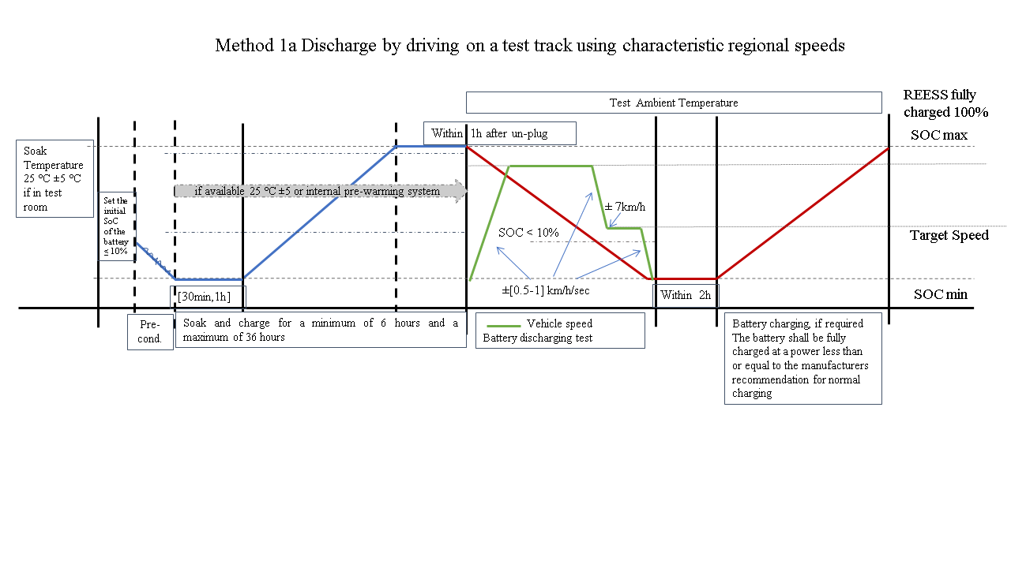**

Figure A3/2

**Test sequence Method 1b**

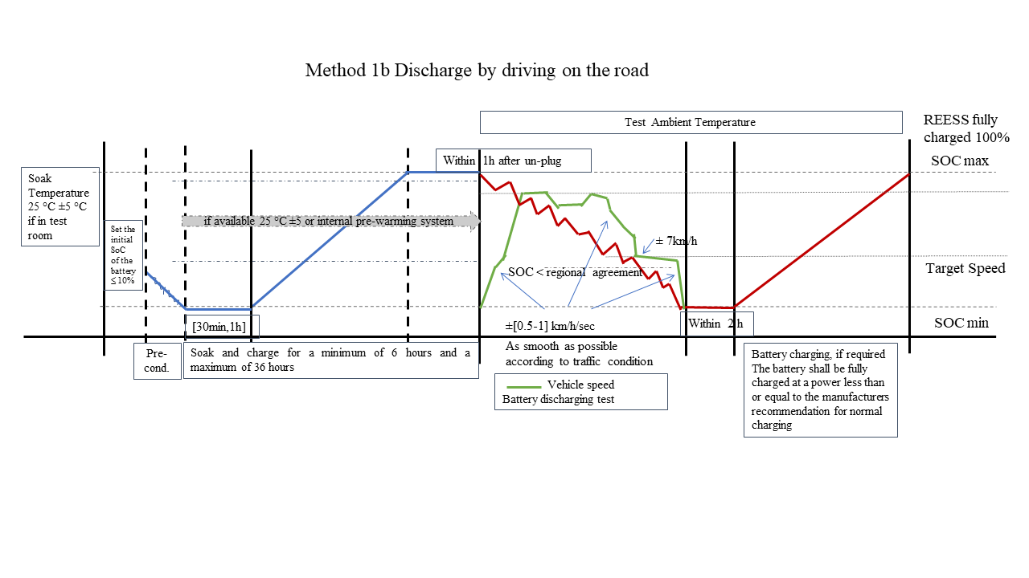

Figure A3/3

**Test sequence Method 2**

**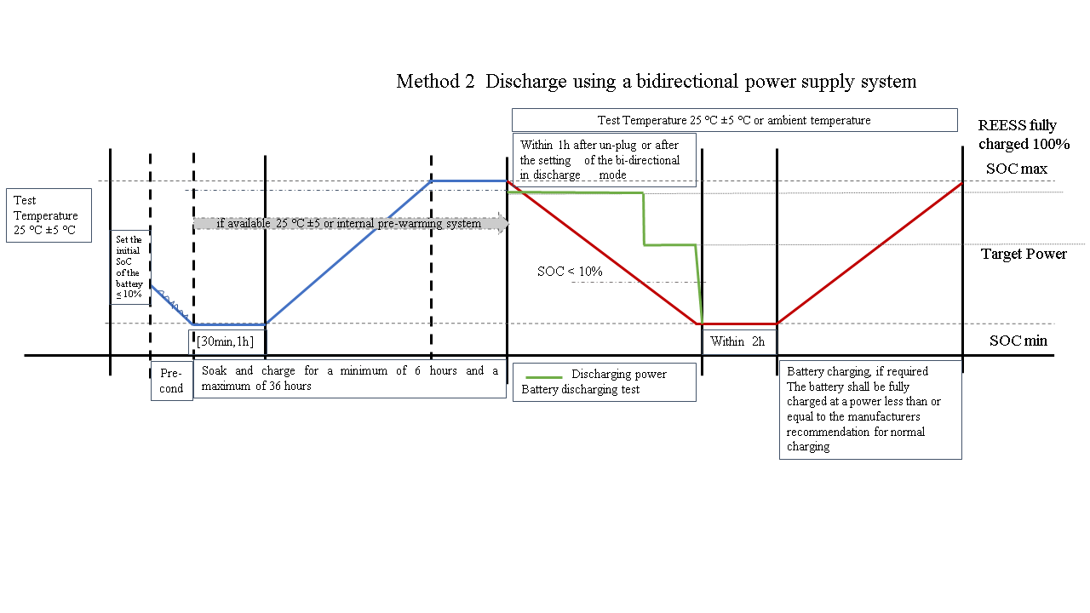**

Figure A3/4

**Test sequence**

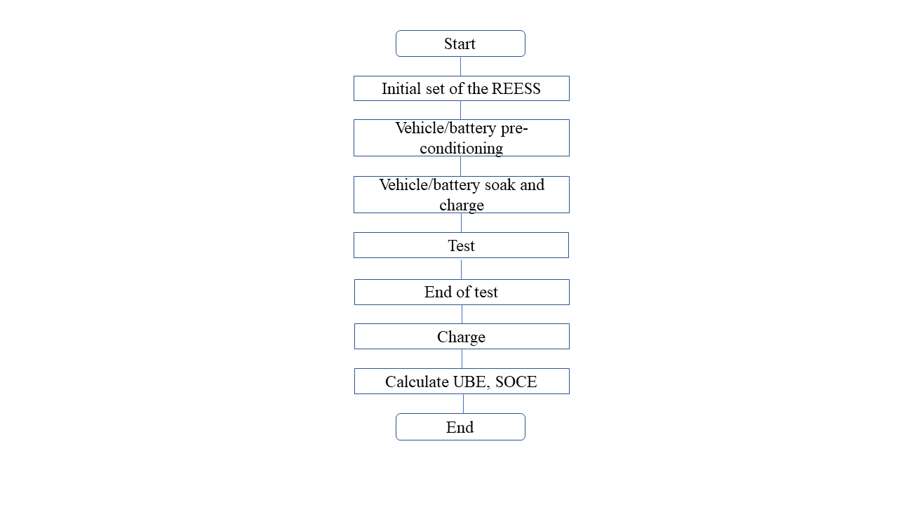

[

2.4. Alternative Method: Discharge using constant and transient cycles test method by using a HDV chassis dynamometer

In the Alternative Method the battery shall be depleted by a cycles test method by driving the vehicle on a HDV chassis dynamometer after pre-conditioning as specified in this paragraph.

[If regional regulations do not foresee HDV chassis dynamometer testing, Method 1a, Method 1b or Method 2 may be applied / elected to be applied.]

2.4.1. General test requirements

[This method allows both constant speed test and transient condition test on HD chassis dynamometer.]

The manufacturer shall guarantee that all the traction batteries installed on the vehicle are engaged during the test to determine the Usable Battery Energy (UBE) certified and measured.

The road load dyno setting, the measurement points together with the test cycle must be identical at certification and during in-service testing Part A verification [if the Alternative Method is applied] for the [~~SOCE monitor~~] vehicle family concerned .

[A section of constant speed driving is allowed to stabilise the SOC of the battery during the depleting test.]

2.4.1.1. Dynamometer

2.4.1.1.1. Dynamometer road load coefficient setting

During the test, the resistance coefficient obtained from the coasting test or the recommended resistance value shall be used for the chassis dynamometer setting conditions. The recommended value shall be determined in agreement with the [responsible/relevant] authorities.

The chassis dynamometer setting and test shall be carried out according to the regional regulations, [for example, referring to the Title 40 of the US Code of Federal Regulation, to the China stage 3 and 4 vehicle tests for fuel consumption determination, to the vehicle data as described in Regulation (EU) 2017/2400, or to other regional requirements.]

2.4.1.1.2. Coasting resistance measurement

Coasting resistance measurement shall follow regional regulations.

2.4.1.1.3. Coasting resistance calculation

The coasting resistance calculation shall follow regional regulations.

[An example of a general description for the coasting resistance calculation is outlined here after.

Road driving resistance calculation:

Where: Ft is the measured road driving resistance, N; M is the gross vehicle mass, kg; ∆v is the velocity deviation from vehicle speed v, km/h; Ta is the average time taken by the vehicle to decelerate from (v+Δv) to (v-∆v) in [n/two] times test.

The coasting resistance Ft measured on the road shall be corrected to the resistance F at the reference state ~~(20℃,100kPa)~~ [of temperature and pressure] according to the regional regulations.]

2.4.1.1.4. Chassis dynamometer settings

Chassis dynamometer settings shall follow regional regulations.

[During the test, the driver should be able to accurately control the driving speed and driving time of the vehicle through the driving assistance device. The driver assistance device should display curve tracking in real time. The deviation between the vehicle driving speed and the target speed of the driving condition shall meet the deviation requirements.]

2.4.1.1.5. The chassis dynamometer shall meet the structural and functional requirements as specified in the regional regulations.

2.4.1.1.6. The accuracy of the chassis dynamometer shall meet the requirements of regional regulations.

[The chassis dynamometer roller(s) shall be clean, dry and free from foreign material that might cause tyre slippage.]

[The test shall be carried out in accordance with paragraph 2.4.2.1. of this Annex.]

2.4.1.2. Test room

The test cell shall have a temperature set point of 25°C and shall not deviate by more than +/- 5 oC during the test.

2.4.1.3. Cooling fan

[When testing with a chassis dynamometer in the Alternative Method, the fan shall synchronise with the speed of the vehicle and follow the regional regulations in relation to the minimum requirements for the fan outlet and the maximum deviation from air velocity related to the driving velocity.]

[~~For example the deviation between the wind speed of the simulated fan and the speed of the vehicle should not be greater than ± 5 km/h~~].

2.4.1.4. Soak area

The temperature of the soak area shall be maintained at 25 °C ±5°C.

2.4.1.5. Required information

The manufacturer shall provide the information required to conduct the test procedure.

The manufacturer shall specify if a testing operation mode shall be set at vehicle level for performing the test.

[The manufacturer shall provide the responsible authority a list of the deactivated devices and justification for the deactivation.

The testing operation mode shall be approved by the responsible authority and the use of a testing operation mode shall be recorded.

The vehicle’s testing operation mode shall not activate, modulate, delay or deactivate the operation of any part that affects the battery energy throughput under the test conditions except for the internal battery heating-cooling system and the eventual eco mode automatically activated at the end of the depleting phase. The manufacturer shall provide evidence to the responsible authority].

2.4.1.6. Required measurements

The test vehicle shall be instrumented with measurement devices for measuring the necessary input values for the UBE calculation (voltage and electrical current). The external equipment shall be powered by an external power supply. The discharge and charge energy shall be measured at the battery to avoid combined battery-inverter efficiency and energy losses based on manufacturer specifications and as demonstrated to the responsible authority.

As an alternative to use of measurement devices, use of voltage on-board measurement data is permissible if the accuracy and frequency of these data is demonstrated to the responsible authority to meet the minimum requirements for accuracy and frequency described in ‎paragraph 1.2. of this annex.

The on-board measurement data of the voltage can be used during the in-service testing only when the accuracy and frequency of on-board measurement data is confirmed during the certification. Safe inspection points shall be made available for the direct measurement verification.

2.4.2. Test sequence

2.4.2.1. General

The test shall be carried out in accordance with ‎paragraphs 2.4.2.4. to ‎2.4.2.11. of this annex, (see Figure A3/8 and Figure A3/9). [The test shall be void if the break-off criterion is not reached.]

2.4.2.1.1. Breaks for the driver are permitted according to the regional regulations if available. If no regulations for HDV dynamometer testing are in place, breaks for the driver are permitted as prescribed below for transient speed test or shortened test and in Table A3/5 for constant speed.

For transient speed test, unless otherwise specified, the vehicle is allowed to stop once every [4] test cycles, the time should not exceed 10 minutes. During the stop the vehicle shall be in the “OFF” state, the test fan shall be turned-off, the brake pedal shall be released, and the battery cannot be charged using an external power source.

In the case that the test is performed using the shortened test method the breaks for the driver and/or operator are permitted only in the constant speed segments.

[Table A3/5

**Break for the driver: for constant speed test**

| *Distance driven in constant speed (km)* | *Maximum total break (min)* |
| --- | --- |
| Up to 100 | 10 |
| Up to 150 | 20 |
| Up to 200 | 30 |
| Up to 300 | 60 |
| More than 300 | Shall be based on the manufacturer’s recommendation |
| *Note:* During a break, the powertrain shall be switched off.  Table A3/5  **Breaks for the driver**   | *Driving time (h)* | *Maximum total break (min)* | | --- | --- | | every each 1h | 10 | | More than 4h | Shall be based on the manufacturer’s recommendation or regional authority | | *Note:* During a break, the powertrain shall be switched off.  ] | | | |

2.4.2.1.2. [The following operational metrics, if present and if required, shall be monitored and recorded throughout the test:

(a) battery temperature (minimum, maximum, as indicated by temperature of the battery cells, modules, or pack, as available);

(b) battery state of charge (SOC) [(from BMS and dashboard)];

(c) battery cooling on/off, as available,

to support the verification of the conditioning of the battery, if needed.

The manufacturer shall specify the normal operating range for each operational metric [in the case that the operational metrics monitoring is applied.]

]

2.4.2.2. Preparation of vehicle

The vehicle shall be presented in good technical condition and shall be run-in in accordance with the manufacturer’s recommendations.

HD-PEVs and HD-OVC-HEVs shall have been run-in at least 300 km or one full charge distance, whichever is longer.

In the case of in-service conformity check, the vehicle shall be subject to the acceptance check criteria defined in Annex 1 of this GTR.

2.4.2.3. Preparation of measurement devices

The measurement devices shall be installed at suitable and safe position(s) within the vehicle. The manufacturer shall recommend the measurement points with the approval of the responsible authority and with appropriate technical justification.

2.4.2.4. Initial setting of the battery

For HD-PEVs and HD-OVC-HEVs, prior to or during vehicle soak (‎paragraphs 2.4.2.5. and 2.4.2.6 of this annex), the battery shall be charged/discharged to an initial state of charge (SOC), as displayed on the monitor of the vehicle, equal or less than 10 per cent. At the request of the manufacturer, with the approval of the responsible authority and with appropriate technical justification, the manufacturer may specify a different initial SOC of the battery.

The battery shall be charged/discharged to the initial SOC in accordance with the procedure specified by the manufacturer.

2.4.2.5. Vehicle installation and pre-conditioning

[The vehicle and the charging station shall be installed for the preconditioning, if the battery discharge will be performed by driving in a test room.]

The battery of the vehicle shall be discharged, left stabilised for a minimum of 30 minutes and maximum [1h] and then fully charged at a power less than or equal to the manufacturer’s recommendation for normal charging before starting the test as specified in Figure A3/9.

The manufacturer may recommend a longer stabilisation time if necessary to ensure stabilisation of the high voltage battery.

This first battery discharge, referred to as pre-conditioning, shall be performed according to manufacturer's recommendation or given speed within the range of the characteristic regional speeds, without requirements on the ambient temperature.

[The manufacturer shall guarantee that the battery is as fully depleted as possible by the discharge test procedure.]

[During the discharge of the battery, the operational metrics (see ‎‎paragraph 2.4.2.1.2. of this annex) shall be recorded if required.]

2.4.2.6. Vehicle soak and charge

The soak and charge is performed in the soak area or test room if available.

If the soak and charge is performed in a soak area or test cell the soak area temperature during soak shall be as specified in [‎‎paragraph 2.4.1.4. of this annex].

Recording the energy consumption for all the soak and charge duration is required.

If the soak and charge is not performed in a soak area external devices, different from charging stations, are not allowed.

The external equipment shall be powered by an external power supply.

Measurement devices installed within the vehicle shall be warmed up as appropriate.

The measurement devices shall start collecting data.

The battery shall be fully charged at a power less than or equal to the manufacturer’s recommendation for normal charging.

[Record the charge current and voltage and the elapsed time required to reach the fully charge battery.]

[The vehicle shall be soaked and charged for a minimum of 6 hours and a maximum of 36 hours to ensure temperature stabilisation of the high voltage battery.

The manufacturer may recommend a minimum time for the soak and charge.]

The end of charge criterion is reached when a fully charged battery is detected by the on-board or external instruments.

Fully charged battery status shall be reached. If the selected power charging does not allow the full charged status of the battery to be reached automatically due to battery protection systems, it is allowed to complete the charging by applying a slower charging method, unplugging and then plugging in again the vehicle if needed, either with or without a waiting time between the two charges.

[The temperature of the battery shall be checked before starting the test.

~~It is allowed to extend the soak and charge time to stabilise the temperature of the battery~~

Thermal equilibration is reached if in the last 1 hour the deviations of the temperature of the battery are lower than [±7 °C] . If this condition is not met the soak and charge shall be repeated.]

If the soak and charge is performed in a soak area, the vehicle shall not receive unjustified exposure to temperatures other than 25 °C ±5 °C, but if that is unavoidable this time should in any case be limited to a maximum of [10] minutes.

[To monitor the operating metrics and perform additional conditioning as necessary is allowed to maintain the operating metrics within the normal operating temperature ranges].

2.4.2.7. Discharge test cycle

[The Contracting Party shall determine the combination of the test cycle according to the regional regulations.]

[2.4.2.8. Test method for HD-PEVs

2.4.2.8.1. The constant velocity method test

The velocity and test cycle shall be determined in agreement with the [responsible/relevant] authorities.

The constant driving speed shall be related to the vehicle category and characteristic regional speeds.

During the test, the speed can be controlled manually or by cruise control system if available. The speed deviation shall be controlled in the scope [of ± 3] km/h.

2.4.2.8.2. The transient cycle method test

The cycle shall be determined in agreement with the local authorities and according to the regional regulations.

As an example, this could be by referring to the Title 40 of the US Code of Federal Regulation, to the China stage 3 and 4 vehicle tests for fuel consumption determination. to Regulation (EU) 2017/2400, or to other regional requirements.

Different test cycles shall be used according to the vehicle type. The tolerance on the speed, time and the total deviation time of each cycle are determined according to regional regulations.

[For example, the tolerance of each point of the speed may be [±3km/h], of the time may be ±1s, and the total deviation time of each cycle may not exceed [15s], as shown in Figure A3/5.

Figure A3/5

**Example, reference curve and tolerance**

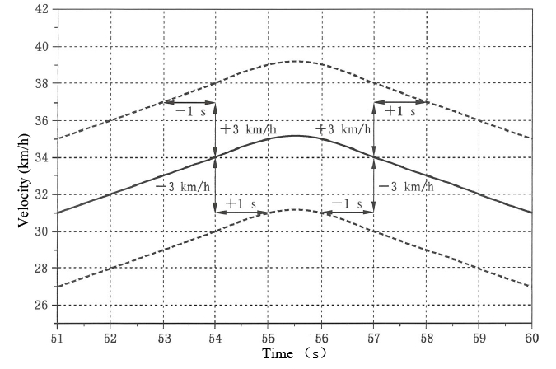

]

2.4.2.8.3. Shortened test method

Figure A3/6

**Shortened test method**

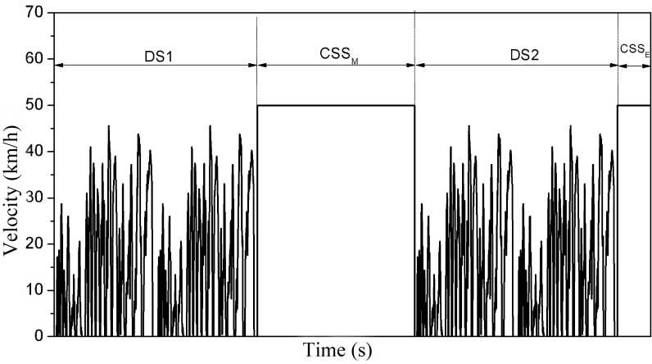

The test cycle for the shortened test method is shown in Figure A3/6. The test condition consists of two dynamic test cycle segments (DS1 and DS2) and two constant speed segments (Constant Speed Segment Middle (CSSM) and Constant Speed Segment End (CSSE)). The constant speed section can be carried out at a higher speed to discharge faster the battery and reduce the test time. The constant speed is selected in accordance with the vehicle category and characteristic regional speeds and regional regulations.

[The same regional characteristic vehicle speed used for certification may be used if applicable, and in accordance with regional provisions, unless there is an agreement between the regional authority and the manufacturer.]

At the request of the manufacturer and with approval of the responsible authority, a higher constant speed in the constant speed segments may be selected.

The transient cycle (DS1 and DS2) and the two constant velocity segments and the length of the constant speed segments shall be defined in agreement with the [responsible/relevant] authority and regional regulations.

[~~The acceleration and deceleration during vehicle speed change shall be smooth and accomplished within the range ± [0.5-1] km/h/sec -~~

~~For the cycle segments, the tolerance requirement shall meet the requirements in Figure A3/5. For the constant velocity segments, the speed deviation shall be controlled in the scope of ± 3 km/h.~~]

2.4.2.8.4. Test termination for HD-PEVs

The end of discharge criterion is reached when the break-off criterion is met.

[The equivalence with the certification test method and break-off criterion shall be demonstrated to the responsible authority.]

For HD-PEVs, the break-off criterion is reached when the vehicle exceeds the driving speed tolerance for 4 consecutive seconds or more. The accelerator control shall be deactivated and the vehicle shall be braked to standstill within 60 seconds after the break-off is reached.

The manufacturer shall provide evidence to the responsible authority after the test that this requirement is fulfilled.

]

[2.4.2.9. Test method for HD-OVC-HEVs

Figure A3/7

**Schematic diagram of state of charge (SOC) variation of heavy-duty hybrid electric vehicle**

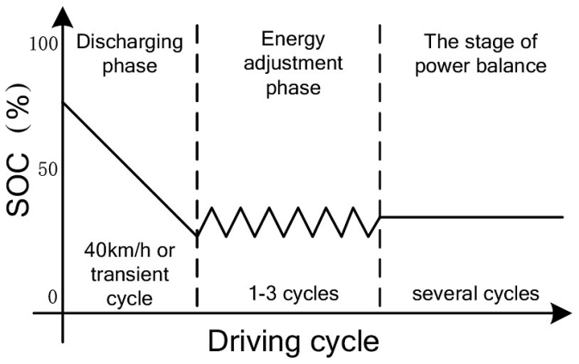

2.4.2.9.1. The HD-OVC-HEV has three operation stages: discharging phase; energy adjustment phase; and the stage of electric power balance, as depicted in Figure A3/7. The UBE testing procedure shall be in phase 1 and phase 2.

The test cycle shall be determined in agreement with the [responsible/relevant] authorities and according to the regional regulations.

2.4.2.9.2. Test termination for HD-OVC-HEVs

The end of discharge criterion is reached when the break-off criterion is met.

[The equivalence with the certification test method and break-off criterion shall be demonstrated to the responsible authority.]

[The break-off criterion is reached, for the constant velocity method test and for the transient cycle method test, when

in the last part of the test over a distance ∆km equivalent to [5] per cent of the total available energy of the battery, the |∆EREESS,∆km|/∆km is equal to or less than [3] per cent of the cumulative UBE/(total distance travelled - ∆km) (energy consumption before the last ∆km).

where:

∆km distance equivalent to [5] per cent of the total available energy of the battery in the last part of the test

is the measured electric energy change of the battery, over the distance ∆km, defined as , Wh

is the measured electric energy change of battery i, over the distance ∆km, Wh;

i is the index number of the considered battery;

n is the total number of batteries;

and:

where:

is the voltage of battery i, V;

is the electric current of battery i, A;

t0,∆km is the starting time of the driving of the ∆km portion of the test, s;

tend,∆km is the end time of the driving of the ∆km portion of the test, s;

is the conversion factor from Ws to Wh;

is the usable battery energy (UBE) ,Wh, calculated as defined as

where

t0 is the time at the beginning of the discharge test, s.

For the transient cycle method test, according to regional regulation a Contracting Party may optionally elect to enforce that the break-off criterion is reached when REECi, as calculated using the following equation, is less than ~~[4]or~~ [5] per cent.

where:

is the relative electric energy change of the applicable test cycle considered i of the charge-depleting test;

is the change of electric energy of all REESSs for the considered charge-depleting test cycle i calculated according to paragraph 3. of this annex, Wh;

Ecycle is the total cycle energy demand E in Ws, and shall be calculated by summing over the corresponding cycle time between tstart and tend according to regional regulations and the following equation:

i is the index number for the considered applicable WLTP test cycle;

is a conversion factor to Wh for the cycle energy demand.

tstart is the time at which the applicable test cycle or phase starts, s;

tend is the time at which the applicable test cycle or phase ends, s;

is the energy demand during time period (i-1) to (i), Ws, calculated according to regional regulations.

[

~~if~~

~~if~~

~~is the driving force during time period (i-1) to (i), N;~~

~~is the distance travelled during time period (i-1) to (i), m.~~

~~where:~~

~~is the driving force during time period (i-1) to (i), N;~~

~~is the target velocity at time t~~~~i~~~~, km/h;~~

~~is the test mass, kg;~~

~~is the acceleration during time period (i-1) to (i), m/s²;~~

~~, , are the road load coefficients for the test vehicle under consideration (, or ) in N, N/km/h and in N/(km/h)² respectively.~~

~~where:~~

~~is the distance travelled in time period (i-1) to (i), m;~~

~~is the target velocity at time , km/h;~~

~~is time, s.~~

~~where:~~

~~is the acceleration during time period (i-1) to (i), m/s²;~~

~~is the target velocity at time , km/h;~~

~~is time, s~~.]

The manufacturer shall provide evidence to the responsible authority after the test that this requirement is fulfilled.]

]

2.4.2.10. Both for HD-PEV and HD-OVC-HEV the UBE is the total discharged energy calculated as described in [paragraph 3. of this annex].

The HD-PEV and HD-OVC-HEV shall be connected to the mains within 120 minutes after coming to a standstill, if required.

The battery shall be fully charged, if required, at a power less than or equal to the manufacturer’s recommendation for normal charging.

The end of charge criterion is reached when a fully charged battery is detected by the on-board or external instruments.

If the selected power charging does not allow the full charged status of the battery to be reached automatically due to battery protection systems, it is allowed to complete the charging by applying a slower charging method, unplugging and then plugging in again the vehicle if needed, either with or without a waiting time between the two charges.

[In the case that UBEcharge is required the total charged energy is calculated as described in paragraph 3. of this annex.]

[The Alternative Method is performed on new vehicles within a family, if the measurement of the UBE is applied at certification, to determine the UBEcertified.

The Alternative Method is performed on aged vehicles within a family, if applicable, to determine the UBEmeasured].

The SOCEmeasured is derived according to paragraph 6.3.2. of this GTR.

2.4.2.11. End of Alternative Test Method

At the end of the Alternative Method test, the measured values and the operational metrics (see ‎‎‎‎paragraph 2.4.2.1.2. of this annex) shall be recorded.

After the measurements are complete, the vehicle and measurement devices shall be stopped.

]

Figure A3/8

**Test sequence Alternative Method**

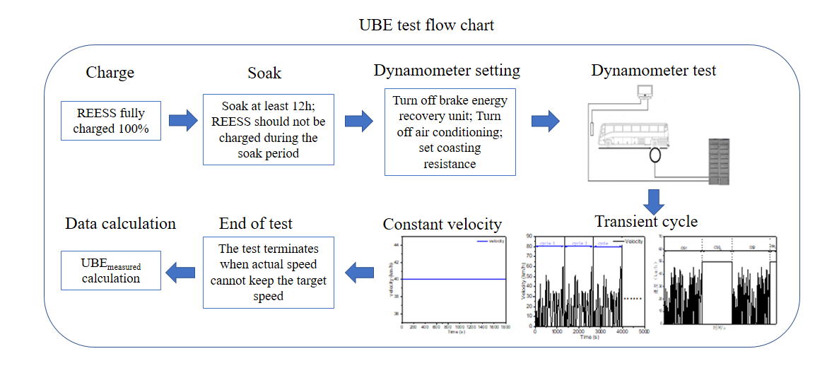

Figure A3/9

**Test sequence Alternative Method using HD chassis dynamometer**

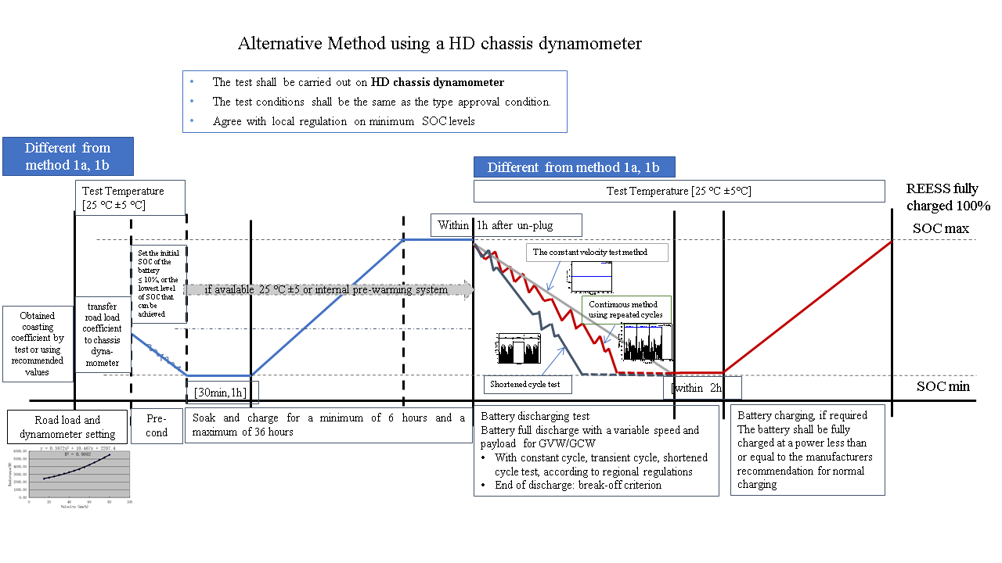

[

3. Performance parameters

3.1. Measured and certified UBE values

3.1.1. Method 1a, Method 1b and Method 2 for HD-PEVs and Method 2 HD-OVC-HEVs and Alternative Method for HD-PEVs

|  |  |
| --- | --- |
| Parameters | Explanation |
| UBEcertified | UBEcertified is the usable battery energy (UBE) of the vehicle at the point of certification. |
| UBEmeasured | UBEmeasured is the usable battery energy (UBE) of the vehicle determined at Part A verification by the test procedure |
|  | The required input parameter UBE is calculated as follows:  where:  is the measured electric energy change of battery i, Wh;  i is the index number of the considered battery;  n is the total number of batteries;  and:  where:  is the voltage of battery i, V;  is the electric current of battery i, A;  t0 is the time at the beginning of the discharge test, s;  tend is the time at the end of the discharge test (break-off criterion), s;  is the conversion factor from Ws to Wh. |
| No rounding shall be applied on UBEmeasured.  UBEcertified shall be rounded according to paragraph 7 of this GTR:  - To the nearest whole number if the unit is Wh  - To three significant numbers if the unit is kWh | |

]

[3.1.2. Method 1a, Method 1b and Alternative Method for HD-OVC-HEVs

|  |  |
| --- | --- |
| *Parameters* | *Explanation* |
| UBEcertified | UBEcertified is the usable battery energy (UBE) of the vehicle at the point of certification. |
| UBEmeasured | UBEmeasured is the usable battery energy (UBE) of the vehicle determined at Part A verification by the test procedure |
|  | UBE shall be the usable battery energy calculated as follows:  where:  UBEnc is the non-corrected usable battery energy of the charge-depleting test, Wh;  the average electric energy change of the stage of power balance, Wh;  SPB means the stage of power balance as defined in paragraph 2.4. of this annex.  For Method 1a and Method 1b it should be intended as the distance ∆km as defined in paragraphs 2.1. and 2.2.  The correction with the average electric energy change in the stage of power balance is required as the break-off criterion allows a toggling around the absolute reference level. |
| The required input parameter UBEnc is calculated as follows:  where:  is the measured electric energy change of battery i, Wh;  i is the index number of the considered battery;  n is the total number of batteries;  and:  where:  is the voltage of battery i, V;  is the electric current of battery i, A;  t0 is the time at the beginning of the charge-depleting test, s;  tend is the time at the end of the stage of power balance of the charge-depleting test break-off criterion, s;  is the conversion factor from Ws to Wh. |
| The required input parameteris calculated as follows:  where:  is the average of the measured electric energy change of battery *i* during the stage of power balance, Wh.  For Method 1a and Method 1b it is the average of the measured electric energy change of battery *i* over the distance ∆km as defined in paragraphs 2.1. and 2.2.;  is the index number of considered battery;  *n* is the total number of batteries;  and  where:  is the voltage of battery *i*, in V  is the current of battery *i*, in A  is the time at the beginning of the stage of power balance of the charge-depleting test, s;  is the time at the end of the stage of power balance of the charge-depleting test break-off criterion, s;  is the conversion factor from Ws to Wh.  SPB means the stage of power balance as defined in paragraph 2.4. of this annex |
| No rounding shall be applied on UBEmeasured.  UBEcertified shall be rounded according to paragraph 7 of this GTR:  - To the nearest whole number if the unit is Wh  - To three significant numbers if the unit is kWh | |

]

[3.1.3. UBEcharge

|  |  |
| --- | --- |
| Parameters | Explanation |
| UBEcharge | The required input parameter [UBEcharge] is calculated as follows:  where:  is the measured electric energy change of battery i, Wh;  i is the index number of the considered battery;  n is the total number of batteries;  and:  where:  is the voltage of battery i, V;  is the electric current of battery i, A;  t0 is the time at the beginning of the charge test, s;  tend is the time at the end of the charge test (break-off criterion), s;  is the conversion factor from Ws to Wh. |
| No rounding shall be applied on UBEcharge. | |

]

## **Annex 4** (optional annex)

[Battery Energy based (SOCE) minimum performance requirements

This optional annex includes the Minimum Performance Requirements (MPR) which a Contracting Party may elect to enforce elect for conforming to the requirements of this GTR (see paragraph 5.2. of this GTR).

Table A4/1

**Battery Energy based (SOCE) MPR for Category 2 vehicles not exceeding 16 tonnes**

| *Battery energy based MPR for* ***Category 2 vehicles not exceeding 16 tonnes*** | *HD-OVC-HEV* | *HD-PEV* |
| --- | --- | --- |
| From start of life to years or km, whichever comes first and kWh in monitoring |  |  |
| 6 yr, 150 000 km | 70% | 70% |
| 8 yr, 300 000 km | 70% | 70% |
| 8 yr, 400 000 km | 70% | 70% |
| 10 yr, 375 000 km | 65% | 65% |

Table A4/2

**Battery Energy based (SOCE) MPR for Category 2 vehicles exceeding 16 tonnes**

| *Battery energy based MPR for* ***Category 2 vehicles exceeding 16 tonnes*** | *HD-OVC-HEV* | *HD-PEV* |
| --- | --- | --- |
| From start of life to years or km, whichever comes first and kWh in monitoring |  |  |
| 6 yr, 150 000 km | 70% | 70% |
| 8 yr, 600 000 km | 70% | 70% |
| 12 yr, 700 000 km | 55% | 55% |
| 15 yr, 875 000 km | 50% | 50% |

Table A4/3

**Battery Energy based (SOCE) MPR for Category 1-2 vehicle not exceeding 5 tonnes**

| *Battery energy based MPR for* ***Category 1-2 vehicle not exceeding 5 tonnes*** | *HD-OVC-HEV* | *HD-PEV* |
| --- | --- | --- |
| From start of life to years or km, whichever comes first and kWh in monitoring |  |  |
| 6 yr, 150 000 km | 70% | 70% |
| 8 yr, 160 000 km | [65%] | [65%] |
| 8 yr, 300 000 km | 70% | 70% |
| 10 yr, 200 000 km | [60%] | [60%] |

Table A4/4

**Battery Energy based (SOCE) MPR for Category 1-2 vehicle exceeding 5 tonnes but not exceeding 7.5 tonnes**

| *Battery energy based MPR for* ***Category 1-2 vehicle exceeding 5 tonnes but not exceeding 7.5 tonnes*** | *HD-OVC-HEV* | *HD-PEV* |
| --- | --- | --- |
| From start of life to years or km, whichever comes first and kWh in monitoring |  |  |
| 6 yr, 150 000 km | 70% | 70% |
| 8 yr, 300 000 km | [65%] | [65%] |
| 8 yr, 500 000 km | 70% | 70% |
| 10 yr, 375 000 km | [60%] | [60%] |

Table A4/5

**Battery Energy based (SOCE) MPR for Category 1-2 vehicle exceeding 7.5 tonnes**

| *Battery energy based MPR for* ***Category 1-2 vehicle exceeding 7.5 tonnes*** | *HD-OVC-HEV* | *HD-PEV* |
| --- | --- | --- |
| From start of life to years or km, whichever comes first and kWh in monitoring |  |  |
| 6 yr, 150 000km | 70% | 70% |
| 8 yr, 600 000 km | 70% | 70% |
| 12 yr, 700 000km | [50%] | [50%] |
| 15 yr, 875 000km | [45%] | [45%] |

]

1. \* In accordance with the programme of work of the Inland Transport Committee for 2025 as outlined in proposed programme budget for 2025 (A/79/6 (Sect. 20), table 20.6), the World Forum will develop, harmonize and update UN Regulations in order to enhance the performance of vehicles. The present document is submitted in conformity with that mandate. [↑](#footnote-ref-2)