Proposal for supplement 4 5 to the original version of UN Regulation No. 61 (External Projections of Commercial Vehicles)
Submitted by the expert from the Kingdom of the Netherlands on behalf of the Task Force on Automated Vehicles Regulatory Screening*
The text reproduced below was prepared by the Task Force on Automated Vehicles Regulatory Screening (TF-AVRS), with the aim to amend and supersede document ECE/TRANS/GRSG/2025/23. The modifications to ECE/TRANS/GRSG/2025/23 are marked in purple (bold) red for new or strikethrough for deleted characters.

I. Proposal
Insert new paragraphs 0. and 0.1. to 0.1.3., to read:
"0. Introduction
0.1. Supplement 4 5 to the original version of the Regulation is introduced to take into account vehicles of categories X and Y ¹, as well as vehicles with a manual mode operating at speeds above 6 km/h which are equipped with an Automated Driving System Feature of Type 2 (ADSF-2) (ADS) ¹.
0.1.1. The Regulation was originally drafted for vehicles with driver, driver cab and manual driving controls. It is the intention of this new amendment to keep the spirit of the Regulation and to extend its application to vehicles without driver and/or driver cab and without manual driving controls in the vehicle. In the absence of driver/driver cab/manual driving controls in the vehicle, provisions related to them shall not be taken into account if not already covered by this amendment.

0.1.2. The definition in paragraph 2.5. has been amended to account for vehicles without a driver’s cab. In such case the front of the vehicle up to and including the vertical plane bounded by the wheels and front wings shall be regarded as the external surface. In this case, theoretical vertical transversal plane is used to define the area in front of and to the sides of the vehicle where external projections are present.

0.1.3. In case of vehicles equipped with an ADS other than vehicles of categories X and Y, in the manual driving mode in any driving mode, no special provisions or exemptions apply. In a mode where an ADS feature is active, basically the same requirements apply with regard to external projections."
Paragraph 1.1., footnote 1, amend to read:
^{"1} As defined in the Consolidated Resolution on the Construction of Vehicles (R.E.3.), document ECE/TRANS/WP.29/78/Rev.38, para. 2 - www.unece.org/trans/main/wp29/wp29wgs/wp29gen/wp29resolutions.html
https://unece.org/transport/vehicle-regulations/wp29/resolutions"
Paragraph 2.1., 2.5., amend to read:
"2.1. "External surface" means that part of the vehicle forward of the cab rear panel as defined in paragraph 2.5. below, with the exception of the rear panel itself, and includes such items as the front wings, front bumpers and front wheels; in case of vehicles of categories X and Y without cab, is limited to the area bounded by the front wings, front bumpers and front wheels.
2.5. "Cab rear panel" means the rearmost part of the external surface of the driver and passenger compartment. Where it is not possible to determine the position of the rear cab panel, for the purposes of this Regulation it would be deemed to be the vertical transversal plane situated 50 cm to the rear of the ‘R’ point of the driver seat, with the seat, if adjustable, located at its rearmost driving position (see Annex 3). However, the manufacturer may, with the agreement of the technical services, request an alternative distance if 50 cm can be shown as being inappropriate for a particular vehicle (2); ; For vehicles of categories X and Y without a cab, the “cab rear panel” shall be replaced by a theoretical vertical transversal plane located 350 mm behind the rearmost point of the tyre of the foremost front axle.
"
Footnote:
(2) The use of this option does not modify the scope of this Regulation.
Insert new paragraphs 2.11. and 2.12., to read:
"2.11. "ADS feature of type 1 (ADSF-1)" means an ADS¹ feature which includes an ADS fallback response requiring a fallback user
2.12. "ADS feature of type 2 (ADSF-2)" means an ADS feature which does not include an ADS fallback response requiring a fallback user."
Paragraph 4.4.1., footnote 3, amend to read:
^{"3} The distinguishing numbers of the Contracting Parties to the 1958 Agreement are reproduced in Annex 3 to the Consolidated Resolution on the Construction of Vehicles (R.E.3), document ECE/TRANS/WP.29/78/Rev.8 - https://unece.org/transport/vehicle-regulations/wp29/resolutions"
II. Justification
- See chapter 0.
- The 350 mm distance corresponds to the 300 mm maximum rear extension plus the 50 mm suppression dimension specified in Regulation (EU) 2021/535, Annex VIII, paragraph 4.8.3.4 and Figure 3.
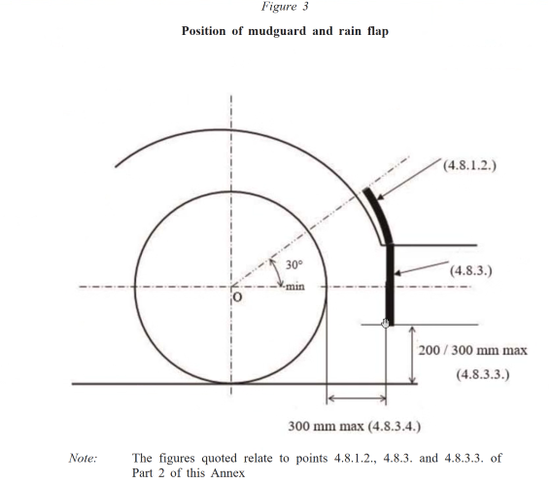

* In accordance with the programme of work of the Inland Transport Committee for 2025 as outlined in proposed programme budget for 2025 (A/79/6 (Sect. 20), table 20.6), the World Forum will develop, harmonize and update UN Regulations in order to enhance the performance of vehicles. The present document is submitted in conformity with that mandate.

