Modifications to ECE/TRANS/WP.29/GRSP/2025/5*
The text reproduced below was prepared by members of the Technical Services Group and is presented on their behalf by the expert from the Kingdom of the Netherlands to update the captions underneath multiple International Organization for Standardization (ISO) envelope drawings in appendix 2 to annex 6, including adding references to UN Regulation No. 129. It is based on informal document GRSP-76-17 (see also paragraph 12 of ECE/TRANS/WP.29/GRSP/76). Amendments to the current text of UN Regulation No. 173 are marked in bold underlined for new or strikethrough for deleted characters. The modifications to working document ECE/TRANS/WP.29/GRSP/2025/5 are marked in blue.

I. Proposal
Annex 6, appendix 1, Figures 1 to 3, amend to read:

"Figure 1

Specifications of the fixture (all dimensions in mm)

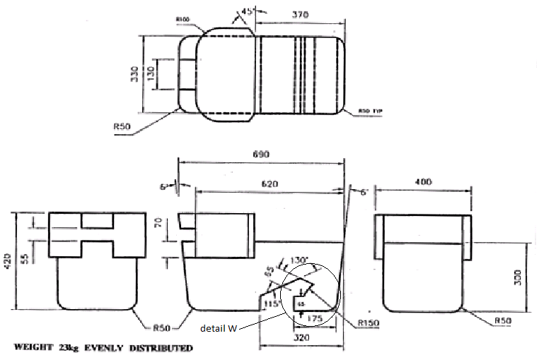

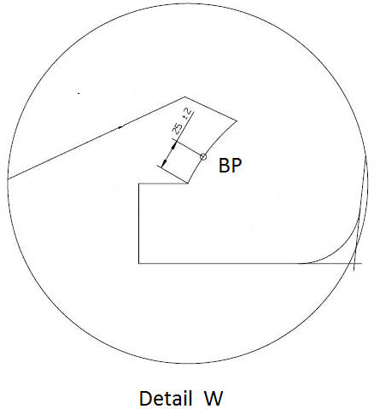
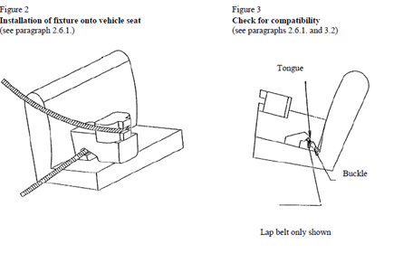"

Annex 6, appendix 2, paragraphs 4.1. to 4.7., amend to read:
“4.1. Full-height forward-facing toddler child restraint systems envelope
1. Figure 1
ISO/F3 envelope dimensions for a full-height forward-facing toddler CRS (height 720 mm) ISOFIX SIZE CLASS A
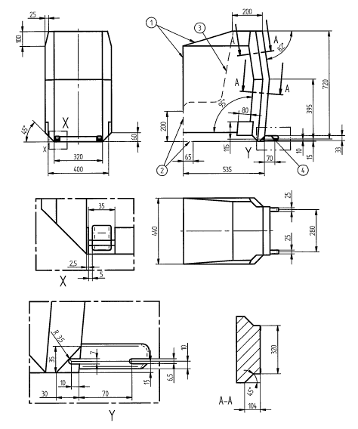
All dimensions in mm

Key:
1 Limits in the forward and upwards directions
2 Dashed line marks area where a support leg, or similar, of a specific vehicle CRS is allowed to protrude.
3 N/A
4 Further specifications of the connector area are given in UN Regulation No. 44/UN Regulation No. 129
4.2. Reduced-height forward-facing toddler child restraint systems envelope
2. Figure 2
ISO/F2 envelope dimensions for a reduced-height forward-facing toddler CRS, (height 650 mm) – ISOFIX SIZE CLASS B
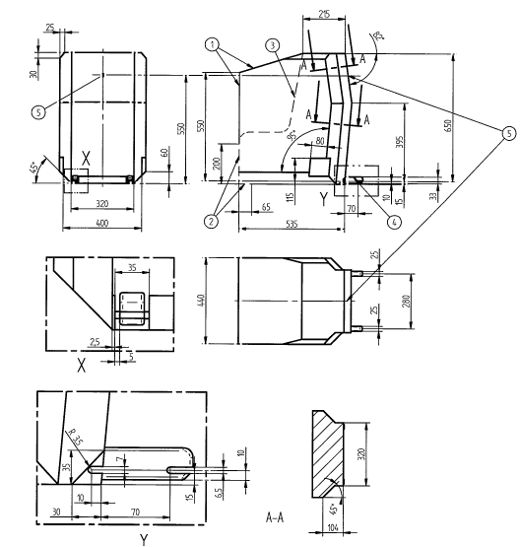
All dimensions in mm

Key:
1 Limits in the forward and upwards directions
2 Dashed line marks area where a support leg, or similar, of a specific vehicle CRS is allowed to protrude
3 N/A
4 Further specifications of the connector area are given in UN Regulation No. 44/UN Regulation No. 129
5 Attachment point for the top tether strap

4.3. Reduced-height second version back shape forward-facing toddler child restraint systems envelope
3. Figure 3
ISO/F2X envelope dimensions for a reduced-height second version back surface shape forward-facing toddler CRS, (height 650 mm) – ISOFIX SIZE CLASS B1

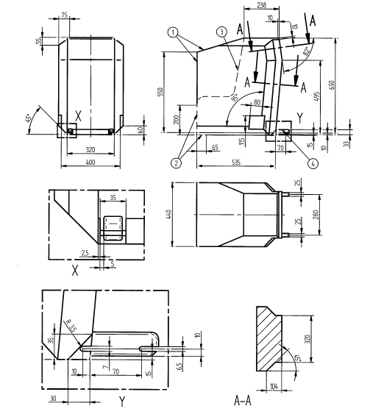
All dimensions in mm

Key:
1 Limits in the forward and upwards directions
2 Dashed line marks area where a support leg, or similar, of a specific vehicle CRS is allowed to protrude
3 N/A
4 Further specifications of the connector area are given in UN Regulation No. 44/UN Regulation No. 129

4.4. Full-size rearward facing toddler child restraint system envelope
4. Figure 4
ISO/R3 envelope dimensions for a full-size rearward-facing toddler
CRS ISOFIX SIZE CLASS C

All dimensions in mm

Key:
1 Limits in the rearward and upwards directions
2 Dashed line marks area where a support leg, or similar, of a specific vehicle CRS is allowed to protrude
3 The backwards limitation (to the right in the figure) is given by the forward-facing envelope in Figure 2
4 Further specifications of the connector area are given in UN Regulation No. 44/UN Regulation No. 129

4.5. Reduced-size rearward-facing toddler child restraint systems envelope
5. Figure 5
ISO/R2 envelope dimensions for a reduced-size rearward-facing toddler
CRS ISOFIX SIZE CLASS D

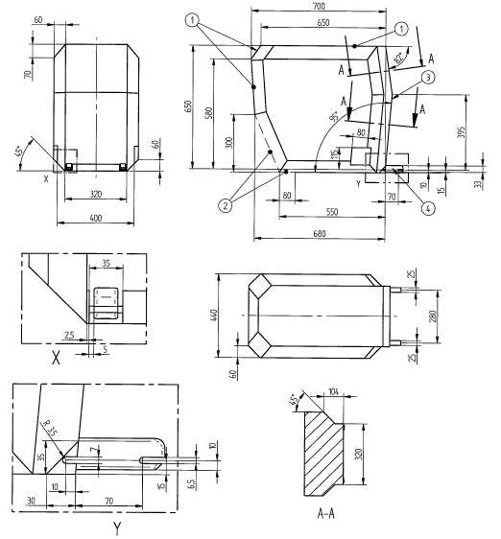
All dimensions in mm
Key:
1 Limits in the rearward and upwards directions
2 Dashed line marks area where a support leg, or similar, of a specific vehicle CRS is allowed to protrude
3 The backwards limitation (to the right in the figure) is given by the forward-facing envelope in Figure 2
4 Further specifications of the connector area are given in UN Regulation No. 44/UN Regulation No. 129

4.6. Rearward facing infant child restraint systems envelope
6. Figure 6
ISO/R1 envelope dimensions for an infant-size rearward-facing CRS ISOFIX SIZE CLASS E

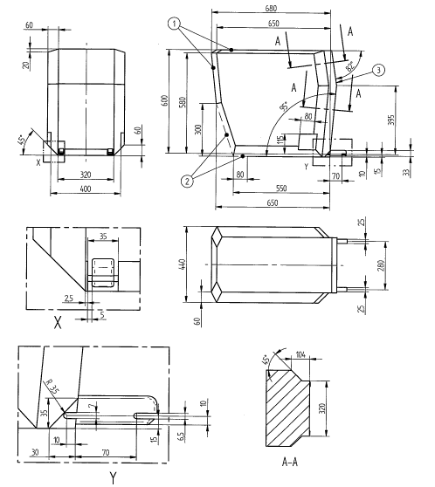
All dimensions in mm

Key:
1 Limits in the rearward and upwards directions
2 Dashed line marks area where a support leg, or similar, of a specific vehicle CRS is allowed to protrude
3 The backwards limitation (to the right in the figure) is given by the forward-facing envelope in Figure 2
4 Further specifications of the connector area are given in UN Regulation No. 44/UN Regulation No. 129

4.7. Lateral facing child restraint systems envelope Rearward-facing toddler child restraint system envelope
Figure 7
ISO/R2X Envelope dimensions of a Reduced-Size Rearward Facing toddler CRS, modified for improved compatibility with the vehicle interior
(all dimensions in mm)
Key
1 Limits in the rearward and upward directions
2 Dashed lines mark the area where an anti-rotation device, or similar (e.g. rebound bar), is allowed to protrude
3 The backward limitation (to the right in the figure) is given by the forward-facing envelope in Figure 2
4 For further specifications of the connector area, see detail Y and ISO 13216-1:1999, Figures 2 and 3. UN Regulation No. 44/UN Regulation No. 129

4.8. Lateral facing child restraint systems envelope
Figure 8
Envelope dimensions for lateral facing position CRS - ISO/L1- or symmetrically opposite - ISO/L2 (figure shown)
Note: The envelope for a left lateral-facing infant CRS (ISO/L1) has dimensions symmetric to ISO/L2 with regard to its intermediate longitudinal plan.

(all dimensions in mm)
Key
1 Limits in the rearward and upward directions
2 Dashed lines mark the area where an anti-rotation device, or similar (e.g. rebound bar), is allowed to protrude
3 The backward limitation (to the right in the figure) is given by the forward-facing envelope in Figure 2
43 For further specifications of the connector area, see UN Regulation No. 44/UN Regulation No. 129

4.9. i-Size support leg

7. Figure 9
Side view of the i-Size support leg installation assessment volume for assessing compatibility of the i-Size seating positions with support legs of i-Size child restraint systems
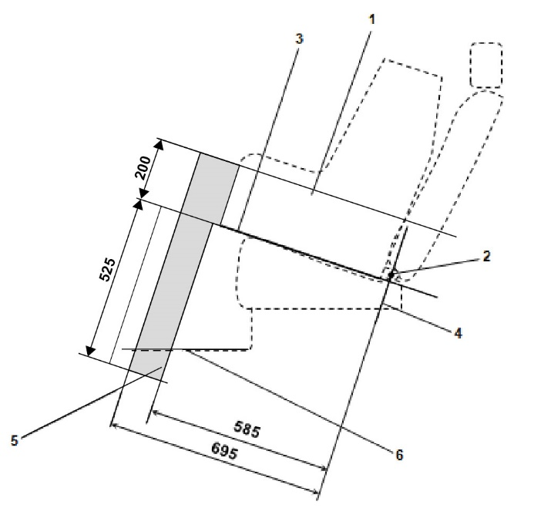
All dimensions in mm
Key:
1. Child Restraint Fixture (CRF).
2. ISOFIX low anchorages bar.
3. Plane formed by the bottom surface of the CRF when installed in the designated seating position.
4. Plane passing through the lower anchorage bar and oriented perpendicular to the median longitudinal plane of the CRF and perpendicular to the plane formed by the bottom surface of the CRF when installed in the designated seating position.
5. i-Size support leg installation assessment volume representing the geometrical boundaries for an i-Size ISOFIX child restraint system support leg.
6. Vehicle floor.
Note: Drawing not to scale.

4.10. i-Size support leg installation assessment volume

8. Figure 10
3D view of the i-Size support leg installation assessment volume for assessing compatibility of the i-Size seating positions with support legs of i-Size child restraint systems
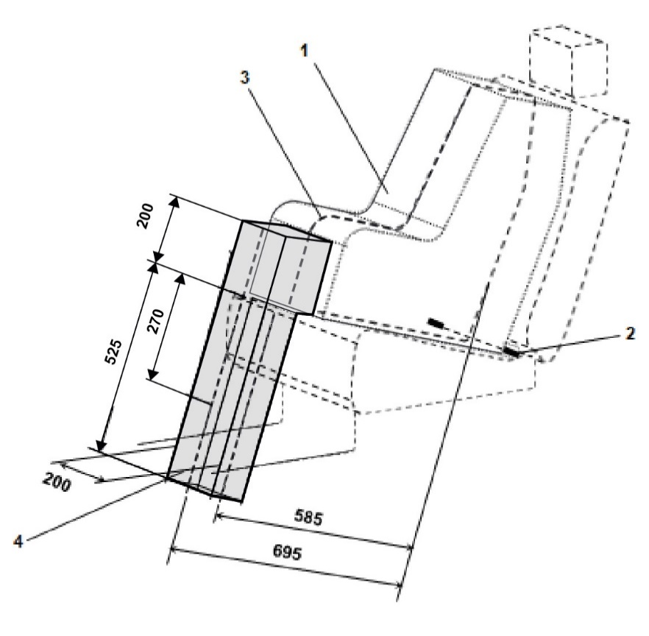
(all dimensions in mm)
Key:
1. Child Restraint Fixture (CRF).
2. ISOFIX low anchorages bar.
3. Median longitudinal plane of the CRF.
4. i-Size support leg installation assessment volume.
Note: Drawing not to scale.”

II. Justification
1. Removal of the wording “specific vehicle” since the type of child restraint is defined in the respective regulation. With the present wording a conflict exists.
2. Addition of a reference to UN Regulation No. 129 since the details of the ISOFIX anchors are also given in UN Regulation No. 129.
3. Removal of incorrect wording in paragraph 4.7.
4. Figure 1 in Annex 6, Appendix 1, was originally introduced as Figure 1 in Annex 17, Appendix 1 of UN Regulation No. 16, by supplement 8 to the 06 series of amendments (revision 8, amendment 3). In the consolidated revision 10 of UN Regulation No. 16, an error was introduced in Figure 1, where the label “Detail W” was missing and the text: “Detail 1 to Figure 1” got shifted to below Figure 2. This error then persistently remained and got copied into the new UN Regulation No. 173.
By including the original figures again, this has now been corrected.

* Proposal for supplement 1 to the 01 series of amendments to UN Regulation No. 173 (Installation of occupant restraint systems)

