UNECE GRE IWG EMC

Change Proposal Form
(One major comment per form.)
(Shaded blocks for the use by the IWG secretary only.)
IWG document Number: |  | IWG-EMC-50-13 |  |  | Date: 2026. 01. 09
Proposer’s Name, Affiliation, and E-mail:  Limit of Harmonics, Flicker for other than 230V / 400V |  |  |  |  | Paragraph:  7.3 , 7.4 |  | Page:
Summary of Change (25 words or less):
- Adding the conversion formula in harmonics limit for other than 230V / 400V region.
Reason for Change (Justification):
- There are no limit for other than 230V / 400V .
- Japan national industry standard
 | <16A | 16A< and <75A
Harmonics | JIS C 61000-3-2 | JEAG 9702
Flicker | Nothing | Nothing
3 Limit of Harmonics (<16A) is Aligned JIS C, however 16A< is no change because no limit in Japan.
(Please see page 4&5 for detail information)
4 No Flicker regulations in Japan, because there is no Flicker trouble & complain in JAPAN.
Original text: -

Revise To:
- 7.3.2.1 : Limit change. Conversion factor is added for other voltage.
“If charging voltage is not covered within 220 to 240 V for single phase or 380 to 415 V for three phase, limit is modified to multiply by “230 / test voltage “ for single phase or “400 / test voltage “ for three phase.”

As Modified Text:

 | Accepted As Written |  |  | Withdrawn
 | Accepted As Modified |  |  | Rejected
 | Deferred |  |  | Other
Rejection Reason / Comments:

Proposal Deferred To:

Proposal Disposition By: |  |  |  |  |  | Date:
- Current condition

< Harmonics >
<16A | JIS C 61000-3-2 | - Applied for below 20A (not 16A)  - Multiply conversion factor to original limit.  Conversion factor = 230 / rated voltage (single phase)  Conversion factor = 400 / rated voltage (three phase)  - If EUT has 2 or more voltage or frequency, test shall be conducted each voltage and frequency.
16A< and <75A | JEAG 9702  (JEA guide line ) | Applied for above 20A (not 16A)  - Not regulated any independent device.  - Guide line is describe the judgement method and limit for user of building designer.  - Device maker only declare the Harmonics result on the spec sheet

- Current R10

- JIS C 61000-3-2：2019
Limit of Class A single phase
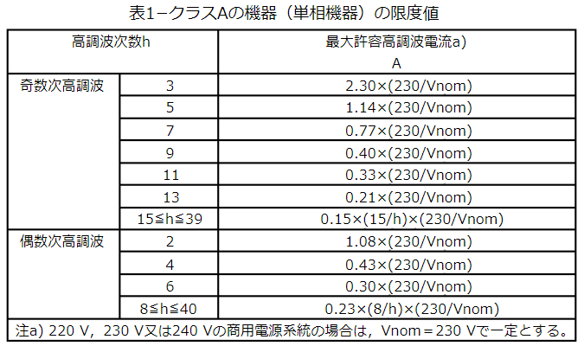
Even
Odd
Maximum current
Harmonics number
Vnom : Rated voltage of vehicle/ESA specification
- : In case of Rated voltage is 220 or 230, 240V, Vnom is 230.
Limit of Class A three phase
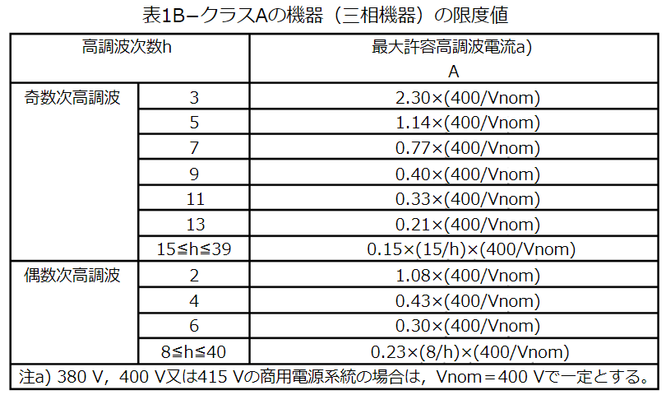
Even
Odd
Maximum current
Harmonics number
Vnom : Rated voltage of vehicle/ESA specification
- : In case of Rated voltage is 380 or 400, 415V, Vnom is 400.

< Flicker >
<16A | No applicable standard in Japan.
16A< and <75A | No applicable standard in Japan.

- Proposal

< Harmonics >

7.3.2.1. If measurements are made using the method described in Annex 11, the limits for input current < 16 A per phase are those defined in IEC 61000-3-2 and given in Table 3.
If charging voltage is not covered within 220 to 240 V for single phase or 380 to 415 V for three phase, limit is modified to multiply by “230 / test voltage “ for single phase or “400 / test voltage “ for three phase.”

< Flicker >

No change

- Additional Information for the New Limit for 100 V Systems

In Japan, the low-voltage (LV) distribution system has significantly lower system impedance compared with that of the EU. In addition, the number of customers connected to each MV (middle-voltage) / LV distribution transformer is much smaller in Japan. As a result, even if individual equipment generates relatively high harmonic currents, the impact on the overall system remains limited, allowing the harmonic emission limits to be relaxed.

・System Impedance (95th percentile values) * Please refer to IEC TR 60725:2012 for details. [1]
Japan (100 V) : 0.35 + j0.13 ohm
EU (230 V) : 0.45 - 1.26 + j0.35 - 0.6 ohm

・MV/LV Distribution Transforme * Please refer to IEC TR 61000-3-18:2024 for details. [2]
- Japan : 20–30 kVA transformers are commonly used, with very few customers
connected.
- EU: Approximately 400 kVA transformers are typical. IEC TR 61000‑3‑18 assumes
153 customers connected per transformer when performing system‑level
simulations.

IEC TR 61000‑3‑18 evaluates harmonic distortion in Japanese and European power systems using simulation models. The results demonstrate that the correction factor (230 / V_{nom)} used in the Japanese JIS standard is appropriate for 100 V systems. A portion of the simulation results is shown in Table 1. * Please refer to IEC TR 61000-3-18:2024 for details. [2]

Table1. Harmonic Distortion from Japan and EU Simulations and Correction Factors
h | CP_{95JP} | CP_{95RNM} | CLR | SR | VR | C_{fh}
2 | 1.48 | 2.00 | 0.83 | 1.35 | 2.3 | 2.59
3 | 0.81 | 5.03 | 0.83 | 6.20 | 2.3 | 11.88
4 | 0.81 | 1.00 | 0.83 | 1.23 | 2.3 | 2.36
5 | 5.03 | 5.97 | 0.83 | 1.19 | 2.3 | 2.27
6 | 0.10 | 0.50 | 0.83 | 5.09 | 2.3 | 9.76
7 | 4.38 | 4.92 | 0.83 | 1.12 | 2.3 | 2.15
CP_{95JP} : 95th percentile cumulative probability of distortion from Japan simulation (%)
CP_{95 RNM} : 95th percentile cumulative probability of distortion from RNM simulation (%)
RNM : European Reference Network Model
CLR : Compatibility Level Ratio
SR : Sensitivity Ratio
VR : Voltage Ratio
C_{fh} : Conversion factor

Calculation of Correction Factor C_{fh}
The correction factor for each harmonic order h is calculated as:
$$C_{fh}=SR×VR×CLR=\frac{{Sh}_{RNM}}{{Sh}_{target}}×\frac{V_{RNm}}{V_{target}}×\frac{{CL}_{newh}}{{CL}_{IECh}}$$

Example: 5th Harmonic
$$C_{f5}=\frac{5.97\%}{5.03\%}×\frac{230V}{100V}×\frac{5\%}{6\%} =2.27$$

The correction factor of 2.27 derived from IEC TR 61000‑3‑18 aligns extremely well with the Japanese proposal of 230 / Vnom = 2.3, which is adopted in JISC 61000‑3‑2.

Furthermore, for harmonic orders other than the 3rd and 6th, the simulation‑based correction factors also show good agreement with the value 2.3.

The reason why the 3rd, 6th, and other multiples of 3 are significantly lower in Japan is that the Japanese MV distribution system predominantly uses the 3‑phase 3‑wire (3P3W) configuration, in which triplen harmonics (multiples of 3) are inherently cancelled.

[1] IEC TR 60725:2012 Consideration of reference impedances and public supply network
impedances for use in determining the disturbance characteristics of electrical equipment
having a rated current ≤75 A per phase

[2] IEC TR 61000-3-18:2024 Electromagnetic compatibility (EMC) - Part 3-18: Limits –
Assessment of network characteristics for the application of harmonic emission limits –
Equipment connected to LV distribution systems not covered by IEC 61000-3-2 and IEC
61000-3-12

Note to the UNECE Secretariat:

The author and the speaker of this presentation confirm that they have authorization to use all content including photos and visual elements.

The material is either copyright-free or the author/speaker hold the necessary copyright or permission.

The UNECE will remove any material from its events and supporting websites if there is unlawful use of copyrighted material.

The author/speaker takes responsibility for any infringement on copyright and holds the UNECE harmless to this effect.

