|  |  |  |  |
| --- | --- | --- | --- |
|  | United Nations | ECE/TRANS/WP.29/GRPE/2025/17 | |
| _unlogo | **Economic and Social Council** | | Distr.: General  5 August 2025  Original: English |

**Economic Commission for Europe**

Inland Transport Committee

**World Forum for Harmonization of Vehicle Regulations**

**Working Party on Pollution and Energy**

**Ninety-third session**

Geneva, 14-17 October 2025

Item 14 of the provisional agenda

**Automotive Life Cycle Assessment (A-LCA)**

Proposal for a new [Mutual] Resolution [No. 5 (M.R.5)] concerning Automotive Life Cycle Assessment (A-LCA)

**Submitted by the Informal Working Group on Automotive Life Cycle Assessment** [[1]](#footnote-2)\*

The text reproduced below was prepared by the Informal Working Group on Automotive - Life Cycle Assessment (A-LCA). It is a proposal for a new [Mutual] Resolution [No. 5 (M.R.5)] concerning Automotive Life Cycle Assessment (A-LCA). It is submitted to the Working Party on Pollution and Energy consideration at its 93rd session.

**[Mutual] Resolution No. [8 (R.E.8)] concerning Automotive Life Cycle Assessment (A-LCA)**

Contents

*Page \**

I. Preamble

II. Statement of technical rationale and justification

1. Introduction

2. Methodology background

3. Existing regulations and standards

4. Technical rationale and justification

III. Text of the [Mutual] Resolution

1. Purpose and principles

2. Scope and application

3. Definitions

4. Abbreviations

5. [Future review]

6. [Language]

7. General methodology

8. Methodology per life cycle [stages]

9. Reporting

10. Verification process

Annex

Service life (in km and years) values for European countries

\* Page number will be added at a later stage prior to WP.29 submission

Preamble

The Administrative Committee of the 1958 Agreement (AC.1) and the Executive Committee of the 1998 Agreement (AC.3),

DESIRING to harmonise technical requirements while ensuring high levels of safety, environmental protection, energy efficiency and anti-theft performance of wheeled vehicles, equipment and parts which can be fitted and/or be used on wheeled vehicles,

BEARING IN MIND that the 1958 Agreement established on 20 March 1958 provides for the adoption of uniform technical prescriptions for wheeled vehicles, equipment and parts which can be fitted and/or be used on wheeled vehicles and the conditions for reciprocal recognition by Contracting Parties of approvals granted on the basis of these prescriptions,

BEARING IN MIND that the 1998 Agreement provides for the establishment of global technical regulations for wheeled vehicles, equipment and parts which can be fitted and/or be used on wheeled vehicles was opened for signature in Geneva on 25 June 1998,

BEARING IN MIND that both Agreements facilitate the trade of wheeled vehicles, equipment and parts with harmonised performance requirements among the respective Contracting Parties,

BEARING IN MIND that this Resolution does not hold regulatory status within Contracting Parties and does not constitute a global technical regulation.

RECOMMENDS that Contracting Parties and manufacturers refer to this [Mutual] Resolution when establishing studies used for the assessment of life cycle CO2 equivalent emissions in the framework of the 1958 or 1998 Agreements respectively.

Statement of technical rationale and justification

1. Introduction

The 2030 Agenda for Sustainable Development, adopted by all United Nations Member States in 2015, provides a shared blueprint for peace and prosperity for people and the planet, now and into the future. At its heart are the 17 Sustainable Development Goals (SDGs), which are an urgent call for action by all developed and developing countries in a global partnership.

UN SDG 12 on "responsible consumption and production" and 13 on "climate action" encourage efficient use of natural resources and to limit climate warming through long term societal goals. Sound and reasoned resource use and climate change mitigation are key preoccupation of citizens, corporations, investors, legislator and society as a whole.

The Paris Agreement has set ambitious targets to limit global warming to well below 2 degrees, preferably to 1.5 degrees Celsius, compared to pre-industrial levels. To achieve this long-term temperature goal, stakeholders aim to reach a global peak of greenhouse gas (GHG) emissions as soon as possible and transition towards achieving a climate neutral world by mid-century.

In 2010 the transport sector was a major contributor to global GHG emissions (23% of global GHG emissions[[2]](#footnote-3)) and road transport had the majority of the overall transport sector emissions (72.06%1).

In the event that a contracting party seeks to have comprehensive, comparable and consistent values for the carbon footprint over the whole life of new automotive products across the globe, from material extraction and processing, to manufacturing, use and dismantling / recycling at the end of life (EoL), it is desirable to define and develop an internationally unified guideline for GHG Life Cycle Assessment (LCA).

The ISO 14040 series has been in effect since 2006 as an international standard on LCA for environmental management, and automotive manufacturers have been publishing results of LCA in accordance with these ISO standards for several types of vehicles.

However, the ISO standards state that the scope of the investigation and the preconditions for conducting LCAs should be determined by the investigator, such as the automotive manufacturer, and since each investigator conducts LCAs according to their own method, an internationally harmonised LCA methodology designed for the automotive industry with global business activity is needed. While LCA is intended to be a multi-impact tool accounting for impact trade-offs, the ISO standards allow for single-impact assessments provided such a choice is acknowledged at the outset and the resulting limitations are noted. This LCA effort focuses entirely on GHG emissions and makes no claims regarding other potential impacts that may arise throughout the life cycles of the assessed technologies.

1. Methodology background

During the 85th GRPE session in January 2022, Japan and Korea proposed to work on clarifying methodologies for assessing life cycle GHG emissions of automotive products in the context of GRPE (GRPE-85-29r1e). GRPE agreed to organise a dedicated workshop during the 86th GRPE session in June 2022. Following the successful workshop, GRPE agreed to put the automotive LCA (A-LCA) methodology on its priority list and agreed to create a new Informal Working Group (IWG) on A-LCA under GRPE (ECE/TRANS/WP.29/GRPE/86/Rev.1). Accordingly, the first session of the IWG on A-LCA was held in October 2022 in Okinawa, Japan.

The IWG on A-LCA is an open structure that will enable the exchange of information and experiences on relevant regulations, policy measures, and standardization efforts. It is intended that the discussions will encompass all types of road automotive products with different technologies for energy pathways.

The 1958 Agreement and the 1998 Agreement do not define methods of measuring GHG emissions from automotive life cycles. The objective of the IWG on A-LCA is to develop an internationally harmonised procedure [methodology] to determine the carbon footprint (CFP) for all [stages] of the life-cycle of a [light duty vehicle], also considering energy use for energy pathways and automotive types from production to use and disposal as a Resolution under the framework of WP.29. The ISO 140xxx series of LCA standards and definitions serves as the foundation of the A-LCA methodology. The definition of CFP used within this methodology is based upon the 100-year global warming potentials (GWP100) – as defined by the United Nations Intergovernmental Panel on Climate Change (IPCC).

This [Mutual] Resolution can inform policy and can help encourage automotive industries to reduce CFP via improved efficiencies at all [stages] of the life-cycle. The methodology shall be [was] developed respecting the principles of transparency and consistency. It shall also strike [also strikes] a balance between accuracy and workload, considering the automotive industry's complex supply chain.

1. Existing regulations and standards

Several countries and organisations throughout the world have already introduced guidelines and standards related to the Life Cycle Assessment of vehicles. However, these guidelines and standards differ in terms of methodology, scope of application, objectives and targeted audiences.

Examples of existing standards:

1. ISO 14040:2006 & 14044:2006: describing the principles and framework for general LCA.
2. ISO 14067:2018 Greenhouse gases — Carbon footprint of products — Requirements and guidelines for quantification.

Examples of existing guidelines from the automotive industry:

1. EPD PCR passenger cars[[3]](#footnote-4): providing rules for the assessment of the environmental performance of passenger cars including internal combustion engine vehicles ICEVs, battery electric vehicles BEVs, fuel cell electric vehicles FCHVs, hybrid electric vehicles HEVs …
2. PFA LCA guidelines[[4]](#footnote-5): where the French automotive platform provided methodological guidelines on vehicle and component LCA for 7 environmental indicators.
3. VDA LCA guidelines[[5]](#footnote-6): where the German Association of the Automotive Industry provided methodological guideline on vehicle and component LCA for 5 environmental indicators.
4. JAMA LCA guidelines[[6]](#footnote-7): the Japanese Automobile Manufacturers Association provided a certified methodology for passenger car, truck, bus and motorcycle, focusing on GHG emissions only.

Example of regulations:

1. [TBD ]
2. [TBD ]
3. Technical rationale and justification

The purpose of this Resolution is to support the global automotive sector's efforts to reduce GHG emissions throughout the supply chain. In other words, it is intended to provide a process [methodology] for automotive manufacturers, component suppliers and government authorities to assess CFPs.

Text of the [Mutual] Resolution

1. Purpose and principles

1.1. This [Mutual] Resolution provides an internationally harmonised methodology to determine the CFP for [light duty vehicles], also considering energy use for energy pathways and automotive types from production to use and disposal, as a [Mutual] Resolution under the framework of WP.29. Note that the methodology is specifically limited in scope to [light duty vehicles].

1.2. This [Mutual] Resolution inform policy and can help encourage automotive industries to reduce CFP via improved efficiencies at all [stages] of the life-cycle. The methodology shall be developed respecting the principles of transparency and consistency and shall be consistent with the ISO 140xxx series of LCA international standards. It shall also strike a balance between the accuracy and the workload considering the complex supply chain of the automotive industry.

1.3. To produce reliable, reproducible, verifiable and comparable A-LCA studies, a core suite of analytical principles shall be adhered to. They shall be considered with respect to each phase, from defining the goal and the scope, through data collection, impact assessment, reporting [and verification] of study outcomes.

1.4. Practitioners of this methodology shall observe the following principles in conducting a CFP study:

* 1. Relevance

The selection of data and methods shall be appropriate to the assessment of the GHG emissions and removals arising from the system under study.

* 1. Completeness

Quantification of the CFP shall include all GHG emissions and removals that provide a significant contribution to the CFP of the product system under study. The level of significance is determined by the cut-off criteria.

* 1. Consistency

Assumptions, methods and data shall be applied in the same way throughout the A-LCA study to arrive at conclusions in accordance with the goal and scope definition.

* 1. Accuracy

Quantification of the CFP shall be accurate, verifiable, relevant and not misleading, and bias and uncertainties shall be reduced as far as is practical.

* 1. Transparency

All relevant issues shall be addressed and documented in an open, comprehensive and understandable presentation of information. Any relevant assumptions shall be disclosed, and methodologies and data sources used shall be appropriately referenced. Any estimates shall be clearly explained, and bias shall be avoided so that the A-LCA study report represents what it purports to represent.

1. Scope and application

This [Mutual] Resolution applies to [light duty vehicles].

1. Definitions
   1. "*Allocation*" means: partitioning the input or output flows of a process or a product system between the product system under study and one or more other product systems.[[7]](#footnote-8)
   2. "*Attributable process*" means those processes that consist of all service, material and energy flows that become, make and carry a product throughout its life cycle.[[8]](#footnote-9)
   3. "*Attributional*" means process-based modelling intended to provide a static representation of average conditions, excluding market-mediated effects.[[9]](#footnote-10)
   4. "Background System" means in contrast (to the foreground system) … processes that are operated as part of the system but are not under direct control or decisive influence of the producer of the good (or operator of the service, or user of the good). [[10]](#footnote-11)
   5. Batteries
      1. "*SLI battery*" means [a battery for starting-lighting-ignition and auxiliary applications only - does not apply to primary battery packs used for electric-drive powertrains (traction batteries)]
      2. [A battery that is specifically designed to supply electric power for starting, lighting, or ignition and that can also be used for auxiliary or backup purposes in vehicles, other means of transport or machinery]
      3. ["*Traction battery*" means a battery system that stores energy with the main purpose of propelling the vehicle.]
   6. "*Bill of Material(s)*", "*Product structure*" or "*Associated list*” means a list of raw materials, sub-assemblies, intermediate assemblies, sub-components, parts and the quantities of each needed to manufacture the product in the scope. In some sectors it is equivalent to the bill of components.[[11]](#footnote-12)
   7. "*Biogenic carbon*" means Carbon derived from biomass.[[12]](#footnote-13)
   8. "*Biomass*" means material of biological origin, excluding material embedded in geological formations and material transformed to fossilised material. Biomass includes organic material (both living and dead), e.g. trees, crops, grasses, tree litter, algae, animals, manure and waste of biological origin. Biomass excludes peat. 11 [[13]](#footnote-14)
   9. "*Carbon Footprint of a Product* " or "*Product Carbon Footprint (PCF)*" means the sum of GHG emissions and GHG removals in a product system, expressed as CO2 equivalents and based on a life cycle assessment using the single impact category of climate change. 11
   10. ["*Carbon offsetting*" means mechanism for compensating for a full PCF or a partial PCF through the prevention of the release of, reduction in, or removal of an amount of GHG emissions in a process outside the product system under study. 11]
   11. "*Characterisation factor*" means a factor derived from a characterisation model, which is applied to convert an assigned life cycle inventory analysis (3.4.26) result to the common unit of the category indicator (3.10.8). [[14]](#footnote-15)
   12. "*Circular Footprint Formula (CFF)*" means a framework for evaluating the environmental impacts of a product throughout its entire life cycle, particularly based on the principles of a circular economy. This method calculates the environmental burdens and benefits obtained from recycling a product and aims to improve resource use efficiency. [[15]](#footnote-16)
   13. "*Climate Change*" means the environmental footprint impact category considering all inputs and outputs that result in greenhouse gas (GHG) emissions. The consequences include increased average global temperatures and sudden regional climatic changes. 8
   14. "*Closed-loop recycling*" means, in a closed loop, the secondary material from one product system is either reused in the same product system (real closed-loop) or used in another product system without changing the inherent technical properties of the material (quasi closed-loop).[[16]](#footnote-17)
   15. "*Carbon dioxide equivalent (CO2eq)* " means the unit for comparing the radiative forcing of a greenhouse gas to that of carbon dioxide . 13
   16. "*Co-product*" means any of two or more products coming from the same unit process or product system. 11
   17. "*Cradle to grave*" means a product’s life cycle that includes raw material extraction, processing, distribution, storage, use, and disposal or recycling [stages]. All relevant inputs and outputs are considered for all of the [stages] of the life cycle. 8
   18. "*Cradle-to-gate*" means a system boundary that is applied for a partial PCF assessment that includes a part of the product’s life cycle. Cradle-to-gate represents the GHG emissions and removals arising from all life cycle [stages], up to the point where the product leaves the production site (the ”gate”). This explicitly excludes the life cycle [stages] use and end-of-life. [[17]](#footnote-18)
   19. "*Cut-off criteria*" means the specification of the amount of material or energy flow or the level of significance of GHG emissions associated with unit process or the product system, to be excluded from a PCF study. 11
   20. Data
       1. "*Primary data*" means a quantified value of a process, or an activity obtained from a direct measurement, or a calculation based on direct measurements. Primary data can include greenhouse gas emission factors and/or greenhouse gas activity data. Average data from industry associations or global averages do not qualify as primary data. 12
       2. "*Secondary data*" means any data which do not fulfil the requirements for primary data. 12

Note 1: Secondary data can include data from databases and published literature, default emission factors from national inventories, calculated data, estimates or other representative data, validated by competent authorities.

Note 2: Secondary data can include data obtained from proxy processes or estimates.

* 1. "*Declared unit*" means the quantity of a product for use as a reference unit in the quantification of a partial PCF. 11
  2. "*Direct emissions*" means the GHG emissions from the processes that are owned or controlled by the reporting company. 7
  3. "*Downstream emissions*" means the indirect GHG emissions that occur in the value chain following the processes owned or controlled by the reporting company. 7
  4. "*Elementary flow*" means the material or energy entering the system being studied that has been drawn from the environment without previous human transformation, or material or energy leaving the system being studied that is released into the environment without subsequent human transformation. 11
  5. "*End of Life allocation*" means rules that define how to allocate environmental credits and/or burdens derived from reuse, recycling or recovery of materials and products after the vehicles’ first life cycle (after End of Life vehicle disposal). [[18]](#footnote-19)
  6. "*End-of-life*" means the point in time during the life cycle at which a product or resource is taken out of use and is disposed. [[19]](#footnote-20)
  7. "*End-of-waste*" means the end-of-waste state for waste in Europe is reached when the material is no longer considered waste under the national implementation of the Waste Framework Directive. [[20]](#footnote-21)
  8. "*Exergy*" means the proportion of the total energy of a system or material flow that can perform work when brought into thermodynamic equilibrium with its environment.
  9. "*Foreground system*" means processes of the system that are regarding their selection or mode of operation directly affected by the decisions analysed in the study. The foreground processes are hence those that are under direct control of the producer of the good or operator of the service or user of the good or where they have decisive influence. 9
  10. "*Functional unit*" means the quantified performance of a product system for use as a reference unit. 11 , [[21]](#footnote-22)
  11. "*Global warming potential (GWP)*" means an index, based on radiative properties of GHGs, measuring the radiative forcing following a pulse emission of a unit mass of a given GHG in the present-day atmosphere integrated over a chosen time horizon, relative to that of carbon dioxide (CO2). 11
  12. "*Greenhouse gases*" (GHGs) means the gaseous constituent of the atmosphere, both natural and anthropogenic, that absorbs and emits radiation at specific wavelengths within the spectrum of infrared radiation emitted by the Earth’s surface, the atmosphere, and clouds. 11
  13. "*Hotspot*" means [a life cycle [stage] whose contribution to the impact category is greater than even distribution of that impact across the life cycle [stages] or all life cycle [stages] collectively contributing more than 50% to any impact category.] [a life cycle “[stage]” (e.g., resource extraction, material processing, production, use, end-of-life, etc.) that disproportionately contributes to an impact category (e.g., global warming potential), exceeding the average distribution across all [stages].]
  14. ["*Indirect emissions scope 2*" means the GHG emissions from the generation of purchased or acquired electricity, steam, heating, or cooling consumed by the reporting company. [[22]](#footnote-23) ]
  15. ["*Indirect emissions scope 3*" means all indirect emissions (not included in scope 2) that occur in the value chain of the reporting company, including both upstream and downstream emissions. [[23]](#footnote-24) ]
  16. "*Infrastructure emission*" means the embodied emissions that arise due to the production or dismantling of infrastructure.

Note 1: infrastructure refers to any capital goods e.g. production facilities, energy provision (powerplants, transmission lines) or transport services (roads, railways, vehicles).

Note 2: emissions arising from the operation of infrastructure (operation of a power plant) is not understood as infrastructure emissions.

* 1. "*Input*" means the product, material, or energy flow that enters a unit process. 6
  2. "*Land use*" means the human use or management of land within the relevant boundary. 11
  3. "*Life cycle*" means the consecutive and interlinked [stages] related to a product, from raw material acquisition or generation from natural resources to end-of-life treatment. 11
  4. "*Life cycle assessment (LCA)*" means the compilation and evaluation of the inputs, outputs and the potential environmental impacts of a product system throughout its life cycle. 11
  5. "*Life cycle emissions*" means the sum of GHG emissions resulting from all [stages] of the life cycle of a product and within the specified boundaries of the product. 7
  6. "*Life Cycle impact Assessment*" (LCIA) means the phase of life cycle assessment aimed at understanding and evaluating the magnitude and significance of the potential environmental impacts for a product system throughout the life cycle of the product. 6
  7. "*Life cycle inventory*" (LCI) means the phase of life cycle assessment involving the compilation and quantification of inputs and outputs for a product throughout its life cycle (such as a product’s GHG emissions and sources). 11
  8. ["*Life cycle inventory results*" means the GHG impact of the studied product per unit of analysis. 22]
  9. ["*Market-mediated effects*" means the indirect impacts that arise from the market dynamics associated with a product or service throughout its life cycle. These effects can occur due to changes in supply and demand, price fluctuations, and shifts in consumer behaviour that are influenced by the introduction or modification of a product.]
  10. Materials
      1. "*Material*" means physical goods that are further processed (and not consumed) in manufacturing processes. [[24]](#footnote-25)
      2. "*Modular Burdens and Benefits Method*" (MBBM) means a concept defined in the UNECE A-LCA Circular Footprint Formula (CFF). It refers to mathematical terms that are used to calculate the emission shares related to burdens and benefits associated with secondary materials input and output in the material recycling or with energy recovery. The MBBM concept is also applied to the traction battery repurposing and to the incineration with energy recovery. The MBBM concept is based on the avoided burden in the expanded system boundary.
      3. "*Primary material*" means material extracted from nature also referred to as virgin material.
      4. "*Secondary material*" means any material taken from a recycling flow.
      5. "*Raw material*" means any primary or secondary material that is used to produce a semi-finished good, product or service. [[25]](#footnote-26)
  11. "*Multi-input-output unit process*" means an operation or process with multiple inputs, such as materials and energy, and multiple outputs, such as co-products and waste. 7
  12. "*Negative emissions*" means the removal of greenhouse gases (GHGs) from the atmosphere by deliberate human activities, i.e., in addition to the removal that would occur via natural carbon cycle processes. [[26]](#footnote-27)
  13. ["*Net negative emissions*" means a situation which is achieved when, as the result of human activities, more greenhouse gases are removed from the atmosphere than are emitted into it. Where multiple greenhouse gases are involved, the quantification of negative emissions depends on the climate metric chosen to compare emissions of different gases (such as global warming potential, global temperature change potential, and others, as well as the chosen time horizon). 25]
  14. "*Open-loop recycling*" means where material is reused in other product systems and its inherent properties are changed (e.g., recycled material may have a different chemical composition, a different structure or a higher concentration of dissolved impurities compared to primary material). [[27]](#footnote-28)
  15. "*Output*" means any product, material, or energy that leaves a unit process. 6
  16. "*Packaging*" means any product to be used for the containment, protection, handling, delivery, storage, transport and presentation of goods, from raw materials to processed goods, from the producer to the user or consumer, including processor, assembler or other intermediary. [[28]](#footnote-29)
  17. "*Partial PCF*" means the sum of GHG emissions and GHG removals of one or more selected process(es) in a product system, expressed as carbon dioxide equivalents and based on the selected [stages] or processes within the life cycle. 11
  18. "*Process*" means the set of interrelated or interacting activities that transforms inputs into outputs. 11
  19. "*Product*" means any good or service. 6

Note 1: The product can be categorised as follows:

1. services (e.g. transport);
2. software (e.g. computer program, dictionary);
3. hardware (e.g. engine mechanical part);
4. processed materials (e.g. lubricant).

Note 2: Services have tangible and intangible elements. Provision of a service can involve, for example, the following:

1. an activity performed on a customer-supplied tangible product (e.g. automobile to be repaired);
2. an activity performed on a customer-supplied intangible product (e.g. the income statement needed to prepare a tax return);
3. the delivery of an intangible product (e.g. the delivery of information in the context of knowledge transmission);
4. the creation of ambience for the customer (e.g. in hotels and restaurants).

Software consists of information and is generally intangible and can be in the form of approaches, transactions or procedures.

Hardware is generally tangible, and its amount is a countable characteristic. Processed materials are generally tangible and their amount is a continuous characteristic.

* 1. "*Product category*" means a group of products that can fulfil equivalent functions. 11
  2. "*Product category rules (PCR)*" means a set of specific rules, requirements and guidelines for developing Type III environmental declarations. 6
  3. "*Product system*" means the collection of unit processes with elementary and product flows, performing one or more defined functions, and which models the life cycle of a product. [[29]](#footnote-30)
  4. "*Recycled Content Method (RCM)*" means a technique used to assess the contribution of recycled materials to the environmental impact of new products. This method quantifies the extent to which the use of recycled materials reduces the environmental impact of new products (as long as the secondary material has less environmental impact than the virgin material). Specifically, it considers the environmental benefits gained by substituting a share of the virgin (primary) raw materials with recycled (secondary) materials. The RCM does not consider any benefit for the provision of recyclable materials at the end-of-life of a product and allocates the full impact of the recycling process (production of the secondary material) to the recycled content (secondary material used in the vehicle production). [[30]](#footnote-31)
  5. "*Reference flow*" means a measure of the inputs to or outputs from processes in a given product system required to fulfil the function expressed by the functional unit. 11
  6. "*Renewable Energy*" or "*Energy from renewable sources*" means energy from renewable non-fossil sources, namely wind, solar (solar thermal and solar photovoltaic) and geothermal energy, ambient energy, tide, wave and other ocean energy, hydropower, biomass, landfill gas, sewage treatment plant gas, and biogas. [[31]](#footnote-32)
  7. "*Sectoral guideline*" means PCF reporting rules issued by industry associations or initiatives as guidance for their members, 11
  8. "*Sensitivity analysis*" means systematic procedures for estimating the effects of the choices made regarding methods and data on the outcome of a CFP study. 11
  9. "*Supply chain*" means a network of organisation involved, through upstream and downstream linkages, in process and activities relating to the provision of products to the user. 11
  10. "*Sustainability*" means a dynamic process that guarantees the persistence of natural and human systems in an equitable manner. 25
  11. "*System boundary*" means a boundary based on a set of criteria representing which unit processes are a part of the system under study. 6
  12. "*Transport / distribution packaging*" means any packaging designed to contain one or more articles or packages, or bulk material, for the purposes of transport, handling and/or distribution. 27
  13. ["*Type III environmental declarations*" means declarations which present quantified environmental information on the life cycle of a product to enable comparisons between products fulfilling the same function. Such declarations

1. are provided by one or more organisations,
2. are based on independently verified life cycle assessment (LCA) data, life cycle inventory analysis (LCI) data or information modules in accordance with the ISO 14040 series of standards and, where relevant, additional environmental information,
3. are developed using predetermined parameters, and
4. are subject to the administration of a programme operator, such as a company or a group of companies, industrial sector or trade association, public authorities or agencies, or an independent scientific body or other organisation. [[32]](#footnote-33)]
   1. "*Unit process*" means the smallest element considered in the life cycle inventory analysis for which input, and output data are quantified. 11
   2. "*Upstream emissions*" means the indirect GHG emissions that occur in the value chain prior to the processes owned or controlled by the reporting company. All upstream transportation emissions are also included as part of upstream emissions. 7
   3. "*Use [stage]*" means that part of the life cycle of a product that occurs between the transfer of the product to the consumer and the end-of-life of the product. 23
   4. "*Value chain*" means all upstream and downstream activities associated with the product system.
   5. "*Waste*" means materials, co-products, products, or emissions that the holder intends or is required to dispose of. 11, 7
5. Abbreviations

A-LCA - Automotive Life Cycle Emissions

[ABS - ]

AC - Air Conditioning

[ADAS - ]

[APEI - ]

ASA - Acrylonitrile Styrene Acrylate

ASR - Automobile shredder residue

[BEV/PEV - Battery Electric Vehicle / Pure Electric Vehicle]

BoM - Bill of Materials

[CATARC - ]

CD - charge depleting electric

CE - Circular Economy

CFF - Circular Footprint Formula

CFP - Carbon Footprint

CNG - Compressed Natural Gas

CO2 - Carbon Dioxide

CO2eq - Carbon Dioxide equivalent

COPERT - Calculations of Emissions from Road Transport

CP - Contracting Party (to an agreement of WP.29)

CS - charge sustaining

DLUC - Direct Land Use Change

EA - European Aluminium

[EAA - ]

EAC - Energy Attribute Certificate

EAER - Equivalent All Electric Range

EEF - EoL Emission factor

EF - Emissions Factor / Environmental Footprint

EGU - Electricity Generation Units

ELV - End of Life Vehicle

[EMEP - European Monitoring and Evaluation Programme]

EoL - End of Life

EP - Epoxy resin

EPD - Environmental Product Declaration

EPDM - Ethylene Propylene Diene Monomer

[ESG (rating) - ]

EV - Electric/Electrified Vehicle

FC - Fuel Cell

FCEV - Fuel Cell Electric Vehicle

FCHV - Fuel Cell Hybrid Vehicle

FCV - Fuel Cell vehicle

FU - Functional Unit

GCD - Great Circle Distance

GHG - Greenhouse Gas

GO - Guarantee of Origin

GREET - The Greenhouse Gases, Regulated Emissions, and Energy Use in Transportation

GRPE - (UNECE) Groupe de Rapporteurs Pollution et Energie

GWP - Global Warming Potential

HC - Hydrocarbon

HCFC - Hydrochlorofluorocarbons

HDV - Heavy Duty Vehicle

HEV - Hybrid Electric Vehicle

HFC - Hydrofluorocarbons

HVAC - Heating, Ventilation and Air Conditioning

IAI - International Aluminium Institute

[ICA - ]

ICE(V) - Internal Combustion Engine (Vehicle)

[IDEA - ]

IEA - International Energy Agency

ILCD Format - International Life Cycle Data Format

ILUC - Indirect Land Use Change

IPCC - (United Nations) Intergovernmental Panel on Climate Change

IPF - Interpolation Family

ISO - International Organization for Standardization

IT - Information Technology

IWG - Informal Working Group

JAMA - Japanese Automobile Manufacturers Association

KPI - Key Performance Indicator

LCI - Life Cycle Inventory

LCIA - Life Cycle Impact Assessment

LDV - Light Duty vehicle

LiB - Lithium Ion Battery

LNG - Liquified Natural Gas

MAC - Mobile Air Conditioning

[MAWP - ]

MBBM - Modular Burdens and Benefits Method

(I)MDS - (International) Material Data Sheet

[MOVES - ]

NiMH - Nickel Metal Hydride

NOVC-HEV - Not Off-Vehicle Charging Hybrid Electric Vehicle

OBFCM - On Board Fuel Consumption Monitoring

OEM - Original Equipment Manufacturer

OVC-HEV - Off-Vehicle Charging Hybrid Electric Vehicle

PA - Nylon

PBT - Polybutylene Terephthalate

PC - Polycarbonate

PCF - Product Carbon Footprint

PCR - Product Category Rules

PDS - Primary Data Share

PE - Polyethylene

PEF - Product Environmental Footprint

PET - Polyethylene Terephthalate

PFA - Plateforme Automobile

PHEV - Plug-in Hybrid Electric Vehicle

pkm - passenger kilometres

PMMA - Acrylic resin

PPA - Power Purchase Agreement

POM - Polyacetal

PP - Polypropylene

PPA - Power Purchase Agreements

PPS - Polyphenylene Sulphide

PUR - Polyurethane

PVC - Polyvinyl Chloride

R&D - Research and Development

RCM - Recycled Content Method

REC - Renewable Energy Certificate

RFS - Program

RED - (methodology)

REEV - Range-Extended Electric Vehicle

RV - Representative Vehicle

SBR - Styrene-Butadiene Rubber

SDG - Sustainable Development Goals

SDS - Sustainable Development Scenario

SFD - Shortest Feasible Distance

SLI - Starting-Lighting-Ignition (Battery)

SOCE - State of Certified Energy

SoH - State of Health

STEPS - Stated Policies Scenario

SUV - Sports Utility Vehicle

tkm - tonne-kilometres

[TfS - ]

TPO - Thermoplastic Olefin

TPV - Thermoplastic Vulcanisate

TSLCA - TranSensus LCA

TtW - Tank to Wheel

UEF - Upstream Emission Factor

UF - Utility Factor

UN GTR - United Nations Global Technical Regulation

UNECE - United Nations Economic Commission for Europe

VDA - German Association of the Automotive Industry

VECTO - Vehicle Energy Consumption Calculation Tool

WEO - World Energy Outlook

WLTP - Worldwide Light-duty Test Procedure

WP.29 - (UN-ECE) Working Party 29

WtT - Well to Tank

WtW - Well to Wheel

ZEV - Zero Emission Vehicle

1. [Future review

The methodology under this [Mutual] Resolution is a first for WP.29. We have organised as much as possible under the current circumstances while understanding the issues that need to be considered. We anticipate that there will be matters that need to be more appropriately considered, new market demands, and challenges that may arise in situations where this methodology will be utilised. In light of such circumstances, revising the methodology as necessary will be desirable.]

1. [Language

English is the original language of this document. Only translations in French and Russian have legal character.]

1. General methodology
   1. Level Concept

The Level Concept was developed in UNECE IWG A-LCA to reflect the different motivations and goals of determination of CFP for [light duty vehicles] and indicates four classes [or levels] which correspond to intended use cases of an automotive LCA. [The importance of LCA has grown considerably in recent years and the number and type of use cases for LCA expanded as a result.] The Level Concept also considers the increasing demand for primary data to inform LCA results. [By addressing variations in availability and quality of data inputs, the Level Concept helps to ensure a consistent analysis across all product systems and goals.] [By transparently addressing these new forms of vehicle LCAs and their input data variation, the Level Concept helps to ensure a consistent application of the vehicle LCA method and the appropriate selection of a product system model for an intended application and scope.]

[Figure 1  
**Life cycle assessment framework according to ISO 14040:2006**

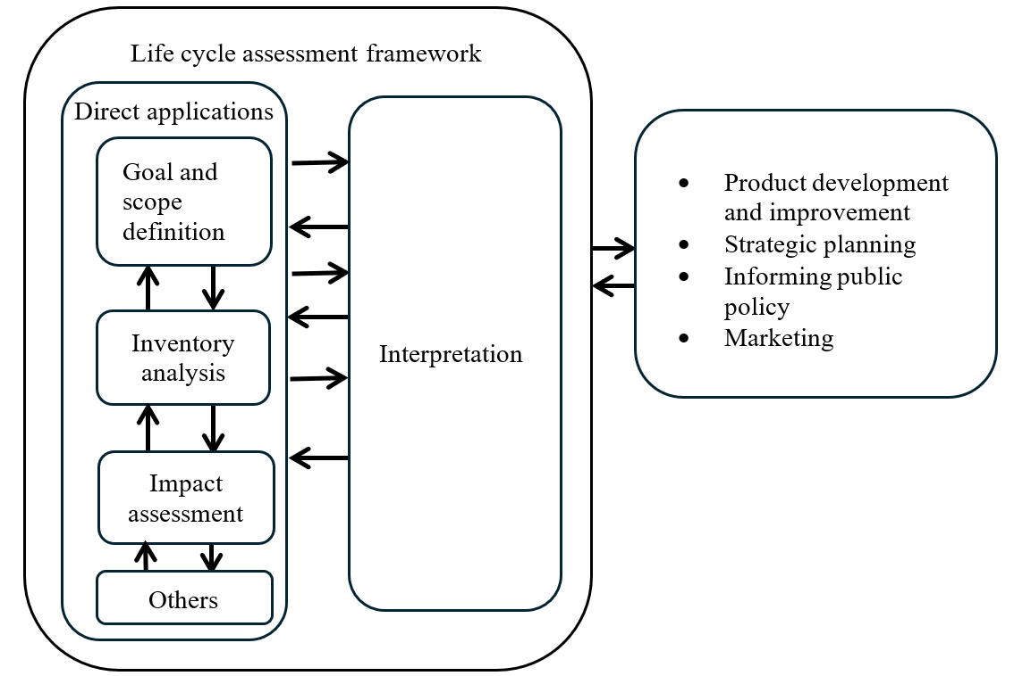

]

Based on the ISO 14040:2006 standard, a life cycle assessment (LCA) consists of four steps ([Figure 1). Goal and scope definition is the first step of these four. In this step the study is defined in detail and central choices are made regarding its conduct.

“The goal definition shall firstly state the intended application(s) of the LCA results in a precise and unambiguous way. The decision-context is one key criterion for determining the most appropriate methods for the LCI model.”[[33]](#footnote-34)

For the practitioner it is crucial to define appropriate requirements for modelling the product system according to the intended purpose and application of an LCA.

[At the same time, vehicle LCAs are used by a growing number of stakeholders for an increasing range of different purposes and applications. Traditionally, vehicle LCAs were mainly used in R&D for technology comparisons and support of strategic decision making (e.g. which powertrain / material / production technology / … is environmentally superior?) or by OEM’s (Original Equipment Manufacturer) to show that their successor models were more environmentally friendly than the previous ones (continuous improvement). This is also reflected in the list of direct applications in ISO 14040:2006 (compare [Figure 1, box on the right). Currently, an extension of applications towards implementation and reporting of reduction measures – especially in the context of GHG reduction and circular economy (CE) – can be observed by various stakeholders with different expectations from automotive LCAs.]

Potential stakeholders are listed below:

1. Society/ Policy makers
2. Green finance & ESG rating
3. Customer
4. OEM
5. Suppliers

Potential motivations are listed below:

1. Decision support of policy making
2. Comparison / rating
3. Communication /marketing
4. Fair competition
5. Incentivisation
6. [Internal steering of decarbonisation
7. Proof of decarbonisation
8. Identification of reduction potentials]

As a consequence, this [Mutual] Resolution on A-LCA addresses different types of use cases by using the Level Concept, and highlights where these require different scope definitions and requirements concerning methodology and data granularity.

* 1. Use cases and application of Level Concept

The Level Concept distinguishes four different levels based on the underlying questions of the assessment. [This could range from “what is the right mobility concept for a city?” to “what is the carbon footprint of a certain vehicle model?”.] This leads to different requirements for the product system model especially with regard to the upstream life cycle phases in the foreground system (supply chain and vehicle production).

According to questions of the assessment granularity, product specificity and the scope of the foreground and background is chosen. To put it the other way round: whereas Level 1 study is representative of a broad range of products, e.g. all vehicles, Level 4 is more focused on the fine variations of individual vehicle models [and the supply chain of their specific components (parts).]

The choice of representativity and specificity also concerns downstream life cycle [stages] (Well To Wheel (WtW) / use [stage], End of Life (EoL)) or background system processes (e.g. energy production). Also, for the use [stage] [or EoL] the data for a specific vehicle could be used. This implies however that the LCA is done retrospectively. For many use cases the analysis (declaration) point in time is the moment the product is put on the market. Consequently, the following life cycle [stages] can only be analysed prospectively. For predictive data, average data (e.g. for lifetime milage) can be used. For predictive data there is no way to provide primary data, [as you cannot measure something that happens in the future.]

In general, every LCA practitioner who has the necessary data (granularity) available for the respective level, may conduct an LCA study for this level. However, in practice mainly OEMs have access to the bills of material (BoM) and the material data system (MDS) which are required as basis of the vehicle models for Levels 2 to 4.

[Following the product development [stages], the determination of the concept can be divided into four levels as follows (see Figure 2).

Figure 2  
**General product development [stages] and level allocation**

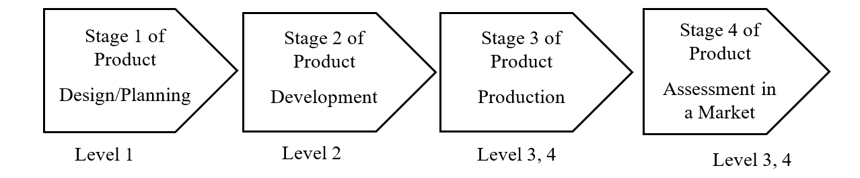

Level 1 for example, assumes that the OEM is in the process of planning a new vehicle, which is often determined as the LCA on a hypothetically defined vehicle.

Level 2 for example, assumes determinations at the [stage] of product development by OEMs, whereas for specific parts, determinations using primary data are possible. Therefore, it is assumed to be used to check the effects of introducing specific components.

Level 3 for example, assumes a situation where primary data exists for parts, etc. of the vehicle in question, where the determination is made at the manufacturing [stage] by the OEM.

Level 4 for example, assumes a situation where primary data exists for the whole supply chains and manufacturing of the vehicle in question. Therefore, the main difference between Levels 3 and 4 is laid on the modelling of the supply chain.

Although the selection of the level is aligned with the product development [stages], it doesn’t exclude general use cases other than vehicle OEM’s own. For example, Level 1 can be used by government officials for public policy making or by researchers for general research purpose, since it doesn’t require proprietary information by OEM, such as BoM.]

[Table 1 summarizes the general structure of the Level Concept, while the practitioner can refer to Chapter ‎8 for the detailed application of the level concept to different life cycle [stages].]

[Table 1  
**General structure of the Level Concept**

|  | *Items* | *Level 1\** | *Level 2\** | *Level 3\*\** | *Level 4\*\** |
| --- | --- | --- | --- | --- | --- |
| *Purpose* | *Strategy* | | *Reporting* | |
| Life cycle [stage] | Possible audiences | Policy makers, researchers | Company strategy/product developers, customers | Government programs, customers | |
| Material production [stage] (See 4.1) | Vehicle weight | Primary data | All primary data | | |
| Material distribution | All secondary data | All primary data | | |
| [Scrap/Yield] rate of material | All secondary data | | Partially primary data | All primary data |
| Carbon intensity of material acquisition | All secondary data | | Partially primary data | [All primary data/Partially primary data] |
| Parts production and vehicle assembly [stage] (See 4.2) | Vehicle model | Average for a vehicle fleet | Average for vehicles of a specific segment or a vehicle chosen as representative for a specific segment | Average for specific vehicle models with different equipment variants | Specific vehicle mode |
| Supply chain model | Generic | | Partly specific for hotspot part supply chain | Mainly specific for whole supply chain |
| Waste | Implicit in surcharge factor | | Implicit in surcharge factor except explicit for hotspot part | Fully explicit |
| Gross vs. net material input (scrap) | Implicit in surcharge factor | | Implicit in surcharge factor except explicit for hotspot part | Fully explicit |
| Transport of parts | Implicit in surcharge factor | | Implicit in surcharge factor except explicit for hotspot part | Fully explicit |
| Transport of vehicles | Generic | | Explicitly reported from OEM gate to customer | |
| Primary/secondary material use | Implicit in material production carbon intensity | | Implicit in material production carbon intensity except explicit for hotspot part | Fully explicit |
| Temporal validity | Most recent data | | Most recent data except annual update for hotspot part | Annual update |
| Geographical representativeness | Determined based on the research question | | As specific as possible while plant level for hotspot part | Plant level |
| Use [stage] (See 4.3) | Service life | Officially available data by CPs; if not available, the values in some peer-reviewed reports or methodology | | | |
| Use phase consumption | Certification value, also considering discrepancy factor and deterioration factor | | | |
| Discrepancy factor | Official monitoring info, inventories like EMEP/EEA, etc, or assume 1 | | Default values provided by CPs | OEM-specific average data from real-world operation with similar powertrains, matched to the region of operation |
| Deterioration factor for fuel cell | Efficiency loss of 10% over the lifetime (6000 hours for LDVs), assuming a starting efficiency of 55% and running at an average of 25% of the peak power rating | | | OEM/supplier specific approach or data, validated by independent third-party expert |
| Deterioration factor for battery SoH in PHEV | SoH loss of 20% over the operational life cycle of 2000 charge/discharge cycles hours for LDVs | | | OEM/supplier specific approach or data, validated by independent third-party expert |
| Future changes in energy mix | Energy mix change considered for the use [stage] based on the latest available dynamic scenario: 1. Official general scenario by CPs, 2. [RCM/Stated Policies Scenario] from the IEA [WEO report], [3. Dispatch modelling, 4. Static scenario] | | | |
| Maintenance | Generic | | List of maintenance parts/consumable and associated frequency provided by OEM | |
| Determination of traction battery and fuel cell system replacement | Excluded by default, unless a simple assumption on replacement is provided | | Excluded by default, unless OEM/supplier specific approach to define the need for a replacement over the operational life is provided | |
| End of life [stage] (See 4.4) | Activity data of EoL processes (e.g., weight of vehicle, parts, materials, etc.) | Global secondary data | Primary data based on BoM and MDS | | |
| Carbon intensity data of EoL processes (e.g., dismantling and shredding/sorting, ASR thermal recovery, materials recycling, etc.) | Global, regional, or country specific, primary or secondary data, depending on the study | | Data requirement specified by CPs | |
| Recovered parts disposal and recycling process  (e.g., tyre, lead battery, driving battery, etc.) | Global, regional, or country specific, primary or secondary data, depending on the study | | Data requirement specified by CPs | |
| Material recycling modelling | RCM or CFF | | | |

(\*) There are multiple approaches possible for Level 1 and Level 2. The descriptions for each item in the rows of Level 1 and Level 2 are the minimum requirements for calculation. In other words, the practitioners can adopt any methodologies for each item from the designated or higher levels. For example, for material distribution, Level 1 practitioner can use either secondary data or primary data, and Level 2 practitioner shall use primary data.

(\*\*) Level 3 and Level 4 shall be carried on the single fixed approach throughout the life cycle [stages], and the practitioners shall follow the descriptions for each item in the designated row. ]

It is crucial to understand that emission magnitudes are only comparable between studies that use the same combination of methodologies applied to each life [stage]. Vehicle LCAs that differ in their combination of methodologies should not be compared on a quantitative basis. Since Level 1 and Level 2 studies can have multiple combinations of approaches depending on the practitioners or the study purposes, comparability across the studies are not typically recommended. [However, Level 3 and Level 4 studies are based on the single fixed approach, and thus the comparability across the studies are [secured]. ]

This does not imply any rating on the quality of studies. Level 1 LCA is not necessarily of lower quality than Level 4 study. Both serve different purposes / use cases (strategy focused or reporting focused) and therefore have different underlying “models of reality”. The following provides intended use cases and general approaches for each level.

Description of Level 1

1. Intended use case:
   1. [General uses], including research and public policy making based on generic data sources
   2. Industry strategic planning: future projection, fleet modelling, etc.
2. Approach:
3. Multiple approaches possible by combining methodologies from different life cycle [stages] in this Resolution, depending on the purpose of the study, availability of data, etc.
4. For comparability and transparency, practitioners shall specify and maintain the discrete combination of methodologies used for their applications.

Description of Level 2

1. Intended use case:
2. Research and public policy development based on specific data sources relevant to the use case (e.g. bill of material, material information system)
3. OEM’s internal assessment and strategic planning
4. Product development and improvement
5. Marketing, e.g. of technology choices
6. Approach:
7. Multiple approaches possible by combining methodologies from different life cycle [stages] in this Resolution, other than vehicle modelling, depending on the purpose of the assessment
8. For comparability and transparency, practitioners shall specify and maintain the discrete combination of methodologies used for their applications.

Description of Level 3

1. [Intended use case:
2. OEM’s official reporting for public information, marketing, etc.
3. Hotspot part supplier’s official reporting for public information, marketing, etc.
4. OEM’s official reporting for government programs
5. Approach:
6. Each lifecycle [stage] provides one fixed methodology for one harmonised A-LCA approach.]

Description of Level 4

1. [Intended use case:
2. OEM’s and supplier’s official reporting for public information, marketing, etc.
3. OEM’s and supplier’s official reporting for government programs
4. Approach:
5. Each lifecycle [stage] provides one fixed methodology for one harmonised A-LCA approach.]
   1. [Hotspots

The 2017 UNEP hotspot Definition[[34]](#footnote-35)

“Having attributed impacts to each life cycle [stage] and normalised / weighted the impacts to allow them to be prioritised, hotspots can be defined. Two approaches may be used. These are illustrated in the figure below.

Figure 3  
**Options for identifying hotspots**

| *Hotspot* | *Warmspot* | *Cold Spot* |
| --- | --- | --- |
|  |  |  |
| A life cycle [stage] whose contribution to the impact category is greater than even distribution of that impact across the life cycle [stages]. | A life cycle [stage] whose contribution is approximately equivalent to an even distribution of the impact across the life cycle [stages]. | A life cycle [stage] whose contribution to any impact category is less than even distribution of that impact across the life cycle [stages] |

| *Hotspot* | *Cold Spot* |
| --- | --- |
|  |  |
| All life cycle [stages] collectively contributing more than 50% to any impact category. | All life cycle [stages] collectively contributing less than 50% to any impact category. |

In the first approach a hotspot shall always be a percentage greater than if the impacts were evenly distributed across life cycle [stages]. So, if there are 5 life cycle [stages], a hotspot should not be defined lower than 20% of the impact category, and if there are 7 [stages], it should not be lower than 14%.

Where the hotspot has been identified based on qualitative information, it will not be possible to identify a hotspot with quantitative precision. To ensure that hotspots are covered, the analysis should therefore be confident that the majority of impacts (i.e., over 50%) (the second approach) are covered. Depending upon the number of impact categories selected, the number of hotspots may vary.

The first approach should be implementable. That is, if a [stage] contributes more than the average share of all [stage] for automotive LCA, then the [stage] is considered to be a hot spot.

Applications of the hotspot definition in the LCA [guideline]

Material/vehicle manufacturing. The current language for separate estimation of battery emissions from the rest of vehicle manufacturing emissions appears to be based on this rationale: The current guideline version allows linear extrapolation of per-vehicle results with vehicle weight. The guideline realizes that battery capacity (and weight) may be independent from vehicle weight. In this regard, the guideline should make battery as an unscalable example with vehicle weight for separation. If this is the case, some general consideration, instead of specific battery consideration, for separation based on un-scalability should be worded.

EoL. As determined on June 19, EoL may use static energy system results if EoL is determined not to be emission hotspot.]

* 1. Product Category

This [Mutual] Resolution applies to [light duty vehicles].

* 1. Functional Unit and reference flow

The primary function of a [light duty vehicle] is to transport people from one location to another. For the present application of this Resolution, the functional unit (FU) for [light duty vehicles] is defined as the distance travelled per passenger over vehicle lifetime.

[However, the definition of a functional unit for light-duty vehicles beyond passenger cars presents notable complexity. For [vans], which are designed primarily for goods transport but often serve mixed functions such as carrying tools, equipment, or passengers, the choice of an appropriate functional unit is challenging.]

Given these considerations, considering only [light duty vehicles] and the fact that their real-life occupancy (number of passengers per vehicle) is difficult to estimate, a more conservative approach should be considered and single passenger per vehicle should be assumed, with the presumption that vehicle technologies and energy sources will not change the [light duty vehicle] occupancy rate. This will also ensure comparability between different vehicles.

Considering the above assumption, the functional unit (FU) for a [light duty vehicles] is defined as the transportation of 1 passenger per km of distance travelled over the vehicle lifetime.

The reference flow for a vehicle is defined as the measurable quantity of inputs and outputs necessary to meet the defined *functional unit* of the product over its lifecycle. The reference flow in automotive LCAs translates this functional unit into specific, quantifiable measures of resources consumed and emissions produced, covering aspects such as:

1. Vehicle components and materials (e.g., steel, aluminium, plastics required to manufacture the car),
2. Fuel and/or energy consumption over the vehicle’s lifetime,
3. Maintenance and replacement parts (such as tires, fluids, SLI batteries[[35]](#footnote-36), etc.),
4. End-of-life treatment for disposal or recycling.

The standardized reference flow enables consistent and comparable assessments across different automotive products, focusing on the impacts associated with achieving the defined service.

* 1. System boundaries
     1. Life cycle [stages]

The following life cycle [stages] are covered (Figure 4):

1. Material production [stage]
2. Parts production and vehicle assembly [stage]
3. Use [stage]
4. End-of-life [stage]

All life-cycle [stages] include fuel and energy cycle

More details regarding system boundaries per life cycle [stages] are given in dedicated life cycle [stage] chapters.

Figure 4  
**Life cycle [stages] covered by this Resolution**

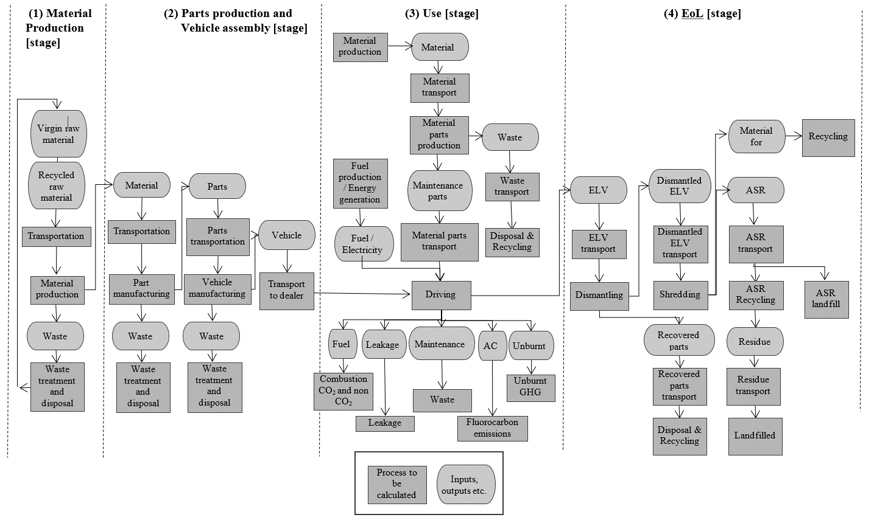

* 1. Infrastructure and capital goods

This section provides rules for infrastructure and capital goods, such as the building in which the product or upstream materials or components are produced, machinery used in the manufacturing of the product or its materials or components, vehicles used for transportation in the product system, the equipment used in the production and supply of energy (e.g. electricity generation equipment), the construction and maintenance of roads and production of charging infrastructure (list without claiming completeness). The applicable infrastructure and capital goods are limited to those that are not consumed and retain their function for a certain period.

In general, the production and end-of-life processes of infrastructure and capital goods used in the product system shall be excluded from the system boundaries. The exception are those infrastructure and capital goods for the production of fuels and for generation of electricity, which should be included by default within the system boundary for the vehicle use [stage] (as is also the best practice adopted by UNECE publications on LCA of electricity generation[[36]](#footnote-37), the GREET model[[37]](#footnote-38), and other models and publications available in different global regions). The general cut-off criteria apply.

Deviations from the above requirements may be possible in the following case:

Infrastructure/capital goods (i.e. also others in addition to those for/resulting from production of fuels and generation of electricity) may be included for any lifecycle phase if a dataset used for A-LCA already includes infrastructure/capital goods, and it is not possible, within reasonable effort, to subtract the data on infrastructure/capital goods from this dataset.

* 1. Land Use Change

[The Indirect Land Use Change (ILUC) can be described as a change in the use or management of land, which is an induced consequence of a direct land use change, but which occurs outside the product system being assessed. The evaluation of the emissions related to the ILUC requires to assess the potential economic impacts induced by increased biofuel demand on commodity prices, and the related shifts in demand and supply across economic sectors, including primarily food and feed production. ILUC cannot be directly measured and is projected with economic models instead. This requires adding consequential element in an LCA methodology, resulting in increasing uncertainties and the potential for arbitrariness. The ILUC emissions, and the spatial dimension of the ILUC effects, are dependent on factors such as local/regional conditions and agronomical practices, regional food import demand and related projections, alternative economic uses of the same feedstock, etc. Given the variability of assumptions underlying the evaluation of indirect effects, quantitative assessment of GHG effects of ILUC is subject to uncertainty and the risk of arbitrary conclusions.

A risk-based approach can be used to take ILUC effects into account. However, the risk-based approach requires to be considered within the framework of sustainability themes.

Conversely, when needed, Direct Land Use Change (DLUC) can be calculated. The DLUC definition can be based on the RED methodology. The DLUC emissions encompass the annualised emissions and sequestration resulting from carbon stock changes in biomass, dead organic matter and soil organic matters, etc.]

Both DLUC and ILUC are already taken into account within LCI provided by some national and regional governments for biofuels. For example, biofuels LCI from the RFS Program in the United States serves as the official source of LCI for biofuels use by light-duty vehicles and engines used in heavy-duty on-road applications. Official, government-provided LCI for biofuels, including treatment of DLUC and ILUC, should be used within national and regional jurisdictions when available.

* 1. Representative vehicle (RV) Determination

Accurately estimating the CFP of vehicles is essential for understanding their environmental impact and guiding efforts to reduce emissions, ultimately contributing to the decarbonisation of the automotive industry.

Vehicles are highly complex products composed of numerous parts manufactured through complex supply chains. Each vehicle’s unique configuration and customisable options make providing and managing LCAs for individual vehicles administratively burdensome for OEMs and but also for authorities. To address this, the methodology introduces the concept of an RV.

In order to ensure comparability of different vehicles /technologies / materials in the automotive industry the compared vehicles ideally should:

1. be calculated with the same functional unit,
2. be of the same vehicle category,
3. have the same body structure characteristics, comparable dimensions (length, width, height, wheelbase) and number of seats in order to ensure a comparable purpose and usability,
4. have comparable powertrain [(drive system)] types and range (if possible)
5. have the same or comparable equipment & configuration considered for the calculation of the ‘test mass’ under the WLTP (e.g. tyre dimensions, ADAS level, trim level).

Accordingly, comparability is a central challenge. For Level 1 and Level 2 LCA studies, different options (vehicles, technologies, powertrains, materials) are compared within one LCA study. In contrast, for Level 3 and Level 4 it is the aim to allow comparability between the individual LCA studies. This comparability requires the practitioner to define an RV .

Level 1 and Level 2 LCAs are mainly conducted to support strategic decisions. It is recommended to model a vehicle which is representative of the considered entity of vehicles / vehicle fleet. Regarding all parameters relevant for the intended research question, it should have generic & average value depending on the availability of the data (e.g. public studies or literature data). For comparison of vehicle LCAs this requires special attention. See the list above.

For level 3 & level 4, the objective is to rationalise the high administrative burden of LCA reporting, while the RV ensures that the selected vehicle accurately reflects the characteristics and impacts of the entire group of vehicles, which is clearly defined. This group of vehicles can be defined based on specific parameters that influence their lifecycle emissions in the upstream, downstream and end-of-life [stages]. By doing so, different types of emissions are considered throughout the entire life cycle.

An ‘RV’ is a benchmark vehicle that reflects the typical characteristics of a defined group of vehicles, allowing for consistent and meaningful environmental impact evaluations. The benchmark vehicle shall be selected in a way that remains representative of the group of vehicles it represents across their lifecycle, promotes the reduction of emissions and energy consumption, and incentivises the use of actual data when possible.

This is in line with the terms of representative outlined by UNECE IWG A-LCA, Article 2.3, “The methodology shall be developed respecting the transparency and consistency. It also shall have balance between the accuracy and the workload considering the complex supply chain of automotive industry”.

This paragraph provides a detailed definition of the RV, which serves as a solid foundation for the calculation of carbon footprint by considering the entire lifecycle of vehicles.

The RV is applicable at Levels 3 and 4 (as described in paragraph ‘‎7.1 Level concept) for reporting purposes (where comparability of results amongst different LCA studies is crucial).

* + 1. RV: Modular Approach

Given the complexity of vehicle production and use, a ‘modular approach’ is adopted for carbon footprint calculation. This involves separately calculating each phase of the vehicle lifecycle, according to the methodology described in paragraph 4, and then combining the results for the given vehicle.

1. Upstream Emissions: These emissions are associated with production, raw material acquisition, and manufacturing, they depend on the production region.
2. Downstream Emissions: These emissions, which occur during the use phase, are well-documented in certified fuel and energy efficiency data. They vary based on the vehicle’s sales region. Consumables and parts used for the scheduled maintenance, according to the manufacturer specifications, are considered.
3. EoL Emissions: These emissions, which occur during the recycling processes, depend on region of sell/use or -recycling
   * 1. RV: Selection

The RV is selected based on [delivery volume information and the highest configuration of a vehicle] within a group of vehicles which is defined based on specific parameters in paragraph ‎7.9.3.1 called “LCA group”.

[To obtain the RV for an LCA group based on the highest expected or known delivery volume within the LCA group, the selection shall be done consistently and be fixed for the time (representative period) when the LCA in the LCA group is performed. Hence, the vehicle with the highest delivery volume is determined once for a LCA group and remains the RV thereafter.

To achieve consistency, actual or estimated delivery volume data shall be chosen based on the following principles.

For an LCA group of vehicles already in serial production but without any LCA reports (i. e. at the phase-in of a reporting legislation), actual sales figures for the respective or former reporting year shall be used to identify the ‘representative vehicle’:

The delivery volume data is used to identify the highest delivery volume of the respective LCA group and if applicable in a subsequent step to identify the powertrain configurations with the highest delivery volume for this vehicle with regard to the powertrain types given in section ‎7.9.3.1. If a powertrain type present in the LCA group is not covered by this selection a further vehicle shall be considered.

For a newly formed LCA group of multiple vehicles at Start of Production (SoP), the first vehicle to go into production defines the representative vehicle of the newly formed LCA group. Depending on the powertrain portfolio of the LCA group further vehicles shall be considered to cover all powertrain types relevant to the respective LCA group. As the rollout of the newly formed LCA group progresses, the selection of the Representative Vehicle may be updated accordingly.

After selecting its base parameters (vehicle, powertrain(s)) if applicable the representative vehicle is configured with in reality offered options until the maximum vehicle weight is reached (worst case). This mass-based method is used instead of delivery volume because it remains consistent despite changing customer preferences and market trends.

Documentation for the choice and configuration of the representative vehicle shall be provided during the third-party certification (see verification paragraph ‎10).

The emissions factors within an LCA group strongly correlate to the mass of the vehicle for a given LCA group, due to similar production characteristics. This selection further decreases deviations when applying the Emissions Factor (EF). Additionally, using the highest delivery numbers in an LCA group increases representativeness of the performed LCA in absolute terms, while equipping the vehicle with options until the maximum vehicle weight is reached (worst case) secures the usage of a technically clear and conservative vehicle setup.

Comparability of LCA classes between different LCA studies can be achieved by checking EFs of comparable LCA groups against each other.]

Important Considerations:

1. If the LCA group includes vehicles with a traction battery, the battery shall be excluded from the calculation of the carbon emissions for upstream & EoL of the individual vehicle as well from the emission factors. This is due to the fact that the capacity of a traction battery and its weight do not have a proportional relationship, which would distort the correlation via vehicle mass. A similar approach should also be adopted for vehicles which have a high-pressure hydrogen storage vessel, for similar reasons.
2. The carbon footprint of the traction battery must be calculated separately. For the calculation of the total vehicle carbon emissions, the carbon footprint of the traction battery shall be subsequently added to the carbon upstream & EoL emission of the vehicle (CFP). A similar approach should also be adopted for high-pressure hydrogen storage vessels.

Once the RV is selected, its carbon footprint is calculated using this Resolution (refer to paragraph ‎8), considering upstream, downstream and ‘EoL’ emissions, in case of powertrain using traction battery the carbon footprint of the traction battery shall be calculated separately.

* + 1. RV: Upstream Emission

Carbon emissions related to upstream emissions should be calculated according to the method described in paragraph ‎8.2.

To determine the upstream emission for RV and upstream emission factor, we need to group vehicles into a ‘upstream [emission group]’ (paragraph ‎7.9.3.1.) and then choose an RV according to paragraph ‎7.9.2.

* + - 1. Definition of Upstream LCA Group

[The main factors that greatly impact the upstream carbon footprint of a vehicle are the body structure, powertrain, energy storage system (only in case this is present in the drivetrain system), [refer to Ricardo[[38]](#footnote-39) & CATARC[[39]](#footnote-40) study] and production region.

Based on these factors, vehicles can be grouped into clusters (Upstream LCA group):

1. Vehicle Structure Family: Means a cluster of vehicles of an automobile manufacturer’s vehicle fleet in which the vehicle has a degree of commonality in technological development level and body construction characteristics, such as in body or chassis design (if applicable), including external dimension span and floor clearance span. Characteristics like vehicle type, model name, brand, marketing division, or roof line, number of doors, seats, windows or level of decor are not relevant for a classification as vehicle structure family.
2. Powertrain (drive System) type: to reflect the impact of the energy storage system/traction system e.g. ICE, OVC-HEV, NOVC-HEV, PEV and FCEV.
3. Region of [final vehicle assembly]: the region is a single market, e.g. Europe, Japan, Korea, US… [For vehicle final assembly in more than one region, the definition of region may be expanded to include additional regional production.]
4. Additional parameters will be declared by the OEMs (with justifications) if required to specify the definition of the LCA group.

If there are shared upstream grouping criteria, a single Life Cycle Assessment (LCA) group can include multiple downstream groups, such as powertrain type families.]

* + - 1. Determination of Upstream Emission factor

In case that CFP values for the vehicles other than the RV need to be declared, the following subchapter will introduce the methodology to estimate the CFP for these vehicles.

The upstream emission factor (UEF), shall be calculated as follows:

(1)

Where;

means the upstream emission factor, [kgCO2eq/kg]

means the upstream carbon emission of the RV, [kgCO2eq];

means the actual mass of the RV (with the accessories & options see paragraph ‎7.9.2), [kg];

In case of powertrain using traction battery the emission factor shall be calculated as follows:

(2)

Where;

means the upstream carbon emission of the RV, [kgCO2eq];

means the upstream carbon emission of the traction battery of the RV, [kgCO2eq];

means the actual mass of the RV (with the accessories & options), [kg];

means the weight of the traction battery of the RV, [kg];

Both and shall be measured on the same RV.

The UEF shall be included in all relevant test reports.

The UEF shall be rounded to 2 points of decimal, the unit of UEF is kgCO2eq/kg.

* + 1. RV: Downstream Emission: In-use

Carbon emissions related to use phase emissions should be calculated according to the method described in paragraph ‎8.3. These emissions are typically derived from certified fuel consumption and energy consumption data, which are included in official homologation documents and regulatory certifications.

* + 1. RV: Powertrain group

As each region or country have their own definition of the powertrain group (e.g. interpolation family approach in EU) it is recommended to use the same powertrain family criteria defined in the ‘fuel and energy consumption regulation’ (see paragraph ‎8.3). In case of WLTP it is defined in UN GTR 15.

* + - 1. Use phase

Each individual vehicle has an ‘energy consumption’ value provided in official documentation (e.g., Certificate of Conformity). Two common approaches to determine downstream emissions are:

1. Interpolation
2. Inertia Class

For representative mass, inertia class defined in the regional fuel consumption regulation must be considered.

Figure 5  
**Explanation of interpolation and inertia approach**

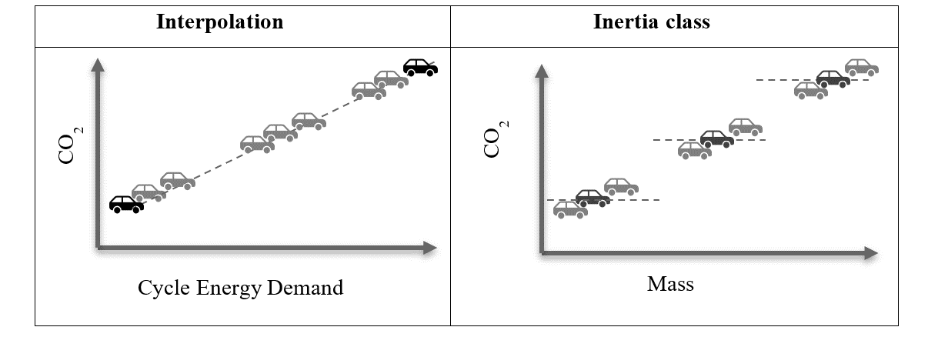

The carbon footprint of a particular type of powertrain and vehicle configuration (mass, aerodynamic, tyre etc.) should be reflected in the selected representative or declared vehicle:

1. In case of ‘interpolation approach’: Individual vehicle configuration of the ‘interpolation family’ should be used as described in the Certificate Of Conformity document.
2. In case of ‘inertia class approach’: Individual inertia class configuration of the ‘powertrain family’ should be used as described in the Certificate Of Conformity document.
   * + 1. Maintenance and leakage

The carbon footprint during the maintenance and leakage does not vary in each powertrain family and hence it is recommended to determine this value for the selected RV of the powertrain family.

* + 1. RV: EoL Emission

EoL emissions encompass carbon emissions generated throughout vehicle collection at the EoL and recycling. Carbon emissions related to EoL emissions should be calculated according to the method described in paragraph ‎8.3.

* + - 1. Definition of EoL LCA group

The main factors that greatly impact the end-of-life carbon footprint of a vehicle is same as that of the upstream phase except the region of recycling. Based on these factors, vehicles can be grouped into clusters (EoL LCA group) according to their common traits such as:

1. All criteria defined for upstream emission except the region of production (see paragraph ‎7.9.3.1)
2. [Expected region of vehicle end-of-life: further expansion of the definition to the region of recycling place is possible]

If the vehicle is produced in the same region as that of expected region of EoL, then both LCA groups Upstream and EoL are the same.

* + - 1. Determination of EoL Emission factor

The EoL emission factor, EEF, shall be calculated as follows:

(3)

Where;

means the EoL emission factor, [kgCO2eq/kg];

means the EoL carbon emission of the RV, [kgCO2eq];

means the actual mass of the RV (with the accessories & options, see paragraph ‎7.9.2), [kg].

In case of powertrain using traction battery the emission factor shall be calculated as follows:

(4)

Where;

means the EoL carbon emission of the RV, [kgCO2eq];

means the EoL carbon emission of the traction battery of the RV, [kgCO2eq];

means the actual mass of the RV (with the accessories & options), [kg];

means the weight of the traction battery of the RV, [kg];

Both and shall be measured on the same RV.

The EEF shall be included in all relevant test reports.

The EEF shall be rounded to 2 points of decimal, the unit of EEF is kgCO2eq/kg.

* + 1. RV: Total carbon footprint

The total carbon footprint of a vehicle is the sum of:

1. Upstream Emissions (see paragraph ‎7.9.3)
2. Upstream Emissions: Traction Battery Emissions (if applicable)
3. Downstream Emissions: use phase energy consumption and maintenance (see paragraph ‎7.9.4)
4. End-of-Life Emissions (see paragraph ‎7.9.6)
5. End-of-Life Emissions: Traction Battery Emissions (if applicable)
   * 1. RV: Carbon footprint value for ‘Declared vehicle ‘

The selected RV (see paragraph ‎7.9.2) should serve as the baseline for estimating the carbon footprint for the values of the other vehicles, if a declaration is required. These vehicles and the RV shall be members of the same [emission group].

The Emission Factors (UEF & EEF) (i.e. carbon emission per kilogram of vehicle weight) is calculated by the ratio between the carbon emissions (upstream & EoL) of the RV and its weight (excluding the weight of the traction battery).

Figure 6  
**Explanation of baseline approach**

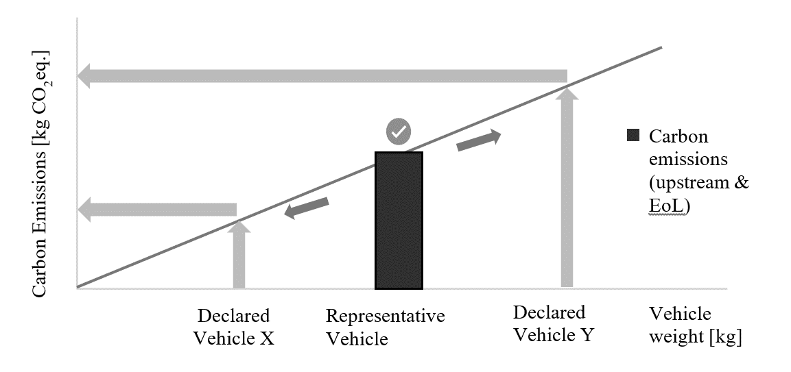

UEF & EEF are describing the correlation between vehicle mass and the CFP value of the RV, as illustrated in Figure 6.

The correlation of CFP value according to the ‘RVs’, should be allowed both below and beyond the mass of the RV,

The carbon emission of the declared vehicles, which belong to the same [emission group], can be estimated using the EF & the weight of the evaluated vehicle.

The definition of the RV & the Declared Vehicle is considered as follow:

1. the “RV” is the one for which to perform the precise and detailed carbon footprint calculation to determine the emission factors for the upstream- & EoL emission.
2. the [“declared vehicle”] is the vehicle for which to calculate the carbon footprint based on the emission factor of its [emission groups] (according to paragraph ‎7.9.8.1.).
   * + 1. Estimated value for the declared vehicles

The upstream emission for the declared vehicles within the same LCA group is estimated using the following formula:

(5)

Where;

means the upstream carbon emission of the declared vehicle, [kgCO2eq];

means the emission factor, [kgCO2eq/kg];

means the actual mass of the declared vehicle (with the accessories & options).

For vehicles with traction batteries:

(6)

Where;

means the carbon emission of the traction battery, [kgCO2eq];

means the weight of the traction battery, [kg];

The downstream emission for the declared vehicles (compare paragraph ‎7.9.5.1)

The EoL emission for the declared vehicles within the same LCA group is estimated using the following formula:

(7)

Where;

means the EoL carbon emission of the declared vehicle, [kgCO2eq];

means the EoL emission factor, [kgCO2eq/kg];

means the actual mass of the declared vehicle (with the accessories & options).

For vehicles with traction batteries:

(8)

Where;

means the EoL carbon emission of the traction battery, CO2eq, [kg];

means the weight of the traction battery, [kg];

* + - 1. Steps to determine carbon footprint value of the ‘declared vehicle’
         1. Step 1 : initial step to define and calculate the carbon footprint of the RV

1. Step 1.1: Define the ‘upstream LCA Group’ (see paragraph ‎7.9.3.1.)
2. Step 1.2: Define an RV out of the defined ‘upstream LCA group’ (see paragraph ‎7.9.2.)
3. Step 1.3: Calculate the upstream carbon footprint of the RV (excl. traction battery)
4. Step 1.4: Calculate the Emission Factor (EF) of the ‘upstream LCA group’ (see paragraph ‎7.9.3.2.)
5. Step 1.5: Add upstream carbon emission of traction battery if available
6. [Optional] – Step 1.6: Calculate the upstream carbon footprint of declared vehicle (see paragraph ‎7.9.8.1)
   * + - 1. Step 2: downstream carbon footprint (depend on cycle energy demand in WLTP and mass for inertia approach)
7. Step 2.1: Check which interpolation family or inertia class the ['defined vehicle'] belongs to.
8. Step 2.2: calculate downstream emission (considering service life, deterioration factor etc.) (see paragraph ‎7.9.4.)
9. Step 2.3: calculate the carbon emission related to leakage & maintenance (see paragraph ‎7.9.5.2.)
   * + - 1. Step 3: EoL carbon footprint (depend on mass)
10. Step 3.1: Define the ‘EoL LCA group’ (see paragraph ‎7.9.6.1.)
11. Step 3.2: Calculate the EoL carbon footprint of the RV (excl. traction battery)
12. Step 3.3: Calculate the EoL Emission Factor (EEF) of the ‘EoL LCA group’ (see paragraph ‎7.9.6.2.)
13. Step 3.4: Add EoL carbon emission of traction battery if available
14. [Optional] – Step 3.5: Calculate the EoL carbon footprint of declared vehicle (see paragraph ‎7.9.8.1.)
    * + - 1. Step 4: total carbon footprint

Total carbon footprint = Upstream carbon footprint + Downstream carbon footprint + EoL carbon footprint

* 1. Environmental impact category and indicator

The calculation of the CFP shall include [non-CO2 GHGs].

The GHGs to be included shall be considered with reference to the latest IPCC Assessment Report. The potential climate change impact of each GHG emitted and removed by the product system shall be calculated by multiplying the mass of GHG released or removed by the 100-year GWP given by the IPCC in units of kgCO2eq per kg emission.

Where GWP values are amended by the IPCC, the latest values shall be used in the calculations. For example, once IPCC releases a new Assessment Report, the GWP100 values shall supersede those of the previous Assessment Report. In any case, there should be a clear statement by the LCA practitioner regarding which AR is used. All life-cycle [stages] include fuel and energy cycle. For reference, the AR6 characterisation factors for the substances that are not listed in case of AR6 in Table 7.15 of the IPCC AR6 shall be extracted from Table 7 SM6 in Section 7 Supplementary Materials of the AR6 Climate Change 2021.

* 1. Inclusion of specific GHG emissions and removals

Biogenic GHG emissions and removals shall be calculated in an A-LCA study and be expressed separately.

All relevant unit processes of the life cycle of biomass-derived products shall be included in the system under study, including, but not limited to, cultivation, production and harvesting of biomass.

A product’s biogenic carbon content shall be calculated and documented separately in the CFP study report. In addition, the biogenic carbon content and total carbon content of products shall be reported separately. If mass-balanced materials are used in the supply, the attributed biogenic carbon content shall additionally be reported to accurately account for emissions from combustion of these materials.

Specific emission values shall be reported as follows (see Figure 7):

1. Net fossil GHG emissions and removals (de-dr)

2. Net biogenic GHG emissions and removals other than biogenic CO2 (if applicable, (be-br))

3. Net biogenic GHG emissions and removals including biogenic CO2 (if applicable, (ce-cr))

4. GHG emissions resulting from aircraft transportation (if applicable, a)

5. Biogenic carbon content (if applicable, f)

6. Total carbon content (g)

If separate emission values do not occur, these emission values may be reported as zero.

Removals in the CFP shall not include any measures not related to the product system, usually referred to as carbon offsets.

Figure 7  
**Illustration of the reporting for specific GHG emissions**

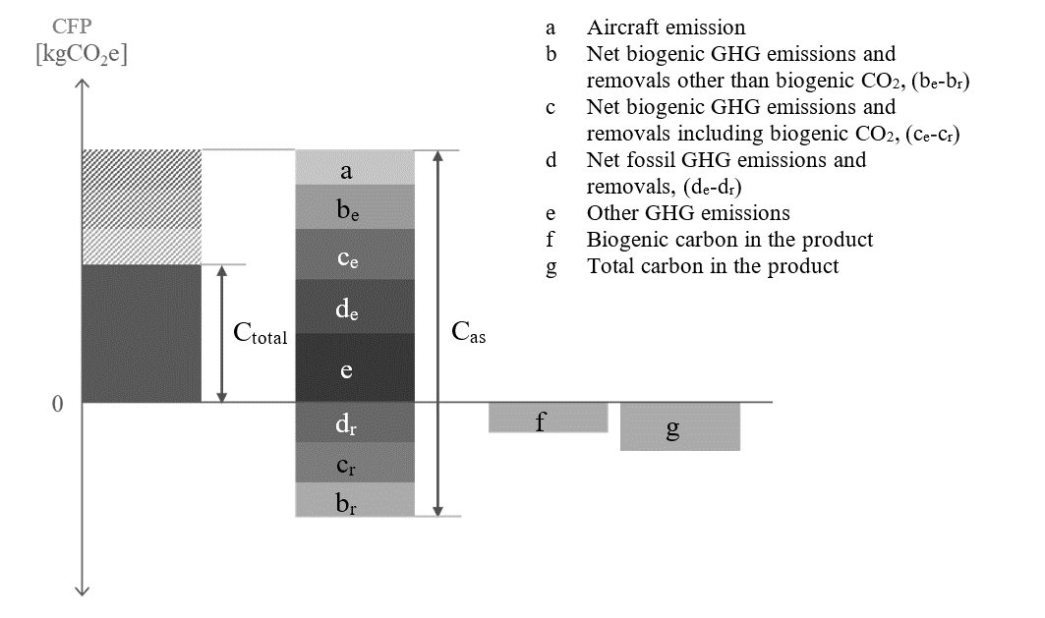

* 1. Data collection requirements and data types

Primary data is a quantified value of a process, or an activity obtained from a direct measurement, or a calculation based on direct measurements. Primary data can include greenhouse gas emission factors and/or greenhouse gas activity data.

Average data from industry associations or global averages do not qualify as primary data.

Primary data may be obtained through meter readings, purchase records, utility bills, engineering models, direct monitoring, material or product balances, stoichiometry or other methods for obtaining data from specific processes in the value chain of a company.

Primary data include primary activity data, i.e., a technical flow, and primary GHG emission factor, i.e., the carbon footprint of the corresponding activity expressed in kgCO2eq per unit (see Table 2  
Types of primary data).

Secondary data do not fulfil the requirements for primary data. Secondary data can include data from databases and published literature, prospective emission factors from national inventories, calculated data, estimates or other representative data, validated by competent authorities. Secondary data can include data obtained from proxy processes or estimates.

[Table 2  
**Types of primary data**

|  |  |  |  |  |  |
| --- | --- | --- | --- | --- | --- |
| Approach | Direct emission measurement | | | | |
| Primary data | Source of emission is within company boundaries and is measured | | | | |
| Approach | Activity data source | | x | Emission factor source | |
| Energy | Material/Product | Energy | Material/Product |
| Primary data | Consumption measured or invoiced (primary) | |  | On-site energy production emission factor  Or energy supplier-specific emission factor | Emission factor quantified and shared by supplier |

]

Requirements regarding data collection and data types (primary or secondary) are given for each life cycle [stages] in dedicated paragraphs (see paragraph ‎8.1. - ‎0.).

* + 1. Data quality

Data selection should follow data quality requirements outlined in ISO 14044:2006 (see sec. 4.2.3.6 of ISO 14044:2006) including:

* + - 1. Temporal representativity:

The data collection period must correspond to the activity data that is most relevant to the process.

For retrospective data emissions shall by default be reported averaged over the period of one year (reporting or calendar year) to avoid seasonal fluctuations and e.g. reflect typical production and operation conditions. Shorter periods may be considered if data on a full year are not yet available. Longer averaging periods may be considered but shall not exceed three years. Any averaging period deviating from the default shall be flagged and justified.

* + - 1. Geographical representativity:

The geographical location of data collection must correspond to the activity data that is [most] geographically relevant to the process.

For material, parts and vehicle production emissions shall be reported as geographically specific as possible by default (e.g. on the plant level). Averaging over a region or country may be considered but shall be flagged as such.

* + - 1. Technological representativity:

The data shall be collected/selected for processes that technologically correspond or are [most] representative to the processes of the activity.

* + - 1. [Completeness:

The data selection shall include all processes and flows that are attributable to the analysed system. Cut-offs (see paragraph ‎7.13) apply.]

* + - 1. Consistency:

The data selection shall ensure uniform application of the methodology to the various components of the analysis.

* + - 1. Traceability:

The source of data used in a study shall be documented.

Primary data are to be prioritised if available, otherwise secondary data shall be used.

Specific details on data quality requirements are provided for individual life cycle [stages] in paragraphs ‎8.1.

* + 1. Primary data share

To create visibility on the share of primary data in CFP calculations for vehicle product, a primary data share (PDS) indicator can be defined. The PDS is the proportion (percentage) of a (partial) CFP that is derived from primary data.

A CFP calculation might include both primary, secondary data and a mix of both expressed by the primary data share. For example, calculating emissions from the consumption of electricity could involve primary activity data, such as data on consumption in kWh, multiplied by a secondary emission factor in CO₂eq per kWh. [The combination of a measured consumptions (primary) and a secondary GHG emission factor or vice versa is reflected in the primary data share calculation by an attribution factor of 50%. ]

Reporting of a PDS is relevant in case of detailed supply chain and vehicle modelling. Therefore, the PDS shall be determined and communicated for material production [stage] (paragraph 4.1), and parts production and vehicle assembly [stage] (paragraph 4.2) and may optionally be determined and communicated for use (paragraph 4.3) and end of life phases (paragraph 4.4). [Reporting primary data is an important aspect of Level 4 and partially Level 3 and limited to these levels (for application on Level 3 refer to paragraphs 4.2.1.3 and 4.2.4).]

[The PDS is reported for the total CFP (Ctotal) only.] To ensure that a consistent PDS can be reported no matter if reporting is done stepwise or collectively for multiple steps, the percentage of the primary data shall relate to the absolute sum of all positive or negative CFP contributions (Cas). The positive or negative CFP contributions (Ci) are to be understood as intermediate summands to the total CFP, which reflects the partial CFP contributions. Figure 8 illustrates the definition of Cas.

(9)

|  |  |  |  |
| --- | --- | --- | --- |
| *Contribution* | *CPFi* | *Ctotal,i* | *Cas,i* |
| a | 1.00 | 1.00 | 1.00 |
| b | 1.50 | 1.50 | 1.50 |
| c | 2.00 | 2.00 | 2.00 |
| d | -1.00 | -1.00 | -1.00 |
| e | -0.75 | -0.75 | -0.75 |
| **Results** |  | **2.75** | **6.25** |

Figure 8  
**Definition of CFPas**

e

d

c

b

a

Result

Contribution

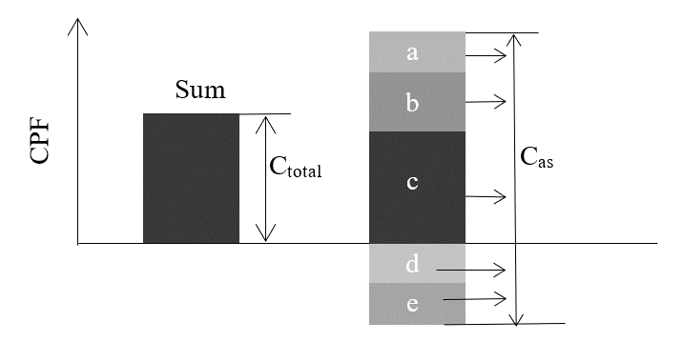

In case there are no negative CFP contributions Ctotal is equal Cas. [In case Cas is not yet reported Ctotal shall be used instead.] Having introduced Cas the primary data share is defined:

(10)

The aggregated primary data share for multiple CFP contributions reported with individual PDS (PDSi)

(11)

As an example, three suppliers, Company A, Company B and Company C, provide parts to Company D. Each part has a different primary data share and contribution to the total CFP valueof the product of Company D (Figure 9). According to formula above, the primary data share of Company D’s part is calculated from the primary data share and contributions to the absolute value total CFP (Table 3).

Figure 9  
**Cascading PDS**

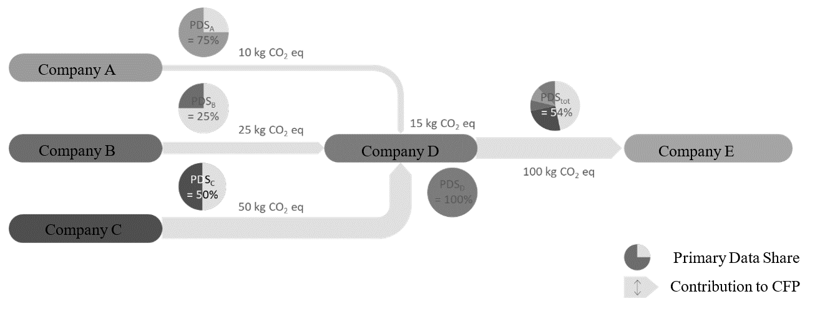

Table 3  
**Primary data share of the example as in Figure 9**

|  | *PDSi* | *Ctotal,i* | *PDS Contribution* |
| --- | --- | --- | --- |
|  |  |  |  |
| Company A | 75% | 10 | 75% \* 10 = 7.5 |
| Company B | 25% | 25 | 25% \* 25 = 6.3 |
| Company C | 50% | 50 | 50% \* 50 = 25 |
| Company D | 100% | 15 | 100% \* 15 = 15 |
| **Total** | **54%** | **100** | 54 , (7.5 + 6.3 + 25 + 15) |

[Data shall only be considered as primary data if declared as such in percentage of primary data share. Only product or company-specific data may contribute to the primary data share.

Note: When a product with a high PDS in the supply chain (e.g., the product of Company A in Figure 9) is decarbonized through carbon reduction measures, the PDS of the final product (e.g., the product of Company D in Figure 9) may rather decrease as a result of the lowered total CFP. Therefore, while the PDS can be an indicator of the primary data usage, it shall be considered only in conjunction with the total CFP value.]

* 1. Cut-off rule

In general, all processes and flows that are attributable to the analysed system shall be included. The analysed system can be the complete product to which the functional unit is associated, (e.g. a passenger car,) but also a subsystem (component, part) to the product or an individual life cycle [stage] that contributes additive to the life cycle GHG emissions of the final product. For practical reasons (see ISO 14067, PEF method), process modules, inputs and outputs may only be excluded if their sum represents less than [3]% of the GHG emissions of the analysed system. It is not permitted to cut-off an entire life cycle [stage], even if that falls below the threshold value. GHG emission reported from upstream entities shall be regarded as correct and complete and may not be subject to any further cut-off. A documentation shall be provided to give evidence that the cut-off criterion is met, and which cut-offs were applied. The documentation can be given in the form of a screening analysis.

Compliance with the cut-off threshold value can be proven on a product category or sectoral level and does not have to be executed on a product level. Product category rules or sectoral guidelines can lay down simplified rules for the evidence to be provided.

* 1. Screening Analysis

A screening analysis ensures that cut-offs in total do not exceed a threshold value of the GWP impact.

The screening shall allow further refinement of the LCI and the associated emission factors of the system in scope in an iterative manner. Within screening, no exemption of flows is allowed, and readily available primary or secondary data may be used. If data, such as emission factors, activity data, or measurements are unavailable or challenging to identify, it is essential to find the most appropriate data or proxy emission factors, in case of doubt a conservative choice shall be taken. Emission factors or activity data received from upstream reporting entities shall be regarded as correct and complete. The scope of the final screening iteration shall be documented to inform on the cut-offs and prove compliance with the cut-off threshold value.

* 1. Energy modelling
     1. Fuel modelling

The definition of emission factors for fuels follows the methodology outlined in the EU Renewable Energy Directive 2018/2001 and other systems such as the U.S. EPA Renewable Fuel Standard and shall include:

1. Upstream processes referring to the extraction or cultivation of raw materials.
2. Processes related to the fuel’s processing.
3. Transport and distribution processes at each life cycle [stage].
4. Emissions from the fuel in use.

Additionally, concerning fuels originated from bio-materials, the following conditions shall be considered;

1. Additional emissions related to changes from soil carbon stock caused by land-use change.(e.g. wetlands conversion, some specific forest areas, etc.).
2. Emission savings from soil carbon accumulation via improved agricultural management (e.g. shifting to reduced or zero-tillage, using cover crops, etc.), CO2 capture and geological sequestration, and CO2 capture and replacement.

In the case of one or more other products (co-products, e.g. sugar beet pulps, Distillers Dried Grains with Solubles), allocation shall be determined in proportion to the energy content of the products, determined by lower heating value in the case of co-products other than electricity and heat, or other allocation methods using the allocation method hierarchy in ISO 14040:2006; or developed for national programs, for example the U.S. Renewable Fuels Standards (RFS). The co-product method used in a study should be transparently presented in the study report, and sensitivity analysis should be conducted with alternative allocation methods for impacts of allocation method choices.

* + 1. Electricity modelling

Two main approaches exist for modelling electricity consumption by a product system: the location-based approach and the market-based approach.

(a) The location-based approach is a method of allocating electricity impacts among end-users based on geographical representativeness (economic area, country, bidding zone , etc.); this approach is currently the most commonly used by LCA practitioners, with main LCA databases offering detailed models at a relatively fine geographic scale. The same average profile per kWh is applied to all electricity consumers within a single grid. The GHG Protocol defines it as follows: “A location-based method reflects the average emissions intensity of grids on which energy consumption occurs (using mostly grid-average emission factor data).”

(b) The market-based approach allocates electricity impacts among end-users based on a principle of individual contractual instruments, which can be claimed by different consumers. This approach seeks a more precise accounting of the environmental impacts of energy choices made by companies and consumers. The GHG Protocol defines it as follows: “A market-based method reflects emissions from electricity that companies have purposefully chosen (or their lack of choice). It derives emission factors from contractual instruments, which include any type of contract between two parties for the sale and purchase of energy bundled with attributes about the energy generation, or for unbundled attribute claims.”

Development of electricity emission factors shall be based on ISO 14067:2018 and shall include upstream processes and production of electricity generation infrastructure for the electricity supply system (e.g. mining of fuels, transport of fuels to power plants, growing and processing of biomass fuel feedstock, and production of equipment generating renewable energy, such as photovoltaic installations).

[The inclusion of such upstream elements should be prioritised for those components that have been shown to contribute significantly to the emissions of the specific technology (e.g., it is established that the embodied emissions of photovoltaic solar panels may significantly contribute to the gCO2eq/kWh of that pathway’s electricity). ]

Details about infrastructure/capital goods for production of fuel or electricity, must be referred to paragraph ‎7.7

1. Processes related to electricity generation, including losses during transmission and distribution
2. Downstream emissions (e.g. treatment of waste arising from the operation of nuclear electricity generators or treatment of ashes from coal -fired electricity plants)

Where possible, the generator specific emission factor for the consumed energy shall be applied. Otherwise, if information on supplier-specific electricity is not available, GHG emissions associated with the respective electricity grid by which the electricity is provided shall be used. The respective grid shall reflect the electricity consumption of the related region, ,

In addition to data based on the average electricity mix of a country or region, specific electricity generation mix data can be used if all of the conditions described in paragraphs ‎7.15.2.1 to ‎7.15.2.4 are met.

* + - 1. Electricity from the grid via a contractual instrument

Electricity data from electricity certificates for a specific generator site or supplier documented by energy certificates may be used in the calculation of emission factors for electricity supplied from the grid if it can be ensured that all the following conditions are met.

1. Information on the unit of electricity is provided, together with the characteristics of the electricity generator.
2. It is guaranteed to be a unique claim.
3. Tracking, redemption, depreciation, cancellation, etc., of the certificate is carried out by the reporting company. For the same year that electricity was produced within the country, or within the market boundaries where consumption occurs and to which the grid is interconnected

In ISO 14067:2018, there are examples of certificates that can be used by contractual instruments, such as European Guarantee of Origin (GOs) and US Renewable Energy Certificates (RECs) which meet the above conditions. Electricity certificates that do not guarantee compliance with the above conditions shall not be used. Contractual instruments may include utility tariffs, power purchase agreements (PPAs) or energy attribute certificates (EACs) themselves.

Notes on handling power certificates

In order to use electricity certificates in this guideline, their reliability and traceability must be ensured, and it must also be guaranteed that double counting does not occur in LCA calculations. Therefore, in addition to ensuring that electricity certificates meet the above requirements, the following must be ensured in LCA calculations that use electricity certificates:

1. The environmental value of electricity certificates must not be biased;
2. There is no double counting with grid electricity (the LCI data for grid electricity uses the residual mix, excluding the value of the electricity certificate. If no residual mix is available, the fossil generation mix for the respective grid shall be used);
3. [Mixing location-based and market-based modelling shall be avoided within one life cycle [stage] of an LCA];
4. Information about the electricity certificate is clearly stated in the LCA report.

The electricity certificate should be accompanied by the following information:

1. Name and location of the generating facility;
2. Method of generation;
3. Amount of electricity generated and amount of electricity certificates issued;
4. If available, tracking number assigned by the electricity certificate system.

When a practitioner choose Market based approach with any kinds of Certifications of electricity, the condition in below should be met…

Conditions for Market-based approaches

The market-based approach for electricity may be used only when the supplier is able to guarantee through a contractual arrangement that the electricity product:

1. conveys the information associated with the unit of electricity delivered;
2. is assured with a unique claim, to avoid double-counting of GHG emissions and GHG removals within the boundary of the subject;
3. is tracked and redeemed, retired or cancelled by, or on behalf of, the reporting entity;
4. is produced as close as possible to the period to which the contractual instrument is applied and comprises a corresponding timespan;
5. is produced within the country, or within the market boundaries where consumption occurs if the grid is interconnected.

If processes within the subject are located in Small Island Developing States (SIDS)[3)], the carbon footprint may additionally be quantified using contractual instruments for such processes, irrespective of grid interconnectivity.

[The entity shall document in the carbon neutrality management plan its plans to improve the efficiency of electricity use of the subject and report actions that have been taken to implement such activities.

The entity should consistently apply the selected approach in subsequent carbon neutrality reports. If the entity changes its selected approach in subsequent reporting periods, it shall reflect this change in the carbon neutrality management plan, including a recalculation of the baseline, and make it transparent in the carbon neutrality report.]

To promote the development of additional renewable energy capacity, entities should apply the following sourcing hierarchy:

(a) self-generation or physical power purchase agreements with direct line connections;

(b) financial power purchase agreements from renewable sources;

(c) contractual instruments from a generation facility no older than 15 years.

Note 1 Contractual instruments are any type of contract between two parties for the sale and purchase of energy bundled with attributes about the energy generation, or for unbundled attribute claims. This can include energy attribute certificates (EACs), renewable energy certificates (RECs), guarantees of origin (GOs), power purchase agreements (PPAs), green energy certificates or supplier specific emission rates.

Note 2 The market-based approach is a method to quantify the indirect emissions from energy of a reporting organisation based on GHG emissions emitted by the generators from which the reporting organisation contractually purchases electricity bundled with contractual instruments, or contractual instruments on their own.

Note 3 The location-based approach is a method to quantify indirect emissions from energy based on physical delivery of energy, using average energy generation emission factors for defined geographic locations at a national or sub-national level.

Note 4 Using biofuels or other bio-based materials based on contractual instruments can result in GHG emissions reductions. These market-based approaches involve a separate certification process, which includes use of contractual arrangements that:

1. convey the information associated with the unit of fuel or materials delivered;
2. are assured with a unique claim, to avoid double-counting of GHG emissions and GHG removals within the boundary of the subject;
3. are tracked and redeemed, retired or cancelled by, or on behalf of, the reporting entity.

Detailed conditions shall be based on ISO 14068 -1:2023.

* + - 1. Electricity from a directly connected supplier

Site-specific electricity data may be used in the calculation of emission factors for electricity supplied directly from electricity generators via dedicated transmission lines to facilities manufacturing the respective products and consumed in the manufacture of such products, if no contractual instruments have been sold to a third party.

* + - 1. On-site generated electricity

Site-specific electricity data may be used in the calculation of emissions factors for on-site electricity generated and consumed on the premises where the respective product is produced, if no contractual instruments have been sold to a third party.

* + - 1. Grid Mix and On-Site Electricity Production:

On-site electricity production can only be accounted for under the following conditions:

1. The production asset is owned by the same entity as the factory, or the asset has a direct connection to the factory and is not connected to the grid.
2. Only the fraction of electricity that is used on-site and not sourced from the grid shall be accounted for.
3. No credits can be claimed for electricity produced in excess and sent to the grid.

Any deviation, along with detailed explanations of the calculation methods or models used to revise emission factors, must be reported in the LCA report

* + 1. Future Changes in Energy Mix

Practitioners shall also account for any potential changes in the fuel or electricity production pathways during the lifetime of the vehicle. (Detailed methodology is provided in paragraph 4.3.5.)

For any prospective LCA, secondary data will be needed. Secondary LCI data should be sourced from data sets provided directly by government authorities. If such data is not available, region-specific secondary data from IEA should be used.

1. Including LCI from regulatory authorities will thus include relevant statutes and regulations under implementation that impact the sector within a specific country or region and within a specified timeframe.
2. When using IEA data, specific sensitivities from the IEA should also be used

The scenario shall also be explained in the final report. Details must be referred to in the “Reporting” section.

* 1. Allocations

In case a process has more than one output, the question how to allocate the CO2eq-burden to the outputs arises. Outputs of a process can be viewed as products, co-products or waste. Products or co-products share the CO2eq-burden of the production/generation process, whereas waste eventually increases the CO2eq-burden for the product. In a first step the question: ‘Is this a waste or a product?’ must be answered (see Figure).

Figure 10  
**Product, Co-Product or Waste**

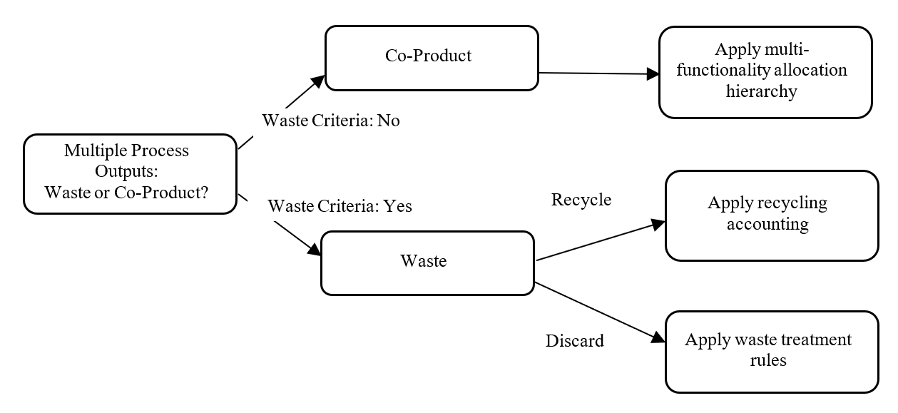

* + 1. Waste vs Co-product

Waste is any material or process output which is not deliberately produced as an integral part of a multi-output production process. No further use of the material or process output is certain. Additionally, the holder discards or intends to discard or is legally required to discard the residue based on national waste legislation.

Waste materials with certain further use but requiring further treatment other than normal industrial practice before use (i.e., waste recovered by recycling) shall follow the requirements on material recycling.

“Normal industrial practice” can include all steps which a producer would take for a product, such as the material being filtered, washed, or dried; or adding materials necessary for further use; or carrying out quality control. However, treatments usually considered as a recovery operation cannot, in principle, be considered as normal industrial practice in this sense. Some of such processing tasks considered as normal industrial practice can be carried out on the production site of the manufacturer, some on the site of the next user, and some by intermediaries, as long as they also meet the criterion of being ‘produced as an integral part of a production process’ (adopted from the EU’s Guidance on the interpretation of key provisions of Directive 2008/98/EC on waste[[40]](#footnote-41)).

A co-product in contrast is produced as an integral part of a multi-output process where its further use is certain. Typically, co-products directly replace a raw material or fuel without requiring further processing other than normal industry practice. For co-product allocation, multi-output allocation applies (please refer to paragraph ‎7.16.2.).

The following hierarchy shall be applied (please refer to ‘Guidance on the interpretation of key provisions of Directive 2008/98/EC on waste’39 for definitions of the respective criteria):

Figure 11  
**Waste vs. co-product classification hierarchy**

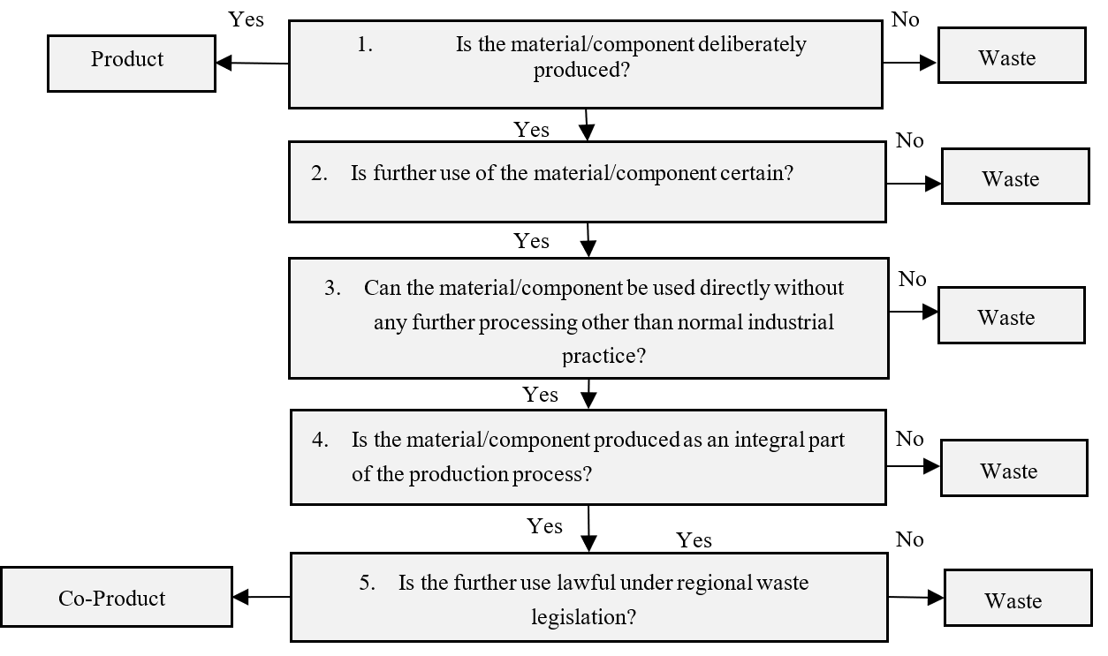Note: This is based on EU Waste Framework Directive

Residues classified as waste following the hierarchy can also be transformed into recycled feedstock. However, this transformation would require further processing other than normal industry practice (see point 3 in Figure 11), such that the residue would be classified as waste in the first instance.

Pre-consumer scrap that is not reintroduced into the same process (i.e., all scrap except run-around scrap) shall be defined as waste unless legal evidence (following legislation of the region where scrap is generated, e.g., legal judgement or legal report from regional waste legislation) exists that classifies the pre-consumer scrap material as co-product.

* + 1. Multi-output allocation

Allocation shall be avoided whenever possible. If allocation cannot be avoided, follow the approach in Figure 12.

Figure 12  
**Multi-output allocation decision procedure**

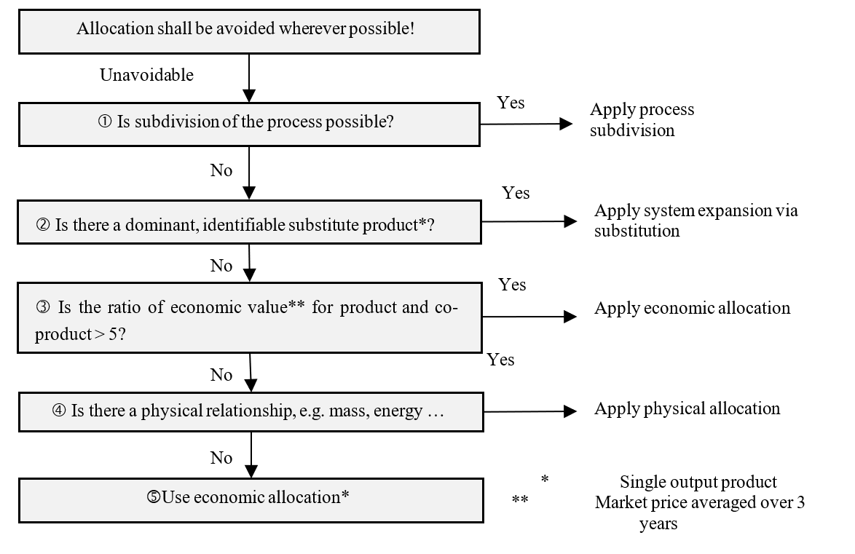

* + - 1. If allocation cannot be avoided and subdivision is possible, subdivision shall be applied. Subdivision refers to disaggregation of multifunctional processes or facilities to isolate the input flows directly associated with each process or facility output.
      2. If subdivision cannot be applied, but a dominant substitute product can be identified, expanding the product system to include the additional functions related to the co-products shall be applied. System expansion via substitution shall only be used if no new multi output allocation is introduced.

System expansion via substitution should only be used if there is a dominant, identifiable displaced product and production path for the displaced product based on sector consensus. Dominant means that the production process is the main process on the market. If available, positive lists of co-products and displaced products based on sector consensus shall be used to model the system expansion and the respective substitution credits. For the emissions data, primary data shall be used, and secondary data may only be used if primary data is not available. In case of secondary data, the requirements in paragraph ‎7.12 shall apply to guarantee that the dataset and source for calculating system expansion credits are compliant. If no sector consensus exists, the following requirements shall always be fulfilled:

1. The production of the co-product is an integral part of the production process;
2. A dedicated, single-output process to produce the co-product exists;
3. The alternative dataset must be representative of the dominant production route;
4. A clear description of the process for selecting the alternative product substituted by the co-product shall be documented.

Double counting shall be avoided. No market-mediated effects shall be applied, as the attributional LCA approach shall be used.

* + - 1. When allocation cannot be avoided, no subdivision is possible and no dominant substitute product can be identified, LCA-practitioners shall calculate the ratio of the economic value of the reference product to each co-product per declared unit. This ratio is employed in the next step of the decision tree to determine the most suitable allocation approach. For the use of economic values, sales prices shall be averaged over the last 3-5 years to smooth out fluctuations. If sales prices are not available or not applicable, other economic factors can be applied (e.g., cost).
      2. If the calculated [economic value ratio is equal to or lower than five][If physical relationships are not used, the validity of the allocation method used in the study should be demonstrated], companies shall apply allocation using a physical relationship to partition inputs and outputs between the studied co-product(s). The physical relationships to choose from are:

1. produced masses;
2. produced pieces;
3. contained exergy;
4. contained energy.
   * + 1. If the calculated ratio is higher than five, companies shall apply an economic allocation using economic value as criterion to partition inputs and outputs between the studied co-product(s).

For the determination and use of economic allocation factors, the following hierarchy shall be applied. Only one type of economic allocation factor shall be chosen consistently in the order of priority of the hierarchy. Only if the respective prioritised factor is not available, the next factor in the hierarchy may be chosen. The chosen factor shall always be averaged over the last multiple years to smooth out fluctuations. A period of 3-5 years is recommended, and a systematic approach should be internally documented for materials with high fluctuations of the selected factor of price/ cost.

1. Global market price (global market prices are usually only available for commodities);
2. Regional market price;
3. Other economic allocation factors (i.e., production costs or sales price).
   1. [Chain of custody]

The LCA methodology guidelines for automobiles assume that the inputs (input resources), outputs (products), and processes are not each a single system, but a complex system with multiple inputs and outputs. In a complex system, it is necessary to introduce the concept of Chain of Custody to increase the transparency and reliability of allocation of product characteristics.

Chain of Custody models are classified into the following five categories according to the definitions of ISO 22095 (Table 4, Figure 13).

Table 4  
**Chain of Custody Models**

| *Input/Output Relation* | *Identity preserved* | *Segregated* | *Controlled blending* | *Mass balance* | *Book and claim* |
| --- | --- | --- | --- | --- | --- |
|  |  |  |  |  |  |
| All input characteristics translate unchanged to output characteristics | ✓ | ー | ー | ー | ー |
| Mixing of inputs from different sources | ー | ✓ | ✓ | ✓ | (✓) |
| Output characteristics reflect the average of input flow characteristics | ✓ | ー | ✓ | ー | ー |
| Physical connection | ✓ | ✓ | ✓ | ✓ | ー |

Figure 13  
**Overview of chain of custody models**

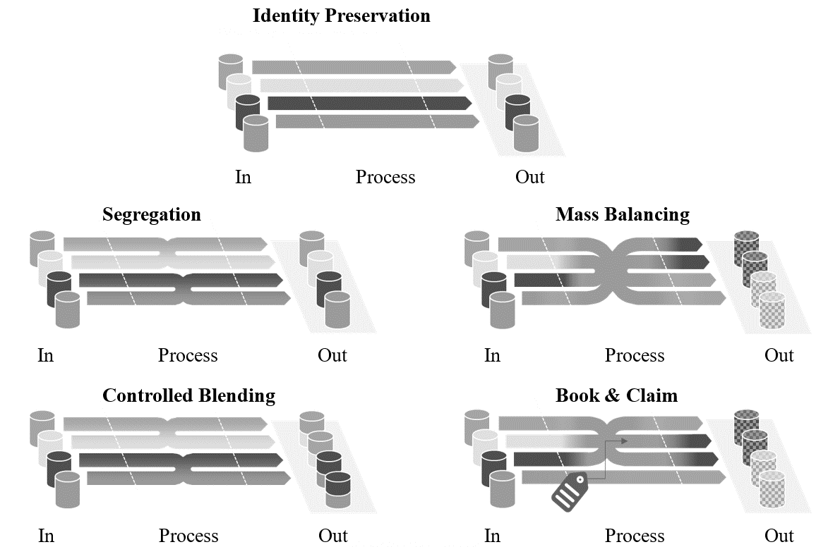

From the five Chain of Custody models, two shall meet specific requirements when applied in LCAs for automobiles: “Mass balance” and “Book and Claim” (Table 5). In LCA of automobiles, only clearly product-related Chain of Custody Models may be used. Book and Claim may only be applied to energy carriers such as electricity, fuels, and biomethane.

Table 5  
**Requirements for the use of Mass balance and Book and claim**

| *Requirement* | *Mass balance* | *Book and claim* |
| --- | --- | --- |
|  |  |  |
| Physical connection between input and output | ✓ | ー |
| Separation of flow and  flow characteristic | ー | ✓ |
| Boundary for accounting: Same product system | ✓ | ✓ |
| Defined accounting period | ✓ | ✓ |
| Traceability (Physical or certificates) | ✓ | ✓ |
| Certification scope within company operations | ✓ | ー |
| Certification scope beyond company operations (tracking and cancellation of certificate) | ー | ✓ |

Guiding principles and requirements

In implementing chain-of-custody methods, including mass balancing/book and claim, the following set of guiding principles shall be fulfilled:

1. The use of chain-of-custody approaches shall achieve significant changes and an effective transition towards a more circular, more bio-based and lower GHG emissions production in complex value chains.
2. The choice and implementation of chain-of-custody approaches and models shall be transparent, clear, credible, and verifiable – abiding by relevant standards such as ISO.   
   Proof must be submitted by the organization using the certificate.
3. Labels and claims referring to chain-of-custody controlled specified characteristics and used on products shall fulfil the following requirements:
4. description of the chain-of-custody approaches and models
5. accurate and appropriate implementation of the chain-of-custody model
6. compliant with existing standards and regulations
7. non-misleading

If the “specified characteristic” content in products cannot be measured and verified, labels and claims shall mention this. For example, this often applies to mass balancing (e.g., chemically recycled content in plastics).

1. No double counting: A reliable accounting system shall be installed at each operating site to ensure that the claimed volume on the output side exactly matches the actual volume on the input side within the declared time and regional scope. These periods shall not exceed the defined reporting period (max. 1 year).

Additional requirements for a mass balance/book and claim chain of custody approach:

1. The operating sites in the spatial boundaries for mass balancing　are under the operational control of the same company/corporate group/joint venture.
2. It shall be technically possible according to standard industry practice to produce a mass-balanced product from an alternative feedstock. The share of the balanced input shall not exceed the maximum technically possible share for this process route (e.g. Blast furnace vs. Electric arc furnace route for steel).
3. Applied emissions factors for the mass-balance system boundaries shall be product and process specific
4. Only additional measures relative to the PCF of the residual product shall be considered. The residual product is the product without reduction measures used in mass balance within the respective reporting year.
5. Physical traceability of the material in the supply chain: By default it shall be possible for portions of the material to be physically present in the product.
6. Technical equivalence: The product must possess the same technical properties as the equivalent product without applied measures.
7. In certain cases, the implementation of chain of custody within complex or geographically distributed production systems may require additional flexibility. Under specific conditions, regionally aligned approaches to mass balance accounting may be considered, provided that they uphold equivalent levels of credibility, verification, and transparency as site-specific methods. Such approaches shall be subject to independent third-party certification or verification and shall remain aligned with the overarching principles of consistency, avoidance of double counting, and technical plausibility.
   1. Waste treatment, disposal and recycling modelling

Any GHG emissions arising from the treatment of production waste shall be included in the total CFP. Waste can be generated during different [stages] of a product’s life cycle (cradle-to-grave), including:

1. Resource extraction, raw material sourcing;
2. Production of materials, semi-finished products;
3. Production of vehicle parts and components;
4. Logistics to supplier, OEM, customer and recycler (including internal logistics);
5. EoL of the vehicle.

All inputs and outputs shall be fully considered in the calculation of the product carbon footprint. Cut-off rules as described in ‎7.13 shall be applied.

The party generating waste is responsible for treatment until final disposal (for example, incineration or landfill). This is also referred to as the “polluter pays principle”. If there is no final disposal, then the further processes are attributed to the company using the recycled or reused material flow as a secondary material (see Section ‎7.16.1.).

The impact of preparatory steps and supporting activities such as collection, transportation, sorting, dismantling, or shredding shall be added to the inventory results of the product system generating the waste.

The impact of the process treating waste with energy recovery (e.g., incineration) shall be added to the inventory results of the product system that generated the waste treated in the process. Burdens and benefits coming from energy recovery are calculated based on paragraph ‎7.18.2.

Production processes may also generate material scrap that is recycled. In this case, please see paragraph ‎7.16.

[GHG emissions shall be calculated using primary data regarding the type of waste, its composition and type of waste treatment activity. Depending on the type of waste treatment (for example landfill or incineration), companies may use waste treatment emission factors based on internal primary data. If no primary emission factors are available, emission factors derived from accepted secondary databases can be employed.

If no primary data for waste treatment are available, waste treatment emissions should be estimated based on primary data on the waste type and composition and specific emission factors according to the quantity and type of waste treatment and final disposal (landfill, incineration).]

* + 1. Material recycling modelling

The Circular Footprint Formula (CFF) or Recycled Content Method (RCM) shall be applied to the evaluation of material recycling for all levels, based on regulation or market observation. The selected method shall be clearly indicated in the vehicle CFP declaration.

In the present guidelines, the material part of the CFF, as originally introduced in the EC recommendation 2021/2279 Annex I, has been rearranged as sum of the three components, having, overall, the same mathematical results of the original CFF introduced in the EC 2021/2279 Annex I.

The rearranged CFF presented in this document is indicated hereafter as “UNECE A-LCA CFF concept”, and it is composed by the three following elements:

1. Production burdens (this term constitutes the RCM method);
2. Burdens and benefits related to secondary materials input;
3. Burdens and benefits related to secondary materials output.

Circular Footprint Formula (CFF) as per EC recommendation 2021/2279:

as Recycled Content Method (RCM)

asModular Burdens and Benefits method (MBBM) which is the sum of 2) and 3)

1) Production burdens

2) Burdens and benefits related to   
secondary materials input   
3) Burdens and benefits related to secondary materials output

Rearranged structure of the CFF, as introduced in this [Mutual] Resolution.

When applying the material part of the CFF, in the production [stage] for materials, the RCM term (corresponding to CFF part 1) shall be evaluated. For the complete vehicle CFP in addition to CFF part 1, the emission shares from recycling (corresponding to CFF parts 2 and 3) shall be evaluated with the Modular Burden and Benefits Method (MBBM) term in the EoL [stage].

Overall, the terms of the UNECE A-LCA CFF concept for material recycling have been defined as following:

(12)

Where;

means the specific GHG emissions of a material in kilogram of carbon dioxide equivalent per kilogram of material. [kgCO2eq/kgmaterial]

means the specific GHG emissions of a material calculated with the CFF in kilogram of carbon dioxide equivalent per kilogram of material. [kgCO2eq/kgmaterial]

means the specific GHG emissions of a material calculated with the RCM in kilogram of carbon dioxide equivalent per kilogram of material. [kgCO2eq/kgmaterial]

means the specific GHG emissions of a material calculated with the MBBM in kilogram of carbon dioxide equivalent per kilogram of material. [kgCO2eq/kgmaterial]

The and emission contributions are defined as follows:

; CFF part 1 (13)

; CFF part 2 and 3

(14)

Where;

means the allocation factor of burdens and credits between supplier and user of recycled materials.

means the quality of the ingoing secondary material or parts, i.e. the quality of the recycled material at the point of substitution.

means the quality of the outgoing secondary material or parts, i.e. the quality of the recyclablematerial at the point of substitution.

means the quality of the primary material or parts, i.e. quality of the virgin material.

means the proportion of material input to the product that has been recycled from a previous system. [%]

means the proportion of the material in the product that will be recycled (or reused) in a subsequent system. [%]

means the specific emissions and resources consumed (per unit of analysis) arising from the recycling process of the recycled (reused) material, including collection, sorting and transportation process. [kgCO2eq/kgmaterial]

means the specific emissions and resources consumed (per unit of analysis) arising from the recycling process at EoL, including collection, sorting and transportation process. [kgCO2eq/kgmaterial]

means the specific emissions and resources consumed (per unit of analysis) arising from the acquisition and pre-processing of virgin material [kgCO2eq/kgmaterial]

means the specific emissions and resources consumed (per unit of analysis) arising from the acquisition and pre-processing of virgin material assumed to be substituted by recyclable materials. [kgCO2eq/kgmaterial]

In the case of CFF application, CM,CFF shall be reported as the part of the total vehicle CFP. In addition, CM,RCM, CM,MBBM and CM,CFF shall be reported separately. The materials to which the CFF is applied shall be reported.

In the case of [just/only?] RCM application, only CM,RCM shall be evaluated in the material production [stage] and reported in the total vehicle CFP.

The meaning and definition of the parameters of the CFF are the same of the ones reported in the EC recommendation 2021/2279 Annex I Chapter 4.4.8.1.

Data set () to be used in CFF and CFF parameters () may be referred to the secondary data set and reference documents in paragraph 4.4..

Parts recycling modelling is specified in [paragraph x.x].

* + 1. Incineration with energy recovery

The incineration with energy recovery shall be evaluated by following the energy formula in the Circular Footprint Formula (CFF). (Equation 15).

Even in the case in which only RCM was applied in the material recycling modelling defined in [paragraph 3.2.18.1], the incineration with energy recovery shall be anyway evaluated by following Equation 15.

= =

(15)

*Where;*

means the specific GHG emissions of a material arising from incineration with energy recovery in kilogram of carbon dioxide equivalent per kilogram of material. [kgCO2eq/kgmaterial]

means the specific GHG emissions related to the credit obtainable by an energy recovery process calculated per MBBM for energy in kilogram of carbon dioxide equivalent per kilogram of material. [kgCO2eq/kgmaterial]

means the allocation factor of energy recovery processes.

means the proportion of the material in the product that is used for energy recovery at EoL.

means the specific emissions and resources consumed (per unit of analysis) arising from the energy recovery process (e.g. incineration with energy recovery, landfill with energy recovery, …). [kgCO2eq/kgmaterial]

means the specific emissions and resources consumed (per unit of analysis) that would have arisen from the specific substituted energy source (heat). [kgCO2eq/MJ]

means the specific emissions and resources consumed (per unit of analysis) that would have arisen from the specific substituted energy source (electricity). [kgCO2eq/MJ]

means the efficiency of the energy recovery process for heat.

means the efficiency of the energy recovery process for electricity.

means the Lower Heating Value of the material in the product that is used for energy recovery. [MJ/kgmaterial]

Thermal energy deduction and electric energy　deduction () shall be evaluated and merged as Modular Burdens and Benefits method for energy. Modular Burdens and Benefits method for energy shall be merged to other Modular Burdens and Benefits method e.g. Material recycling. Modular Burdens and Benefits method separately reported and included into total vehicle CFP.

CI shall be reported as the part of the total vehicle CFP. In addition, CI,MBBM shall be reported separately, as single contributions to the overall CI. The materials contained in the product that are sent to incineration with energy recovery shall be reported.

The meaning and definition of the parameters of the CFF are the same of the ones reported in the EC recommendation 2021/2279 Annex III Chapter 4.4.8.1.

Data set (,) to be used in CFF and CFF parameters (,) may be referred to the secondary data set and reference documents in 4.4 EoL [stage].

* + 1. Disposal

The disposal shall include all of waste treatment except for the material recycling and the incineration with energy recovery, e.g. landfill. The disposal shall be evaluated by following disposal formula in Circular Footprint Formula (CFF) (Equation 16).

Even in the case in which only RCM was applied in the material recycling defined in [paragraph 3.2.18.1], the disposal shall be anyway evaluated by following Equation 16.

(16)

*Where;*

means the specific GHG emissions of a material arising from the disposal in kilogram of carbon dioxide equivalent per kilogram of material. [kgCO2eq/kgmaterial]

means the proportion of the material in the product that will be recycled (or reused) in a subsequent system. [%]

means the proportion of the material in the product that is used for energy recovery at EoL.

: means the specific emissions and resources consumed (per functional unit) arising from disposal of waste material at the EoL of the analysed product, without energy recovery. [kgCO2eq/kgmaterial]

The meaning and definition of the parameters of the CFF are the same of the ones reported in the EC recommendation 2021/2279 Annex III Chapter 4.4.8.1.

Dataset (ED) to be used in CFF and CFF parameter (R2, R3) may be referred to the secondary data set and reference documents in paragraph 4.4.

* 1. Logistics

In addition to emissions from production, manufacturing, use [stage] and EoL, there are also emissions from the transportation and logistics of vehicles, products, or materials.

Emissions from transportation shall cover emissions from well-to-wheel, i.e., the system boundaries span from energy provision, production and distribution ending at the transportation operation itself, and should be compliant with paragraph ‎7.7.

Figure 14  
**System boundaries for transportation**

*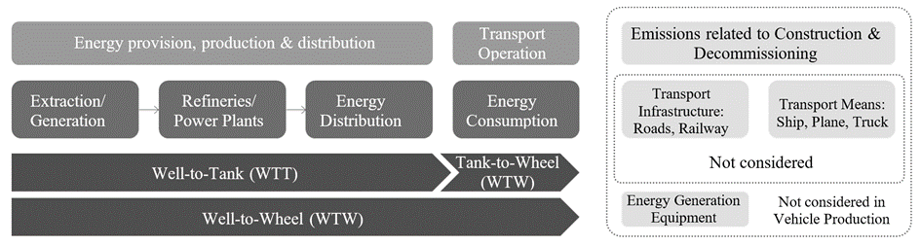*

In case of transport chains (transport of a product by more than one transport mode) the chain links shall be individually quantified and subsequently summed up.

The ultimate approach of quantifying transportation emissions shall be based on measuring the fuel and energy consumption of a trip and multiplying it by the emission factor of the fuel/energy that covers all upstream emissions of the fuel/energy. Only transport emissions quantified on the basis of measured fuel/energy consumption shall be considered as primary data. In case of collective transport, the primary data-based transport emissions require allocation to the individual product. Such allocations do not change the classification of emission data as being primary data.

Direct measurement of fuel/energy consumption of a transport operation may however not always be possible and modelling transport emissions is required. Calculation of transport emissions shall follow the recommendation set out in the GLEC Framework V3.1 or latest, except for the mandate to include emissions from the construction and dismantling of energy infrastructure. The GLEC framework allows for three approaches to establish transport distances: Shortest feasible distance (SFD), great circle distance (GCD) and actual distance. These approaches shall be used according to the following hierarchy:

1. Actual distance
2. SFD
3. GCD

Emissions reduction from the use of low-carbon fuels may only be claimed if a statement of sustainability (origin and emissions reduction) for the fuel is provided as issued by a bonded warehouse.

1. Methodology per life cycle [stages]
   1. Material production [stage]

Table 6 shows a level concept of material production phase. The development of the assessment method will be focused only on Level 3, and for other levels, only the concept and overview will be described.

Table 6  
**Level concept of material production [stage]**

| *Level* | *Activity Data* | | *Intensity Data* |
| --- | --- | --- | --- |
|  | *Material weight [kg]* | | *Carbon Intensity of Material production*  *[kg-CO2eq/kg]* |
| Level 1 | Primary data | All Secondary data | All Secondary data |
| Level 2 | All Primary data | | All Secondary data |
| Level 3 | All Primary data | | Primary and secondary data |
| Level 4 | All Primary data | | [All Primary data/ Partially Primary data] |

* + 1. Level 1,2

The specific GHG emissions of a material are basically calculated with material weight multiplied by carbon intensity of the material production.

As for yield rate during material production process, it is practically complicated due to material related manufacturers as upstream side and couldn’t be untraceable. On the other hand, the ratio of input to output of material weight during parts production and vehicle assembly process could be traceable. Therefore, yield rate shall be considered as parts production and vehicle assembly phase (see paragraph [X.X.X]).

In Level 1, the material weight of the vehicle and the carbon intensity of each material (in kgCO2eq / kg) are secondary data. LCA practitioner should assume a proportion of each material to vehicle weight.

In Level 2, the material weight of the vehicle are primary data. The carbon intensity of each material production are secondary data.

(17)

Where;

means the specific GHG emissions of a material in carbon dioxide equivalent [kgCO2e]

means each material classification

means material weight [kg]

means yield rate of input to output of material weight during parts production and vehicle assembly process. (See in paragraph [X.X.X])

means the carbon intensity of the material production [kgCO2eq. / kg of material]

* + 1. Level 3,4

In Level 3, the specific GHG emissions of a material are calculated with virgin material and recycled material separately.

Details of Level 3 will be described in a later chapter, but the assessment of the produced vehicle is set as the purpose of use. The weight of the material and carbon intensity are collected as much as possible as primary data considering hot spots in the system boundary. The environmental impact shall be assessed compared to the actual process.

One of other factors which affects critically GHG emissions can be considered electricity utilized during material production phase. LCA practitioners should incorporate electricity effect which includes regionality and regenerated power in the formula.

Finally, in Level 4 is an ideal LCA, with the goal of compiling the basic carbon intensity of all materials as primary data. However, it is challenging to collect data on hundreds of thousands of items per vehicle.

(18)

Where;

means the proportion of material input to the product that has been recycled from a previous system. [%]

means carbon intensity of virgin material primary data [kgCO2eq./kg of material]

means carbon intensity of recycled material primary data [kgCO2eq./kg of material]

* + 1. Automotive material classification

In Level 3, material classification is basically extracted by investigating composed materials species in typical automotive vehicle models, i.e., ICE, HEV, FCV and EV. As material information, BoM and IMDS are commonly referenced in worldwide automotive industry.

Then the number of material types shall be set by taking cut-off into account after practitioners calculated GHG emissions of each material to total vehicle. The material classification shall be in accordance with other [stages] as Parts production and vehicle assembly, Use, and EoL. The cut-off criteria, should be in line with paragraph ‎7.8.

As a base example of material classification in Level 3, Table 7 shows an automotive material list.

To reduce GHG emissions of material production phase, LCA practitioners shall determine cutoff criteria of the number of material classification and investigate a system boundary for the target materials. Especially, material upstream process is known to be relatively higher GHG emissions than material downstream process. Practitioners should identify hotspot process in the system boundary. System boundaries of typically high GHG emissions materials (steel, aluminium, copper, plastic and Lithium-ion battery materials) are shown in

Figure 15, Figure 16, Figure 17, Figure 18 and Figure 19 referring to the documents from international institutions e.g., worldsteel, IAI (International Aluminium institute), EA (European Aluminium), ICA (International Copper Association), and TfS (Together for Sustainability) . Since the material classification and the system boundary depends on a target vehicle specification, procedures to select material classification shall be reported.

Table 7  
**Automotive material list**

| *Material group* | *Material classification* |
| --- | --- |
|  |  |
| Steel | Cast iron, Cast steel, Hot-rolled steel sheet, Cold-rolled steel sheet, Electromagnetic steel sheet, Hot-rolled hot-dip galvanised steel sheet, Hot-rolled electro-galvanised steel sheet, Cold-rolled hot-dip galvanised steel sheet, Cold-rolled electro galvanised steel sheet, Carbon steel bar/wire rod, Special steel bars, Special steel wire rod/spring steel, Stainless steel sheet/bar, Sintered steel |
| Aluminium | Cast aluminium, Die cast aluminium, Wrought aluminium(sheet), Wrought aluminium(extruded) |
| Copper | Tough pitch bare/coated copper wire, Oxygen free bare/coated copper wire, Tough pitch copper strip/bar, Oxygen free copper strip/bar |
| Plastic | PP(Polypropylene), PE(Polyethylene), PVC(Polyvinyl Chloride), ABS (Acrylonitrile Butadiene Styrene), PA (Nylon), PC (Polycarbonate), PET (Polyethylene Terephthalate), PBT (Polybutylene Terephthalate), PUR (Polyurethane), POM (Polyacetal), ASA (Acrylonitrile Styrene Acrylate), PMMA (Acrylic resin), EP(Epoxy resin), PPS (Polyphenylene Sulphide), TPO (Thermoplastic Olefin), TPV (Thermoplastic Vulcanisate) |
| Non-ferrous metals | Magnesium alloy, Zinc alloy, Platinum/Rhodium, Lead, Other metals |
| Other organic materials | SBR (Styrene-Butadiene Rubber), EPDM (Ethylene Propylene Diene Monomer), Other thermoplastic resins, Other thermosetting resins, Natural rubber, Synthetic rubber, Anti-rust oil, Leather, Adhesives |
| Other materials | Laminated Glass, Paints, Electrodeposition Coating, Electronic Components (Silicon), Engine oil, Brake fluid, Coolant, Refrigerant, Other inorganic materials, Tyres, Battery materials (Lead-Acid battery, Ni-MH battery, LiB: Lithium-Ion Battery) |

* + 1. System boundaries

Figure 15 shows a system boundary of the material production [stage].

Figure 15  
**A system boundary of materials production [stage]**

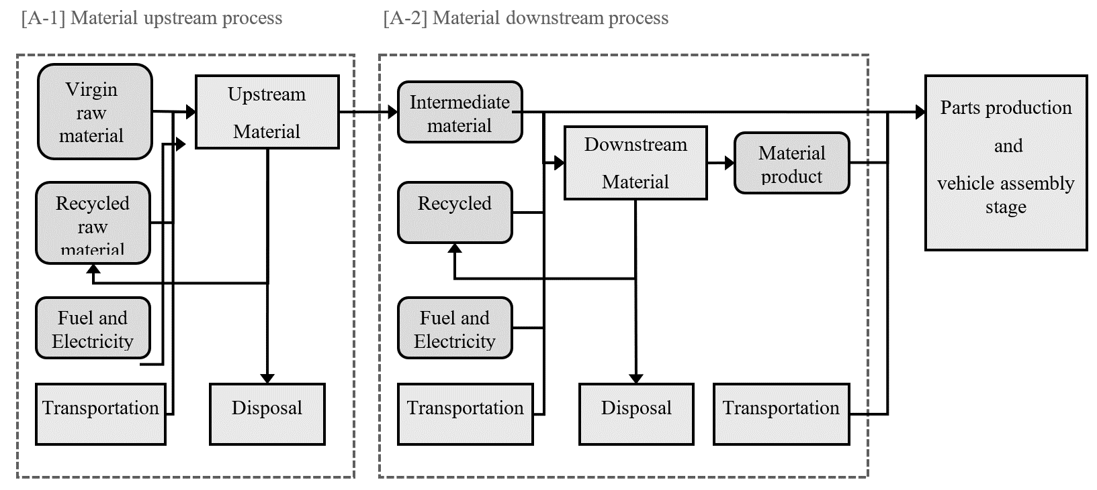

[A-1] Processes related to material mining, refining, and impurity removal (defined as material upstream process)

[A-2] Processes related to material production (defined as material downstream process)

In the material production [stage], an actual production flow for each automotive part shall be reflected.

These materials production [stages] are mainly divided into two processes.

The first is ‘upstream process’ which has mining, refining, and impurity removal with relatively high CO2 impact.

Then, ‘downstream process’ which has from the intermediate material [stage] (e.g. crude steel, aluminium ingot) to the material product [stage] (e.g. steel sheet, aluminium extruded bars).

After that, it is transferred to the Parts production and vehicle assembly [stage].

System boundaries of the main dominant materials (steel, aluminium, copper, plastic, Lithium-Ion Battery) in automotive are shown in Figure 16, Figure 17, Figure 18, Figure 19 and [Figure 20].

Figure 16  
**A system boundary of steel material production [stage]**

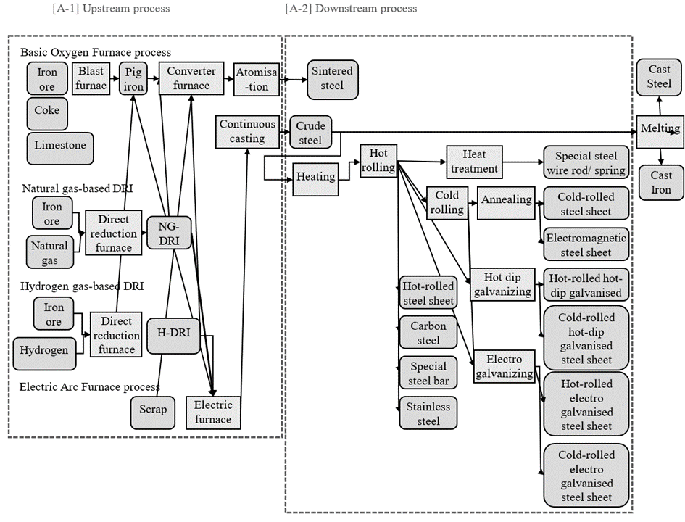

Figure 17  
**A system boundary of aluminium material production [stage]**

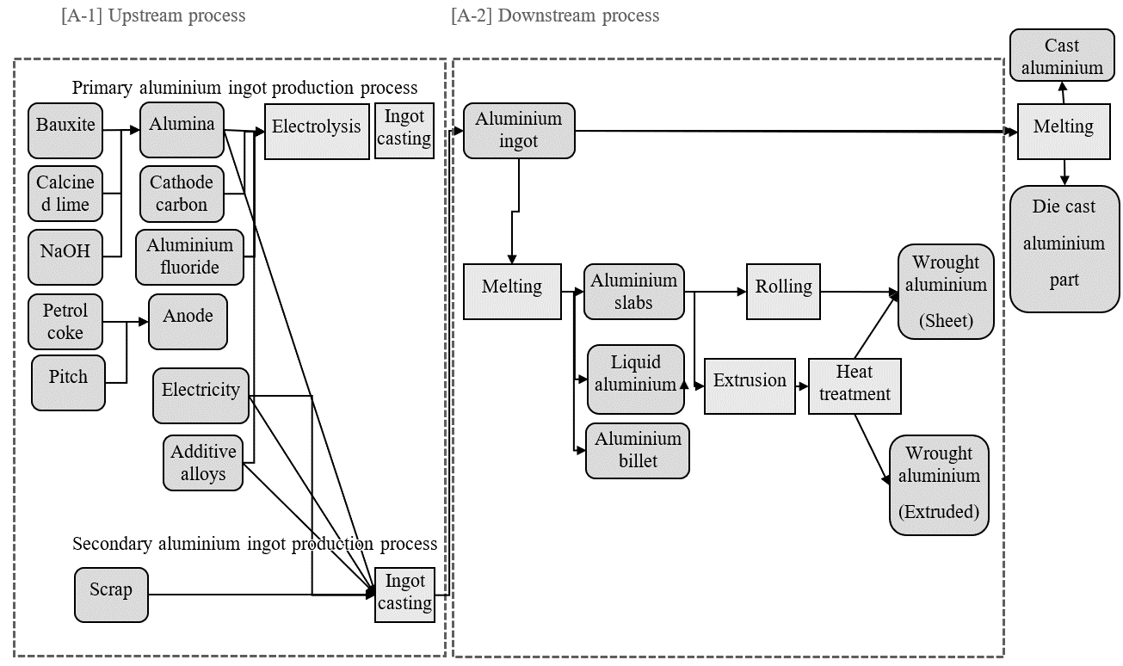

Figure 18  
**A system boundary of copper material production [stage]**

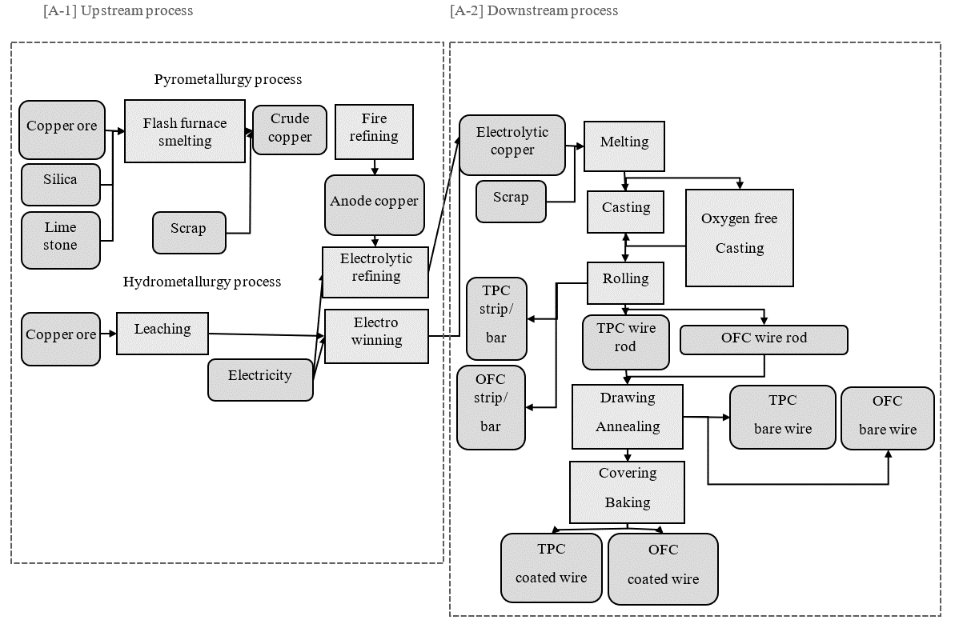

Figure 19  
**A system boundary of plastic material production [stage]**

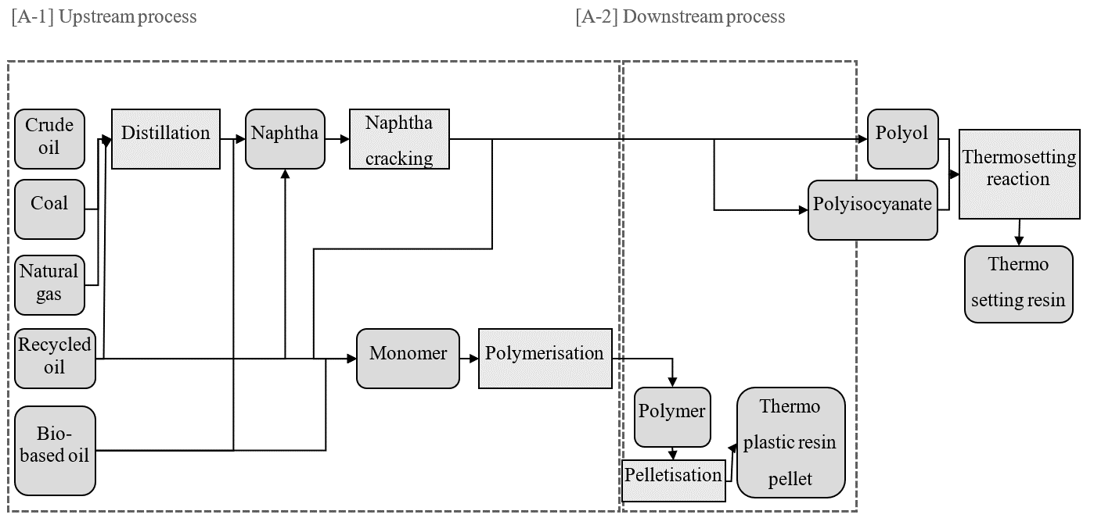

[Figure 20  
**A system boundary of Lithium-Ion Battery material production [stage]**

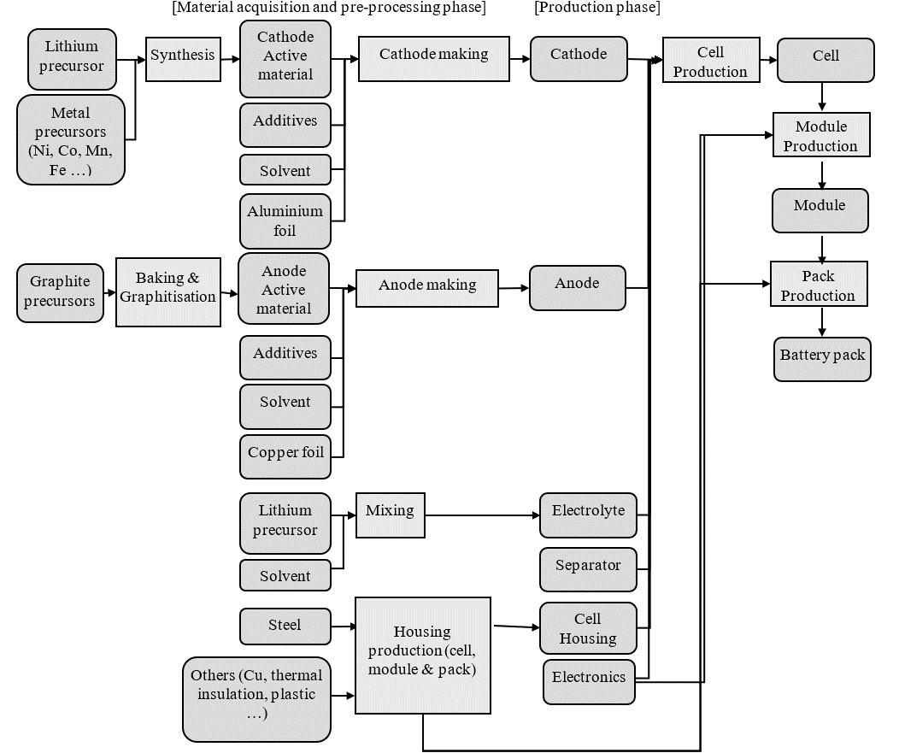

]

Burdens related to “recycled material to raw material” shall be evaluated using the RCM methodology described in paragraph ‎7.18.

(19)

Where;

means the specific GHG emissions of a material calculated with the RCM in kilogram of carbon dioxide equivalent per kilogram of material. [kgCO2eq/kg]

means the proportion of material input to the product that has been recycled from a previous system. [%]

means the specific emissions and resources consumed (per unit of analysis) arising from the acquisition and pre-processing of virgin material [kgCO2eq/kg]

means the specific emissions and resources consumed (per unit of analysis) arising from the recycling process of the recycled (reused) material, including collection, sorting and transportation process. [kgCO2eq/kg]

* + 1. Data collection and data type

Material data collection is conducted with data types of primary and secondary, and their related information as follows; material name, material classification (VDA, ISO code, and other standards), the number of materials, material weight, chemical substance composition, recycled material ratio, biomass blended ratio, [scrap/yield] rate, electricity, and fuel consumption, etc.

For a material production [stage], the carbon footprint shall be calculated based on per 1 kg of material products, regardless of its state, as its specific density is considered.

* + - 1. Primary data collection

In level 3, the weight of the material used, its [scrap/yield] rate, and material carbon intensity are collected as primary data as much as possible, considering hot spots in the system boundary. The following points should be considered to clarify transparency and accuracy.

1. High GHG emissions in the system boundary should be extracted to clarify hotspots.
2. Unit process data of material production process should be confirmed
3. country or region where material production was conducted
4. amount of electricity and fuel used, rate of renewable energy used
5. usage rate of recycled material and bio-derived material to total material weight

Then the environmental impact of primary data is assessed with data quality and shall be reported. The prerequisites shall be clarified as self-declaration of practitioners and related companies or certificated by external parties.

* + - 1. Secondary data collection

In case primary data is not practically collected, secondary data should be collected. When collecting secondary data from available databases, data quality shall be explained and the following points should be considered to clarify transparency and accuracy..

1. High GHG emissions in the system boundary should be extracted to clarify hotspots.
2. Unit process data in material production process should be confirmed.
3. It shall be utilised as attributional data and not be utilised as consequential data to avoid an assumption in the future
4. Material carbon intensity using an allocation between some life cycle generations shall not be utilised to assure data consistency.
   * 1. Energy Modelling

For general rules refer to paragraph ‎7.15.

* + - 1. Energy Mix

Practitioners shall account for the fuel or electricity production pathways associated with the production locations of each material. (detailed methodology shall be considered)

The energy mix shall be based on the latest dataset associated with the location or region of production in question.

The methods described in paragraph [3.2.8.] shall guide the modelling of fuel and electricity for these regions.

* 1. Parts production and vehicle assembly [stage]
     1. Levels in parts production and vehicle assembly

The analysis of global warming potential can also be carried out for parts production and vehicle assembly in different levels of detail. In case the goal of the analysis is e.g. concerned with mobility concepts rather than individual vehicles or the specific details of the vehicle production are not the main interest, an archetypal vehicle production is included in the analysis. The cradle to gate carbon footprint of parts production or vehicle manufacturing can thus reflect:

1. an average for a vehicle fleet (various segments, models on global or national level) –> Level 1
2. an average for vehicles of a specific segment (various models on global or national level) or a vehicle chosen as representative for a specific segment both based on BoM-Data –> Level 2
3. an average for specific vehicle models (with different equipment variants on global, national or local production site level) –> Level 3
4. a specific vehicle model. –> Level 4

In the ideal case, the average values are calculated as weighted averages of a population of individual vehicles. If the analysis of the individual vehicle were based on real emission data (primary data), even the averages would reflect the correct averages of real emissions. As there is no abundance of analysis data on individual vehicles very often the average vehicle is defined by assumptions and modelling and secondary data is used to quantify the environmental impact.

Within this Resolution four levels detail are differentiated.

* + - 1. Level 1

[As described in Section ‎7.1. there are multiple approaches possible for Level 1, the following section minimum standard for calculation. GHG-emissions due to the production of vehicle parts and vehicle assembly are quantified with a (lump) carbon emission factor which is a function of net vehicle weight. All specific emission effects due to different materials, gross material input, different production processes or transport of parts or vehicles is included in the carbon emission factor. The calculation of vehicle carbon footprint from production is simply given by:

(20)

Where;

*CVP* means carbon emissions due to material production, component and vehicle manufacturing in kilogram of carbon dioxide equivalent (kgCO2eq)

*CMP* means carbon emissions due to material production in kilogram of carbon dioxide equivalent (kgCO2eq)

*CPVA* means carbon emissions due to parts production and vehicle assembly in kilogram of carbon dioxide equivalent (kgCO2eq)

*CEFMP* means carbon emission intensity of material production in kilogram of carbon dioxide equivalent per vehicle net mass (kgCO2eq/kgNM)

*MNM* means the net mass of the vehicle in kilogram (kg), i.e. mass of the vehicle in running order minus the mass of the driver (75kg) minus the mass of any fuels.

*SCV* means the surcharge factor for carbon emissions from parts/component and vehicle manufacturing on top of carbon emissions due to material production.

*CTP* means carbon emissions due to transport of the fully assembled vehicle to customer in kilogram of carbon dioxide equivalent (kgCO2eq)

The SCV may be determined from literature, OEM publications or secondary databases. The factor may reflect geographical differences, if there is evidence that parts/component and vehicle production is more CO2eq-intense in some parts of the world than in others. For transparency all the factors used in calculation shall be reported.]

* + - 1. Level 2

GHG-emissions due to the production of vehicle parts and vehicle manufacturing are quantified by breaking down the vehicle as delivered to the customer by mass of materials. Breaking down by material is common in automotive industry because material and mass declaration systems are mandatory for decades. The calculation of the cradle to gate vehicle carbon footprint is given by:

(21)

Where;

*CVP* means carbon emissions due to material production, component and vehicle manufacturing in kilogram of carbon dioxide equivalent (kgCO2eq)

*CMP* means carbon emissions due to material production in kilogram of carbon dioxide equivalent (kgCO2eq)

*CPVA* means carbon emissions due to parts production and vehicle assembly in kilogram of carbon dioxide equivalent (kgCO2eq)

*COP* means carbon emissions due to manufacturing processes at the OEM in kilogram of carbon dioxide equivalent (kgCO2eq)

*CMP,i* means carbon emissions due to production of material i in kilogram of carbon dioxide equivalent (kgCO2eq)

*SC,i* means the surcharge factor for carbon emissions from parts/component and vehicle manufacturing on top of carbon emissions due to production of material i.

*CTP* means carbon emissions due to transport of the fully assembled vehicle to customer in kilogram of carbon dioxide equivalent (kgCO2eq)

Again, all specific emission effects due to different production processes, production rejects or transport of parts or vehicles is included in the surcharge factor. COP may be determined from literature or OEM publications. For transparency all the factors used in calculation shall be reported.

* + - 1. Level 3

[The contribution of different subsystems of a vehicle to the GHG-emissions of vehicle production is by far not evenly distributed. Accounting these most relevant subsystems in terms of GHG-emissions from vehicle production (so called ‘hotspots’) in a more detailed manner differentiates Level 3 from Level 2 in the calculation of the cradle to gate vehicle carbon footprint.]

[For a hotspot, company specific (OEM / supplier specific) data shall be used for at least one material or component of choice.

This means, for the selected component / material:

1. for at least one process at OEMs’ and/or preceding suppliers’ production sites (depending on availability and vertical integration);
2. it is required to collect primary information on,
3. which is then utilised for the calculation of the cradle-to-gate carbon footprint.

The selected component as well as the chosen process or material or supplier component shall be named including type of primary information collected.

As a recommendation, the following should be taken into account:

1. steel, aluminium,
2. body-in-white, battery, wheel rims, tyres.]

[For hotspot primary data-based reporting is the preferred approach and the use of available site-specific primary data is mandated. In case primary data cannot be obtained, secondary data shall be used. Secondary data shall be traceable and based on field survey data and designated by government authorities, if available.

The calculation of vehicle carbon footprint from production is given by:

(22)

Where;

*CVP* means the carbon emissions due to material production, component and vehicle manufacturing in kilogram of carbon dioxide equivalent (kgCO2eq)

*CMP* means carbon emissions due to material production in kilogram of carbon dioxide equivalent (kgCO2eq)

*CPVA* means carbon emissions due to parts production and vehicle assembly in kilogram of carbon dioxide equivalent (kgCO2eq)

*CMP,j* means carbon emissions due to production of material j in kilogram of carbon dioxide equivalent (kgCO2eq)

*CHS* means the carbon emissions due to manufacturing of hotspot subsystems (including material production processes and component production) and their assembly to the vehicle in kilogram of carbon dioxide equivalent (kgCO2eq)  
Index i refers to a specific hotspot subsystem.

*CBV* means the carbon emissions due to material production, component and vehicle manufacturing with the exception of hotspot subsystems in kilogram of carbon dioxide equivalent (kgCO2eq)

*CTP* means the carbon emissions due to transport of the fully assembled vehicle to customer in kilogram of carbon dioxide equivalent (kgCO2eq)

CHS is calculated according to Level 4 definitions. CBV for the remaining vehicle materials, parts and production processes excluding hotspots follow the calculation defined for Level 2. Intermediate transport operations are covered by CHS and CBV.]

* + - 1. Level 4

GHG-emissions due to the production of vehicle parts and vehicle assembly are quantified by a stepwise attributional reporting of real emissions (site specific, primary data) for the material and components along the supply chain until the final assembly in the vehicle. For each Tier level this requires to add the GHG-emissions for the manufacturing of a product in its own operations to the sum of GHG-emissions of the purchased parts or materials for that product. Transport within the supply chain is accounted according to the definitions in paragraphs ‎7.19 and ‎8.2.5.

The calculation of vehicle carbon footprint from production is given by:

(23)

(24)

Where;

*CVP* means the carbon emissions due to component and vehicle manufacturing in kilogram of carbon dioxide equivalent (kgCO2eq)

*CMP* means carbon emissions due to material production in kilogram of carbon dioxide equivalent (kgCO2eq)

*CPVA* means carbon emissions due to parts production and vehicle assembly in kilogram of carbon dioxide equivalent (kgCO2eq)

*CMP,j* means carbon emissions due to production of material j in kilogram of carbon dioxide equivalent (kgCO2eq)

*Cop* means the carbon emissions due to manufacturing processes at the OEM in kilogram of carbon dioxide equivalent (kgCO2eq)

*CTP1* means the carbon emissions due to transport from Tier 1 supplier to the OEM in kilogram of carbon dioxide equivalent (kgCO2eq) per part

*CT1* means the carbon emissions reported from the Tier 1 supplier for supplied parts in kilogram of carbon dioxide equivalent (kgCO2eq) per part

*CTP* means the carbon emissions due to transport of the fully assembled vehicle to customer in kilogram of carbon dioxide equivalent (kgCO2eq)

*CTi* means the carbon emissions reported from the Tier j supplier for the component production of supplied parts in kilogram of carbon dioxide equivalent (kgCO2eq)

*CTPj* means the carbon emissions due to transport of parts from Tier j-1 supplier to Tier j in kilogram of carbon dioxide equivalent (kgCO2eq) per part

*Cop,j* means the carbon emissions due to manufacturing processes at the Tier j in kilogram of carbon dioxide equivalent (kgCO2eq) per part

In case primary data cannot be obtained, secondary data shall be used. Secondary data shall be traceable and based on field survey data and designated by government authorities, if available.

Any product during parts and vehicle production generating material/parts for recycling, re-use or re-manufacturing follows a cut-off approach in a cradle-to-gate scope, i.e. only the RCM methodology is applied. Preparatory steps for recycling shall generally be allocated to the waste receiving system (i.e., the product system using the (to be) recycled material/parts). This deviation from the polluter pays principle is a pragmatic exemption as following the polluter pays principle in this context would require defining material- and component-specific system boundaries. Other than the emissions from the respective preparatory steps and the recycling, re-used or re-manufactured treatment emissions, to be recycled, to be re-used, or to be re-manufactured materials/parts enter the product system using recycled material/parts burden-free.

For pre-consumer scrap, preparatory steps shall be accounted for by the producer of the waste (they might be insignificant; cut-off rules apply).

* + - 1. Level overview

Table 8 gives an overview how relevant aspects in vehicle and parts production should/shall be handled in the different levels.

Table 8  
**Level overview for parts production and vehicle assembly [stage]**

|  | *Level 1* | *Level 2* | *Level 3* | *Level 4* |
| --- | --- | --- | --- | --- |
|  |  |  |  |  |
| Waste | Included in SCV | Included in SC,i | Hotspot:  Considered explicitly.  Rest of vehicle:  Included in SC,i | Considered explicitly |
| Gross vs. net material input (Scrap) | Included in SCV | Included in SC,i | Hotspot:  Considered explicitly.  Rest of vehicle:  Included in SC,i | Considered explicitly |
| Transport | Included in CTP & SCV | Included in CTP & SC,i | Transport from OEM gate to customer  reported explicitly.  Hotspot:  Considered explicitly.  Rest of vehicle:  Included in SC,i | Considered explicitly |
| Primary/ secondary material use | Included in CEFMP | Included in CMP,i | Hotspot:  Considered explicitly.  Rest of vehicle:  Included in CMP,i | Considered explicitly |
| Temporal validity | Most recent data | Most recent data | Hotspot:  Reference year  Rest of vehicle:  Most recent data | Reference year |
| Geographical Representativity | As specific as possible for research question | As specific as possible for research question | Hotspot:  Plant level  Rest of vehicle:  As specific as possible | Plant level |
| Energy Modelling | Recommen-dation: Location based | Recommen-dation: Location based | Hotspot:  Marked based  Rest of vehicle:  Location based | Marked based approach |

* + 1. Declared unit

The product carbon footprint shall be assessed for a declared unit. A functional equivalent is established by the data recipient and is defined from a product use perspective (see 3.2.3).

For countable products, i.e., a component or part, the declared unit shall be 1 piece as described in the part description including a defined weight and a unique identifier (part number).

For materials, i.e., mass products or commodities, the declared unit shall be 1 kg of products, regardless of its state (solid, liquid, gas), as its specific density is considered.

If packaging is included, the declared unit is 1 kg or 1 piece of unpackaged product at the factory gate. The PCF however includes the PCF contribution of packaging.

For the vehicle manufacturer the declared unit it the fully assembled vehicle delivered to customer at show room.

* + 1. System boundaries

The system boundary of the parts and vehicles production [stage] is outlined in Figure 21.

Figure 21  
**System boundaries in production.**

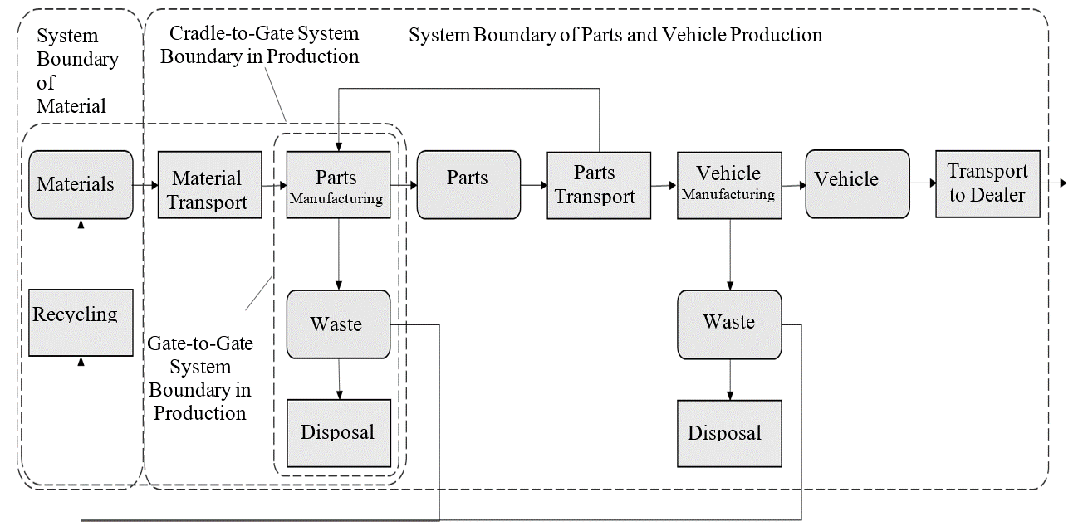

The system boundary towards material production is generally defined by the outbound gate of the production site processing material inputs to a neat material or an initial semi-finished product in a tradable form, e.g. steel bar, aluminium ingot, plastic granulate.

Transport of the final assembled vehicle to the end customer is also included in the parts and vehicle production and therefore to be included in the CFP of the vehicle in production.

The cradle-to gate CFP includes all attributable upstream and direct emissions of producing a product, including all upstream transportation activities.

When accounting for emissions all attributable processes shall be listed to clearly define the cradle-to-gate boundary of their studied product.

The system boundaries for parts/components and vehicle production are therefore including:

1. Production of materials from virgin or recycled materials, semi-finished products
2. Production of vehicle parts and components
3. Auxiliary production processes (e.g., lighting, air conditioning, storage facilities)
4. Disposal of production waste
5. Packaging of vehicle parts and components, including all operations required for performing packaging
6. Disposal of production waste (incl. packaging waste, see ‎7.18)
7. Logistics (including internal logistics and transport packaging, see ‎7.19 and ‎8.2.5)
8. Quality control in production
9. Energy consumption of IT for process and manufacturing control

Despite of being included in the system boundaries in principle, insignificant processes may be excluded based on the cut-off rules (see ‎7.13).

In general, GHG emissions not connected directly to the production system relevant for the product shall be excluded from the system boundaries. These are amongst others:

1. Employee commuting and work travel
2. Research and development, administration, or sales processes
3. Auxiliary inputs not directly related to the production process (such as heating and lighting of associated office rooms, secondary services like maintenance, sanitary facilities, canteen services, facility management e.g., plant security and fire safety and general IT)
4. Auxiliary inputs to maintain the manufacturing equipment
5. Emissions from construction or dismantling of capital good (such as buildings, manufacturing equipment or any other infrastructure for transport, media or energy distribution and energy generation, within or outside the control of the reporting company).

Data collection and data types

Emissions shall by default be reported averaged over the period of one year (reporting or calendar year) to avoid seasonal fluctuations and reflect typical production conditions.

Shorter periods may be considered if data on a full year are not yet available. Longer averaging periods may be considered but shall not exceed five years. Any averaging period deviating from the default shall be flagged and justified.

Emissions shall by default be reported for the most recent year (reporting or calendar year). In case there is the intention to extend the validity period of the CFP report beyond the reference year of reporting, an annual check is recommended to ensure that data is up to date.

To perform the annual check, the initial screening analysis should be updated based on data for the most recent year. An update of data is recommended if the reported emission increases by 10% or more based on the screening analysis compared to the previous reporting period. Additionally, an update of data is mandatory in the following situations.

1. Structural changes in operation to the product system under study, including significant process change in operation, change in production technologies or technology advancement, as well as changes in raw material or energy supply.
2. Changes in calculation methodology or improvements in the accuracy of emission factors or activity data or inclusion of new types of sources that result in a significant impact on the emissions data.
3. Discovery of significant errors, or a number of cumulative errors that are collectively significant.

Emissions shall by default be reported as granular as the purpose of the CFP-study allows for. Averaging globally or over a region, country, continent may be considered but shall be flagged as such. Reasoning shall be provided if continental or global average values are used in cases where the use of primary data is recommended.

* + 1. [Energy modelling

For the general rules reference is made to paragraph ‎7.15.

In case of electricity supply from the grid and marked based energy modelling (Level 4 & hotspots in Level 3) the following rules shall apply:

1. If no contractual instruments are applied the residual electricity mix shall be used if available.
2. If no residual grid mix is provided, secondary data shall be applied reflecting the country specific grid mix.

For Level 3 and partially Level 4 the risk of double counting cannot completely be avoided (parallel use of marked-base and location-based reporting). On the one hand the consistent deployment of secondary data based on residual mixes - if available - represents substantial effort that is out of scope for the LCA-practitioner. On the other hand, the use of contractual instruments is not limited to hotspots in the vehicle.]

* + 1. Logistics

This section deals with transportation from a supplier to its customer. The general rules for logistics apply (see paragraph ‎7.19)

Figure 22  
**Definition of scopes**

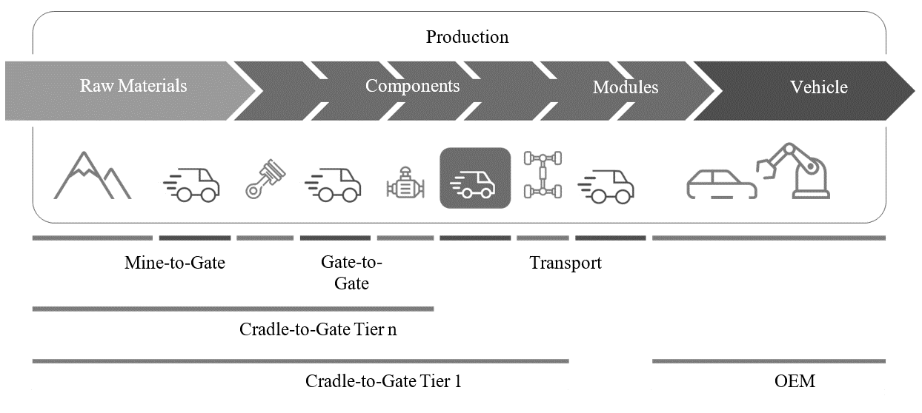

As for the product carbon footprint, the cradle-to-gate boundaries end at the suppliers' outbound gates (cf. paragraph ‎7.6 System Boundaries). This boundary applies independently from the responsibilities in economic or operative terms for transportation processes.

In case the transport details are known the following section defines the reporting responsibilities of supplier and customer.

Nonetheless, if a supplier is responsible in economic or operative terms for the outbound logistics (i.e., transportation from the supplier to its customer), the supplier shall report the product carbon footprint from this transportation in addition to and separately from the product carbon footprint (Table 9). Otherwise, the customer shall account for transportation between the supplier’s and its own shipping site (factory gate or distribution centre, see Figure 23 and Figure 24).

The table below describes different cases of responsibility and accountability for transportation from supplier to customer:

Table 9  
**Transportation between supplier and customer.**

| ***Case*** | ***Description*** | ***Economic/operative responsibility for transportation from supplier to customer*** | ***Accounting for transportation emissions*** |
| --- | --- | --- | --- |
| **1** | Multiple shipping sites, and/or multiple unloading sites  Une image contenant capture d’écran, cercle, diagramme, Caractère coloré  Le contenu généré par l’IA peut être incorrect.  Customer  Supplier | Inbound transportation contracted or operated by customer | Customer respon­sible for quantifica­tion of transporta­tion emissions.  As for multiple transportation relations, emissions shall be attributed by mass between the respective products |
| **2** | Multiple shipping sites, and/or multiple unloading sites  Une image contenant capture d’écran, cercle, diagramme, Caractère coloré  Le contenu généré par l’IA peut être incorrect.  Customer  Supplier | Outbound transportation contracted or operated by supplier | Transportation emissions to be reported separately by supplier to the customer (additionally to supplier's PCF).  As for multiple transportation relations, emissions shall be attributed by mass between the respective product |

Transports from production sites to suppliers' distribution centres are deemed as suppliers' in-house logistics, i.e., the distribution centre is regarded as the shipping point (Figure 23).

Figure 23  
**Distribution centre on supplier side.**

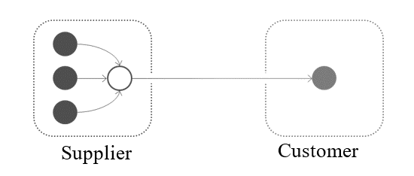

Transports from customers' distribution centres to production sites are deemed as customers' in-house logistics, i.e., the distribution centre is regarded as the unloading point (see Figure 24).

Figure 24  
**Distribution centre on customer side.**

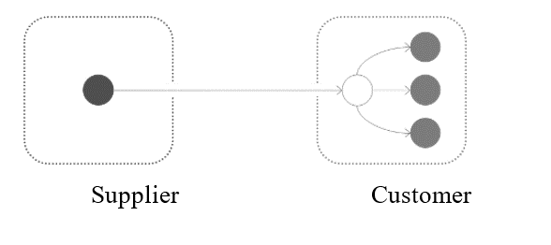

Regardless of whether transportation emissions are quantified by a supplier or a customer, they shall be consolidated within the customers' PCFs.

* 1. Use [stage]
     1. [Service life/Vehicle activity] and functional unit

[Vehicle activity is defined as an annual distance of operation for a vehicle model or fleet that may be integrated over a fixed time period (e.g., the vehicle life, such as 15 years), and includes a vehicle scrappage rate (removal of vehicles from the fleet due to accidents, age, failure, or retirement). Integration of the annual vehicle activity shall be used together with annual emission rates, such as emission rates of electric generation mix, within emissions calculations in regions where up-to-date, powertrain-specific, annual vehicle activity data is available. In regions where detailed vehicle activity data is not available, aggregate vehicle lifetime activity may be used in place of annual vehicle activity. Vehicle lifetime activity is expressed in terms of a fixed distance in kilometres (km) driven over a fixed service life and should be representative of typical regional usage patterns. This is represented mathematically as:

*Lifetime vehicle emissions = ∫n(annual VMT(n) (km)) x emission rates (g/km)]* (25)

[The vehicle lifetime (or service life) is defined as the full period of time during which a vehicle is operated and thereby contributes to GHG emissions. This lifetime is expressed in terms of kilometres (km) driven and is chosen to represent typical usage patterns. Alongside the distance travelled, the years of operation for a vehicle is defined as the assumed total number of years a vehicle remains in active use between point of sale and point of recycling. Both are relevant for the purpose of the methodology.

Vehicle lifetime mileage is required to translate vehicle production emissions (in tonnes of CO2eq) into the functional unit (gCO2eq per km driven over the lifetime). Vehicle lifetime in years is needed to calculate the lifetime mileage, but also to determine the period of time over which the changes in the emission intensity of the fuel and electricity will be accounted for. Lifetime duration is also needed to calculate the number of replacements/refills for certain maintenance and consumable items. As for the annual driven distance, a constant average annual mileage is assumed, based on gathered data on total vehicle activity (in kilometres) and vehicle lifetime.]

* + - 1. Service life: methodology and guideline

[Precisely assessing these values for each region may present further challenges, underscoring the need for flexibility and regional adaptation in their definition and application.]

The actual service life and lifetime distance reference flow of a vehicle can vary significantly depending on the region and its specific applications. This variability makes it challenging to accurately estimate these values universally. Therefore, this guideline proposes to define service life for each region or country of usage.

De-registration in a country (i.e., as indicated by “survival curves”) can be significantly earlier than reaching end of life. In some countries, a significant share of vehicles is exported before reaching the end of service life. Hence, the average age when being de-registered is lower than the average age when being recycled. In general, these guidelines recommend to consider statistical evidence on the average vehicle age at the point of recycling. For the reasons discussed above, statistics on the average age at the point of de-registration in a country is not recommended, as these values exclude the potential export and continued operation of a proportion of the vehicle in other countries. Therefore, for all vehicles, the lifetime used to calculate life cycle emissions should align with the average age of vehicles at the time of recycling, considering only those registered and recycled within the same country.

Some frameworks adopt different lifetime values by vehicle segment. There are both advantages and disadvantages to offering differentiation by segments. (1) Differentiation offers a more accurate representation of the typical usage expected, which also partly highlights the greater potential utility that larger vehicles can provide. (2) However, near the boundaries between segments, it may unintentionally influence consumer decisions (for instance, a specific user is unlikely to choose a vehicle solely because it belongs to a different segment – it's typically bought for a particular use). Until further in-depth analysis is conducted, this guideline does not recommend differentiating service life by segment.

Although statistics indicate that service life varies considerably between powertrains, this may be influenced by user behaviour, as well as current economic/taxation policies, which are subject to change. Since one of the objectives of LCA is to compare different powertrains, based on the same functionality, i.e., the same use case, this guideline does not recommend assigning different service lives to different powertrains.

Moreover, vehicle annual mileage generally declines over time. Consequently, higher mileage in the early years should be assigned greater weight to account for the typically higher emissions intensity of electricity mixes during that period. Nevertheless, the guidelines do not prescribe a specific function to model the evolution of annual mileage over vehicle age; instead, a constant value may be assumed, as previously noted. Alternatively, practitioners may adopt a different approach, provided that the chosen method is clearly documented and transparently reported.

[Some vehicles, such as special purpose or sports vehicles, have very low usage, leading to a significantly reduced service life. The guidelines suggest that the practitioners can indicate a shorter service life supported by primary data, which will lead to a more stringent functional unit. However, the guidelines currently do not advise declaring a longer service life than the regional default value, as this could result in a more favourable functional unit.]

* + - 1. Service life values

Service life (in both km and years) will be defined by each contracting parties according to official available data on vehicle service life until point of recycling.

In the absence of the above values, the following values as defined in official databases or peer-reviewed reports (see Annex for reference) can be used as an indication of typical service life as fall-back option.

Table 10  
**[Average age of end-of-life vehicles reported in a selection of countries]**

| *Region / Country* | *Year* | *Duration*  *(Years)* | *Source* |
| --- | --- | --- | --- |
|  |  |  |  |
| EU27 | 2024 | 20 | [Multiple sources as in the table below] |
| United Kingdom | 2022 | 18 | LSE, 2024 |
| Japan | 2022 | 16.5 | [Ministry of Economy, Trade and Industry, 2023 - Status of the Enforcement of the Automobile Recycling Law](https://www.meti.go.jp/shingikai/sankoshin/sangyo_gijutsu/resource_circulation/jidosha_wg/pdf/058_03_00.pdf#page=4) |
| [USA | 2003 | 18 | US DoT] |
| Brazil | 2020 | 22 | Ministry of Science, Technology and Innovations of Brazil, 2020 |

* + 1. System boundaries

When defining the system boundaries, it is pivotal to highlight that the scope is to provide a comprehensive methodology for calculating realistic GHG emissions and energy consumption over vehicle use [stage] at various levels of detail and considering the availability of different information and datasets. Therefore, in an intermediate step this requires the calculation of energy consumption as activity data for electrified vehicles such as HEV, PHEV, FCHV and PEV. As outlined in the figure below, the use [stage] encompasses the operation of the vehicle itself and direct impacts from this, as well as impacts from the production and distribution of fuel/electricity, and for impacts relating to vehicle maintenance and replacement parts.

Impacts directly from the energy used in operation of the vehicle include in the CO2 equivalent calculation the tank-to-wheel (TtW) contribution are hereby addressed, hence:

1. Electric energy: from vehicle charging port to the wheels, if already included in the certification protocol;
2. Fuel: from tank to wheel

Conversely, impacts resulting from the production and distribution of fuel and electricity for the operation of the vehicle, i.e. well-to-tank (WtT), shall follow the methodology outlined in paragraph ‎7.6 and paragraph ‎7.15.

These latter WtT GHG emissions shall be covered in the conversion factor of each energy type according to paragraph ‎7.15.

Use [stage] boundaries are depicted in the figure below:

Figure 25  
**Use [stage] Life-cycle flow schematic**

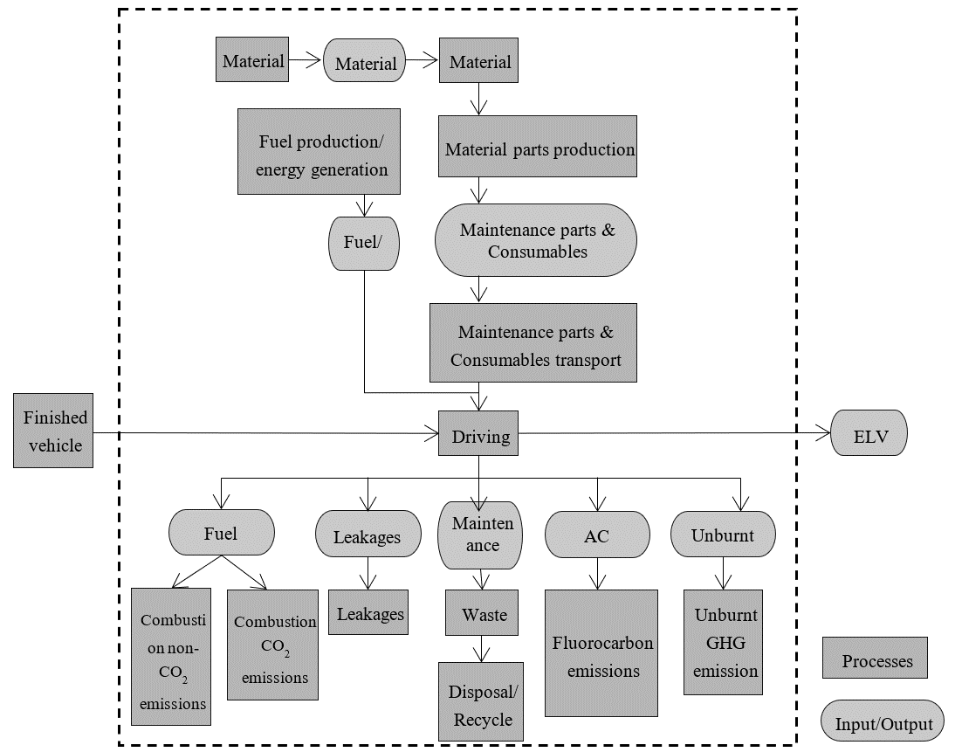

As a matter of fact, the use [stage] covers mainly two aspects of the whole life cycle, such as the “In-use energy consumption and GHG emissions” (covering WtT and TtW impacts), and the “Maintenance and consumables” impacts. It is relevant to address also leakages such as emissions of methane and other hydrocarbons, together with emissions of climate active species from the vehicles (e.g. methane leakage from CNG cars) and the formation of non-CO2 GHG gasses (e.g. N2O) during the fuel combustion. More in detail, the figure below shows the system boundaries related to vehicle operation.

Figure 26  
**Vehicle operation system boundaries**

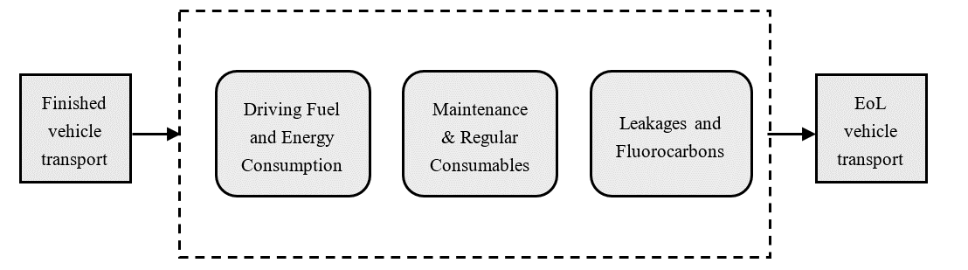

The handover point from the “Parts Production and Vehicle Assembly” [stage] is defined at the point of delivery to the final customer, once the finished vehicle has been handed over. On the disposal and recycling side, GHG emissions after the vehicle service lifetime fall within the EoL (End-of-Life) domain. Therefore, it is acknowledged that the transportation of the vehicle to EoL treatment facilities is included within the EoL domain.

Considering the proposed system boundaries, the CO2 equivalent emissions for the use [stage] comprise emissions from in-use consumption, emissions due to maintenance parts and consumables, and the contribution of leakages and fluorocarbon emissions. The following equation highlights these components:

(26)

Where;

means carbon emissions for the whole use [stage] (kgCO2eq);

means carbon emissions due to the fuel combustion, including both CO2 and non-CO2 exhaust emissions and fuel leakages (kgCO2eq);

means carbon emissions due to maintenance and consumables (kgCO2eq);

means carbon emissions due to leakages, including unburnt GHG species emissions (kgCO2eq);

means carbon emissions due to fluorocarbons emissions (kgCO2eq);

In the following paragraphs, the methodology for assessing each term of the equation is detailed.

* + 1. Use phase consumption

Contrary to upstream activities where carbon footprint is unique for a vehicle, downstream activities are different for different regions for the same vehicle. The LCA vehicle's GHG emissions are declared at the point of sale, but it is difficult to measure energy consumption after sale. As a matter of fact, for Level 1 and Level 2 analysis, projections or estimations can be made based on available information such as certification values. These should be considered as minimum requirements and do not prevent the use of more realistic or detailed data to better characterize vehicle behaviour, where such data is available. For Level 3 and Level 4, where stricter requirements are in place, please refer to guidelines in [Table 11.

Usage of [light duty vehicles] depends on regional customer behaviour. To provide a standard approach that ensures repeatability, comparability and verifiability by authorities, each region has defined homologation driving cycles and test conditions to be followed. In some regions, these certification values are repeatedly found to underestimate the average fuel consumption in real-life operation. In this regard, Table 12 provides an overview of the primary certification protocols used globally. This table serves as an illustrative example of the methodologies employed in key regions to determine fuel and energy consumption for [light duty vehicles], depending on the powertrain type. The selection and verification of the appropriate homologation procedure remain the responsibility of each contracting party, to be determined on a case-by-case basis. As a result, using regional certification values is considered to be a good starting point to later reach an accurate representation of in-use energy consumption, compared to using globally standardised values.

The scientific community widely acknowledges that there remains a substantial disparity between certification values and actual energy or fuel consumption in real-world conditions across all types of powertrains in some regions. This gap is particularly pronounced for plug-in hybrid electric vehicles, as evidenced by numerous scientific studies. The gap may vary per powertrain, region, driving behaviour and other variables that have to be taken into account. However, in some regions such as Europe and Japan, real-world fuel consumption can be monitored through on-board systems. This data is compiled annually and shows the gap between certified values and actual usage for each powertrain. To address this, the guidelines propose using a "discrepancy factor" if data are available for the region in question. If the factor is not available for a specific region, then the factor should be calculated based on best available data and expert qualified assumptions with a minimum value of ‘1’. For vehicles that have more than one mode of operation (e.g. PHEVs working in Charge Depleting and Sustaining mode), distinct discrepancy factors should be applied to accurately characterise each operational mode.

[For example, considering a ‘Level 4’ calculation (see paragraph ‎7.1), OEM-specific average data may be used to determine the “Discrepancy factor” based on analysis of data from their vehicles operating in the real-world for similar powertrains (e.g. for ICEVs, or ZEV/electric powertrains such as PEVs, FCHVs, etc.), matched to the defined region of operation (i.e. sale).] [However, OEM-specific average data cannot substitute publicly available official data, such as EU OBFCM data]. [Practitioners must disclose details about the fleet sample used to derive the data, including, for example, the sample size and period of collection.] “Discrepancy factors” can only be quantified at the first time of vehicle registration (0 km). These factors should be defined and updated on a regular basis by the authorities.

Vehicle emissions may increase over time due to wear, component deterioration and other factors. If emissions "Deterioration factors"[[41]](#footnote-42)  for the specific modules are available for a particular region, they should be used to account for this issue. Emissions deterioration factors based upon measurement and used for vehicle emissions certification and/or type approval shall be considered primary data. If a deterioration factor is not available for a region, then a deterioration factor should be calculated based on best available data and expert qualified assumptions with a minimum value of ‘1’. Since the deterioration effect covers vehicle aging, it is important to note that this factor may also be reflected in on-board fuel consumption monitoring data used to quantify the “Discrepancy factor”, and hence double counting shall be avoided.

As far as the mere Fuel and/or Energy consumption is considered, the in-use consumption, ECin-use shall be calculated as follows for vehicles with powertrains with only one mode of operation:

(27)

Where;

means the energy consumption or fuel consumption (MJ/km or Wh/km);

means the discrepancy factor (if not available for a region, then 1 should be used)

means the deterioration factor (if not available for a region, then 1 should be used)

[For vehicles with powertrains with two modes of operation (for example OVC-HEVs, including plug-in hybrid vehicles – PHEVs, or range-extended electric vehicles – REEVs), the in-use energy consumption shall be defined separately for each mode of operation, so that overall in-use energy consumption may be defined. An additional formula shall be used to account also for changes to the share of operation (i.e. in mode 1 – e.g. charge depleting electric - CD, or mode 2 –charge sustaining - CS) that may result from accounting for the discrepancy and deterioration factors for each fuel mode:

(28)

And,

|  |  |
| --- | --- |
| Mode 1  (e.g. charge depleting) |  |
| Mode 2 (e.g. charge sustaining) |  |

Where;

Mode 1/M1 means the first mode of operation, e.g. Charge Depleting (CD) where the on-board battery is being depleted. In some OVC-HEV architectures (e.g. pure range extended electric vehicles), this may be 100% operation on electricity. However, in other PHEV architectures, this may include still some mixed operation (i.e. use of electricity from the battery as well as a smaller degree of the use of the combustion engine) – and therefore energy consumption of both electricity and fuel may need to be accounted for.

Mode 2/M2 means the second mode of operation, e.g. Charge Sustaining (CS) where the on-board battery is not being depleted/the vehicle is essentially operating as a non-plug-in hybrid vehicle mode. In this case there is only fuel consumption (and no net consumption of electricity).

means the in-use Utility Factor (= share of operation) in fuel mode 1 (= electric charge depleting for PHEVs and REEVs), calculated according to the regional vehicle certification procedures. For example, under European WLTP this is defined by the electric range in charge depleting mode.

For regions where the Utility Factor (or equivalent) is defined according to the range operating in Mode 1 / electric charge depleting, the in-use electric range is needed, which shall be calculated according to the following equation:

(29)

Where;

means the certified electric range (i.e. in charge depleting mode of operation) in km or miles, as defined in the regional type-approval requirements. In some regions (and for some specific powertrain types – e.g. range extended electric vehicles), this may be defined as the full/equivalent all electric range. In other regions, such as the EU WLTP, the charge depleting range may include also some use of the combustion engine in mixed operation, which is included in the certified charge-depleting cycle range (RCDC). In WLTP, the equivalent all electric range (EAER) is the part of the actual RCDA range that can be attributed to the use of the electric battery (and is the value included in public disclosures).

means the in-use electric range (i.e. in charge depleting mode of operation) in km or miles, i.e. including accounting for the discrepancy and deterioration factors.

means the certified electric energy consumption (in MJ/km or Wh/km) in charge depleting mode (i.e. draining the on-board battery). This is defined in WLTP as the distance driven in charge depleting on a single full charge. For some vehicle types, this may include mixed operation (i.e. use of electricity from the battery as well as a smaller degree of the use of the combustion engine), which should be accounted for in the calculations.

means the in-use electric energy consumption (in MJ/km or Wh/km) in 100% charge depleting mode (which may include small amounts of fuel consumption, as well as electricity in some cases). ]

[Table 11  
**Level Concept for Use phase Energy Consumption certification values**]

| *Level* | *Representativeness* | *Energy Consumption Certification* |
| --- | --- | --- |
|  |  |  |
| Level 1 | LCA family reference vehicle | Regional typical consumption factors or other local representative realistic data |
| Level 2 |
| Level 3 | Vehicle High in selected IP family/Inertia class | OEM segment-powertrain certification values |
| Level 4 | Specific vehicle configuration | OEM vehicle specific certification values |

Note: in defining regional discrepancy and deterioration factors for different modes of operation based on real-world energy consumption monitoring, care should be taken to avoid double-counting of the effects of the Utility Factor.]

[Table 12  
**Energy consumption certification protocols for main regions**

| *Region* | *Powertrain* | *Protocol* |
| --- | --- | --- |
|  |  |  |
| Europe | ICE, HEV, PHEV, FCHV, PEV | WLTP (WLTC 4 phases) |
| Japan | ICE, HEV, PHEV, FCHV, PEV | WLTP (WLTC 3 phases) |
| China | ICE, HEV, PHEV | WLTP (WLTC 4 phases) |
|  | FCHV, PEV (Pass. Car) | CLTC-P |
|  | FCHV, PEV (Vans/LCV) | CLTC-C |
| Korea | ICE, HEV, PHEV, FCHV, PEV | Combined (FTP75+HWFET) |
| US | ICE, HEV, PHEV, PEV, FCHV | Combined (FTP-75+HWFET) |
| Canada | ICE, HEV, PHEV, PEV, FCHV | Combined (FTP-75+HWFET) |

]

* + - 1. Calculation of ‘Discrepancy Factor’

[A significant gap remains between certification values and real-world energy or fuel consumption across all powertrains in some regions. To address this, guidelines suggest applying a "discrepancy factor" where regional data exists. If unavailable, the factor should be estimated using the best available data and expert assumptions, with a minimum value of 1. For vehicles with multiple modes, such as PHEVs, discrepancy factors should reflect each mode of operation separately, as outlined in the previous section.]

Table 13  
**Prioritisation for discrepancy factor calculation**

| *Level* | *Discrepancy Factor* |
| --- | --- |
|  |  |
| Level 1 | If OEM/ CPs / supplier-specific data is not available, assume official monitoring info, inventories like EMEP/EEA Guidebook, COPERT, MOVES, APEI, etc… |
| Level 2 |
| Level 3 | Default values provided by CPs based on methodology development/impact assessment/internal studies on real-world gap (OBFCM or equivalent standardised) |
| Level 4 | Default values provided by CPs or OEM-specific average data based on analysis of data from their vehicles operating in the real-world for similar powertrains (i.e. for electric powertrains = PEVs, FCHVs, etc.), matched to the region of operation. |

]

* + - 1. Calculation of ‘Deterioration Factor’

[Given the loss in (charge/discharge) efficiency of batteries over the lifetime of the vehicle is reportedly relatively low, and no approaches have been identified to quantify this objectively, it is not proposed to include this aspect for PEVs. However, the situation for fuel cells is different, where efficiency degradation is expected to be significant. Therefore, the following overall methodological approach is proposed for determining fuel cell efficiency degradation over lifetime of the vehicle.]

[Fuel Cell Hybrid Electric Vehicles]

[ For fuel cells, efficiency losses occur over the operational life of the vehicle. It is proposed to calculate the average loss of efficiency (used to calculate an amended lifetime average energy consumption in MJ/km) based on the fuel cell durability assumptions and operational lifetime km, as outlined below. Fuel cell durability is defined as the number operational hours to reach 10% degradation of the original fuel cell rated power (in kW). The following general methodological approach is therefore proposed to determine the average loss in efficiency over the service life of a vehicle using fuel cell based powertrain (i.e. an FCHV or FC-REEV powertrain).

Potential for further development of knowledge in this area is expected. To adjust to this perspective, the recommended practices allow OEM or suppliers to propose an alternative owned methodology to define operational fuel cell efficiency loss, as long as it is validated by an independent third party expert on fuel cells.

For operation on hydrogen for FCHV – amended to account for fuel cell degradation, the efficiency loss should be to a maximum of 5% degradation over the life of the vehicle, i.e. in the case where FC [lifetime energy] >FC [max energy], where a fuel cell replacement will be required in any case. The following formula is proposed to calculate the average efficiency reduction in the intermediate cases up to this point:

(30)

Where;

*EnCon [AvLife]* means the average input hydrogen energy consumption in MJ/km over the entire lifetime of the vehicle.

*EnCon [Start]* means the input hydrogen energy consumption in MJ/km at the start of the vehicle life (i.e. before any FC degradation), as defined in vehicle certification (i.e. before any real-world adjustments being applied).

*FCEV [lifetime energy]* means the lifetime vehicle operational electrical energy requirement (i.e. fuel cell output, kWh) based on the input hydrogen energy consumption (in kWh/km), the lifetime activity (in km) and the average fuel cell efficiency (%).

*FC [max energy]* means the maximum energy delivered by the fuel cell (in kWh) over the defined service life (in hours) at the average fuel cell running power (in kW). As per the formula given below.

NB: Fuel cell durability/service life is defined as based on the number of operational hours to 90% of original peak power rating, hence an efficiency loss of 10% over the life of the fuel cell, equal to an average reduction in overall efficiency of 10% divided by 2.

The (i) maximum lifetime energy that can be delivered by the fuel cell before reaching 10% degradation (FC [max energy]), and (ii) fuel cell electric vehicle lifetime energy requirements (FCEV [lifetime energy]) is proposed be calculated as follows:

(i) Fuel cell lifetime maximum electrical energy output (FC [max energy]):

(31)

Where;

Fuel cell average running power (kW) means the maximum rated fuel cell power (kW) \* average operation % of rated fuel cell power. See paragraph underneath to define assumptions and values.

(ii) Fuel cell electric vehicle lifetime electrical energy requirement (i.e. energy output from fuel cell)

(= FCEV [lifetime energy]):

(32)

Where;

*EnCon [Start]* means the input hydrogen energy consumption in MJ/km at the start of the vehicle life (i.e. before any FC degradation), as defined in vehicle certification (i.e. before any real-world adjustments being applied).

*EnConConversion*  means the conversion factor for converting MJ to kWh = 3,6 MJ/kWh

Prioritisation for fuel cell durability assumptions:

The following recommended prioritisation is proposed for the underlying assumptions of fuel cell life and average operational efficiency, with the choice of which option is most appropriate or feasible left to the practitioner (i.e. depending on the availability of data and objective of the study).

The different options are listed in order of accuracy and preference. The third option is proposed as a mandatory minimum default approach, where sufficient information is not available for the other options.

Table 14  
**Prioritisation for fuel cell durability assumptions**

| *Level* | *Fuel Cell Deterioration Factor* |
| --- | --- |
|  |  |
| Level 1 | If OEM/ supplier-specific data is not available, assume an operational life of 6000/24000 hours (for LDVs/HDVs)(a), an efficiency of 55%/52% (at the start of the fuel cell life for LDVs/HDVs)(b), with efficiency loss of 10% over the life of the fuel cell, and running at an average of 25%(c)/25%(d) (for LDVs/HDVs) of the peak power rating |
| Level 2 |
| Level 3 | Optional, depending on availability  OEM / supplier specific data on fuel cell life (to 10% loss in power) and average operational power level (as % of the peak power of the fuel cell, according to regulatory testing cycles) |
| Level 4 | Optional, depending on availability  OEM / supplier specific methodological approach to define operational fuel cell efficiency loss, if validated by an independent third-party expert on fuel cells. |

*Notes: (a) based on 2025 targets from FCH2JU KPIs FCH 2 JU - MAWP Key Performance Indicators (KPIs) - European Commission (europa.eu); (b) based on Ricardo review of typical fuel cell efficiency for LDV and HDV applications; (c) based on Fuel Cell Electric Vehicle Durability and Fuel Cell Performance (nrel.gov), (d) average approximation based on Ricardo analysis of VECTO simulation results for different HDVs and cycles.*

]

**[Off-Vehicle Charging Hybrid Electric Vehicles (OVC-HEV)]**

[For OVC-HEVs (i.e. including plug-in hybrid electric vehicles – PHEVs - and range-extended electric vehicles – REEVs), the proposed methodology should account for the effect of the change in the battery energy capacity (i.e. State of Health / Certified Energy as defined in UN GTR 22) over the lifetime of the vehicle and its impact on electric range and via the Utility Factor (UF) on the share of operation in charge sustaining and charge depleting modes, which ultimately affects the combined fuel consumption and CO2 emissions]

[The average lifetime in-use electric range for vehicles operating in dual-mode shall be calculated according to the following formula, accounting for the average loss in energy capacity (i.e. as defined by the battery SoH – state-of-health):

(33)

Where;

means the certified electric range (i.e. in charge depleting mode of operation) in km or miles.

means the in-use electric range (i.e. in charge depleting mode of operation) in km or miles, i.e. including accounting for the discrepancy and deterioration factors.

means the net usable battery energy capacity (in kWh) available at the start of the vehicle lifetime, defined as UBEcertified in UN GTR 22.

means the average net usable battery capacity (in kWh) available over the lifetime of the vehicle, which may be defined as the average of the capacity available at the start of the vehicle lifetime, and the capacity left at the end-of-life of the vehicle (i.e. according to the state-of-health – SoH), i.e. according to the following equation:

= (34)

And Where;

means the average net usable battery energy capacity (in kWh) available at the end of the vehicle lifetime.

means the average battery state-of-health (SoH) in % of the original capacity at the end-of-life of the vehicle (or battery, whichever comes first).

(\* UN GTR 22 defines the “State Of Certified Energy” - SOCE to provide a precise definition of battery state of health based on energy, and should be used as the primary definition/basis where available[[42]](#footnote-43)).

The average available battery capacity at end-of-life of the vehicle (or ) may be defined according to alternative methodologies, as outlined in [Table 16] below. Where OEM / supplier specific calculated value for end-of-life available battery capacity or is not available, the following formula shall be used to estimate the , which assumes as an approximation a linear relationship for battery degradation based on the number of full charge/discharge cycles:

) (35)

Where;

means the operational cycle lifetime (i.e. number of full charge/discharge cycles) of the battery to reach 80% SoH. (Note: depending on the definition of, for example minimum battery durability requirements, in different regions for different vehicle types, the equation may be adjusted to account for the defined minimum SoH for end-of-life use in a vehicle).

means the average number of full battery charge/discharge cycles over the use-[stage] vehicle lifetime, which may be estimated according to the following formula:

(36)

Where;

*Service Life* means the number of km driven over the use [stage] lifetime.

*Charging Losses* means the charging losses included within the certified or in-use vehicle electricity consumption in charge-depleting mode of operation.

Other parameters are defined as earlier.

Table 15  
**Prioritisation for average battery SoH reduction assumptions**

| *Level* | *Traction Battery Deterioration Factor* |
| --- | --- |
|  |  |
| Level 1 | If OEM / supplier-specific data is not available, assume an operational cycle life of 2000/3000 charge/discharge cycles hours (for LDVs/HDVs) to calculated the average SOH according to the defined formula. |
| Level 2 |
| Level 3 |
| Level 4 | Optional, depending on availability  OEM / supplier specific data on battery cycle life (i.e. to 80% loss in energy capacity\*), according to regulatory durability testing requirements. |

Notes: \* Depending on the definition of battery end-of-life in a vehicle in different regions for example via minimum battery durability requirements for different vehicle types, the SoH/SOCE cycle life definition may be adjusted. [For jurisdictions with standards defining a minimum SOCE at specific points of vehicle life, the SOHvehicle EoL shall be consistent with the SOCE standards in that particular jurisdiction. For example, the U.S. has standards requiring minimum SOCE of 80% @ 5 years or 62,000 miles and 70% @ 8 years or 100,000 miles. For that jurisdiction, vehicle scrappage at or below 5 years or 62,000 miles would require a minimum SOCE of 80%; and vehicle scrappage at more than 5 years or 62,000 miles and less than 100,000 miles would require a minimum SOCE of 70%.]

* + - 1. Quantification of Leakages

This section deals with GHG emissions arising from the fuel system, such as evaporation, hydrogen and methane leakages.

[Evaporative emissions

Evaporative emissions occur in vehicles due to the nature of the fuel system and the volatility of petrol fuel. As part of the homologation process, vehicles are subjected to emissions testing to ensure compliance with regulations, including limits on evaporative emissions.

Limits of evaporative emission (2g to 0.5g of HC) and duration of measurement (24h to 48h) varies between different regions of the world (worst case limit is 2g / 24h).

Given the very low impact on the entire use [stage] GHG emissions, this recommended practices neglect the emissions arising from fuel evaporation.

Hydrogen leakage

Hydrogen emissions primarily occur during production and distribution, mainly due to fugitive leakage. To a lesser extent, emissions can also arise directly from hydrogen-fuelled vehicles, although standardized test methods to quantify these emissions are currently lacking. Hydrogen can also escape from combustion engines and storage systems, particularly in the case of liquefied hydrogen.

Recent research suggests that hydrogen leakage rates across the supply chain may be comparable to methane losses in the natural gas supply chain. Estimates indicate that green hydrogen supply chains could experience net leakage rates between 2.6% and 6.9% (Cooper, Dubey, Bakkaloglu, & Hawkes, 2022).

Hydrogen emissions are not commonly included in life cycle inventory (LCI) datasets, and a characterization factor for hydrogen is currently absent from established impact assessment methods (e.g., the Environmental Footprint (EF) method), due to its omission from the explicit list of greenhouse gases in the latest IPCC Assessment Report. As such, it is recommended that the inclusion of hydrogen as a greenhouse gas in default LCA calculations be deferred until formal consensus is reached on its global warming potential (GWP) and/or its integration into the EF method.

In the interim, practitioners are required to account for hydrogen emissions as a mandatory flow indicator until a standardized GWP value is formally adopted. The following hierarchy shall be applied by practitioners to account for typical fugitive hydrogen emissions from both the supply chain and vehicle use:

Where available, practitioners should use official governmental estimates or supplier-specific data on typical fugitive hydrogen emissions. These should differentiate between various hydrogen production pathways, local versus imported hydrogen, and distinct hydrogen vehicle types.]

Methane leakage

To account for methane emissions, practitioners should use official governmental estimates or supplier-specific data on typical fugitive CH4 emissions, where available. In the absence of such official or supplier-specific data, practitioners shall apply peer-reviewed data from scientific literature, such as the ones proposed hereafter as an example.

Based on studies on Euro 6 cars in Europe (Prussi et al., 2020); Valverde & Giechaskiel, 2020; Vojtíšek-Lom et al., 2018; Hagos & Ahlgren, 2018), the methane emissions from gasoline, diesel, and CNG cars are considered with 5 mg CH4/km, 9 mg CH4/km, and 60 mg CH4/km. This corresponds to about additional 0.15 g CO2eq/km, 0.12 g CO2eq/km, and 1.81 g CO2eq/km for the 100-year GWP.

For CNG cars in China, several studies report a high methane slip of 2% (Pan et al., 2020), which corresponds to about 1 g CH4/km and thus additional 30 g CO2eq/km for the 100-year GWP.]

* + - 1. [Quantification of fluorocarbons emissions]

[Refrigerant leakage has a direct environmental impact, primarily due to the use of hydrofluorocarbons (HFCs), a class of synthetic gases that replaced hydrochlorofluorocarbons (HCFCs). HCFCs were phased out due to their destructive effects on the ozone layer, attributed to their chlorine content. While HFCs do not pose a significant threat to the ozone layer, they are potent greenhouse gases with high global warming potential (GWP).

Although HFCs are considered short-lived climate pollutants with an atmospheric lifespan of approximately 15 years, many exhibit strong global warming effects.

In automotive applications, HFC leakage is nearly unavoidable, leading to continuous emissions throughout a vehicle's lifespan.

Refrigerant emissions shall be included in the life cycle inventory as elementary flows. For mobile air conditioning (MAC) systems in passenger vehicles or temperature-controlled commercial freight vehicles, such emissions should be reported as non-exhaust emissions if the refrigerant used has a GWP₁₀₀ value equal to or greater than 150 kg CO₂eq/kg. Refrigerants with a GWP₁₀₀ below this threshold may also be reported as non-exhaust emissions, at the discretion of the practitioner.

For Level 1 and Level 2, these recommended practices do not prescribe a specific methodology for quantifying refrigerant leakage to the environment. Instead, the approach for estimation is left to the practitioner, provided that the method is clearly documented and transparently reported.

However, for Level 3 and Level 4, the calculation of non-exhaust emissions arising from processes concerning MAC systems use should be performed with the following data:

1. Air conditioning refrigerant leakage volume [kg/year]
2. Fluorocarbon GWP100
3. Fluorocarbon production intensity [kg-CO2e/kg-fluorocarbon]
4. Years of use [years]

The refrigerants leakage shall be calculated as follows:

(37)

]

* + - 1. Quantification of vehicle emissions exported out of region of sales

Ideally, the GHG emissions related to operation of vehicles exported from the country where they are sold/used shall be evaluated by using energy consumption performance (and fuel mix) and vehicle lifetime (and km activity) of the country where they are exported, used and eventually disposed/recycled. However, to avoid unnecessary complexity, if data in the region to which they are exported cannot be tracked down or it is difficult to grasp the needed values of the country where they are exported, used and eventually disposed/recycled, a simplified approach can be adopted. Hence, the full lifetime period (and km activity) shall be considered but the energy consumption performance (and fuel mix) and vehicle life (activity) of the primary region of sale/use are adopted for the calculations. For those countries and regions that export used vehicles, the actual average vehicle lifetime is higher than the average period during which the vehicles are used domestically.

Therefore, for all vehicles, the lifetime used to calculate life cycle emissions shall align with the average age of vehicles at the time of recycling, considering only those registered and recycled within the same country.

* + 1. Data Collection and data type

Data shall be collected for the items outlined below. Where applicable, activity data shall be collected as primary data. In case of the difficulty, secondary data may be applied to activity data. GHG emission intensity data shall be collected as secondary data. Secondary data source shall be reported. The following data shall be collected:

[Table 16  
**Processes and Data to be included in Use [stage]**

| *Processes* | *Activity data* | *GHG emissions Intensity Data* |
| --- | --- | --- |
| *(Primary Data basis)* | *(Secondary Data basis)* |
|  |  |
| Driving | Certified Fuel consumption [l/100km] and/or electricity consumption [kWh/100km] |  |
|  | Discrepancy factor RW data |
|  | Degradation factor |
| Separate Certified fuel/electricity consumption for the charge depleting (CD) and charge sustaining (CS) modes for OVC-HEVs |  |
| Utility Factor definition for dual-mode powertrains (e.g. OVC-HEVs) |  |
| Certified charge depleting (CD) range [km] for dual-mode powertrains (e.g. OVC-HEVs) |  |
|  | Average lifetime Battery SoH loss for dual-mode powertrains (e.g. OVC-HEVs) |
|  | Average xEV charging/discharging efficiency if not included in certification values |
| Vehicle lifetime (years), and activity (km) | Vehicle recycling statistics/ Nationally authorized statistics/OEM's average vehicle life |
|  | GHG emission factor for burning fuel |
|  | Vehicle occupancy rates for potential scenario analysis |
| Leakages | Evaporative emissions, hydrogen, CNG |  |
| Emitting Fluorocarbons | Fluorocarbon emissions | GHG emission factor for emitting fluorocarbons |
| Maintenance and Consumables Production | List of maintenance parts and consumables | Fixed percentage of upstream emission attributed to maintenance processes depending upon powertrain, service life, vehicle segment and region of use. |
| Frequency of replacement/service intervals |  |
|  | GHG emission factor for producing maintenance parts, in line with Section ‎8.2.1 |
| Maintenance and Consumables Transportation | List of maintenance parts and consumables |  |
| Frequency of replacement/service intervals |  |
| Transport Weight [kg] Transport Distance [km] | GHG emission factor for transporting maintenance parts |
| Maintenance and Consumables End of Life | To be evaluated in line with Section ‎0 | To be evaluated in line with Section ‎0 |
| Vehicle activity out of region of sales | Out of scope | Out of scope |
| Second life of components | Out of scope | Out of scope |

]

* + 1. Application of the energy modelling schemes

For general rules, refer to paragraph ‎7.15.

* + - 1. Future Changes in Energy Mix:

Practitioners shall also account for any expected changes in the fuel or electricity production pathways during the lifetime of the vehicle. (detailed methodology shall be considered)

The energy mix for the use [stage] shall be based on the latest available dynamic scenario following the defined hierarchy for prioritising this outlined below[; a static scenario may be used only where a dynamic scenario is not available for the geographical region of interest, or to meet specific corporate GHG emission reporting requirements (if relevant)].

For renewable fuels, [future scenarios issued or recognised by an official source or by a regional association can be considered, specifying the future evolution of the share of renewable fuel versus fossil fuel in a specific geographical region or country of interest/future changes in the average fuel mix can be considered with the same methodology and the same hierarchy of scenarios as for electricity modelling outlined below. A static scenario for the average fuel mix shall be used where no official general scenario based on implemented policies or no Stated Policy Scenario from the IEA is available].

Specifically, the following recommendations are made on how to model electricity inputs to the use phase:

* + - 1. Use phase electricity:
         1. [A scenario for the expected future evolution of the electricity grid mix in the geographical region of interest shall be selected, according to the following order of preference:

The official published scenario specifically for electricity supply mix for the country or geographical region of interest.

1. The official general scenario based on currently implemented policy for the country or geographical region of interest (providing this has been updated within < 3 years).
2. Stated Policies Scenario (STEPS) from the most recent International Energy Agency’s World Energy Outlook (IEA WEO) report, for the geographical region of interest. The Sustainable Development Scenario (SDS) shall be used as a sensitivity case.
3. [(reinstate) If none of the previous options above are available for the geographical region of interest, a projected future grid mix (or LCI for this) from either dispatch modelling or peer-reviewed published literature based dispatch modelling may be used.]

(Note) Dispatch modelling: An electric power sector dispatch model is a mathematical representation of how sources of electricity generation are chosen and scheduled (i.e., “dispatched”) to meet a given electricity demand. It essentially models the decision-making process of electricity system operators and is capable of making projections of future generation and future emissions given cost constraints, environmental policy and emissions constraints, and constraints related to resource adequacy. Dispatch models also include representations of individual electricity generation units (EGU) and regional interconnection of EGUs as part of regional, national, and international electricity grids.

* + - * 1. The grid mix composition for each year of vehicle operation shall be estimated (i.e., the shares Si,n of electricity supplied by each technology i in the year n), by applying linear interpolation between the respective electricity supply shares reported for the nearest pre-defined time horizons in the scenario selected at point 1 above.
        2. The average representative grid mix composition over the full service life of the vehicle shall be calculated as follows:

1. By default, as the arithmetic average of the individual electricity supply shares at point 2 above. Doing so entails the implicit simplifying assumption that the vehicle’s use is distributed homogenously over its full service life (i.e., L/N km are driven each of the N years of operation, where L = total lifetime activity).
2. Alternatively, if there is reason to expect that the vehicle’s use intensity will change over time, and if year-specific activities may be estimated with sufficient confidence, then a more refined (and accurate) modelling approach may be adopted, employing a weighted average (as opposed to a simple arithmetic average) of the individual shares Si,n of electricity supplied by each technology i in the year n, i.e.: , where Wn = An/L (An = vehicle activity in year n, L = total lifetime activity).
   * + - 1. A bespoke grid mix model shall finally be built using the grid mix composition calculated at point 3 above and leveraging the most up-to-date database processes available for the individual electricity generation technologies. The resulting grid mix thus modelled shall be used to estimate the Emission Factor of the electricity input to the use phase of the vehicle.]
     1. Maintenance

Vehicle maintenance refers to the recommended regular inspection defined by the vehicle manufacturer in order to ensure its optimal performance, longevity, and safety by preventing issues from arising and preserving its overall condition. Maintenance in the use [stage] of a vehicle's life cycle can have a none-negligible impact on its carbon footprint. Recent life cycle assessment studies estimate that the greenhouse gas emissions produced by vehicle maintenance during the use [stage] can range from [2%- 5%] of total vehicle carbon footprint, depending on the powertrain type and vehicle segment.

* + - 1. Maintenance scope

Two types of maintenance are included in this methodology:

1. Consumables: These are materials, fluids, and components that are regularly used, replaced, or replenished during the operation and maintenance of a vehicle. These items typically have a limited lifespan and require periodic replacement to ensure the vehicle's proper functioning, safety, and performance. This includes items such as engine oil, transmission fluid, brake fluid, windshield washer fluid, filter, brake pads and discs, etc… Carbon footprint related to material, production and EoL should be considered.
2. Maintenance parts: This refers to the replacement of parts due to normal wear and tear, including components that are not designed to last the entire lifespan of a vehicle, such as the brakes, clutch, tyres, starter battery etc... The range of parts that need to be replaced during maintenance varies between different cars, depending on factors such as the driver's behaviour, road conditions and other variables (weather etc.). Hence, it is difficult for OEMs to recommend a frequency of exchange of these parts to the customer. The frequency of maintenance of such parts can only be estimated with acceptable probability through statistical analysis and a generic frequency of these parts shall be used for the purpose of carbon footprint estimation. For these parts recycling aspects must be considered and are same as that of original production parts.

Other repair or maintenance activities not included in the methodology are:

1. Unexpected repairs (i.e., accident): Looking at the challenge of estimating the consequences of road accidents and premature fails (for components expected to last for service life), the guideline does not address such cases. Furthermore, impact of such cases is not very significant compared to overall carbon footprint of a car.
2. Cleaning operations: Effect of car wash may not be a significant factor in the calculation as it is a very small fraction of the overall carbon footprint of a car. Hence, the guideline does not address cleaning operations.
   * + 1. Maintenance carbon emission estimation

Since the carbon footprint related to maintenance occurs after the vehicle is placed on the market, it can only be calculated based on the known frequency specified by the vehicle manufacturer.

For Level 3 and Level 4, there are two possibilities (considered in a hierarchical order):

1. List of maintenance parts/consumable and associated frequency provided by the manufacturer.
2. List of maintenance parts/consumable not available

[For Level 1 and Level 2, the approach for maintenance and consumables emissions estimation should follow point b) of the aforementioned list of possibilities.]

* + - * 1. Maintenance Data Availability

If a list of maintenance parts/consumable and associated frequency is provided by the manufacturer or parts supplier, then the following estimation shall be used.

As this will reflect the effort from the manufacturer to reduce carbon footprint of maintenance, the manufacturer or part supplier should provide all the assumptions (list, frequency, carbon emission) used for carbon footprint estimation.

(38)

Where;

*i* means consumable/ maintenance parts

means the maintenance frequency of the consumable/maintenance parts defined

means the carbon emission factor of the consumable/maintenance parts as used for calculation of upstream emissions (kgCO2e).

* + - * 1. Determination of list of consumables and parts

The following table provides a list of consumables and parts for guidance and should not be considered as exhaustive. The manufacturer should provide the list adapted to the powertrain and vehicle segment for which the carbon footprint is calculated. However, for Level 3 and Level 4, last column of the table indicates items responsible for the most significant potential impacts that shall be included if a replacement is needed (to be justified) in the considered lifetime of the vehicle.

Table 17  
**List of consumables and maintenance parts**

|  |  |  |  |  |  |  |  |  |  |  |  |
| --- | --- | --- | --- | --- | --- | --- | --- | --- | --- | --- | --- |
|  |  | *Petrol* | *Diesel* | *CNG* | *NOVC-HEV* | *OVC-HEV* | *Pure EV* | *FCHV* | *OVC-FCHV* | *H2-ICE* | *Level 3/ Level 4* |
| Consumables | Engine coolant | ✓ | ✓ | ✓ | ✓ | ✓ | - | - | - | ✓ |  |
| Engine lubricant | ✓ | ✓ | ✓ | ✓ | ✓ | - | - | - | ✓ |  |
| Screen wash | ✓ | ✓ | ✓ | ✓ | ✓ | ✓ | ✓ | ✓ | ✓ |  |
| Brake fluids | ✓ | ✓ | ✓ | ✓ | ✓ | ✓ | ✓ | ✓ | ✓ |  |
| AdBlue/Urea/Reagent | - | ✓ | - | - | - | - | - | - | - | YES |
| Maintenance parts | Passenger air filter | ✓ | ✓ | ✓ | ✓ | ✓ | ✓ | ✓ | ✓ | ✓ |  |
| Engine air/oil filter | ✓ | ✓ | ✓ | ✓ | ✓ | - | - | - | ✓ |  |
| Spark plug | ✓ | - | ✓ | ✓ | ✓ | - | - | - | ✓ |  |
| Windshield wiper blades | ✓ | ✓ | ✓ | ✓ | ✓ | ✓ | ✓ | ✓ | ✓ |  |
| Tyres | ✓ | ✓ | ✓ | ✓ | ✓ | ✓ | ✓ | ✓ | ✓ | YES |
| Brake linings | ✓ | ✓ | ✓ | ✓ | ✓ | ✓ | ✓ | ✓ | ✓ | YES |
| Brake discs | ✓ | ✓ | ✓ | ✓ | ✓ | ✓ | ✓ | ✓ | ✓ |  |
| SLI battery | ✓ | ✓ | ✓ | ✓ | ✓ | ✓ | ✓ | ✓ | ✓ | YES |
| Aftertreatment | ✓ | ✓ | ✓ | ✓ | ✓ | - | - | - | ✓ |  |

The impacts resulting from different maintenance items can vary greatly, with some items being less significant and others usually accounting for a significant proportion of overall impacts. It is therefore proposed that the following items should be mandatorily included (where relevant for a given vehicle powertrain type):

1. Consumables: AdBlue/Urea, Refrigerants for HVAC (heating, ventilation and air conditioning) systems
2. Maintenance and wear parts: Tyres, SLI battery, brake pads, brake discs, additional auxiliary batteries (if relevant for commercial vehicles – e.g. for temperature controlled payload areas)
3. Notable parts to be considered: traction/storage battery (i.e. for electric powertrain vehicles), [(fuel cell stack (for fuel cell electric vehicles].

For certain items, including mandatory items, replacements might not be needed in the vehicle’s typical operational lifetime based on the supplier assessment. In these cases, exclusions made on this basis should be justified.

* + - * 1. Determination of Frequency

For most maintenance items frequency can be simply calculated by the following two approach:

Frequency by distance

(39)

Frequency by duration

(40)

In case the manufacturer/supplier recommends frequency by both distance and duration, both calculations should be performed, and most conservative frequency shall be considered for the carbon footprint estimation.

[ Based on consultations with experts, stakeholders, and manufacturers, there is no evidence to suggest that battery or fuel cell replacement is a common or routine occurrence. In fact, traction batteries and fuel cell systems are generally designed to last for the entire lifetime of the vehicle without the need for replacement.

However, given the significant impact of batteries and fuel cells on vehicle life cycle analysis, their inclusion in the study must be assessed and justified in cases involving non-standard circumstances. These may include niche applications, small battery sizes, low-durability battery chemistries, or other factors identified by the practitioner.

This Resolution proposes the following approaches are adopted to provide a structured hierarchy for determining the need for replacements of traction batteries and fuel cells, which could be applied across all types of LCA study (i.e. for general analyses and scientific studies, as well as product LCA or prospective LCA).]

* + - * 1. [Methodology for calculating the need for traction battery replacement(s)]

[The following recommended prioritisation is proposed for the underlying assumptions of traction battery replacement, with the choice of which option is most appropriate or feasible left to the practitioner (i.e. depending on the availability of data and objective of the study). The different options are listed in order of accuracy and preference. It is recognised that OEMs and battery suppliers will likely have more sophisticated battery performance modelling supporting their product development and specification. The most important point is that in all cases the study should clearly indicate whether a battery replacement is included or not, and the basis/explanation for this assumption.

Table 18  
**Prioritisation for traction battery replacement in order of accuracy and specificity (highest to lowest)**

| *Level* | *Traction Battery Deterioration Factor* |
| --- | --- |
|  |  |
| Level 1 | Simple assumption on whether battery replacement is needed or not, including explanation for this. |
| Level 2 |
| Level 3 | Standardized methodology based on battery cycle life and lifetime operational activity (below). An explanation/justification for the result should be provided. |
| Level 4 | Optional, depending on availability  OEM / supplier specific methodological/modelling approach to define the need for a battery replacement (or not) over the operational life of the vehicle. An explanation/justification for the result should be provided. |

* + - * 1. Standardised Methodology

For vehicle traction batteries, the following approach for accounting for the frequency of energy storage replacement for Option 2, which is based on a combination of parameters including the anticipated battery cycle life (i.e. number full charge/discharge cycles)[[43]](#footnote-44). This methodology also provides a dynamic link to the vehicle battery capacity and the lifetime activity/service life (as defined in the study Goal & Scope), which can be used in product LCA, prospective LCA or other more generic studies.

The methodology for determining the number of traction battery replacements is as follows (i.e. where a value of N > 1 means at least one replacement is likely to be needed):

(41)

Where;

N means the total number of traction batteries needed over the vehicle lifetime

C [Battery usable] means the usable (i.e. ‘net’) traction battery capacity in kWh

CL [Battery] means the average battery cycle life – number of full charge/discharge cycles (within the usable capacity)

A [Lifetime] means the vehicle lifetime activity (in km). Note: As a sensitivity it is recommended to also explore the potential number of replacements needed based on the warrantied number of km for the battery (where this is present).

E [Average] means the vehicle average electrical energy consumption, in kWh per km

In the absence of manufacturer-specific data on the battery cycle life (parameter ‘CL’ above), then it is proposed to use a value of 2000 charge/discharge cycles, which is representative of a typical value for current technology. Should the battery come with an expected calendar lifetime lower than the defined vehicle lifetime in the Goal & Scope of the LCA study, then a replacement will also be required.]

* + - * 1. [Methodology for calculating the need for fuel cell system replacement(s)]

[Fuel cell durability(/life) is defined as the number operational hours to reach 10% degradation of the original fuel cell rated power (in kW)[[44]](#footnote-45). The following general methodological approach is therefore proposed to determine the need for one or more fuel cell replacements over the service lifetime of a vehicle using fuel cell based powertrain (i.e. an FCHV or FC-REEV powertrain), consistent with the similar methodology proposed for fuel cell efficiency degradation (see earlier paragraph ‎0[x.x.x)).

(Recognising the potential for further development of knowledge in this area, it is also proposed to that should an OEM / supplier specific methodological approach be subsequently developed to define operational fuel cell efficiency loss and/or replacements, this would also be acceptable, if validated by an independent third party expert on fuel cells.)

Fuel cell lifetime max energy output (= FC [max energy]):

(42)

Where;

*Fuel cell average running power (kW)* means the maximum rated fuel cell power (kW) \* average operation % of rated fuel cell power

Fuel cell vehicle lifetime energy requirement (energy output from fuel cell) (= FC [lifetime energy]):

Equation

(43)

Where;

*MJ/km* means the hydrogen energy input to the vehicle, i.e. hydrogen energy consumption.

The number of fuel cells needed (and therefore the number replacements) is defined by the ratio of the vehicle’s lifetime energy requirements and the maximum fuel cell lifetime energy delivered:

(44)

]

* + - * 1. Maintenance Data not available

The maintenance parts/consumable are already included in the upstream emission as they are part of the vehicle before placing the vehicle on the market. Hence, if list of maintenance parts/consumables is not available then a fixed percentage of upstream emissions can be attributed to maintenance depending upon powertrain, service life, vehicle segment and region of use.

These factors can be defined by each region through statistical analysis. For all [light duty vehicles] it can be assumed that there is no variation within segments.

(45)

Where;

means themaintenance frequency as defined in [Table 19

means thecarbon footprint of material acquisition [stage],

means thecarbon footprint of production [stage]

means thecarbon footprint of recycling [stage] for maintenance parts, to be evaluated in line with paragraph ‎7.18.

[Table 19  
**Default maintenance frequency as a function of powertrain**

| *Powertrain* | *Petrol* | *Diesel* | *CNG* | *NOVC-HEV* | *OVC-HEV* | *Pure EV* | *FCHV* | *OVC-FCHEV* | *H2-ICE* | *. . .* |
| --- | --- | --- | --- | --- | --- | --- | --- | --- | --- | --- |
|  |  |  |  |  |  |  |  |  |  |  |
| fmaintenance | YY % | ZZ % |  |  |  |  |  |  |  |  |

]

* 1. EoL
     1. Levels in disposal and recycling [stage]

As introduced in paragraph ‎7.1., the analysis of global warming potential can also be carried out for Disposal and recycling [stage] in different levels of detail according to the chart below.

Table 20  
**Level concept of disposal and recycling [stages]**

|  |  |  |  |
| --- | --- | --- | --- |
|  | *Level Concept of Disposal and Recycling stage* | | |
|  | *1. Activity data of each EoL processes* | *2. Intensity data of each EoL processes* | *3. Recovered parts disposal and recycling process* |
| *e.g. Weight of vehicle, parts, material etc* | *e.g. Dismantling and shredding/sorting, ASR thermal recovery, Materials. recycle etc* | *e.g. Tyre, SLI battery, Traction battery, etc* |
| Level 1 | Global or Generic secondary data | Global or Region or Country primary data or secondary data can be chosen, depend on the study | Global or Region or Country process can be chosen, depend on the study |
| Level 2 | Primary data (BoM&MDS) |
| Level 3 | Global or Region or Country primary data or secondary data shall be specified by LCA owner (e.g. CPs) | Global or Region or Country process shall be specified by LCA owner (e.g. CPs) |
| Level 4 |

* + 1. System boundaries

The system boundary of the disposal and recycling stage as well as its calculation method are outlined below.

Figure 27  
**System boundaries of Disposal and Recycling [stages]**

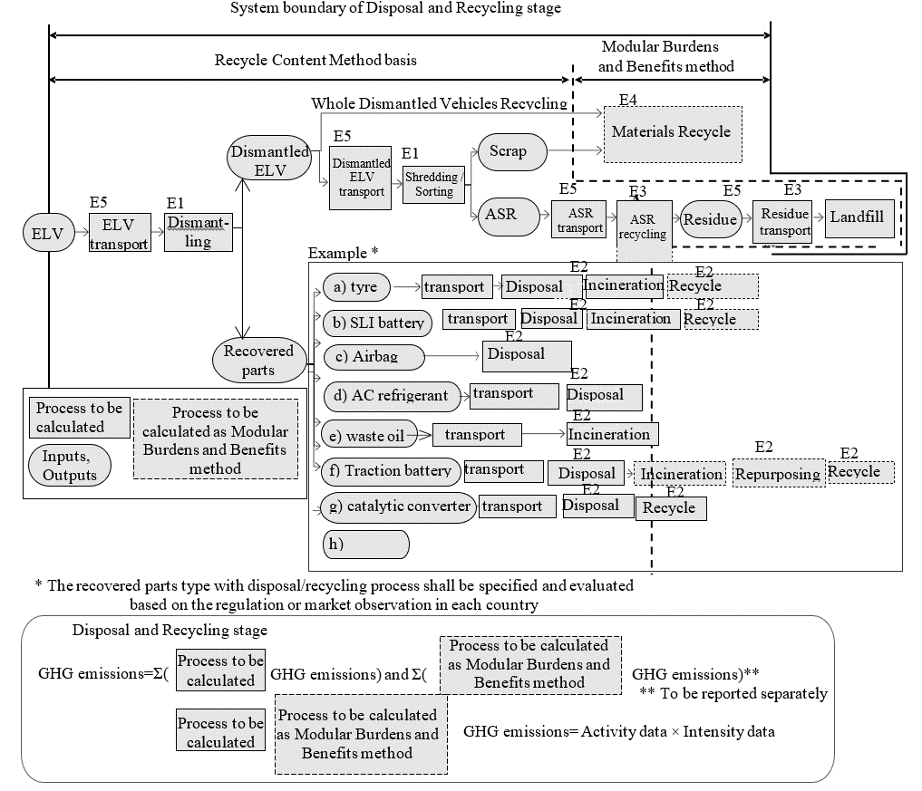

Data collection applies to the processes outlined below.

E1; End-of-life vehicle (ELV) dismantling and shredding/sorting process

E2; Recovered parts disposal and recycling process

E3; Automobile shredder residue (ASR) disposal and recycling process

E4; Materials recycling processes

E5; Transport processes

* + 1. Data collection and data types

Data shall be collected for the item outlined below. Activity data shall be collected as primary data in level 2 or 3 or 4. The secondary data may be applied to activity data in level 1. GHG emission intensity data shall be collected as primary or secondary data in all levels. Scenarios for secondary data and secondary data source shall be reported. Secondary data may be referred, among others, to the following data set.

1. Environmental Footprint (EF) compliant data sets
2. IDEA
3. JAMA CFP guideline

Table 21  
**Data types for disposal and recycling [stages] with each symbols**

| *Processes* | | | *Activity data* | *GHG emissions intensity data* |
| --- | --- | --- | --- | --- |
| *(Primary data basis)* | *(Secondary data basis)* |
| E1; End-of-life vehicle (ELV) dismantling and shredding/sorting process (CE1) | | | ･ELV Weight [kgcomponent] (WE1) | ･ELV dismantling and shredding/sorting [kgCO2eq/kg applicable ELV] (CD,E1) |
| E2; Recovered parts disposal and recycling process  Remarks)  The recovered parts type with disposal and recycling process shall be specified and evaluated based on the regulation or market observation in each country | a) Tyre　 (CE2a) | a-1) Disposal, Incineration  (CE2a-1) | ･Tyre weight [kgcomponent] (WE2a) ･Wearing ratio [%] (RE2a)  ･Weight fractions of each material in the tyre [kgmaterial/kgcomponent]  (TIi,E2a, TDi,E2a) | ･Tyre incineration with thermal and electricity recovery [kgCO2eq/kgmaterial] (CIi, E2a) and disposal [kgCO2eq/kgmaterial] (CDi, E2a) which may include residue landfill and transport. |
| a-2) Recycle  (CM,MBBM,E2a) | ･Material weight to which CFF is applied  [kgmaterial] (WMi,E2a) | ･Modular Burdens and Benefits method (MBBM) of each material [kgCO2eq/kgmaterial] (CMi,MBBM) |
| b) SLI battery 　(CE2b) | b-1) Disposal, Incineration  (CE2b-1) | ･SLI battery weight [kgcomponent] (WE2b)  ･Weight fractions of each material in the battery [kgmaterial/kgcomponent]  (TIi,E2b, TDi,E2b) | ･SLI battery incineration with thermal and electricity recovery [kgCO2eq/kgmaterial] (CIi, E2b) and disposal [kgCO2eq/kgmaterial] (CDi, E2b) which may include lead scrap treatment and electrolyte neutralisation treatment and transport. |
| b-2) Recycle  (CM,MBBM,E2b) | ･Material weight to which CFF is applied  [kgmaterial] (WMi,E2b) | ･MBBM of each material [kgCO2eq/kgmaterial] (CMi,MBBM) |
| c) Airbag (CE2c) | | ･Airbag weight [kg] [kgcomponent] (WE2c) | ･Airbag proper disposal [kgCO2eq/kgcomponent] (CD, E2c) |
| d) Air conditioner (AC) refrigerant (CE2d) | | ・AC refrigerant weight [kgmaterial], filled in air conditioner at vehicle production. (WE2d) | ･AC refrigerant (fluorocarbons) disposal [kgCO2eq/kgmaterial] (CD, E2d),, which may include fluorocarbons destruction, CO2 from destruction and transport |
| e) Waste oil (CE2e) | | ･Waste oil weight [kgmaterial] (WE2e) | ･Waste oil incineration with thermal and electricity recovery [kgCO2eq/kgmaterial] (CI, E2e) |
| f) Traction battery　 (CE2f) | f-1) Disposal, Incineration  (CE2f-1) | ･Used battery pack weight[kg] (WE2f)  ･Weight fractions of each material in the battery [kgmaterial/kgcomponent]  (TIi,E2f, TDi,E2f) | ･Used battery pack proper treatment which includes battery pack incineration (where allowable) with thermal and electricity recovery (CIi,E2f) and disposal (CDi, E2f) which may include residue landfill and transport. [kgCO2eq/kgmaterial] |
| f-2) Secondary use (Repurposing)  (CTBR,MBBM) | ･Number of Driving battery pack | ･MBBM for the battery repurposing[kgCO2eq/pack] (CTBR,MBBM) |
| f-3) Material recycle (CM,MBBM,E2f) | ･Material weight to which CFF is applied [kgmaterial] (WMi,E2f,Material) and battery cell weight to which CFF is applied [kg battery cells] (WE2f,Cells) | ･MBBM of each single material [kgCO2eq/kg Material] (CMi,MBBM) recovered from the battery disassembly process and sent to material recycling, and Modular Burdens and Benefits method of battery cells specific recycling process [kgCO2eq/kg battery cells] (C,MBBM, Cells), if applicable according to regional regulations |
| g) Catalytic converters (CE2g) | g-1) Disposal  (CE2g-1) | ･Catalytic converters weight [kgcomponent] (WE2g)  ･Weight fractions of each material in the converters [kgmaterial/kgcomponent]  (TDi,E2g) | ･Catalytic converters disposal [kgCO2eq/kgmaterial] (CDi, E2g), which may include residue landfill after recycling process |
| g-2) Material recycle  (CM,MBBM,E2g) | ･Material weight to which CFF is applied [kgmaterial] (WMi,E2g) | ･MBBM of each material [kgCO2eq/kgmaterial] (CMi,MBBM) |
| E3; Automobile shredder residue (ASR) disposal and recycling process(CE3) | ASR | | ･ASR combustible material material weight [kgmaterial] (Wi,ASR) | ･ASR incineration with thermal and electricity recovery [kgCO2eq/kgmaterial] (CIi,ASR) and disposal [kgCO2eq/kgmaterial] (CDi, ASR) which may include the residue landfill |
| Wood (mainly for truck/bus use) | | ･Wood material weight [kgmaterial] (Wi,Wood) | ･Wood incineration with thermal and electricity recovery [kgCO2eq/kgmaterial] (CIi, Wood) and disposal [kgCO2eq/kgmaterial] (CDi, Wood), not including CO2 absorption effect |
| E4; Materials recycling processes (CM,MBBM,E4) | | | ･Material weight to which CFF is applied  [kgmaterial] (WMi,E4) | ･MBBM of each material [kgCO2eq/kgmaterial] (CMi,MBBM) |
| E5; Transport processes (CE5) | | | ・Each transported goods weight [t] (Wi,E5)  ・Each transport distance [km] (Di,E5) | Transport per transport goods weight and per transport distance [kgCO2eq/t-km] (CTi) |

* + 1. Recycling modelling for second life parts

The second life parts for Remanufacturing, Reuse or Repurposing shall be evaluated in all levels based on regulation or market observation, data availability for parameters and verification criteria. In any case the second life parts traceability shall be confirmed with following recommendation of recycling modelling.

Table 22  
**Recycling modelling recommendations for second life**

| *Second life application* | *Definition* | *Recycling modelling Recommendation* |
| --- | --- | --- |
|  |  |  |
| 1. Remanufacturing | ELV parts recycling  to new vehicle parts | RCM |
| 2. Reuse | ELV parts recycling  to repair vehicle | RCM |
| 3. Repurposing | ELV parts recycling  to another function in other industries  e.g. Traction battery from EoL EV repurposed to the stationary battery in a building | CFF |

RCM formula for Remanufacturing or Reuse shall be referred to CM,RCM formula in 3.2.13.2 Material recycling modelling. CFF formula for Repurposing shall be referred to CM,MBBM formula in 3.2.13.2 Material recycling modelling and (f-2) Secondary use (Repurposing) of E2; (f) Traction battery in 4.4.8 GHG calculation for each process. The type of date for RCM or CFF parameter shall be confirmed according to the regulation or market observation.

* + 1. EoL emissions treatment of ELV exported out of region of sales

Ideally, the EoL GHG emissions of vehicles exported from the country where they were originally sold and used shall be evaluated based on the EoL processes of the country where they are eventually used and disposed/recycled. However, to avoid complexity, if the country to which the vehicle is exported cannot be tracked or the EoL process of the country where they were exported, used and disposed/recycled cannot be determined, a simplified approach can be adopted. In such cases, the EoL emissions may be evaluated using the process of the country where the vehicle was first registered and primarily used.

* + 1. Future recycling process and technology modelling

GHG emissions intensity for each disposal and recycling process and CFF parameters shall be set in view of the process and recycling technology about 13-17 years later in the future. For recycling, process data should be those available at the point of declaration of the vehicle (First time vehicle registration).When a specific recycling process does not yet exist, and assumptions on such a future process cannot be appropriately justified, a scenario based on the current process and recycling technology may be applied.

* + 1. Energy modelling

For general rules refer to paragraph ‎7.15.

* + - 1. Future Changes in Energy Mix

Practitioners shall also account for any expected changes in the fuel or electricity production pathways during the lifetime of the vehicle. (detailed methodology shall be considered)

Specifically, the following recommendations are made on how to model electricity inputs to the EoL phase:

* + - 1. EoL phase electricity

1. The same scenario for the expected future evolution of the electricity grid mix in the geographical region of interest shall be adopted, as previously selected for the dynamic modelling of the use phase electricity input in paragraph [x.x.x].

2. The grid mix composition for the specific year of vehicle decommissioning (i.e., year of vehicle registration + expected lifetime) shall be estimated (i.e., the shares Si,N of electricity supplied by each technology i in the year N), by applying linear interpolation between the respective electricity supply shares reported for the two nearest pre-defined time horizons in the scenario selected at point 1 above

3. A bespoke grid mix model shall be built using the grid mix composition calculated at point 2 above and leveraging the most up-to-date database processes available for the individual electricity generation technologies. The resulting grid mix thus modelled shall be used to estimate the Emission Factor of the electricity input to the EoL phase of the vehicle.

For dynamically evolving fuel mixes (e.g., “green”/”grey” hydrogen; bio/fossil diesel blends; etc.), a similar approach to the one described above for electricity should be employed, whereby the respective fuel mix models for the use phase and EoL phase are arrived at by considering the existing future scenarios. "

In case of the process in the EoL phase is not hot spot, the static energy modelling may be applied.

* + 1. GHG calculation for each process

The total GHG emission in EoL [stage] shall be calculated by the following equation.

CEoL = CE1 + ΣjCE2j + CE3 + CM,MBBM, E4 + CD,E5 (46)

Where;

CEoL  means the GHG emissions in EoL [stage] [kgCO2eq]

CE1  means the GHG emissions in ELV dismantling and shredding/sorting process [kgCO2eq]

CE2j  means the GHG emissions in each recovered parts disposal and recycling process [kgCO2eq]

CE3  means the GHG emissions in the automobile shredder residue (ASR) disposal and recycling process [kgCO2eq]

CM,MBBM, E4  means the GHG emissions in the materials recycling processes [kgCO2eq]

CD,E5  means the GHG emissions in the transport processes [kgCO2eq]

Each MBBM value in CEoL, which are CM,MBBM, CI,MBBM and CTBR,MBBM, shall be separately reported with the following equation.

CM,MBBM = ΣjCM,MBBM,E2j + CM,MBBM, E4 (47)

Where;

CM,MBBM means the specific GHG emissions in the total materials recycling processes [kgCO2eq]

CM,MBBM, E2j means the specific GHG emissions in each parts material recycling [kgCO2eq]

CM,MBBM, E4 means the specific GHG emissions in the materials recycling processes [kgCO2eq]

CI,MBBM = Σi,j(WE2j×TIi,E2,j×CIi,MBBM,E2j) + Σi,ASRorWood (Wi, ASRorWood×CIi,MBBM,ASRorWood ) (48)

Where;

CI,MBBM means the specific GHG emissions related to the credit obtainable by total material energy recovery process [kgCO2eq]

WE2j means each parts weight [kgcomponent]

TIi,E2j means each material weight fraction of each parts for the incineration [%]

CIi,MBBM,E2j means the specific GHG emissions related to the credit obtainable by the energy recovery process of each material in each parts calculated per MBBM for energy in kilogram of carbon dioxide equivalent per kilogram of material. [kgCO2e/kgmaterial]

Wi, ASRorWood means the weight of each combustible materials in ASR or wood material [kgmaterial]

CIi,MBBM,ASEorWood means the specific GHG emissions related to the credit obtainable by the energy recovery process of each combustible materials in ASR or wood calculated per MBBM for energy in kilogram of carbon dioxide equivalent per kilogram of material. [kgCO2e/kgmaterial]

CTBR,MBBM means the specific GHG emissions of traction battery repurposing [kgCO2eq]

* + - 1. E1; End-of-life vehicle (ELV) dismantling and shredding/sorting process

CE1 = WE1 × TE1 × CD,E1 (49)

Where;

CE1 means the GHG emissions in ELV dismantling and shredding/sorting process [kgCO2eq]

WE1 means the ELV weight [kgcomponent]

TE1 means the applicable ELV weight fraction of the ELV weight [%]

CD,E1 means the specific GHG emissions intensity for ELV arising from dismantling and shredding/sorting in kilogram of carbon dioxide equivalent per kilogram of the applicable ELV weight [kgCO2eq/kg applicable ELV]

* + - 1. E2; Recovered parts disposal and recycling process

The recovered parts type with disposal and recycling process shall be specified and evaluated based on the regulation or market observation in each country following GHG calculation example for each processes.

* + - * 1. Tyre

Disposal, Incineration

CE2a-1 = WE2a × (1- RE2a) × {Σi (TIi,E2a × CIi, E2a )+ Σi (TDi,E2a × CDi,E2a)} (50)

Where;

CE2a-1 means the GHG emissions in tyre incineration with thermal and electricity recovery (CI, E2a) and disposal (CD, E2a), which may include residue landfill and transport [kgCO2eq]

WE2a means the tyre weight [kgcomponent]

RE2a means the percentage of weight loss during total tyre wear based on calculations of tyre specifications [%].

TIi,E2a means the i-th material weight fraction of the tyre weight at EoL{WE2a×(1-RE2a)} that is sent to incineration [%]

TDi,E2a means the i-th material weight fraction of the tyre weight at EoL{WE2a×(1-RE2a)} that is sent to disposal [%]

CIi, E2a means the specific GHG emissions arising from incineration with energy recovery of tyre materials, expressed in kilogram of carbon dioxide equivalent per kilogram of material. [kgCO2eq/kgmaterial]

CDi,E2a means the specific GHG emissions arising from the disposal of tyre materials, expressed in kilogram of carbon dioxide equivalent per kilogram of material. [kgCO2eq/kgmaterial]

CIi,E2a and CDi,E2a shall be evaluated following paragraphs [3.2.13.2 and 3.2.13.3 ].

Recycle

CM,MBBM,E2a = (1- RE2a) × Σi (WMi,E2a × CMi,MBBM) (51)

Where;

CM,MBBM,E2a means the specific GHG emissions in tyre materials recycling [kgCO2eq]

WMi,E2a means each tyre material weight to which CFF is applied [kgmaterial]

CMi,MBBM means the specific GHG emissions of a tyre material calculated with the MBBM in kilogram of carbon dioxide equivalent per kilogram of material. [kgCO2eq/kgmaterial]

CMi,MBBM shall be evaluated following paragraph [3.2.13.1].

* + - * 1. SLI battery

Disposal, Incineration

CE2b-1 = WE2b × {Σi (TIi,E2b × CIi, E2b )+ Σi (TDi,E2b × CDi,E2b)} (52)

Where;

CE2b-1 means the GHG emissions in SLI battery incineration with thermal and electricity recovery (CI, E2b) and disposal (CD, E2b), which may include lead scrap treatment, electrolyte neutralisation treatment and transport [kgCO2eq]

WE2b means the weight of the SLI battery [kgcomponent]

TIi,E2b means the i-th material weight fraction of the SLI battery weight that is sent to incineration [%]

TDi,E2b means the i-th material weight fraction of the SLI Battery weight that is sent to disposal [%]

CIi, E2b means the specific GHG emissions arising from incineration with energy recovery of SLI battery materials, expressed in kilogram of carbon dioxide equivalent per kilogram of material. [kgCO2eq//kgmaterial]

CDi,E2b means the specific GHG emissions arising from the disposal of SLI battery materials, expressed in kilogram of carbon dioxide equivalent per kilogram of material. [kgCO2eq/kgmaterial]

CIi, E2b and CDi,E2b shall be evaluated following paragraphs [3.2.13.2 and 3.2.13.3].

Recycle

CM,MBBM,E2b = Σi (WMi,E2b × CMi,MBBM) (53)

Where;

CM,MBBM,E2b means the specific GHG emissions in SLI battery materials recycling [kgCO2eq]

WMi,E2b means the weight of each SLI battery material to which CFF is applied [kgmaterial]

CMi,MBBM means the specific GHG emissions of a SLI battery material calculated with the MBBM in kilogram of carbon dioxide equivalent per kilogram of material. [kgCO2eq/kgmaterial]

CMi,MBBM shall be evaluated following paragraph [3.2.13.1].

* + - * 1. Airbag

CE2c = WE2c × CD,E2c (54)

Where;

CE2c means the GHG emissions in Airbag disposal [kgCO2eq]

WE2c means the weight of the Airbag(s) [kgcomponent]

CD,E2d means the specific GHG emissions of airbag arising from the proper disposal in kilogram of carbon dioxide equivalent per kilogram of airbag. [kgCO2eq/kgcomponent]

* + - * 1. Air conditioner (AC) refrigerant

CE2d = WE2d × CD,E2d (55)

Where;

CE2d means the GHG emissions in AC refrigerant disposal [kgCO2eq]

WE2d means the weight of the AC refrigerant, filled in air conditioner at vehicle production. [kgmaterial]

CD,E2d means the specific GHG emissions of AC refrigerant arising from the disposal in kilogram of carbon dioxide equivalent per kilogram of material., which may include fluorocarbons destruction, CO2 from destruction and transport. [kgCO2eq/kgmaterial]

CD,E2d shall be evaluated following paragraph [3.2.13.3].

* + - * 1. Waste Oil

CE2e = WE2e × CI, E2e (56)

Where;

CE2e means the GHG emissions in waste oil incineration with thermal and electricity recovery [kgCO2eq]

WE2e means the weight of waste oil [kgmaterial]

CI, E2e means the specific GHG emissions of waste oil arising from incineration with energy recovery in kilogram of carbon dioxide equivalent per kilogram of material. [kgCO2eq/kgmaterial]

CI, E2e shall be evaluated following paragraph [3.2.13.2]

* + - * 1. Traction battery

Disposal, Incineration

CE2f-1 = (1- RE2f-2 - RE2f-3) × WE2f × {Σi (TIi,E2f × CIi, E2f )+ Σi (TDi,E2f × CDi,E2f)} (57)

Where;

CE2f-1 means the GHG emissions in used battery pack proper treatment which includes battery pack incineration (where allowable) with thermal and electricity recovery (CI, E2f) and disposal (CD, E2f) which may include residue landfill and transport [kgCO2eq]

RE2f-2 means the (F-2) battery repurposing ratio [%]

RE2f-3 means the (F-3) battery material recycling ratio [%]

WE2f means the weight of the used battery pack [kgcomponent]

TIi,E2f means the i-th material weight fraction of the traction battery weight at EoL{(1-RE2f-2-RE2f-3)×WE2f}that is sent to incineration [%]

TDi,E2f means the i-th material weight fraction of the traction battery weight at EoL{(1-RE2f-2-RE2f-3)×WE2f}that is sent to disposal [%]

CIi, E2f means the specific GHG emissions arising from incineration with energy recovery of traction battery materials, expressed in kilogram of carbon dioxide equivalent per kilogram of material. [kgCO2eq/kgmaterial]

CDi,E2f means the specific GHG emissions arising from the disposal of traction battery materials, expressed in kilogram of carbon dioxide equivalent per kilogram of material. [kgCO2eq/kgmaterial]

CIi, E2f and CDi,E2f shall be evaluated following paragraphs [3.2.13.2 and 3.2.13.4].

Secondary use (Repurposing)

The repurposing of the traction battery shall be specified and evaluated based on the regulation or market observation, data availability for parameters and verification criteria.

Battery repurposing Environmental Footprint (EF) compliant studies shall follow EF recommendations and regional regulations. Battery repurposing for other studies/other regions can follow other recommendations (e.g., the JAMA CFP guidelines)

Strong evidence shall be provided by the industry and the practitioner about the definition of the parameters, the definition of the new product substituted by the repurposed one, and the source of data to be used for modelling

In the case of applying the UNECE A-LCA CFF concept to the repurposing of the traction battery from the vehicle substituting a virgin battery into a different application, the evaluation will be based on the regulation or market observation, and the availability of data for parameters and verification criteria.

The evaluation will consist of two parts, each corresponding to the CFF components outlined in the CFF equation in paragraph ‎7.18.1.

The production burden for the traction battery, which corresponds to CFF part 1, will be evaluated in the production [stage] of the traction battery. The burdens and benefits related to the output of secondary batteries, corresponding to CFF part 3, will be evaluated in the disposal and recycling [stage] as the Modular Burdens and Benefits method for traction battery repurposing. The value derived from the Modular Burdens and Benefits method for traction battery repurposing will be integrated with the values from other Modular Burdens and Benefits methods. The total value of the Modular Burdens and Benefits method shall be reported and included in the total vehicle CFP.

Modular Burdens and Benefits Method formula for traction battery repurposing

(58)

Where;

means the specific GHG emissions of traction battery repurposing in kilogram of carbon dioxide equivalent per kilogram of battery pack. [kgCO2eq/battery pack]

TBR means the allocation factor of burdens and credits between supplier and user of repurposed battery.

means the proportion of the battery at EoL that will be reused in a subsequent system. [%]

means the quality of outgoing secondary traction battery / quality of virgin battery substituted by the repurposed battery

means the specific GHG emissions (per unit of analysis) arising from the production of virgin battery that is going to be substituted by the repurposed battery. [kgCO2eq/battery pack]

means the specific GHG emissions (per unit of analysis) arising from the recycling process at EoL, including collection, sorting and transportation process. [kgCO2eq/battery pack]

Datasets () to be used in the Modular Burdens and Benefits method for the traction battery repurposing may be collected as primary data. Parameters in the Modular Burdens and Benefits Method for traction battery repurposing (TBR) may be defined as default values in reference documents.

Material recycle

CM,MBBM,E2f = Σi (WMi,E2f,Material × CMi,MBBM,Material) + Σi (WE2f,cells × CMBBM,Cells) (59)

Where;

CM,MBBM,E2f means the specific GHG emissions arising from traction battery materials recycling. [kgCO2eq/kg]

WMi,E2f,Material means the weight of each traction battery material to which CFF is applied except battery cells. [kg]

WE2b,cells means the weight of traction battery cells derived from battery pack dismantling to which CFF is applied. [kg]

CMi,MBBM,Material means the specific GHG emissions arising from of the material recycling of a traction battery pack material except for material in cells calculated with the MBBM in kilogram of carbon dioxide equivalent per kilogram of material. [kgCO2eq/kgmaterial]

CMBBM,Cells means the specific GHG emissions arising from the recycling process applied to traction battery cells calculated with the MBBM in kilogram of carbon dioxide equivalent per kilogram of traction battery cells. [kgCO2eq/kgbattery cells]

CMi,MBBM,Material or Cells shall be evaluated following paragraph [3.2.13.1].

In case that the used battery is repurposed, the recycle of the material which is used in the repurposed traction battery shall not be evaluated.

* + - * 1. Catalytic converters

Disposal

CE2g-1 = WE2g × TDi,E2g × CDi,E2g (60)

Where;

CE2g-1 means the GHG emissions in catalytic converters disposal, which may include residue landfill after recycling process. [kgCO2eq]

WE2g means the weight of the catalytic converters [kgcomponent]

TDi,E2g means the i-th material weight fraction of the catalytic converters weight that is sent to disposal [%]

CDi,E2g means the specific GHG emissions arising from the disposal of catalytic converters materials, expressed in kilogram of carbon dioxide equivalent per kilogram of material. [kgCO2eq/kgmaterial]

CDi,E2g shall be evaluated following paragraph [3.2.13.3].

Recycle

CM,MBBM,E2g = Σi (WMi,E2g × CMi,MBBM) (61)

Where;

CM,MBBM,E2g means the specific GHG emissions in catalytic converters materials recycling [kgCO2eq]

WMi,E2g means the weight of each catalytic converters material to which CFF is applied [kgmaterial]

CMi,MBBM means the specific GHG emissions of a catalytic converters material calculated with the MBBM in kilogram of carbon dioxide equivalent per kilogram of material. [kgCO2eq/kgmaterial]

CMi,MBBM shall be evaluated following paragraph [3.2.13.1]

* + - 1. E3; Automobile shredder residue (ASR) disposal and recycling process

CE3 = Σi{Wi,ASR × ( CIi, ASR + CDi, ASR )}+ Σi{WI, Wood × (CIi, Wood + CDi, Wood)} (62)

Where;

CE3 ; means the GHG emissions in ASR incineration with thermal and electricity recovery (CI, ASR) and disposal (CD, ASR), which may include the residue landfill and the transport [kgCO2eq]

Wi, ASR means the weight of each combustible material in ASR [kgmaterial]

Wi,, Wood means the weight of each wood material [kgmaterial]

CIi, ASR means the specific GHG emissions arising from incineration with energy recovery of combustible materials in ASR, expressed in kilogram of carbon dioxide equivalent per kilogram of material. [kgCO2eq/kgmaterial]

CIi, Wood means the specific GHG emissions arising from incineration with energy recovery of wood materials, expressed in kilogram of carbon dioxide equivalent per kilogram of material. [kgCO2eq/kgmaterial]

CDi, ASR means the specific GHG emissions arising from the disposal of combustible materials in ASR, expressed in kilogram of carbon dioxide equivalent per kilogram of material. [kgCO2eq/kgmaterial]

CDi, Wood means the specific GHG emissions arising from the disposal of wood materials, expressed in kilogram of carbon dioxide equivalent per kilogram of material. [kgCO2eq/kgmaterial]

CIi,ASR or Wood, and CDi,ASR or Woodshall be evaluated following paragraphs [3.2.13.2 and 3.2.13.3].

* + - 1. E4; Materials recycling processes

CM,MBBM,E4 = Σi (WMi,E4 × CMi,MBBM) (63)

Where;

CM,MBBM,E4 means the specific GHG emissions in materials recycling [kgCO2eq]

WMi,E4 means the weight of each material to which CFF is applied [kgmaterial]

CMi,MBBM means the specific GHG emissions of a material calculated with the MBBM in kilogram of carbon dioxide equivalent per kilogram of material. [kgCO2eq/kgmaterial]

CMi,MBBM shall be evaluated following paragraph [3.2.13.1].

* + - 1. E5; Transport processes

CE5 = Σi ( Wi,E5 × Di,E5 × CTi) (64)

Where;

CE5 means the specific GHG emissions in transport processes [kgCO2eq]

Wi,E5 means the weight of each transported goods [t]

Di,E5 means each transport distance [km]

CTi means specific GHG emissions arising from a transport in kilogram of carbon dioxide equivalent per ton of transport goods and per kilometre of transport distance. [kgCO2eq/t-km]

Transport processes in disposal and recycling [stage] may cover following transport processes.

1. Dealer → Dismantler
2. Dismantler → Shredder
3. Shredder → ASR recycler
4. ASR recycler → Landfill

Di,E5 and CTi shall be evaluated according to paragraph [3.2.14].

1. Reporting

[The results of the A-LCA based on this Resolution shall be completely and accurately reported without bias to the intended audience and in accordance with paragraph 6 “Reporting” of ISO 14040: 2006. The results, data, methods, assumptions and limitations described in the background report shall be transparent and presented in sufficient detail to allow the reader to comprehend the complexities and trade-offs inherent in the LCA. For all levels of the level concept, this background report is the basis for critical review / verification. Additionally, the following information shall be described within the background report and in a summary report whenever the results of the A-LCA are available to the public.

Table 23  
**Required information in the report when LCA results are available in the public**

|  |  |  |  |  |  |  |  |  |  |  |  |  |
| --- | --- | --- | --- | --- | --- | --- | --- | --- | --- | --- | --- | --- |
| General information | | | | | | | |  | | | | |
|  | practitioner | | | | | | |  | | | | |
| date of report | | | | | | |  | | | | |
| Goal of the study: | | | | | | | |  | | | | |
|  | reasons for carrying out the study; | | | | | | |  | | | | |
|  | its intended applications; | | | | | | |  | | | | |
|  | the target audiences; | | | | | | |  | | | | |
| Applicable Methodology Level | | | | | | | | 1/2/3/4 | | | | |
| Vehicle configuration (Level 3&4) | | | | | | | |  | | | | |
|  | Declared vehicle configuration | | | | | | |  | | | | |
| Mass without traction battery | | | | | | |  | | | | |
| Battery configuration | | | | | | |  | | | | |
| LCA group ID | | | | | | |  | | | | |
| Results (t CO2eq\_xxx/veh.) | | | | | | | | 123456 | | | | |
|  | Material production [stage] | | | | | | |  | | | | |
| Parts production and vehicle assembly [stage] | | | | | | |  | | | | |
| Use [stage] | | | | | | |  | | derived from | | |
|  | Fuel/Electric consumption | | | | | |  | | homologation | | |
| Discrepancy factor | | | | | |  | |  | | |
| Deterioration factor | | | | | |  | |  | | |
| Service life | | | | | |  | |  | | |
| Emission factor | | | | | |  | | | | |
|  | | Modelling | | | | Statistic/dynamic/dispatch | | | | |
| Database, if applicable | | | |  | | | | |
|  | | | | |
| Leakage | | | | | |  | | | | |
| Maintenance | | | | | |  | | | | |
| End of Life [stage] | | | | | | |  | | | | |
| MBBM (Material, Energy, Battery repurposing) | | | | | | |  | | | | |
| Batteries | | | | | | | (Least terms of specifications of Batteries) | | | | |
|  |  | | | | | |  | | | | |
|  | | | | | |  | | | | |
|  | | | | | |  | | | | |
|  | | | | | |  | | | | |
| Representative vehicle | | | | | | | |  | | | | |
|  | Configuration | | | | | | |  | | | | |
| Mass without traction battery | | | | | | |  | | | | |
| Results of RV without traction battery | | | | | | | |  | | | | |
|  | Material production [stage]: | | | | | | |  | | | | |
|  | System boundaries | | | | | |  | | | | |
| Cut-off items and its effect | | | | | |  | | | | |
| Applicable recycling modelling | | | | | |  | | | | |
| In case of CFF application, CFF applied material type | | | | | |  | | | | |
| Applicable material type sent to incineration with energy recovery | | | | | |  | | | | |
| Applicable future recycling process and technology modelling | | | | | |  | | | | |
| Applicable Energy modelling | | | | | |  | | | | |
| Carbon intensity for Energy | | | | | |  | | | | |
| Applicable secondary data base or set name | | | | | |  | | | | |
| Validated by xxx | | | | | |  | | | | |
| list up at least 97% of “6.2)”  Data Sources (DS) and its Weighting Factors (WF)  Provide the evidence and the third-party validation in the case that primary data is applied | | | | | | | | | | | |
|  | material | Mass (kg) | | Factor  (CO2eq/km) | DS1 | WF1 | | DS2 | | WF2 | Notes |
| ex) steel | 1,250 | | xxx | IDEA | 0.75 | | XX | | 0.25 |  |
|  |  | |  |  |  | |  | |  |  |
|  |  | |  |  |  | |  | |  |  |
|  |  | |  |  |  | |  | |  |  |
| Parts production and vehicle assembly [stage] | | | | | | | | | | | |
|  | System boundaries | | | | | |  | | | | |
| Cut-off items and its effect | | | | | |  | | | | |
| Carbon intensity for Energy | | | | | |  | | | | |
| Validated by | | | | | |  | | | | |
| Provide the evidence and the third-party validation in the case that primary data is applied | | | | | | | | | | | |
| End of Life [stage] | | | | | | | | | | | |
|  | Applicable method | | | | | |  | | | | |
| System boundaries | | | | | |  | | | | |
| Cut-off items and its effect | | | | | |  | | | | |
| Carbon intensity for Energy | | | | | |  | | | | |
| Applicable secondary data base or set name | | | | | |  | | | | |
| Validated by xxx | | | | | |  | | | | |
| Provide the evidence and the third-party validation in the case that primary data is applied | | | | | | | | | | | |

As outlined in ISO 14044, data quality considerations and uncertainty shall be documented in the study summary report and assessed using a suitable methodology such as those described by ILCD[[45]](#footnote-46), ecoinvent, and U.S. EPA[[46]](#footnote-47) [[47]](#footnote-48).]

1. Verification process

Verification shall be conducted to confirm that the results of the A-LCA have been obtained in accordance with this Resolution while ensuring transparency and consistency. Therefore, for A-LCA studies of level 1, 2, 3 and 4 a critical review shall be conducted according to ISO 14040:2006 paragraph 7 („Critical Review“) with additional focus on compliance with this Resolution. The verification statement shall be available on the report of A-LCA studies intended for publication .

Verification thus refers to

1. methodology applied,
2. input data used,
3. interpretation of results,
4. interpretation of robustness of the study
5. reporting of these topics in the background report and
6. check of the numerical results of the calculation.

For Level 1 and 2, LCA practitioners should decide whether to perform an internal or external critical review in accordance with ISO 14040:2006 paragraph 7 whereas for Level 3 and 4 an external third-party review is mandatory. [For Level 3 and 4, the verification shall be conducted at the OEM level (i.e. vehicle assembly and production at OEM enterprises) and shall include the definition of the LCA group and the choice of the representative vehicle for which the OEM declares a CFP value. Verification at the OEM level shall build on verifications of suppliers’ input data without re-verifying these data.] The verification of the OEM's LCA calculation system shall include data collection, internal sources, assumptions, calculation processes and tools applied. In case an LCA calculation system is verified and that verification is still valid, no reverification of the system is required for an LCA study based on the verified LCA calculation system. OEMs shall make the system verification statements available to the contracting parties’ according to their requests. The same holds true for suppliers who are responsible for providing data in accordance with this [Mutual] Resolution.

[In the case that no verification body has been nominated by the Contracting Party to the UNECE secretariat, the current practice referring to ISO should be continued.]

Annex

Service life (in km and years) values for European countries

| *Region / Country* | *Year* | *Duration*  *(Years)* | *Source* |
| --- | --- | --- | --- |
|  |  |  |  |
| Belgium | 2023 | 18.5 | [Febelauto (2023), rapport annuel 2023 *(Febelauto is the extended producer responsibility organization for vehicles in Belgium)*](https://urldefense.com/v3/__https:/www.febelauto.be/rapportannuel2023/chiffres-cles-vehicules-hors-d-usage.html__;!!DOxrgLBm!EZu9Z_zxq39CVwSFNGRMbY8VBNolYXfI0SxW1f7WFWWbg4-vGSaHVd5r4xGdtvjmUVI74M_rSymdgt4BCWJjGQGkLY8LEJE$) |
| Finland | 2024 | 22.8 | [Finnish Information Centre of Automobile Sector (2025), based on Statistics Finland](https://urldefense.com/v3/__https:/www.aut.fi/en/statistics/statistics_of_scrapped_vehicles/average_scrapping_age_of_passenger_cars__;!!DOxrgLBm!EZu9Z_zxq39CVwSFNGRMbY8VBNolYXfI0SxW1f7WFWWbg4-vGSaHVd5r4xGdtvjmUVI74M_rSymdgt4BCWJjGQGkDg4zfHk$) |
| France | 2022 | 19.8 | [Agence de l'environnement et de la maîtrise de l'énergie (2024), Véhicules : données 2022](https://urldefense.com/v3/__https:/librairie.ademe.fr/economie-circulaire-et-dechets/7602-vehicules-donnees-2022.html__;!!DOxrgLBm!EZu9Z_zxq39CVwSFNGRMbY8VBNolYXfI0SxW1f7WFWWbg4-vGSaHVd5r4xGdtvjmUVI74M_rSymdgt4BCWJjGQGkDgBXkpA$) |
| Germany | 2022 | 18.6 | [Federal Ministry for the Environment and Umweltbundesamt (2024), Jahresbericht über die Altfahrzeug-Verwertungsquoten in Deutschland im Jahr 2022](https://urldefense.com/v3/__https:/www.bmuv.de/download/jahresberichte-ueber-die-altfahrzeug-verwertungsquoten-in-deutschland__;!!DOxrgLBm!EZu9Z_zxq39CVwSFNGRMbY8VBNolYXfI0SxW1f7WFWWbg4-vGSaHVd5r4xGdtvjmUVI74M_rSymdgt4BCWJjGQGk4RxaejI$) |
| Netherlands | 2023 | 19.6 | [Auto Recycling Nederland (2024), Highlights of the Sustainability Report 2023 *(ARN covers 84% of vehicles recycled in the Netherlands)*](https://urldefense.com/v3/__https:/duurzaamheidsverslag2023.arn.nl/en/__;!!DOxrgLBm!EZu9Z_zxq39CVwSFNGRMbY8VBNolYXfI0SxW1f7WFWWbg4-vGSaHVd5r4xGdtvjmUVI74M_rSymdgt4BCWJjGQGkikdnc9w$) |
| Portugal | 2022 | 23.8 | [Portuguese Environment Agency (2024), Reporte de Qualidade VFV 2022](https://urldefense.com/v3/__https:/apambiente.pt/residuos/reporte-comunitario__;!!DOxrgLBm!EZu9Z_zxq39CVwSFNGRMbY8VBNolYXfI0SxW1f7WFWWbg4-vGSaHVd5r4xGdtvjmUVI74M_rSymdgt4BCWJjGQGkJc_MoDY$) |
| Spain | 2023 | 21.1 | [SIGRAUTO *(Spanish Association for the Environmental Treatment of End-of-Life Vehicles)*](https://urldefense.com/v3/__https:/www.sigrauto.com/cuantos-vehiculos-fuera-de-uso-se-tratan-al-ano/antiguedad-vehiculos__;!!DOxrgLBm!EZu9Z_zxq39CVwSFNGRMbY8VBNolYXfI0SxW1f7WFWWbg4-vGSaHVd5r4xGdtvjmUVI74M_rSymdgt4BCWJjGQGkEKqbvX0$) |

1. \* In accordance with the programme of work of the Inland Transport Committee for 2025 as outlined in proposed programme budget for 2025 (A/79/6 (Sect. 20), table 20.6), the World Forum will develop, harmonize and update UN Regulations in order to enhance the performance of vehicles. The present document is submitted in conformity with that mandate. [↑](#footnote-ref-2)
2. https://www.ipcc.ch/site/assets/uploads/2018/02/ipcc\_wg3\_ar5\_chapter8.pdf [↑](#footnote-ref-3)
3. [missing reference] [↑](#footnote-ref-4)
4. https://pfa-auto.fr/wp-content/uploads/2023/04/DT\_Me%CC%81thodologie\_2023\_V15\_ENGLISH.pdf [↑](#footnote-ref-5)
5. https://webshop.vda.de/VDA/en/vda-900-100-082022 [↑](#footnote-ref-6)
6. https://www.jama.or.jp/operation/ecology/LCA/pdf/JAMA\_guidelines\_CFP\_2024\_en.pdf [↑](#footnote-ref-7)
7. ISO 14040, Feb. 2021 [↑](#footnote-ref-8)
8. WBCSD Pathfinder [↑](#footnote-ref-9)
9. PEF guidelines (EC-JRC, 2021) [↑](#footnote-ref-10)
10. ILCD Handbook - General guide on LCA [↑](#footnote-ref-11)
11. Adapted from PEF guidelines (EC-JRC, 2021) [↑](#footnote-ref-12)
12. ISO 14067, Feb. 2019 [↑](#footnote-ref-13)
13. ISO 14021 [↑](#footnote-ref-14)
14. ISO 14050:2020 [↑](#footnote-ref-15)
15. EC recommendation 2021/2279 Annex I [↑](#footnote-ref-16)
16. ISO 5157:2023 [↑](#footnote-ref-17)
17. adapted from TFS PCF Guideline and in reference to ISO 14067 6.3.4.2 System boundary options [↑](#footnote-ref-18)
18. Adapted from ISO 14040:2006/44 and ILCD handbook [↑](#footnote-ref-19)
19. ISO 59004 [↑](#footnote-ref-20)
20. EN 15804 [↑](#footnote-ref-21)
21. ISO 14040 : 2006 [↑](#footnote-ref-22)
22. adapted from GHG Protocol [↑](#footnote-ref-23)
23. GHG Protocol [↑](#footnote-ref-24)
24. adapted from WBCSD Pathfinder [↑](#footnote-ref-25)
25. Adapted from ISO 14040:2006/44 [↑](#footnote-ref-26)
26. IPCC Glossary [↑](#footnote-ref-27)
27. Catena-X PCF Rulebook V2 [↑](#footnote-ref-28)
28. ISO 21067: 2007 [↑](#footnote-ref-29)
29. Adapted from ISO 14067: 2019 [↑](#footnote-ref-30)
30. Weidema, B. P., et al. (2008). "Overview of the Recycling Credit Method." International Journal of Life Cycle Assessment. [↑](#footnote-ref-31)
31. Renewable Energy Directive (2018/2001) [↑](#footnote-ref-32)
32. ISO 14025, Oct. 2011 [↑](#footnote-ref-33)
33. ILCD handbook [↑](#footnote-ref-34)
34. Barthel, M., Fava, J., James, K., Hardwick, A., & Khan, S. (2017). Hotspots Analysis: An overarching methodological framework and guidance for product and sector level application. United Nations Environment Programme: Paris, France. <https://www.lifecycleinitiative.org/library/hotspots-analysis-an-overarching-methodological-framework-and-guidance-for-product-and-sector-level-application/> [↑](#footnote-ref-35)
35. Batteries for starting-lighting-ignition (SLI) and auxiliary applications only - does not apply to primary battery packs used for electric-drive powertrains [↑](#footnote-ref-36)
36. Life Cycle Assessment of Electricity Generation Options | UNECE [↑](#footnote-ref-37)
37. www.greet.anl.gov for the model and reports [↑](#footnote-ref-38)
38. Ricardo study: Determining the environmental impacts of conventional and alternatively fuelled vehicles through LCA, Section A1.1.2.1 Figure A13 [↑](#footnote-ref-39)
39. CATARC study: Exemplary research cases of the different levels and Hotspot analysis, LCA-SG3-04-03 [↑](#footnote-ref-40)
40. <https://ens.dk/sites/ens.dk/files/Affald/guidance_on_the_interpretation_of_key_provisions_on_waste.pdf> [↑](#footnote-ref-41)
41. While the term "deterioration factor" is commonly used for emissions certification, note that emissions deterioration may be expressed as a multiplicative term, an additive term, or a complex polynomial [↑](#footnote-ref-42)
42. <https://unece.org/sites/default/files/2023-01/ECE_TRANS_180a22e.pdf> [↑](#footnote-ref-43)
43. As also previously implemented in (Ricardo et al., 2020) based on consultation with stakeholders. [↑](#footnote-ref-44)
44. [FCH 2 JU - MAWP Key Performance Indicators (KPIs) - European Commission (europa.eu)](https://www.clean-hydrogen.europa.eu/knowledge-management/strategy-map-and-key-performance-indicators/fch-2-ju-mawp-key-performance-indicators-kpis_en) [↑](#footnote-ref-45)
45. European Commission. (2010). ILCD handbook: General guide for Life cycle Assessment - Detailed guidance. Italy: European Union. [↑](#footnote-ref-46)
46. U.S. EPA. (2016). Guidance on Data Quality Assessment for Life Cycle Inventory Data. EPA Document No. EPA/600/R-16/096. <https://nepis.epa.gov/Exe/ZyPDF.cgi/P100R8JX.PDF?Dockey=P100R8JX.PDF> [↑](#footnote-ref-47)
47. U.S. EPA. (2024). Data Quality Assessment Method to Support the Label Program for Low Embodied Carbon Construction Materials (Version 1). <https://www.epa.gov/system/files/documents/2024-08/dqa-method_v2_final.pdf> [↑](#footnote-ref-48)