 | United Nations | ECE/TRANS/WP.29/2025/134
 | Economic and Social Council |  | Distr.: General  20 August 2025  Original: English
Economic Commission for Europe
Inland Transport Committee
World Forum for Harmonization of Vehicle Regulations
197th session
Geneva, 11–14 November 2025
Item 4.9.15 of the provisional agenda
1958 Agreement:
Consideration of draft amendments to existing
UN Regulations submitted by GRSP

Proposal for supplement 1 to the 01 series of amendments to UN Regulation No. 173 (Installation of occupant restraint systems)

Submitted by the Working Party on Passive Safety*
The text reproduced below was adopted by the Working Party on Passive Safety (GRSP) at its seventy-seventh session (ECE/TRANS/WP.29/GRSP/77, paragraph 34). It is based on informal document GRSP-77-55 (as reproduced in annex VII of the report). It is submitted to the World Forum for Harmonization of Vehicle Regulations (WP.29) and to the Administrative Committee (AC.1) for consideration at their November 2025 sessions.

Annex 6, appendix 1, figures 1 to 3, amend to read:
"Figure 1
Specifications of the fixture (all dimensions in mm)

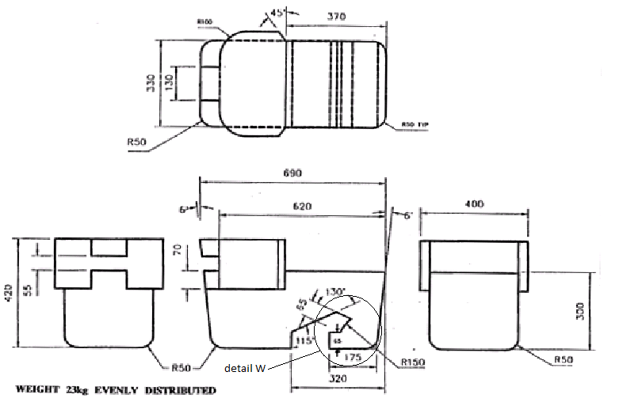
Weight: 23 kg, evenly distributed

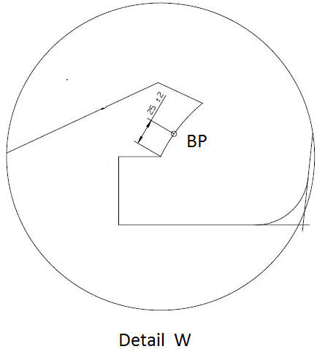
Detail W
Figure 2 Figure 3
Installation of fixture onto vehicle seat Check for compatibility
(see paragraph 2.6.1.) (see paragraphs 2.6.1. and 3.2)

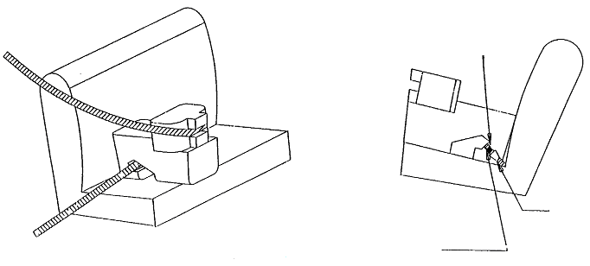
Lap belt only shown
Tongue
Buckle
"
Annex 6, appendix 2, paragraphs 4.1. to 4.6., amend as follows:
(a) Delete the spurious paragraph numbers before the figure headings.
(b) Amend item 2 of the keys to read: "2 Dashed line marks area where a support leg is allowed to protrude".
(c) In item 4 of the keys, at the end, add "/UN Regulation No. 129".
Annex 6, appendix 2, paragraph 4.7., amend to read as follows:
"4.7. Rearward-facing toddler child restraint system envelope
Figure 7
ISO/R2X Envelope dimensions of a Reduced-Size Rearward Facing toddler CRS, modified for improved compatibility with the vehicle interior
[…]
(all dimensions in mm)
Key
[…]
4 For further specifications of the connector area, see UN Regulation No. 44/UN Regulation No. 129
4.8. Lateral facing child restraint systems envelope
Figure 8
[…]
(all dimensions in mm)
Key
1 Limits in the rearward and upward directions
2 Dashed lines mark the area where an anti-rotation device, or similar (e.g. rebound bar), is allowed to protrude
3 For further specifications of the connector area, see UN Regulation No. 44/UN Regulation No. 129
4.9. i-Size support leg
Figure 9
[…]
(all dimensions in mm)
[…]
4.10. i-Size support leg installation assessment volume
Figure 10
[…]
(all dimensions in mm)
[…]"

* In accordance with the programme of work of the Inland Transport Committee for 2025 as outlined in proposed programme budget for 2025 (A/79/6 (Sect. 20), table 20.6), the World Forum will develop, harmonize and update UN Regulations in order to enhance the performance of vehicles. The present document is submitted in conformity with that mandate.

