Proposal for the 01 series of amendments to UN Regulation No. 170 (Child restraint systems for safer transport of children in buses and coaches)
The text reproduced below has been prepared by the Informal Working Group on the Safe Transport of Children in Buses and Coaches to align the text of the UN Regulations covering adult and child safety. The modifications to the current text of the UN Regulation are marked in bold for new or strikethrough for deleted characters.

I. Proposal
1. Introduction, amend to read:

A Child Restraint System (CRS) approved according to UN Regulation No. 129 or UN Regulation No.44 which can be installed in vehicle seats using the 3-point belt type and/or ISOFIX attachments can may be used in coaches and buses without further requirements.
The requirements defined in Part I of this UN Regulation do not apply to CRS approved according to UN Regulation No. 129 or UN Regulation No.44.

In case the vehicle seat is also intended to be used by an adult, the vehicle seats and its safety-belt anchorages shall be approved according to UN Regulation No. 14 and UN Regulation No. 80 or UN Regulation No. 17 if applicable.

2. Scope, amend to read:

This Regulation applies:
2.1 Part I: to Built-in Child Restraint Systems installed in vehicles of categories M₂ and M₃ class B and class III 1 with regards to the securing of children from 40 – 150 cm in forward facing and rearward facing vehicle seats.
At the request of the manufacturer, this Regulation may also apply to any Built-in Child Restraint Systems installed in vehicles of categories M₂ or M₃ of classes I, II and A¹.

Insert a new paragraph 2.2., to read:

2.2 Part II: to Child Restraint Systems approved according to UN Regulation No. 129 or UN Regulation No.44 which may be installed to a bus seat by 2-point belt in vehicles of categories M₂ and M₃ class B and class III¹ with regards to the securing of children from 40 – 150 cm in forward facing and rearward facing vehicle seats.

At the request of the manufacturer, this Regulation may also apply to any Built-in Child Restraint Systems installed in vehicles of categories M₂ or M₃ of classes I, II and A¹.

Insert footnote ¹, to read:

Renumber paragraph 6. to 5.
Renumber paragraph 6.1. to 5.1.
Paragraph 5.1., Amend to read:

5.1. 6.1. Each Built-in Child Restraint System sample submitted in conformity with paragraphs 4.2.2. and 4.2.3. above shall meet the specifications set forth in paragraph 7 part I of this Regulation in every respect before approval can be granted.
Insert a new paragraph 5.2., to read:

5.2. Each Child Restraint System installed with 2-point belt submitted in conformity with paragraphs 4.2.2. and 4.2.3. above shall meet the specifications set forth in part II of this Regulation in every respect before approval can be granted.

Renumber paragraph 6.2. to 5.3.
Paragraph 5.3., Amend to read:

5.3. 6.2. An approval number shall be assigned to each type approved. Its first two digits shall indicate the series of amendments. The same Contracting Party shall not assign the same number to another type of Child Restraint System covered by this Regulation.
A Built-in type of Child Restraint System approved according to this Regulation shall not bear another approval mark according to any other Regulation regarding CRS.
A Child Restraint System installed with 2-point belt shall be approved according to UN Regulation No. 129 or UN Regulation No. 44.

Renumber paragraph 6.3. to 5.4.
Renumber paragraph 6.4. to 5.5.
Paragraph 5.5., Amend to read:

5.5. 6.4. In addition to the marks prescribed in paragraph 5. above, The following particulars shall be affixed in a suitable space to every Child Restraint System conforming to a type approved under this Regulation:
Renumber paragraph 6.4.1. to 5.5.1.
Renumber paragraph 6.4.1.1. to 5.5.1.1.
Renumber paragraph 6.4.1.2. to 5.5.1.2.
Paragraph 5.5.1.2., Amend to read:

5.5.1.2. 6.4.1.2. An approval number, the words "Regulation No." followed by the number of this Regulation, a slash and the series of amendment ("Regulation No. XXX/XX 170/01");
Renumber paragraph 6.4.2. to 5.5.2.
Renumber paragraph 6.4.2.1. to 5.5.2.1.
Renumber paragraph 6.4.2.2. to 5.5.2.2.
Insert a new paragraph 5.5.3., to read:

5.5.3. The approval according to this regulation may be granted to Child Restraint System that have been previously approved according to UN Regulation No. 129 or UN Regulation No. 44 and are already on the market and in use by consumers. In absence of an approval mark according to this regulation on the product, the information regarding approval for use in buses and coaches shall be made available in the product description on a publicly accessible database, this may be on the manufacturers' website.
This information shall include the identification of the product and the approval mark according to UN Regulation No. 129 or UN Regulation No.44 and the approval mark according to UN Regulation No. 170.
Renumber paragraph 6.5. to 5.6.
Renumber paragraph 6.6. to 5.7.
Paragraph 5.7., Amend to read:

5.7. 6.6. The particulars referred to in paragraph 5.5 6.4. above shall be clearly legible and be indelible and may be affixed either by means of a label or by direct marking. The label or marking shall be resistant to wear.
Renumber paragraph 6.7. to 5.8.
Paragraph 5.8., Amend to read:

5.8. 6.7. The labels referred to in paragraph 5.5 6.4. above may be issued either by the Type Approval Authority which has granted the approval or, subject to that Type Approval Authority's authorization, by the manufacturer.

Insert a new paragraph (after paragraph 5. and before paragraph 6.), to read:

Part I General Specifications with regard to the Built-in Child Restraint Systems.
The requirements defined in paragraphs 6, 7 and 8 of this Regulation apply to this part.

Renumber paragraph 5. to 6.
Renumber paragraph 5.1. to 6.1.
Renumber paragraph 5.2. to 6.2.
Paragraph 6.2., Amend to read:

6.2. 5.2. Integral Child Restraint Systems that can be used forward and rearward facing, shall have the following label permanently attached on the part hosting the child and visible to the person installing the Child Restraint System:
The manufacturer shall be permitted to include the word "months" to explain the symbol "M" in the label. The word "months" should be in a language commonly spoken in the country where the vehicle with the Child Restraint System is registered. More than one language is allowed.
Figure 1
Label for a Forward- and Rearward-Facing Child Restraint System
Minimum label size 40 x 40 mm.
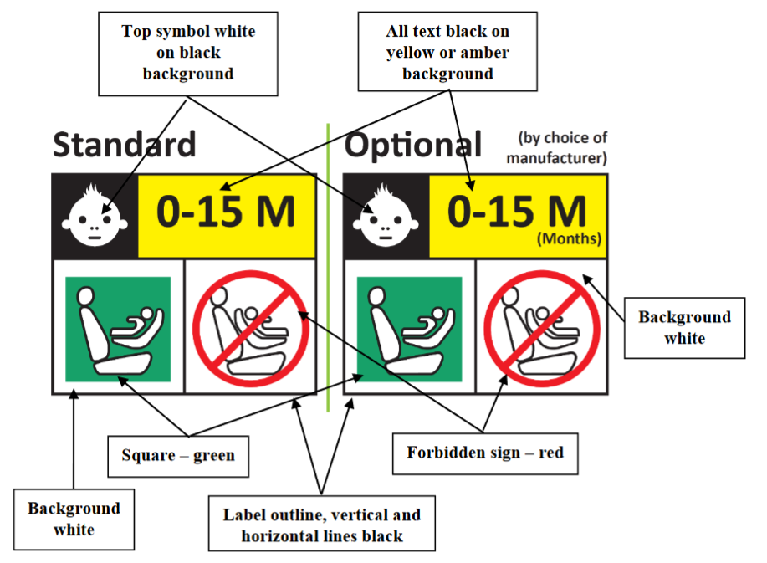

Integral Child Restraint Systems that can be used forward facing only shall have the following label permanently attached on the part hosting the child and visible to the person installing restraining the child:
The manufacturer shall be permitted to include the word "months" to explain the symbol "M" in the label. The word "months" should be in a language commonly spoken in the country or countries where the vehicle is registered. More than one language is allowed.
Figure 2
Label for a Forward-Facing Child Restraint System
Minimum label size 40 x 40 mm
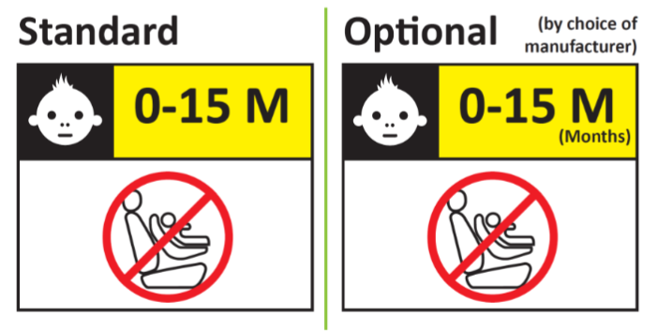
Renumber paragraph 5.3. to 6.3.
Renumber paragraph 5.3.1. to 6.3.1.
Renumber paragraph 5.3.2. to 6.3.2.
Renumber paragraph 5.4. to 6.4.
Renumber paragraph 5.5. to 6.5.
Renumber paragraph 5.6. to 6.6.
Renumber paragraph 5.7. to 6.7.
Paragraph 6.7., Amend to read:

67. 5.7. Additional information on how to install restrain the child shall be provided by either a webpage or QR code permanently attached to the CRS.

Paragraph 7.4.1., Amend to read:

7.4.1. The Technical Service conducting the approval tests shall verify that the markings conform to the requirements of paragraph 6 5. of this Regulation

Insert a new paragraph (after paragraph 8. and before paragraph 9.), to read:

Part II General Specifications with regard to Child Restraint Systems installed with 2-point belt.
The requirements defined in paragraphs 9 and 10 of this Regulation apply to this part.
Insert new paragraphs 9. to 9.3.1., to read:

9. General Specifications

9.1 The requirements defined in item 8.2 above regarding overturning test shall be fulfilled with the Child Restraint System installed in the test bench as defined in Annex 12.

9.2 The requirements defined in item 8.3 above regarding dynamic test shall be fulfilled with the Child Restraint System installed in the test bench as defined in Annex 12.

9.2.1 Compliance with paragraphs 8.3.6.5. and 8.3.6.6. of this Regulation shall be demonstrated from 1 September 2029. Before this date the results shall be recorded for monitoring purposes only.

9.3 Any reference to the installation of the Child Restraint System shall be provided through the instructions manual only.

9.3.1 Markings regarding the installation with the 2-point belt are not allowed on the Child Restraint System.

Insert new paragraphs 10. to 10.2.9., to read:

10. Instructions
10.1. Each Child Restraint System shall be accompanied by information for its use in buses and coaches. The information shall be provided to the user, either in paper form or digital form on the manufacturer’s webpage.
Instructions for the installation with 2-point belt shall be separately from the instructions for installation according to UN Regulation No.129 or UN Regulation No.44.

It shall make visible in the front page with a warning that the instructions refer only to buses and coaches installation.

10.2. Instruction manual shall include as a minimum the following information:
10.2.1 A 2-point belt installation guide in the language of the country where the device is sold.
10.2.2. The user shall be advised that 2-point belt attachment is only permitted in buses and coaches.
10.2.3. For integral Child Restraint Systems reference to the UN Regulation No. 129 or UN Regulation No. 44 for restraining the child in the Child Restraint System.
10.2.4. Picture or drawing that the belt buckle must not be positioned within the belt guiding of the Child Restraint System.
10.2.5. The user shall be advised that the Child Restraint System must remain belted on the seat even when unoccupied.
10.2.6. Rearward facing Child Restraint System should only be installed on forward facing seating positions.
10.2.7. Child Restraint Systems shall not be installed in side facing bus seating positions.
10.2.8. The user shall be advised that the safety of the child for not complying with the installation and instruction manual is not guaranteed.
10.2.9. Contact information where the customer can refer to for further information on fitting the Child Restraint System.

Renumber paragraph 9. to 11.
Paragraph 11.1., Amend to read:

11.1. 9.1. The test report shall record the results of all tests and measurements including the following test data:
(a) The type of device used for the test (acceleration or deceleration device);
(b) The trolley speed immediately before impact only for deceleration sleds;
(c) The acceleration or deceleration curve during all the velocity change of the trolley and at least 300 ms;
(d) The time (in ms) when the head of the manikin reaches its maximum displacement during the performance of the dynamic test;
(e) The place occupied by the buckle during the tests, if it can be varied;
(f) The name and address of the laboratory where tests have been
performed;
(g) Any failure or breakage;
(h) The following dummy criteria: HPC, resultant head acceleration cum 3ms, upper neck tension force, upper neck moment, resultant chest acceleration cum 3ms, chest deflection; abdominal pressure; and
(i) The minimum and maximum approved stature range for the CRS Built-in Child Restraint System approved according to Part I.

Renumber paragraph 9.2.2. to 11.2.
Renumber paragraph 9.2.3. to 11.3.
Paragraph 11.3., Amend to read:

11.3. 9.2.3. The evidence for all the requirements and specifications defined above in Part I or Part II paragraphs 7 and 8 shall be detailed in the test report.

Renumber paragraphs from 10. to 10.2. to 12. to 12.2.
Paragraph 12., Amend to read:

Built-in Child Restraint System approved according to Part I shall undergo conformity of production procedures.
The conformity of production procedures shall comply with those set out in the Agreement, (Schedule 1 E/ECE/TRANS/505/Rev.3), with the following requirements:

Renumber paragraphs from 11. to 11.3. to 13. to 13.3.

Renumber paragraphs from 12. to 12.2. to 14. to 14.2.

Renumber paragraphs from 13. and 13.1. to 15. and 15.1.

Renumber paragraph 14. to 16.

Insert new paragraphs 16. to 16.1.6., to read:

16. Transitional Provisions
16.1. Transitional provisions of 01 series of amendments.
16.1.1. As from the official date of entry into force of the 01 series of amendments, no Contracting Party applying this UN Regulation shall refuse to grant or refuse to accept UN type approvals under this UN Regulation as amended by the 01 series of amendments.
16.1.2. Contracting Parties applying this UN Regulation shall not refuse to grant extensions of UN type approvals for existing types which have been granted according to the preceding series of amendments to this UN Regulation.
16.1.3. As from [1st January 2027], Contracting Parties applying this Regulation shall not be obliged to accept type approvals issued to the original series of amendments to this Regulation.
16.1.4. Notwithstanding paragraph 16.1, Contracting Parties applying this Regulation shall continue to accept type approvals issued according to the preceding series of amendments to this Regulation, for systems which are not affected by the changes introduced by the 01 series of amendments.
16.1.5. Contracting Parties applying this Regulation may grant type approvals according to any preceding series of amendments to this Regulation.
16.1.6. Contracting Parties applying this Regulation shall continue to grant extensions of existing approvals to any preceding series of amendments to this Regulation
Annex 1., Amend to read:
…
of restraining systems for child occupants of Buses and Coaches, pursuant to UN Regulation No. 170

Annex 1. Paragraph 1.3., Amend to read:

1.3. Belt type: ²
(Adult) three-point belt ²
Special type belt/retractor ²

Annex 1, Insert a new paragraph 14., to read:

14. If applicable, Approval number according to UN Regulation No. 129 or UN Regulation No. 44:

Annex 1, Renumber paragraphs from 14. to 17. to 15. To 18.
Annex 1. Paragraph 18., Amend to read:

18. 17. The following documents, bearing the approval number shown above, are attached to this communication:
(a) Drawings, diagrams and plans of the child restraint, including any retractor, chair assembly, impact shield fitted;
(b) Drawings, diagrams and plans of the vehicle structure and the seat structure, as well as of the adjustment system and the attachments, including any energy absorber fitted;
(c) Photographs of the child restraint and/or vehicle structure and seat structure;
(d) Instructions for fitting and use;
(e) List of vehicle models for which the restraint is intended.
Insert a new Annex 12., to read:

Annex 12

Procedure for testing Child Restraint Systems installed with 2-point belt.

- Test seat

  - The test seat shall be constructed as follows:

    - A seat which represents a bus seat with the dimensions specified in Figure 1 of this Annex.

Figure 1
Dimensions of the test seat.

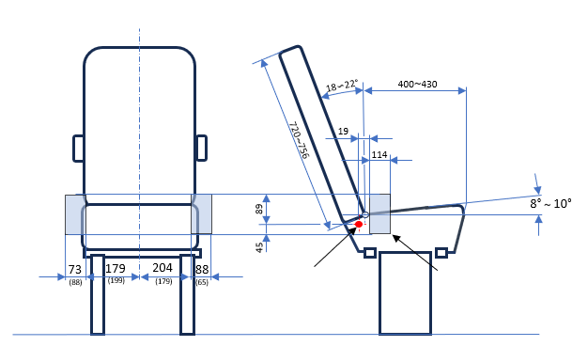
Range of the seat belt anchorage
Reclining center

Density
EN ISO 845
Foam seat cushion | 59~78±5 kg/㎥
Foam backrest | 40~96±5 kg/㎥

  - Certification of test seat cushion.

    - The test seat cushion shall be certified when new to establish initial values for impact peak deceleration, and then after every 50 dynamic tests or at least every month, whichever is the sooner.

    - The certification and measuring procedures shall correspond to those specified in the latest version of ISO 6487; the measuring equipment shall correspond to the specification of a data channel with a channel filter class (CFC) 60.

    - Using the test head form shown in Figure 2, conduct three tests on the seat base prepared as described in Annex X, foam covered with textile, 100 ± 5 mm from the front edge of the cushion on the centre line and at 100 ± 5 mm in each direction from the centre line.

      - The headform shall consist of a solid wooden hemisphere with an added smaller spherical segment. It shall be constructed so that it can be dropped freely along the axis marked and it shall have provision for mounting an accelerometer in order to measure the acceleration along the direction of fall.

      - The headform shall have a total mass, including the accelerometer of 2.75 ± 0.05 kg.

      - The acceleration shall be recorded during the test, using equipment in accordance with channel frequency class 1000 as specified in the latest version of ISO 6487.

Figure 2
Headform

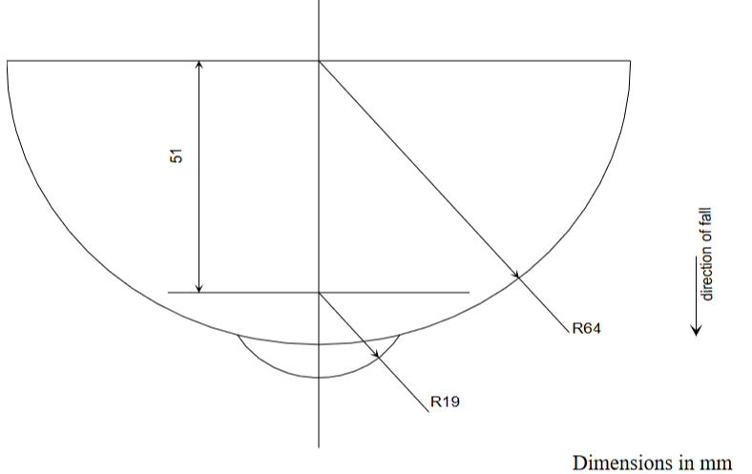

Place the seat cushion on a flat rigid surface. Place the device vertically above the test point, at a height of 500 ± 5 mm and allow it to fall freely to make impact on the seat surface. Record the deceleration curve.

1.2.4 The initial peak recorded values for impact deceleration shall be 20 ± 3 g and subsequent peak values recorded shall not deviate by more than 15 per cent from the initial values.

- 2-point belt installation method.

  - The safety-belt assembly for the dynamic test and for the maximum length requirement check shall be made according to the configuration shown in Figure 3.

  - The two-point belt assembly as shown in Figure 3 consists on one standard anchorage plate, as shown in Figure 4, one standard retractor, as shown in Figure 5, and a strap fulfilling the requirements of paragraph 2.3. below.

  - The strap requirements for the belt are as follows:
Material: polyester
- width: 48 ± 2 mm at 10,000 N
- thickness: 1.0 ± 0.2 mm
- elongation: 8 ± 2 percent at 10,000 N

    - The two-point belt anchorage plate (see Figure 2) shall be fitted to trolley anchorage point A and the retractor shall be fitted to the trolley anchorage point B. The total length of the belt webbing is 1,600 ± 5 mm. The length of the strap inside the retractor spool shall not be less than 150mm. To fit the belt webbing to the anchorage plate 150mm shall be used. The maximum length requirement for the approval of child restraints systems with two-point belt is 1,300+5 mm.

  - Distribute and maintain the load of 75 N ± 5 N in the complete belt.

  - The retractor shall comply with the requirements of Regulation No. 16 for retraction force. The retractor spool diameter is 33 ± 0.5 mm.

Figure 3
Two-point belt assembly

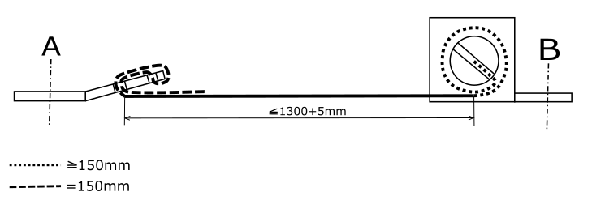

Figure 4
Standard Anchorage plate

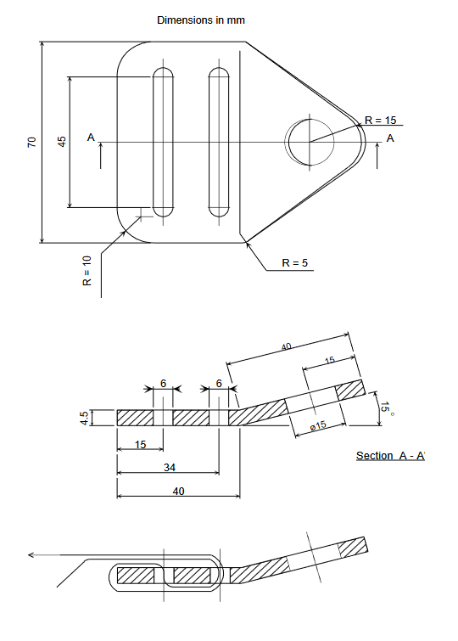

II. Justification
1. Phase 1 of UN Regulation No. 170 for built-in Child Restraint Systems in vehicles of category M2 and M3 class B and class III, is already in force.
2. 90 % of the bus fleet is equipped with 2-point belts, therefore there is the need to find a solution for Child Restraint Systems to be installed with 2-point belts.
3. The objective is retaining children during rollovers or frontal impacts in the seat.
4. The provisions for Child Restraint Systems installed with 2-point belts are defined in phase 2 of UN Regulation No. 170 described in this proposal.

As defined in the Consolidated Resolution on the Construction of Vehicles (R.E.3.), document ECE/TRANS/WP.29/78/Rev.7, para. 2 - www.unece.org/trans/main/wp29/wp29wgs/wp29gen/wp29resolutions.html.

