 | United Nations | ECE/TRANS/WP.29/GRSG/2026/23
 | Economic and Social Council |  | Distr.: General  29 January 2026  Original: English
Economic Commission for Europe
Inland Transport Committee
World Forum for Harmonization of Vehicle Regulations
Working Party on General Safety Provisions
131st session
Geneva, 13-17 April 2026
Item 14(l) of the provisional agenda
Other business:
UN Regulation No. 125 (Forward Field of Vision of Drivers)

Proposal for Supplement 5 to the 00 Series, Supplement 4 to the 01 Series, Supplement 4 to the 02 Series and Supplement 1 to the 03 Series of Amendments to UN Regulation No. 125 (Forward Field of Vision)

Submitted by the expert from the International Organization of Motor Vehicle Manufacturers*
The text reproduced below was prepared by the expert from the International Organization of Motor Vehicle Manufacturers (OICA) to harmonize the location of the lower datum point (5°) of paragraph 5.1.1.3. to the angle of obstruction requirement of paragraph 5.1.3. (4°). It is based on GRSG-130-20, distributed at the 130th session of the Working Party on General Safety Provisions (see paragraph 50 of ECE/TRANS/WP.29/GRSG/109). The modifications to the current text of the UN Regulation are marked in bold for new or strikethrough for deleted characters.

I. Proposal
Paragraph 5.1.1.3., amend to read:
"5.1.1.3. A lower vertical datum point forward of V2 and 5 4 deg. below the horizontal;"
Annex 4, Figure 1, amend to read:
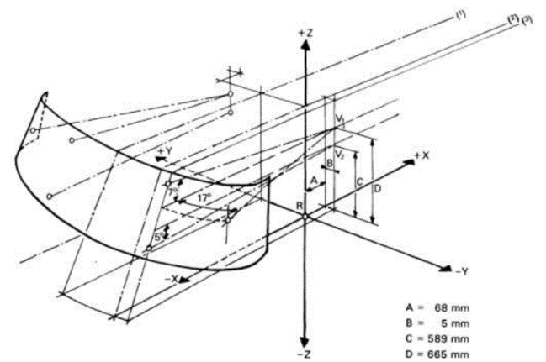
"
5 4°
"

II. Justification
1. In order to meet the visibility requirements of UN Regulation No. 125, there is a notch in the lower edge of the black band of the front window in some vehicles. This is required to satisfy the requirements of UN Regulation No. 125 but is considered to be meaningless for driving vision and needs to be corrected.
2. The first edition of 77/649/EEC (Forward Vision) included requirements similar to UN Regulation No. 125 paragraphs 5.1.1. and 5.1.3. However, since this regulation seems to be a compilation of the regulations of various European countries from about 50 years ago, it is difficult to trace the original rationale for setting the datum point at 5° and the obstruction requirement at 4°.
3. The 5° datum point has consistently been described only as a reference point from the earliest regulations up to the current UN Regulation No. 125, and it has not been used for any other technical requirements. In both UN Regulations Nos. 125 and 43, the datum point is mentioned solely as a reference and is not applied to technical requirements.
4. The 4° obstruction requirement was considered in a past amendment proposal for UN Regulation No. 125 (ECE/TRANS/WP.29/GRSG/2009/20, Amendments to S Area: French proposal), so it is considered reasonable to continue using 4° as the obstruction requirement.
5. The obstruction requirements are determined by paragraphs 5.1.2., 5.1.3., and 5.1.4. of UN Regulation No. 125. The datum point specified in 5.1.1. is not used for the obstruction requirements in vehicle testing under UN Regulation No. 125. While there is a proposal to delete 5.1.1., doing so would eliminate all upper and lateral restrictions. Therefore, it is considered appropriate to retain the upper and lateral aspects of 5.1.1. as they are, but to change the position of the datum point for the lower side from 5° to 4°.
6. Since this requirement is a vehicle requirement and not a component requirement, the datum point should be deleted from UN Regulation No. 43 and retained only in UN Regulation No. 125.

* In accordance with the programme of work of the Inland Transport Committee for 2026 as outlined in proposed programme budget for 2026 (A/80/6 (Sect. 20), table 20.7), the World Forum will develop, harmonize and update UN Regulations in order to enhance the performance of vehicles. The present document is submitted in conformity with that mandate.

