 | United Nations | ECE/TRANS/WP.29/GRSG/2026/22
 | Economic and Social Council |  | Distr.: General  29 January 2026  Original: English
Economic Commission for Europe
Inland Transport Committee
World Forum for Harmonization of Vehicle Regulations
Working Party on General Safety Provisions
131st session
Geneva, 13-17 April 2026
Item 3 of the provisional agenda
Amendments to safety glazing regulations:
UN Regulation No. 43 (Safety Glazing)

Proposal for Supplement 13 to the 01 Series of Amendments to UN Regulation No. 43 (Safety Glazing)

Submitted by the expert from the International Organization of Motor Vehicle Manufacturers*
The text reproduced below was prepared by the expert from the International Organization of Motor Vehicle Manufacturers (OICA) to harmonize the location of the lower datum point (5°) of paragraph 5.1.1.3. to the angle of obstruction requirement of paragraph 5.1.3. (4°). It is based on GRSG-130-21, distributed at the 130th session of the Working Party on General Safety Provisions (see paragraph. 6 of ECE/TRANS/WP.29/GRSG/109). The modifications to the current text of the UN Regulation are marked in bold for new or strikethrough for deleted characters.

I. Proposal
Annex 21, paragraph 2.5., amend to read:
"2.5. Definition of the datum points (see Figure 3)
The datum points are points situated at the intersection with the outer surface of the windscreen of lines radiating forward from the V points:
2.5.1. Upper vertical datum point forward of V₁ and 7° above the horizontal (P_{r1});
2.5.2. Lower vertical datum point forward of V₂ and 5 4° below the horizontal (P_{r2});
2.5.3. Horizontal datum point forward of V₁ and 17° to the left (P_{r3});
2.5.4. Three additional datum points symmetrical to the points defined under paragraphs 2.5.1. to 2.5.3. in relation to the longitudinal median plane of the vehicle (respectively P'_{r1}, P'_{r2}, P'_{r3})."

Annex 21, Figure 3, amend to read:
"Figure 3
Determination of the datum points (example of a left-hand steering control vehicle)
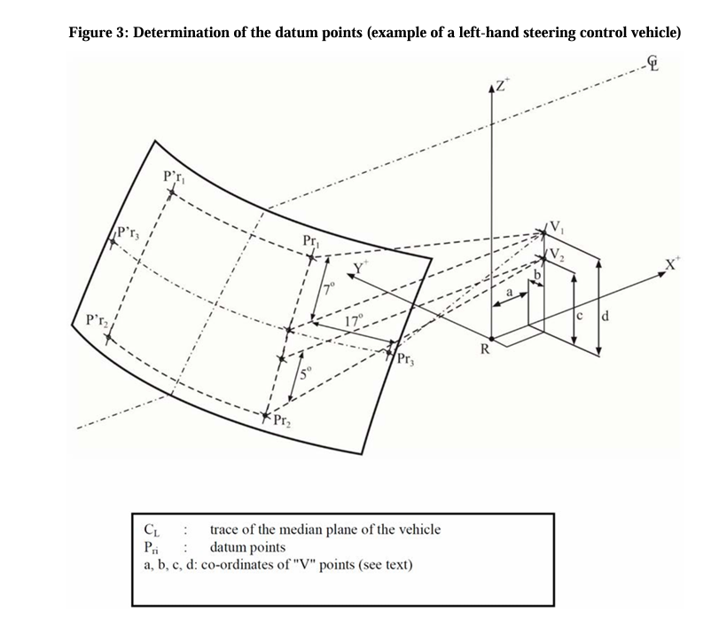"

5 4°
C_{L} : trace of the median plane of the vehicle
P_{ri} : datum points
a,b,c,d: : Coordinates of "V" points (see text)

II. Justification
- Definition of the datum points is described in both UN Regulation Nos. 43 and 125. Historically, there has been an inconsistency in UN Regulation No. 125 between the lower datum point (paragraph 5.1.1.3.) and the obstruction requirement (paragraph 5.1.3.). To resolve such an inconsistency, the proposal to amend UN Regulation No. 125 (see ECE/TRANS/WP.29/GRSG/2026/23) harmonizes the location of the lower datum point (at 5°) of the para.5.1.1.3. to the angle of obstruction requirement in paragraph 5.1.3. (at 4°).
- This proposal is to align with the proposed amendment to UN Regulation No. 125 (ECE/TRANS/WP.29/GRSG/2026/23) regarding the lower datum point.

* In accordance with the programme of work of the Inland Transport Committee for 2026 as outlined in proposed programme budget for 2026 (A/80/6 (Sect. 20), table 20.7), the World Forum will develop, harmonize and update UN Regulations in order to enhance the performance of vehicles. The present document is submitted in conformity with that mandate.

