Proposal for amendments to working document GRSG/2025/51 (Draft Proposal for a new UN Regulation on the approval of a vehicle type with an advanced driver distraction warning system)
The modifications to the document GRSG/2025/51 of the Regulation are marked in bold for new characters.

I. Proposal for Draft Proposal for a new UN Regulation on the approval of a vehicle type with an advanced driver distraction warning system
1. Scope amend to read:
" 1. Scope
1.1. This Regulation applies to vehicles of category M and N where the "R" point of the driver seat is more than 450 mm from ground level.
1.2. This Regulation is without prejudice to requirements of national or regional
laws related to privacy, data protection and personal data processing.
1.3. This Regulation does not apply to vehicles of category X and Y.
II. Justification
- This proposal seeks to provide an exemption from certification of vehicles having unique designs and architectures (e.g. high-performance vehicles), where generally the "R" point of the driver seat is not more than 450 mm from ground level. High-performance vehicles have unique design characteristics. For instance, in order to reduce the aerodynamic drag the frontal surface is reduced. This leads to specific architectural solutions such as thinner and very tilted “A” pillar, smaller field of view, low volume cabin compartment. As consequence, for high performance vehicles:
- installation of interior sensors for driver monitoring is more technically challenging;
- components specifications, as developed by Tier 1 suppliers, for mass-market applications are not suitable and often not available for niche vehicle designs.
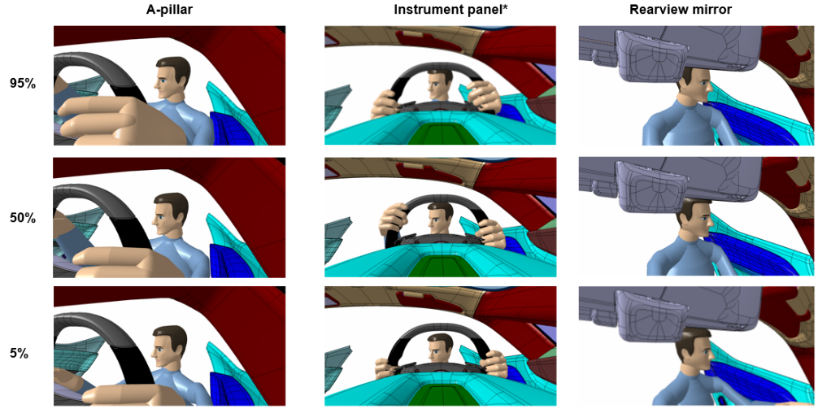
- At-the-date, ADDW systems are mainly based on a camera sensor able to monitor the driver’s gaze. In order to fulfil ADDW performance/testing requirements, camera-system should be able to monitor both driver’s eyes. Considering the peculiar cabin architecture of high performance vehicles (e.g. thinner and very tilted “A” pillar, smaller field of view, low volume cabin compartment), the following images show cases where the gaze of the driver, looking at the boundaries of the distraction zone as define by the GRSG/2025/51 proposal, is not fully visible (i.e. both driver’s eyes) for most common camera-installation positions in a car. This could lead to false positives, system unavailability.In addition, high-performance vehicles have smaller frontal field of vision compared to mass market vehicles. Therefore, a reduced frontal area to fit information inside central cluster leads to challenging installation of ADDW camera.
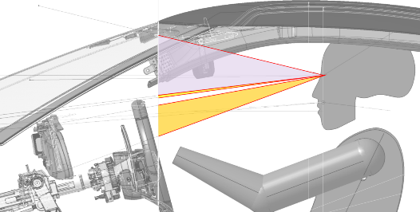

- A similar provision providing an exemption for such vehicles is currently under discussion for the inclusion of the equivalent Delegated Regulation (EU) 2023/2590 within Whole Vehicle Type Approval Regulation (EU) 2018/858.

