 | United Nations | ECE/TRANS/WP.29/GRSP/2025/29
 | Economic and Social Council |  | Distr.: General  19 September 2025  Original: English
Economic Commission for Europe
Inland Transport Committee
World Forum for Harmonization of Vehicle Regulations
Working Party on Passive Safety
Seventy-eighth session
Geneva, 1–4 December 2025
Item 13 of the provisional agenda
UN Regulation No. 127 (Pedestrian safety)

Proposal for supplement 3 to the 04 series of amendments to UN Regulation No. 127 (Pedestrian safety)

Submitted by the experts from Germany and the Kingdom of the Netherlands *
The text reproduced below was prepared by the experts from Germany and the Kingdom of the Netherlands to clarify the scope of data from tests to the windscreen that must be provided for the purpose of type approval. It is based upon informal document GRSP-77-38. The modifications to the current text of UN Regulation No. 127 are marked in bold for new and strikethrough for deleted characters.

I. Proposal
Paragraph 2.43., footnote 5, amend to read:
“5 or WAD 2,100 in accordance with paragraphs 11.9 to 11.11 11.19. to 11.21.”
Paragraph 2.48. (a), amend the first paragraph to read:
“(a) The absolute value of the minimum value of the derivation of the resultant headform acceleration versus time is less than 180 g/ms within the first 4 ms after the initial contact of the headform to the windscreen as shown in figure 16; and/or”
Paragraph 2.48. (b), amend to read:
“(b) The minimum value of the resultant headform acceleration below 300 m/s² between the initial peak and 10 milliseconds ms is reached later than 4 ms in the time/acceleration plot, or glass breaking which expands to the whole windshield is not visibly observed.”
Insert new paragraph 4.4.3., to read:
“4.4.3. The approval mark shall contain an additional character after the type approval number, the purpose of which is to distinguish vehicles for which the approval has been granted based upon the specific provisions related to WAD 2,100 boundary versus vehicles approved with the extended WAD 2,500 boundary. This letter should be chosen according to paragraph 4.2.”
Insert new paragraphs 4.8. to 4.10., to read:
“4.8. Each Contracting Party applying this Regulation shall notify and inform by its Approval Authority other Approval Authorities of the Contracting Parties applying this UN Regulation about the test results of the cowl monitoring area and the windscreen.
This information shall be shared (a) when granting an approval according to this Regulation for the first time and (b) with each extension when new tests in these areas have been performed.
This information is intended to be shared for the purposes of collection and analysis of the cowl area and atypical windscreen fracture behaviour in order to be able to further develop future amendments of the Regulation.
4.9. The information referred to in paragraph 4.8. shall be uploaded in English language to the secure internet database "DETA"^{[x]}, established by the United Nations Economic Commission for Europe.
4.10. Each Approval Authority granting a type approval or extension thereto pursuant to this Regulation shall notify other Approval Authorities of the approval granted. The type approval together with the test results of the cowl monitoring area and the windscreen shall be uploaded in English language by the Approval Authority within 14 days after the day of granting the approval, to DETA.”
Insert new footnote [x], to read:
“^{[x]} https://www.unece.org/trans/main/wp29/datasharing.html”
Paragraphs 11.1. to 11.15., replace by:
“11.1. to 11.15. (deleted)”
Insert new paragraphs 11.16. to 11.25., to read:
“11.16. As from the official date of entry into force of the 04 series of amendments, no Contracting Party applying this UN Regulation shall refuse to grant or refuse to accept type-approvals under this UN Regulation as amended by the 04 series of amendments.
11.17. As from 1 September 2026, Contracting Parties applying this UN Regulation shall not be obliged to accept type-approvals to the preceding series of amendments first issued after 1 September 2026.
11.18. Contracting Parties applying this UN Regulation shall continue to accept type approvals issued according to the preceding series of amendments to this UN Regulation first issued before 1 September 2026.
11.19. Contracting Parties applying this Regulation shall continue to grant type approvals using the test proceedings related to atypical windscreen fracture behaviour (see Annex 5 paragraphs 4.8. and 5.8.) until 1 September [2033] and specific provisions related to WAD 2,100 boundary (see paragraphs 2.1. and 2.45.) until 1 September 2028.”
11.20. Until 1 September 2029, Contracting Parties applying this UN Regulation shall continue to accept type approvals issued using the specific provisions related to WAD 2,100 boundary (see paragraphs 2.1. and 2.45.).
11.21. As from 1 September 2029, Contracting Parties applying this UN Regulation shall not be obliged to accept type approvals issued for a vehicle with a WAD 2,100 boundary on the bonnet top (see paragraphs 2.1. and 2.45.).
11.22. Notwithstanding paragraph 11.19., until 1 September 2030, Contracting Parties applying this Regulation shall continue to grant type approvals using the specific provisions related to BRRL (see paragraph 2.1.).
11.23. Notwithstanding paragraphs 11.20. and 11.21., until 1 September 2031, Contracting Parties applying this UN Regulation shall continue to accept type approvals issued using the specific provisions related to BRRL (see paragraph 2.1.).
11.24. Contracting Parties applying this UN Regulation may grant type approvals according to any preceding series of amendments to this UN Regulation.
11.25. Contracting Parties applying this UN Regulation shall continue to grant extensions of existing approvals to any preceding series of amendments to this UN Regulation.”
Annex 1, Part 2, paragraph 16.1., amend the text under the table to read:
“WAD 2,100 boundary in accordance with paragraphs 11.9. to 11.11.13.: applicable / not applicable.”
Annex 1, Part 2, paragraph 16.1., footnote 3, amend to read:
“³ Coordinate system as defined by appendix 2 to Annex 1 of the Consolidated Resolution on the Construction of Vehicles (R.E.3), document ECE/TRANS/WP.29/78/Rev.6 - https://unece.org/transport/standards/transport/vehicle-regulations-wp29/resolutions Annex B of Addendum 6 of Mutual Resolution No. 1 (M.R.1) (document ECE/TRANS/WP.29/1101/Amend.5); see https://unece.org/transport/vehicle-regulations/wp29/resolutions”
Annex 2, text under the heading, amend to read:
(See paragraphs 4.4. to 4.4.23. of this Regulation)
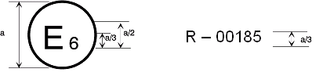
127R – 04185-T
a = 8 mm min
The above approval mark affixed to a vehicle shows that the vehicle type concerned has been approved in Belgium (E 6) with regard to its pedestrian safety performance pursuant to UN Regulation No. 127. The first two digits of the approval number indicate that the approval was granted in accordance with the requirements of UN Regulation No. 127 as amended by the 04 series of amendments; the letter "T" indicates the approval was granted using the specific provisions on WAD 2,100 boundary in accordance with paragraph 11.19.”
Annex 5, paragraph 4.1., amend to read:
“4.1. Tests shall be made to the front structure within the boundaries as defined in paragraph 2.16. of this Regulation. Test shall also be made to the windscreen within the boundaries as defined in paragraph 2.44. For all tests to the windscreen, resultant acceleration versus time and jerk (derivation of the resultant acceleration) versus time histories must be provided and evaluated against the atypical fracture criteria according to paragraph 2.48. (see Figure 6) and reported for monitoring purpose according to paragraphs 4.8. to 4.10. For tests on the rear area of the bonnet top, the headform impactor shall not contact the windscreen or A-pillar before impacting the bonnet top. For tests on the windscreen, the headform impactor shall not directly contact the A-pillars, windscreen header and cowl, except in the case of monitoring testing.
Figure 6
Evaluation of resultant acceleration and jerk for tests to the windscreen.
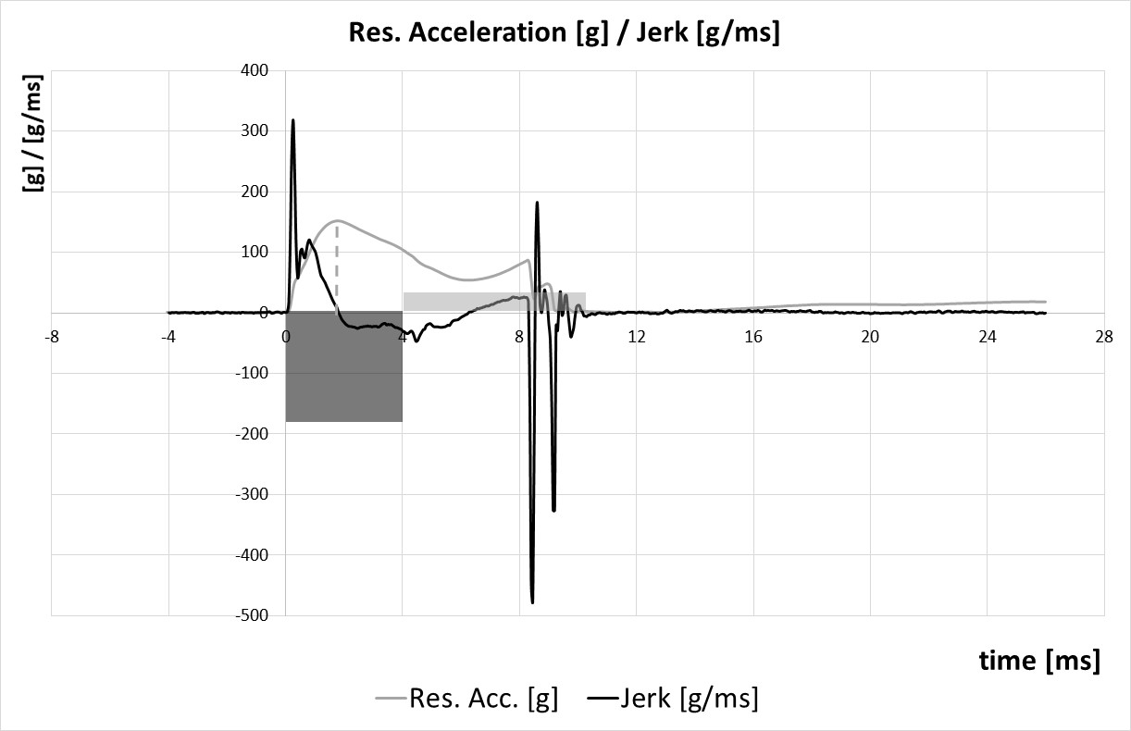
Jerk (g/ms)
res. acc. (g)
(g)/(g/ms)
time (ms)
Resultant acceleration (g) / Jerk (g/ms)
HIC:
min(a(t)) for 0 ms < t < 10 ms:
|min(da/dt)| for 0 ms < t < 4 ms:
Note: Both alternatives, 1 graph for each criterion or 1 graph for both criteria, are accepted.”
Annex 5, paragraph 5.1., amend to read:
“5.1. Tests shall be made to the front structure within the boundaries as defined in paragraph 2.1. of this UN Regulation. Tests shall also be made to the windscreen within the boundaries as defined in paragraph 2.44. For all tests to the windscreen, resultant acceleration versus time and jerk (derivation of the resultant acceleration) versus time histories must be provided and evaluated against the atypical fracture criteria according to paragraph 2.48. (see Figure 6) and reported for monitoring purposes according to paragraphs 4.8. to 4.10. For tests at the rear of the bonnet top, the headform impactor shall not contact the windscreen or A-pillar before impacting the bonnet top. For the tests on the windscreen, the headform impactor shall not directly contact the A-pillars, windscreen header and cowl, except in the case of monitoring testing.”

II. Justification
1. Paragraph 2.48. of the 03 series of amendments to UN Regulation No. 127 contains the definition for atypical windscreen fracture behaviour. A clarification is needed that the resultant acceleration of all three axes (x, y and z) is referred to in this definition. Also it is clarified that all three alternatives are allowed:
- a) only
- b) only
- both a) and b).
2. Paragraphs 4.8. and 5.8. of annex 5 of the 03 series of amendments to UN Regulation No. 127 prescribe tests with atypical windscreen fracture to be duly recorded in the test report. However, since atypical behaviour during windscreen tests meeting the performance criteria may not be detected, provisions are needed as a guideline of the scope of data that must always be provided during the type approval procedure.

* In accordance with the programme of work of the Inland Transport Committee for 2025 as outlined in proposed programme budget for 2025 (A/79/6 (Sect. 20), table 20.6), the World Forum will develop, harmonize and update UN Regulations in order to enhance the performance of vehicles. The present document is submitted in conformity with that mandate.

