 | United Nations | ECE/TRANS/WP.29/GRSP/2025/10
 | Economic and Social Council |  | Distr.: General  18 September 2025  Original: English
Economic Commission for Europe
Inland Transport Committee
World Forum for Harmonization of Vehicle Regulations
Working Party on Passive Safety
Seventy-eighth session
Geneva, 1–4 December 2025
Item 16 of the provisional agenda
UN Regulation No. 170 (Child restraint systems
for safer transport of children in buses and coaches)

Proposal for the 01 series of amendments to UN Regulation No. 170 (Child restraint systems for safer transport of children in buses and coaches)

Submitted by the Chair of the Informal Working Group on Safer Transport of Children in Buses and Coaches (IWG-STBC) *
The text reproduced below has been prepared by the IWG-STBC to introduce the requirements of phase 2 of UN Regulation No. 170. It is based on informal document GRSP-77-20. When reproducing texts, modifications to the current text of the UN Regulation are marked in bold for new or strikethrough for deleted characters.

I. Proposal
Section 1, amend the first two paragraphs to read:
“ A Child Restraint Systems (CRS) approved according to UN Regulation No. 129 or UN Regulation No. 44 which can be installed in vehicle seats using the 3-point belt type and/or ISOFIX attachments can may be used in coaches and buses vehicles of categories M₂ and M₃ in forward facing and rearward facing vehicle seats without further requirements.
The requirements defined in Part I of this UN Regulation do not apply to CRS approved according to UN Regulation No. 129 or UN Regulation No.44.”
Section 2, amend the text under the heading to read:
“This Regulation applies:
2.1. Part I: to Built-in Child Restraint Systems installed in vehicles of categories M₂ and M₃ class B and class III ¹ with regards to the securing of children from 40 – 150 cm in forward facing and rearward facing vehicle seats.
At the request of the manufacturer, this Regulation may also apply to any Built-in Child Restraint Systems installed in vehicles of categories M₂ or M₃ of classes I, II and A¹.
2.2. Part II: to Child Restraint Systems approved according to UN Regulation No. 129 or UN Regulation No.44 which may be installed in a bus seat with a 2-point belt in vehicles of categories M₂ and M₃ class B and class III¹ with regards to the securing of children from 40 – 150 cm in forward facing and rearward facing vehicle seats.
At the request of the manufacturer, this Regulation may also apply to any Built-in Child Restraint Systems installed in vehicles of categories M₂ or M₃ of classes I, II and A¹.”
Section 2, insert footnote 1, to read:
“¹ As defined in the Consolidated Resolution on the Construction of Vehicles (R.E.3.), document ECE/TRANS/WP.29/78/Rev.7, paragraph 2 - www.unece.org/trans/main/wp29/wp29wgs/wp29gen/wp29resolutions.html.”
Renumber paragraphs 6. and 6.1. as 5. and 5.1.
Paragraph 5.1. (renumbered), amend to read:
“5.1. 6.1. Each Built-in Child Restraint System sample submitted in conformity with paragraphs 4.2.2. and 4.2.3. above shall meet the specifications set forth in paragraph 7 part I of this Regulation in every respect before approval can be granted.”
Insert a new paragraph 5.2., to read:
“5.2. Each Child Restraint System installed with a 2-point belt submitted in conformity with paragraphs 4.2.2. and 4.2.3. above shall meet the specifications set forth in part II of this Regulation in every respect before approval can be granted.”
Renumber paragraphs 6.2. to 6.7. as 5.3. to 5.8.
Paragraph 5.3. (renumbered), amend to read:
“5.3. 6.2. An approval number shall be assigned to each type approved. Its first two digits shall indicate the series of amendments. The same Contracting Party shall not assign the same number to another type of Child Restraint System covered by this Regulation.
A Built-in type of Child Restraint System approved according to this Regulation shall not bear another approval mark according to any other Regulation regarding CRS.
A Child Restraint System installed with a 2-point belt shall be approved according to UN Regulation No. 129 or UN Regulation No. 44.”
Paragraph 5.5. (renumbered), amend to read:
“5.5. 6.4. In addition to the marks prescribed in paragraph 5. above, The following particulars shall be affixed in a suitable space to every Child Restraint System conforming to a type approved under this Regulation:”
Paragraph 5.5.1.2. (renumbered), amend to read:
“5.5.1.2. 6.4.1.2. An approval number, the words "Regulation No." followed by the number of this Regulation, a slash and the series of amendment ("Regulation No. XXX/XX 170/01");”
Insert a new paragraph 5.5.3., to read:
“5.5.3. Approval according to this regulation may be granted to Child Restraint Systems that have been previously approved according to UN Regulation No. 129 or UN Regulation No. 44 and are already on the market and in use by consumers. In absence of an approval mark according to this regulation on the product, the information regarding approval for use in buses and coaches shall be made available in the product description on a publicly accessible database, this may be on the manufacturers' website.
This information shall include the identification of the product and the approval mark according to UN Regulation No. 129 or UN Regulation No. 44 and the approval mark according to UN Regulation No. 170.”
Paragraphs 5.7. and 5.8., in the first sentences, renumber the references to 6.4. as 5.5.
After paragraph 5.8. (renumbered), insert:
“
Part I General specifications for Built-in Child Restraint Systems
The requirements defined in paragraphs 6, 7 and 8 of this Regulation apply to this part.”
Renumber paragraphs 5. to 5.7. as 6. to 6.7.
Paragraph 6.2. (renumbered), in the first paragraph after the first figure, replace “installing” by “restraining”.
Paragraph 6.7. (renumbered), replace “install” by “restrain”.
Paragraph 7.2.1.1., amend the second paragraph to read:
“ Inserts shall form only one layer on the seat surface. An exception is permitted for one additional insert layer to provide protection for small babies with a stature [≤ 45 cm]. This does not preclude the use of aAdditional ‘comfort’ inserts are permitted for any stature, provided they are not needed to comply with the requirements of the regulation.”
Paragraph 7.4.1., renumber the reference to 5. as 6.
After paragraph 8.4.5.3., insert:
“
Part II General specifications for Child Restraint Systems installed with a 2-point belt
The requirements defined in paragraphs 9 and 10 of this Regulation apply to this part.”
9. General specifications
9.1. The requirements defined in item 8.2 above regarding the overturning test shall be fulfilled with the Child Restraint System installed in the test bench as defined in Annex 12.
9.2. The requirements defined in item 8.3 above regarding the dynamic test shall be fulfilled with the Child Restraint System installed in the test bench as defined in Annex 12.
9.2.1. Compliance with paragraphs 8.3.6.5. and 8.3.6.6. of this Regulation shall be demonstrated from 1 September 2029. Before this date the results shall be recorded for monitoring purposes only.
9.3. Any reference to the installation of the Child Restraint System shall be provided through the instructions manual only.
9.3.1. Markings regarding the installation with the 2-point belt are not allowed on the Child Restraint System.”
10. Instructions
10.1. Each Child Restraint System shall be accompanied by information for its use in buses and coaches. The information shall be provided to the user, either in paper form or in digital form on the manufacturer’s webpage.
Instructions for the installation with a 2-point belt shall be separate from the instructions for installation according to UN Regulation No. 129 or UN Regulation No. 44.
A warning that the instructions refer only to installation in buses and coaches shall be visible in the front page.
10.2. The instruction manual shall include as a minimum the following information:
10.2.1. A 2-point belt installation guide in the language of the country where the device is sold.
10.2.2. The user shall be advised that 2-point belt attachment is only permitted in buses and coaches.
10.2.3. For integral Child Restraint Systems, a reference to UN Regulation No. 129 or UN Regulation No. 44 for restraining the child in the Child Restraint System.
10.2.4. A picture or drawing that the belt buckle must not be positioned within the belt guiding of the Child Restraint System.
10.2.5. The user shall be advised that the Child Restraint System must remain belted on the seat even when unoccupied.
10.2.6. Rearward facing Child Restraint System should only be installed on forward facing seating positions.
10.2.7. Child Restraint Systems shall not be installed in side facing bus seating positions.
10.2.8. The user shall be advised that the safety of the child for not complying with the installation and instruction manual is not guaranteed.
10.2.9. Contact information where the customer can refer to for further information on fitting the Child Restraint System.”
Renumber paragraphs 9. and 9.1. as 11. and 11.1.
Paragraph 11.1. (d) (renumbered), amend to read:
“ (i) The minimum and maximum approved stature range for the CRS Built-in Child Restraint System approved according to Part I.”
Renumber paragraphs 9.2.2. and 9.2.3. as 11.2. and 11.3.
Paragraph 11.3. (renumbered), amend to read:
“11.3. 9.2.3. The evidence for all the requirements and specifications defined above in Part I or Part II paragraphs 7 and 8 shall be detailed in the test report.”
Renumber paragraph 10. as 12.
Paragraph 12. (renumbered), amend the text under the heading to read:
“10.1. Built-in Child Restraint System approved according to Part I shall undergo conformity of production procedures.
10.2. The conformity of production procedures shall comply with those set out in the Agreement, (Schedule 1 E/ECE/TRANS/505/Rev.3), with the following requirements:”
Renumber paragraphs 10.1. and 10.2. as 12.2.1. and 12.2.2.
Renumber sections 11. to 14. as 13. to 16.
Insert new paragraphs 16. to 16.1.6., to read:
“16. Transitional Provisions
16.1. Contracting Parties applying this Regulation may grant type approvals according to any preceding series of amendments to this Regulation.
16.2. Contracting Parties applying this Regulation shall continue to grant extensions of existing approvals to any preceding series of amendments to this Regulation
16.3. Transitional provisions of 01 series of amendments.
16.3.1. As from the official date of entry into force of the 01 series of amendments, no Contracting Party applying this UN Regulation shall refuse to grant or refuse to accept UN type approvals under this UN Regulation as amended by the 01 series of amendments.
16.3.2. Contracting Parties applying this UN Regulation shall not refuse to grant extensions of UN type approvals for existing types which have been granted according to the preceding series of amendments to this UN Regulation.
16.3.3. As from 1st January 2027, Contracting Parties applying this Regulation shall not be obliged to accept type approvals issued to the original series of amendments to this Regulation.
16.3.4. Notwithstanding paragraph 16.3.3., Contracting Parties applying this Regulation shall continue to accept type approvals issued according to the preceding series of amendments to this Regulation, for systems which are not affected by the changes introduced by the 01 series of amendments.”
Annex 1., paragraph 1.3.,remove the reference to footnote 2 from the second and third lines.
Annex 1, insert a new paragraph 14., to read:
“14. If applicable, approval number according to UN Regulation No. 129 or UN Regulation No. 44: ”
Annex 1., renumber paragraphs from 14. to 17. as 15. to 18.
Annex 1. paragraph 18. (renumbered), delete (e).
Annex 3., table, in the section “Applicable to all CRS”, amend the first seven rows to read:
40* |  |  |  | <27.415.8
45 | 39.0 | 12.1 | 14.2 | 27.417.6 | 29.023.5
50 | 40.5 | 14.1 | 14.8 | 27.619.4 | 29.224.8
55 | 42.0 | 16.1 | 15.4 | 27.821.2 | 29.426.1
60 | 43.5 | 18.1 | 16.0 | 28.023.0 | 29.627.4
65 | 45.0 | 20.1 | 17.2 | 28.224.8 | 29.828.7
70 | 47.1 | 22.1 | 18.4 | 28.326.6 | 30.0
Annex 3., table, add a new table note to read “* The minimum shoulder height dimension for statures below 40 cm shall be determined by extrapolation.”
Insert a new Annex 12., to read:

“Annex 12

Procedure for testing Child Restraint Systems installed with 2-point belt
- Test seat
  - The test seat shall be constructed as follows:
    - A seat which represents a bus seat with the dimensions specified in Figure 1 of this Annex.
Figure 1
Dimensions of the test seat.
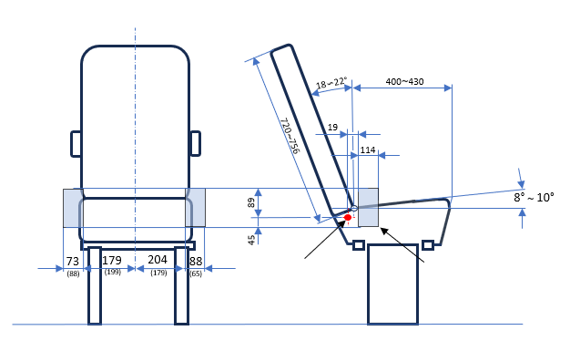
Range of the seat belt anchorage
Reclining center
Density
EN ISO 845
Foam seat cushion | 59~78±5 kg/㎥
Foam backrest | 40~96±5 kg/㎥
  - Certification of test seat cushion
    - The test seat cushion shall be certified when new to establish initial values for impact peak deceleration, and then after every 50 dynamic tests or at least every month, whichever happens first.
    - Certification and measuring procedures shall correspond to those specified in the latest version of ISO 6487. Measuring equipment shall correspond to the specification of a data channel with a channel filter class (CFC) 60.
    - Using the test head form shown in Figure 2, conduct three tests on the seat base prepared as described in Annex X, foam covered with textile, 100 ± 5 mm from the front edge of the cushion on the centre line and at 100 ± 5 mm in each direction from the centre line.
      - The headform shall consist of a solid wooden hemisphere with an added smaller spherical segment. It shall be constructed so that it can be dropped freely along the axis marked and it shall have provision for mounting an accelerometer in order to measure the acceleration along the direction of fall.
      - The headform shall have a total mass, including the accelerometer of 2.75 ± 0.05 kg.
      - The acceleration shall be recorded during the test, using equipment in accordance with channel frequency class 1000 as specified in the latest version of ISO 6487.
Figure 2
Headform
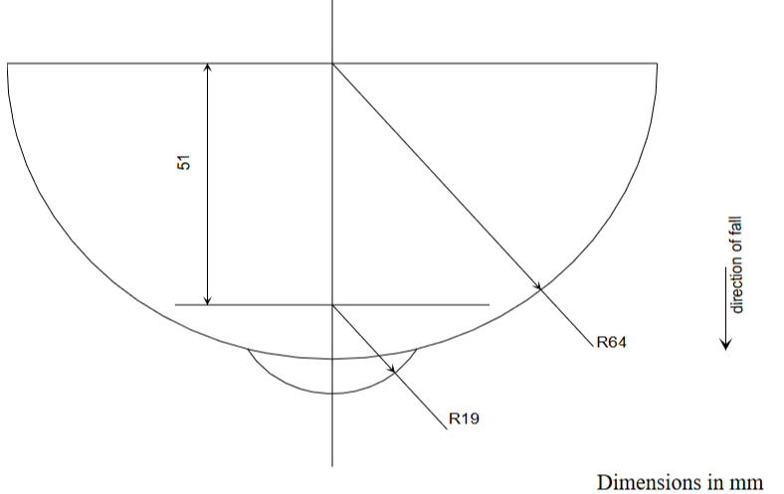
Place the seat cushion on a flat rigid surface. Place the device vertically above the test point, at a height of 500 ± 5 mm and allow it to fall freely to make impact on the seat surface. Record the deceleration curve.
1.2.4. The initial peak recorded values for impact deceleration shall be 20 ± 3 g and subsequent peak values recorded shall not deviate by more than 15 per cent from the initial values.
- 2-point belt installation method.
  - The safety-belt assembly for the dynamic test and for the maximum length requirement check shall be made according to the configuration shown in Figure 3.
  - The two-point belt assembly as shown in Figure 3 consists on one standard anchorage plate, as shown in Figure 4, one standard retractor, as shown in Figure 5, and a strap fulfilling the requirements of paragraph 2.3. below.
  - The strap requirements for the belt are as follows:
Material: polyester
- width: 48 ± 2 mm at 10,000 N
- thickness: 1.0 ± 0.2 mm
- elongation: 8 ± 2 percent at 10,000 N
    - The two-point belt anchorage plate (see Figure 2) shall be fitted to anchorage point A of the trolley and the retractor shall be fitted to anchorage point B of the trolley. The total length of the belt webbing is 1,600 ± 5 mm. The length of the strap inside the retractor spool shall not be less than 150 mm. To fit the belt webbing to the anchorage plate 150 mm shall be used. The maximum length requirement for the approval of child restraints systems with two-point belt is 1,300+5 mm.
  - Distribute and maintain the load of 75 N ± 5 N in the complete belt.
  - The retractor shall comply with the requirements of Regulation No. 16 for retraction force. The retractor spool diameter is 33 ± 0.5 mm.
Figure 3
Two-point belt assembly
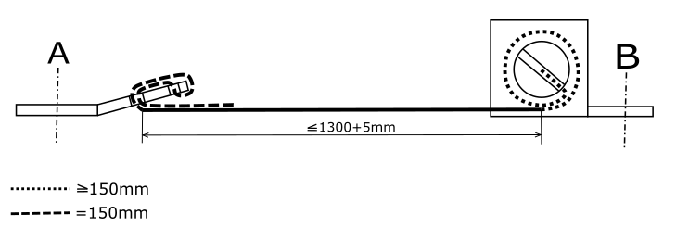
Figure 4
Standard anchorage plate
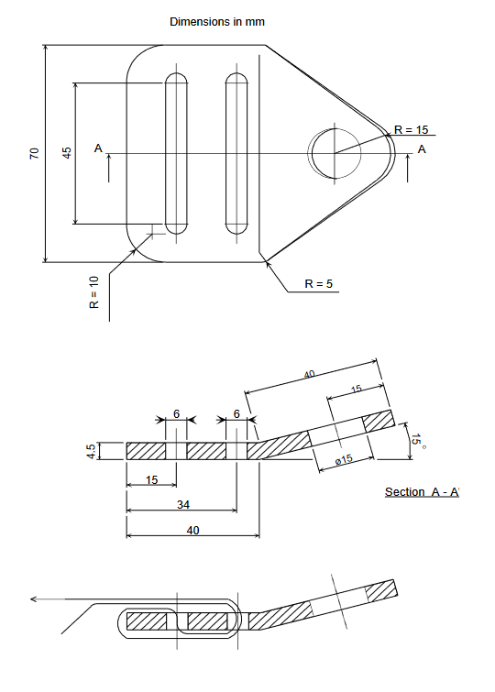

II. Justification
1. Phase 1 of Regulation UN No. 170 for built-in Child Restraint Systems in vehicles of category M₂ and M₃ class B and class III, is already in force.
2. As 90 % of the bus fleet is equipped with 2-point belts, there is the need to find a solution for Child Restraint Systems to be installed with 2-point belts. The objective is to retain children during rollovers or frontal impacts in the seat.
3. The provisions for Child Restraint Systems installed with 2-point belts are defined in phase 2 of UN Regulation No. 170 described in this proposal.
4. Finally, paragraph 7.2.1.1. and Annex 3 are amended to harmonize UN Regulation No. 170 with UN Regulation No. 129 regarding internal measurements. This topic was discussed at the 77th session of GRSP (informal document GRSP-77-35) and is on the agenda of this 78th session for adoption as ECE/TRANS/WP.29/GRSP/2025/32.

* In accordance with the programme of work of the Inland Transport Committee for 2025 as outlined in proposed programme budget for 2025 (A/79/6 (Sect. 20), table 20.6), the World Forum will develop, harmonize and update UN Regulations in order to enhance the performance of vehicles. The present document is submitted in conformity with that mandate.

