Submitted by the experts from GTB | Informal document GRE-94-07  (94th GRE, 27-30 April 2026,  agenda item 7 (a))

This paper provides additional information and justification regarding document GRE/2026/10

I. Proposal for a Supplement to the 01 series of amendments to UN Regulation No. 148
Paragraph 3.3.1.2., amend to read:
“3.3.1.2. With regard to the size of the approval marking the value for “a” shall be at least 5 mm.

Figure I
Approval markings proportions
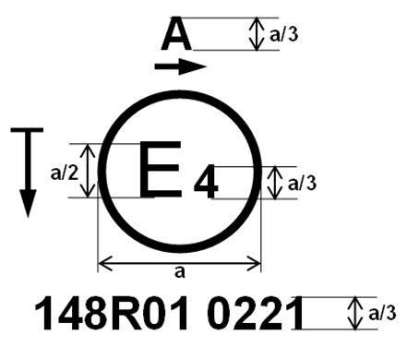
Examples of the arrangement of the markings are shown in Annex 7. ”

Add a new Paragraph 3.3.4.4.1., to read:
“3.3.4.4.1. For the additional approval markings specific to the device, labels may be used. Such labels shall be durable for the useful life of the device. Labels shall be clearly legible and their letters and figures shall be indelible.
Additionally, labels shall be attached in such a manner that their fixing is durable for the useful life of the device, and the labels cannot be removed without destroying or defacing them. ”

II. Proposal for a Supplement to the 01 series of amendments to UN Regulation No. 149
Add a new Paragraph 3.3.4.4.1., to read:
“3.3.4.4.1. For the additional approval markings specific to the device, labels may be used. Such labels shall be durable for the useful life of the device. Labels shall be clearly legible and their letters and figures shall be indelible.
Additionally, labels shall be attached in such a manner that their fixing is durable for the useful life of the device, and the labels cannot be removed without destroying or defacing them. ”

Add a new Figure A13-VII, in Annex 13, to read:
“Figure A13-VII
Marking example 7
148R01 A E1 6535 6536

149R01 HCR PL 30

The above example corresponds to the marking of a part intended to be used in different types of headlamps, namely:

- Either a headlamp, with a passing-beam Class C (C) designed for right-hand traffic only (Approval number 6535) and a driving-beam Class B (HR) with a maximum intensity comprised between 1.24∙10⁵ and 1.45∙10⁵ candelas (as indicated by the number 30), approved in accordance with the requirements of this Regulation, as amended by the 01 series of amendments and incorporating part with a front position lamp approved in accordance with the 01 series of amendments to UN Regulation No. 148. The horizontal arrow indicates the side on which the required photometric specifications are met up to an angle of 80° H;

- Or a headlamp, with a passing-beam Class C (C) designed for left-hand traffic only (Approval number 6536) and a driving-beam Class B (HR) with a maximum intensity comprised between 1.24∙10⁵ and 1.45∙10⁵ candelas (as indicated by the number 30), approved in accordance with the requirements of this Regulation, as amended by the 01 series of amendments and incorporating a part with a front position lamp approved in accordance with the 01 series of amendments to UN Regulation No. 148. The horizontal arrow indicates the side on which the required photometric specifications are met up to an angle of 80° H. ”

Annex 13, Figure A13-VII (former), renumber and amend to read:
“Figure A13 VIIVIII
Light source module marking example
MD E3 17325
The light source module bearing the identification code shown in Figure A13-VII VIII has been approved together with a lamp approved in Italy (E3) under approval number 17325. ”

Annex 13, Figure A13-VIII (former), renumber and amend to read:
“Figure A13 VIIIIX
Lighting unit marking example
ALU E43 1234
The additional lighting unit bearing the identification code shown in Figure A13-VIII IX has been approved together with a headlamp initially approved in Japan (E43) under approval number 1234. ”

III. Justification
1. During the introduction of new technologies for the additional marking, the usage of a label was discussed with several Type Approval Authorities.
2. Some Authorities were in favour of a label instead of a traditional engraving, but these Authorities were asking for some requirements for such a label and prepared information for manufacturers. Accordingly, a reference to a label for type approval marking was found in UN Regulation No. 132 (approval of Retrofit Emission Control devices (REC)) and the text was introduced into UN Regulations Nos. 148 and 149.
3. This proposal also aims to align with UN Regulation No. 148 and thus add one example of additional marking in Annex 13 of UN Regulation No. 149.
4. It should be noted that under Regulations Nos. 10 (EMC) and 45 (Headlamp cleaners), the use of labels for displaying the approval mark is already permitted. This proposal deals only with UN Regulations Nos. 148 and 149 and does not intend to change the existing practice with other Regulations.
5. Figure I in UN Regulation No. 148-01 was without title. This proposal adds a title in consistency with the proposed amendment to UN Regulation No. 150-01 (GRE/2026/14).

Additional information

Abstract of UN Regulation No. 132:

5.2.2. Labels shall be durable for the useful life of the device. Labels shall be clearly legible and their letters and figures shall be indelible. Additionally, labels shall be attached in such a manner that their fixing is durable for the useful life of the device, and the labels cannot be removed without destroying or defacing them.
____________

