Proposal to amend Working Document ECE/TRANS/WP.29/GRPE/2025/21

The text below is the updates to the scope change proposal for UNR177 in Working Document ECE/TRANS/WP.29/GRPE/2025/9 prepared by the experts of OICA, adding the application of system benches for all vehicle types.
I. Proposal

Paragraph 3.5.11., add to read:

3.5.11. "Major maintenance" means the adjustment, repair or replacement of a component or module that could affect the accuracy of a measurement.

Paragraph 7.1.3., amend to read:

7.1.3. Cooling fan
A current of air of variable speed shall be blown towards the vehicle sufficient to maintain the proper system operating temperatures and system functions (see paragraph 8.8.1.).. The set point of the linear velocity of the air at the blower outlet shall be equal to the corresponding dynamometer speed above measurement speeds of 5 km/h. The deviation of the linear velocity of the air at the blower outlet shall remain within ±10 % of the corresponding measurement speed, up to the maximum speed of the blower. In case of system bench, the manufacturer should recommend the airflow velocity necessary to maintain proper system operating temperatures and system function, equivalent when those are in a vehicle. Excessive cooling is prohibited.

Paragraph 7.2.1., amend to Measurement items and required accuracy in Table 2:

Table 2
Measurement items and required accuracy
Item | Units | Accuracy | Remarks
Chassis  dynamometer  speed | km/h | The dynamometer speeds shall be controlled with an accuracy of ±0.2 km/h or ±0.1% of full scale vehicle speed, whichever is greater.
Chassis  dynamometer force | N | The accuracy of the force transducer shall be at least ±10 N for all measured increments. This shall be verified upon initial installation, after major maintenance and within 370 days before testing.
Axle/wheel rotational speed of Hub dynamometer or System bench | rev/s | ± 0.05 s⁻¹ or ± 1 % of full scale rotational speed, whichever is greater.
Axle/wheel torque of Hub dynamometer or System bench | Nm | ± 6 Nm or ± 0.5 %  of full scale torque, whichever is greater.

Paragraph 8.1., amend to read:

8.1. General
The following test procedures determine a vehicle system power rating for a hybrid electric vehicle, or for a pure electric vehicle with more than one propulsion energy converter.
Two test procedures are described herein.
Test procedure 1 (TP1) is based on measured electrical power, estimated ICE power, and estimated electrical conversion efficiency.
Test procedure 2 (TP2) is based on measured torque and speed at the drive shaft(s) or wheel hub(s) and estimated mechanical conversion efficiency.
TP1 and TP2 are intended to be technically equivalent methods for determining a vehicle system power rating from available measurements. TP1 and TP2 are distinguished by the specific instrumentation, measurements, other inputs, and calculations necessary to determine the vehicle system power rating.
Each powered axle that provides propulsion under the maximum power condition shall be tested by chassis dynamometer or hub dynamometer or system bench. Vehicles that are powered by two powered axles under the maximum power condition shall be tested on a four-wheel-drive chassis dynamometer, or each powered axle shall be tested simultaneously by hub dynamometer or system bench. In the case of vehicles whose maximum power, in the judgment of the Type-Approval Authority, exceeds that of readily available dynamometers, it It is permissible to use a system bench, which may include simulators, in place of a dynamometer. In that case, the facilities must be approved by the Type-Approval Authority according to Annex 6 for facilities approval.

Paragraph 8.1.2.2., amend to read:

8.1.2.2. Measurements specific to TP2
For TP2, the following measurements are additionally required: torque and rotational speed at the powered axle shafts or wheel hubs.
Important: if the ICE power needs to be corrected according to the provisions of paragraph ‎8.9.3.2., the measurement requirements of TP1 with regard to current and voltage may also apply (see paragraph 8.9.3.3.).
Wheel torque and rotational speed measurement may be provided either by means of a hub dynamometer or by means of system bench or by means of appropriate, calibrated measurement device(s) for torque and rotational speed of the powered axle shaft(s) or wheel hub(s) or drive shaft(s).

Paragraph 8.11., amend to read:

8.11. Internal validation of vehicle system power rating
The vehicle system power rating according to TP1 or TP2 shall fulfil the following requirement:

The implied downstream efficiency between the reference point(s) and the road shall not be greater than 1. Implied downstream efficiency is computed by dividing the average power recorded at the dynamometer rollers (or hub dynamometer or system bench if applicable) between the 8th and 10th second by the sustained vehicle system power result (prior to any correction under paragraph ‎8.9.3.3.).

Annex 1, Appendix 2, Test Report 2.1., amend to read:

2.1. | Chassis dynamometer/Hub dynamometer/System bench ²⁾

Annex 1, Appendix 2, Test Report 3.5., amend to read:

3.5. | Speed of maximum power … km/h or rev/s

Annex 5, 5~6., amend to read:

5. The power delivered to the dynamometer at each operating point may be determined by reference to dynamometer power data, or dynamometer speed and torque or forth data, where available.
6. Once determined, the speed of maximum power shall be reported in kilometres per hour or revolutions per second as a whole number.

Annex 5, Figure 29, amend to graph:

Figure 29
Relation between power and speed
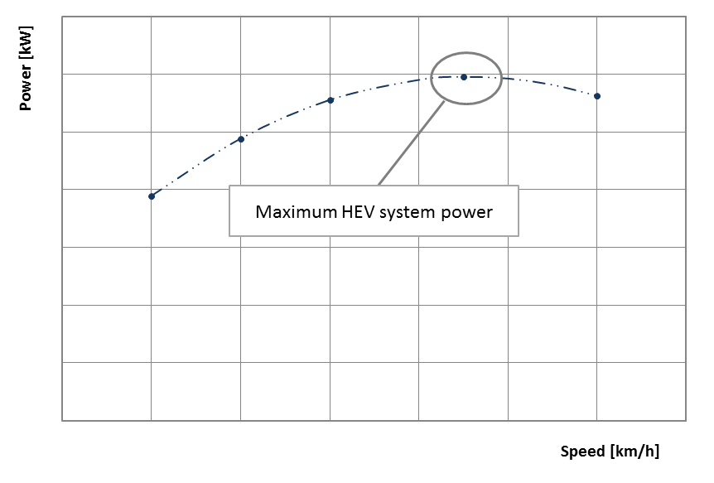
or [rev/s]
Annex 6, add to read:

Annex 6
Approval of the system bench facility by the Type-Approval Authority
The results of the system bench testing shall be compared to those obtained using the chassis dynamometer to demonstrate qualification of the facility and recorded.

1. Test procedure

1.1 Two vehicles covering the maximum and minimum outputs of the vehicles planned to be measured with the facility shall be selected, and their respective system power values shall be obtained by testing with a chassis dynamometer in accordance with paragraph 6. and by using the system bench facility concerned.

2. Approval criteria

2.1 The facility used shall be approved if both of the following two criteria are fulfilled:

(a) The difference between the dynamometer test results in accordance with paragraph 6. of this document and the results from the relevant system bench facility for each vehicle shall be [0.05 or less]:

$$P_{k}= \frac{p_{k, SB}}{p_{k, DM}}-1$$
where

P_{k} is the difference in system power for vehicle k between the system bench and the chassis dynamometer, in percent

P_{k,SB} is the system power value obtained at the system bench testing, in kilowatts

P_{k,DM} is the system power value obtained at the dynamotor testing in accordance with paragraph 6., in kilowatts.

(b) The arithmetic average $\overline{x}$ of the two differences shall be within [0.02].
$$\overline{x}=\left| \frac{P_{1}+ P_{2}}{2}\right|$$

2.2 The approval shall be recorded by the responsible authority including measurement data and the facilities concerned.

2.3 The facility may be used for system power determination for five years after the approval has been granted or until prior to major maintenance.

2.4 In the case of vehicles whose maximum power, in the judgment of the Type-Approval Auyhority, exceeds that of readily available dynamometers, it is permissible to use a system bench, which may include simulators, in place of a dynamometer, without the comparison tests specified in this section.

2.5 The manufacturer shall provide the most recent calibration data of the measurement equipment based on the request by the responsible authority.

II. Justification

- The updated text aims to expand the availability of the proposed amendments set out in working document ECE/TRANS/WP.29/GRPE/2025/21 by adding the expansion of test applications at the system bench facility proposed by Japan.

