Submitted by the experts from GTB | Informal document GRE-94-11  (94th GRE, 27-30 April 2026,  agenda item 7 (c))

This paper provides additional information and justification regarding document GRE/2026/14

I. Proposal for a Supplement to the 01 series of amendments to UN Regulation No. 150
Paragraph 3.3.1.3., amend to read:
“3.3.1.3. With regard to the size of the approval marking the value for "a" is defined in Table 1.

Figure I
Approval markings proportions
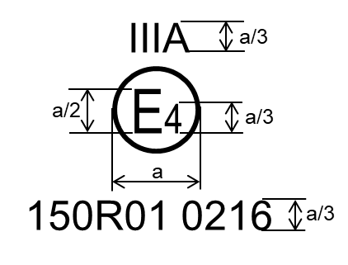
Examples of the arrangement of the markings are shown in Annex 10. ”

[Paragraph 3.3.3.1., renumber “Figure I” to read “Figure II”:
“ Figure II
Unique Identifier (UI)
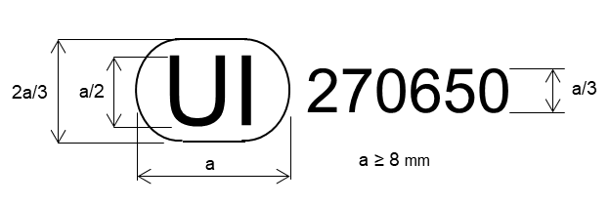”]

Figure A10-1, amend to read:

“ Figure A10-I: Marking examples for single devices

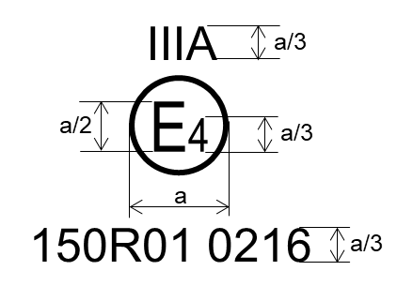 | Model A:  This approval mark affixed to a retro-reflective device shows that the type of device concerned has been approved in the Netherlands (E4) under approval number 150R01 0216. The approval number shows that approval was granted in accordance with the requirements of this Regulation as modified by the 01 series of amendments.  For a = see Table 1
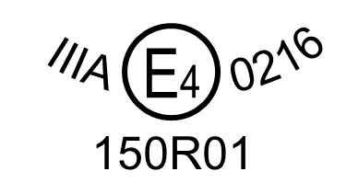 | Model B:  Same device as Model A, different arrangement.
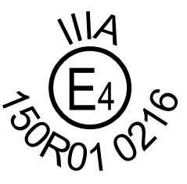 | Model C:  Same device as Model A, different arrangement.

Note: The above approval number and the group of symbols indicating the class must be placed close to, but in any position in relation to, the circle surrounding the letter "E". The digits constituting the approval number must face the same way as the "E". The group of symbols indicating the class must be diametrically opposite the approval number. The Type Approval Authorities shall avoid using approval numbers IA, IB, IIIA, IIIB and IVA which might be confused with the class symbols IA, IB, IIIA, IIIB and IVA.
These sketches show various possible arrangements and are given as examples only.”

II. Justification
Square brackets around Figure II
- The GRE adopted proposal to delete the UI from UN Regulation No. 150-01 (GRE-92-18) is not part of the GRE submission to WP.29 in March 2026. Therefore, at the current stage, the text of the regulation should be amended. However, if this proposal will be merged with informal document GRE-92-18, the amendment to former Figure I will no longer be necessary.
Requirements for the value "a"
- This proposal is following the same approach used for UN Regulation No. 148 (see Suppl. 1 to UN Regulation No. 148-01, doc. GRE/2024/17), i.e. include one example of the approval marking in the body text and refer to the other arrangements in Annex 10.
- With this modification the reference to Table 1 below the “Model A” can be deleted. Moreover, the various ratio-explanations (i.e. a, a/2, a/3) can also be deleted from Figure A10-I, as they are now provided in Figure I in the body text.
Deletion of diametrically opposite requirement
- UN Regulations Nos. 3 and 7 required that the group of the function symbols shall be located near the circle surrounding the letter “E” and diametrically opposite to the approval number. When UN Regulation No. 148 was introduced, this requirement was no longer required for the functions applying UN Regulation No. 148. However, UN Regulation No. 150 still contains this requirement.
- Nowadays, there is no reason for the group of symbols indicating the class to be place diametrically opposite the approval number.
- This requirement is written only in Annex 10 without any reference in the body text. This situation is generating different interpretations in some technical services. The amendment to the note below Figure A10-I is intended to provide clarity and avoid different interpretations.
____________

