|  |  |  |  |
| --- | --- | --- | --- |
|  | United Nations | ECE/TRANS/WP.29/2025/37 | |
| _unlogo | **Economic and Social Council** | | Distr.: General  24 December 2024  Original: English |

**Economic Commission for Europe**

Inland Transport Committee

**World Forum for Harmonization of Vehicle Regulations**

**195th session**

Geneva, 4–7 March 2025

Item 4.10.8 of the provisional agenda

**1958 Agreement:**

**Consideration of draft amendments to existing**

**UN Regulations submitted by GRE**

Proposal for Supplement 4 to the 01 series of amendments to UN Regulation No. 148 (Light-Signalling Devices)

Submitted by the Working Party on Lighting and Light-Signalling[[1]](#footnote-2)\*, \*[[2]](#footnote-3)\*

The text reproduced below was adopted by the Working Party on Lighting and Light-Signalling (GRE) at its ninety-first session (ECE/TRANS/WP.29/GRE/91, para. 20). It is based on ECE/TRANS/WP.29/GRE/2024/17. It is submitted to the World Forum for Harmonization of Vehicle Regulations (WP.29) and to the Administrative Committee (AC.1) for consideration at their March 2025 sessions.

*Paragraph 3.3.1.2.*, amend to read:

“3.3.1.2. With regard to the size of the approval marking the value for “a” shall be at least 5 mm.

Figure I

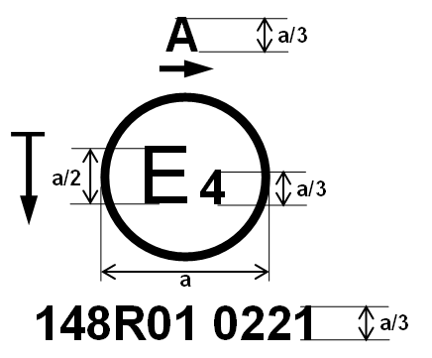

Examples of the arrangement of the markings are shown in Annex 7.”

*Paragraph 3.3.3.1.*, *Figure I*, renumber to “Figure II”.

*Annex 7*, *part 1,* amend to read:

**“1. Approval marking of a single light signalling lamp**

|  |  |
| --- | --- |
| Figure A7-I - Marking example 1 | The lamp bearing the approval marking shown on the left is a front position lamp (A) approved in the Netherlands (E4), under approval number 0221 pursuant to this Regulation (148R).  The number (01) mentioned after 148R indicates that approval was granted in accordance with the requirements of this Regulation as set in the 01 series of amendments. The horizontal arrow indicates the outwards of the vehicle. The vertical arrow starting from a horizontal segment and directed downwards indicates a lamp with reduced light distribution (vertically downwards and/or horizontally below the H plane). |

…”

1. \* This document was scheduled for publication after the standard publication date owing to circumstances beyond the submitter's control. [↑](#footnote-ref-2)
2. \*\* In accordance with the programme of work of the Inland Transport Committee for 2025 as outlined in proposed programme budget for 2025 (A/79/6 (Sect. 20), table 20.6), the World Forum will develop, harmonize and update UN Regulations in order to enhance the performance of vehicles. The present document is submitted in conformity with that mandate. [↑](#footnote-ref-3)