 | United Nations | ECE/TRANS/WP.29/GRE/2026/10
 | Economic and Social Council |  | Distr.: General  10 February 2026  Original: English
Economic Commission for Europe
Inland Transport Committee
World Forum for Harmonization of Vehicle Regulations
Working Party on Lighting and Light-Signalling
Ninety-fourth session
Geneva, 27-30 April 2026
Item 7 (a) of the provisional agenda
Device UN Regulations:
UN Regulation No. 148 (Light-Signalling Devices)
Proposal for a Supplement to the 01 series of amendments to both UN Regulation No. 148 and UN Regulation No. 149
Submitted by the experts from The International Automotive Lighting and Light-Signalling Expert Group*
The text reproduced below was prepared by the experts from the International Automotive Lighting and Light-Signalling Expert Group (GTB) with the aim to provide a clarification of grouped markings and labels. The proposed modifications to the current text of the UN Regulations are marked in bold for new or strikethrough for deleted characters.

I. Proposal for a Supplement to the 01 series of amendments to UN Regulation No. 148
Paragraph 3.3.1.2., amend to read:
“3.3.1.2. With regard to the size of the approval marking the value for “a” shall be at least 5 mm.

Figure I
Approval markings proportions
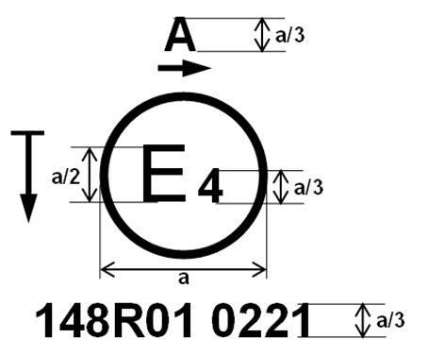
Examples of the arrangement of the markings are shown in Annex 7. ”
Add a new paragraph 3.3.5.4.1., to read:
“3.3.5.4.1. For the additional approval markings specific to the device, labels may be used. Such labels shall be durable for the useful life of the device. Labels shall be clearly legible and their letters and figures shall be indelible.
Additionally, labels shall be attached in such a manner that their fixing is durable for the useful life of the device, and the labels cannot be removed without destroying or defacing them.”
II. Proposal for a Supplement to the 01 series of amendments to UN Regulation No. 149
Add a new paragraph 3.3.5.4.1., to read:
“3.3.5.4.1. For the additional approval markings specific to the device, labels may be used. Such labels shall be durable for the useful life of the device. Labels shall be clearly legible and their letters and figures shall be indelible.
Additionally, labels shall be attached in such a manner that their fixing is durable for the useful life of the device, and the labels cannot be removed without destroying or defacing them. ”
Annex 13, add a new Figure A13-VII and its description, to read:
“Figure A13-VII
Marking example 7
148R01 A E1 6535 6536

149R01 HCR PL 30

The above example corresponds to the marking of a part intended to be used in different types of headlamps, namely:
- Either a headlamp, with a passing-beam Class C (C) designed for right-hand traffic only (Approval number 6535) and a driving-beam Class B (HR) with a maximum intensity comprised between 1.24∙10⁵ and 1.45∙10⁵ candelas (as indicated by the number 30), approved in accordance with the requirements of this Regulation, as amended by the 01 series of amendments and incorporating part with a front position lamp approved in accordance with the 01 series of amendments to UN Regulation No. 148. The horizontal arrow indicates the side on which the required photometric specifications are met up to an angle of 80° H;
- Or a headlamp, with a passing-beam Class C (C) designed for left-hand traffic only (Approval number 6536) and a driving-beam Class B (HR) with a maximum intensity comprised between 1.24∙10⁵ and 1.45∙10⁵ candelas (as indicated by the number 30), approved in accordance with the requirements of this Regulation, as amended by the 01 series of amendments and incorporating a part with a front position lamp approved in accordance with the 01 series of amendments to UN Regulation No. 148. The horizontal arrow indicates the side on which the required photometric specifications are met up to an angle of 80° H.”
Annex 13, Figure A13-VII (former), renumber to Figure A13-VIII and update the reference in the paragraph below acordingly.
Annex 13, Figure A13-VIII (former), renumber to Figure A13-IX and update the reference in the paragraph below accordingly.
III. Justification
The proposed amendment is intended to provide a clarification of grouped markings and labels. Further details can be found in informal document GRE-94-07.

* In accordance with the programme of work of the Inland Transport Committee for 2026 as outlined in proposed programme budget for 2026 (A/80/6 (Sect. 20), table 20.7), the World Forum will develop, harmonize and update UN Regulations in order to enhance the performance of vehicles. The present document is submitted in conformity with that mandate.

